Supplementary Material
Click beetles (Elateridae) identify conservation units in Oriental and European beech forests
Giorgi Mamadashvili et al.

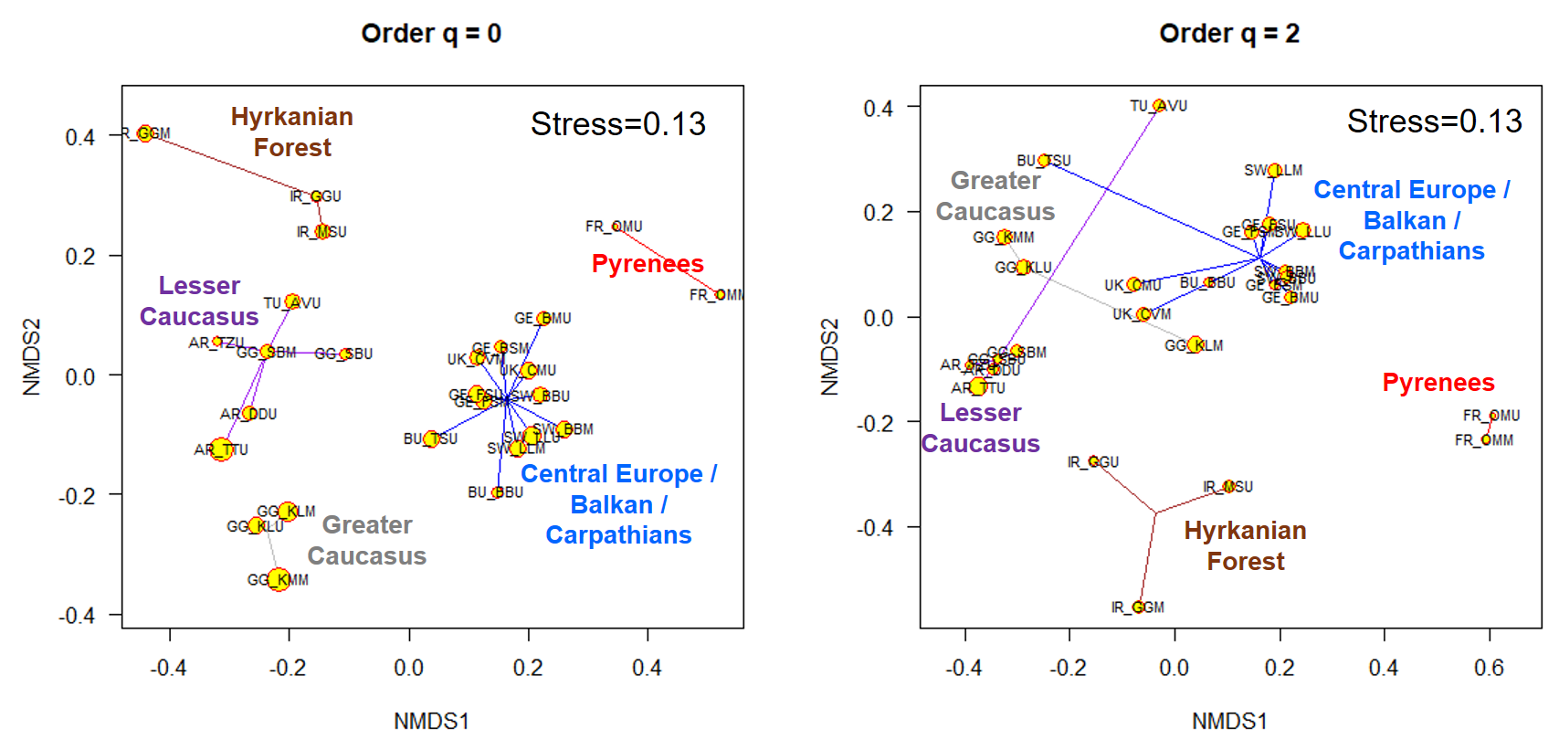
Figure S1: Non-metric ordination of the distance matrix for rare species (Jaccard similarity) and dominant species (Morisita-Horn similarity) under consideration of unseen species for samples from flight traps only (112 species, 6743 specimen). ANOSIM statistic for q0: R 0.92, p=0.001 and for q2: R 0.80, p=0.001.

Table S1: Results of linear models for four measures of elaterid community diversity and composition in 26 beech forests; t values are shown, ***=p<0.001.
Predictor | Diversity q0 | Diversity q2 | Saproxylics (%) | Endemics (%)
Elevation | -0.99 | -1.50 | 0.39 | 0.63
Forest Type: Unmanaged | 0.96 | -0.91 | -0.48 | -1.23
Longitude | 1.82 | 1.68 | 0.25 | 6.04***

