Supplementary Information

Table S1. Number of plots (1 m²) surveyed per site and visit across the study sites.
Site | 2021 |  |  | 2022 |  |  |  |  |  |  |  | Total
Site | Aug | Sep | Oct | Mar | Apr | May | Jun | Jul | Aug | Sep | Oct | Total
S1 | 43 | 51 | 51 | 50 | 50 | 50 | 49 | 45 | 49 | 44 | 49 | 531
S2 | 50 | 74 | 74 | 75 | 75 | 73 | 64 | 68 | 65 | 67 | 65 | 750
S3 | 58 | 55 | 55 | 31 | 55 | 55 | 53 | 55 | 53 | 55 | 55 | 580
S4 | 0 | 0 | 0 | 0 | 0 | 48 | 64 | 62 | 62 | 35 | 61 | 332
S5 | 0 | 0 | 0 | 0 | 60 | 60 | 59 | 55 | 57 | 59 | 59 | 409
Total |  |  |  |  |  |  |  |  |  |  |  | 2602

Table S2. Pearson’s correlation matrix for all predictors used in model selection. Bold and underscored values indicate correlations with |r| >0.7, which were considered indicative of multicollinearity.
Variables | Simpson | Shannon | VegH  mean | Veg  Hstd | CovSp  Mean | CovSp  Std | Presence | FL  Richness | CovPlt  Allmean | Cov  Plt | CovPref  SpSiPr | CovPref  SpCaPr | CovPref  SpSi | CovPref  SpCa
Simpson | 1
Shannon | 0.97 | 1
VegHmean | 0.17 | 0.22 | 1
VegHstd | 0.30 | 0.35 | 0.84 | 1
CovSpMean | -0.10 | -0.06 | 0.31 | 0.08 | 1
CovSpStd | -0.08 | -0.04 | 0.31 | 0.05 | 0.9 | 1
Presence | 0.55 | 0.62 | 0.22 | 0.14 | 0.55 | 0.55 | 1
FLRichness | 0.74 | 0.86 | 0.31 | 0.37 | 0.09 | 0.16 | 0.74 | 1
CovPltAllmean | 0.33 | 0.42 | 0.33 | 0.18 | 0.71 | 0.72 | 0.88 | 0.60 | 1
CovPlt | 0.37 | 0.44 | 0.37 | 0.26 | 0.71 | 0.67 | 0.71 | 0.60 | 0.86 | 1
CovPrefSpSiPr | 0.06 | 0.03 | 0.27 | 0.20 | 0.25 | 0.12 | 0.02 | -0.02 | 0.14 | 0.28 | 1
CovPrefSpCaPr | 0.17 | 0.16 | 0.66 | 0.48 | 0.42 | 0.30 | 0.29 | 0.16 | 0.43 | 0.41 | 0.63 | 1
CovPrefSpSi | 0.15 | 0.19 | 0.35 | 0.17 | 0.75 | 0.73 | 0.58 | 0.26 | 0.83 | 0.74 | 0.42 | 0.57 | 1
CovPrefSpCa | 0.13 | 0.17 | 0.37 | 0.16 | 0.75 | 0.74 | 0.60 | 0.26 | 0.85 | 0.73 | 0.36 | 0.60 | 0.98 | 1

S3. Bumblebee abundance and habitat traits
In the main text, a summarised analysis of bumblebee abundance and habitat traits is provided. However, the time-series results are shown in this section to provide a general overview.
Flower presence
In March, no forage resources were observed during the habitat surveys, but by April we found flowers in almost 20% of the plots surveyed. The percentage of plots with flowers increased over time, peaking in June (56%) and July (57%), followed by a sharp decline in August (15%), and then a relatively stable proportion of plots with flowers until October (10%) (Figure S3.1, Presence panel).
Flower diversity
In April, the average number of flower species per site (Figure S3.1, FLRIchness panel) was only 1; however, it increased to 5 in May, and peaked at 10 in June. Species richness decreased after this point, with the most significant decline occurring from July to August, when the number of species dropped from 8 to 4.
Shannon-Wiener and Simpson’s Diversity indices revealed similar trends: the highest diversity of flower species was observed in May, June and July, with Simpson Diversity Index above 0.5 and Shannon-Wiener Index above 1 (Figure S3.1, Simpson and Shannon panels).
Flower preference
In early spring, few of the preferred forage plants identified in the literature such as Carvell et al. (2006a) were present, but the plant species that bumblebees were observed foraging on during BeeWalk transect walks were found widely across the sites. In April, although the percentage of plots with flowers (Presence) and the mean percentage of flower coverage (CovPlt, Table 1) were both low overall, the mean proportion of the visited flower species was 0.5 (Figure S3.1 CovPrefSpSiPr panel). From April (0.5) to May (0.1), there is a sharp decline in the proportion of the visited flower species (Figure S3.1 CovPrefSpSiPr panel), before an increase to peak in July (0.8) and then a gradual decrease through August (0.7) and September (0.7). Finally, in October (0.3) the proportion of visited flower species (Figure S3.1 CovPrefSpSiPr panel) available to bumblebees decreased. This was broadly similar to the prevalence of preferred flower species from the literature (Figure S3.1 CovPrefSpSiCaPr) (Goulson and Darvill, 2004; Carvell et al., 2006a), which showed an increase in summer, particularly in July (0.8). This was followed by a sharp decline in August (0.4), and in October (0.0) there weren’t preferred flower species from the literature available to bumblebees (Figure S3.1 CovPrefSpSiCaPr panel). It’s noteworthy that the highest total percentage of flower coverage preferred species observed in July (Figure S3.1 CovPrefSpSiPr and CovPrefSpSiCaPr panels), is largely explained by the abundance of Cirsium arvense, particularly at site 4.
Flower abundance
The mean flower coverage percentage varied monthly, peaking in July with 7% (Figure S3.1 CovPltAllmean panel). Similar trends were seen in the mean percentage of flower coverage among plots with flowers (Figure S3.1 CovPlt panel).
The mean flower species coverage (Figure S3.1 CovSpmean panel) and its corresponding standard deviation (Figure S3.1 CovSpStd panel) varied monthly also peaking in July, at 62% and 93%, respectively. Notably, CovSpmean and CovSpStd exhibited a decreasing trend from April to May, contrasting with the increasing trends observed in CovPltAllmean and CovPlt.
Nesting conditions and heterogeneity
The mean vegetation height of the plots was lowest in March, with 4.7cm. The height consistently increased until it peaked in July (49.5cm), before decreasing through the following three months reaching 25.3cm in October (VegHmean, Table 1, Figure S3.1).
The standard deviation of vegetation height (VegHstd, Table 1, Figure S3.1) also exhibited its lowest value in March (2.8cm). Over time, the standard deviation (VegHstd, Table 1) consistently increased, showing its highest value in August (24.7cm). Subsequently, it decreased in the following two months, reaching 15.8cm in October (VegHstd, Table 1, Figure S3.1).
The increase in the standard deviation observed in August (VegHstd, Table 1, Figure S3.1) can be attributed to different factors occurring at sites 4 and 5. At site 4, the presence of Cirsium arvense, a tall plant species, typically declines in August, leaving few standing plants. This contributes to a greater variability in vegetation height, therefore increasing the standard deviation. Similarly, at site 5, patches of tussock-forming grass tend to grow taller towards the end of summer. This adds to the variability in vegetation height at these sites, further increasing the standard deviation.
Reference
Carvell, C., Roy, D. B., Smart, S. M., Pywell, R. F., Preston, C. D., & Goulson, D. (2006a). Declines in forage availability for bumblebees at a national scale. Biological Conservation, 132(4), 481–489. https://doi.org/10.1016/j.biocon.2006.05.008

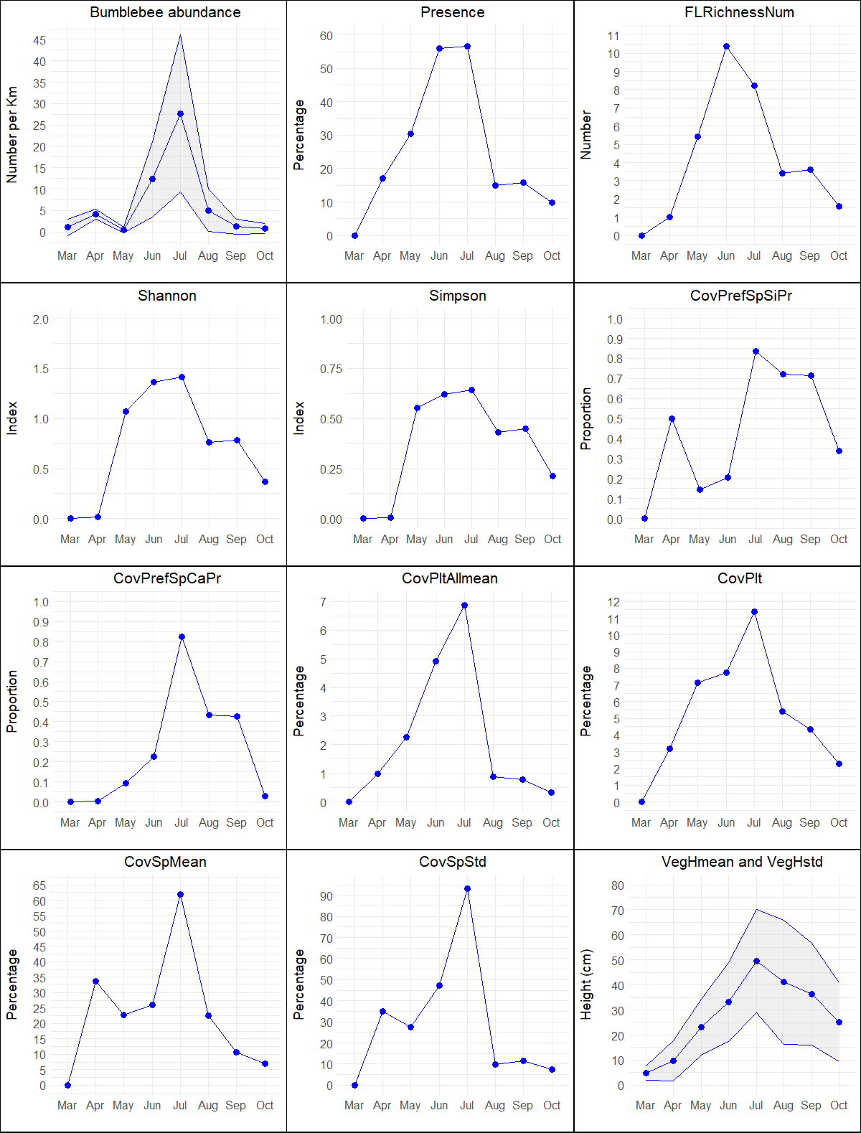
Fig. S3.1. Monthly bumblebee abundance and bumblebee habitat traits graphs. In Bumblebee abundance the shaded areas indicate ± 1 standard deviation. In VegHmean and VegHstd the blue points represent the mean vegetation height (VegHmean) and the shaded area corresponds to the mean vegetation height (VegHmean) ± 1 standard deviation (VegHstd).
Table S4. List of flowering species found in the habitat surveys.
No. | Plant species |  | No. | Plant species
1 | Achillea ptarmica |  | 27 | Lotus corniculatus
2 | Ajuga sp. |  | 28 | Lotus pedunculatus
3 | Anthriscus sylvestris |  | 29 | Mentha sp.
4 | Archillea millefolium |  | 30 | Odontites vernus
5 | Bellis sp. |  | 31 | Ononis repens
6 | Campanula rotundifolia |  | 32 | Pedicularis sylvatica
7 | Cardamine sp. |  | 33 | Potentilla erecta
8 | Carex sp. |  | 34 | Primula veris
9 | Centaurea nigra |  | 35 | Prunella vulgaris
10 | Cirsium palustre |  | 36 | Pulicaria dysenterica
11 | Cirsium arvense |  | 37 | Ranunculus acris
12 | Conopodium majus |  | 38 | Ranunculus flammula
13 | Crepis capillaris |  | 39 | Ranunculus repens
14 | Cruciata sp. |  | 40 | Rhinanthus minor
15 | Dactylorhiza sp. |  | 41 | Rubus sp.
16 | Ficaria verna |  | 42 | Silene flos-cuculi
17 | Geranium sp. |  | 43 | Stellaria sp.
18 | Glechoma hederacea |  | 44 | Succisa pratensis
19 | Hypericum sp. |  | 45 | Taraxacum sp.
20 | Hypochaeris glabra |  | 46 | Trifolium dubium
21 | Hypochaeris radicata |  | 47 | Trifolium medium
22 | Jacobaea vulgaris |  | 48 | Trifolium pratense
23 | Lathyrus sp. |  | 49 | Trifolium repens
24 | Leontodon autumnalis |  | 50 | Veronica chamaedrys
25 | Leontodon hispidus |  | 51 | Vicia villosa
26 | Liposthenes sp.

Table S5. Flower species visited by bumblebees and their presence in habitat surveys across all sites.
Visited flower species | Observation site(s) | Present in habitat surveys
Visited flower species | Observation site(s) | Site 1 | Site 2 | Site 3 | Site 4 | Site 5
Anthriscus sylvestris | 2 | Yes | No | No | No | No
Centaurea nigra | 2 | No | Yes | No | No | No
Cirsium sp. | All | Yes | No | No | Yes | Yes
Cyclamen hederifolium | 2 | No | No | No | No | No
Digitalis purpurea | 1 | No | No | No | No | No
Epilobium angustifolium | 2, 3 | No | No | No | No | No
Leontodon autumnalis | 2, 3 | Yes | Yes | Yes | No | No
Leontodon saxatilis | 3 | No | Yes | No | No | No
Lotus corniculatus | 2, 3 | Yes | Yes | Yes | Yes | Yes
Ranunculus sp. | 2 | Yes | Yes | Yes | Yes | Yes
Rubus sp. | 1, 2, 3, 5 | No | Yes | No | No | No
Stachys sp. | 1 | No | No | No | No | No
Succisa pratensis | 1 | Yes | Yes | No | No | No
Taraxacum sp. | 2, 3 | Yes | Yes | Yes | Yes | No
Trifolium pratense | 1, 2, 3 | Yes | Yes | Yes | No | Yes
Trifolium repens | 2 | Yes | Yes | Yes | No | Yes
Vicia villosa | 3 | No | Yes | No | No | No

S6. Habitat traits influencing bumblebee abundance
We explored two approaches to estimate the proportion of flower coverage from preferred forage species for bumblebees. In the first approach, we calculated this proportion based on a list of plant species identified in the study by Carvell et al. (2006a). In the second approach, we determined the proportion based on the species we observed bumblebees foraging on during BeeWalks at our field sites. Notably, the first approach did not contribute to the prediction of bumblebee abundance, as it was not included in any of the most parsimonious models. This was despite the fact that both variables exhibited similar values during May, June & July 2022, suggesting that the preferred forage species were approximately the same. Nevertheless, the second approach outperformed the first, as indicated by its consistent inclusion in nearly all the equivalent models. This is likely to be attributable to a better representation of the available forage resources, especially in April, August, September and October, when compared to more general suggestions. For example, species like Leontodon autumnalis, Leontodon saxatilis, and Taraxacum sp. were observed to be used by bumblebees at our sites but are not included in Carvell et al. (2006a) list. In contrast, Cirsium arvense, a species that is included in Carvell et al. (2006a) list, was also frequently used at our sites, showing that both lists capture important resources, though the BeeWalk-based list provided a more representative picture of the forage composition that bumblebees were using in our study sites.
Consequently, our study highlights that the composition of preferred forage species throughout the entire flying season constitutes a better indicator of habitat quality. This implies that while general lists can be helpful, collecting local data is of the utmost importance, as bumblebees will make preferential use of different flower species depending on their availability. This finding aligns with prior research demonstrating the significance of preferred forage species abundance in predicting bumblebee abundance (Carvell, 2002; Carvell et al., 2006b; Pakeman and Stockan, 2013).
Together with the proportion of preferred forage species, flower richness was a consistently important predictor of bumblebee abundance. Florally diverse areas are more likely to ensure a constant provision of forage resources throughout the bumblebee flight season, because different plants are likely to bloom at different times, providing a more continuous food source than can a small number of species (Carvell, 2002; Pakeman and Stockan, 2013; Blaauw and Isaacs, 2014; Hülsmann et al., 2015). Our estimations for flower richness were conducted monthly and we only considered the species in bloom during the surveys. Hence, in this context, this variable is depicting temporal dynamics of floral resources and the provision of both pollen and nectar. This dietary diversity also contributes to bumblebee health and colony growth (Roger et al., 2017), including strengthening the response of queen bumblebees to pesticides (Costa et al., 2022).
Bumblebees need forage plants to feed from, but they also require suitable sites for both nesting and overwintering (Carvell, 2002). However, these wider needs have largely remained unstudied. We attempted to take these into account by including vegetation height measurements as a proxy for heterogeneity (VegHmean and VegHstd, Table 1), and thus potential nesting conditions. VegHmean was included in the best-performing model, which resulted in a better generalisation power of the model, indicated by the low LOOCV among the analysed models. Its low predictive power is likely due, in part, to the variability in nesting preferences among bumblebee species (O’Connor, 2013), and the range of tall plants encountered which would not form suitable nesting or overwintering sites for any bumblebee species (e.g. Cirsium arvense). Additionally, the area needed for nesting and overwintering site provision is likely to be much smaller than that needed for foraging provision (e.g. one nest may forage over several square kilometres, (Osborne et al., 1999, 2008; Knight et al., 2005; Rao and Strange, 2012), and this provision may not be within forage areas, both of which would make these habitats difficult to find compared to forage provision.
Another important factor that affects bumblebee abundance is the month of the survey, which is why it was included as a random effect in the GLME models. The habitat model showed that May, September, and October had negative estimates, which suggests that during those months, even though there might be good habitat conditions, bumblebee abundance will be negatively affected. For September and October this is to be expected, as these months represent the end of the life cycle of many bumblebee species colonies; however, this was not expected to occur in May. By contrast, in May bumblebee abundance was expected to be higher than in April. A similar tendency for bumblebee abundance to decline from April to May 2022 was reported by Comont and Dickinson (2023), but only for the species Bombus terrestris. In contrast, we found a decreasing trend for the aggregated group that comprises B. terrestris and B. lucorum, as well as for B. pascuorum and B. lapidarius. It’s likely that the decrease in bumblebee abundance from April to May could be explained by an increase in the availability of more attractive forage resources elsewhere, as found in Carvell et al. (2006b). It’s also possible that this was indicative of a slow start to the year by these species, with the number of queen bumblebees observed dropping as individuals died, but with worker bumblebees taking longer than normal to first emerge from the new nests.
References
Blaauw, B. R., & Isaacs, R. (2014). Larger patches of diverse floral resources increase insect pollinator density, diversity, and their pollination of native wildflowers. Basic and Applied Ecology, 15(8), 701–711. https://doi.org/10.1016/j.baae.2014.10.001
Carvell, C. (2002). Habitat use and conservation of bumblebees (Bombus spp.) under different grassland management regimes. Biological Conservation, 103(1), 33–49. https://doi.org/10.1016/S0006-3207(01)00114-8
Carvell, C., Roy, D. B., Smart, S. M., Pywell, R. F., Preston, C. D., & Goulson, D. (2006a). Declines in forage availability for bumblebees at a national scale. Biological Conservation, 132(4), 481–489. https://doi.org/10.1016/j.biocon.2006.05.008
Carvell, C., Westrich, P., Meek, W. R., Pywell, R. F., & Nowakowski, M. (2006b). Assessing the value of annual and perennial forage mixtures for bumblebees by direct observation and pollen analysis. Apidologie, 37(3), 326–340. https://doi.org/10.1051/apido:2006002
Comont, R., & Dickinson, H. (2023). BeeWalk Annual Report 2023 About BeeWalk. www.beewalk.org.uk.
Costa, C. P., Leza, M., Duennes, M. A., Fisher, K., Vollaro, A., Hur, M., Kirkwood, J. S., & Woodard, S. H. (2022). Pollen diet mediates how pesticide exposure impacts brain gene expression in nest-founding bumble bee queens. Science of The Total Environment, 833, 155216. https://doi.org/10.1016/j.scitotenv.2022.155216
Hülsmann, M., von Wehrden, H., Klein, A.-M., & Leonhardt, S. D. (2015). Plant diversity and composition compensate for negative effects of urbanization on foraging bumble bees. Apidologie, 46(6), 760–770. https://doi.org/10.1007/s13592-015-0366-x
Knight, M. E., Martin, A. P., Bishop, S., Osborne, J. L., Hale, R. J., Sanderson, R. A., & Goulson, D. (2005). An interspecific comparison of foraging range and nest density of four bumblebee (Bombus) species. Molecular Ecology, 14(6), 1811–1820. https://doi.org/10.1111/j.1365-294X.2005.02540.x
O’Connor, S. A. (2013). The Nesting Ecology of Bumblebees. University of Stirling.
Osborne, J. L., Clark, S. J., Morris, R. J., Williams, I. H., Riley, J. R., Smith, A. D., Reynolds, D. R., & Edwards, A. S. (1999). A landscape-scale study of bumble bee foraging range and constancy, using harmonic radar. Journal of Applied Ecology, 36(4), 519–533. https://doi.org/10.1046/j.1365-2664.1999.00428.x
Osborne, J. L., Martin, A. P., Carreck, N. L., Swain, J. L., Knight, M. E., Goulson, D., Hale, R. J., & Sanderson, R. A. (2008). Bumblebee Flight Distances in Relation to the Forage Landscape. In Source: Journal of Animal Ecology (Vol. 77, Issue 2).
Pakeman, R. J., & Stockan, J. (2013). Using plant functional traits as a link between land use and bee foraging abundance. Acta Oecologica, 50, 32–39. https://doi.org/10.1016/j.actao.2013.04.004
Rao, S., & Strange, J. P. (2012). Bumble bee (Hymenoptera: Apidae) foraging distance and colony density associated with a late-season mass flowering crop. Environmental Entomology, 41(4), 905–915. https://doi.org/10.1603/EN11316
Roger, N., Michez, D., Wattiez, R., Sheridan, C., & Vanderplanck, M. (2017). Diet effects on bumblebee health. Journal of Insect Physiology, 96, 128–133. https://doi.org/10.1016/j.jinsphys.2016.11.002

