Supplementary information

Data analysis on species proportions, sex ratio, and wing condition
As in a previous study (Wong et al. 2004), our field observations suggested that relative proportions of the dominant E. midamus and E. core in forested valley aggregations may change with the progression of the season. We tested this trend using a binomial generalized linear mixed model with date (day number from the first sampling date in each aggregation) as the fixed effect and aggregation (site-season combination) as the random effect, allowing a random slope of species proportion within aggregations. We included only aggregations for which we conducted more than two days of sampling and only those days with more than 20 individuals of the species in question.

The sex ratio of each genus within aggregation sites was tested with the binomial test for any deviation from 1:1. Only genera represented by more than 20 individuals within each site were included. As E. sylvester was reported to become more male-biased over time in overwintering aggregations in Taiwan (Chao et al. 2007), we tested sex ratio trends of E. midamus and E. core within forested valley aggregations using a binomial generalized linear mixed model, with male proportion as the response variable, date (day number from the first sampling date in each aggregation) and species as fixed effects, and aggregation (site-season combination) as the random effect (random slope allowed).

Trends in wing condition were tested with a binomial generalized linear model using the proportion of individuals with the freshest wing condition (= 1 on the five-point scale, which usually accounted for more than 50% of all tagged individuals) as the response variable, with genus and week number from October 1 as fixed effects. Only weeks with more than 20 individuals sampled in each genus were included. Data from the 2021-22 pilot season were excluded.

Specifications of the Jolly-Seber models
The Jolly-Seber model was selected as danaid aggregations are open populations that often exhibit significant turnover in species over time (Chao et al. 2007; Wong et al. 2004). Among the model parameters, we allowed variation in apparent survival (Φ) and probability of new individuals entering from the super-population (p_{ent}) with time, while keeping detection probability (p) and super-population size (N_{super}) constant over time. The best model was selected based on the Akaike information criterion (AIC). The super-population size (N_{super}) represents the cumulative number of individuals that have entered (and may have exited) the aggregation (Schwarz and Arnason 1996), while the transitory aggregation size (N), calculated based on the N_{super}, Φ, and p_{ent} estimated at each sampling event, represents the number of individuals at a particular point in time.

All danaid species within an aggregation were included in the same model (as recaptures were rare for non-dominant species), except for Chi Ma Wan Peninsula (Site 1) in season 2021-22. At this site, three dominant species (E. midamus, E. core, and I. similis) were modelled separately and estimates were later combined as the full model did not converge. Recaptures of tagged butterflies immigrating from other locations were excluded from the models.

Possible explanations behind genus-specific movement patterns
In Euploea, the multiple westbound (in both species) and south-southwest (only in E. midamus) movements recorded were consistent with a prior mark-recapture study (Wong et al. 2004) and the observed undistracted flights. Euploea midamus and E. core may differ in their movement and overwintering patterns as seen from the observable (but non-statistically significant) shifting species proportions within aggregations (similar to those in Taiwan; Chao et al. 2007). Movements were likely assisted by the prevailing winter northeasterly winds in the East Asian monsoon system (Chang et al. 2006), which are also used regionally by migratory danaids in Taiwan (Wang and Emmel 1990) and P. sita from Japan (Fukuda 2021). To the southwest of Hong Kong, several winter danaid aggregations dominated by Euploea butterflies have been anecdotally reported, including Hebao Island at Zhuhai (80 km from Hong Kong; Yiu 2009), Shuangchuan Island at Jiangmen (120 km from Hong Kong; Yuen 2011), and Yinggeling at Hainan (570 km from Hong Kong; Yuen 2011), all of which are located along the southern coast of China. However, limited documentation on the species composition of these aggregation sites exists, making it difficult to evaluate the potential links with the danaid system in Hong Kong.

We found no evidence of T. limniace flying with the prevailing northeasterly monsoon (Chang et al. 2006), as most local movements recorded for the species were east- or northeast-bound, indicating that they may use distinct overwintering grounds and movement routes compared to Euploea species. Our movement records for D. genutia, D. chrysippus, I. similis, and P. aglea were too limited to draw broader implications, though some of these species are involved in the migratory systems elsewhere in Asia. In India, small numbers of D. genutia and D. chrysippus have been observed in migrating swarms (Kunte 2005; Vinayan et al. 2023). In Taiwan, tagged I. similis fly as far as 200 km in spring (Chao 2008), and D. genutia form single-species overwintering colonies separate from Euploea and Tirumala (Wang and Emmel 1990). While I. similis and P. aglea are sometimes suggested to be non-migratory (Chao 2008; Yiu 2009), further research in these species is needed to understand their overwintering behaviours. This also applies to the rarer danaid species (e.g., E. mulciber, T. septentrionis, and P. melaneus) for which we do not have movement records. Euploea mulciber and T. septentrionis migrate in Taiwan (Chao et al. 2007; Ishii and Matsuka 1990) and India (only T. septentrionis; Kunte 2005; Santhosh and Basavarajappa 2017) and may well be migrating through Hong Kong.


Fig. S1 Template of tag design. An Adobe Illustrator Artwork file (.ai) of this template is available in the supplementary materials.

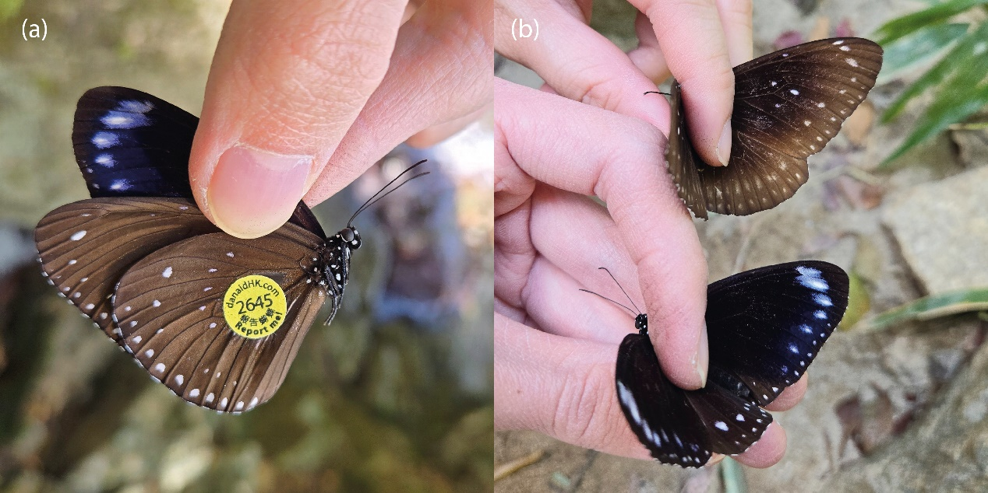
Fig. S2 (a) A female Euploea sylvester tagged at Deep Water Bay, Hong Kong in January 2025. (b) The same E. sylvester individual (lower) compared side by side with a female E. core (upper) found at the same site. This is the first time E. sylvester has been found in a winter forested valley aggregation in Hong Kong, and only the third record of the species in territory, preceded by two reports in June in 1997 and 1999 (Bascombe et al. 1999; Young and Yiu 2002). In the southern Chinese region, E. sylvester can be found in Hainan and Guangdong (subspecies nica; Chou 1999; Gu and Chen 1997), and Taiwan (subspecies swinhoei; Lee and Wang 1997). Despite the close proximity to Guangdong, all E. sylvester individuals found in Hong Kong so far (Bascombe et al. 1999; Young and Yiu 2002; this study) resemble the Taiwanese subspecies swinhoei morphologically (Chao and Wang 1997; Chou 1999). It is unclear whether the individuals in Hong Kong are vagrant (Pun 2024), breeding, or even migratory as in Taiwan (Chan 2022). Clarification of the origin and subspecies of E. sylvester in Hong Kong will be needed through further monitoring of species occurrence and examination of specimens from Guangdong (Hsu 2017).

Table S1 Larval hostplants used by Hong Kong danaids as reported by Young et al. (2011). Danaid genera involved: Danaus, Euploea, Ideopsis, Parantica, Tirumala. Note that hostplants of several rare danaid species are not reported by Young et al. (2011), including E. sylvester, P. melaneus, P. swinhoei, T. septentrionis, and T. hamata. Asterisk (*) denotes confirmed use of hostplant species by wild danaids by EEJ; square brackets ([]) denote wild use observed by EEJ not reported in Young et al. (2011).
Larval hostplants | Plant family | Danaid species
Asclepias curassavica | Apocynaceae | D. chrysippus*, I. similis, P. aglea, T. limniace
Cryptolepis sinensis | Apocynaceae | E. mulciber, [E. core]
Dregea volubilis (Stephanotis volubilis) | Apocynaceae | T. limniace*
Ficus microcarpa | Moraceae | E. core
Graphistemma pictum | Apocynaceae | D. genutia*, D. chrysippus
Gymnema sylvestre | Apocynaceae | E. core, E. mulciber
Hoya carnosa | Apocynaceae | P. sita
Nerium oleander | Apocynaceae | E. core, E. midamus
Strophanthus divaricatus | Apocynaceae | E. midamus*
Toxocarpus wightianus | Apocynaceae | E. core, E. midamus, E. mulciber
Tylophora ovata (Vincetoxicum hirsutum) | Apocynaceae | I. similis*, P. aglea*, P. sita
Urceola rosea | Apocynaceae | E. core, E. mulciber

Table S2 Common nectar plants used by Hong Kong danaids as observed by EEJ. Flowering periods are reported by Hong Kong Herbarium and SCBG (2008).
Nectar plant | Plant family | Flowering period
Ageratum conyzoides | Asteraceae | June to October
Bidens alba | Asteraceae | May to December
Celosia argentea | Amaranthaceae | July to November
Eupatorium (Chromolaena) odoratum | Asteraceae | April to December
Melaleuca spp. | Myrtaceae
Schefflera heptaphylla | Araliaceae | August to September
Stachytarpheta jamaicensis | Verbenaceae | August
Zanthoxylum avicennae | Rutaceae | June to August

Table S3 Sampling period, study locations, and number of danaid butterflies tagged at each location during each study season. Hyphens indicate locations that were not visited in a certain season, and zeros indicate locations that were visited but no butterflies were tagged. Note that sampling effort was reduced (mid-December to January) during our pilot season in 2021-22 and extended in 2023 (June to September) to include early monitoring at PA sites. Refer to Table S9 for site name abbreviations. Tai Long Wan Ctm: Tai Long Wan Catchment.
 | 2021-22 | 2022-23 | 2023-24 | 2024-25 | Total
Sampling period | Dec-Jan, & Apr | Oct-Jan | Jun-Feb | Oct-Feb
Locations visited | 4 | 25 | 30 | 26 | 34
Number tagged:
Cheung Sha | - | - | 2 | - | 2
Chi Ma Wan | - | 0 | 204 | 38 | 242
CMWP1 & surroundings | 1,951 | 19 | 318 | 844 | 3,132
Cyberport | - | 3 | 3 | - | 6
Deep Water Bay | - | 34 | 6 | 509 | 549
Fan Lau | - | 161 | 886 | 296 | 1,343
Fanling | - | - | 216 | 245 | 461
FYBR | - | - | - | 14 | 14
Kau Ling Chung | - | 0 | 5 | 4 | 9
KSCP1 & surroundings | - | 628 | 401 | 42 | 1,071
KSCP2 & surroundings | - | - | 111 | 387 | 498
Lai Chi Wo | - | 120 | 32 | - | 152
Lamma Island N | 661 | 32 | 137 | 185 | 1,015
Lamma Island S | - | - | - | 57 | 57
LNEC | - | 577 | 461 | 357 | 1,395
Lung Fu Shan | - | - | 1 | 58 | 59
Mong Tung Wan | - | 0 | 2 | - | 2
Pak Tam Chung | - | 175 | 573 | 115 | 863
Pokfulam | - | 1 | - | - | 1
Pui O | - | - | 744 | 172 | 916
Repulse Bay | - | 61 | 227 | 173 | 461
Shek Pik | - | 0 | 104 | 1 | 105
Shing Mun | - | 0 | - | - | 0
Shui Hau | 1 | 21 | 292 | 12 | 326
Shui Long Wo | - | 98 | 430 | 54 | 582
Siu Lang Shui | - | - | 201 | 56 | 257
Tai Long | - | 2 | 231 | 499 | 732
Tai Long Wan Ctm | - | 0 | 80 | 1 | 81
Tai O | - | 0 | 0 | 0 | 0
Tai Tam | - | 41 | 82 | - | 123
Tai Lam Country Park | 22 | 218 | 726 | 329 | 1,295
Tong Fuk | - | - | 99 | 9 | 108
Wu Kau Tang | - | 3 | 1 | - | 4
Yi O | - | 0 | 26 | 31 | 57
Total | 2,635 | 2,194 | 6,601 | 4,488 | 15,918

Table S4 Five-point wing condition scale modified from Miller et al. (2012) and used in this study (except for pilot season 2021-22).
Score | Description of wing conditions
1 | Newly emerged; or generally very fresh with negligible or very little wing wear
2 | Little fraying (small area broken) on wing edges (1-2 parts); usually with few scales lost
3 | Some fraying (small area broken) on wing edges (> 2 parts); usually with some scales missing; wings may become dull
4 | Tearing (large area broken) around wing margins (1-2 parts); or a lot of fraying (small area broken, > 5 parts); usually with large number of scales missing
5 | Wings tattered with substantial tearing (large area broken) even to the middle of the wings (> 2 parts); also with much fraying and usually substantial scales missing

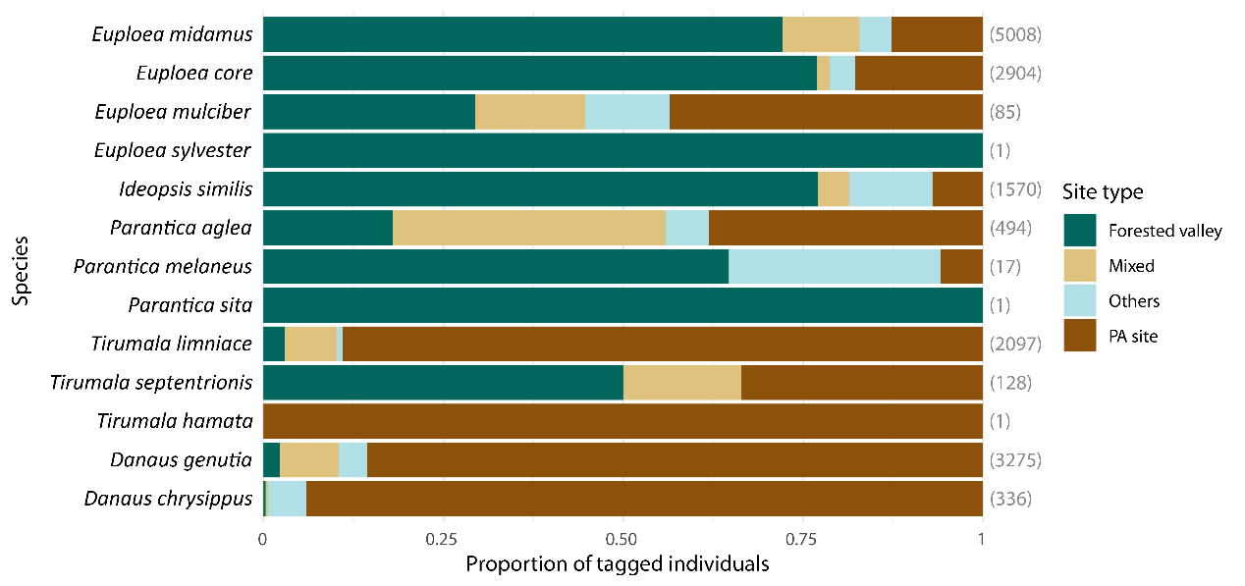
Fig. S3 Proportion of danaid butterflies of each species tagged at each site type, including forested valleys (green), PA sites (brown), one mixed site (yellow), and other sites (light blue). Sample size for each species is shown in parentheses on the right.

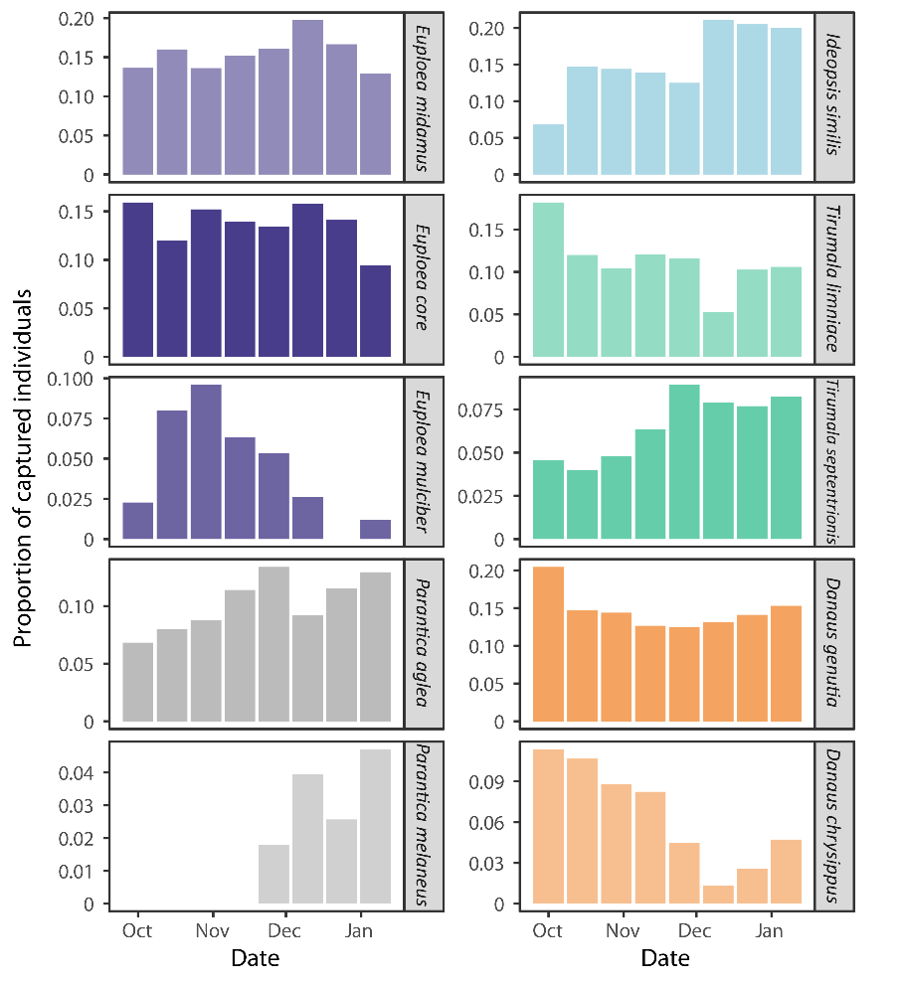
Fig. S4 Proportion of individuals of each species captured within each two-week time bin starting from October 1 across all four study seasons and all study sites. Only time bins with more than 20 butterflies captured were included. Note that Danaus chrysippus was heavily sampled in season 2023-24.

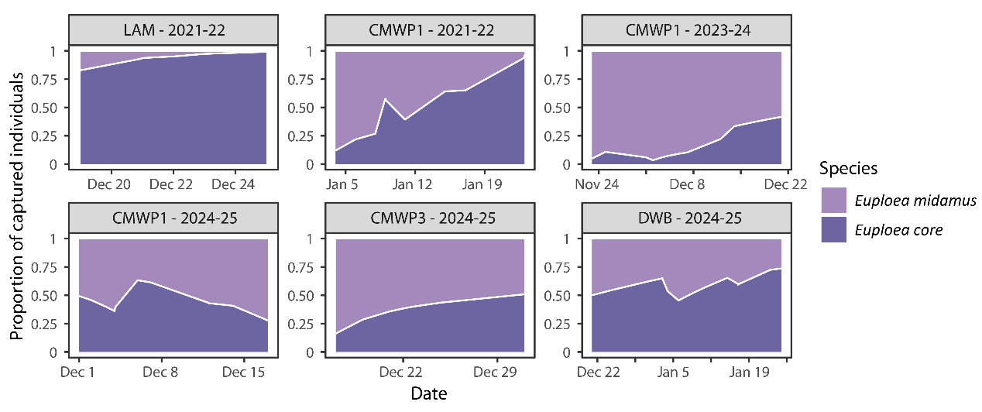
Fig. S5 Trends in relative proportions between Euploea midamus and E. core in forested valley aggregations based on our capture data. Only aggregations with more than two days of sampling and only days with more than 20 individuals from these two species sampled were included. Refer to Table S9 for site name abbreviations.

Table S5 Parameter estimates of the binomial generalized linear mixed models on the effects of date and species (if applicable) on the (a) species proportion and (b) sex ratio of Euploea midamus and E. core in forested valley aggregations; and (c) parameter estimates of the binomial generalized linear model on the effects of week, genus, and their interactive effect on the proportion of individuals having the freshest wing condition (score = 1).
 | Estimate | SE | z | p
- Species proportion
Intercept | -4.975 | 3.104 | -1.603 | 0.109
Date | 0.094 | 0.102 | 0.926 | 0.355
- Sex ratio
Intercept | 1.564 | 1.131 | 1.383 | 0.167
Date | 0.095 | 0.094 | 1.005 | 0.315
Species | -1.796 | 0.889 | -2.019 | 0.044
- Wing condition
Intercept | 0.408 | 1.029 | 0.396 | 0.692
Week | -0.073 | 0.103 | -0.710 | 0.478
Genus (Ideopsis) | -0.225 | 1.811 | -0.124 | 0.901
Genus (Parantica) | 1.093 | 2.411 | 0.453 | 0.650
Genus (Tirumala) | -0.156 | 1.474 | -0.106 | 0.916
Genus (Danaus) | 0.212 | 1.468 | 0.144 | 0.885
Week × Genus (Ideopsis) | 0.093 | 0.167 | 0.558 | 0.577
Week × Genus (Parantica) | 0.005 | 0.218 | 0.024 | 0.981
Week × Genus (Tirumala) | 0.051 | 0.151 | 0.341 | 0.733
Week × Genus (Danaus) | 0.045 | 0.145 | 0.313 | 0.754

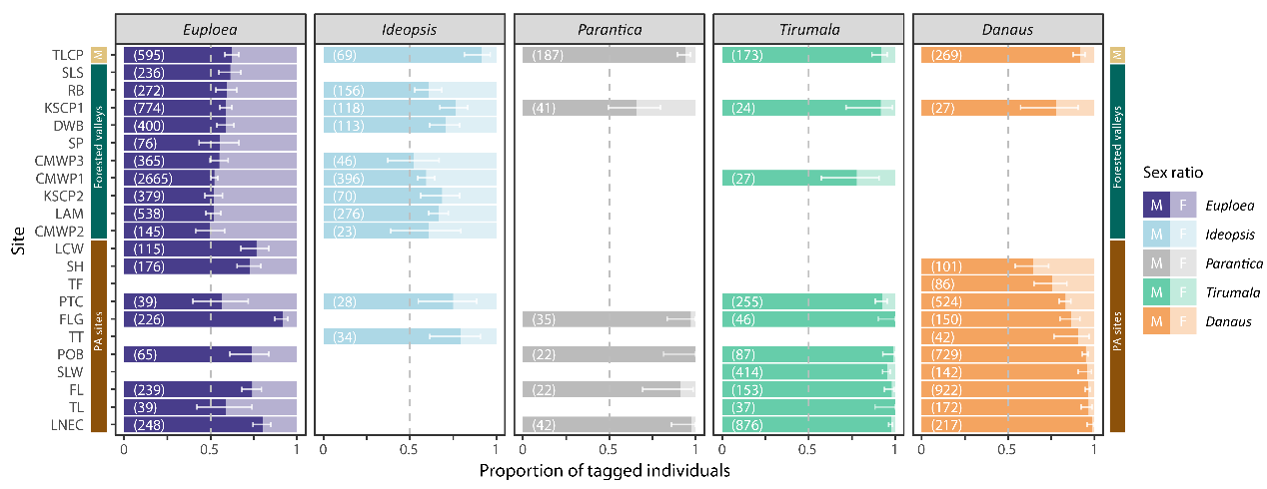
Fig. S6 Sex ratio within danaid genera at each aggregation site based on our tagging data. Error bars represent 95% confidence intervals from binomial tests. Sample size for each genus at each site is shown in parentheses. Only genera with more than 20 butterflies tagged at each site are included. Coloured vertical bars on the sides of boxes represent site types – mixed site (M, yellow), forested valleys (green), and PA sites (brown). Refer to Table S9 for site name abbreviations.

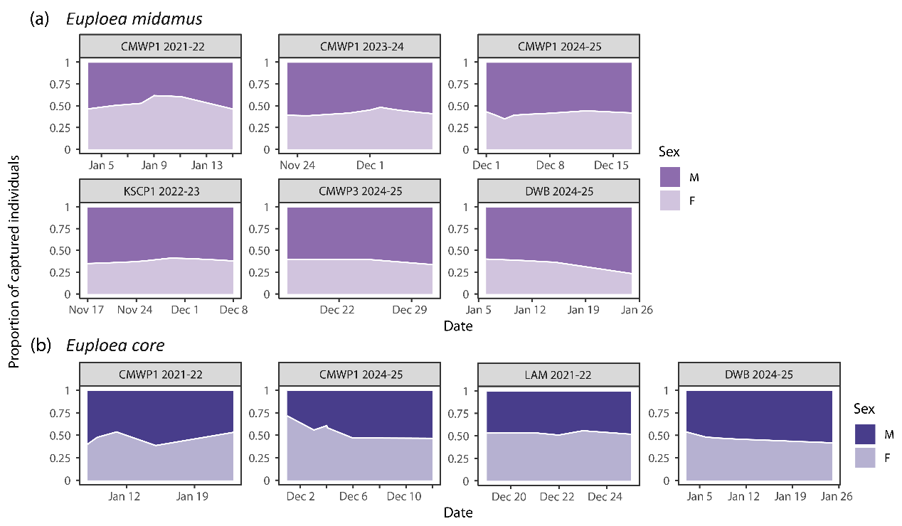
Fig. S7 Trends in male and female proportions in (a) Euploea midamus and (b) E. core within forested valley aggregations based on our tagging data. Only aggregations with more than two days of sampling and only days with more than 20 individuals for each of the two species sampled were included. Refer to Table S9 for site name abbreviations.

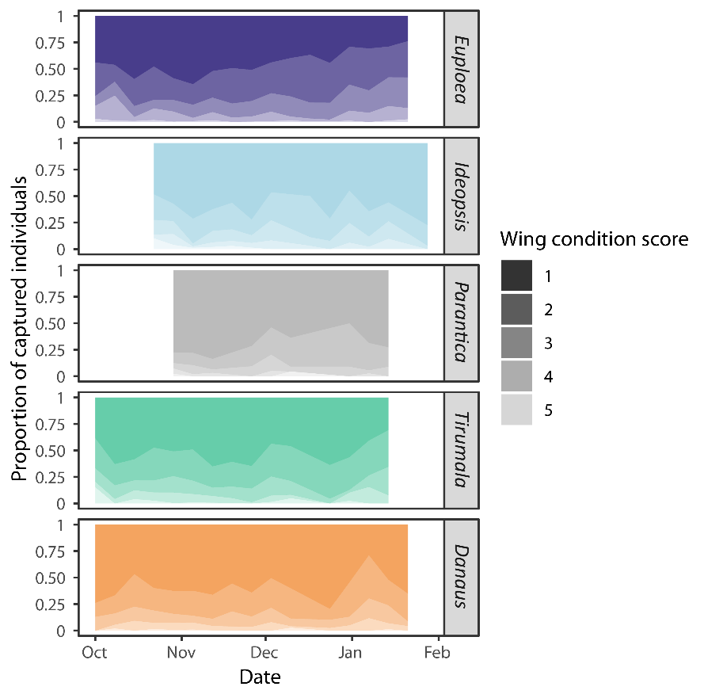
Fig. S8 Trends in wing condition scores (1: freshest, 5: most worn-out) of butterflies by genus from October to February. Wing condition is expressed as the proportions of captured (tagged and recaptured) individuals having different wing condition scores for each genus within every week starting from October 1. Only weeks with more than 20 individuals captured within genus are included. See Fig. S3 for details of the five-point wing condition scale used in this study.

Table S6 Tagged butterflies that were recovered at least 60 days after tagging, arranged in descending order of number of days elapsed between tagging and recovery (column “Day”). The means of recovery is included as either by our team or the public (reports). Species name abbreviations: Euploea core (Ec), Ideopsis similis (Is), Tirumala limniace (Tl), Danaus genutia (Dg). Dates are in the format DD/MM/YYYY. Refer to Table S9 for site name abbreviations.
Species | Sex | Tagging |  | Recovery |  | Day | Means of recovery
Species | Sex | Date | Site | Date | Site | Day | Means of recovery
Is | M | 22/12/2021 | LAM | 21/4/2022 | LAM | 120 | Report
Is | M | 23/12/2021 | LAM | 5/4/2022 | LAM | 103 | Report
Ec | F | 19/12/2021 | LAM | 31/3/2022 | LAM | 102 | Our team
Ec | M | 23/12/2021 | LAM | 3/4/2022 | LAM | 101 | Our team
Tl | M | 24/10/2023 | LNEC | 20/1/2024 | LNEC | 88 | Report
Is | M | 12/10/2023 | TLCP | 7/1/2024 | TLCP | 87 | Report
Ec | M | 3/1/2025 | DWB | 13/3/2025 | ABD | 69 | Report
Is | M | 17/9/2023 | LAM | 19/11/2023 | LAM | 63 | Our team
Ec | M | 6/11/2024 | RB | 6/1/2025 | DWB | 61 | Our team
Tl | M | 5/9/2023 | LNEC | 4/11/2023 | LNEC | 60 | Our team
Dg | M | 21/11/2023 | PTC | 20/1/2024 | PTC | 60 | Report
Tl | M | 21/11/2023 | LNEC | 20/1/2024 | LNEC | 60 | Report
Tl | M | 21/11/2023 | LNEC | 20/1/2024 | LNEC | 60 | Report

Table S7 Estimates of Jolly-Seber model parameters for the estimation of danaid aggregations size using tagging and recapture data. Model parameters: apparent survival (Φ), probability of new individuals entering from the super-population (p_{ent}), detection probability (p), and super-population size (N_{super}). The best model selected based on the Akaike information criterion (AIC), where Φ and p_{ent} were allowed to vary with time while p and N_{super} were kept constant over time, was included beneath the site names. The transitory aggregation size (N) was calculated based on the N_{super}, Φ, and p_{ent} estimated at each sampling event. Other abbreviations: occasion (Occ), number of individuals tagged (Tag), number of individuals recaptured (Recap). It should be noted that the three dominant species at CMWP1 in 2021-22 were modelled separately; the total N_{super} (16,060) and peak N (N at occasion 4 = 9,638) reported in the manuscript were derived from simple addition of estimates. The aggregation sizes for the two sites marked with asterisks were estimated by simple Lincoln indices due to insufficient sampling episodes and recaptures. Estimates of N_{super} and N were corrected to the nearest integer. Refer to Table S9 for site name abbreviations.
Aggregation | Occ | Date | Tag | Recap | Φ | p_{ent} | N
LAM, 2021-22  Φ(~1) p(~1) p_{ent}(~time) N_{super}(~1)  - p = 0.047  - N_{super} = 5,620 | 1 | Dec 19 | 99 | 0 | 0.769 | 0.359 | 2,017
 | 2 | Dec 21 | 64 | 0 |  | <0.001 | 1,551
 | 3 | Dec 22 | 210 | 12 |  | 0.604 | 4,589
 | 4 | Dec 23 | 152 | 9 |  | 0.002 | 3,539
 | 5 | Dec 25 | 122 | 13 | NA | 0.034 | 2,914
CMWP1, 2021-22  Euploea midamus  Φ(~time) p(~1) p_{ent}(~time) N_{super}(~1)  - p = 0.056  - N_{super} = 9,360 | 1 | Jan 4 | 82 | 0 | 0.246 | 0.155 | 1,454
 | 2 | Jan 8 | 130 | 1 | 0.451 | 0.210 | 2,324
 | 3 | Jan 9 | 93 | 1 | 0.562 | 0.071 | 1,717
 | 4 | Jan 11 | 345 | 7 | 0.602 | 0.560 | 6,204
 | 5 | Jan 15 | 198 | 15 | 0.009 | 0.003 | 3,763
 | 6 | Jan 23 | 1 | 1 | NA | <0.001 | 35
CMWP1, 2021-22  Euploea core  Φ(~time) p(~1) p_{ent}(~time) N_{super}(~1)  - p = 0.118  - N_{super} = 3,783 | 1 | Jan 4 | 11 | 0 | 0.781 | 0.025 | 93
 | 2 | Jan 8 | 48 | 0 | 0.484 | 0.090 | 414
 | 3 | Jan 9 | 127 | 1 | 0.661 | 0.238 | 1,101
 | 4 | Jan 11 | 219 | 10 | 1.000 | 0.324 | 1,953
 | 5 | Jan 15 | 340 | 41 | 0.138 | 0.323 | 3,175
 | 6 | Jan 23 | 39 | 13 | NA | <0.001 | 440
CMWP1, 2021-22  Ideopsis similis  Φ(~1) p(~1) p_{ent}(~time) N_{super}(~1)  - p = 0.044  - N_{super} = 2,916 | 1 | Jan 4 | 15 | 0 | 0.888 | 0.116 | 339
 | 2 | Jan 8 | 41 | 0 |  | 0.216 | 931
 | 3 | Jan 9 | 34 | 0 |  | <0.001 | 827
 | 4 | Jan 11 | 72 | 6 |  | 0.256 | 1,480
 | 5 | Jan 15 | 43 | 3 |  | <0.001 | 1,315
 | 6 | Jan 23 | 98 | 9 | NA | 0.412 | 2,370
PTC, 2023-24  Φ(~time) p(~1) p_{ent}(~time) N_{super}(~1)  - p = 0.199  - N_{super} = 1,924 | 1 | Sep 5 | 25 | 0 | 0.001 | 0.065 | 126
 | 2 | Sep 14 | 63 | 0 | 0.131 | 0.164 | 316
 | 3 | Sep 22 | 67 | 2 | 0.267 | 0.158 | 345
 | 4 | Sep 26 | 23 | 4 | <0.001 | 0.023 | 135
 | 5 | Oct 12 | 28 | 0 | <0.001 | 0.073 | 141
 | 6 | Oct 24 | 78 | 0 | 0.097 | 0.203 | 392
 | 7 | Nov 2 | 30 | 1 | 0.304 | 0.062 | 158
 | 8 | Nov 9 | 27 | 1 | 0.254 | 0.051 | 147
 | 9 | Nov 16 | 14 | 0 | 0.376 | 0.014 | 64
 | 10 | Nov 17 | 0 | 3 | 1.000 | <0.001 | 24
 | 11 | Nov 21 | 60 | 5 | <0.001 | 0.150 | 312
 | 12 | Jan 11 | 14 | 0 | NA | 0.037 | 70
POB, 2023-24  Φ(~time) p(~1) p_{ent}(~time) N_{super}(~1)  - p = 0.093  - N_{super} = 4,935 | 1 | Oct 23 | 8 | 0 | 0.005 | 0.017 | 86
 | 2 | Nov 1 | 24 | 0 | <0.001 | 0.052 | 258
 | 3 | Nov 10 | 10 | 0 | <0.001 | 0.022 | 108
 | 4 | Nov 14 | 53 | 0 | 0.425 | 0.116 | 571
 | 5 | Nov 23 | 114 | 2 | 0.679 | 0.203 | 1,247
 | 6 | Nov 25 | 70 | 7 | 0.277 | <0.001 | 849
 | 7 | Nov 26 | 111 | 1 | 1.000 | 0.204 | 1,240
 | 8 | Dec 2 | 174 | 19 | <0.001 | 0.160 | 2,030
 | 9 | Dec 31 | 47 | 0 | 0.994 | 0.096 | 476
 | 10 | Jan 5 | 37 | 7 | 0.068 | <0.001 | 473
 | 11 | Jan 11 | 6 | 0 | 1.000 | 0.008 | 70
 | 12 | Jan 15 | 29 | 2 | <0.001 | 0.051 | 324
 | 13 | Jan 26 | 15 | 0 | <0.001 | 0.033 | 162
 | 14 | Feb 2 | 17 | 0 | NA | 0.037 | 183
FL, 2023-24  Φ(~time) p(~1) p_{ent}(~time) N_{super}(~1)  - p = 0.046  - N_{super} = 12,039 | 1 | Nov 1 | 56 | 0 | 1.000 | 0.102 | 1,226
 | 2 | Nov 14 | 83 | 2 | 0.382 | 0.054 | 1,873
 | 3 | Nov 18 | 205 | 2 | 0.462 | 0.318 | 4,541
 | 4 | Nov 21 | 238 | 7 | 0.465 | 0.268 | 5,330
 | 5 | Nov 30 | 209 | 7 | 0.020 | 0.188 | 4,741
 | 6 | Dec 21 | 5 | 0 | 1.000 | 0.002 | 117
 | 7 | Dec 27 | 33 | 1 | 1.000 | 0.051 | 735
 | 8 | Jan 15 | 41 | 2 | NA | 0.017 | 943
TLCP, 2023-24  Φ(~time) p(~1) p_{ent}(~time) N_{super}(~1)  - p = 0.045  - N_{super} = 11,020 | 1 | Nov 2 | 100 | 0 | 0.998 | 0.202 | 2,223
 | 2 | Nov 7 | 135 | 5 | 0.240 | 0.080 | 3,099
 | 3 | Nov 16 | 62 | 2 | 0.187 | 0.063 | 1,435
 | 4 | Nov 22 | 101 | 1 | <0.001 | 0.181 | 2,266
 | 5 | Nov 29 | 173 | 0 | 0.258 | 0.349 | 3,843
 | 6 | Jan 9 | 104 | 2 | <0.001 | 0.124 | 2,355
 | 7 | Jan 30 | 1 | 0 | NA | 0.002 | 22
CMWP1, 2024-25  Φ(~time) p(~1) p_{ent}(~time) N_{super}(~1)  - p = 0.062  - N_{super} = 7,559 | 1 | Dec 1 | 148 | 0 | 0.609 | 0.317 | 2,396
 | 2 | Dec 3 | 115 | 3 | 0.608 | 0.065 | 1,953
 | 3 | Dec 4 | 76 | 5 | 1.000 | 0.022 | 1,355
 | 4 | Dec 6 | 300 | 18 | 0.400 | 0.490 | 5,058
 | 5 | Dec 12 | 143 | 12 | 0.142 | 0.065 | 2,516
 | 6 | Dec 17 | 38 | 3 | NA | 0.041 | 664
DWB, 2024-25  Φ(~time) p(~1) p_{ent}(~time) N_{super}(~1)  - p = 0.145  - N_{super} = 1,583 | 1 | Dec 21 | 45 | 0 | 0.773 | 0.195 | 310
 | 2 | Jan 3 | 55 | 2 | 0.722 | 0.110 | 413
 | 3 | Jan 6 | 118 | 7 | 0.975 | 0.365 | 877
 | 4 | Jan 15 | 124 | 32 | 0.542 | 0.107 | 1,024
 | 5 | Jan 17 | 56 | 12 | 1.000 | <0.001 | 556
 | 6 | Jan 25 | 100 | 43 | NA | 0.222 | 908
KSCP2, 2024-25* | 1 | Dec 11 | 130 | 0 | NA | NA | 5,018
 | 2 | Dec 18 | 188 | 5
CMWP3, 2024-25* | 1 | Dec 17 | 98 | 0 | NA | NA | 4,595
 | 2 | Dec 25 | 235 | 1
 | 3 | Dec 31 | 64 | 5

Table S8 Tagged butterflies recovered at least 10 km away from their tagging localities, arranged in descending order of distance travelled. Records with status “Fung Yuen” refer to butterflies which were marked by the Fung Yuen Butterfly Reserve in Hong Kong and later recovered by our team, while other statuses refer to butterflies which were tagged by us and later recovered by our team or the public (reports). Species name abbreviations: Euploea midamus (Em), Euploea core (Ec), Tirumala limniace (Tl), Danaus genutia (Dg), Parantica aglea (Pa). Column name abbreviations: number of days elapsed between tagging and recovery (Day), distance travelled in km (Dis.), bearing in degrees (Bear.). Dates are in the format DD/MM/YYYY. Refer to Table S9 for site name abbreviations.
Species | Sex | Tagging |  | Recovery |  | Day | Dis. | Bear. | Status
Species | Sex | Date | Site | Date | Site
Em | F | 22/11/2023 | TLCP | 21/12/2023 | CMWP2 | 29 | 17.1 | 196.9 | Our team
Tl | M | 23/11/2023 | CMWP2 | 1/12/2023 | TLCP | 8 | 17.1 | 16.9 | Report
Dg | M | 24/10/2023 | FYBR | 7/11/2023 | TLCP | 14 | 16.8 | 233.2 | Fung Yuen
Em | M | 18/11/2024 | TLCP | 29/11/2024 | CMWP1 | 11 | 16.8 | 203.3 | Report
Em | M | 28/11/2024 | TLCP | 12/12/2024 | CMWP1 | 14 | 16.8 | 203.3 | Our team
Tl | M | 24/10/2023 | PTC | 27/10/2023 | TPWP | 3 | 15.0 | 294.2 | Report
Ec | M | 12/11/2024 | FL | 6/12/2024 | CMWP1 | 24 | 14.2 | 73.4 | Our team
Ec | M | 23/12/2021 | LAM | 9/1/2022 | CMWP1 | 17 | 13.7 | 273.1 | Report
Em | M | 5/10/2024 | HKU | 14/10/2024 | TLCP | 9 | 13.6 | 319.7 | Our team
Dg | M | 30/10/2024 | LNEC | 8/11/2024 | FYBR | 9 | 13.5 | 319.3 | Report
Tl* | M | 18/11/2023 | FL | 23/11/2023 | POB | 5 | 13.4 | 70.8 | Report
Tl | M | 4/10/2023 | FYBR | 9/11/2023 | SLW | 36 | 12.2 | 124.5 | Fung Yuen
Tl | M | 2/11/2023 | FYBR | 9/11/2023 | SLW | 7 | 12.2 | 124.5 | Fung Yuen
Em | M | 3/11/2024 | FYBR | 14/12/2024 | KSCP2 | 41 | 12.2 | 192.1 | Our team
Em | M | 7/11/2023 | SLS | 24/12/2023 | TLCP | 47 | 12.0 | 89.1 | Report
Em | M | 19/9/2023 | TLCP | 23/10/2023 | ST | 34 | 11.9 | 47.7 | Report
Dg | M | 3/12/2024 | FLG | 17/12/2024 | SMBG | 14 | 11.5 | 164.6 | Report
Tl | M | 26/10/2023 | KSCP1 | 28/10/2023 | FYBR | 2 | 11.3 | 17.4 | Report
Em | M | 24/10/2023 | FYBR | 22/11/2023 | KSCP1 | 29 | 11.3 | 197.4 | Fung Yuen
Em | M | 22/11/2023 | TLCP | 9/1/2024 | KSCP2 | 48 | 11.0 | 99.5 | Our team
Tl | M | 2/11/2023 | TPWP | 9/11/2023 | SLW | 7 | 10.8 | 119.6 | Fung Yuen
Pa | M | 8/12/2022 | KSCP1 | 22/12/2022 | HKP | 14 | 10.3 | 171.5 | Report
Em | F | 22/11/2023 | KSCP1 | 22/12/2023 | TLCP | 30 | 10.1 | 274.3 | Report
* This Tirumala limniace individual showed a two-step movement, first moving from FL to POB, then being reported from CMWP1 (1.1 km from POB) on 7/12/2023.

Table S9 Abbreviations and site types of our study sites. PA sites refer to open sites with plants rich in pyrrolizidine alkaloids (PAs) such as Crotalaria retusa and Heliotropium indicum. The exact site name is not provided for some forested valley sites to avoid excessive visitation following this publication to reduce disturbance to aggregating butterflies.
Abbreviation | Site name | Site type
ABD | Aberdeen | Others
CMWP1 | Chi Ma Wan Peninsula (Site 1) | Forested valley
CMWP2 | Chi Ma Wan Peninsula (Site 2) | Forested valley
CMWP3 | Chi Ma Wan Peninsula (Site 3) | Forested valley
DWB | Deep Water Bay | Forested valley
FL | Fan Lau | PA site
FLG | Fanling | PA site
FYBR | Fung Yuen Butterfly Reserve | Others
HKP | Hong Kong Park | Others
HKU | The University of Hong Kong | Others
KSCP1 | Kam Shan Country Park (Site 1) | Forested valley
KSCP2 | Kam Shan Country Park (Site 2) | Forested valley
LAM | Lamma Island | Forested valley
LCW | Lai Chi Wo | PA site
LNEC | Lion’s Nature Education Centre | PA site
POB | Pui O Beach | PA site
PTC | Pak Tam Chung | PA site
RB | Repulse Bay | Forested valley
SH | Shui Hau | PA site
SHV | Shui Hau valley | Forested valley
SLS | Siu Lang Shui | Forested valley
SLW | Shui Long Wo | PA site
SMBG | Shing Mun Butterfly Garden | Others
SP | Shek Pik | Forested valley
ST | San Tong, Lam Tsuen | Others
TF | Tong Fuk | PA site
TL | Tai Long | PA site
TLCP | Tai Lam Country Park | Mixed
TPWP | Tai Po Waterfront Park | Others
TT | Tai Tam | PA site

References
Bascombe MJ, Johnston G, Bascombe FS (1999) The butterflies of Hong Kong. Academic Press, Hong Kong
Chan C-L (2022) 紫斑蝶 (修訂版) [Euploea butterflies (revised edition)], 2nd edn. Morning Star, Taichung
Chao L, Wang HY (1997) 中國鱗翅目3：鳳蝶科、斑蝶科、粉蝶科、環紋蝶科 [Lepidoptera of China 3 - Papilionidae, Danaidae, Pieridae, Amathusiidae]. Taiwan Museum, Taipei
Chou I (1999) 中國蝶類誌 (修訂本) (上冊) [Monographia Rhopalocerorum Sinensium (Revised edition) (Volume 1)]. Henan Science and Technology Publishing House
Gu MB, Chen PZ (1997) 海南島蝴蝶 [Butterflies in Hainan Island]. China Forestry Publishing House
Hong Kong Herbarium, SCBG (2008) Flora of Hong Kong - volume 2 (Hong Kong Herbarium, Agriculture, Fisheries and Conservation Department (AFCD) & South China Botanical Garden (SCBG), Chinese Academy of Sciences, eds.). Agriculture, Fisheries and Conservation Department, Hong Kong
Hsu Y-F (2017) 台灣蝴蝶圖鑑 - 下 (蛺蝶) [The butterflies of Taiwan - volume 3 (Nymphalidae)]. Morning Star, Taichung
Lee JY, Wang HY (1997) 臺灣冬天的蝴蝶谷 [Migration and overwinter aggregations of nine danaine butterfly species in Taiwan]. Taiwan Museum, Taipei
Miller NG, Wassenaar LI, Hobson KA, Norris DR (2012) Migratory connectivity of the monarch butterfly (Danaus plexippus): patterns of spring re-colonization in eastern North America. PLOS ONE 7: 1–6. https://doi.org/10.1371/journal.pone.0031891
Pun SF (2024) Fung Yuen Eco Series - Hong Kong butterfly identification guide (Man KL, Wong WK, Luk TH, Wong CH, eds). Environmental Association Ltd, Fung Yuen Butterfly Reserve, Hong Kong
Young JJ, Yiu V (2002) 香江蝶影：香港蝴蝶觀賞全集 [Butterfly watching in Hong Kong]. Wan Li Book Co Ltd, Hong Kong
Young JJ, Pun SF, Lam W, Law YS, Yau SM, Choi KP, Chor HK (2011) A photographic monograph on Hong Kong butterflies (volumes 1-4). Hong Kong Lepidopterists’ Society Limited, Hong Kong

