Supplementary Material
Journal name: Journal of Insect Conservation
Article title: Does vineyard abandonment negatively affect the taxonomic and functional diversity of ground-dwelling beetles?
Author of correspondence:
Mine Yilmazer
Department of Biology
Institute for Integrated Natural Sciences
University of Koblenz
Universitätsstraße 1
D-56070 Koblenz, Germany
Email: myilmazer@uni-koblenz.de
Table S1 Coordinates of sampling locations (N, E) across four different management categories
Vineyards (n = 10) | Grazed grasslands (n = 10)
50.116131, 7.718362 | 50.122122, 7.725569
50.109821, 7.710451 | 50.11883, 7.71816
50.09085, 7.73771 | 50.04877, 7.769745
50.09817, 7.71865 | 50.039441, 7.785705
50.09728, 7.72464 | 50.02746, 7.767275
50.070938, 7.767231 | 50.026271, 7.764486
50.06052, 7.766991 | 50.035234, 7.804409
50.039758, 7.78476 | 50.03377, 7.802854
50.023873, 7.779477 | 50.033176, 7.7999
50.023356, 7.81775 | 50.029746, 7.79894
Mown grasslands (n = 10) | Fallows (n = 10)
50.116526, 7.71793 | 50.120655, 7.723942
50.109803, 7.711391 | 50.099301, 7.716702
50.096023, 7.73751 | 50.09763, 7.71382
50.099274, 7.718189 | 50.09763, 7.73939
50.096281, 7.707734 | 50.094942, 7.702589
50.072619, 7.764386 | 50.066644, 7.768459
50.0605204, 7.766344 | 50.0602895, 7.7661039
50.039029, 7.782359 | 50.038844, 7.784243
50.025544, 7.778997 | 50.03792, 7.780918
50.024769, 7.815866 | 50.024362, 7.816901

Table S2 Information on the conventionally managed vineyards (n = 10) including location, size, growing orientation, characteristic plant species, interrow spacing (modern = 1.80 m, traditional = 1.30 m), mowing, and tillage
Site | Community | Size (m²) | Growing orientation | Characteristic plants | Interrow spacing | Mowing | Tillage
1 | Oberwesel | 3832 | Downhill | Tragopogon pratensis, Galium mollugo agg., Potentilla reptans, Convolvulus arvensis, Daucus carota, Rumex crispus | Alternating: every 3rd row has been removed | 3 times during sampling period | None
2 | Oberwesel | 1332 | Downhill | - | Modern | None | None
3 | Oberwesel/  Dellhofen | 3715 | Downhill | Torilis arvensis, Crepis capillaris | Traditional | None | None
4 | Engelhöll | 4945 | Downhill | Echium vulgare, Convolvulus arvensis, Achillea millefolium agg., Chichorium intybus, Lactuca serriola, Amaranthus retroflexus | Modern | Once: before sampling period (May) | None
5 | Engelhöll | 4899 | Terrace | Echium vulgare, Achillea nobilis, Papaver somniferum L. | Modern | Interrow: two times during sampling period; embankments: not pruned | None
6 | Bacharach | 2963 | Downhill | Trifolium spec. | Modern | None | Every 2nd interrow; at least once a year
7 | Bacharach | 1325 | Downhill | Lean lawn | Modern | None | None
8 | Oberdiebach | 8034 | Terrace | Triticum aestivum, Papaver somniferum L., Echium vulgare, Rosa canina, Cirsium vulgare, Hypericum perforatum, Torilis arvensis | Modern | None | None
9 | Oberheimbach | 5479 | Downhill | Daucus carota, Galium album | Modern | None | Every 2nd interrow; at least once a year
10 | Niederheimbach | 2981 | Downhill | Lean lawn | Modern | Two times during sampling period | Every 2nd interrow; at least once a year

Table S3 Information on the grazed grasslands (n = 10) including location, size, age of viticultural abandonment, characteristic plant species, grazing animal and intensity
Site | Community | Size (m²) | Age  (years) | Characteristic plants | Grazing animal | Grazing intensity
1 | Urbar | 1768 | 64 | Juglans regia, Quercus spec., Crataegus monogyna, thistle flowers (Cirsium vulgare), Lapsana communis | German Improved White Goats | Temporarily
2 | Oberwesel | 3832 | 64 | Geranium pyrenaicum, Campanula rapunculus, Lapsana communis | German Improved White Goats | Temporarily
3 | Bacharach | 3212 | 25-30 | Rubus fruticosus agg., Quercus spec. | Boer Goats: males | Permanently
4 | Oberdiebach | 5036 | 30 | Rubus fruticosus agg., Quercus spec. | Boer Goats: females + lambs | Permanently
5 | Oberdiebach | 3518 | 30 | Rubus fruticosus agg., Potentilla neumanniana | Exmoor-Ponies, Boer Goats, Thuringian Goats | Permanently
6 | Oberdiebach | 6709 | 30 | Woody structures, trees (predominantly: Quercus spec.) | Exmoor-Ponies, Boer Goats, Thuringian Goats | Permanently
7 | Niederheimbach | 6643 | 30-70 | Grassy, trees (Quercus spec.) | German Improved White Goats | Temporarily
8 | Niederheimbach | 5219 | 30-70 | Rubus fructicosus agg. | German Improved White Goats | Temporarily
9 | Niederheimbach | 2192 | 30-70 | Rubus fructicosus agg. | Cameroon Sheep | Permanently
10 | Niederheimbach | 1607 | 30-70 | Woody structures, trees (predominantly: Quercus spec.) | Cameroon Sheep | Permanently

Table S4 Information on the mown grasslands (n = 10) including location, size, age of viticultural abandonment, characteristic plant species, and mowing intensity
Site | Community | Size (m²) | Age (years) | Characteristic plants | Mowing intensity
1 | Oberwesel | 1429 | 18 | Rumex crispus, Echium vulgare, Cirsium vulgare, Cichorium intybus, Hypericum perforatum, Centaurium erythraea, Daucus carota | Once a year (March)
2 | Oberwesel | 1987 | 9 | Juglans regia, Prunus persica, Daucus carota, Securigera varia | 4 times during sampling period
3 | Oberwesel | 1211 | 20 | Torilis arvensis, Juglans regia, Clematis vitalba, Carduus spec., Cirsium spec., Echinops spec., Rubus fruticosus agg. | Once a year (March)
4 | Engelhöll | 4868 | 20 | Echium vulgare, Daucus carota, Rubus fruticosus agg., Torilis arvensis, Lactuca serriola, Crepis capillaris | Once a year (March)
5 | Engelhöll | 7377 | 20 | Echium vulgare, Daucus carota, Isatis tinctoria agg., Cichorium intybus, Achillea nobilis | Once a year (March)
6 | Bacharach | 2436 | 35 | Clematis vitalba, Isatis tinctoria agg., Echium vulgare, Rubus fruticosus agg. | Once a year (March)
7 | Bacharach | 512 | 2 | Isatis tinctoria agg., Echium vulgare, Cirsium vulgare, Torilis arvensis | Once a year (March)
8 | Oberdiebach | 6486 | 6 | Clematis vitalba, Fragaria vesca, Cirsium vulgare, Rosa canina, Jacobeae vulgaris, Isatis tinctoria agg., Tanacetum vulgare, Echium vulgare, Daucus carota, Rubus fruticosus agg., Knautia arvensis agg. | Twice a year (March/August)
9 | Oberheimbach | 6394 | 26 | Achillea nobilis, Torilis arvensis, Plantago lanceolata, Cirsium vulgare, Convolvulus arvensis, Achillea millefolium, Rosa canina, Knautia arvensis agg., Jacobea vulgaris | Twice a year (March/August)
10 | Niederheimbach | 6228 | 20 | Plantago lanceolata, Cirsium vulgare, Convolvulus arvensis, Rosa canina, Rubus fructicosus agg., Achillea millefolium | Once a year (March)
Table S5 Information on the vineyard fallows (n = 10) including location, size, age of being set aside, characteristic plant species, and successional stage (stage I = 3-4 years old, overgrown with Rubus fructicosus agg.; stage II = 5-10 years old, harbouring diverse wildflowers, bushes, and shrubs; stage III > 15 years old, trees and shrubs; Fig. S1)
Site | Community | Size (m²) | Age (years) | Characteristic plants | Successional stage
1 | Oberwesel | 2373 | 10 | Clematis vitalba, Rubus fruticosus agg. | II
2 | Oberwesel | 2726 | 20 | Crataegus laevigata, Prunus mahaleb, Cornus sanguinea, Hedera helix, Quercus spec., Crataegus rhipidophylla agg. | III
3 | Engelhöll | 3217 | 18 | Corylus avellana, Prunus avium, Ligustrum vulgare | III
4 | Engelhöll | 6519 | 4 | Rubus fructicosus agg. | I
5 | Engelhöll | 9523 | 15-20 | Corylus avellana, Quercus spec., Rubus fructicosus agg. | III
6 | Bacharach | 6515 | 25-30 | Corylus avellana, Juglans regia, Athyrium filix-femina | III
7 | Bacharach | 477 | 3 | Rubus fructicosus agg., Clematis vitalba | I
8 | Oberdiebach | 3948 | 20 | Isatis tinctoria, Fraxinus excelsior, Rubus fructicosus agg., Hypericum perforatum, Rosa canina, Clematis vitalba, Cirsium vulgare | III
9 | Oberdiebach | 2933 | 8 | Crataegus monogyna, Rubus fructicosus agg., Rosa canina, Cirsium vulgare, Clematis vitalba, Prunus mahaleb | II
10 | Niederheimbach | 700 | 7 | Rubus fructicosus agg., Clematis vitalba, Ligustrum vulgare | II

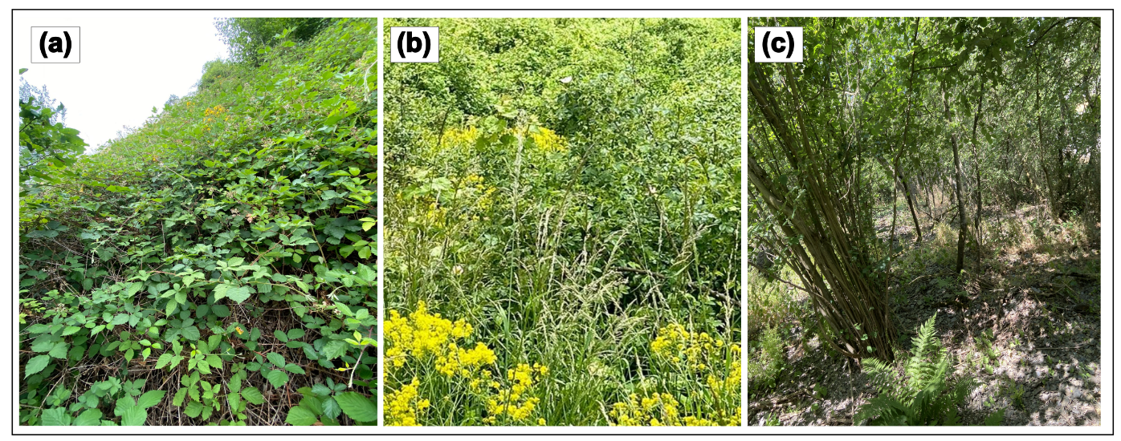Fig. S1. Successional stages of studied fallows: (a) stage I (3–4 years old, site 4, August 2023), densely overgrown with Rubus fructicosus agg.; (b) stage II (5–10 years old, site 8, May 2023), featuring dense shrubs and a more diverse assemblage of wildflowers and small woody plants; and (c) stage III (>15 years old, site 6, June 2023), characterised by increasingly forest-like structures, including partly shaded woody plants and trees (© Mine Yilmazer, May-August 2023)

Table S6 Recorded landscape variables and their descriptions
Variable | Description
Vineyards  (VY %) | Proportion of the surrounding landscape covered by conventionally managed vineyards
Fallows  (F %) | Proportion of vineyard fallows in the surrounding landscape
Mown grasslands (MG %) | Proportion of set-aside vineyards that are no longer under vine cultivation, and are managed as mown grasslands
Grazed grasslands (GG %) | Proportion of set-aside vineyards that are no longer under vine cultivation, and are managed as grazed grasslands
Semi-natural habitats (SNH %) | Proportion of structurally rich habitats (vegetation structure similar to vineyard fallows), either never managed with vines or located outside winegrowing areas
Forests  (Forest %) | Proportion of forests
Crops  (Crops %) | Proportion of agricultural land excluding vineyards, mainly comprising annual crops
Meadows  (M %) | Proportion of the surrounding landscape covered by meadows
Infrastructure  (INF %) | Proportion of infrastructure, including roads, paths, and railways
Settlement  (STLM %) | Proportion of the surrounding landscape covered by buildings, including houses, courtyards, and gardens

Table S7 GLM model family (POIS: poisson, NB: negative binomial, GAUSS: gaussian), final model for each beetle group (Carabidae, Staphylinidae, all beetles) and diversity parameter (Y: species: number of species, individuals: number of individuals, ENS: effective number of species, RR: rarefied richness, FRic: functional richness) for the effect of treatment (treat; 4 levels, fixed) and various landscape predictors (covariables; pvy: proportion of vineyards, pf: proportion of fallows, pmg: proportion of mown grasslands, pSNH: proportion of semi-natural habitats, pm: proportion of meadows, pforest: proportion of forests, pcrops: proportion of crops, pinfra: proportion of infrastructural elements, pstlm: proportion of settlements) including AIC values of full and reduced models
Group | Parameter | Model Family | Model (final) | AIC (full) | AIC (reduced)
Carabidae | Species | POIS | Y~ treat + pmg + pSNH + pforest + pinfra + pstlm | 213.07 | 207.6
 | Individuals | NB | Y ~ treat + pvy + pforest + pcrops + pm + pinfra + pstl | 364.10 | 359.29
 | ENS | GAUSS | Y~ treat + pvy + pmg + pSNH + pcrops + pinfra | 200.79 | 194.72
 | RR (ln) | GAUSS | Y ~ treat | 100.86 | 91.39
Staphylinidae | Species | POIS | Y ~ treat + pvy + pmg + pforest + pcrops + pm + pinfra + pstlm | 186.61 | 183.38
 | Individuals | NB | Y ~ treat + pmg + pfallow + pcrops + pinfra | 249.62 | 246.44
 | ENS | GAUSS | Y ~ treat + pvy + pmg + pforest + pm | 184.59 | 179.77
 | RR (ln) | GAUSS | Y ~ treat + pvy + pmg + pforest + pm + pinfra + pstlm | 59.77 | 53.94
 | FRic | GAUSS | Y ~ treat + pvy + pforest + pm | 118.51 | 113.57
All beetles | Species | NB | Y~ treat + pmg + pSNH + pforest + pcrops + pinfra + pstlm | 270.63 | 265.56
 | Individuals | NB | Y ~ treat + pvy + pmg + pforest + pm | 419.86 | 414.89
 | ENS | GAUSS | Y ~ treat + pmg + pSNH + pcrops + pinfra | 269.7 | 263.65
 | RR | GAUSS | Y ~ treat + pmg + pSNH + pforest + pcrops | 345.29 | 338.78
 | FRic | GAUSS | Y ~ treat + pf + pmg + pSNH + pforest + pcrops + pm + pinfra | -141.93 | -143.44

Table S8 List of the captured beetle species including beetle family (in alphabetical order), conservation status according to the Red List (RL) of Germany (Geiser 1998, NT: near threatened, E: endangered with unknown extent, 3: vulnerable, 2: endangered, 1: critically endangered), number of individuals per management type (GG: grazed grasslands, VY: vineyards, MG: mown grasslands, F: fallows), the total number of individuals (∑), and percentage (%) of all individuals
Beetle family | Beetle species | RL | GG | VY | MG | F | ∑ | %
Anthicidae | Hirticomus hispidus | E | 28 | 41 | 4 | 0 | 73 | 2.17
Bostrichidae | Bostrichus capucinus | NT | 0 | 2 | 0 | 0 | 2 | 0.06
 | Lyctus linearis |  | 0 | 1 | 0 | 0 | 1 | 0.03
Bruchidae | Spermophagus sericeus |  | 0 | 1 | 0 | 0 | 1 | 0.03
Buprestidae | Agrilus laticornis |  | 1 | 0 | 0 | 0 | 1 | 0.03
 | Agrilus ribesi |  | 1 | 0 | 1 | 0 | 2 | 0.06
Byrrhidae | Byrrhus pilula |  | 2 | 0 | 0 | 0 | 2 | 0.06
Carabidae | Amara aenea |  | 2 | 4 | 4 | 0 | 10 | 0.30
 | Amara apricaria |  | 0 | 0 | 1 | 0 | 1 | 0.03
 | Amara communis |  | 4 | 5 | 1 | 3 | 13 | 0.39
 | Amara convexior |  | 1 | 0 | 0 | 0 | 1 | 0.03
 | Amara eurynota |  | 0 | 3 | 0 | 0 | 3 | 0.09
 | Amara familiaris |  | 17 | 1 | 0 | 0 | 18 | 0.54
 | Amara littorea |  | 1 | 0 | 0 | 0 | 1 | 0.03
 | Amara ovata |  | 2 | 2 | 7 | 0 | 11 | 0.33
 | Amara similata |  | 0 | 0 | 1 | 0 | 1 | 0.03
 | Amara spreta |  | 0 | 0 | 1 | 0 | 1 | 0.03
 | Amara tibialis |  | 0 | 3 | 2 | 0 | 5 | 0.15
 | Anchomenus dorsalis |  | 6 | 1 | 0 | 0 | 7 | 0.21
 | Anisodactylus poeciloides | 2 | 0 | 3 | 2 | 0 | 5 | 0.15
 | Asaphidion flavipes |  | 6 | 0 | 0 | 1 | 7 | 0.21
 | Bembidion lampros |  | 1 | 2 | 0 | 0 | 3 | 0.09
 | Brachinus crepitans | NT | 102 | 391 | 239 | 7 | 739 | 21.97
 | Brachinus explodens | NT | 21 | 176 | 94 | 2 | 293 | 8.71
 | Calosoma inquisitor | 3 | 2 | 1 | 0 | 0 | 3 | 0.09
 | Carabus auratus |  | 10 | 0 | 10 | 0 | 20 | 0.59
 | Carabus convexus | NT | 5 | 0 | 0 | 0 | 5 | 0.15
 | Cicindela campestris |  | 1 | 2 | 5 | 0 | 8 | 0.24
 | Diachromus germanus |  | 0 | 0 | 6 | 0 | 6 | 0.18
 | Harpalus affinis |  | 6 | 53 | 8 | 0 | 67 | 1.99
 | Harpalus atratus |  | 6 | 2 | 2 | 0 | 10 | 0.30
 | Harpalus dimitiatus | 3 | 7 | 6 | 6 | 1 | 20 | 0.59
 | Harpalus distinguendos |  | 0 | 2 | 2 | 0 | 4 | 0.12
 | Harpalus flavescens | 3 | 0 | 2 | 0 | 0 | 2 | 0.06
 | Harpalus froelichii |  | 1 | 0 | 0 | 0 | 1 | 0.03
 | Harpalus griseus |  | 3 | 3 | 3 | 0 | 9 | 0.27
 | Harpalus honestus |  | 9 | 61 | 36 | 4 | 110 | 3.27
 | Harpalus latus |  | 3 | 20 | 14 | 0 | 37 | 1.10
 | Harpalus melancholicus |  | 2 | 8 | 1 | 0 | 11 | 0.33
 | Harpalus rubripes |  | 0 | 7 | 5 | 1 | 13 | 0.39
 | Harpalus rufipalpis |  | 7 | 0 | 3 | 1 | 11 | 0.33
 | Harpalus rufipes |  | 7 | 42 | 1 | 0 | 50 | 1.49
 | Harpalus smaragdinus |  | 1 | 12 | 6 | 0 | 19 | 0.56
 | Harpalus subcylindricus |  | 0 | 0 | 1 | 0 | 1 | 0.03
 | Harpalus tardus |  | 36 | 18 | 10 | 0 | 64 | 1.90
 | Harpalus tenebrosus |  | 0 | 0 | 1 | 0 | 1 | 0.03
 | Harplaus xanthopus winkleri |  | 1 | 0 | 0 | 0 | 1 | 0.03
 | Loricera pilicornis |  | 0 | 0 | 0 | 1 | 1 | 0.03
 | Microlestes maurus |  | 0 | 35 | 18 | 0 | 53 | 1.58
 | Microlestes minutulus |  | 15 | 35 | 25 | 9 | 84 | 2.50
 | Nebria brevicollis |  | 1 | 1 | 0 | 0 | 2 | 0.06
 | Nebria salina |  | 2 | 2 | 0 | 0 | 4 | 0.12
 | Notiophilus rufipes |  | 4 | 1 | 0 | 0 | 5 | 0.15
 | Notiophilus substriatus |  | 0 | 1 | 0 | 0 | 1 | 0.03
 | Ophonus ardosiacus |  | 0 | 18 | 43 | 1 | 62 | 1.84
 | Ophonus azureus |  | 0 | 1 | 2 | 0 | 3 | 0.09
 | Ophonus cordatus | 3 | 0 | 3 | 0 | 0 | 3 | 0.09
 | Ophonus nitidulus/laticollis |  | 0 | 3 | 21 | 1 | 25 | 0.74
 | Ophonus puncticeps |  | 5 | 2 | 0 | 2 | 9 | 0.27
 | Ophonus puncticollis |  | 0 | 0 | 0 | 2 | 2 | 0.06
 | Ophonus schaubergerianus |  | 1 | 14 | 25 | 2 | 42 | 1.25
 | Panagaeus bipustulatus |  | 1 | 0 | 0 | 0 | 1 | 0.03
 | Parophonus maculicornis |  | 2 | 1 | 16 | 0 | 19 | 0.56
 | Peocilus cupreus |  | 0 | 15 | 0 | 0 | 15 | 0.45
 | Perigona nigriceps |  | 0 | 2 | 0 | 0 | 2 | 0.06
 | Philorhizus melanocephalus |  | 0 | 1 | 0 | 0 | 1 | 0.03
 | Poecilus versicolor |  | 0 | 1 | 0 | 0 | 1 | 0.03
 | Pseudoophonus calceatus |  | 17 | 2 | 3 | 0 | 22 | 0.65
 | Pterostichus madidus |  | 9 | 0 | 0 | 0 | 9 | 0.27
 | Tachys scutellaris | 1 | 0 | 0 | 2 | 0 | 2 | 0.06
 | Trechus quadristriatus |  | 0 | 0 | 1 | 0 | 1 | 0.03
Cantharidae | Aplocnemus nigricornis |  | 2 | 0 | 0 | 0 | 2 | 0.06
 | Cantharis fusca |  | 0 | 1 | 1 | 0 | 2 | 0.06
 | Cantharis rustica |  | 0 | 3 | 1 | 0 | 4 | 0.12
Cerambycidae | Leiopus nebulosus |  | 0 | 0 | 0 | 1 | 1 | 0.03
 | Pseudovadonia livida |  | 2 | 1 | 0 | 1 | 4 | 0.12
 | Rutpela maculata |  | 0 | 0 | 0 | 1 | 1 | 0.03
 | Stenurella bifasciata |  | 0 | 0 | 1 | 1 | 2 | 0.06
 | Stictoleptura spec. |  | 1 | 0 | 0 | 0 | 1 | 0.03
Chrysomelidae | Aphthona nonstriata |  | 0 | 1 | 0 | 0 | 1 | 0.03
 | Cassida nebulosa |  | 0 | 1 | 0 | 0 | 1 | 0.03
 | Chaetocnema hortensis |  | 1 | 6 | 0 | 0 | 7 | 0.21
 | Galeruca tanaceti |  | 0 | 0 | 1 | 0 | 1 | 0.03
 | Hispa atra |  | 0 | 0 | 1 | 0 | 1 | 0.03
 | Hypocassida subferruginea |  | 0 | 2 | 0 | 0 | 2 | 0.06
 | Longitarsus anchusae |  | 0 | 0 | 0 | 1 | 1 | 0.03
 | Longitarsus brunneus |  | 1 | 0 | 0 | 0 | 1 | 0.03
 | Longitarsus dorsalis |  | 0 | 0 | 3 | 0 | 3 | 0.09
 | Longitarsus exsoletus |  | 1 | 0 | 0 | 1 | 2 | 0.06
 | Longitarsus luridus |  | 0 | 1 | 0 | 1 | 2 | 0.06
 | Longitarsus rubiginosus |  | 0 | 1 | 1 | 1 | 3 | 0.09
 | Lythraria salicariae |  | 1 | 0 | 0 | 0 | 1 | 0.03
 | Ochrosis ventralis | 2 | 0 | 0 | 2 | 0 | 2 | 0.06
 | Phyllotreta crucifera |  | 5 | 1 | 0 | 0 | 6 | 0.18
 | Phyllotreta vitula |  | 1 | 0 | 0 | 0 | 1 | 0.03
 | Podagrica fuscicornis |  | 0 | 15 | 0 | 0 | 15 | 0.45
 | Podagrica fuscipes | 2 | 0 | 64 | 0 | 0 | 64 | 1.90
 | Psylliiodes dulcamarae |  | 0 | 1 | 0 | 0 | 1 | 0.03
 | Timarcha tenebricosa | NT | 2 | 0 | 3 | 1 | 6 | 0.18
Coccinellidae | Coccinella septempunctata |  | 2 | 2 | 1 | 0 | 5 | 0.15
 | Coccinula quatuordecimpustulata |  | 0 | 0 | 3 | 0 | 3 | 0.09
 | Hippodamia variegata |  | 0 | 1 | 0 | 0 | 1 | 0.03
 | Rhyzobius chrysomeloides |  | 1 | 0 | 0 | 0 | 1 | 0.03
 | Scymnus apetzi |  | 0 | 0 | 2 | 0 | 2 | 0.06
 | Stethorus pusillus |  | 1 | 0 | 0 | 0 | 1 | 0.03
 | Tytthaspis sedecimpunctata |  | 1 | 0 | 2 | 0 | 3 | 0.09
Corylophidae | Sericoderus lateralis |  | 9 | 12 | 0 | 2 | 23 | 0.68
Cryptophagidae | Atomaria basalis |  | 0 | 2 | 0 | 0 | 2 | 0.06
 | Atomaria linearis |  | 0 | 0 | 0 | 1 | 1 | 0.03
 | Atomaria rhenana |  | 2 | 0 | 0 | 0 | 2 | 0.06
 | Cryptophagus dorsalis |  | 1 | 0 | 0 | 1 | 2 | 0.06
 | Cryptophagus pallidus |  | 0 | 1 | 0 | 0 | 1 | 0.03
 | Cryptophagus quercinus | 3 | 0 | 0 | 1 | 0 | 1 | 0.03
 | Cryptophagus scanicus |  | 0 | 0 | 0 | 1 | 1 | 0.03
Curculionidae | Aspidapion aeneum |  | 0 | 0 | 1 | 0 | 1 | 0.03
 | Aspidapion validum |  | 0 | 1 | 0 | 0 | 1 | 0.03
 | Aulacobaris fallax |  | 1 | 0 | 0 | 0 | 1 | 0.03
 | Aulacobaris coerulescens |  | 0 | 0 | 1 | 0 | 1 | 0.03
 | Betulapion simile |  | 0 | 0 | 2 | 0 | 2 | 0.06
 | Ceutorhynchus contractus |  | 0 | 0 | 1 | 0 | 1 | 0.03
 | Echinodera hypocrita |  | 1 | 0 | 0 | 0 | 1 | 0.03
 | Eutrichapion punctigerum |  | 0 | 0 | 2 | 0 | 2 | 0.06
 | Exomias araneiformis |  | 2 | 0 | 0 | 0 | 2 | 0.06
 | Exomias pellucidus |  | 50 | 0 | 2 | 0 | 52 | 1.55
 | Exomias trichopterus |  | 76 | 0 | 0 | 0 | 76 | 2.26
 | Micrelus ericae |  | 1 | 0 | 0 | 0 | 1 | 0.03
 | Microplontus campestris |  | 0 | 1 | 0 | 0 | 1 | 0.03
 | Mitoplinthus caliginosus |  | 3 | 0 | 0 | 0 | 3 | 0.09
 | Mogolones geographicus |  | 0 | 1 | 0 | 0 | 1 | 0.03
 | Orthotomicus laricis |  | 1 | 0 | 0 | 0 | 1 | 0.03
 | Otiorhynchus ovatus |  | 0 | 0 | 1 | 0 | 1 | 0.03
 | Otiorhynchus parvulus | NT | 0 | 0 | 1 | 0 | 1 | 0.03
 | Otiorhynchus porcatus |  | 3 | 0 | 0 | 0 | 3 | 0.09
 | Otiorhynchus sulcatus |  | 1 | 0 | 0 | 1 | 2 | 0.06
 | Pissodes castaneus |  | 1 | 0 | 0 | 0 | 1 | 0.03
 | Protapion fulvipes |  | 2 | 1 | 0 | 0 | 3 | 0.09
 | Sciaphilus asperatus |  | 0 | 0 | 1 | 0 | 1 | 0.03
 | Sitona humeralis |  | 0 | 1 | 0 | 0 | 1 | 0.03
 | Sitona inops |  | 1 | 0 | 0 | 0 | 1 | 0.03
 | Sphenophorus striatopunctatus | NT | 0 | 2 | 0 | 0 | 2 | 0.06
 | Xyleborinus saxesenii |  | 3 | 0 | 0 | 0 | 3 | 0.09
 | Xyleborus monographus |  | 3 | 0 | 0 | 0 | 3 | 0.09
 | Zacladus geranii |  | 1 | 0 | 0 | 0 | 1 | 0.03
Dasytidae | Danacea nigritarsis |  | 0 | 0 | 3 | 0 | 3 | 0.09
 | Danacea pallipes |  | 0 | 1 | 7 | 0 | 8 | 0.24
 | Dasytes niger |  | 1 | 1 | 0 | 0 | 2 | 0.06
 | Drilus concolor |  | 1 | 0 | 0 | 0 | 1 | 0.03
Dermestidae | Dermestes undulatus |  | 0 | 0 | 1 | 0 | 1 | 0.03
Drilidae | Drilus flavescens |  | 1 | 0 | 0 | 0 | 1 | 0.03
 | Rhagonycha fulva |  | 0 | 1 | 0 | 0 | 1 | 0.03
Elateridae | Adrastus pallens |  | 0 | 0 | 1 | 0 | 1 | 0.03
 | Agriotes acuminatus |  | 0 | 2 | 0 | 0 | 2 | 0.06
 | Agriotes gallicus |  | 1 | 0 | 0 | 0 | 1 | 0.03
 | Agriotes lineatus |  | 1 | 0 | 1 | 0 | 2 | 0.06
 | Agriotes obscurus |  | 0 | 0 | 1 | 0 | 1 | 0.03
 | Agriotes pallidulus |  | 0 | 3 | 0 | 1 | 4 | 0.12
 | Agriotes sordidus |  | 0 | 2 | 3 | 0 | 5 | 0.15
 | Agriotes sputator |  | 0 | 3 | 9 | 0 | 12 | 0.36
 | Agrypnus murinus |  | 1 | 1 | 4 | 1 | 7 | 0.21
 | Athous haemorrhoidalis |  | 2 | 3 | 0 | 0 | 5 | 0.15
 | Cidnopus pilosus |  | 0 | 1 | 0 | 0 | 1 | 0.03
 | Ectinus aterrimus |  | 0 | 0 | 1 | 0 | 1 | 0.03
 | Hemicrepidius hirtus |  | 1 | 0 | 0 | 0 | 1 | 0.03
 | Quasimus minutissimus | 3 | 0 | 0 | 0 | 1 | 1 | 0.03
 | Zorochros meridionalis |  | 0 | 0 | 0 | 1 | 1 | 0.03
Eucinetidae | Eucinetus haemorroidalis |  | 1 | 0 | 0 | 0 | 1 | 0.03
Eucnemidae | Dromaeolus barnabita |  | 1 | 0 | 0 | 0 | 1 | 0.03
Histeridae | Margarinotus purpurascens |  | 0 | 2 | 0 | 0 | 2 | 0.06
 | Margarinotus merdarius |  | 1 | 0 | 0 | 0 | 1 | 0.03
Hydrophilidae | Sphaeridium scarabaeoides |  | 1 | 0 | 0 | 0 | 1 | 0.03
 | Cercyon melanocephalus |  | 8 | 0 | 0 | 0 | 8 | 0.24
 | Cercyon quisquilius |  | 1 | 0 | 0 | 0 | 1 | 0.03
Latridiidae | Corticarina minuta |  | 0 | 1 | 0 | 2 | 3 | 0.09
 | Corticarina similata |  | 7 | 20 | 9 | 11 | 47 | 1.40
 | Corticarina truncatella |  | 0 | 5 | 4 | 1 | 10 | 0.30
 | Cortinicara gibbosa |  | 8 | 15 | 12 | 19 | 54 | 1.61
 | Enicmus amici |  | 1 | 3 | 0 | 0 | 4 | 0.12
 | Enicmus transversus |  | 0 | 5 | 4 | 2 | 11 | 0.33
 | Lathridius distinguenda |  | 0 | 1 | 0 | 0 | 1 | 0.03
Leiodidae | Ptomaphagus sericatus |  | 21 | 25 | 11 | 8 | 65 | 1.93
 | Ptomaphagus subvillosus |  | 2 | 9 | 1 | 4 | 16 | 0.48
Lucanidae | Dorcus parallelipipedus |  | 8 | 0 | 0 | 0 | 8 | 0.24
Malachiidae | Anthocomus coarctatus |  | 0 | 0 | 0 | 1 | 1 | 0.03
Mordellidae | Mordella aculeata |  | 8 | 1 | 2 | 1 | 12 | 0.36
Oedemeridae | Nacerdes carniolica |  | 0 | 1 | 0 | 0 | 1 | 0.03
 | Oedemera femoralis | E | 9 | 1 | 0 | 0 | 10 | 0.30
 | Oedemera monticola |  | 0 | 1 | 0 | 1 | 2 | 0.06
Omalisidae | Omalisus fontisbellaquei |  | 0 | 0 | 0 | 1 | 1 | 0.03
Ptinidae | Ptinus rufipes |  | 0 | 1 | 0 | 0 | 1 | 0.03
Scarabidae | Acrossus depressus |  | 8 | 0 | 0 | 0 | 8 | 0.24
 | Acrossus rufipes |  | 8 | 0 | 0 | 0 | 8 | 0.24
 | Agrilinus ater |  | 1 | 0 | 0 | 0 | 1 | 0.03
 | Anoplotrupes stercorosus |  | 17 | 0 | 0 | 0 | 17 | 0.51
 | Aphodius spec. |  | 2 | 0 | 0 | 0 | 2 | 0.06
 | Cetonia aurata aurata |  | 2 | 1 | 0 | 0 | 3 | 0.09
 | Esymus pusillus |  | 9 | 0 | 0 | 0 | 9 | 0.27
 | Melinopterus consputus | 2 | 6 | 0 | 0 | 0 | 6 | 0.18
 | Onthophagus coenobita |  | 10 | 0 | 0 | 0 | 10 | 0.30
 | Onthophagus fracticornis |  | 4 | 0 | 0 | 0 | 4 | 0.12
 | Onthophagus joannae |  | 11 | 0 | 0 | 0 | 11 | 0.33
 | Onthophagus ovatus |  | 28 | 1 | 8 | 11 | 48 | 1.43
 | Onthophagus simillis |  | 7 | 0 | 0 | 0 | 7 | 0.21
 | Onthophagus verticicornis |  | 1 | 0 | 0 | 0 | 1 | 0.03
 | Othophorus haemorrhoidalis |  | 4 | 0 | 0 | 0 | 4 | 0.12
 | Oxyomus sylvestris |  | 3 | 0 | 0 | 0 | 3 | 0.09
 | Phalacronothus biguttatus |  | 5 | 1 | 0 | 0 | 6 | 0.18
 | Phyllopertha horticola |  | 0 | 0 | 0 | 1 | 1 | 0.03
 | Pleurophorus caesus |  | 0 | 1 | 0 | 0 | 1 | 0.03
 | Psammoporus sabuleti | 1 | 2 | 0 | 0 | 0 | 2 | 0.06
 | Rhizotrogus aestivus | 1 | 9 | 0 | 0 | 0 | 9 | 0.27
 | Rhizotrogus marginipes |  | 4 | 0 | 1 | 0 | 5 | 0.15
 | Valgus hemimpterus |  | 8 | 3 | 0 | 2 | 13 | 0.39
 | Volinus sticticus |  | 12 | 0 | 0 | 0 | 12 | 0.36
Scarptiidae | Anaspis frontalis |  | 0 | 0 | 0 | 1 | 1 | 0.03
Silphidae | Phosphuga atrata |  | 2 | 0 | 0 | 0 | 2 | 0.06
 | Silpha tyrolensis |  | 4 | 0 | 0 | 0 | 4 | 0.12
Staphylinidae | Aleochara bipustulata |  | 6 | 3 | 5 | 4 | 18 | 0.54
 | Aleochara curtula |  | 1 | 0 | 0 | 0 | 1 | 0.03
 | Aleochara haematoptera |  | 2 | 0 | 1 | 0 | 3 | 0.09
 | Aleochara intricata |  | 7 | 2 | 1 | 1 | 11 | 0.33
 | Aleochara spec. |  | 1 | 0 | 0 | 0 | 1 | 0.03
 | Aleochara tristis |  | 1 | 0 | 0 | 0 | 1 | 0.03
 | Anotylus inustus |  | 28 | 1 | 1 | 2 | 32 | 0.95
 | Anotylus sculpturatus |  | 7 | 1 | 0 | 0 | 8 | 0.24
 | Anotylus tetracarinatus |  | 17 | 5 | 0 | 3 | 25 | 0.74
 | Atheta graminicola |  | 12 | 13 | 5 | 5 | 35 | 1.04
 | Atheta spec. 1 |  | 0 | 1 | 0 | 0 | 1 | 0.03
 | Atheta spec. 2 |  | 0 | 1 | 0 | 0 | 1 | 0.03
 | Atheta spec. 3 |  | 1 | 0 | 0 | 0 | 1 | 0.03
 | Atheta spec. 4 |  | 0 | 0 | 1 | 0 | 1 | 0.03
 | Atheta spec. 5 |  | 0 | 0 | 0 | 0 | 0 | < 0.01
 | Atheta spec. 6 |  | 1 | 0 | 0 | 0 | 1 | 0.03
 | Bisnius fimetarius |  | 1 | 0 | 0 | 0 | 1 | 0.03
 | Bledius spec. |  | 0 | 1 | 0 | 0 | 1 | 0.03
 | Bolitobius cingulatus |  | 2 | 0 | 3 | 0 | 5 | 0.15
 | Brachida exigua |  | 2 | 0 | 2 | 0 | 4 | 0.12
 | Bryoporus cernuus |  | 1 | 0 | 0 | 0 | 1 | 0.03
 | Claviger testaceus | 2 | 1 | 1 | 0 | 0 | 2 | 0.06
 | Drusilla canaliculata |  | 21 | 15 | 11 | 17 | 64 | 1.90
 | Falagrioma thoracica |  | 5 | 0 | 0 | 0 | 5 | 0.15
 | Haploglossa nidicola |  | 5 | 0 | 0 | 1 | 6 | 0.18
 | Lathhrobium pallidum |  | 0 | 2 | 0 | 1 | 3 | 0.09
 | Lathrobium brunnipes |  | 0 | 1 | 0 | 0 | 1 | 0.03
 | Leptacinus batychrus |  | 0 | 1 | 0 | 0 | 1 | 0.03
 | Leptacinus intermedius |  | 0 | 2 | 0 | 0 | 2 | 0.06
 | Leptusa ruficollis |  | 0 | 2 | 0 | 0 | 2 | 0.06
 | Leptusa spec. |  | 4 | 0 | 2 | 0 | 6 | 0.18
 | Metopsia clypeata |  | 0 | 0 | 1 | 0 | 1 | 0.03
 | Ocypus olens |  | 3 | 0 | 2 | 0 | 5 | 0.15
 | Ocypus ophthalmicus |  | 2 | 0 | 2 | 0 | 4 | 0.12
 | Pella lugens |  | 1 | 0 | 0 | 1 | 2 | 0.06
 | Philonthus carbonarius |  | 1 | 0 | 0 | 0 | 1 | 0.03
 | Philonthus cognatus |  | 1 | 0 | 0 | 0 | 1 | 0.03
 | Philonthus debilis |  | 1 | 0 | 0 | 0 | 1 | 0.03
 | Philonthus fumarius |  | 3 | 0 | 1 | 0 | 4 | 0.12
 | Philonthus spec. |  | 1 | 0 | 1 | 0 | 2 | 0.06
 | Philonthus splendens |  | 1 | 0 | 0 | 1 | 2 | 0.06
 | Placusa spec. |  | 1 | 0 | 0 | 0 | 1 | 0.03
 | Plataraea brunnea |  | 10 | 3 | 0 | 2 | 15 | 0.45
 | Platydracus chalcocephalus |  | 2 | 0 | 1 | 0 | 3 | 0.09
 | Platydracus stecorarius |  | 1 | 1 | 6 | 2 | 10 | 0.30
 | Platystethus cornutus |  | 1 | 0 | 0 | 0 | 1 | 0.03
 | Quedius maurorufus |  | 1 | 0 | 0 | 1 | 2 | 0.06
 | Quedius microps |  | 1 | 0 | 0 | 0 | 1 | 0.03
 | Quedius nigriceps |  | 1 | 0 | 0 | 0 | 1 | 0.03
 | Quedius persimilis |  | 2 | 1 | 0 | 0 | 3 | 0.09
 | Quedius picipes |  | 0 | 0 | 0 | 1 | 1 | 0.03
 | Sepedophilus marshami |  | 1 | 0 | 0 | 0 | 1 | 0.03
 | Sepedophilus testaceus |  | 0 | 0 | 0 | 1 | 1 | 0.03
 | Stenus impressus |  | 2 | 0 | 0 | 0 | 2 | 0.06
 | Stenus ossium |  | 0 | 2 | 0 | 0 | 2 | 0.06
 | Tachinus corticinus |  | 1 | 1 | 2 | 3 | 7 | 0.21
 | Tachinus humeralis |  | 0 | 0 | 0 | 1 | 1 | 0.03
 | Tachinus rufipes/signatus |  | 3 | 0 | 0 | 0 | 3 | 0.09
 | Tachyporus chrysomelinus |  | 0 | 1 | 0 | 1 | 2 | 0.06
 | Tachyporus dispar |  | 0 | 2 | 3 | 1 | 6 | 0.18
 | Tachyporus hypnorum |  | 3 | 0 | 2 | 1 | 6 | 0.18
 | Tachyporus nitidulus |  | 3 | 9 | 1 | 0 | 13 | 0.39
 | Tachyporus solutus |  | 4 | 3 | 0 | 0 | 7 | 0.21
 | Tasgius melanarius |  | 1 | 2 | 0 | 0 | 3 | 0.09
Tenebrionidae | Asida sabulosa |  | 0 | 1 | 0 | 0 | 1 | 0.03
 | Isomira murina |  | 1 | 0 | 1 | 0 | 2 | 0.06
 | Lagria hirta |  | 0 | 0 | 0 | 1 | 1 | 0.03
 | Opatrum sabulosum |  | 3 | 22 | 41 | 0 | 66 | 1.96
 | Prionychus ater |  | 1 | 0 | 0 | 0 | 1 | 0.03
Trogidae | Trox perlatus | NT | 8 | 0 | 0 | 0 | 8 | 0.24
Trogossitida | Nemozoma elongatum |  | 0 | 1 | 0 | 0 | 1 | 0.03
Zopheridae | Pycnomerus spec. |  | 0 | 1 | 0 | 0 | 1 | 0.03
 | Synchita humeralis |  | 2 | 0 | 0 | 0 | 2 | 0.06

Table S9 Bray-Curtis dissimilarity indices for beetle assemblages across management categories. Indices were calculated for (a) Carabidae, (b) Staphylinidae, and (c) all beetle families. Differences among categories were tested with PERMANOVA (999 permutations), followed by pairwise PERMANOVA comparisons. p-values are adjusted using sequential Benjamini & Hochberg corrections. Bottom left: Bray-Curtis dissimilarity indices; higher values imply higher dissimilarity. Top right, p-values; significant values in bold. GL: Grassland
(a) Carabidae | Grazed GL | Vineyards | Mown GL | Fallows
Grazed GL |  | 0.183 | 0.038 | 0.395
Vineyards | 0.49 |  | 0.207 | 0.006
Mown GL | 0.60 | 0.43 |  | 0.006
Fallows | 0.44 | 0.85 | 0.91
(b) Staphylinidae | Grazed GL | Vineyards | Mown GL | Fallows
Grazed GL |  | 0.401 | 0.162 | 0.401
Vineyards | 0.42 |  | 0.401 | 0.429
Mown GL | 0.62 | 0.51 |  | 0.429
Fallows | 0.45 | 0.40 | 0.44
(c) All beetle families | Grazed GL | Vineyards | Mown GL | Fallows
Grazed GL |  | 0.006 | 0.012 | 0.006
Vineyards | 0.71 |  | > 0.999 | 0.012
Mown GL | 0.95 | 0.43 |  | 0.006
Fallows | 0.67 | 0.69 | 0.83

Table S10 PERMANOVA results for functional traits (the relative abundance of beetles with different preferences for biotope type, habitat, food, temperature and humidity or differences in hind wing morphology) of beetle assemblages across different management categories. All parameters were analysed for (1) Carabidae, (2) Staphylinidae, and (3) all beetle families jointly. Significant p-values are given in bold. In Staphylinidae, no variation in hindwing morphology was found such that no statistics could be calculated
Parameter | Beetle family | Df | R² | F | p-value
Biotope | Carabidae | 3,35 | 0.10 | 1.30 | 0.255
 | Staphylinidae | 3,32 | 0.21 | 2.96 | 0.001
 | All beetle families | 3,36 | 0.16 | 2.37 | 0.012
Habitat | Carabidae | 3,36 | 0.06 | 0.79 | 0.528
 | Staphylinidae | 3,30 | 0.08 | 0.88 | 0.501
 | All beetle families | 3,36 | 0.36 | 6.76 | 0.001
Food | Carabidae | 3,36 | 0.07 | 0.89 | 0.440
 | Staphylinidae | 3,36 | 0.18 | 2.62 | 0.052
 | All beetle families | 3,36 | 0.14 | 1.99 | 0.033
Temperature / humidity | Carabidae | 3,36 | 0.09 | 1.19 | 0.290
 | Staphylinidae | 3,26 | 0.12 | 1.14 | 0.357
 | All beetle families | 3,36 | 0.20 | 2.99 | 0.010
Hind wing morphology | Carabidae | 3,33 | 0.04 | 0.47 | 0.838
 | Staphylinidae | - | - | - | -
 | All beetle families | 3,36 | 0.16 | 2.24 | 0.031

Table S11 Results of PERMANOVA pairwise comparisons for the relative abundances of the most abundant beetle families, and functional traits (the relative abundance of beetles with different preferences for biotope type, habitat, food, temperature and humidity or differences in hind wing morphology) of beetle assemblages across four different management types and beetle groups (all beetle families and Staphylinidae). VY: vineyards, GG: grazed grasslands, MG: mown grasslands, F: fallows. p-values are adjusted using sequential Benjamini & Hochberg corrections, significant p-values are given in bold. Results are only given for significant global tests, for Carabidae no significant differences were found; PERMANOVAs, see Table S10)
Parameter | Beetle family | Pairs of pairwise comparisons | Df | MS | F | p-value
Dominant families | All beetle families | GG-VY | 1 | 0.34 | 6.69 | 0.014
 | “ | GG-MG | 1 | 0.72 | 17.83 | 0.003
 | “ | GG-F | 1 | 0.03 | 0.44 | 0.646
 | “ | VY-MG | 1 | 0.08 | 2.11 | 0.202
 | “ | VY-F | 1 | 0.51 | 8.22 | 0.014
 | “ | MG-F | 1 | 0.92 | 19.83 | 0.003
Biotope preference | All beetle families | GG-VY | 1 | 0.14 | 1.89 | 0.535
 | “ | GG-MG | 1 | 0.21 | 2.66 | 0.064
 | “ | GG-F | 1 | 0.05 | 0.66 | 0.570
 | “ | VY-MG | 1 | 0.04 | 0.52 | 0.681
 | “ | VY-F | 1 | 0.27 | 3.59 | 0.036
 | “ | MG-F | 1 | 0.40 | 4.85 | 0.006
Biotope preference | Staphylinidae | GG-VY | 1 | 1.01 | 5.73 | 0.003
 | “ | GG-MG | 1 | 1.42 | 8.52 | 0.003
 | “ | GG-F | 1 | 0.39 | 2.21 | 0.157
 | “ | VY-MG | 1 | 0.13 | 0.51 | 0.732
 | “ | VY-F | 1 | 0.25 | 0.99 | 0.518
 | “ | MG-F | 1 | 0.51 | 1.98 | 0.157
Habitat preference | All beetle families | GG-VY | 1 | 0.27 | 9.02 | 0.006
 | “ | GG-MG | 1 | 0.41 | 19.51 | 0.006
 | “ | GG-F | 1 | 0.16 | 3.46 | 0.033
 | “ | VY-MG | 1 | 0.05 | 2.02 | 0.168
 | “ | VY-F | 1 | 0.16 | 3.33 | 0.055
 | “ | MG-F | 1 | 0.36 | 9.09 | 0.006
Food preference | All beetle families | GG-VY | 1 | 0.26 | 2.97 | 0.138
 | “ | GG-MG | 1 | 0.36 | 5.02 | 0.024
 | “ | GG-F | 1 | 0.19 | 1.43 | 0.304
 | “ | VY-MG | 1 | 0.09 | 1.27 | 0.336
 | “ | VY-F | 1 | 0.07 | 0.56 | 0.742
 | “ | MG-F | 1 | 0.23 | 2.04 | 0.148
Thermal & humidity prefrence | All beetle families | GG-VY | 1 | 0.15 | 1.94 | 0.204
 | “ | GG-MG | 1 | 0.36 | 6.37 | 0.012
 | “ | GG-F | 1 | < 0.01 | 0.01 | 0.959
 | “ | VY-MG | 1 | 0.04 | 0.44 | 0.728
 | “ | VY-F | 1 | 0.19 | 2.61 | 0.140
 | “ | MG-F | 1 | 0.44 | 8.11 | 0.006
Hind wing morphology | All beetle families | GG-VY | 1 | 0.06 | 4.57 | 0.036
 | “ | GG-MG | 1 | 0.07 | 4.21 | 0.036
 | “ | GG-F | 1 | 0.07 | 2.59 | 0.076
 | “ | VY-MG | 1 | 0.02 | 3.01 | 0.076
 | “ | VY-F | 1 | 0.01 | 0.45 | 0.706
 | “ | MG-F | 1 | 0.01 | 0.18 | 0.744

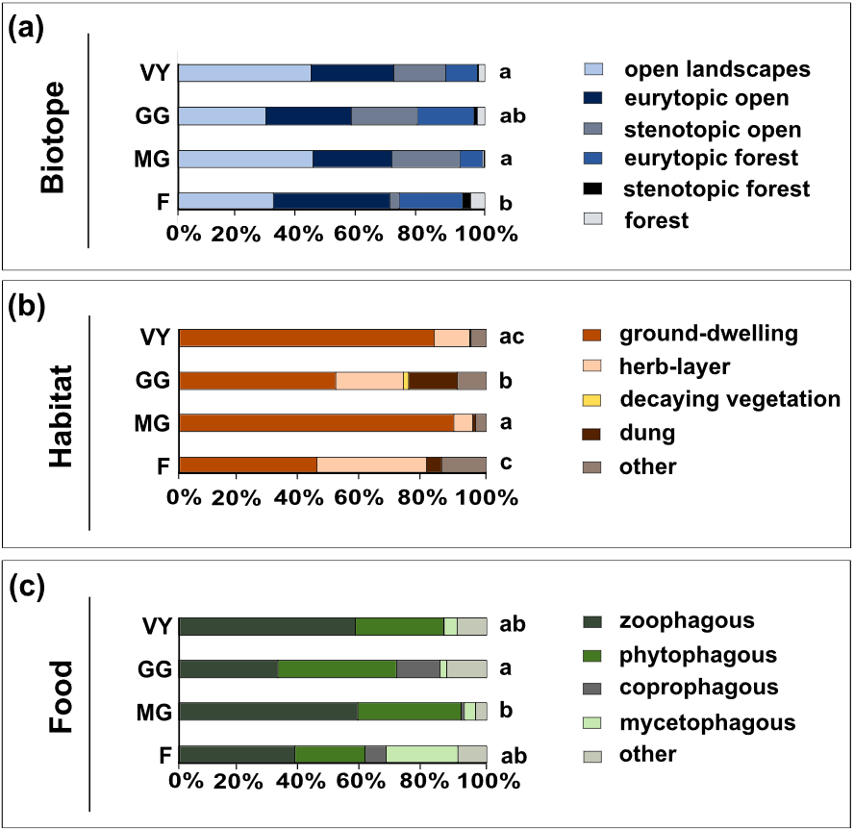
Fig. S2 Relative abundance of species with different preferences for (a) biotope type, (b) habitat, and (c) food, across management categories (VY: vineyards, GG: grazed grasslands, MG: mown grasslands, F: fallows) for all beetle families. Different letters behind bars show significant differences across categories (PERMANOVAs, Table S10; PERMANOVA pairwise comparisons; Table S11)

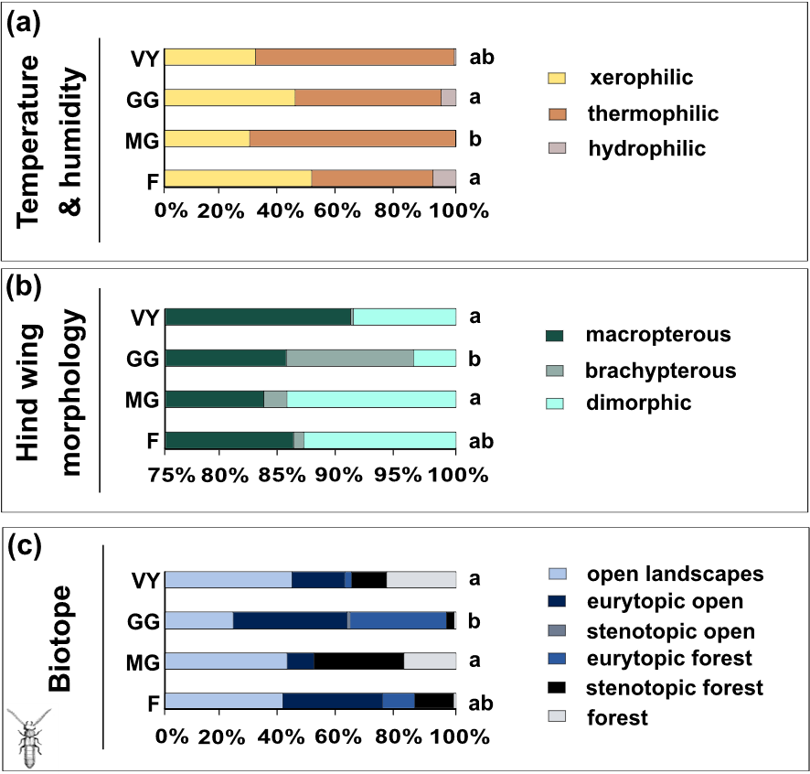
Fig. S3 Relative abundance of species with different preferences for (a) temperature and humidity, and (b) with different hind wing morphologies for all beetle families, and (c) biotope preference for Staphylinidae across management categories (VY: vineyards, GG: grazed grasslands, MG: mown grasslands, F: fallows). Different letters behind bars show significant differences across categories (PERMANOVAs, Table S10; PERMANOVA pairwise comparisons; Table S11)

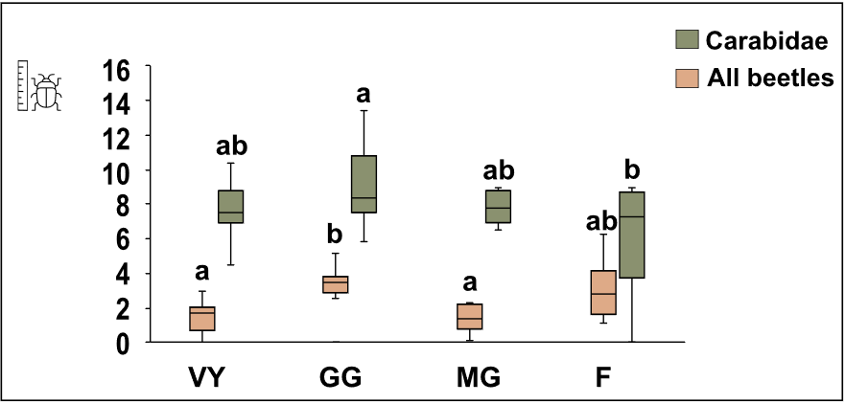Fig. S4 CWM body size for the Carabidae and all beetle families across four management categories (VY: vineyards, GG: grazed grasslands, MG: mown grasslands, F: fallows). Boxplots show the interquartile range (25-75%; box), the median (horizontal line within box), and the maximum and minimum values (whiskers). Different letters above boxplots show significant differences among management categories within taxon (Tukey HSD after ANOVAs)

Table S12 GLM coefficient estimates (± SE) for the effects of landscape predictors on beetle diversity parameters at a 200 m buffer across beetle groups (Carabidae, Staphylinidae, all beetles). Diversity parameters: Individuals = number of individuals, Species = number of species, ENS = effective number of species, RR = rarefied richness, FRic = functional richness. Reported are estimates ± SE and the corresponding test statistics (z for Poisson/negative binomial models: number of species and individuals; t for Gaussian models: ENS, RR, and FRic). Positive and negative estimates indicate the direction of the effect. Only significant predictors (p < 0.05) are shown VY: vineyards, MG: mown grasslands, SNH: semi-natural habitats, M: meadows

Group | Parameter | Predictor | Estimate ± SE | t/z | p-value
Carabidae | Species | MG % | 0.043 ± 0.009 | 4.891 | < 0.001
 | Species | SNH % | 0.038 ± 0.009 | 4.130 | < 0.001
 | Species | Forest % | 0.012 ± 0.004 | 2.709 | 0.007
 | Species | Infrastructure % | -0.102 ± 0.033 | -3.123 | 0.002
Group | Parameter | Predictor | Estimate ± SE | t/z | p-value
Carabidae | Individuals | VY % | 0.040 ± 0.016 | 2.559 | 0.011
 | Individuals | Forest % | 0.028 ± 0.013 | 2.169 | 0.030
 | Individuals | M % | 0.061 ± 0.023 | 2.678 | 0.007
 | Individuals | Infrastructure % | -0.194 ± 0.071 | -2.756 | 0.006
Group | Parameter | Predictor | Estimate ± SE | t/z | p-value
Carabidae | ENS | MG % | 0.222 ± 0.064 | 3.481 | 0.002
 | ENS | SNH % | 0.195 ± 0.067 | 2.905 | 0.007
Group | Parameter | Predictor | Estimate ± SE | t/z | p-value
Staphylinidae | Species | MG % | 0.040 ± 0.012 | 3.266 | 0.001
 | Species | M % | 0.038 ± 0.011 | 3.451 | < 0.001
 | Species | Infrastructure % | -0.125 ± 0.047 | -2.662 | 0.008
Group | Parameter | Predictor | Estimate ± SE | t/z | p-value
Staphylinidae | Individuals | MG % | 0.039 ± 0.017 | 2.452 | 0.014
 | Individuals | SNH % | 0.039 ± 0.017 | 2.268 | 0.023
 | Individuals | Crops % | -0.055 ± 0.019 | -2.885 | 0.004
 | Individuals | Infrastructure % | -0.081 ± 0.037 | -2.206 | 0.027
Group | Parameter | Predictor | Estimate ± SE | t/z | p-value
Staphylinidae | ENS | VY % | 0.076 ± 0.031 | 2.459 | 0.019
 | ENS | MG % | 0.177 ± 0.052 | 3.445 | 0.002
 | ENS | Forest % | 0.065 ± 0.028 | 2.349 | 0.025
 | ENS | M % | 0.167 ± 0.055 | 3.051 | 0.005
Group | Parameter | Predictor | Estimate ± SE | t/z | p-value
Staphylinidae | RR | VY % | 0.032 ± 0.008 | 4.908 | < 0.001
 | RR | MG % | 0.028 ± 0.013 | 2.142 | 0.042
 | RR | Forest % | 0.031 ± 0.006 | 4.766 | < 0.001
 | RR | M % | 0.047 ± 0.015 | 3.108 | 0.005
 | RR | Infrastructure % | -0.156 ± 0.042 | -3.766 | < 0.001
 | RR | Settlement % | 0.043 ± 0.015 | 2.892 | 0.008
Group | Parameter | Predictor | Estimate ± SE | t/z | p-value
Staphylinidae | FRic | VY % | 0.096 ± 0.043 | 2.263 | 0.037
 | FRic | Forest % | 0.118 ± 0.038 | 3.121 | 0.006
 | FRic | M % | 0.298 ± 0.072 | 4.160 | < 0.001
Group | Parameter | Predictor | Estimate ± SE | t/z | p-value
All beetles | Species | MG % | 0.038 ± 0.007 | 5.677 | < 0.001
 | Species | SNH % | 0.037 ± 0.007 | 5.538 | < 0.001
 | Species | Forest % | 0.014 ± 0.004 | 3.836 | < 0.001
 | Species | Crops % | -0.013 ± 0.006 | -1.974 | 0.048
 | Species | Infrastructure % | -0.093 ± 0.023 | -4.003 | < 0.001
 | Species | Settlement % | 0.019 ± 0.007 | 2.472 | 0.013
Group | Parameter | Predictor | Estimate ± SE | t/z | p-value
All beetles | Individuals | VY % | 0.021 ± 0.010 | 2.061 | 0.039
 | Individuals | MG % | 0.038 ± 0.017 | 2.171 | 0.030
 | Individuals | Forest % | 0.029 ± 0.009 | 3.156 | 0.002
 | Individuals | M % | 0.051 ± 0.018 | 2.818 | 0.005
Group | Parameter | Predictor | Estimate ± SE | t/z | p-value
All beetles | ENS | MG % | 0.399 ± 0.149 | 2.680 | 0.012
 | ENS | SNH % | 0.399 ± 0.157 | 2.534 | 0.016
 | ENS | Crops % | -0.305 ± 0.131 | -2.339 | 0.026
Group | Parameter | Predictor | Estimate ± SE | t/z | p-value
All beetles | RR | MG % | 1.265 ± 0.376 | 3.363 | 0.002
 | RR | Forest % | 0.458 ± 0.213 | 2.153 | 0.039
Group | Parameter | Predictor | Estimate ± SE | t/z | p-value
All beetles | FRic | MG % | 0.003 ± 0.001 | 3.030 | 0.005
 | FRic | SNH % | 0.004 ± 0.001 | 3.206 | 0.003
 | FRic | Forest % | 0.002 ± 0.001 | 3.883 | < 0.001
 | FRic | Infrastructure % | -0.005 ± 0.002 | -2.362 | 0.025

References
Geiser, R. (1998). Rote Liste der Käfer (Coleoptera). In: Bundesamt für Naturschutz (Hrsg): Rote Liste gefährdeter Tiere Deutschlands. Schriftenreihe für Landschaftspflege und Naturschutz 55: 178–179 (in German). Bonn-Bad Godesberg, pp 178-179

