Supplementary Information

Revisiting a historical plant-bee network from a Brazilian cerrado: insights from a 50-year-old dataset on bee diversity, functional roles, and network structure
Leandro Hachuy-Filho^{1,2*}, Caio Simões Ballarin^{1,2*}, Gerhard Gottsberger³, Ilse Silberbauer-Gottsberger³, Eduardo A. B. Almeida⁴ & Felipe W. Amorim^{1,2*}
¹ Programa de Pós-graduação em Ciências Biológicas (Zoologia), Instituto de Biociências, Universidade Estadual Paulista “Júlio de Mesquita Filho” - UNESP, Botucatu, São Paulo, Brazil

² Laboratório de Ecologia da Polinização e Interações – LEPI, Instituto de Biociências, Universidade Estadual Paulista “Júlio de Mesquita Filho” - UNESP, Botucatu, São Paulo, Brazil

³ Botanischer Garten/Herbarium, Hans-Krebs-Weg, Universität Ulm, 89081, Ulm, Germany

⁴ Laboratório de Biologia Comparada e Abelhas, Departamento de Biologia, Faculdade de Filosofia, Ciências e Letras de Ribeirão Preto, Universidade de São Paulo 14040-901, Ribeirão Preto, São Paulo, Brazil

*Corresponding authors
Felipe W. Amorim; Caio S. Ballarin; Leandro Hachuy-Filho
Postal address: Institute of Biosciences, São Paulo State University, UNESP, Street Prof. Dr. Antonio Celso Wagner Zanin, nº 250, mailbox: 510 CEP 18618-689, Botucatu, São Paulo state, Brazil
Telephone number: +55 14 3880-0120
E-mail addresses: felipe.amorim@unesp.br; cs.ballarin@unesp.br; hachuybion@hotmail.com

Table S1. Bee species collected between 1971 and 1975 at Fazenda Treze de Maio in a Brazilian Cerrado, São Paulo state, Brazil. Floral resources collected by each bee species, as well as their body size, are also included.
Family | Tribe | Species | Floral resource | Body size | Social organization | Specialized resource collection
Andrenidae | Oxaeini | Oxaea flavescens Klug, 1807 | Nectar/Pollen | Large | Non-eusocial | Buzz
 | Protandrenini | Parapsaenythia paspali (Schrottky, 1909) | Nectar/Pollen | Small | Non-eusocial | No information
 |  | Psaenythia sp. 1 | Nectar/Pollen | Small | Non-eusocial | No information
 |  | Psaenythia sp. 2 | Nectar/Pollen | Small | Non-eusocial | No information
Apidae | Ancyloscelidini | Ancyloscelis apiformis (Fabricius, 1793) | Nectar/Pollen | Small | Non-eusocial | None
 | Apini | Apis mellifera Linnaeus, 1758 | Nectar/Pollen | Large | Eusocial | None
 | Bombini | Bombus (Fervidobombus) pauloensis Friese, 1913 | Nectar/Pollen | Large | Eusocial | Buzz
 |  | Bombus (Fervidobombus) morio (Swederus ,1787) | Nectar/Pollen | Large | Eusocial | Buzz
 | Centridini | Centris (Melanocentris) discolor Smith, 1874 | Nectar/Pollen/Oil | Large | Non-eusocial | Buzz/Oil-collection
 |  | Centris (Melanocentris) dorsata Lepeletier, 1841 | Nectar/Pollen/Oil | Large | Non-eusocial | Buzz/Oil-collection
 |  | Centris (Trachina) fuscata Lepeletier, 1841 | Nectar/Pollen/Oil | Large | Non-eusocial | Buzz/Oil-collection
 |  | Centris (Aphemisia) mocsaryi Friese, 1899 | Nectar/Pollen/Oil | Large | Non-eusocial | Buzz/Oil-collection
Table S1. Continued |  |  | Floral resource | Body size | Social organization | Specialized resource collection
Apidae | Centridini | Centris (Ptilotopus) moerens (Perty, 1833) | Nectar/Pollen/Oil | Large | Non-eusocial | Buzz/Oil-collection
 |  | Centris (Centris) nitens Lepeletier, 1841 | Nectar/Pollen/Oil | Large | Non-eusocial | Buzz/Oil-collection
 |  | Centris (Melanocentris) obsoleta Lepeletier, 1841 | Nectar/Pollen/Oil | Large | Non-eusocial | Buzz/Oil-collection
 |  | Centris (Ptilotopus) scopipes Friese, 1899 | Nectar/Pollen/Oil | Large | Non-eusocial | Buzz/Oil-collection
 |  | Centris (Hemisiella) tarsata (Smith, 1874) | Nectar/Pollen/Oil | Large | Non-eusocial | Buzz/Oil-collection
 |  | Centris (Centris) varia (Erichson, 1848) | Nectar/Pollen/Oil | Large | Non-eusocial | Buzz/Oil-collection
 |  | Centris (Melanocentris) violácea Lepeletier, 184 | Nectar/Pollen/Oil | Large | Non-eusocial | Buzz/Oil-collection
 |  | Epicharis (Xanthepicharis) bicolor Smith, 1854 | Nectar/Pollen/Oil | Large | Non-eusocial | Buzz/Oil-collection
 |  | Epicharis (Epicharitides) cockerelli Friese, 1900 | Nectar/Pollen/Oil | Large | Non-eusocial | Buzz/Oil-collection
 |  | Epicharis (Anepicharis) dejeanii Lepeletier, 1841 | Nectar/Pollen/Oil | Large | Non-eusocial | Buzz/Oil-collection
 |  | Epicharis (Hoplepicharis) fasciata Lepeletier & Serville, 1828 | Nectar/Pollen/Oil | Large | Non-eusocial | Buzz/Oil-collection
 |  | Epicharis (Epicharis) flava Friese, 1900 | Nectar/Pollen/Oil | Large | Non-eusocial | Buzz/Oil-collection
 |  | Epicharis (Triepicharis) analis Friese, 1899 | Nectar/Pollen/Oil | Large | Non-eusocial | Buzz/Oil-collection
Table S1. Continued. |  |  | Floral resource | Body size | Social organization | Specialized resource collection
Apidae | Centridini | Epicharis sp. 1 | Nectar/Pollen/Oil | Large | Non-eusocial | Buzz/Oil-collection
 | Caupolicanini | Ptiloglossa hemileuca Moure, 1944 | Nectar/Pollen | Large | Non-eusocial | No information
 |  | Ptiloglossa sp. 1 | Nectar/Pollen | Large | Non-eusocial | No information
 | Emphorini | Diadasia sp. 1 | Nectar/Pollen | Small | Non-eusocial | None
 |  | Diadasia sp. 2 | Nectar/Pollen | Small | Non-eusocial | None
 | Ericrocidini | Mesocheira bicolor (Fabricius, 1804) | Nectar/Pollen | Small | Non-eusocial | None
 |  | Mesoplia rufipes (Perty, 1833) | Nectar/Pollen | Small | Kleptoparasite | None
 |  | Mesoplia sp. 1 | Nectar/Pollen | Small | Kleptoparasite | None
 | Eucerini | Florilegus (Floriraptor) melectoides (Smith, 1879) | Nectar/Pollen | Small | Non-eusocial | Buzz
 |  | Melissodes sp. 1 | Nectar/Pollen | Large | Non-eusocial | Buzz
 |  | Melissodes sp. 2 | Nectar/Pollen | Large | Non-eusocial | Buzz
 | Euglossini | Euglossa (Euglossa) cordata (Linnaeus, 1758) | Nectar/Pollen/Fragrance | Large | Non-eusocial | Buzz/Fragrance-collection
Table S1. Continued. |  |  | Floral resource | Body size | Social organization | Specialized resource collection
Apidae | Euglossini | Euglossa (Euglossa) townsendi Cockerell, 1904 | Nectar/Pollen/Fragrance | Large | Non-eusocial | Buzz/Fragrance-collection
 |  | Euglossa (Euglossa) melanotricha Moure 1967 | Nectar/Pollen/Fragrance | Large | Non-eusocial | Buzz/Fragrance-collection
 |  | Euglossa (Euglossa) pleosticta Dressler, 1982 | Nectar/Pollen/Fragrance | Large | Non-eusocial | Buzz/Fragrance-collection
 |  | Eulaema (Apeulaema) nigrita (Lepeletier, 1841) | Nectar/Pollen/Fragrance | Large | Non-eusocial | Buzz/Fragrance-collection
 |  | Eufriesea violascens (Mocsáry, 1898) | Nectar/Pollen/Fragrance | Large | Non-eusocial | Buzz/Fragrance-collection
 | Exomalopsini | Exomalopsis (Exomalopsis) auropilosa Spinola, 1853 | Nectar/Pollen | Small | Non-eusocial | Buzz
 |  | Exomalopsis (Exomalopsis) fulvipennis Schrottky, 1910 | Nectar/Pollen | Small | Non-eusocial | Buzz
 |  | Exomalopsis (Exomalopsis) fulvofasciata Smith, 1879 | Nectar/Pollen | Small | Non-eusocial | Buzz
 |  | Exomalopsis sp. 1 | Nectar/Pollen | Small | Non-eusocial | Buzz
 | Meliponini | Geotrigona sp. 1 | Nectar/Pollen | Small | Eusocial | None
 |  | Leurotrigona muelleri (Friese, 1900) | Nectar/Pollen | Small | Eusocial | None
 |  | Melipona (Eomelipona) marginata Lepeletier, 1836 | Nectar/Pollen | Small | Eusocial | Buzz
 |  | Melipona (Melipona) quadrifasciata quadrifasciata Lepeletier, 1836 | Nectar/Pollen | Small | Eusocial | Buzz
Table S1. Continued. |  |  | Floral resource | Body size | Social organization | Specialized resource collection
Apidae | Meliponini | Melipona (Melipona) quadrifasciata anthidioides Lepeletier, 1836 | Nectar/Pollen | Small | Eusocial | Buzz
 |  | Scaptotrigona postica (Latreille, 1807) | Nectar/Pollen | Small | Eusocial | None
 |  | Nannotrigona testaceicornis (Lepeletier, 1836) | Nectar/Pollen | Small | Eusocial | None
 |  | Paratrigona lineata (Lepeletier, 1836) | Nectar/Pollen/Resin | Small | Eusocial | Resin-collection
 |  | Plebeia droryana (Friese, 1900) | Nectar/Pollen | Small | Eusocial | None
 |  | Scaptotrigona depilis (Moure, 1942) | Nectar/Pollen | Small | Eusocial | None
 |  | Tetragona clavipes (Fabricius, 1804) | Nectar/Pollen/Resin | Small | Eusocial | Resin-collection
 |  | Tetragonisca angustula (Latreille, 1825) | Nectar/Pollen/Resin | Small | Eusocial | Resin-collection
 |  | Trigona hyalinata (Lepeletier, 1836) | Nectar/Pollen | Small | Eusocial | None
 |  | Trigona spinipes Fabricius, 1793 | Nectar/Pollen | Small | Eusocial | None
 | Epeolini | Thalestria spinosa (Fabricius, 1804) | Nectar/Pollen | Large | Kleptoparasite | None
 | Osirini | Osiris sp. 1 | Nectar/Pollen | Small | Kleptoparasite | None
 | Tapinotaspidini | Monoeca sp. 1 | Nectar/Pollen/Oil | Small | Non-eusocial | Buzz/Oil-collection
Table S1. Continued |  |  | Floral resource | Body size | Social organization | Specialized resource collection
Apidae | Tapinotaspidini | Paratetrapedia sp. 1 | Nectar/Pollen/Oil | Small | Non-eusocial | Buzz/Oil-collection
 |  | Paratetrapedia sp. 2 | Nectar/Pollen/Oil | Small | Non-eusocial | Buzz/Oil-collection
 | Tetrapediini | Tetrapedia diversipes Klug, 1810 | Nectar/Pollen/Oil | Small | Non-eusocial | Oil-collection
 |  | Tetrapedia sp. 1 | Nectar/Pollen/Oil | Small | Non-eusocial | Oil-collection
 | Ceratinini | Ceratina (Crewella) asuncionis Strand, 1910 | Nectar/Pollen | Small | Non-eusocial | None
 |  | Ceratina (Crewella) cf. gossypii Schrottky, 1907 | Nectar/Pollen | Small | Non-eusocial | None
 |  | Ceratina (Crewella) maculifrons Smith, 1854 | Nectar/Pollen | Small | Non-eusocial | None
 |  | Ceratina (Crewella) paraguayensis Schrottky, 1907 | Nectar/Pollen | Small | Non-eusocial | None
 |  | Ceratina sp. 1 | Nectar/Pollen | Small | Non-eusocial | None
 |  | Ceratina sp. 2 | Nectar/Pollen | Small | Non-eusocial | None
 |  | Ceratina (Ceratinula) oxalidis Schrottky, 1907 | Nectar/Pollen | Small | Non-eusocial | None
 |  | Ceratina (Ceratinula) sp. 3 | Nectar/Pollen | Small | Non-eusocial | None
 | Xylocopini | Xylocopa (Megaxylocopa) frontalis (Olivier, 1789) | Nectar/Pollen | Large | Non-eusocial | Buzz
Table S1. Continued. |  |  | Floral resource | Body size | Social organization | Specialized resource collection
Apidae | Xylocopini | Xylocopa (Neoxylocopa) hirsutissima Maidl, 1912 | Nectar/Pollen | Large | Non-eusocial | Buzz
 |  | Xylocopa (Schonnherria) macrops Lepeletier, 1841 | Nectar/Pollen | Large | Non-eusocial | Buzz
 |  | Xylocopa (Neoxylocopa) transitoria Pérez, 1901 | Nectar/Pollen | Large | Non-eusocial | Buzz
 |  | Xylocopa (Megaxylocopa) fimbriata Fabricius, 1804 | Nectar/Pollen | Large | Non-eusocial | Buzz
Colletidae | Hylaeini | Hylaeus sp. 1 | Nectar/Pollen | Small | Non-eusocial | Buzz
Halictidae | Augochlorini | Augochlora (Augochlora) esox (Vachal, 1911) | Nectar/Pollen | Small | Non-eusocial | Buzz
 |  | Augochlora sp. 1 | Nectar/Pollen | Small | Non-eusocial | Buzz
 |  | Augochlora sp. 2 | Nectar/Pollen | Small | Non-eusocial | Buzz
 |  | Augochlora sp. 3 | Nectar/Pollen | Small | Non-eusocial | Buzz
 |  | Augochlora sp. 4 | Nectar/Pollen | Small | Non-eusocial | Buzz
 |  | Augochlorella urania (Smith, 1853) | Nectar/Pollen | Small | Eusocial | Buzz
 |  | Augochloropsis smithiana (Cockerell, 1900) | Nectar/Pollen | Small | Eusocial | Buzz
 |  | Augochloropsis electra (Smith, 1853) | Nectar/Pollen | Small | Eusocial | Buzz
Table S1. Continued. |  |  | Floral resource | Body size | Social organization | Specialized resource collection
Halictidae | Augochlorini | Augochloropsis aurifluens (Vachal, 1903) | Nectar/Pollen | Small | Eusocial | Buzz
 |  | Augochloropsis brachycephala Moure, 1943 | Nectar/Pollen | Small | Eusocial | Buzz
 |  | Augochloropsis melanochaeta Moure, 1950 | Nectar/Pollen | Small | Eusocial | Buzz
 |  | Augochloropsis cleopatra (Schrottky, 1902) | Nectar/Pollen | Small | Eusocial | Buzz
 |  | Augochloropsis cupreola (Cockerell, 1900) | Nectar/Pollen | Small | Eusocial | Buzz
 |  | Augochloropsis sp. 1 | Nectar/Pollen | Small | Eusocial | Buzz
 |  | Augochloropsis sp. 2 | Nectar/Pollen | Small | Eusocial | Buzz
 |  | Augochloropsis sp. 3 | Nectar/Pollen | Small | Eusocial | Buzz
 |  | Augochloropsis sp. 4 | Nectar/Pollen | Small | Eusocial | Buzz
 |  | Augochloropsis sp. 5 | Nectar/Pollen | Small | Eusocial | Buzz
 |  | Ceratalictus clonius (Brèthes, 1909) | Nectar/Pollen | Small | Eusocial | No information
 |  | Megalopta sp. 1 | Nectar/Pollen | Large | Eusocial | Buzz
 |  | Pseudaugochlora graminea (Fabricius, 1804) | Nectar/Pollen | Small | Non-eusocial | Buzz
Table S1. Continued. |  |  | Floral resource | Body size | Social organization | Specialized resource collection
Halictidae | Augochlorini | Pseudaugochlora sp. 3 | Nectar/Pollen | Small | Non-eusocial | Buzz
 |  | Pseudaugochlora sp. 1 | Nectar/Pollen | Small | Non-eusocial | Buzz
 |  | Pseudaugochlora sp. 2 | Nectar/Pollen | Small | Non-eusocial | Buzz
 |  | Temnosoma metallicum Smith, 1853 | Nectar/Pollen | Small | Non-eusocial | No information
 |  | Temnosoma sp. 1 | Nectar/Pollen | Small | Non-eusocial | No information
 |  | Thectochlora alaris (Vachal, 1904) | Nectar/Pollen | Small | Non-eusocial | No information
 | Caenohalictini | Agapostemon chapadensis Cockerell, 1900 | Nectar/Pollen | Small | Eusocial | Buzz
 | Halictini | Dialictus opacus (Moure, 1940) | Nectar/Pollen | Small | Eusocial | Buzz
 |  | Dialictus sp. 1 | Nectar/Pollen | Small | Eusocial | Buzz
 |  | Dialictus sp. 2 | Nectar/Pollen | Small | Eusocial | Buzz
 |  | Dialictus sp. 3 | Nectar/Pollen | Small | Eusocial | Buzz
 |  | Dialictus sp. 4 | Nectar/Pollen | Small | Eusocial | Buzz
 |  | Dialictus sp. 5 | Nectar/Pollen | Small | Eusocial | Buzz
Table S1. Continued. |  |  | Floral resource | Body size | Social organization | Specialized resource collection
Megachilidae | Anthidiini | Anthodioctes sp. 1 | Nectar/Pollen | Small | Non-eusocial | None
 |  | Anthodioctes sp. 2 | Nectar/Pollen | Small | Non-eusocial | None
 |  | Anthodioctes sp. 3 | Nectar/Pollen | Small | Non-eusocial | None
 |  | Dicranthidium gregarium (Schrottky, 1905) | Nectar/Pollen/Resin | Small | Non-eusocial | No information
 | Megachilini | Coelioxys (Glyptocoelioxys) cf. cerasiopleura Holmberg, 1903 | Nectar/Pollen | Small | Kleptoparasite | None
 |  | Megachile (Moureapis) maculata Smith, 1853 | Nectar/Pollen | Large | Non-eusocial | No information
 |  | Megachile (Leptorachis) aureiventris Schrottky, 1902 | Nectar/Pollen | Large | Non-eusocial | Buzz
 |  | Megachile (Pseudocentron) curvipes Smith, 1853 | Nectar/Pollen | Small | Non-eusocial | Buzz
 |  | Megachile (Leptorachis) friesei Schrottky, 1902 | Nectar/Pollen | Large | Non-eusocial | Buzz
 |  | Megachile (Leptorachis) paulistana Schrottky, 1902 | Nectar/Pollen | Large | Non-eusocial | Buzz
 |  | Megachile (Pseudocentron) terrestris Schrottky, 1902 | Nectar/Pollen | Large | Non-eusocial | Buzz
 |  | Megachile sp. 1 | Nectar/Pollen | Large | Non-eusocial | Buzz

Table S2. Plant species collected between 1971 and 1975 at Fazenda Treze de Maio in a Brazilian Cerrado, São Paulo state, Brazil.
Family | Species | Floral resource offered
Acanthaceae | Ruellia geminiflora Kunth | Nectar/Pollen
Annonaceae | Annona cornifolia A.St.-Hil. | Pollen
Apocynaceae | Hancornia speciosa Gomes | Nectar
Araliaecae | Schefflera vinosa (Cham. & Schltdl.) Frodin & Fiaschi | Pollen/Nectar
Arecaceae | Acrocomia hassleri (Barb.Rodr.) W.J.Hahn | Pollen
 | Butia paraguayensis (Barb.Rodr.) L.H.Bailey | Nectar/Pollen
 | Syagrus Mart. sp. 1 | Nectar/Pollen
 | Syagrus sp. 2 | Nectar/Pollen
Asteraceae | Baccharis dracunculifolia DC. | Nectar/Pollen
 | Baccharis selloi Baker | Nectar/Pollen
 | Bidens segetum Mart. ex Colla | Nectar/Pollen
 | Calea mediterranea (Vell.) Pruski | Nectar/Pollen
 | Chromolaena barbacensis (Hieron.) R.M.King & H.Rob. | Nectar/Pollen
 | Chromolaena campestris (DC.) R.M.King & H.Rob. | Nectar/Pollen
 | Gochnatia barrosoae Cabrera | Nectar/Pollen
 | Lessingianthus bardanoides (Less.) H.Rob. | Nectar/Pollen
 | Lessingianthus grandiflorus (Less.) H.Rob. | Nectar/Pollen
 | Mikania micrantha (Hieron.) B.L.Rob. | Nectar/Pollen
 | Moquiniastrum polymorphum (Less.) G.Sancho | Nectar/Pollen
 | Porophyllum lanceolatum DC. | Nectar/Pollen
 | Stomatanthes warmingii (Baker) H.Rob. | Nectar/Pollen
 | Trichogonia attenuata G.M.Barroso | Nectar/Pollen
 | Vernonanthura ferruginea (Less.) H.Rob. | Nectar/Pollen
 | Vernonanthura lindbergii (Baker) H.Rob. | Nectar/Pollen
 | Wedelia floribunda (Gardner) B.L.Turner | Nectar/Pollen
Bignoniaceae | Adenocalymma peregrinum (Miers) L.G.Lohmann | Nectar/Pollen
Table S2. Continued.
Bignoniaceae | Amphilophium elongatum (Vahl) L.G.Lohmann | Nectar/Pollen
 | Anemopaegma arvense (Vell.) Stellfeld ex J.F.Souza | Nectar/Pollen
 | Cuspidaria pulchra (Cham.) L.G.Lohmann | Nectar/Pollen
 | Fridericia platyphylla (Cham.) L.G.Lohmann | Nectar/Pollen
 | Handroanthus ochraceus (Cham.) Mattos | Nectar/Fragrance/Pollen
 | Jacaranda decurrens Cham. | Nectar/Fragrance/Pollen
 | Jacaranda rufa Silva Manso | Nectar/Pollen
 | Tabebuia aurea Benth. & Hook.f. ex S.Moore | Nectar/Pollen
Bixaceae | Cochlospermum regium (Schrank) Pilg. | Nectar/Pollen
Bromeliaceae | Ananas comosus var. microstachys L.B.Sm. | Nectar/Pollen
Calophyllaceae | Kielmeyera variabilis Mart. & Zucc. | Pollen
Caryocaraceae | Caryocar brasiliense Cambess. | Nectar/Pollen
Celastraceae | Tontelea micrantha (Mart. ex Schult.) A.C.Sm. | Nectar
Chrysobalanaceae | Licania humilis Cham. & Schltdl. | Nectar/Pollen
Commelinaceae | Commelina erecta L. | Pollen
Connaraceae | Connarus suberosus Planch. | Nectar/Pollen
Convolvulaceae | Jacquemontia blanchetii Moric. | Nectar/Pollen
 | Distimake digitatus (Spreng.) A.R.Simões & Staples | Nectar/Pollen
Dilleniaceae | Davilla elliptica A.St.-Hil. | Pollen
Erythroxylaceae | Erythroxylum pelleterianum A.St.-Hil. | Nectar/Pollen
 | Erythroxylum suberosum A.St.-Hil. | Nectar/Pollen
 | Erythroxylum tortuosum Mart. | Nectar/Pollen
Euphorbiaceae | Manihot violacea Pohl | Nectar/Pollen/Resin
Fabaceae | Bauhinia holophylla (Bong.) Steud. | Nectar/Pollen
 | Bowdichia virgilioides Kunth | Nectar/Pollen
 | Chamaecrista campestris H.S.Irwin & Barneby | Pollen
 | Chamaecrista cathartica (Mart.) H.S.Irwin & Barneby | Pollen
 | Chamaecrista desvauxii (Collad.) Killip | Pollen
Table S2. Continued.
Fabaceae | Chamaecrista desvauxii var. latistipula (Benth.) G.P.Lewis | Pollen
 | Chamaecrista desvauxii var. parvifoliola | Pollen
 | Chamaecrista flexuosa (L.) Greene | Pollen
 | Chamaecrista labouriaeae (H.S.Irwin & Barneby) H.S.Irwin & Barneby | Pollen
 | Crotalaria micans Link | Nectar/Pollen
 | Crotalaria paulina Schrank | Nectar/Pollen
 | Dimorphandra mollis Benth. | Nectar/Pollen
 | Leptolobium elegans Vogel | Nectar/Pollen
 | Machaerium acutifolium Vogel | Nectar/Pollen
 | Mimosa falcipinna Benth. | Nectar/Pollen
 | Plathymenia reticulata Benth. | Nectar/Pollen
 | Rhynchosia pyramidalis (Lam.) Urb. | Nectar/Pollen
 | Rhynchospora exaltata Kunth | Nectar/Pollen
 | Senna rugosa (G.Don) H.S.Irwin & Barneby | Pollen
 | Stryphnodendron adstringens (Mart.) Coville | Nectar/Pollen
 | Stylosanthes gracilis Kunth | Nectar/Pollen
 | Stylosanthes guianensis (Aubl.) Sw. | Nectar/Pollen
 | Tachigali aurea Tul. | Nectar/Pollen
 | Tephrosia sessiliflora Hassl. | Nectar/Pollen
 | Vigna longifolia (Benth.) Verdc. | Nectar/Pollen
Lamiaceae | Eriope crassipes Benth. | Nectar/Pollen
 | Medusantha crinita (Benth.) Harley & J.F.B.Pastore | Nectar/Pollen
Malpighiaceae | Banisteriopsis argyrophylla (A.Juss.) B.Gates | Oil/Pollen
 | Banisteriopsis latifolia (A.Juss.) B.Gates | Oil/Pollen
 | Byrsonima coccolobifolia Kunth | Oil/Pollen
 | Byrsonima intermedia A.Juss. | Oil/Pollen
 | Byrsonima verbascifolia Rich. ex Juss. | Oil/Pollen
 | Diplopterys pubipetala (A.Juss.) W.R.Anderson & C.Davis | Oil/Pollen
Table S2. Continued.
Malvaceae | Tetrapterys ramiflora A.Juss. | Oil/Pollen
 | Eriotheca gracilipes (K.Schum.) A.Robyns | Nectar/Pollen
 | Luehea grandiflora Mart. | Nectar/Pollen
 | Pavonia biflora Fryxell | Nectar/Pollen
 | Sida glaziovii K.Schum. | Nectar/Pollen
 | Sida L. sp. 1 | Nectar/Pollen
 | Waltheria indica L. | Nectar/Pollen
Melastomataceae | Miconia ligustroides Naudin | Pollen
Myrtaceae | Campomanesia pubescens O.Berg | Pollen
 | Eugenia aurata O.Berg | Pollen
 | Eugenia pyriformis Cambess. | Pollen
 | Eugenia L. | Pollen
 | Myrcia bella Cambess. | Pollen
 | Myrcia torta DC. | Pollen
Nyctaginaceae | Guapira graciliflora (Mart. ex J.A.Schmidt) Lundell | Nectar/Pollen
Ochnaceae | Ouratea spectabilis Engl. | Pollen
Polygalaceae | Bredemeyera floribunda Willd. | Nectar/Pollen
 | Securidaca divaricata Nees & Mart. | Nectar/Pollen
Proteaceae | Roupala montana Aubl. | Nectar/Pollen
Rubiaceae | Cordiera sessilis Kuntze | Nectar/Pollen
 | Spermacoce capitata Ruiz & Pav. | Nectar/Pollen
 | Palicourea rigida Kunth | Nectar/Pollen
 | Richardia grandiflora (Cham. & Schltdl.) Steud. | Nectar/Pollen
Salicaceae | Casearia sylvestris Sw. | Nectar
Sapindaceae | Serjania reticulata Cambess. | Nectar/Pollen
Solanaceae | Solanum lycocarpum A.St.-Hil. | Pollen
Styracaceae | Styrax ferrugineus Nees & Mart. | Nectar/Pollen
Verbenaceae | Lantana camara L. | Nectar
Table S2. Continued.
 | Lippia lupulina Cham. | Nectar
 | Lippia origanoides Kunth | Nectar
 | Stachytarpheta simplex Hayek | Nectar
Vochysiaceae | Vochysia cinnamomea Pohl | Nectar

Table S3. Bee species-level network roles
Bee species | Nested contribution | Nested rank | Closeness centrality | Among-module connectivity | Within-module degree
Agapostemon chapadensis | -3.08429 | 0.253968 | 0.008377 | 0.551111 | -0.67124
Ancyloscelis apiformis | 0.137035 | 0.34127 | 0.007687 | 0.486111 | -0.96291
Anthodioctes sp. 1 | 0.563999 | 0.563492 | 0.007136 | 0 | -0.81312
Anthodioctes sp. 2 | 0.149399 | 0.349206 | 0.007136 | 0 | 0.984309
Anthodioctes sp. 3 | -1.11839 | 0.571429 | 0.007021 | 0 | -0.51355
Apis mellifera | 11.1066 | 0 | 0.012433 | 0.41646 | 3.322923
Augochlora esox | -0.00396 | 0.579365 | 0.007159 | 0 | -0.96291
Augochlora sp. 1 | 1.120032 | 0.357143 | 0.008699 | 0.27322 | -0.75413
Augochlora sp. 2 | -0.46908 | 0.587302 | 0.007228 | 0 | -0.66844
Augochlora sp. 4 | 1.358671 | 0.365079 | 0.009296 | 0.470615 | -0.644
Augochlora sp. 6 | 0.911867 | 0.595238 | 0.008262 | 0 | -0.77668
Augochlorella michaelis | 1.719893 | 0.603175 | 0.008469 | 0 | -0.48917
Augochloropsis aphrodite | 0.827334 | 0.055556 | 0.009813 | 0.494549 | 0.366214
Augochloropsis artemisia | -0.26796 | 0.611111 | 0.007113 | 0 | -0.70711
Augochloropsis aurifluens | 0.153184 | 0.373016 | 0.008653 | 0.103141 | -0.51355
Augochloropsis brachycephala | 1.331496 | 0.261905 | 0.0084 | 0.600937 | -0.86754
Augochloropsis cf melanochaeta | 1.516872 | 0.619048 | 0.008331 | 0 | -0.31975
Augochloropsis cleopatra | 0.831679 | 0.626984 | 0.008469 | 0 | -0.46372
Augochloropsis cupreola | 1.235936 | 0.031746 | 0.009871 | 0.483745 | 2.723934
Augochloropsis sp. 1 | 0.842901 | 0.198413 | 0.008308 | 0 | 2.332385
Augochloropsis sp. 2 | -1.79217 | 0.174603 | 0.008974 | 0.557904 | 0.834523
Augochloropsis sp. 3 | -0.21484 | 0.634921 | 0.006531 | 0 | -0.76697
Augochloropsis sp. 5 | -0.44806 | 0.642857 | 0.006336 | 0 | 0
Augochloropsis sp. 6 | -0.4824 | 0.380952 | 0.008147 | 0.18 | -0.28767
Bombus pauloensis | 1.416022 | 0.063492 | 0.009549 | 0.547165 | 2.89798
Bombus morio | 1.707149 | 0.071429 | 0.009802 | 0.399578 | 1.14447
Centris dorsata | 1.427856 | 0.206349 | 0.008917 | 0.427408 | 0.229896
Centris discolor | 0.755365 | 0.650794 | 0.008296 | 0 | -0.94824
Centris fuscata | 1.148526 | 0.65873 | 0.008423 | 0 | -0.644
Centris moerens | 0.429186 | 0.666667 | 0.007641 | 0 | -0.84295
Centris mocsaryi | 0.697749 | 0.674603 | 0.008296 | 0 | -0.94824
Centris nitens | 1.165682 | 0.111111 | 0.009652 | 0.412443 | 0.755632
Centris obsoleta | 0.746996 | 0.214286 | 0.00848 | 0 | 1.915803
Centris scopipes | 1.400373 | 0.388889 | 0.008089 | 0.4488 | -0.68969
Centris tarsata | 0.439426 | 0.269841 | 0.008974 | 0.64 | -0.97809
Centris varia | 1.070429 | 0.277778 | 0.008595 | 0.499913 | -0.8149
Centris violacea | 1.501336 | 0.68254 | 0.008423 | 0 | -0.42933
Ceratina asuncionis | 0.945882 | 0.119048 | 0.010008 | 0.689199 | -0.39862
Ceratina cf. gossypii | 1.253141 | 0.222222 | 0.008721 | 0.705 | -0.25044
Ceratina maculifrons | 1.248493 | 0.079365 | 0.009802 | 0.572179 | 0.688987
Ceratina paraguayensis | 1.230981 | 0.126984 | 0.008928 | 0.237419 | 0.986615
Ceratina sp. 1 | 1.453869 | 0.396825 | 0.008767 | 0.341797 | -0.49828
Ceratina sp. 2 | 1.50795 | 0.690476 | 0.008423 | 0 | -0.644
Table S3. Continued
Ceratina sp. 3 | -0.48436 | 0.698413 | 0 | 0 | 0
Ceratinula oxalides | 0.776213 | 0.404762 | 0.008009 | 0.499406 | -0.39862
Ceratalictus theius | 1.096515 | 0.18254 | 0.009859 | 0.705814 | -0.46372
Chloralictus cf opacus | 1.456209 | 0.412698 | 0.008676 | 0.494341 | -0.4722
Chloralictus sp. 1 | 0.656577 | 0.706349 | 0.008469 | 0 | -0.48917
Coelioxys cf. serasiopleura | 0.41705 | 0.714286 | 0.006715 | 0 | -0.50089
Diadasia sp. 1 | 0.249766 | 0.285714 | 0.006274 | 0.297521 | 1.502656
Diadasia sp. 2 | -0.5583 | 0.722222 | 0.004553 | 0 | 0
Dialictus sp. 1 | 3.530958 | 0.190476 | 0.009549 | 0.705988 | 0
Dialictus sp. 2 | -0.27076 | 0.420635 | 0.007653 | 0 | 1.154701
Dialictus sp. 3 | 1.863825 | 0.730159 | 0.00794 | 0 | -0.98473
Dialictus sp. 9 | 0.33102 | 0.738095 | 0.00794 | 0 | -0.98473
Epicharis bicolor | 0.178368 | 0.134921 | 0.009422 | 0.632637 | 1.917413
Epicharis cockerelli | 1.307966 | 0.142857 | 0.009285 | 0.335561 | 1.703875
Epicharis dejeanii | 1.090021 | 0.230159 | 0.009078 | 0.290608 | 0.383161
Epicharis fasciata | 1.573902 | 0.293651 | 0.008296 | 0.499607 | -0.75345
Epicharis flava | 0.952475 | 0.087302 | 0.010158 | 0.701392 | 0.251877
Epicharis schrottkyi | 2.413167 | 0.095238 | 0.010732 | 0.552093 | 0.910167
Epicharis sp. 1 | 0.877135 | 0.428571 | 0.00871 | 0.345679 | -0.38348
Euglossa cordata | -1.28166 | 0.746032 | 0 | 0 | 0
Euglossa cyanosoma | 0.401487 | 0.753968 | 0.00748 | 0 | -0.59794
Euglossa melanotricha | 0.243567 | 0.150794 | 0.008905 | 0.617026 | 1.230915
Euglossa pleiosticta | 1.280265 | 0.761905 | 0.008262 | 0 | -0.77668
Eulaema nigrita | 1.202563 | 0.436508 | 0.008653 | 0.438276 | -0.53666
Eufriesea violacens | -0.48483 | 0.769841 | 0 | 0 | 0.385164
Exomalopsis auropilosa | 0.38192 | 0.444444 | 0.008813 | 0.29562 | -0.86754
Exomalopsis fulvofasciata | 4.100817 | 0.007937 | 0.012065 | 0.58374 | 1.266804
Exomalopsis fulvipennis | 1.765517 | 0.238095 | 0.009595 | 0.479222 | -0.24787
Exomalopsis sp. 1 | 1.011649 | 0.777778 | 0.008112 | 0 | -0.36541
Florilegus melectoides | 0.145876 | 0.452381 | 0.008446 | 0.5 | -0.68969
Geotrigona sp. 2 | -0.00998 | 0.785714 | 0.007113 | 0 | 0.707107
Hylaeus sp. 1 | -0.56058 | 0.793651 | 0.007389 | 0 | -0.42979
Hypanthidioides cf gregarium | 0.65277 | 0.801587 | 0.00709 | 0 | -0.57735
Leurotrigona muelleri | 0.694272 | 0.15873 | 0.009859 | 0.776477 | -0.57735
Megachile auriventris | 0.163774 | 0.460317 | 0.007825 | 0.408163 | -0.25044
Megachile anthidioides | -2.48295 | 0.468254 | 0.006952 | 0 | 1.133893
Megachile curvipes | -1.15764 | 0.809524 | 0 | 0 | 0.689689
Megachile frisei | 0.105718 | 0.81746 | 0.007733 | 0 | -0.29788
Megachile paulistana | 0.073463 | 0.301587 | 0.008561 | 0.64 | -0.88455
Megachile sp. 1 | -1.14701 | 0.47619 | 0.006561 | 0.444444 | 0
Megachile terrestris | -0.1436 | 0.309524 | 0.008124 | 0.642722 | 0
Megalopta sp. 1 | -1.66988 | 0.825397 | 0.005784 | 0 | -0.51355
Melipona marginata | -0.67956 | 0.833333 | 0.007021 | 0 | -0.28767
Melipona quadrifasciata quadrifasciata | -0.24568 | 0.484127 | 0.008561 | 0.40473 | -0.14786
Melipona quadrifasciata anthidioides | -0.5731 | 0.492063 | 0.008331 | NA | NA
Melissodes sp. 1 | -0.33611 | 0.84127 | 0.007182 | 0 | -0.2885
Table S3. Continued
Melissodes sp. 2 | -0.21539 | 0.849206 | 0.007182 | 0 | -0.32601
Mesocheira bicolor | -1.32043 | 0.857143 | 0.007021 | 0 | -0.51355
Mesoplia rufipes | -0.99517 | 0.865079 | 0.006067 | 0 | 0
Mesoplia sp. 1 | -0.23565 | 0.873016 | 0.007733 | 0 | -0.97044
Monoeca sp. 1 | 0.310907 | 0.5 | 0.006929 | 0 | 0.813726
Nannotrigona postica | 0.084808 | 0.507937 | 0.0084 | 0 | -0.2213
Nannotrigona. testaceicornis | -5.91006 | 0.31746 | 0.007446 | 0.42 | -0.21036
Osiris sp. 1 | 0.512036 | 0.880952 | 0.00748 | 0 | -0.76697
Oxaea flavescens | 5.121623 | 0.015873 | 0.011744 | 0.611048 | 1.876173
Parapsaenythia pasp. alis | 0.727028 | 0.888889 | 0.008262 | 0 | -0.68648
Paratetrapedia sp. 1 | 0.208876 | 0.166667 | 0.009422 | 0.621876 | 0.249316
Paratetrapedia sp. 2 | -2.05493 | 0.515873 | 0.007664 | 0 | 1.323293
Paratrigona lineata | 1.072227 | 0.047619 | 0.010755 | 0.65138 | 1.630143
Plebeia droryana | 0.810719 | 0.896825 | 0.007986 | 0 | -0.33069
Psaenythia sp. 2 | -0.74395 | 0.904762 | 0.000138 | 0 | 0
Psaenythia sp. 3 | -1.09908 | 0.912698 | 0.000138 | 0 | 0
Pseudaugochlora graminea | 0.005414 | 0.103175 | 0.009285 | 0.523268 | -0.04723
Pseudaugochlora nigerrima | 0.040871 | 0.920635 | 0.007389 | 0 | -0.42979
Pseudaugochlora sp. 1 | 0.090889 | 0.928571 | 0.007159 | 0 | 0
Pseudaugochlora sp. 2 | 1.068237 | 0.936508 | 0.007343 | 0 | -0.36541
Ptiloglossa hemileuca | -0.95397 | 0.944444 | 0.00652 | 0 | -0.19931
Ptiloglossa sp. 1 | 0.725733 | 0.952381 | 0.008112 | 0 | -0.36541
Scaptotrigona depilis | 0.105259 | 0.52381 | 0.008055 | 0.345679 | -0.75593
Temnosoma cf. metallicum | -0.64549 | 0.960317 | 0.007021 | 0 | -0.37796
Temnosoma sp. 2 | -0.2977 | 0.968254 | 0.005578 | 0 | -0.51355
Tetragona clavipes | -1.74935 | 0.97619 | 0.007021 | 0 | -0.33069
Tetragonisca angustula | -0.58289 | 0.531746 | 0.005578 | 0 | 1.283882
Tetrapedia diversipes | 0.327113 | 0.539683 | 0.008423 | 0.32 | -0.97809
Tetrapedia sp. 1 | -0.34043 | 0.984127 | 0.007779 | 0 | -0.276
Thalestria sp. inosa | 0.03564 | 0.547619 | 0.008561 | 0.375 | -0.50089
Thectochlora alaris | 0.178543 | 0.325397 | 0.008733 | 0 | 0.465062
Trigona hyalinata | 0.85473 | 0.039683 | 0.009871 | 0.251043 | 2.411901
Trigona sp. inipes | 10.26651 | 0.02381 | 0.01195 | 0.663181 | 0.825645
Xylocopa frontalis | 1.112343 | 0.246032 | 0.008997 | 0.611111 | 0.738549
Xylocopa macrops | 0.614455 | 0.992063 | 0.007641 | 0 | -0.99622
Xylocopa transitoria | -1.43161 | 0.555556 | 0.008078 | 0.128419 | 0
Xylocopa virescens | -0.86353 | 1 | 0.005784 | 0 | -0.51355
Xylocopa hirsutissima | 1.096916 | 0.333333 | 0.009388 | 0.661602 | -0.32601
Figure S1. Rank-abundance curve showing bee species degree i.e., the number of pairwise interactions performed by each bee with plants. Colors depict each bee tribe.

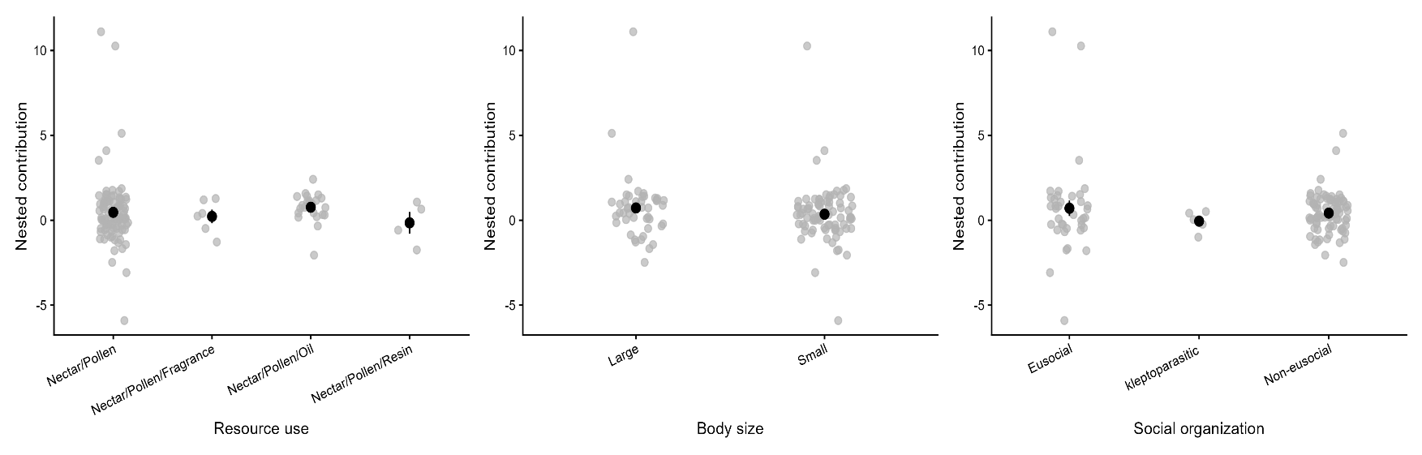
Figure S2. Nested contribution across bee functional trait categories. Panels show comparisons of nested rank values among categories of floral resource use, body size, and social organization. Gray points represent individual bee species, whereas black points and error bars indicate mean values ± standard error for each category. Overall, nested contribution values broadly overlapped among trait categories.

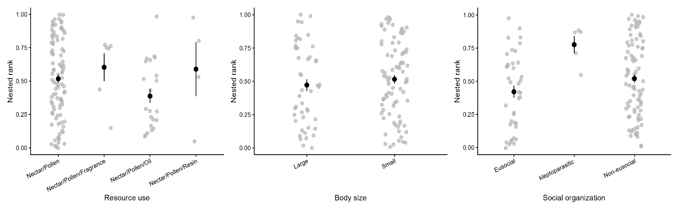
Figure S3. Nested rank across bee functional trait categories. Panels show comparisons of nested rank values among categories of floral resource use, body size, and social organization. Gray points represent individual bee species, whereas black points and error bars indicate mean values ± standard error for each category. Overall, nested rank values broadly overlapped among trait categories, despite high nested rank for kleptoparasite species, indicating only subtle differences in species’ positions within the nested structure of the interaction network.

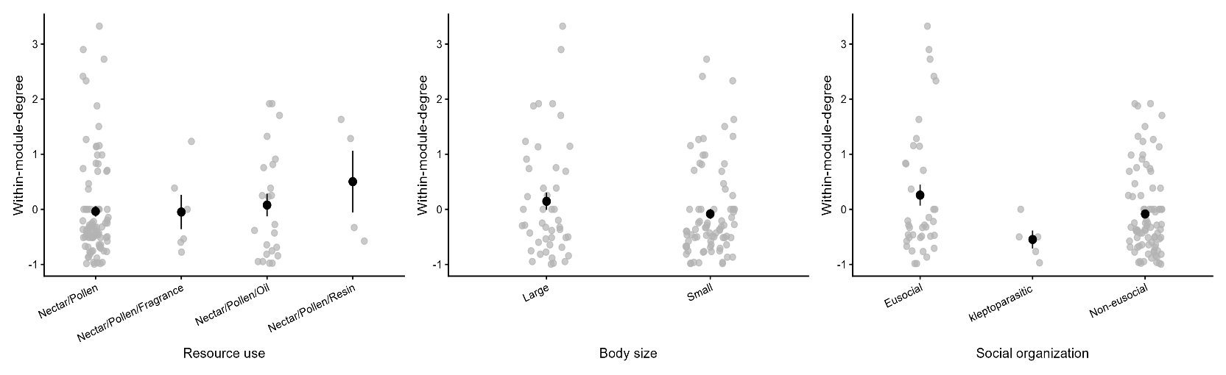
Figure S4. Within-module-degree (z) across bee functional trait categories. Panels show comparisons of among-module connectivity values among categories of floral resource use, body size, and social organization. Gray points represent individual bee species, whereas black points and error bars indicate mean values ± standard error for each category. Differences among trait categories were generally small, although resin-collecting or eusocial bees tended to exhibit slightly higher within-module-degree values.

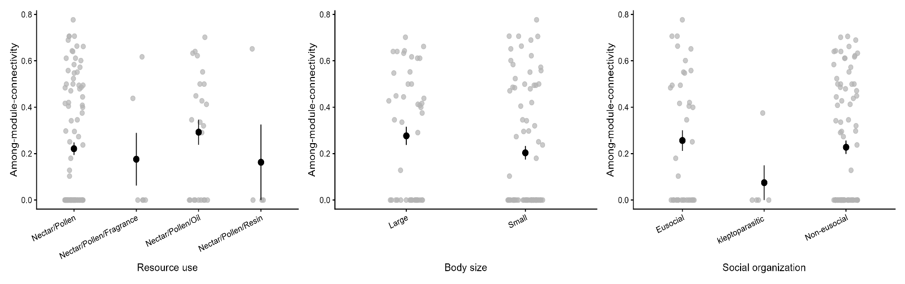
Figure S5. Among-module connectivity (c) across bee functional trait categories. Panels show comparisons of among-module connectivity values among categories of floral resource use, body size, and social organization. Gray points represent individual bee species, whereas black points and error bars indicate mean values ± standard error for each category. Differences among trait categories were generally small, although kleptoparasite or small bees tended to exhibit slightly lower among-module connectivity values.

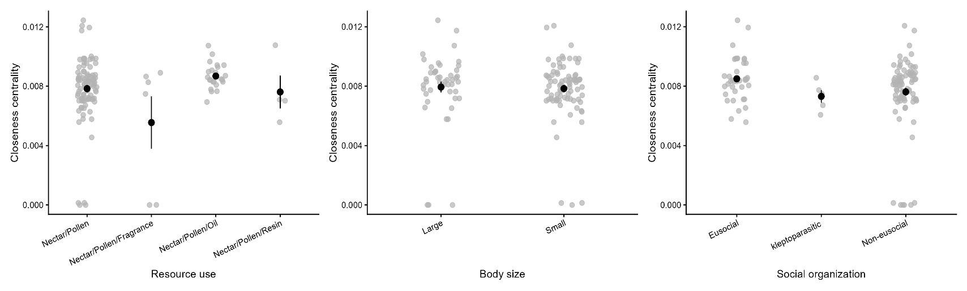
Figure S6. Closeness centrality across bee functional trait categories. Panels show comparisons of closeness centrality values among categories of floral resource use, body size, and social organization. Gray points represent individual bee species, whereas black points and error bars indicate mean values ± standard error for each category. Closeness centrality showed broad overlap among trait categories, with only slight tendencies for higher values in eusocial or oil-collecting bee species.

