Appendix

Table A1: List of Products in the Sample
Product number | Product description | Product number | Product description
1 | Double bed mattress | 68 | Macaroni, 500 g (Fattis and Monis)*
2 | Castle Lager beer, 330ml* | 69 | Mahleu, 500ml*
3 | Toilet paper per roll , 500 single ply | 70 | Malt,1 kg (Mtombo)*
4 | A bag of firewood | 71 | Mayonnaise, 750ml*
5 | Aluminum kettle | 72 | Men’s elegant dress shoes; outer material
6 | Apples per kg* | 73 | Microwave; cooking power-800watts; control
7 | Aqua fresh tooth paste, 100ml* | 74 | Minced beef, per kg*
8 | Axe | 75 | Mutton chops, per kg*
9 | Bananas, per kg* | 76 | Nan, 400 g*
10 | Beef sausages ( Frankfurt/Vienna), per kg * | 77 | Newden candles, 450 g (pkt of six)*
11 | Beef stock, 12 cubes* | 78 | Fruit Juice, 1L (Not 100%)*
12 | Beef, per kg* | 79 | Oil filter for Toyota Corolla*
13 | Beetroot, per kg* | 80 | Olive oil, 1litre*
14 | Blanket (mink) | 81 | One egg*
15 | Blue label, 200g* | 82 | One packet of ten matches*
16 | Boy’s school shoes, black | 83 | Onion, per kg*
17 | Boys shirts; short sleeve; cotton 100%; | 84 | Oranges, per kg*
18 | Bread flour, 12.5 kg* | 85 | Other leaf vegetables, per bundle*
19 | Brandy, 750 ml, Martell VSOP* | 86 | Cow offal per kg
20 | Brown sugar, 1 kg* | 87 | Palmolive, 125 g*
21 | Butter, 250g* | 88 | Paracetamol, 500mg*
22 | Cabbage, per kg* | 89 | Maluti 450 ml*
23 | Cake flour, 2.5 kg* | 90 | Paraffin, per liter*
24 | Canned beans, 410 g (Koo)* | 91 | Peaches, per kg*
25 | Canned fish in tomato sauce, 420 g* | 92 | Peanut butter in plastic bottle, 500g*
26 | Carrots, per kg* | 93 | Peanuts, 55g*
27 | Chest of drawers; pressed wood, veneer | 94 | Pears, per kg*
28 | Chewing Gum | 95 | Pop up toaster; capacity 2 slices; power
29 | Chili sauce, 200ml* | 96 | Pork chops, per kg*
30 | Cigarettes P. Stuyvesant, pkt of 20* | 97 | Potato chips, 30g*
31 | Clean trousers | 98 | Potatoes, per kg*
32 | Coal, one bag of 50kg* | 99 | Processed cheese- international brands
33 | Coca-Cola, 330 ml can* | 100 | Propane gas; BP domestic gas, 9kg*
34 | Cocoa with milk powder, 250g* | 101 | Pumpkins, per kg*
35 | Colour TV, (51) 54 cm; flat screen; original | 102 | Rama, 250g*
36 | Comforters | 103 | Refrigerator, electric, 180 liters,
37 | Concentrated drinks; Oros 750ml* | 104 | Rice, 500 g (Tastic)*
38 | Cornflakes, 500g* | 105 | Rooibos tea bags, 200 g*
39 | Cream, 250ml* | 106 | Samp, 1 kg (Induna)*
40 | Cremora, 250g* | 107 | Sanitary towel (Pads), pack of 10 (Stayfree)*
41 | Curtain material per meter; printed design; polyester 100% | 108 | Scotch cart*
42 | Custard | 109 | Seshoeshoe material, per meter*
43 | Dining table with chairs; material of legs & top-solid wood; varnished | 110 | Condoms, pack of 3
44 | Drinking glass in cardboard box, 6 units | 111 | Simple tiles in cartoon box
45 | DSTV set | 112 | Sorghum meal, 1 kg*
46 | DVD player, original brands (e.g Sony) | 113 | Sour milk, 500g*
47 | Easy bake flour, 12.5 kg* | 114 | Sparkling White Wine, 750ml*
48 | Electric iron; type-steam iron; power-80 | 115 | Spinach, per bundle*
49 | Engine oil, 500 ml (petrol engine)* | 116 | Split dried peas, 500g*
50 | Frozen chicken, per kg* | 117 | Steak and chop,40g*
51 | Frozen fish | 118 | Still water, 500ml*
53 | Gin, 750ml (Gordon’s)* | 120 | Sugar beans red speckled, 500g*
54 | Ginger powder, 10g* | 121 | Sunflower cooking oil,750ml*
55 | Green beans, per kg* | 122 | Surf, 1 kg*
56 | Headscarf; fiber type-polyester 100% | 123 | Table salt, 1kg*
57 | Hi-fi set; radio cassette(double deck);original | 124 | Tomato sauce, 375 ml*
58 | Hot plate (2plates) with selective heat | 125 | Tomatoes, per kg*
59 | Indoor house broom, plastic | 126 | Toyota Corolla; power steering; 5Ds
60 | Jacket; Cotton 35-65%, Linen 35-65%; sin | 127 | Trotters jelly, 40g*
61 | Jungle oats, 500g* | 128 | TV aerial
62 | Ladies briefs; cotton 90%, spandex 10%; | 129 | Vinegar, 750 ml*
63 | Lawn mower/ Grass cutter | 130 | Wheelbarrow
64 | Light bulb; 60 watts | 131 | White short sleeve
65 | Liver, per kg (cow)* | 132 | Yeast, 10g*
66 | Lounge suite | 133 | Yoghurt, 100ml*
67 | Low fat cow milk in carton box, 1litre* | 134 | Zip fastener ``6î
Source: BOS historical price data
Notes: 1) * indicates a homogeneous product. 2) Paraffin in our sample is sold in retail outlets and not in petrol stations.

Table A2: List of retail outlets in the sample by district
District | Number of outlets | Percent
Maseru | 28 | 13.33
Butha-Buthe | 17 | 8.1
Leribe | 22 | 10.48
Berea | 24 | 11.43
Mafeteng | 13 | 6.19
Mohale’s Hoek | 21 | 10
Quthing | 24 | 11.43
Qacha’s Neck | 23 | 10.95
Mokhotlong | 16 | 7.62
Thaba-Tseka | 22 | 10.48
Total | 210 | 100
Source: Outlet survey data

Figure A1: Lesotho Map
Source: www.mapsofworld.com
Accessed July 21, 2015

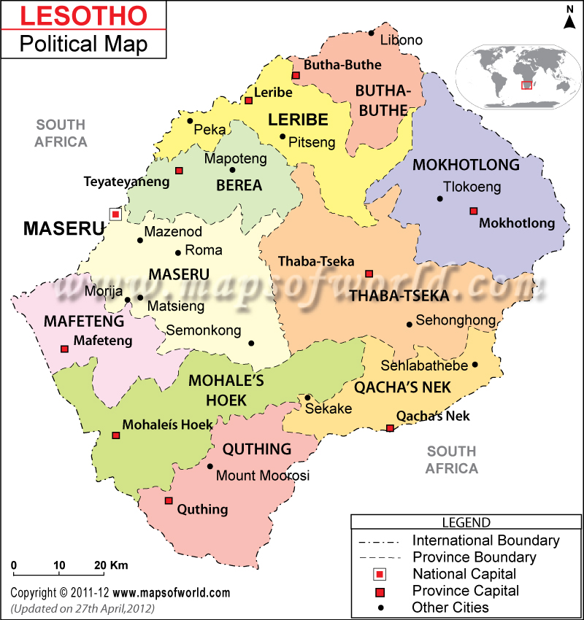

Figure A2: Selected key questions used in the analysis

LESOTHO RETAIL OUTLET AND SERVICES FIRMS SURVEY 2013
QUESTIONNAIRE

A.4 | Is this establishment a retail outlet or a Services outlet?

Retail outlet | 1
Services outlet | 2

B.2 | What type of establishment best describes the products sold on this premises?

Product code
Outlet type

[INTERVIEWER: SHOW LIST OF ESTABLISHMENT TYPES]

B.9 | Is this establishment a branch of retail or services chain or a franchise?

 | Yes | No | Don’t know
a. Franchise | 1 | 2 | -9 | IF NO OR DON’T KNOW GO TO QUESTION B.11
b. Retail or services branch | 1 | 2 | -9 | IF NO OR DON’T KNOW GO TO QUESTION B.11

C. ASSETS

READ THE FOLLOWING TO RESPONDENT BEFORE PROCEEDING:
I would like to ask you a few questions about the assets of this establishment

C.1 | Does this establishment possess any of the following assets? (either owned by the establishment or provided by the owner)

[INTERVIEWER: IF YES, PROVIDE QUANTITY]

 | Yes | Quantity | No | Don’t Know
a. Vehicles | 1 |  | 2 | -9
b. Fridges | 1 |  | 2 | -9
c. Generator | 1 |  | 2 | -9
d. Computer (desktop, laptop) | 1 |  | 2 | -9
e. Till | 1 |  | 2 | -9
f. Telephone(landline) | 1 |  | 2 | -9
g. Mobile/cell phone | 1 |  | 2 | -9
h. Fax machine | 1 |  | 2 | -9
i. Storage | 1 |  | 2 | -9
j. Other (SPECIFY) | 1 |  | 2 | -9

READ THE FOLLOWING TO RESPONDENT BEFORE PROCEEDING:
The following questions deal with how prices of your MAIN product are set

D.6 | How do you set prices of your main product or service?

A fixed margin is applied to unit production costs (costs of labour and of other inputs) | 1
The price is regulated by government | 2
Price is set by the business council/association | 3
Price is informally set by the community | 4
Price is determined by head office/parent company | 5
Price is determined by main competitor’s price | 6
Don’t know | -9

D.8 | Which factors are likely to lead to an INCREASE in the price of your main product?  (Please attribute the degree of importance to each answer by choosing one of the following four options: 1=unimportant 2=minor importance 3=important 4=very important)

 | Unimportant | Minor importance | Important | Very important | Don’t know
An increase in labour costs | 1 | 2 | 3 | 4 | -9
An increase in cost of material inputs or supplies of product | 1 | 2 | 3 | 4 | -9
An increase in demand | 1 | 2 | 3 | 4 | -9
An increase in price by a close competitor | 1 | 2 | 3 | 4 | -9
Other (SPECIFY) | 1 | 2 | 3 | 4 | -9

D.9 | Which factors are likely to lead to a DECREASE in the price of your main product?  (Please attribute the degree of importance to each answer by choosing one of the following four options: 1=unimportant 2=minor importance 3=important 4=very important)

 | Unimportant | Minor importance | Important | Very important | Don’t know
An decrease in labour costs | 1 | 2 | 3 | 4 | -9
An decrease in cost of material inputs or supplies of product | 1 | 2 | 3 | 4 | -9
An decrease in financial costs | 1 | 2 | 3 | 4 | -9
An decrease in demand | 1 | 2 | 3 | 4 | -9
An decrease in price by a close competitor | 1 | 2 | 3 | 4 | -9
Other (SPECIFY) | 1 | 2 | 3 | 4 | -9

E. COMPETITION

READ THE FOLLOWING TO RESPONDENT BEFORE PROCEEDING:
The following questions deal with competing businesses in your local area

E.1 | How many other businesses compete directly with you in the local area (provide a number)?

Number
Number of competing outlets

E.2 | How long does it take for an average person to walk to your main competitor (in minutes)

EMPLOYMENT AND LABOUR COSTS

READ THE FOLLOWING TO RESPONDENT BEFORE PROCEEDING:
The following questions deal with employment and labour costs

I.2 | How many workers are currently employed for each of the following categories: full-time employees, part-time employees, casual employees?

INTERVIEWER: Permanent employees are defined as all paid employees that are contracted for a term of one or more fiscal years and/or have a guaranteed renewal of their employment contract and that work 8 or more hours per day.
 | Number
a. Full time employees (this option includes the business owner)
b. Part-time employees (25 hours or less per week)
c. Casual workers (works on irregular basis)
d. do not know | -9
Table A3: Types of retail outlets
Outlet type | Outlet code
New Car and motor bike Dealers | 1
Used Car Dealers | 2
Auto Parts and Accessories dealers | 3
Furniture, and household appliance Stores | 4
Computer and Electronics Stores | 5
Hardware Stores | 6
Hardware and furniture Stores | 7
Grocery Stores | 8
general dealer | 9
butchery | 10
Fruit and Vegetable Markets | 11
Liquor Stores | 12
Cosmetics Stores | 13
Hair and Beauty Salons | 14
Fuel stations | 15
Coal and gas kiosk | 16
Clothing stores | 17
Dry cleaning and Laundry Services stores | 18
Footwear stores | 19
Books and stationary Stores | 20
Restaurants and other eating places | 21
Pharmacy Stores | 22
Medical and health care services (includes hospitals and clinics) | 23
Music and entertainment stores | 24
Hotels & Other Accommodations | 25
Postal Services | 26
Insurance Agencies and Brokerages | 27
Funeral Services Homes | 28
Security services/ security company | 29
Internet cafe | 30
Footwear/shoe repairs | 31
Driving school | 32
Satellite dish installation company | 33

Table A4: TYPES OF MAIN PRODUCTS
Food (staples, cereals, bread, meat products, dairy products, fruits and vegetables) | 1
Non-alcoholic beverages | 2
Alcoholic beverages | 3
Tobacco and narcotics | 4
Clothing and footwear, shoe repair, textiles, leather goods | 5
Fuel and power | 6
Household furniture and equipment | 7
Household operations (e.g. cleaning products and building materials) | 8
Medicine and medical care | 9
Education and stationary | 10
Accommodation | 11
Personal care | 12
Transport (including tyres, batteries, driving school) | 13
Communications and entertainment | 14
Other services (Hairdressing and beauty services, Social protection service, Health insurance services, Financial services, Funeral services including sale of coffins, repairs, computer repairs) | 15

