Supplement
Figure S1
Structures of the antifungal azoles
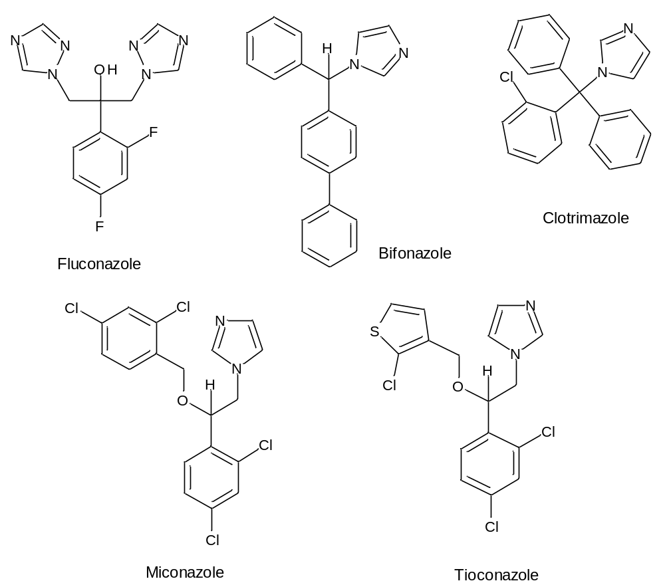

Figure S2.
CD and UV spectra of fluconazole (1.6 mM), FLZ-HPBCyD (red); FLZ+SBBCyD (blue); FLZ+BCyD (green). CyD-s are in 10x excess
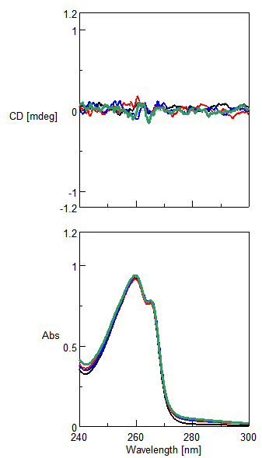
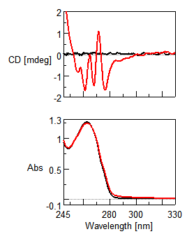
Figure S3. CD and UV spectra of CLZ (black) and CLZ-HPBCyD (red)

Figure S4.
UV spectra of tioconazole (black), TIZ-ACyD (red), TIZ-HPBCyD (blue) and TIZ-GCyD (green)