Supporting Information
Prediction of the Free Energy of Binding for Cyclodextrin-Steroid Complexes: Phase Solubility and Molecular Dynamics Studies
Parisa Fereidounpour
parisaf@bio.aau.dk, https://orcid.org/0000-0002-4276-766X
Department of Chemistry and Bioscience, Section of Chemistry, Aalborg University, Fredrik Bajers Vej 7H, 9220, Aalborg, Denmark
Casper Steinmann (corresponding author)
css@bio.aau.dk, https://orcid.org/0000-0002-5638-1346
Department of Chemistry and Bioscience, Section of Chemistry, Aalborg University, Fredrik Bajers Vej 7H, 9220, Aalborg, Denmark
Kim Lambertsen Larsen
kll@bio.aau.dk, https://orcid.org/0000-0003-2172-7519
Department of Chemistry and Bioscience, Section of Chemistry, Aalborg University, Fredrik Bajers Vej 7H, 9220, Aalborg, Denmark

Table S1. Representative structures sampled from molecular dynamics simulations of steroids in complex with native CDs.
 | Orientation-a | Orientation-b
α-CD/hydrocortisone |  | 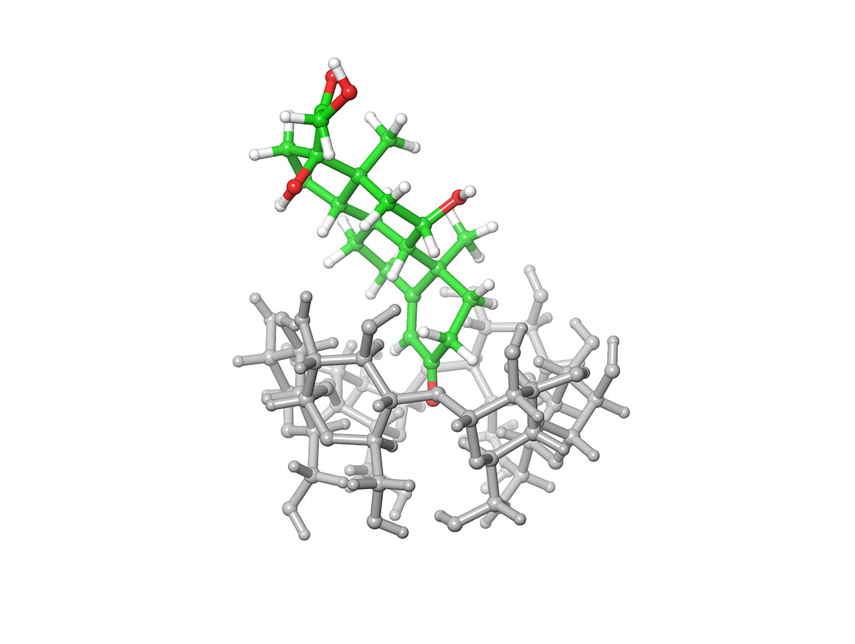
β-CD/hydrocortisone | 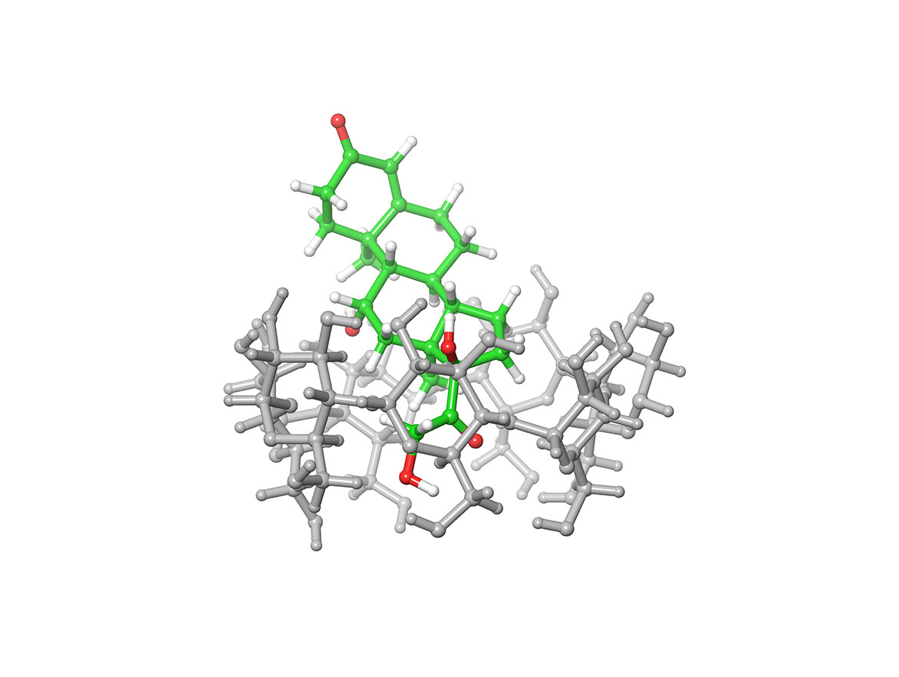 | 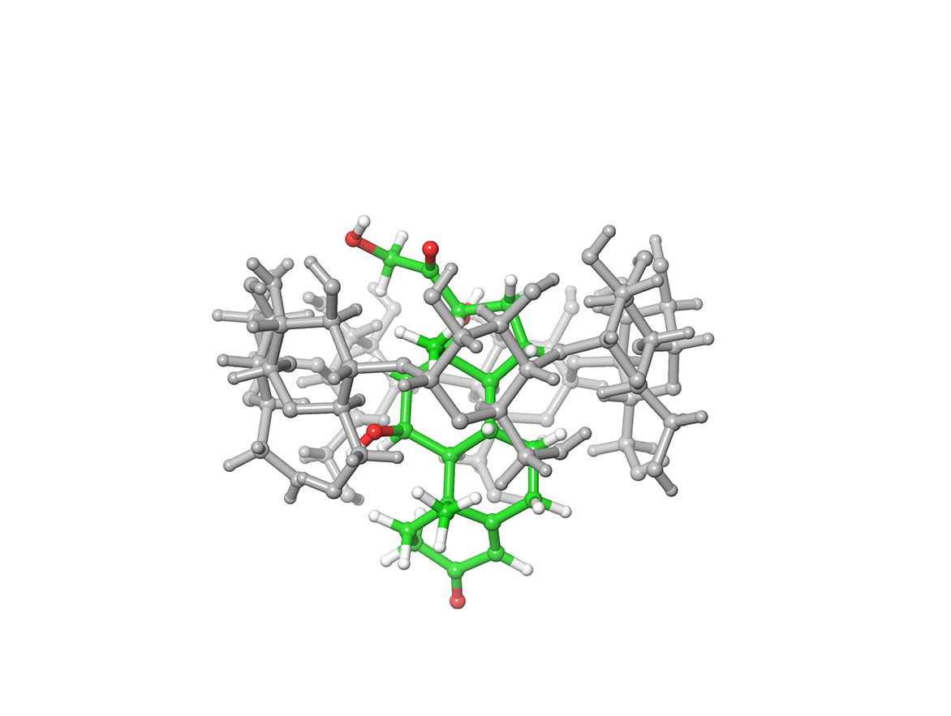
γ-CD/hydrocortisone | 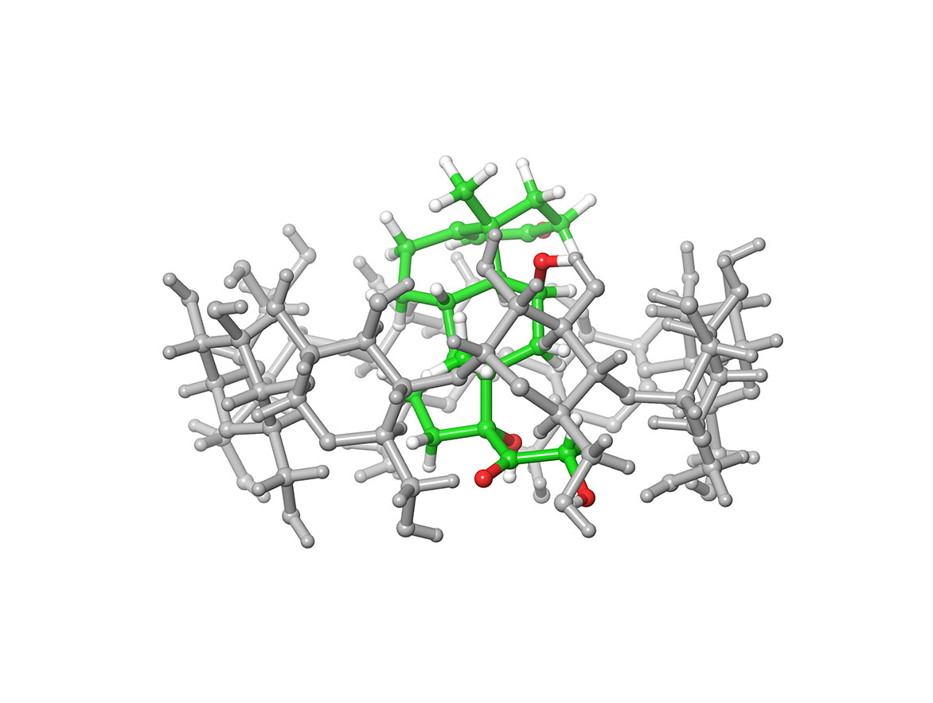 | 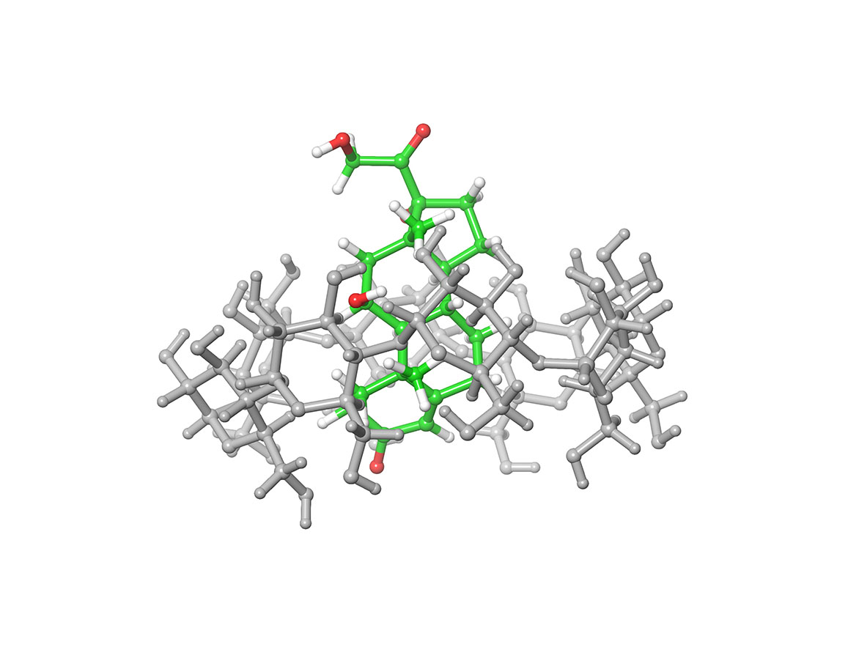
α-CD/dexamethasone |  | 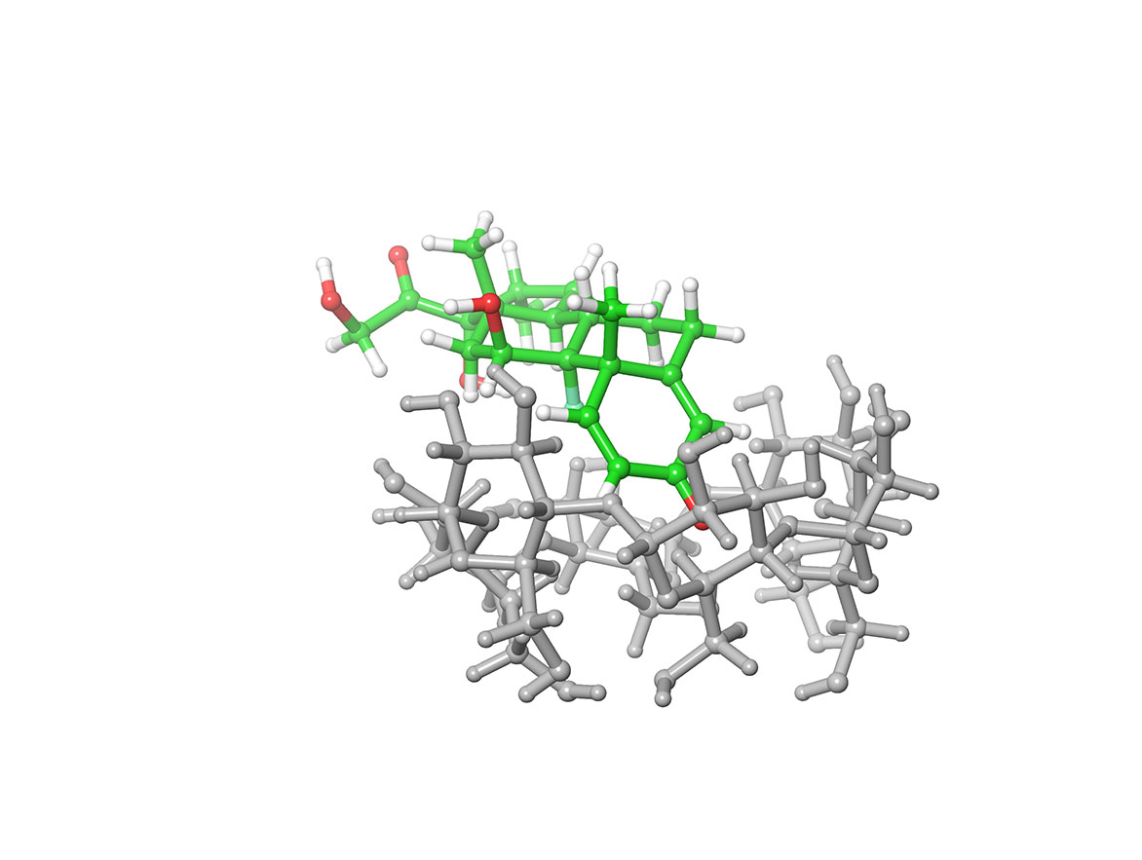
β-CD/dexamethasone | 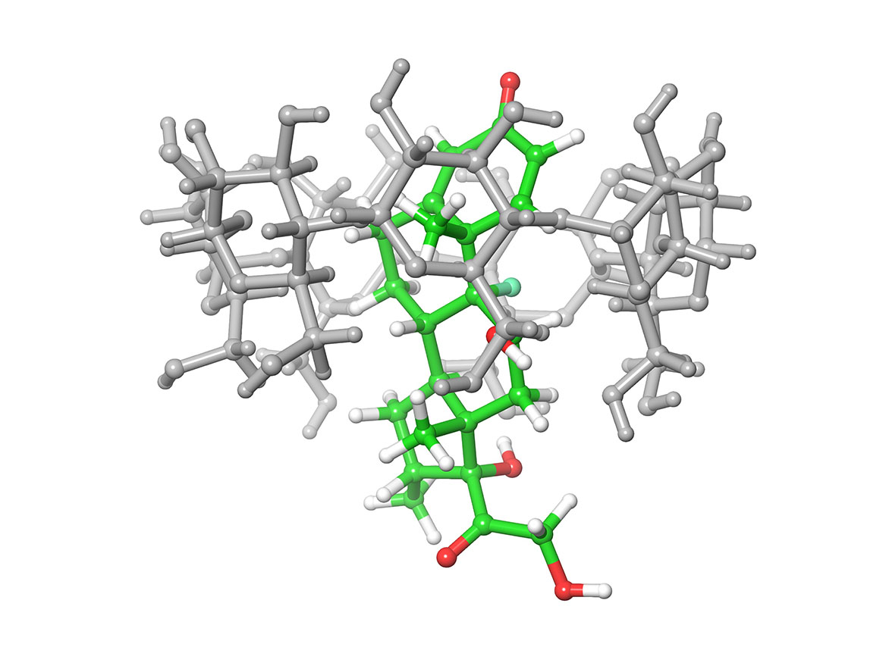 | 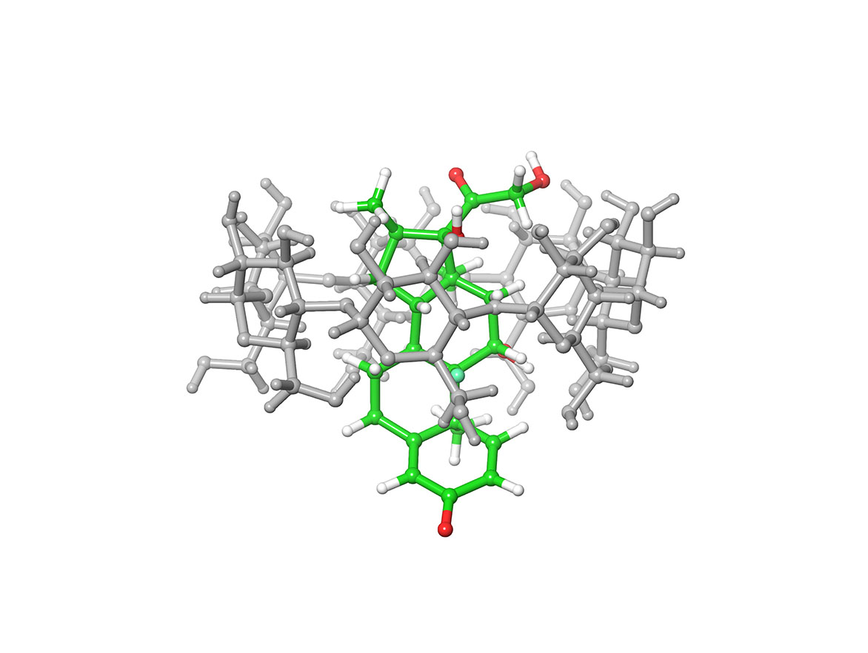
γ-CD/dexamethasone | 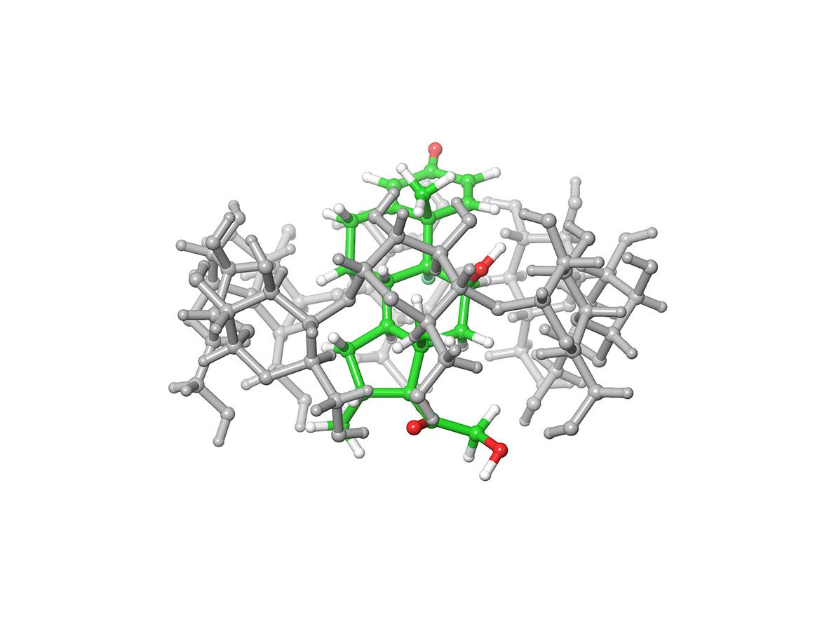 | 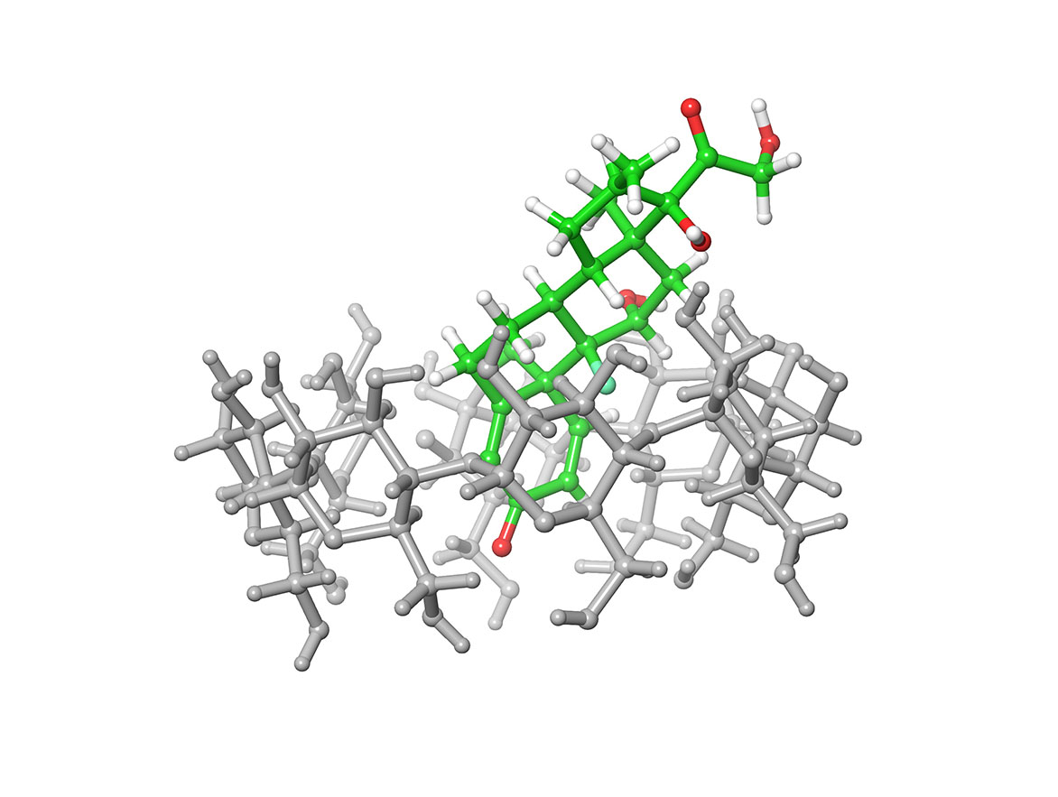
α-CD/prednisolone |  | 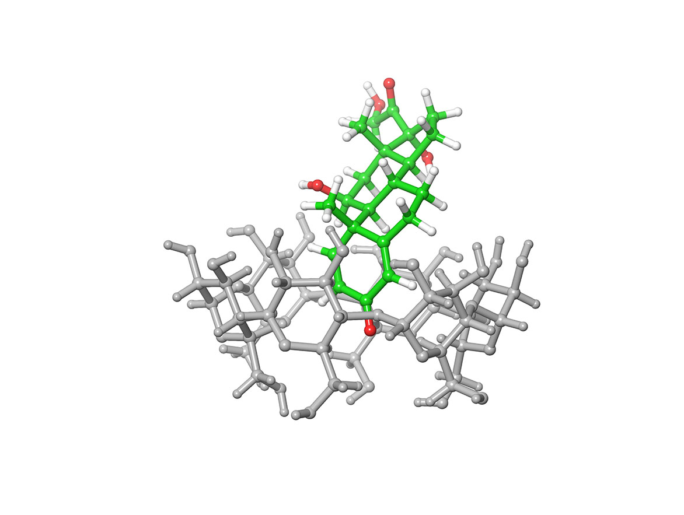
β-CD/prednisolone | 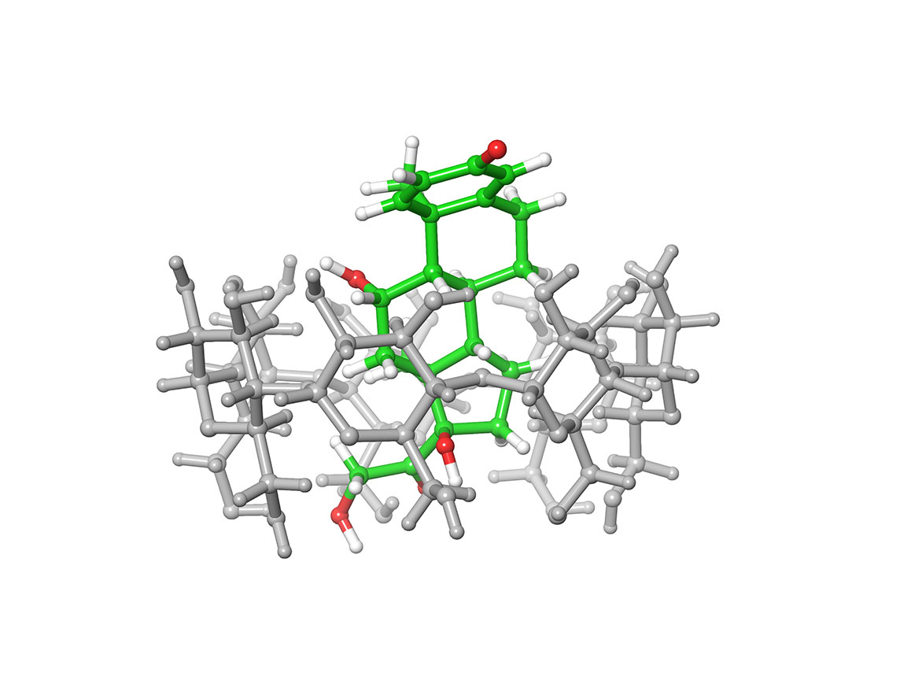 | 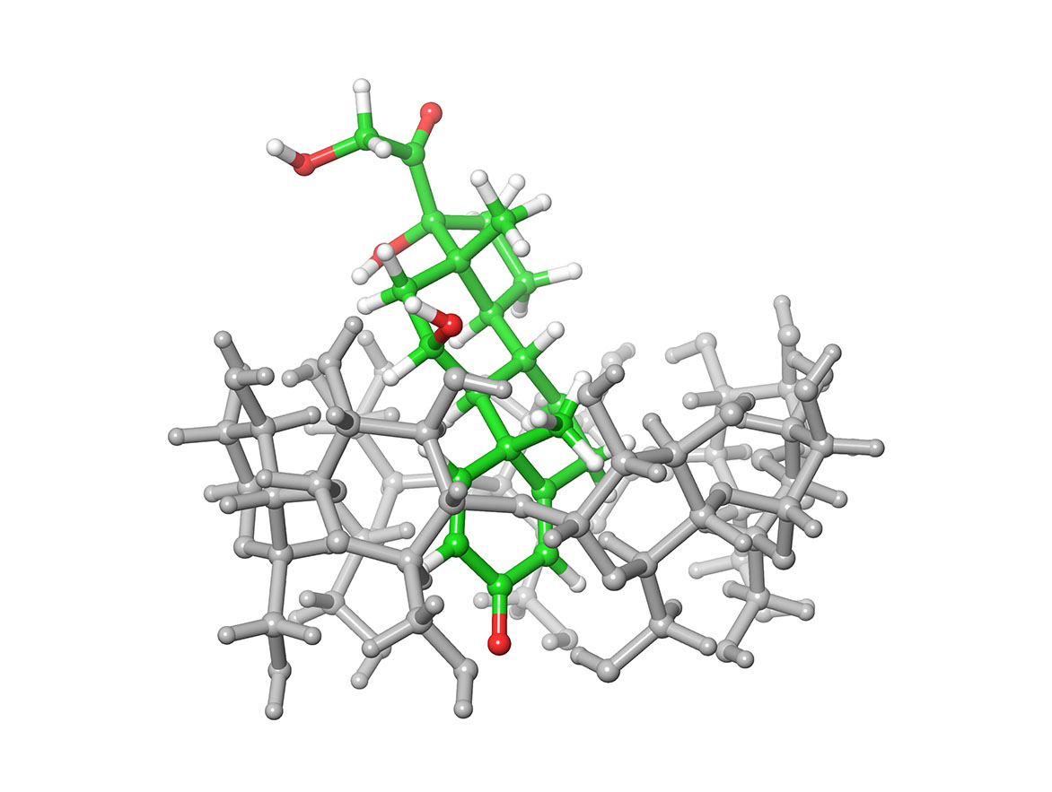
γ-CD/prednisolone | 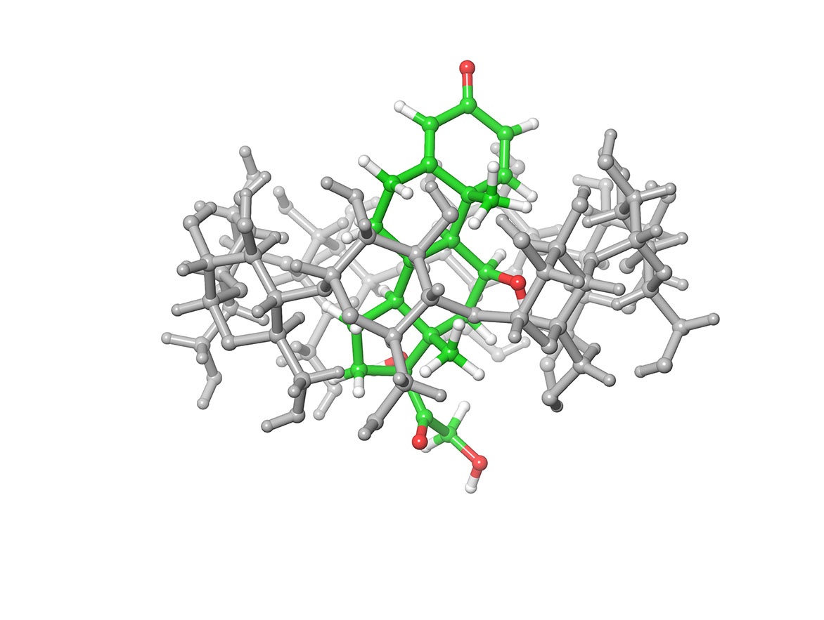 | 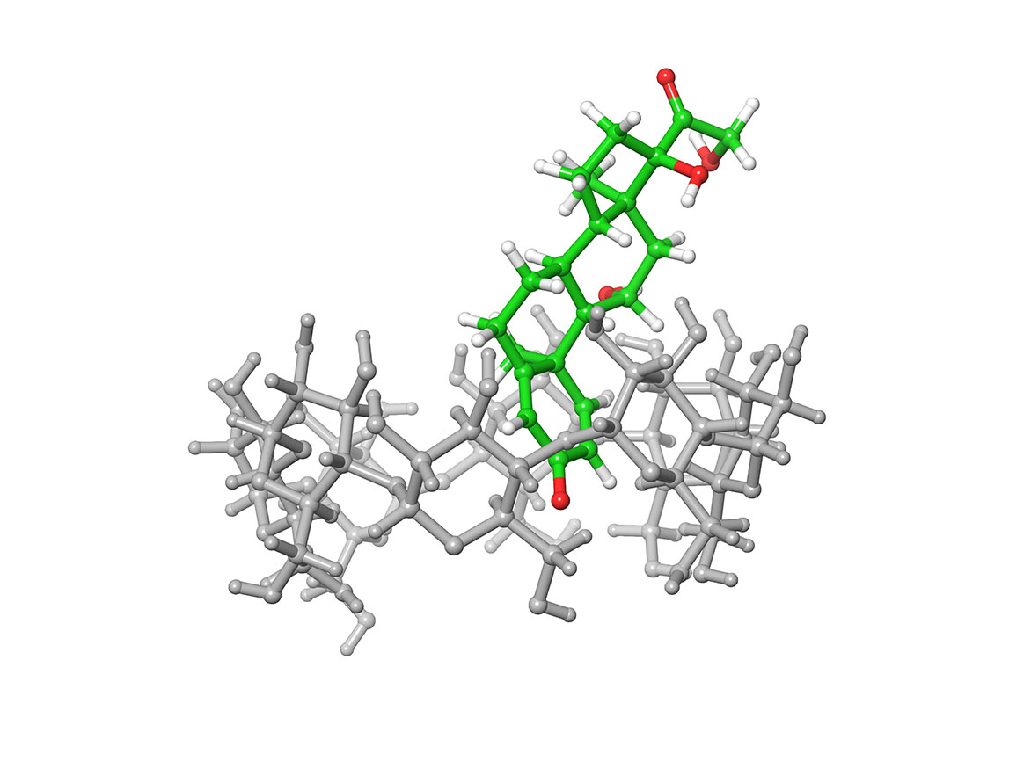
α-CD/6α-methylprednisolone |  |  | 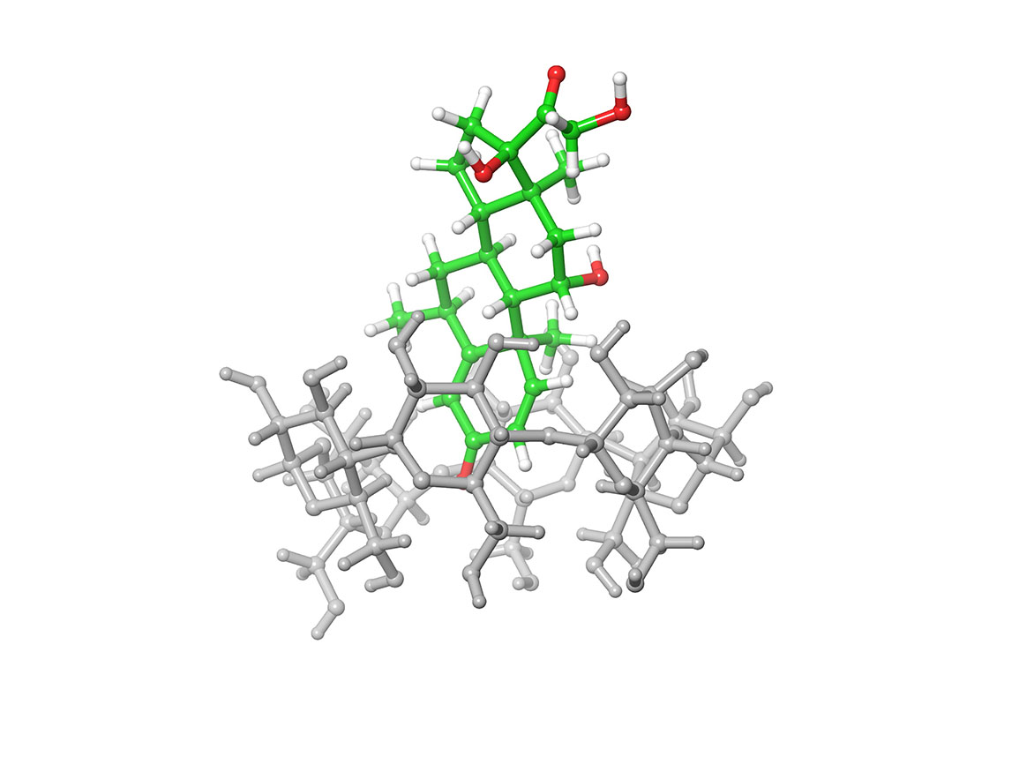
β-CD/6α-methylprednisolone | 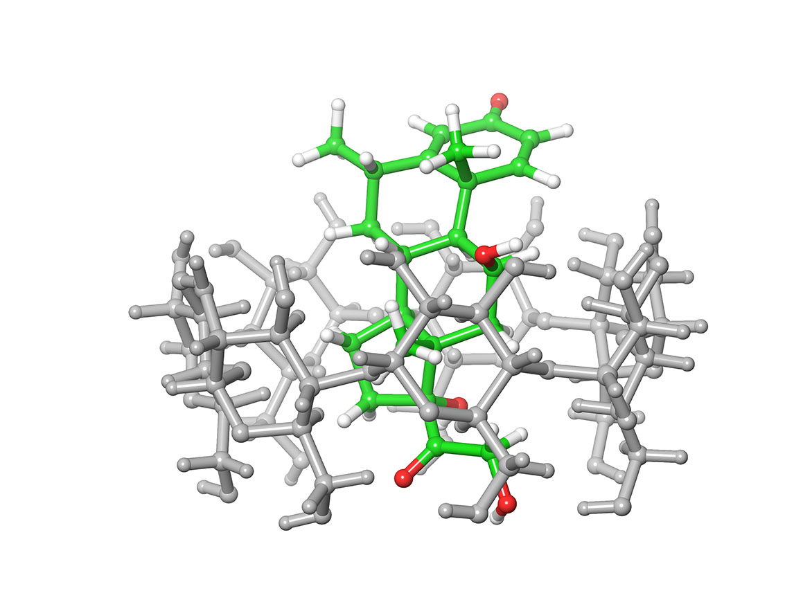 | 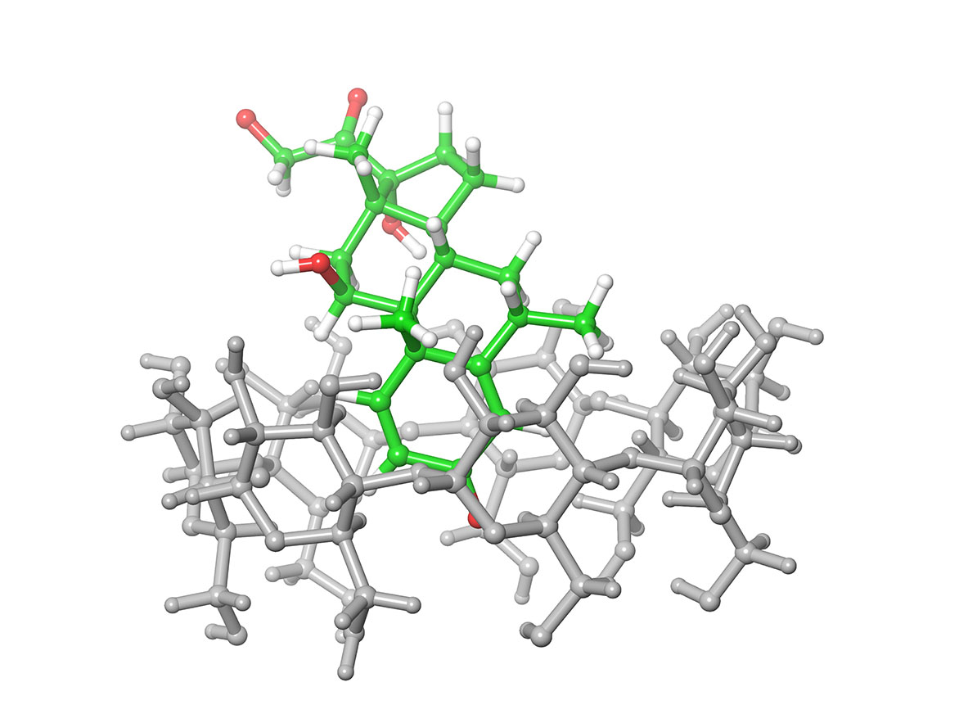
γ-CD/6α-methylprednisolone | 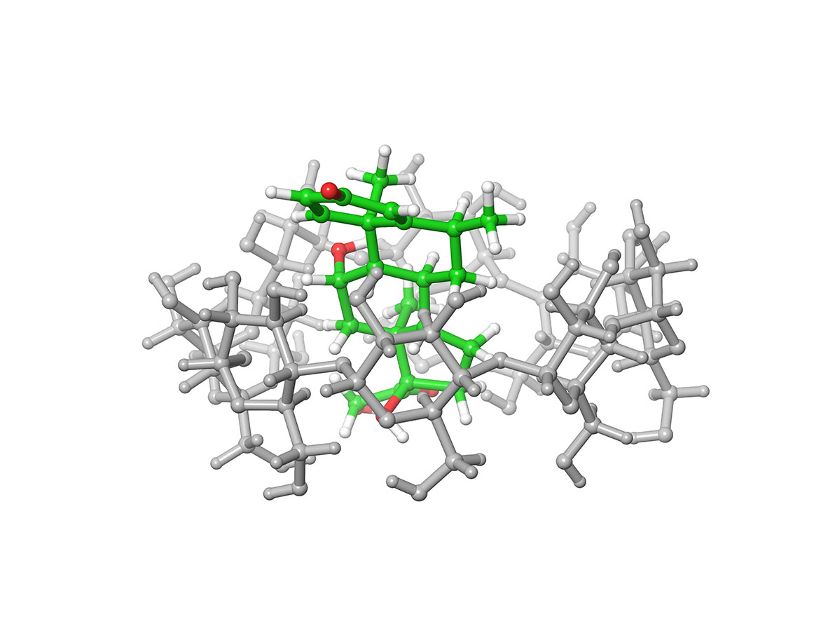 | 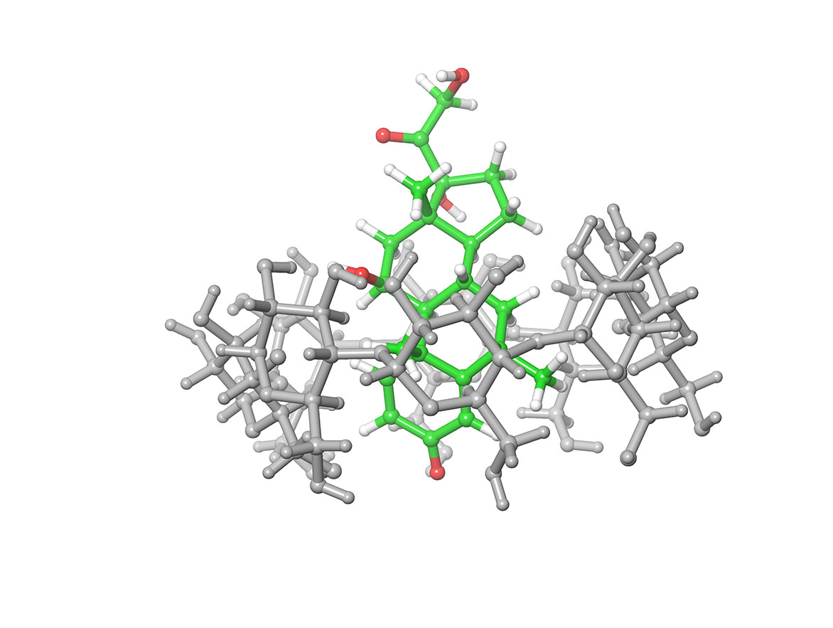

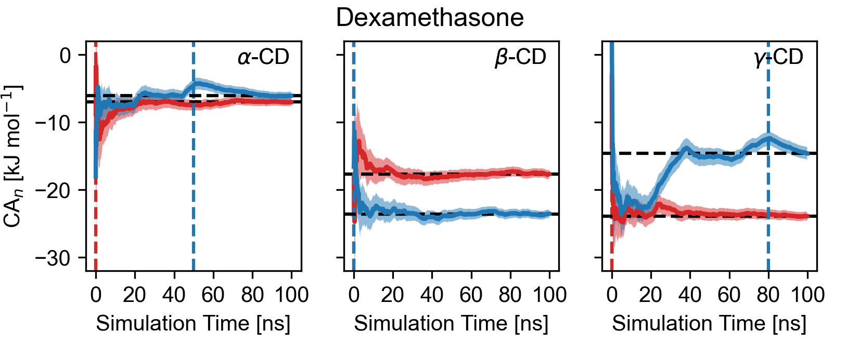
Fig. S1 Cumulative averages of free energies of binding of dexamethasone to α-, β-, and γ-CD in either the orientation-a (red) or orientation-b (blue). Dashed horizontal lines mark the free energy of binding using all available data. Dashed vertical lines indicate from when the simulations have converged.
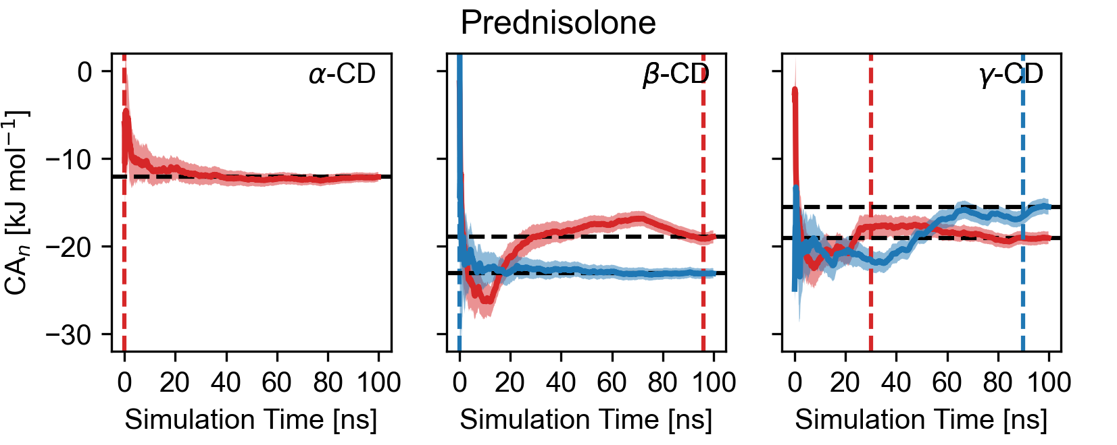
Fig. S2 Cumulative averages of free energies of binding of prednisolone to α-, β-, and γ-CD in either the orientation-a (red) or orientation-b (blue). Dashed horizontal lines mark the free energy of binding using all available data. Dashed vertical lines indicate from when the simulations have converged.

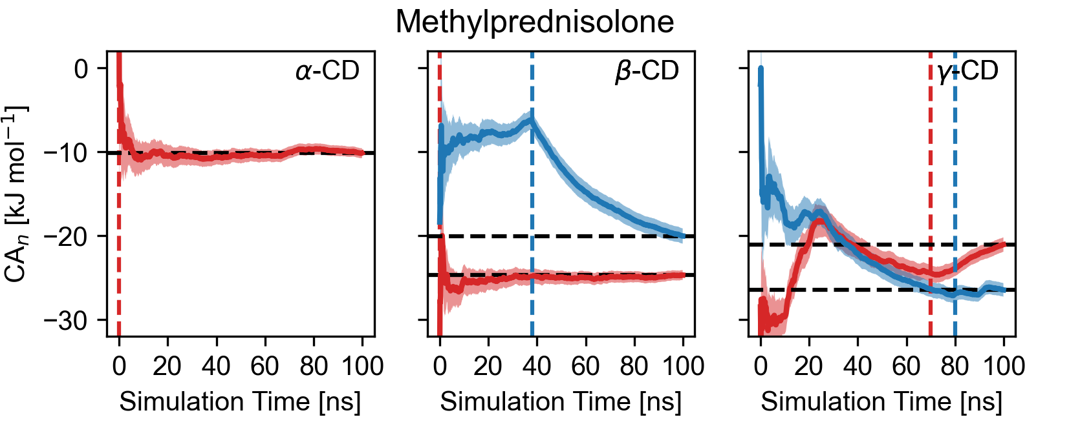
Fig. S3 Cumulative averages of free energies of binding of methylprednisolone to α-, β-, and γ-CD in either the orientation-a (red) or orientation-b (blue). Dashed horizontal lines mark the free energy of binding using all available data. Dashed vertical lines indicate from when the simulations have converged.
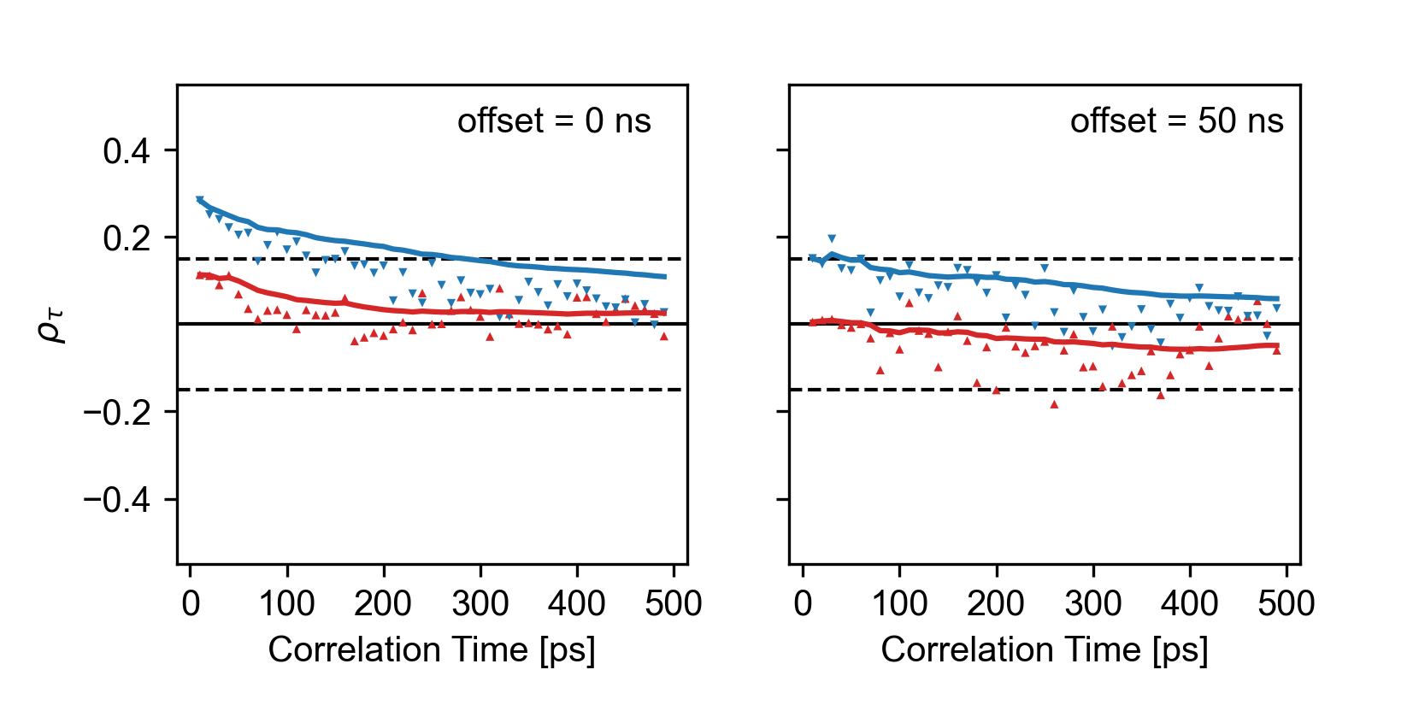
Fig. S4 Measured autocorrelation of hydrocortisone using no offset (left panel) and a 50 ns offset in the right panel. A value of $ρ_{τ}≤0.15$ yields acceptable numerical stability for computed $ΔG_{bind}^{MM/GBSA}$.
Table S2. Offset times used to ignore the first part of the simulation to compute $ΔG_{bind}^{MM/GBSA}$. All times in ns.
CD | Orientation | Hydrocortisone | Dexamethasone | Prednisolone | Methyl-prednisolone
α | a | 0 | 0 | 0 | -
α | b | - | 50 | - | 0
β | a | 0 | 0 | 96 | 0
β | b | 50 | 0 | 0 | 38
γ | a | 80 | 0 | 30 | 70
γ | b | 70 | 80 | 90 | 80

