Synthesis of crystalline uranyl ion coordination polymers with zwitterionic carboxylate ligands: Comparing solvothermal and ambient conditions

Sotaro Kusumoto¹ · Yoshihiro Koide¹ · Shinya Hayami² ·
Yang Kim^{2*} · Jack Harrowfield^{3*} · Pierre Thuéry^{4*}
¹ Department of Material & Life Chemistry, Kanagawa University, 3-27-1 Rokkakubashi, Kanagawa-ku, Yokohama 221-8686, Japan
² Department of Chemistry, Graduate School of Science and Technology, Institute of Industrial Nanomaterials (IINa), Kumamoto University, 2-39-1 Kurokami, Chuo-ku, Kumamoto 860-8555, Japan
³ Université de Strasbourg, ISIS, 8 allée Gaspard Monge, 67083 Strasbourg, France
⁴ Université Paris-Saclay, CEA, CNRS, NIMBE, 91191 Gif-sur-Yvette, France

Supplementary Information

Figure S1 ¹H-NMR spectrum of L1H₂Cl₂ in D₂O.

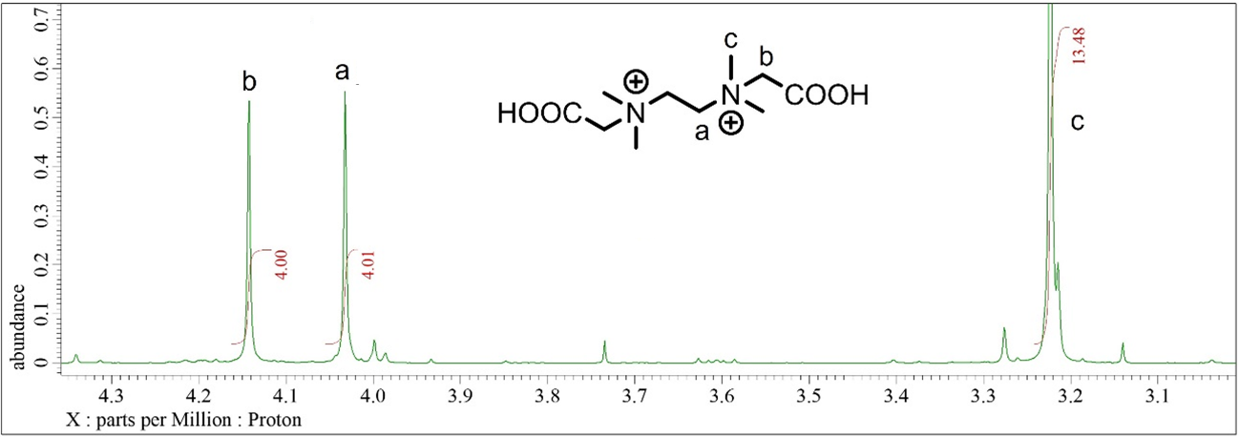

Figure S2 ¹H-NMR spectrum of L2H₂Cl₂ in DMSO-d₆.

