SUPPORTING INFORMATION

(4R,5R)-bis(diphenylhydroxymethyl)-2-spiro-1’-cyclohexane-1,3-dioxolane: An investigation of its host ability and selectivity behaviour in crystallization experiments from four heterocyclic guest solvents

Daniella L. Recchia,* Benita Barton and Eric C. Hosten

Department of Chemistry, PO Box 77000, Nelson Mandela University, Gqeberha (Port Elizabeth), 6031, South Africa. E-mail: s220241104@mandela.ac.za

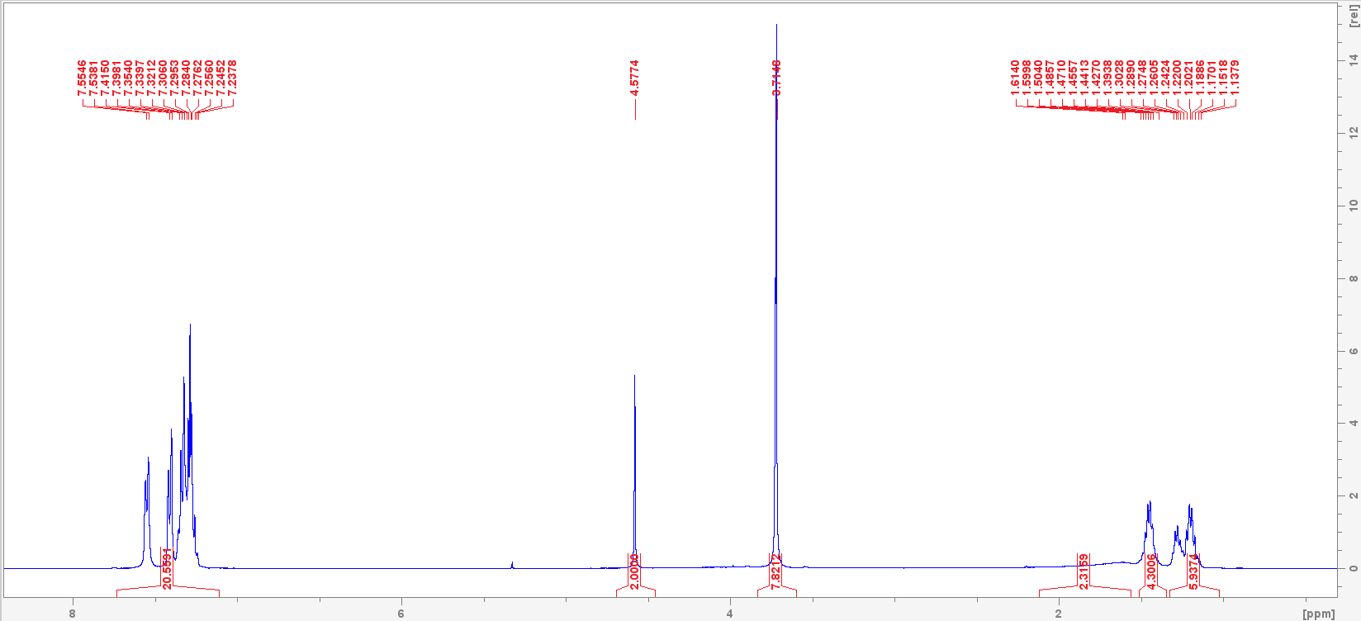
Figure S1 ¹H-NMR spectrum for TADDOL6 and DIO.
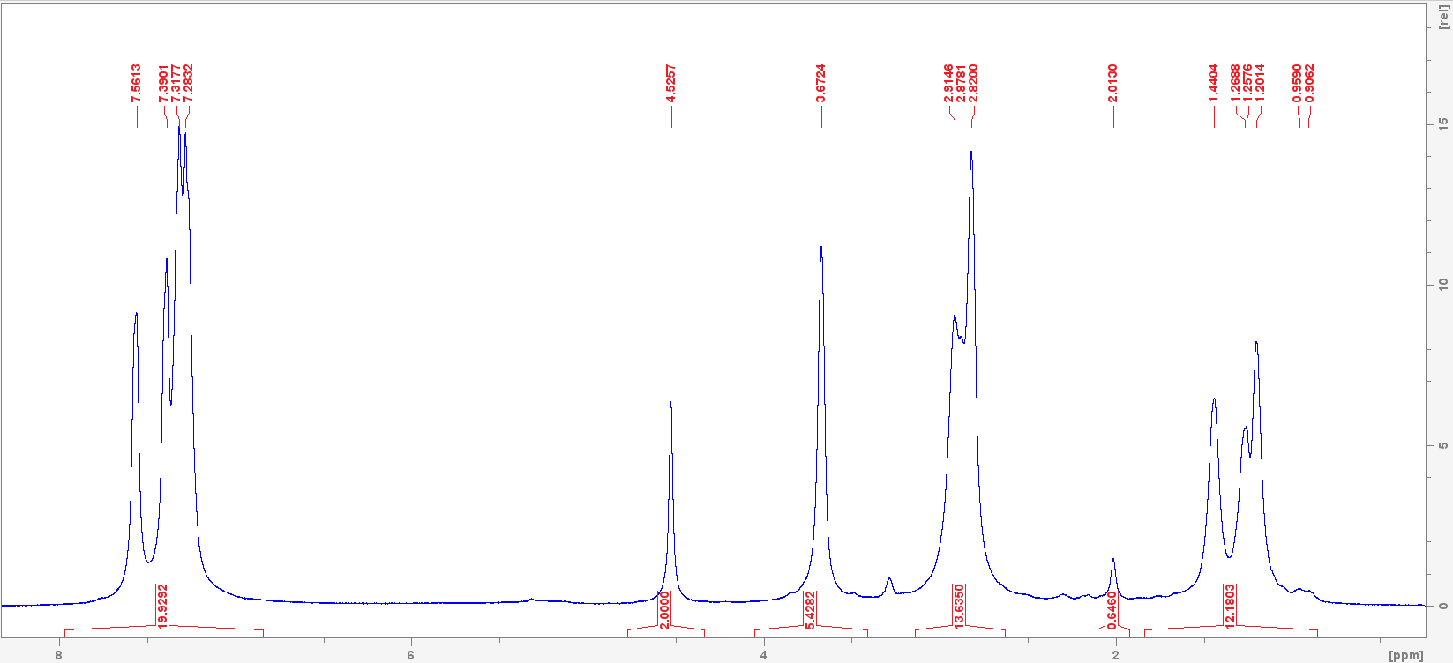
Figure S2 ¹H-NMR spectrum for TADDOL6 and MOR.
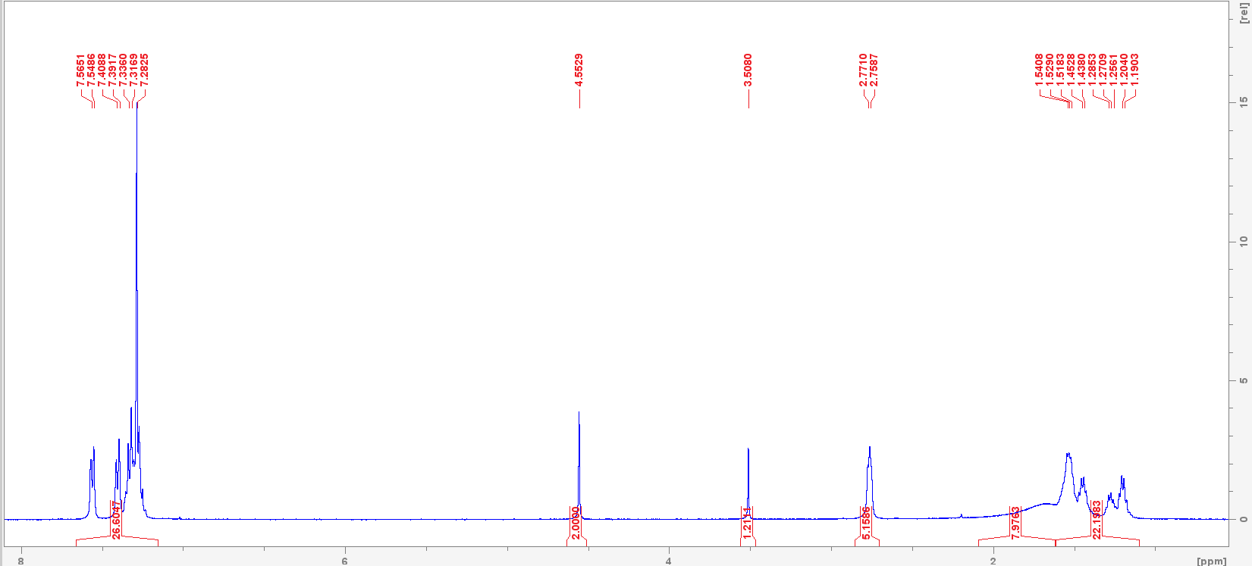
Figure S3 ¹H-NMR spectrum for TADDOL6 and PIP.

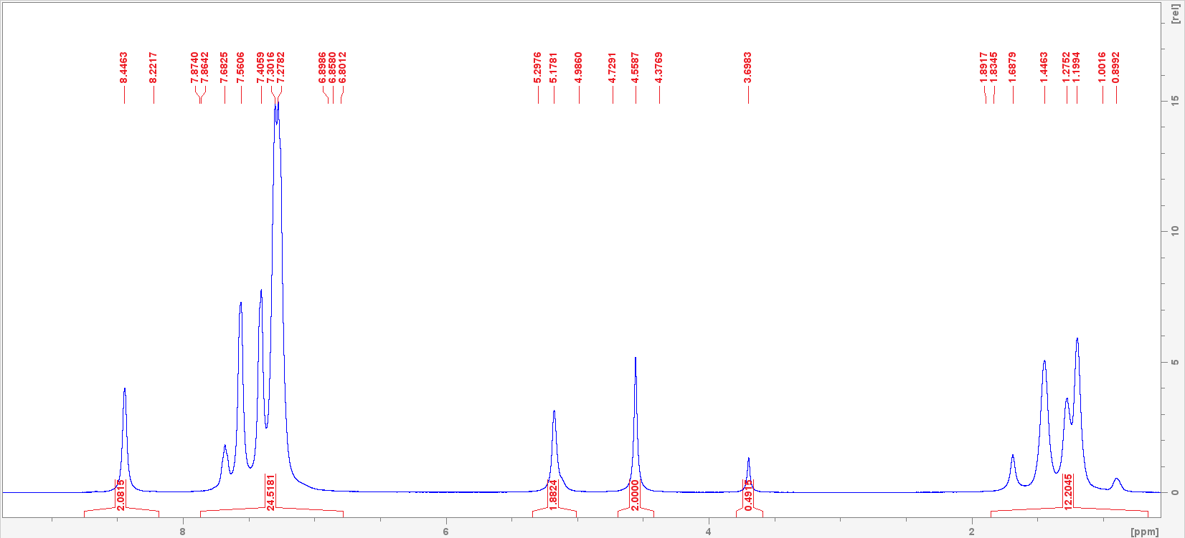
Figure S4 ¹H-NMR spectrum for equimolar binary PYR:DIO with TADDOL6.
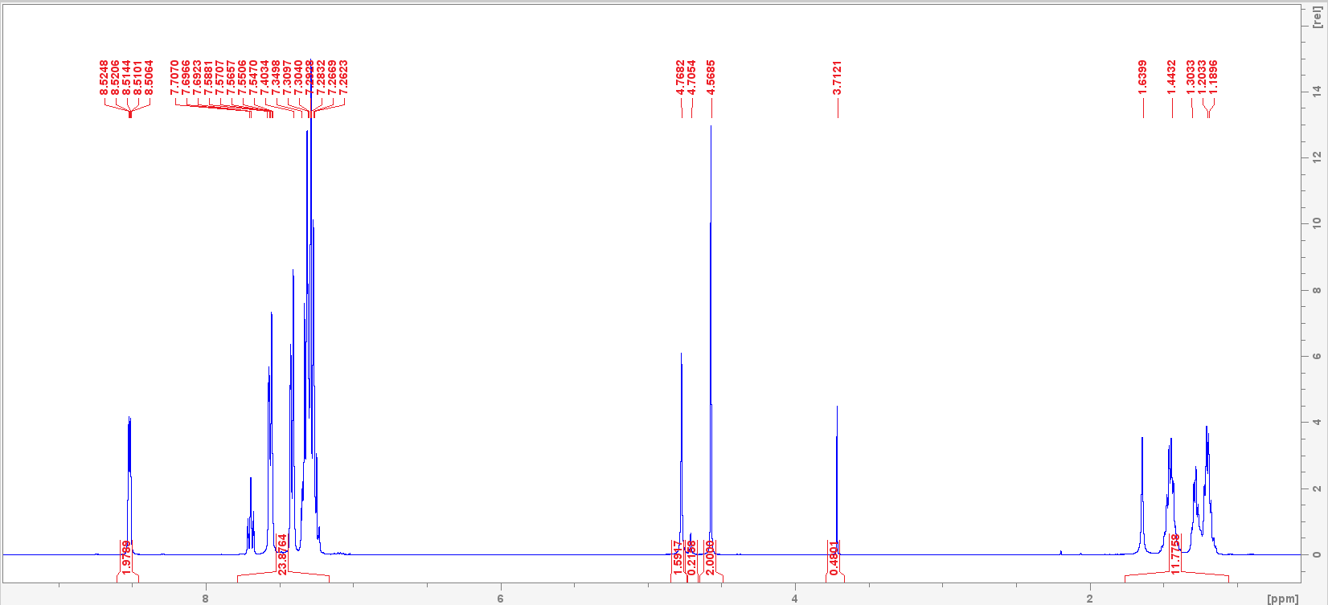
Figure S5 ¹H-NMR spectrum for equimolar binary PYR/DIO duplicate with TADDOL6.
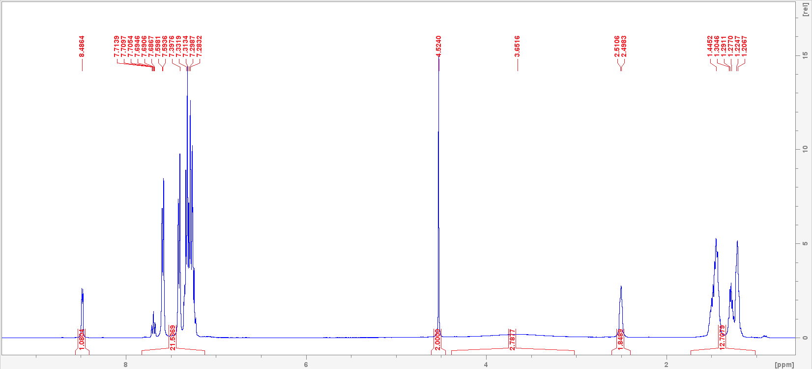
Figure S6 ¹H-NMR spectrum for equimolar binary PYR/PIP with TADDOL6.
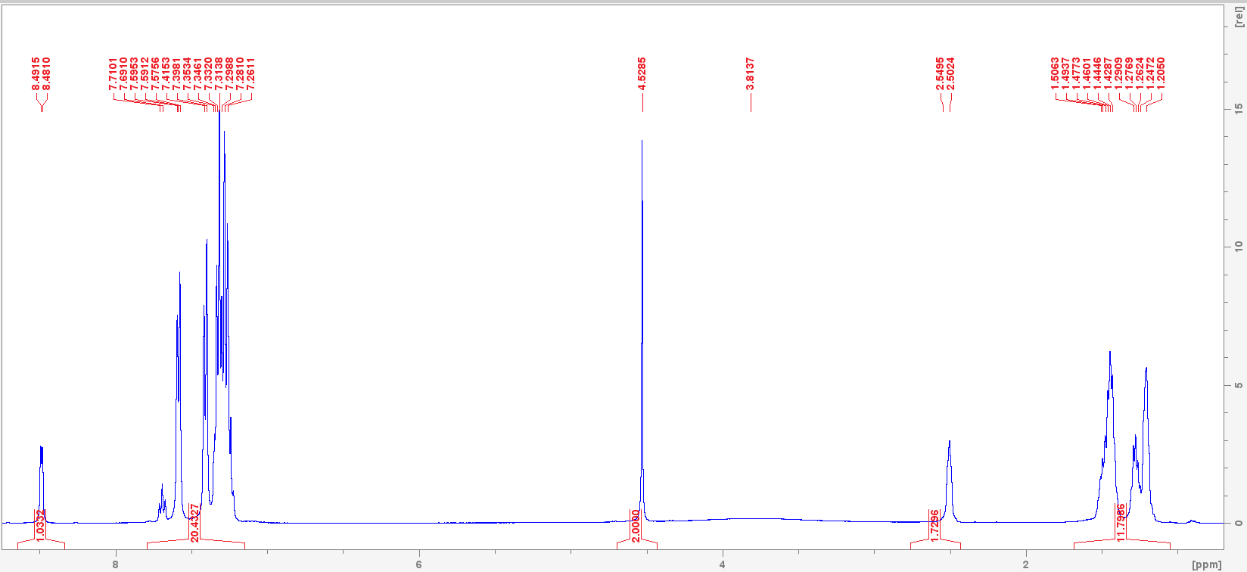
Figure S7 ¹H-NMR spectrum for equimolar binary PYR/PIP duplicate with TADDOL6.
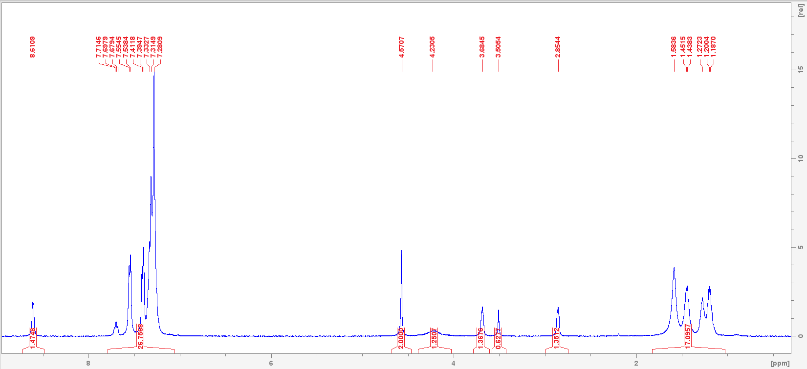
Figure S8 ¹H-NMR spectrum for equimolar binary PYR/MOR with TADDOL6.
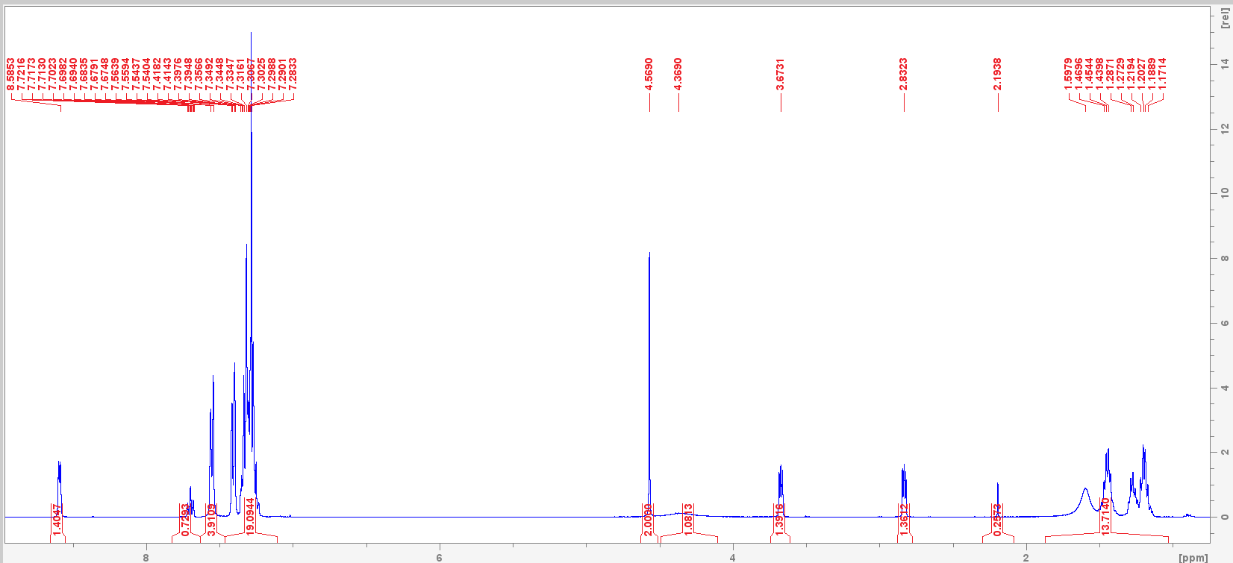
Figure S9 ¹H-NMR spectrum for equimolar binary PYR/MOR duplicate with TADDOL6.
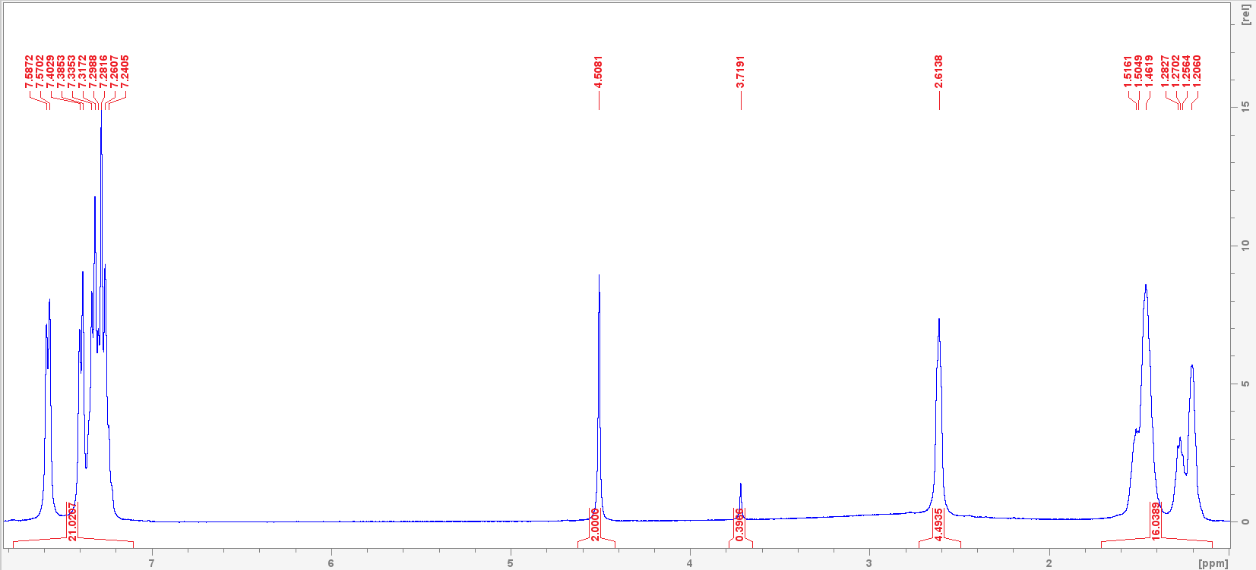
Figure S10 ¹H-NMR spectrum for equimolar binary PIP/DIO with TADDOL6.
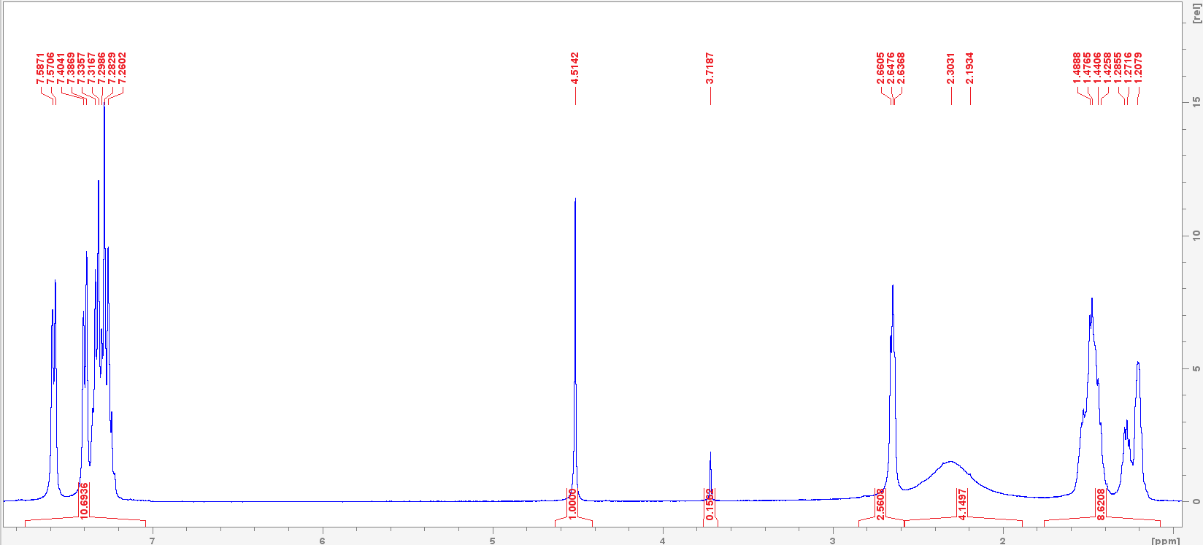
Figure S11 ¹H-NMR spectrum for equimolar binary PIP/DIO duplicate with TADDOL6.
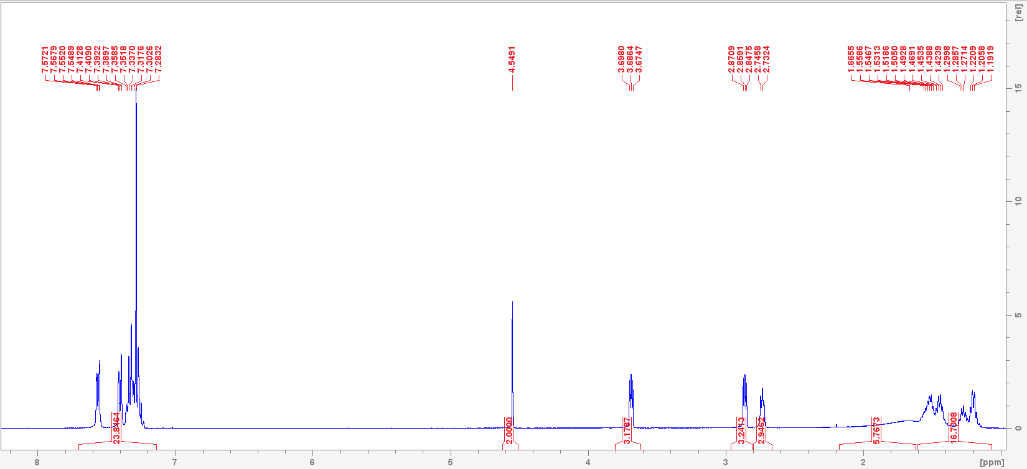
Figure S12 ¹H-NMR spectrum for equimolar binary PIP/MOR with TADDOL6.
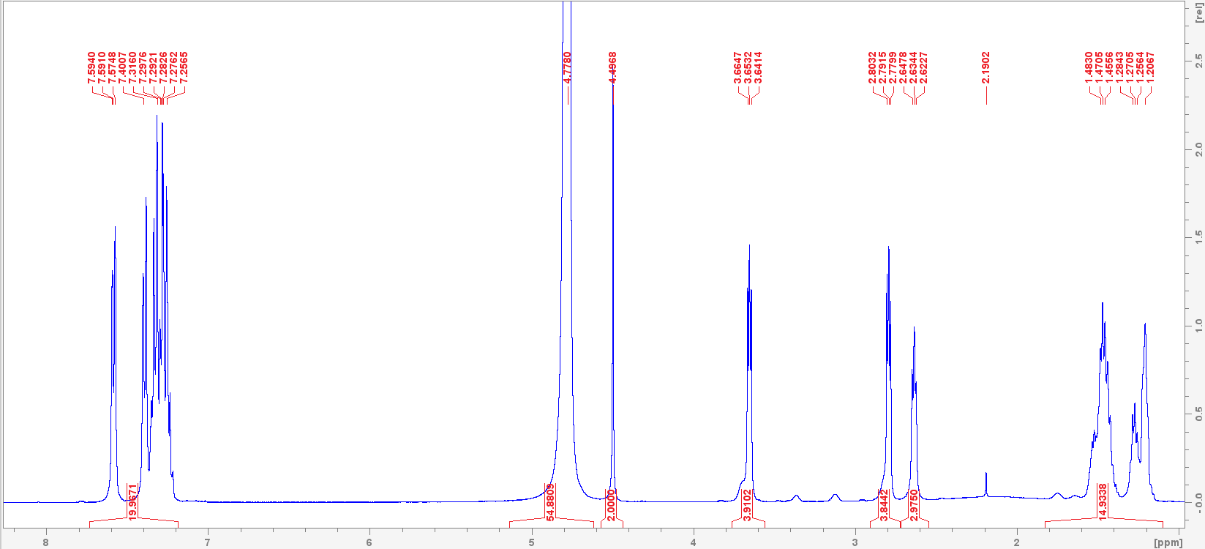
Figure S13 ¹H-NMR spectrum for equimolar binary PIP/MOR duplicate with TADDOL6.
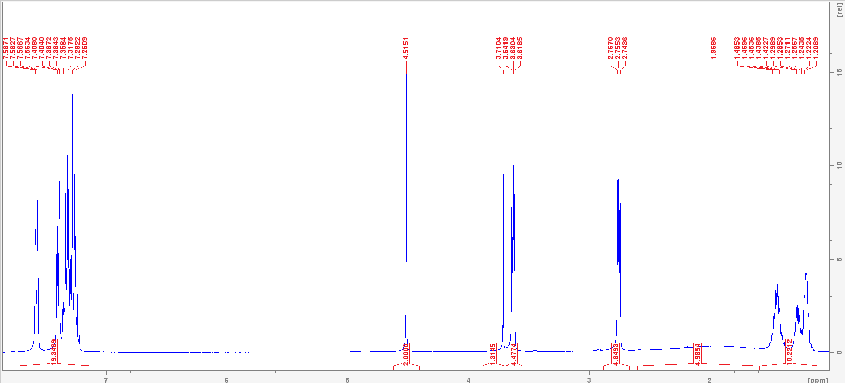
Figure S14 ¹H-NMR spectrum for equimolar binary DIO/MOR with TADDOL6.
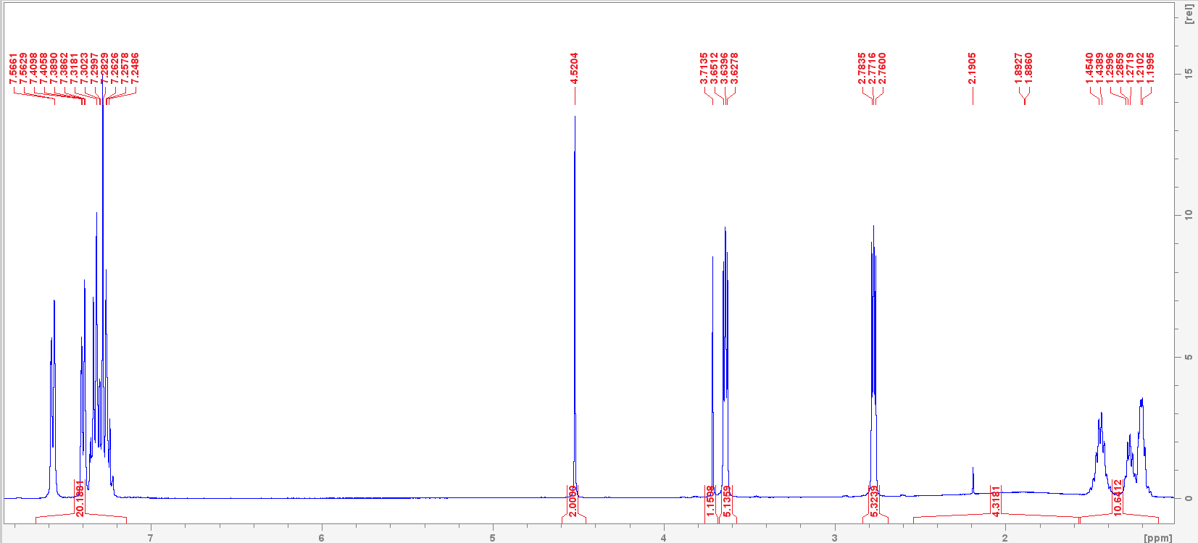
Figure S15 ¹H-NMR spectrum for equimolar binary DIO/MOR duplicate with TADDOL6.
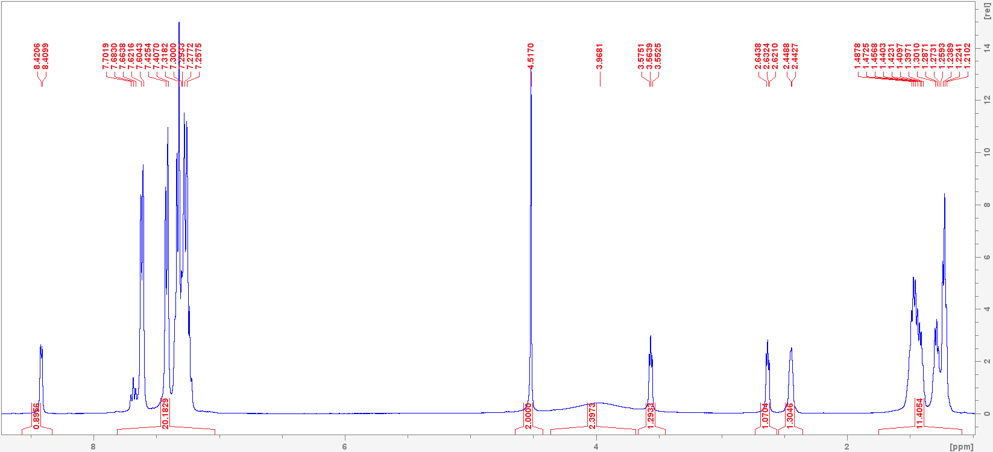
Figure S16 ¹H-NMR spectrum for equimolar ternary PYR/MOR/PIP with TADDOL6.
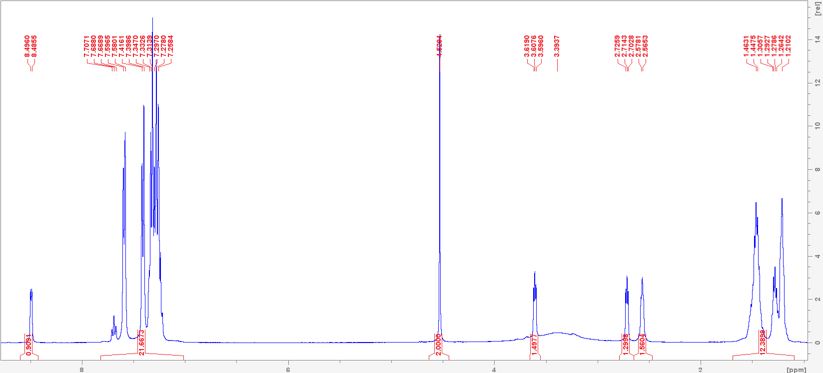
Figure S17 ¹H-NMR spectrum for equimolar ternary PYR/MOR/PIP duplicate with TADDOL6.
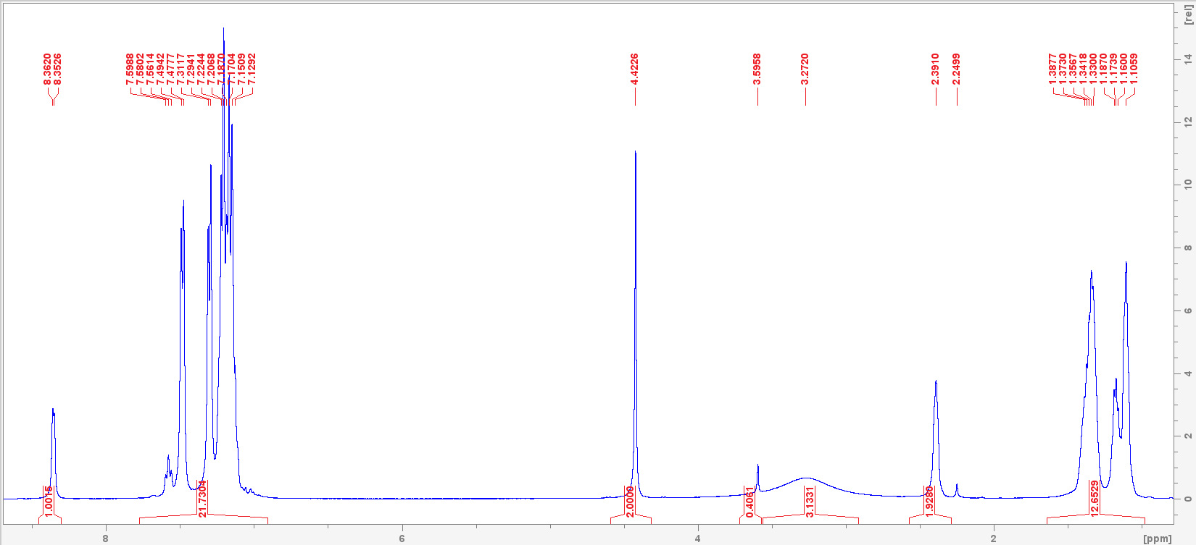
Figure S18 ¹H-NMR spectrum for equimolar ternary PYR/PIP/DIO with TADDOL6.
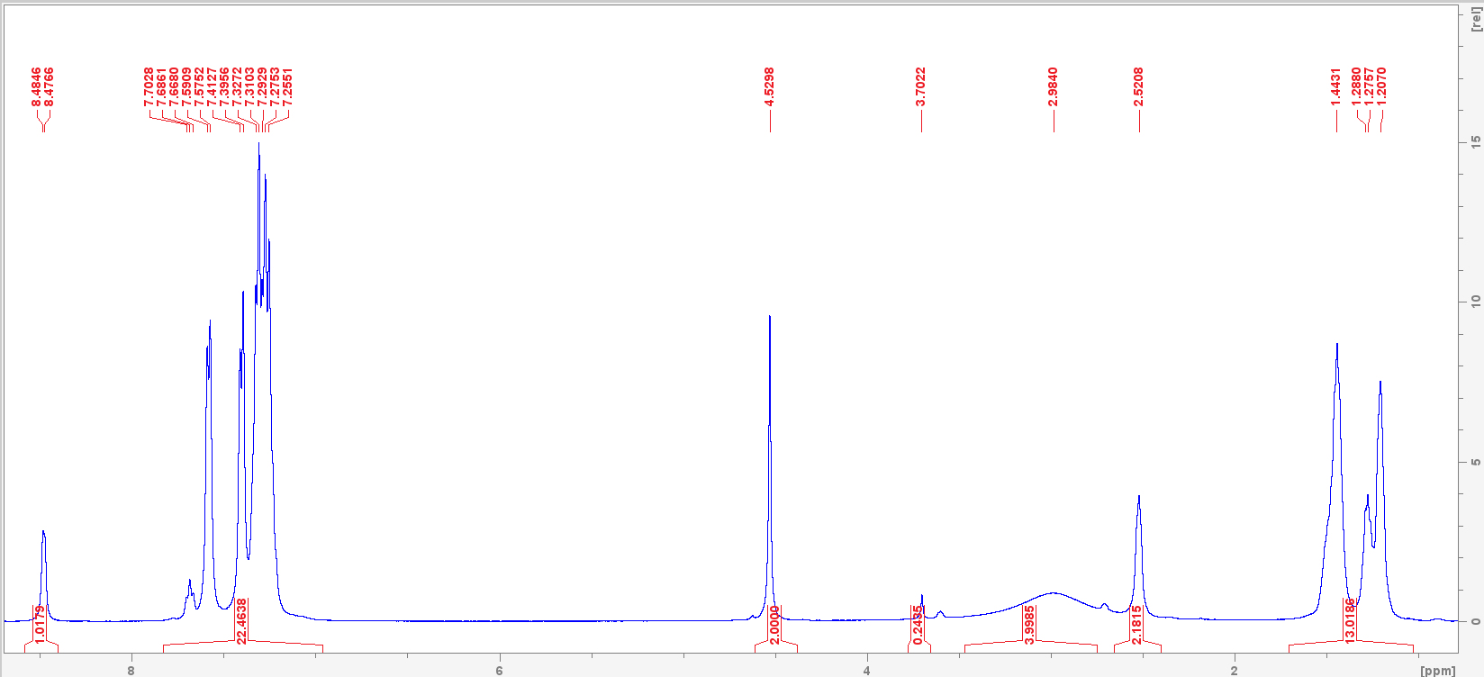
Figure S19 ¹H-NMR spectrum for equimolar ternary PYR/PIP/DIO duplicate with TADDOL6.
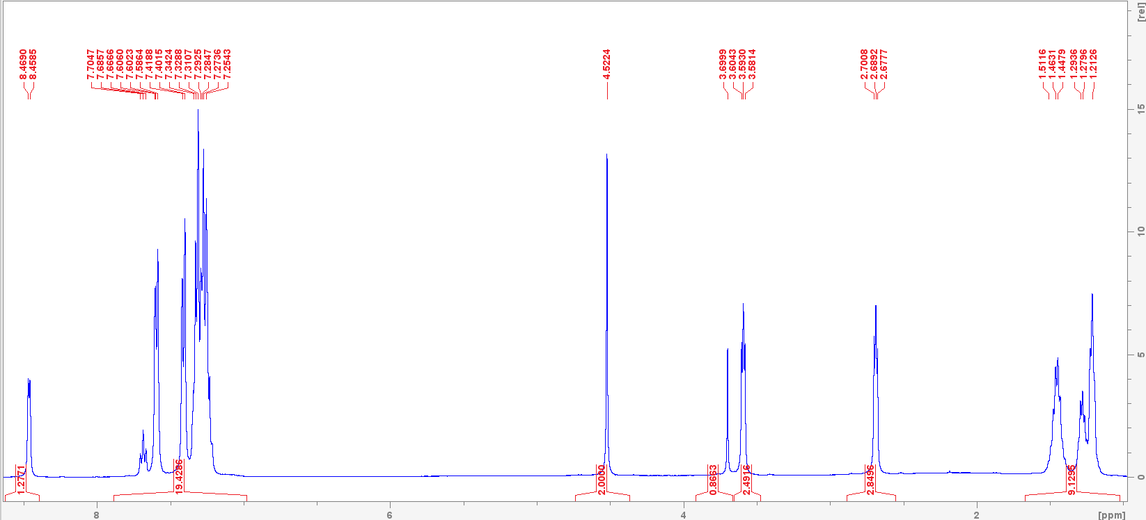
Figure S20 ¹H-NMR spectrum for equimolar ternary PYR/MOR/DIO with TADDOL6.
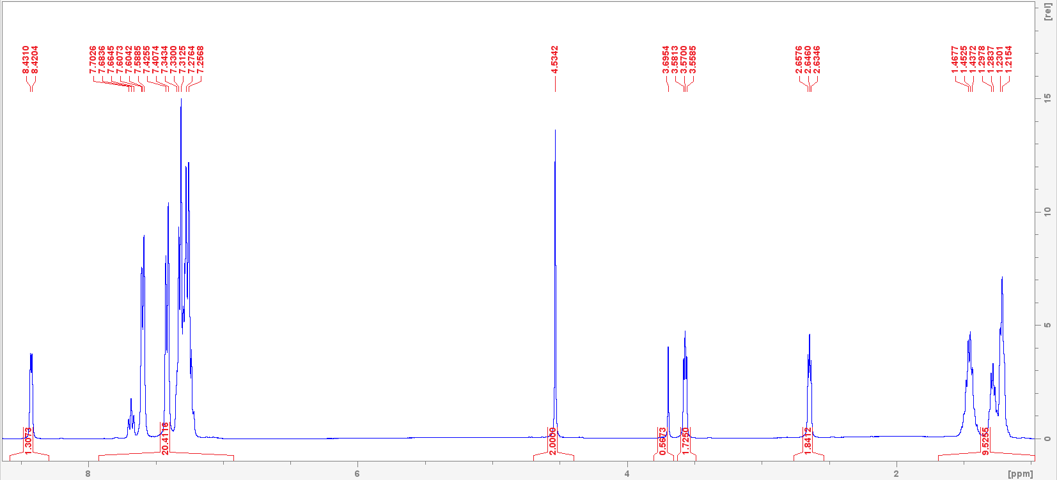
Figure S21 ¹H-NMR spectrum for equimolar ternary PYR/MOR/DIO duplicate with TADDOL6.
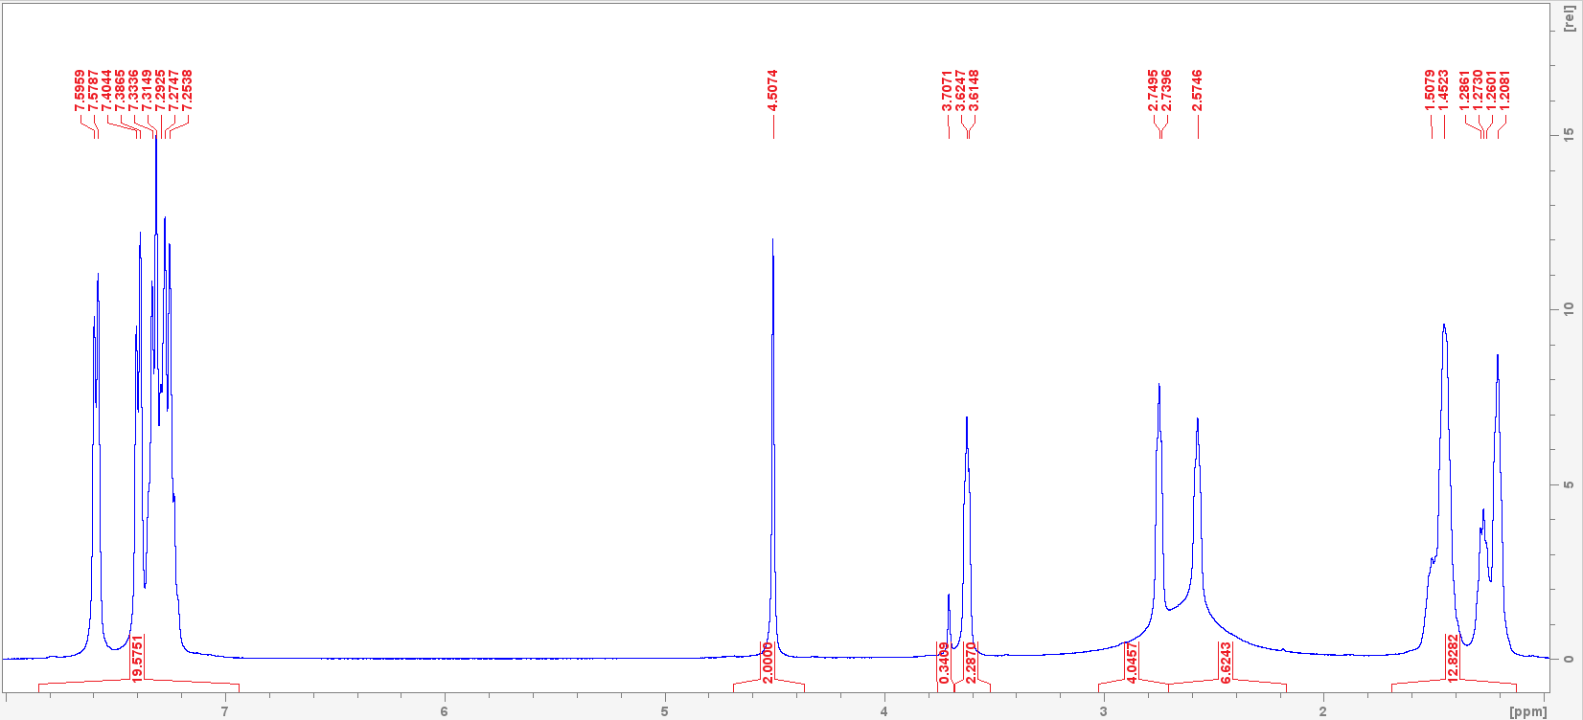
Figure S22 ¹H-NMR spectrum for equimolar ternary PIP/MOR/DIO with TADDOL6.
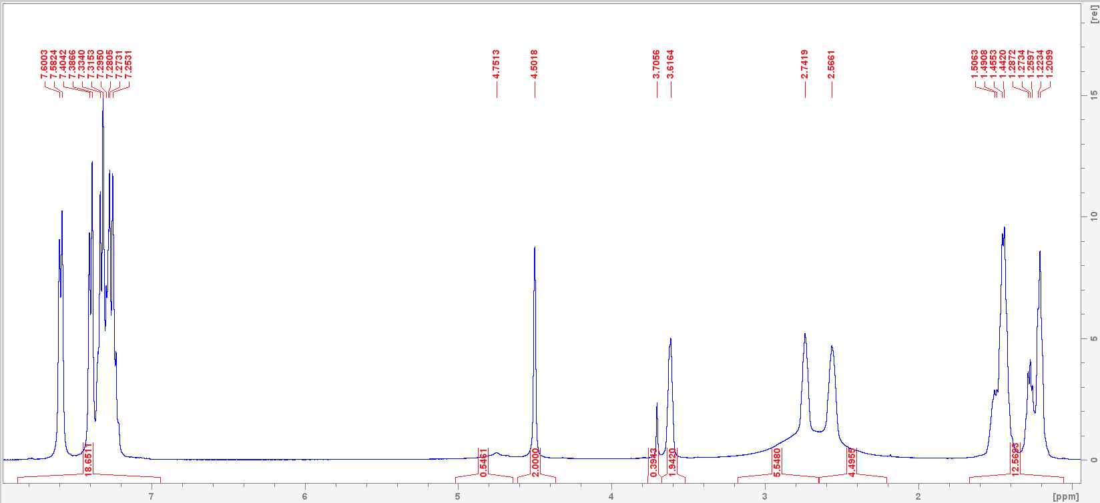
Figure S23 ¹H-NMR spectrum for equimolar ternary PIP/MOR/DIO duplicate with TADDOL6.
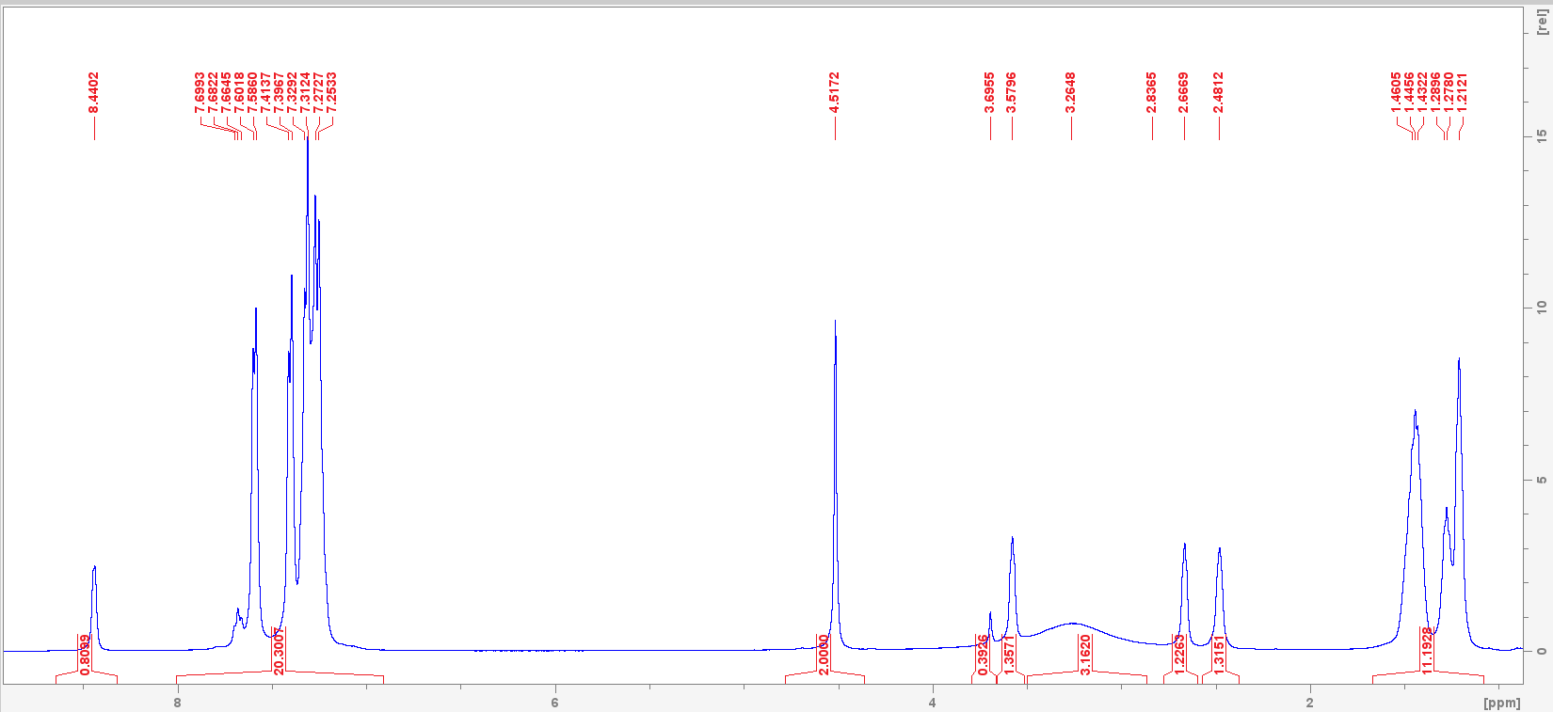
Figure S24 ¹H-NMR spectrum for equimolar quaternary PYR/PIP/MOR/DIO with TADDOL6.
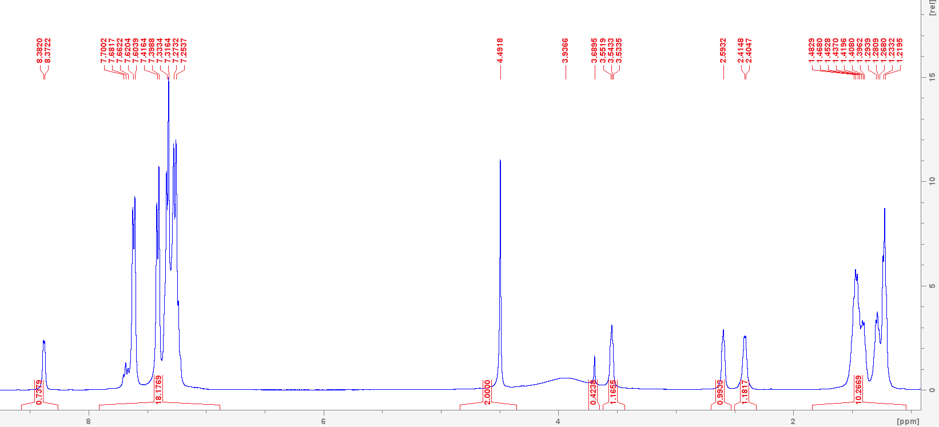
Figure S25 ¹H-NMR spectrum for equimolar quaternary PYR/PIP/MOR/DIO duplicate with TADDOL6.
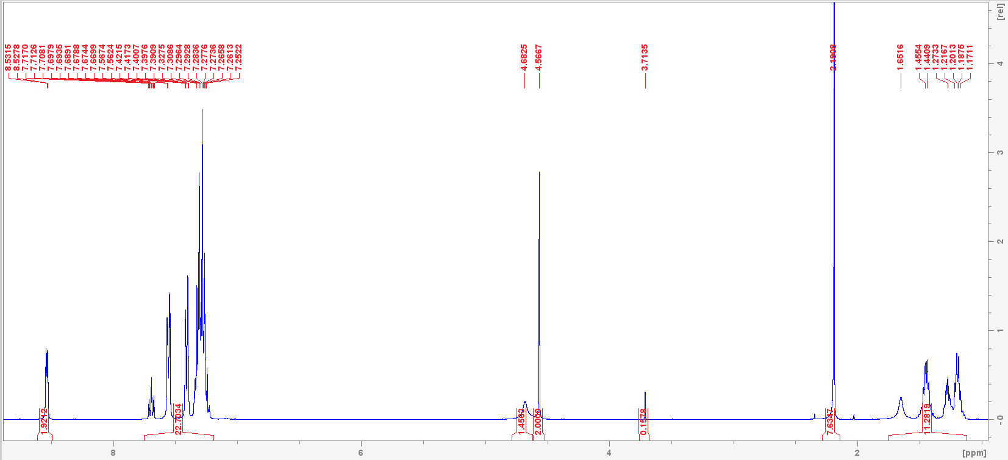
Figure S26 ¹H-NMR spectrum for selectivity profile 80:20 PYR/DIO with TADDOL6.
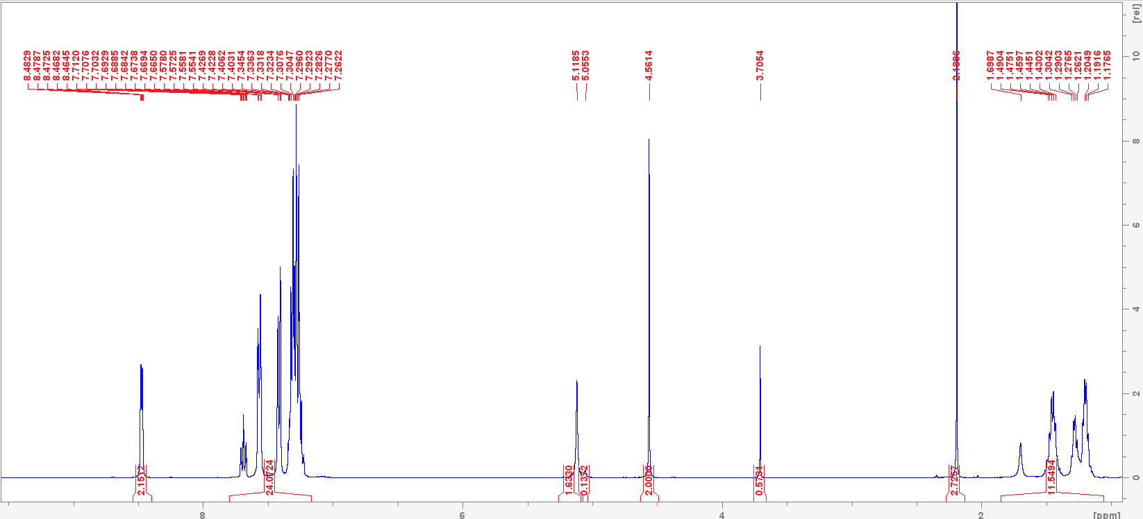
Figure S27 ¹H-NMR spectrum for selectivity profile 60:40 PYR/DIO with TADDOL6.
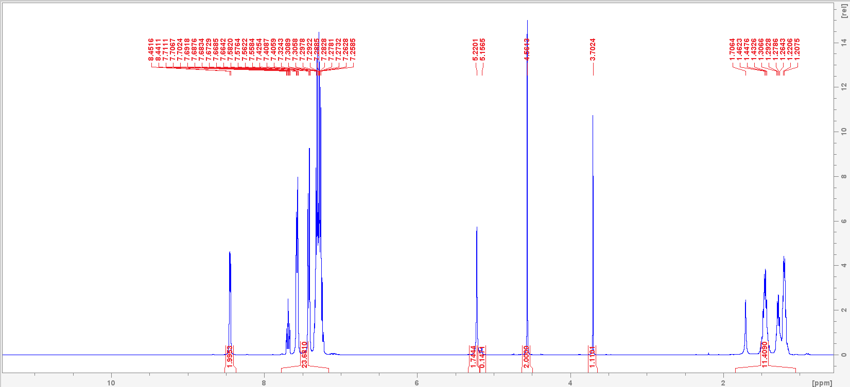
Figure S28 ¹H-NMR spectrum for selectivity profile 40:60 PYR/DIO with TADDOL6.
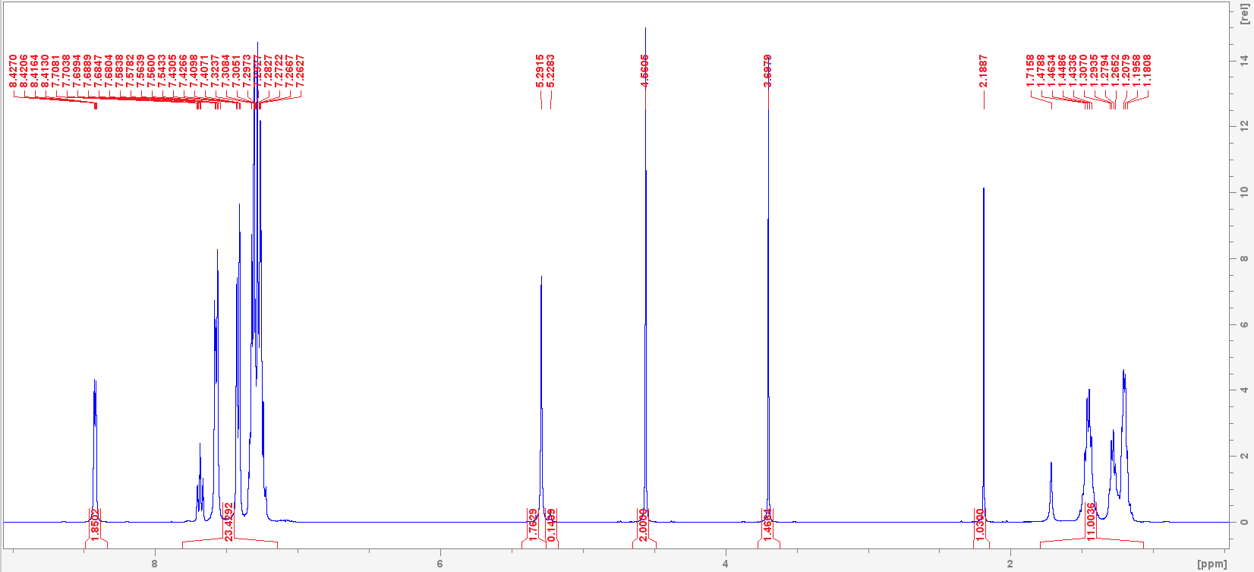
Figure S29 ¹H-NMR spectrum for selectivity profile 20:80 PYR/DIO with TADDOL6.
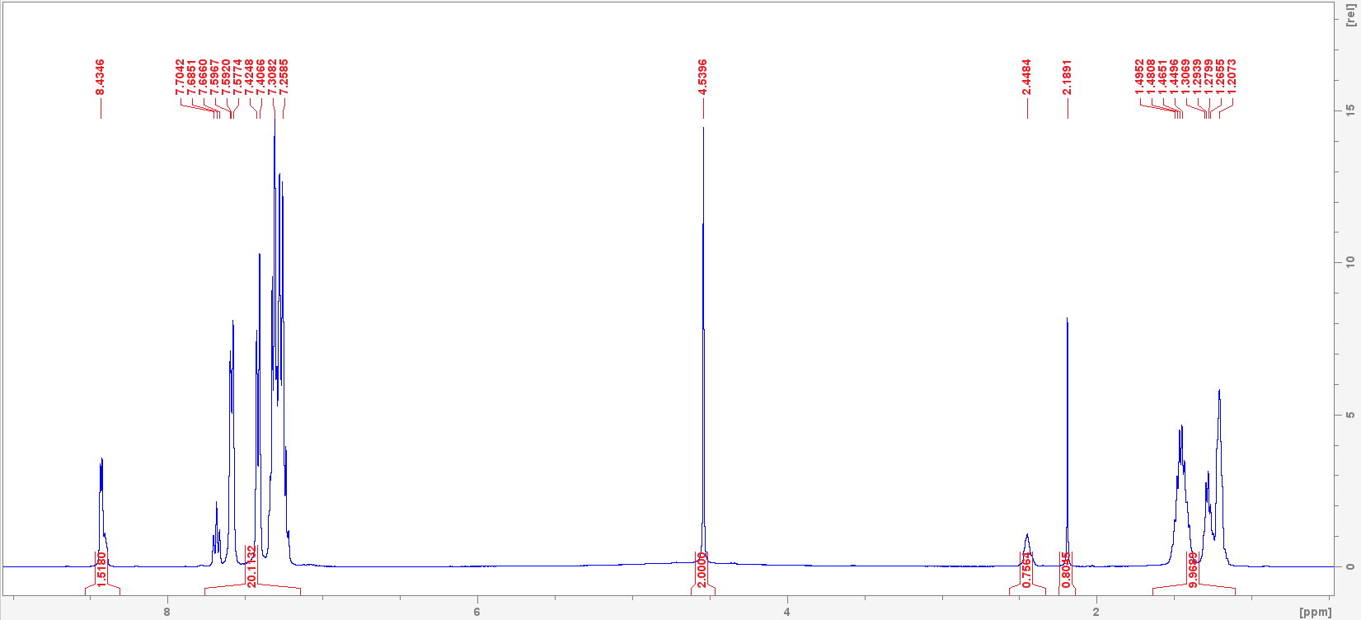
Figure S30 ¹H-NMR spectrum for selectivity profile 80:20 PYR/PIP with TADDOL6.
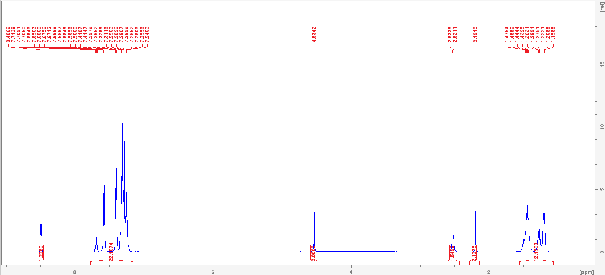
Figure S31 ¹H-NMR spectrum for selectivity profile 60:40 PYR/PIP with TADDOL6.
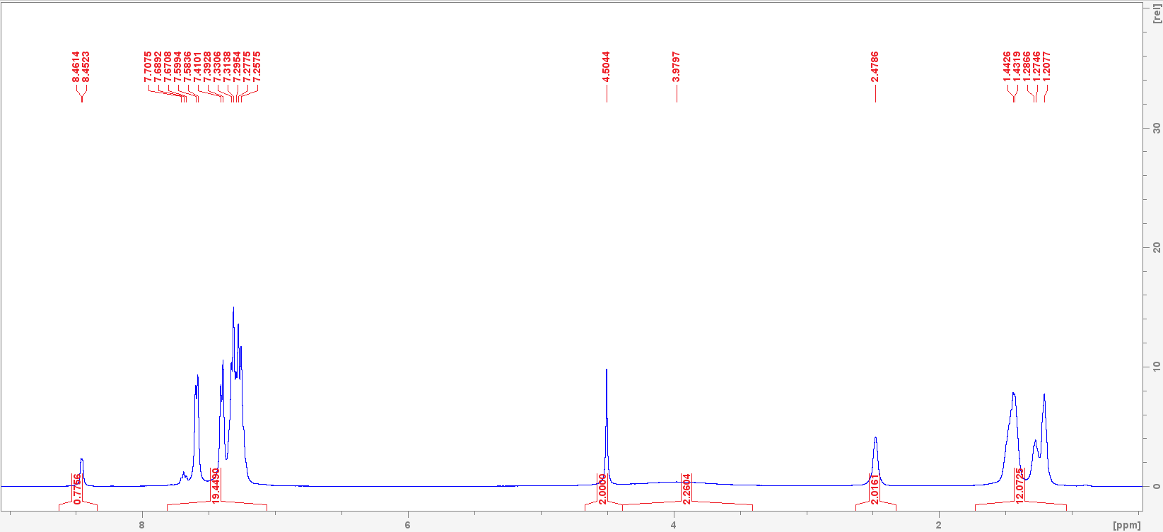
Figure S32 ¹H-NMR spectrum for selectivity profile 40:60 PYR/PIP with TADDOL6.
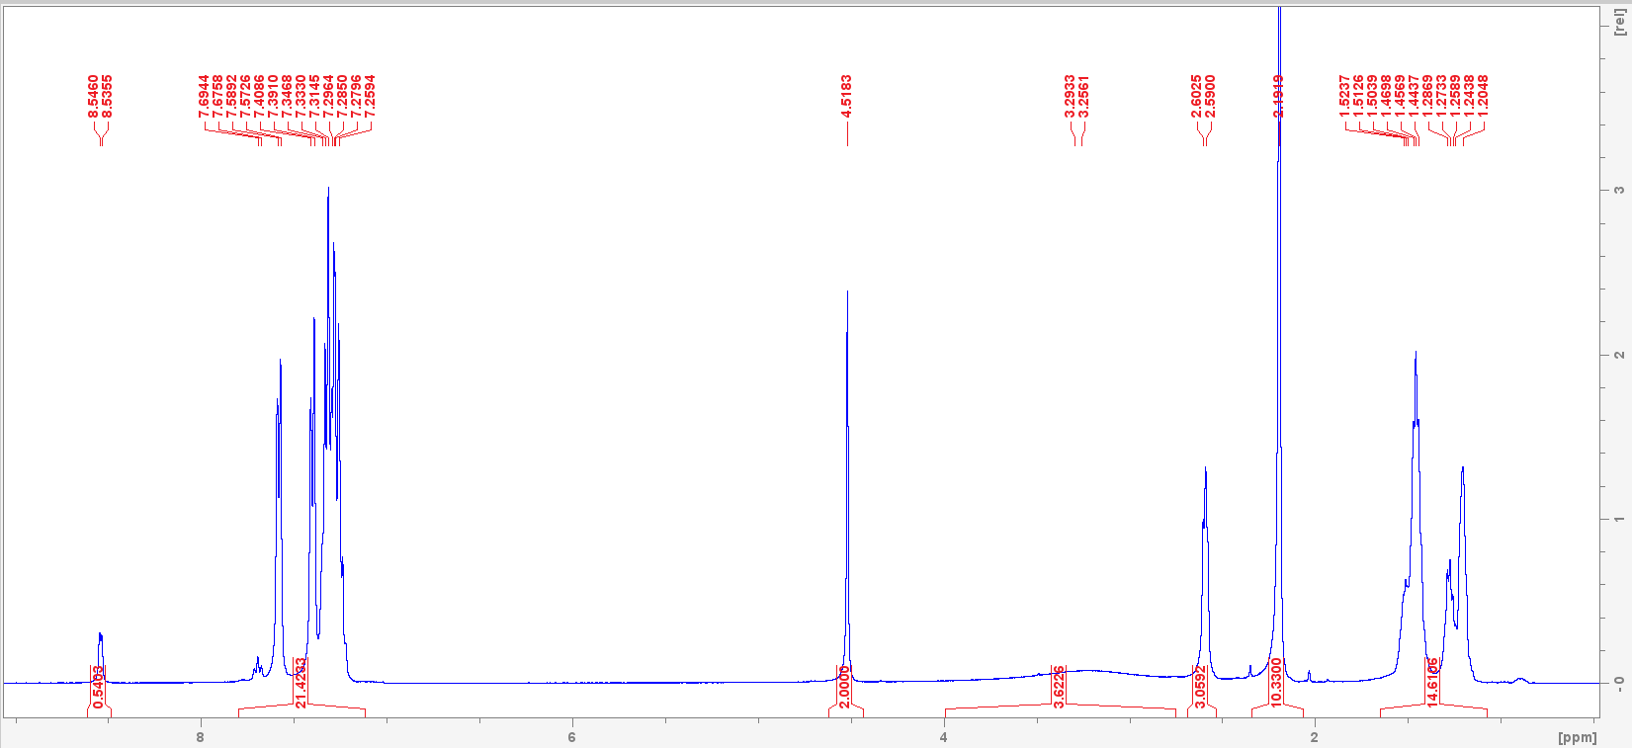
Figure S33 ¹H-NMR spectrum for selectivity profile 20:80 PYR/PIP with TADDOL6.
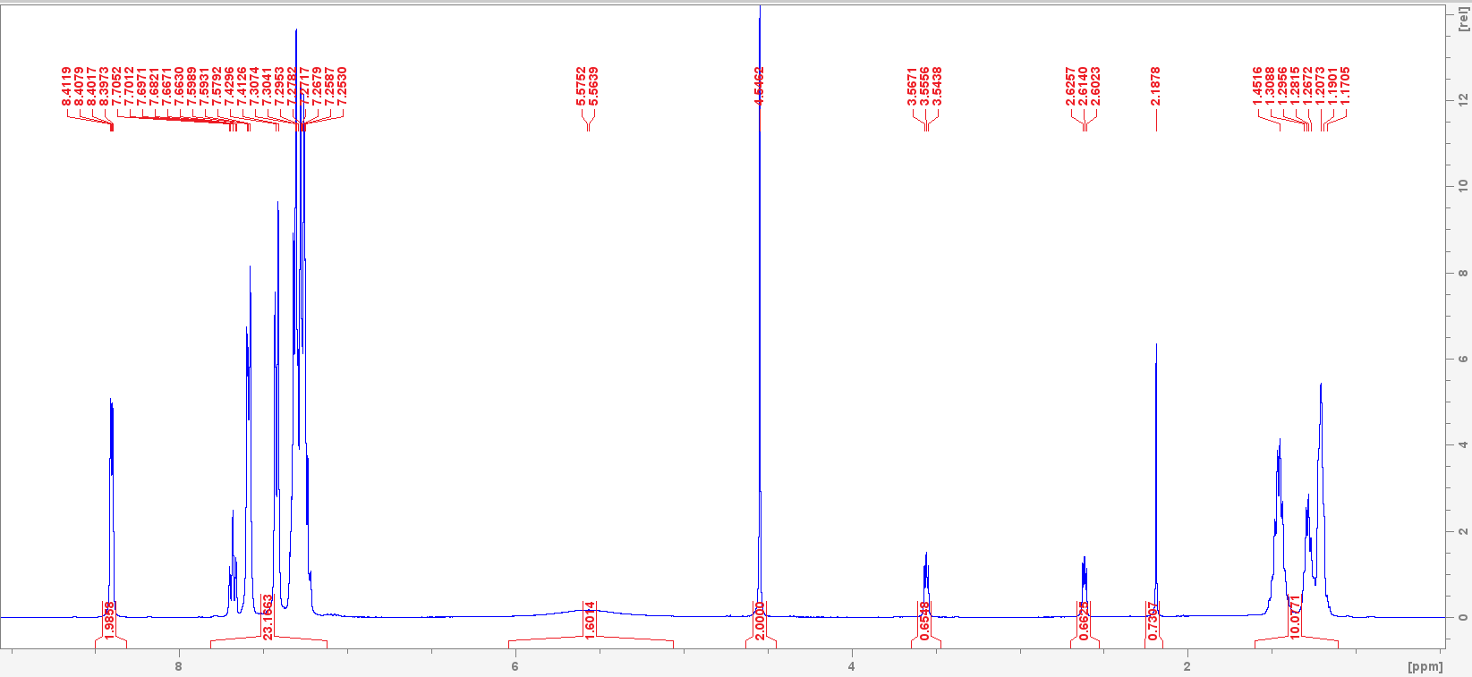
Figure S34 ¹H-NMR spectrum for selectivity profile 80:20 PYR/MOR with TADDOL6.
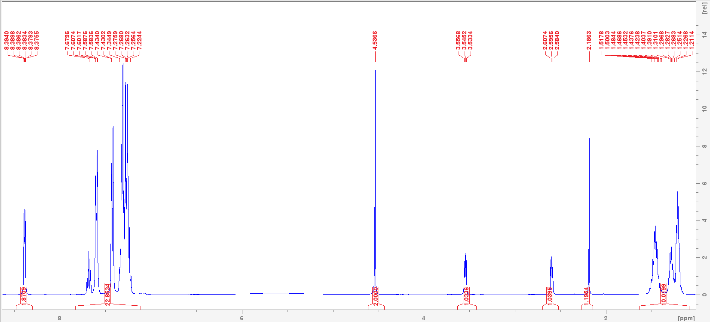
Figure S35 ¹H-NMR spectrum for selectivity profile 60:40 PYR/MOR with TADDOL6.
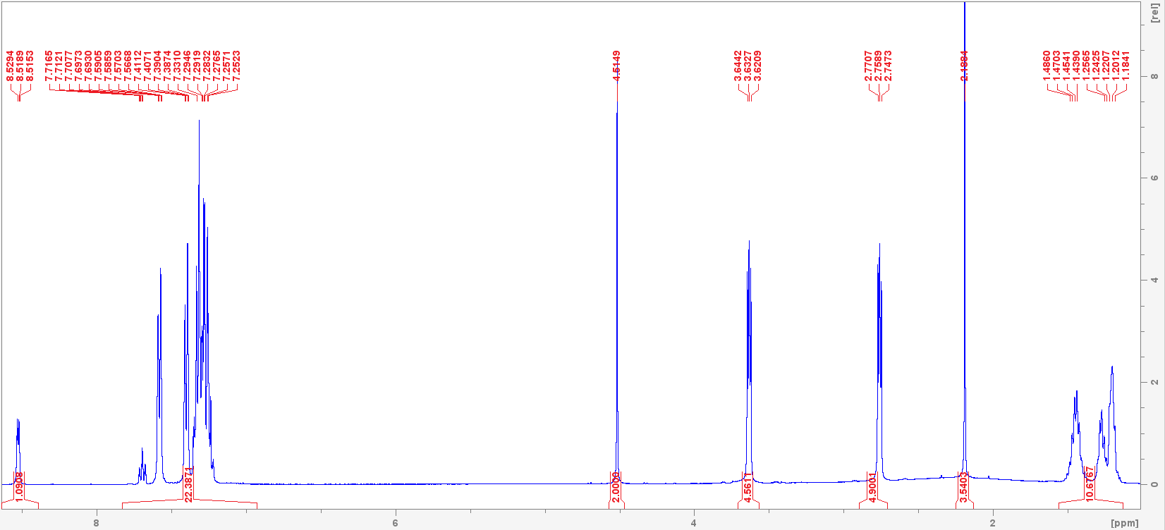
Figure S36 ¹H-NMR spectrum for selectivity profile 40:60 PYR/MOR with TADDOL6.
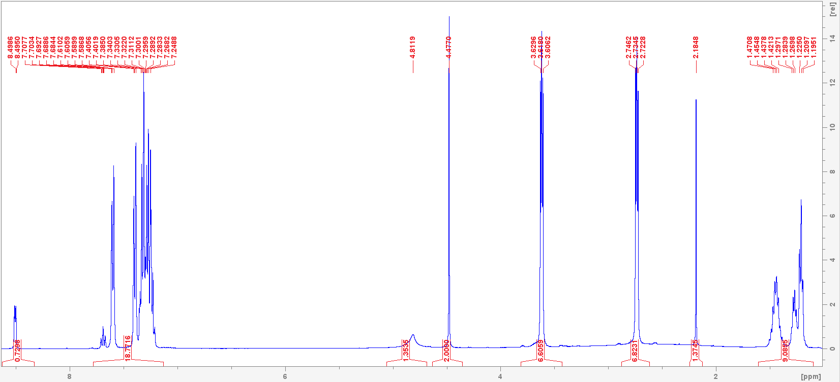
Figure S37 ¹H-NMR spectrum for selectivity profile 20:80 PYR/MOR with TADDOL6.
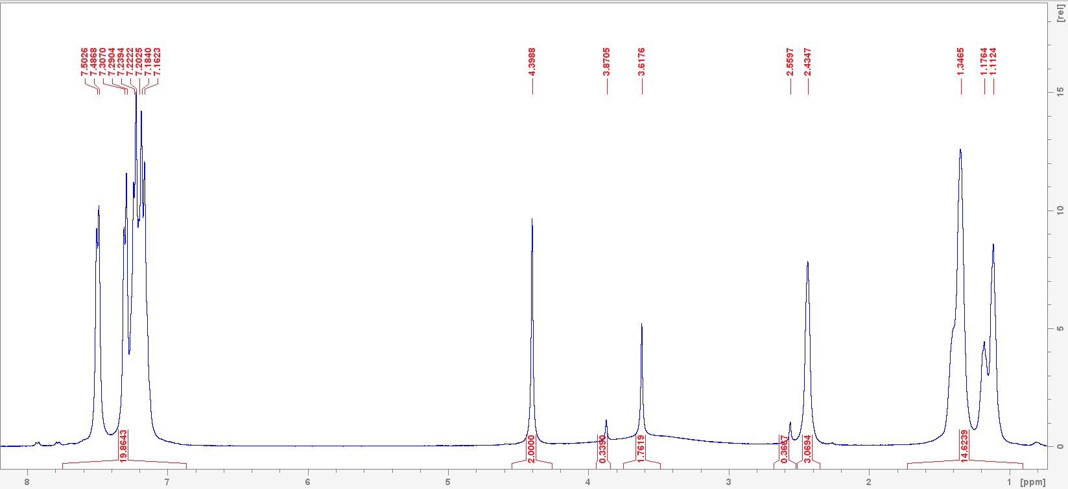
Figure S38 ¹H-NMR spectrum for selectivity profile 80:20 DIO/PIP with TADDOL6.
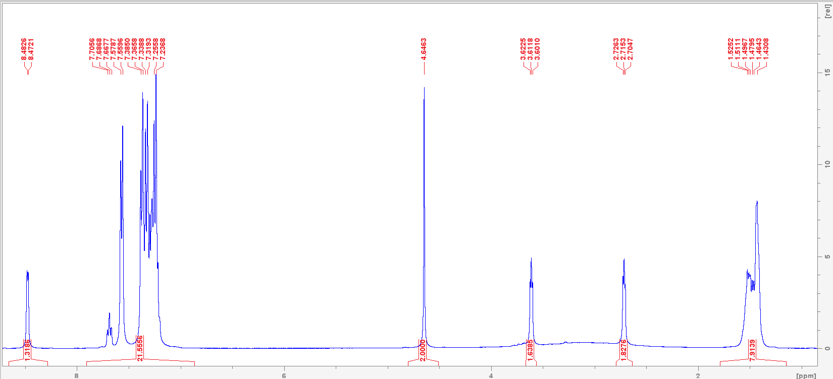
Figure S39 ¹H-NMR spectrum for selectivity profile 60:40 DIO/PIP with TADDOL6.
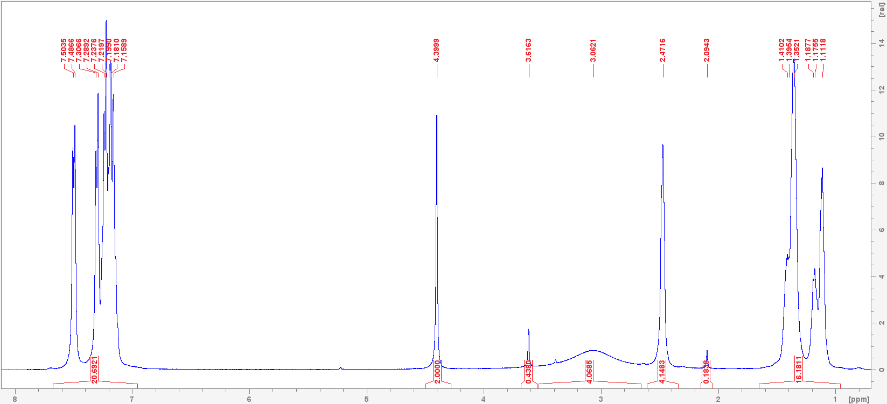
Figure S40 ¹H-NMR spectrum for selectivity profile 40:60 DIO/PIP with TADDOL6.
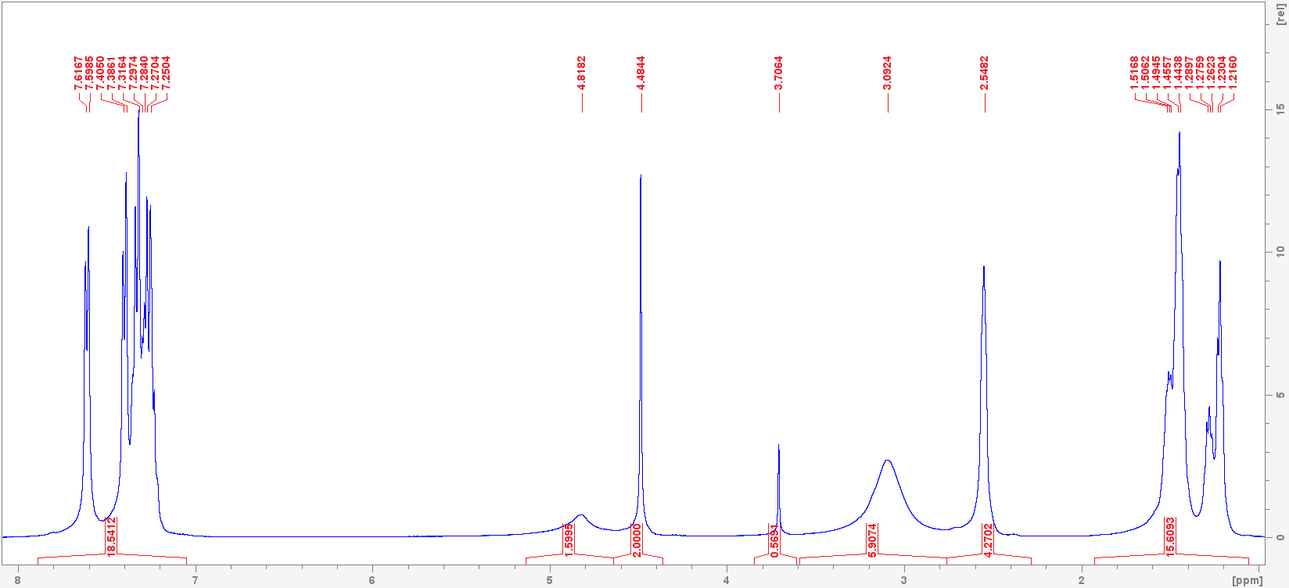
Figure S41 ¹H-NMR spectrum for selectivity profile 20:80 DIO/PIP with TADDOL6.
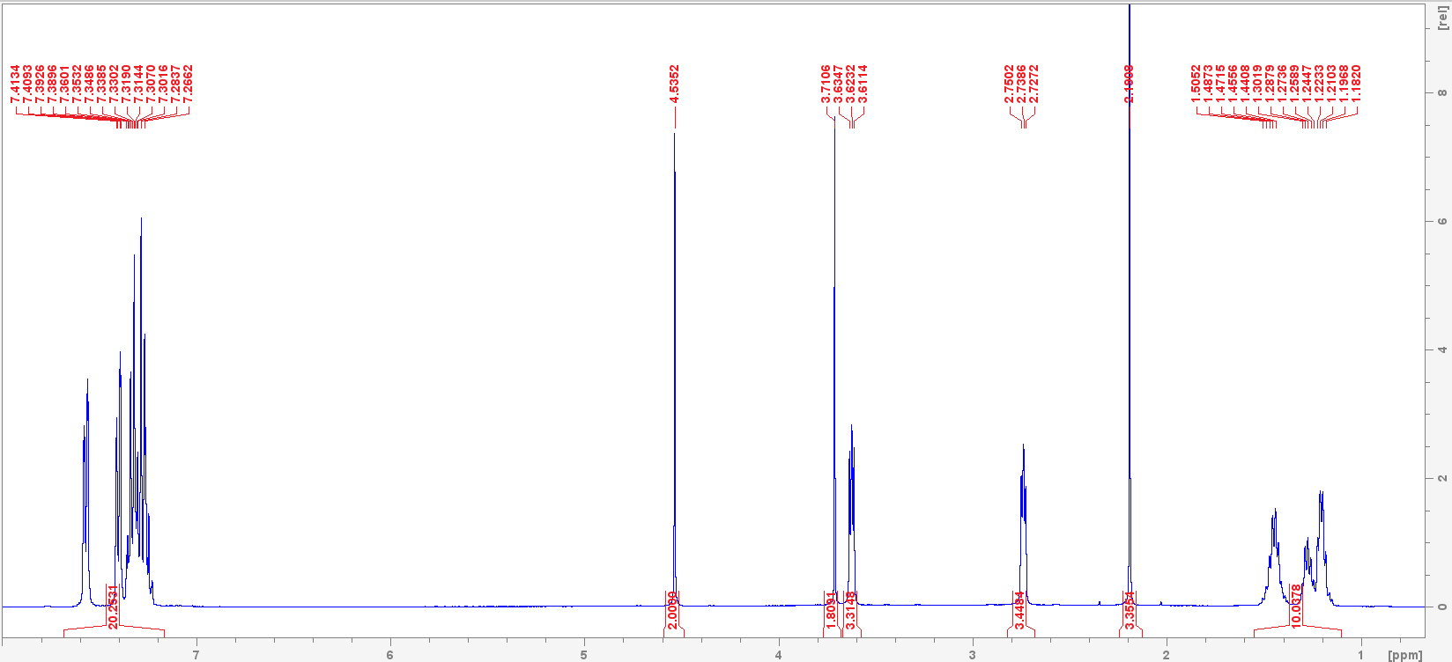
Figure S42 ¹H-NMR spectrum for selectivity profile 80:20 DIO/MOR with TADDOL6.
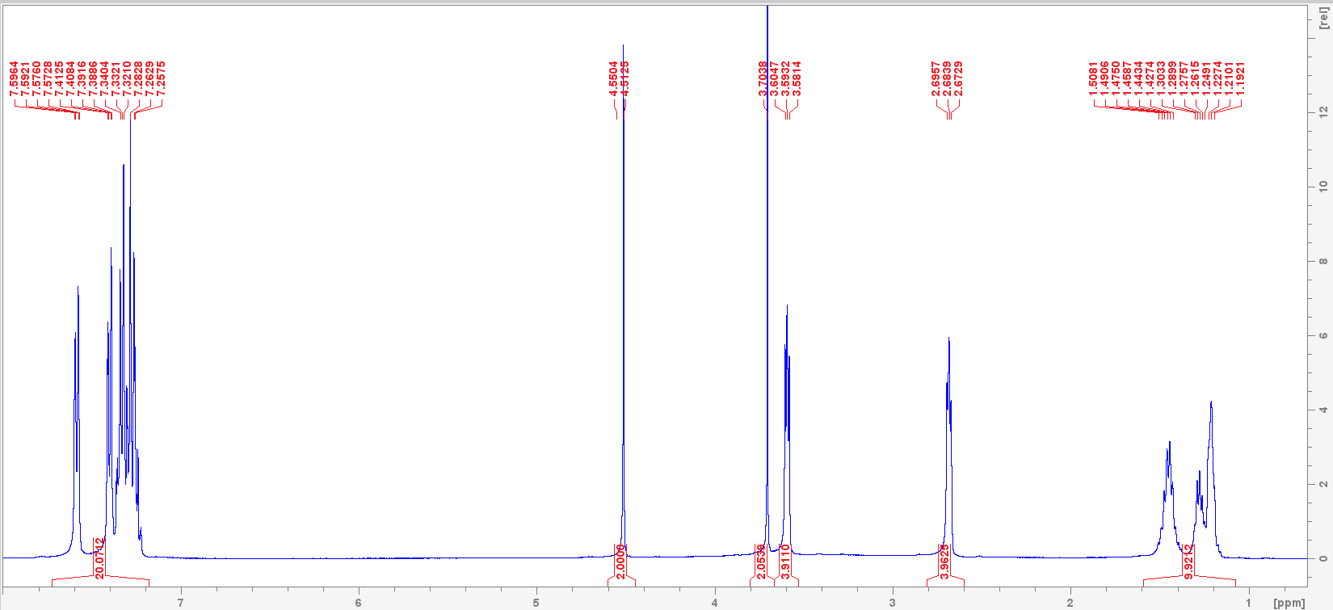
Figure S43 ¹H-NMR spectrum for selectivity profile 60:40 DIO/MOR with TADDOL6.
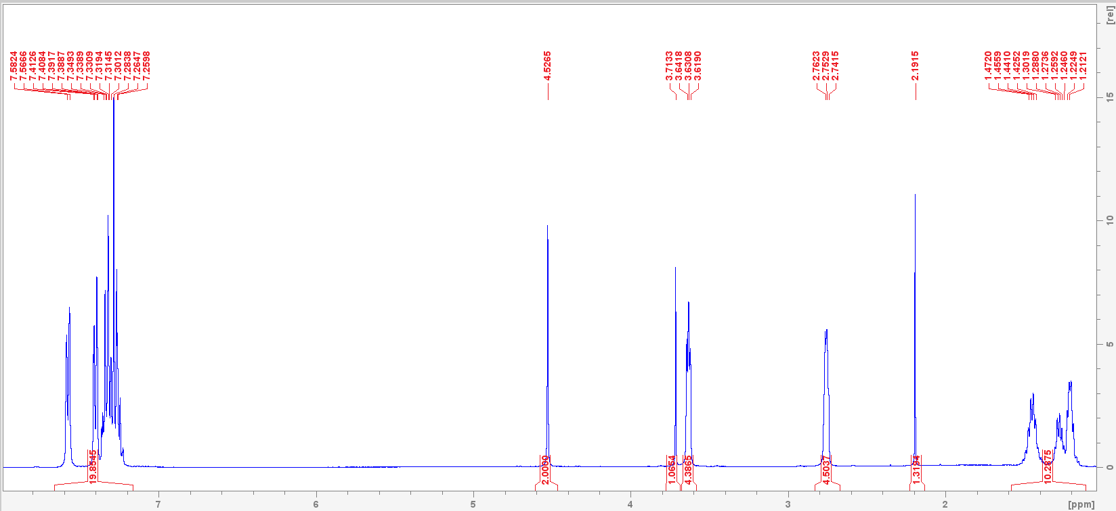
Figure S44 ¹H-NMR spectrum for selectivity profile 40:60 DIO/MOR with TADDOL6.
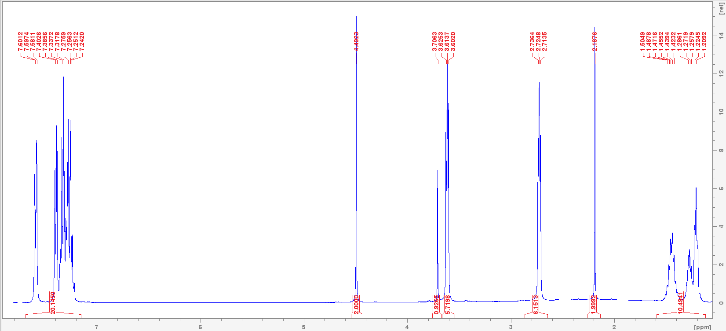
Figure S45 ¹H-NMR spectrum for selectivity profile 20:80 DIO/MOR with TADDOL6.
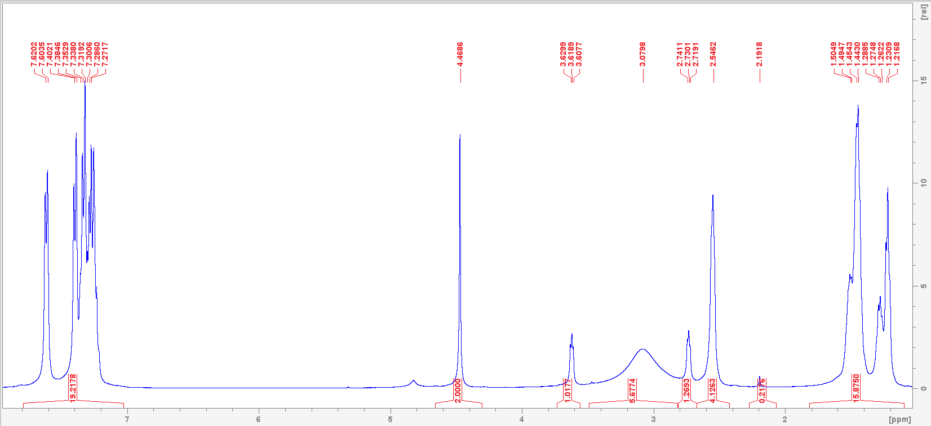
Figure S46 ¹H-NMR spectrum for selectivity profile 80:20 PIP/MOR with TADDOL6.
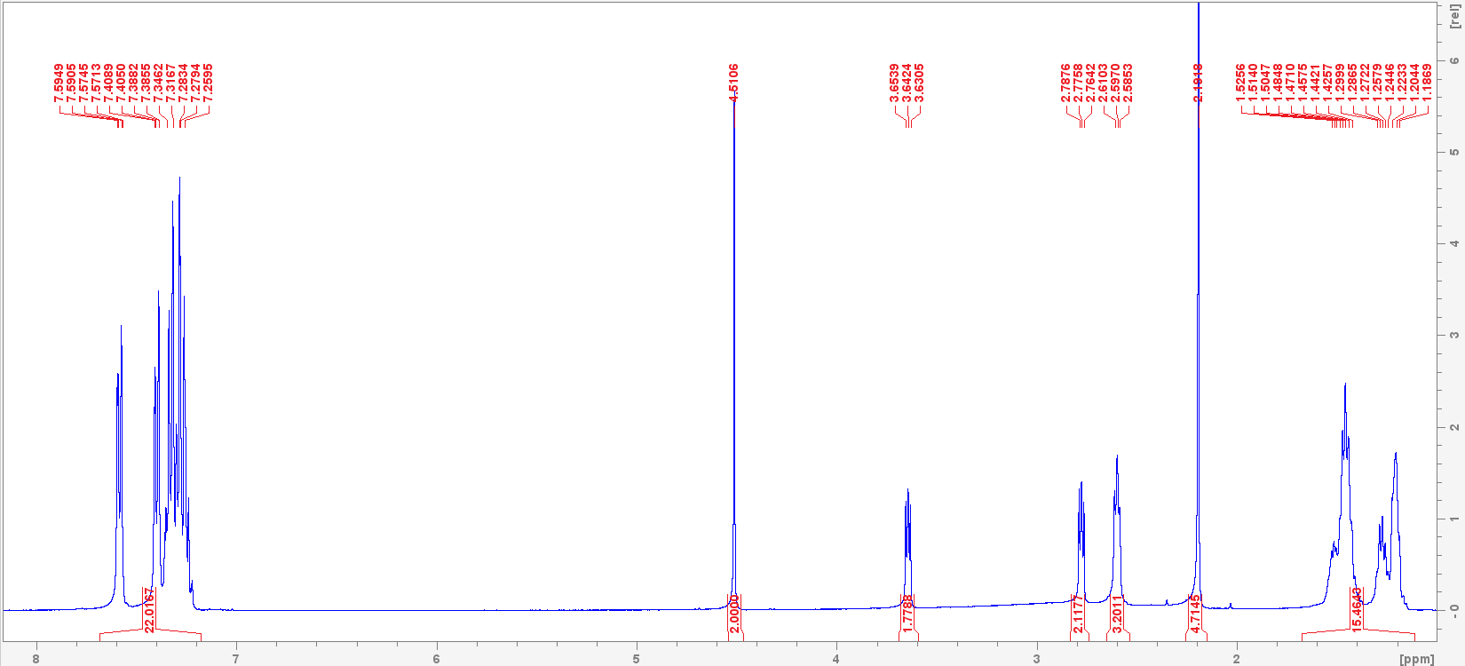
Figure S47 ¹H-NMR spectrum for selectivity profile 60:40 PIP/MOR with TADDOL6.
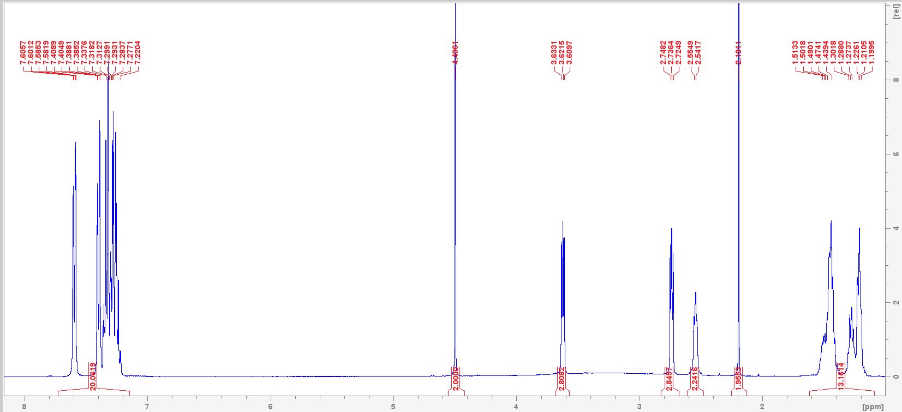
Figure S48 ¹H-NMR spectrum for selectivity profile 40:60 PIP/MOR with TADDOL6.
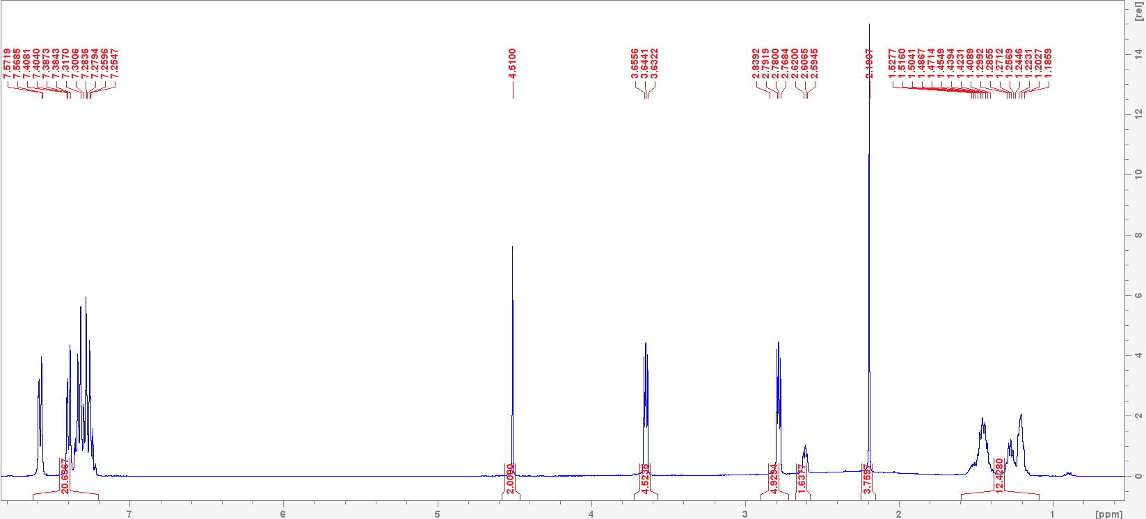
Figure S49 ¹H-NMR spectrum for selectivity profile 20:80 PIP/MOR with TADDOL6.

