Supplementary Material

Hybrid sol-gel inorganic/gelatin porous fibres via solution blow spinning
Ryan D. Greenhalgh^{1#}, William S. Ambler^{1,2#}, Stephen J. Quinn¹, Eliton S. Medeiros³, Michael Anderson⁴, Barbara Gore⁴, Angelika Menner⁵, Alexander Bismarck⁵, Xu Li², Nicola Tirelli⁶, Jonny J. Blaker^{1*}

^{1*}Bio-Active Materials Group, School of Materials, MSS Tower, The University of Manchester, Manchester, M13 9PL, UK
²Institute of Materials Research and Engineering (IMRE), Agency for Science, Technology and Research (A*STAR), 2 Fusionopolis Way, Innovis, #08-03, 138634, Singapore
³Materials and Biosystems Laboratory (LAMAB), Department of Materials Engineering (DEMat), Federal University of Paraíba (UFPB), CEP58051-900, João Pessoa- PB, Brazil
⁴School of Chemistry, The University of Manchester, Brunswick Street, Manchester, M13 9PL, UK
⁵Polymer and Composite Engineering (PaCE) Group, Institute of Materials Chemistry and Research, Faculty of Chemistry, University of Vienna, Währingerstr. 42, A-1090 Vienna, Austria
⁶Division of Pharmacy and Optometry, School of Health Sciences, The University of Manchester, Stopford Building, Oxford Road, Manchester, M13 9PT, UK

#Joint first Authors due to equal contribution
Corresponding Author: *jonny.blaker@manchester.ac.uk
Table S1. Sol-gel precursor solution typical volumes used according to molar ratios given in the article
Sol precursor solutions | TEOS  [mL] | EtOH  [mL] | TBA  [mL] | H₂O  [mL] | 1M HCl  [μL]
Neat sol-gel | 17.1 | 2 | - | 2 | 57
Class I hybrid for conventional SBS | 5.7 | 1.03 | - | 0.73*Including H₂O from 1M HCl | 300
Class I and II hybrid for cryo-SBS | 2.216 | - | 4.782 | *Water from 1M HCl | 500

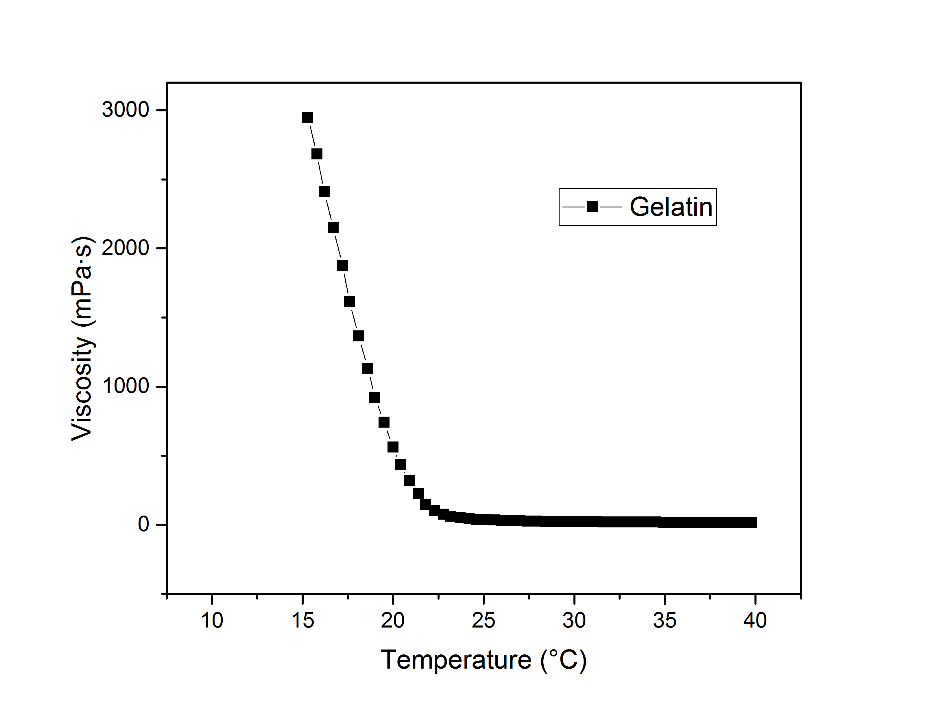
Fig. S1 Viscosity of gelatin (10% w/v in PBS) as function of temperature, measured at constant shear stress of 500 s⁻¹, showing the sol-gel transition

