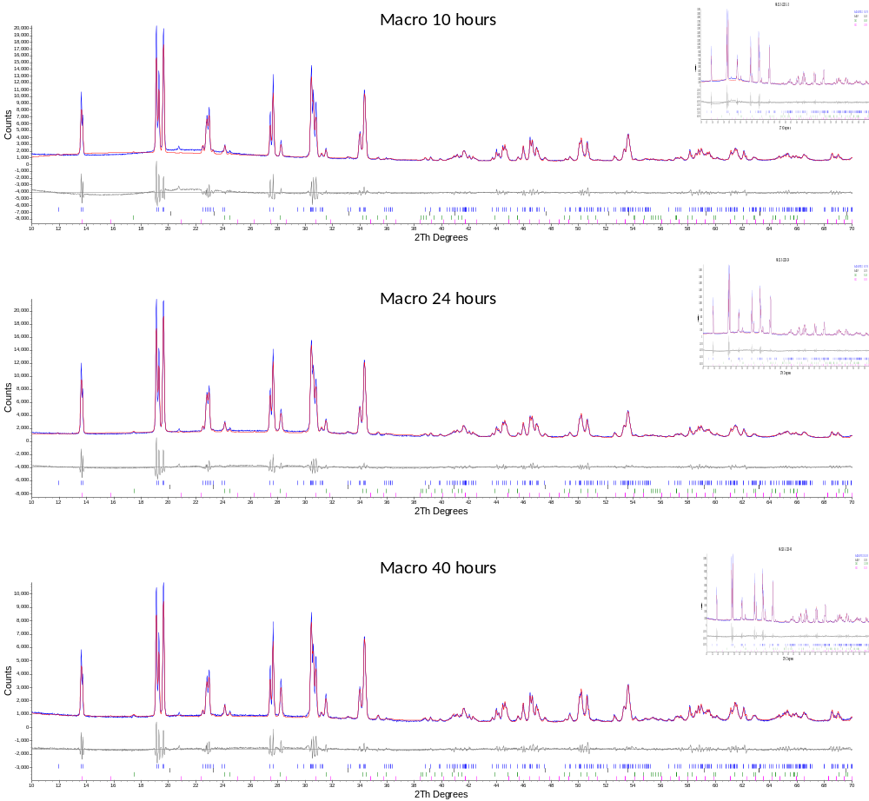
Figure S1: Fitting of XRD data to models – Macro precursors
Supplementary material for “Solid State Synthesis of NASICON (Na₃Zr₂Si₂PO₁₂) using Nanoparticle Precursors for Optimisation of Ionic Conductivity “
A. Jalalian-Khakshour*, C. O. Phillips, L.Jackson, T. O. Dunlop, S. Margadonna, D. Deganello*
College of Enginnering, Swansea University, Swansea University Bay Campus, Fabian Way, Crymlyn Burrows, Swansea, SA1 8EN, UK
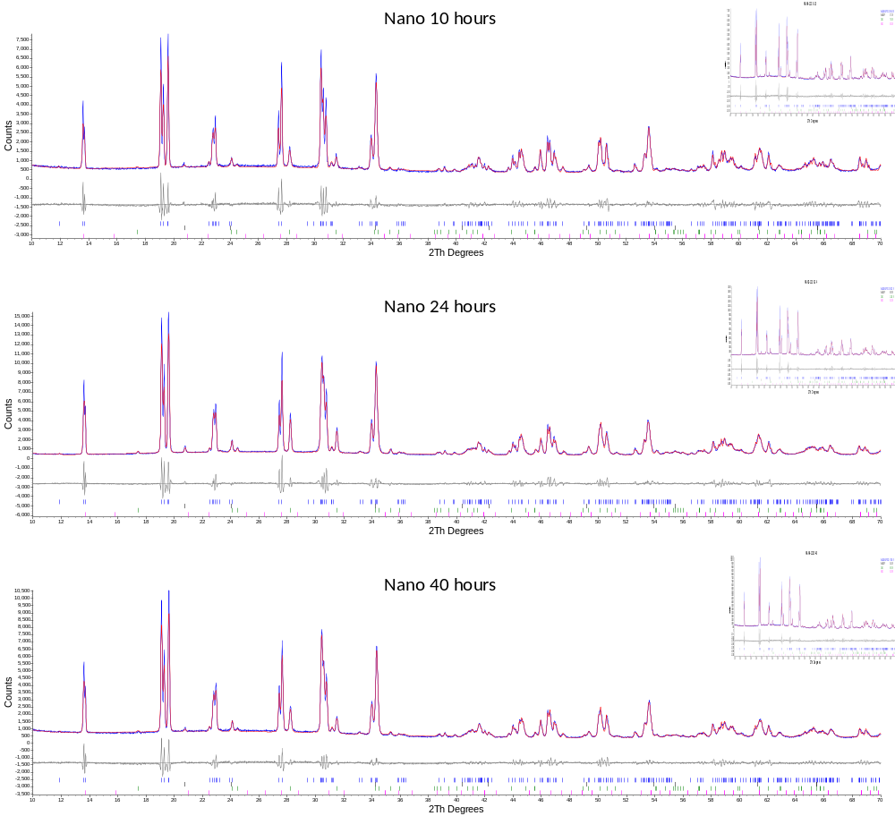
Figure S2: Fitting of XRD data to models – Nano precursors

