Multifunctional stratified Composite Coatings by Electrophoretic Deposition and RF Co-sputtering for Orthopedic Implants
Qaisar Nawazª, Steffen Fastnerª, Muhammad Atiq Ur Rehman^{b}, Sara Ferraris^{c}, Sergio Perero^{c}, G. Gautier di Confiengo^{d}, Emre Yavuz^{e}, Monica Ferraris^{c}, Aldo R. Boccacciniª*
ª Institute of Biomaterials, Department of Material Science and Engineering, University of Erlangen-Nuremberg, Cauerstr.6, 91058 Erlangen, Germany
^{b} Department of Materials Science and Engineering, Institute of Space Technology Islamabad, Islamabad 44000, Pakistan
^{c} Institute of Materials Physics and Engineering, Department of Applied Science and Technology, Politecnico di Torino, 10129, Torino, Italy
^{d} Institute of Science and Technology for Sustainable Energy and Mobility (STEMS), Strada delle Cacce 73, Turin, 10135, Italy
^{e} Institute of Science, Department of Chemistry, University of Akdeniz University 07058 Antalya, Turkey
* Corresponding author: aldo.boccaccini@ww.uni-erlangen.de

Supplementary figure
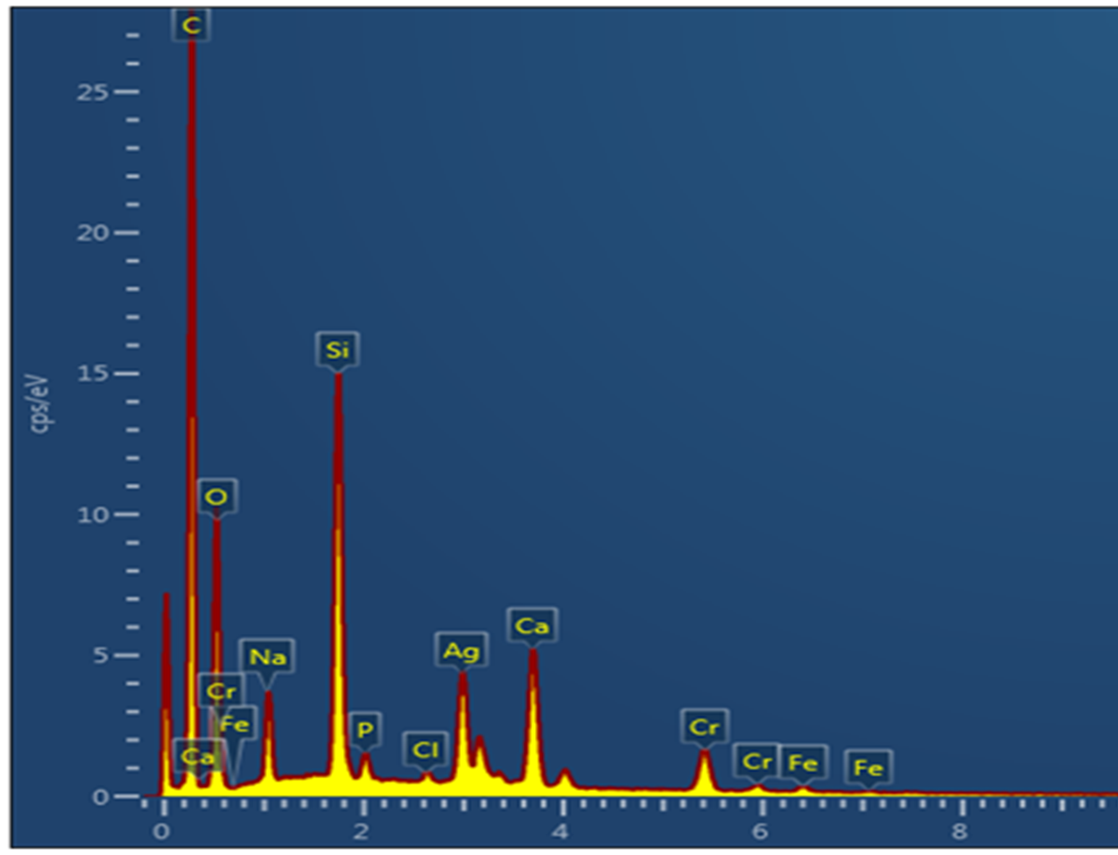
Figure S1. Comparative EDX analysis of EPD layer (yellow line) and EPD/RF-40 sample (red line).

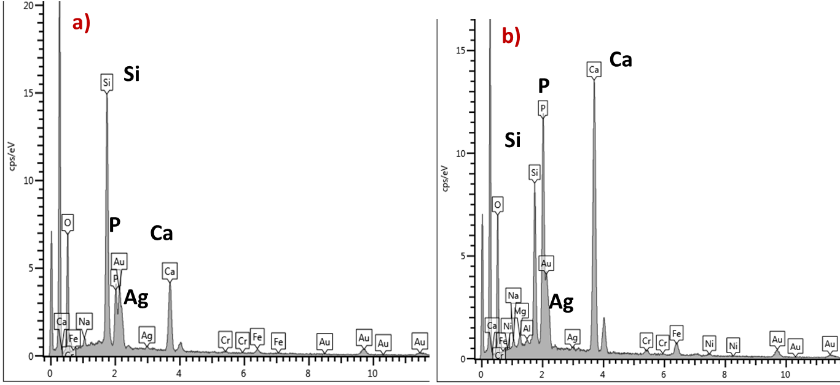
Figure S2. EDX analysis of the EPD/RF-40 coatings after immersion in SBF for (a) 1 day, (b) 14 days

