Supplementary Material
See the supplementary material for more information about process tasks, used devices and a more comprehensive view of parallel execution of multiple batches on L1.

Supporting Information
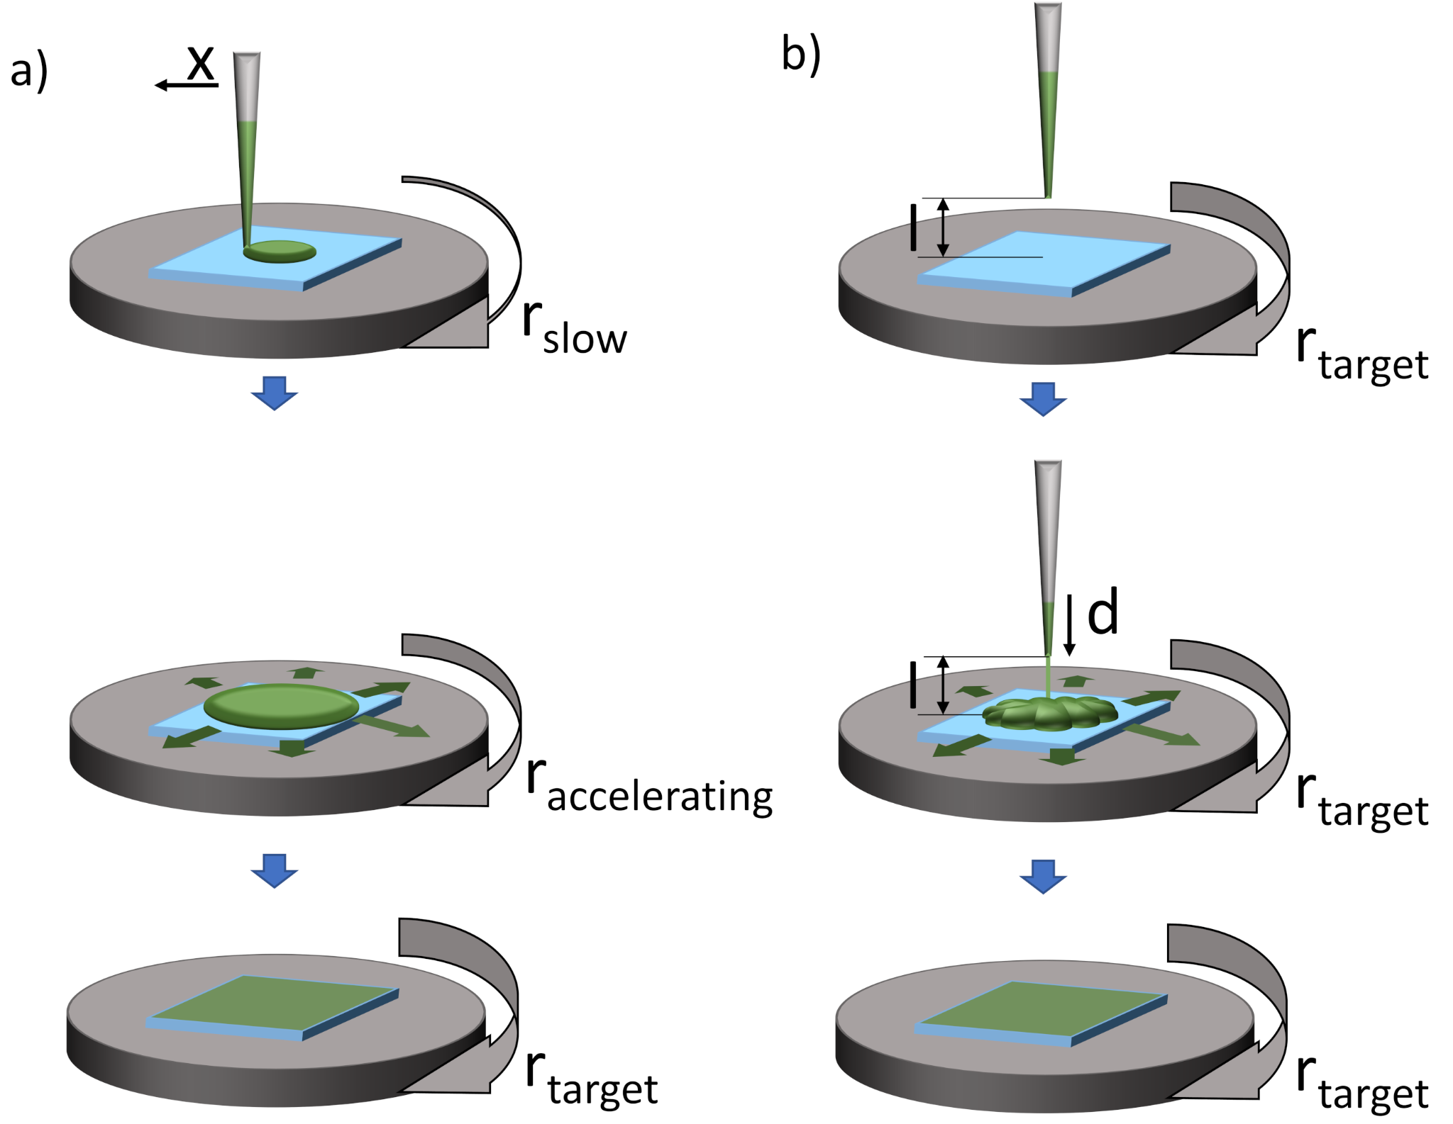
Fig. S1 The two spin coating modes available on L1: a) quasi static mode (on-the-fly) were the solution is distributed onto the substrate with dispense speed d, while the tip moves linearly over the substrates surface with speed x and the spin coater rotates slowly with velocity r_{slow}. The substrate then accelerates to the target velocity r_{target}. b) dynamic mode. The tip is in distance l over the substrate center, the spin coater is rotating at target velocity r_{target} while the solution is dispensed with dispense speed d

Table S1: List of all devices in L1 controlled by AMANDA.
Amount | Category | Device
5 | Infrastructure | Remote Controllable Power Distribution Unit
2 | Robot | Liquid Handling Robot (Hamilton Starlet)
2 | Robot | SCARA Robot
8 | Device | Heatshaker
1 | Device | Heatshaker with Gripping Mechanism
1 | Virtual | WaitDevice
1 | Virtual | MySQLDevice
1 | Virtual | TestDevice
1 | Virtual | TokenDevice
1 | Virtual | MachineLearningDevice
1 | Measurement | Industrial Grade Camera
1 | Measurement | UV VIS Spectrometer (Molecular Devices Spectramax M2e)
1 | Device | Solar Simulator (Wavelabs Sinus-70)
3 | Device | Magnetic Stirrer with Heating
2 | Measurement | Source Measurement Unit
1 | Robot | Rotation-Centric 6 Axis Robot
2 | Measurement | Scale
1 | Film Application | Doctor Blade
3 | Film Application | Spin Coater
1 | Device | Heat Sealer
13 | Infrastructure | Surveillance Cameras
1 | Device | Photo Light Table
4 | Sensor | Raspberry Pi + Sensors
8 | Connectors | RS232 to Ethernet Adapters
7 | Infrastructure | Gigabit Network Switches
3 | Infrastructure | Lights inside Glovebox
11 | Infrastructure | Network controllable relay
1 | Infrastructure | Signal Post
2 | Device | Hot Plate (in Sluice)
2 | Device | Sluice
7 | Infrastructure | Airlock Doors
1 | Device | XYZ-Stage
1 | Film Application | Evaporator (Leybold Univex 250)
1 | Film Application | Evaporator Film Controller
1 | Measurement | Measurement SMU Switch
48 | Stability | LED Light Controller
3 | Infrastructure | Radiator

Table S2: List of all processing tasks necessary to fabricate and characterize organic solar cells in AMANDA L1, ordered after their first occurence in the standard process (compare figure 4). Some of the steps appear multiple times at different stages during the process.
 | Task | Equipment Involved | parameters | Task description
1 | Register substrates and substrate carrier | AMANDA Control | substrate type | Generate a virtual entity for substrate carrier and its containing samples and assigns sample IDs
2 | Pick up substrate carrier | SCARA Transport Robot | carrier ID | Pick up a substrate carrier, identified by its ID
3 | Put down substrate carrier | SCARA Transport Robot | target position | Put the substrate carrier to the target position
4 | Pick up vial holder | SCARA Transport Robot | vial holder ID | Pick up a certain vial holder, identified by its ID
5 | Put down vial holder | SCARA Transport Robot | target position | Put the vial holder to the target position
6 | Turn on heat shaker | Hot plate | target Temperature, target shaker intensity | Set target temperature and shaker intensity of the hot plate and starts heating/shaking
7 | Pick up single substrate | Pipetting Robot | substrate ID | Pick up a substrate, identified by its ID
8 | Put down single substrate | Pipetting Robot | target position | Put substrate to target position
9 | Pick up pipetting tip | Pipetting Robot | tip size | Pick up next available pipetting tip of tip size
10 | Decap vial | Pipetting Robot | target vial | Open the target vial
11 | Aspirate solution | Pipetting Robot | target vial, volume, aspiration speed, mixing parameters | Aspiration of solution into the pipetting tip with the given parameters
12 | Dispense solution in vial | Pipetting Robot | target vial, volume, dispense speed | Dispensing of Solution into vial, e.g. for Mixing of multiple solutions
13 | Start spin coater | Spin coater | target velocity, acceleration, duration | Start the rotational movement of the spin coater with the given parameters
14 | Dispense solution onto substrate | Pipetting Robot | substrate ID, volume, dispense speed, distance from substrate, distance from substrate center | Dispense solution onto a substrate, the substrate can be still (=drop casting), or rotated by the spin coater (= dynamic spin coating)
15 | Dispense solution onto substrate -- on-the-fly | Pipetting Robot | substrate ID, volume, dispense speed, distance from substrate, movement speed of pipette | Dispensing solution onto a slowly rotating substrate in the spin coater while moving over it with the pipetting channel
16 | Stop spin coater | Spin coater | deceleration | Stop movement of spin coater
17 | Move to take out position | Spin coater | angle | The spin coater rotates to the angle where the substrate can be picked up by the robot arm
18 | Cap vial | Pipetting Robot | target vial | Close vial
19 | Trash tip | Pipetting Robot | - | Put pipetting tip into trash bin
20 | Pick up fresh cotton swab | Pipetting Robot | - | The pipette channel picks up a fresh cotton swab adaptor
21 | Wipe edges | Pipetting Robot | - | Movement of the attached cotton swab over the substrate to wipe off stripes of the coated film
22 | Put cotton swab back | Pipetting Robot | - | The cotton swab adaptor is put back into a rack of used adaptors, the cotton swabs in the adaptor will be replaced manually.
23 | Transport substrate carrier to free waiting position | SCARA transport robot | carrier ID | The transport robot picks up the carrier by its ID and puts it to a free waiting position
24 | Thermal annealing | Hot plate & SCARA transport robot | target Temperature, duration | The hot plate starts heating up to the target temperature. The transport robot then puts the substrate to the plate and leaves it there for the annealing duration
25 | Cool down samples | SCARA transport robot | - | The hot substrates are transferred to a cold metal surface.
26 | Take quality control image | Inspection camera & Light table | - | A picture of the whole substrate carrier is taken
27 | Crop individual samples | AMANDA calculations | sample ID | The edges of the samples are detected and the samples are cropped and saved into the DB referenced to the sample IDs
28 | Calculate layer homogeneity | AMANDA calculations | measurement ID | The texture of the cropped images of the samples is analyzed with the Gray-Level Co-Occurrence Matrix Method (GLCM)
29 | Measure Absorbance | UV-VIS Spectrometer | sample ID, start wavelength, end wavelength, step width | Measures an absorption spectrum at certain points on the sample with the given parameters
30 | Transfer carrier from Box2 to Box3 | SCARA transport robots | carrier ID | The carrier is moved through a sluice from Box2 to Box3 by both of the SCARA transpor robots
31 | Put shadow mask to carrier | SCARA transport robots | carrier ID, mask ID | A shadow mask is put onto the substrate carrier by the transport robot
32 | Turn carrier/mask stack | 6-axis robot | - | The stack of carrier/mask is turned around 180°
33 | Load carrier/mask stack to evaporation holder | SCARA transport robots | - | The stack of carrier/mask is loaded to a holder for the evaporator
34 | Open evaporator door | Evaporator | - | The flange door to the evaporator chamber is opened
35 | Load evaporation holder into evaporator | 6-axis robot | - | The evaporation holder is loaded into the evaporator
36 | Close Evaporator door | Evaporator | - | The flange door to the evaporator chamber is closed
37 | Evacuate evaporation chamber | Evaporator | target pressure | The pumping procedure starts and evacuates the evaporation chamber.
38 | Evaporate material | Evaporator | material, target thickness, evaporation rate, evaporation profile | The material is evaporated automatically. The rate is controlled by an internal PID control until the target thickness is reached
39 | Vent evaporation chamber | Evaporator | - | Evaporation chamber is vented with nitrogen
40 | Unload evaporation Holder from evaporator | 6-axis robot | - | The evaporation holder is unloaded from the evaporator
41 | Unload carrier/mask stack to evaporation holder | SCARA transport robot | - | The stack of carrier/mask is taken out of the evaporation holder
42 | take shadow mask from carrier | SCARA transport robot | - | The mask is taken away from the carrier by the SCARA transport robot
43 | Turn on Solar simulator | Solar simulator | light intensity | The lamp of the solar simulator is turned on with target intensity
44 | Drive sample into light beam | Linear stage | - | The substrates are located on a x-y-table which moves the active sample into the middle of the light beam
45 | Contact to sample | Linear stage | - | Electrical contact is made to the solar cells by a pin board
46 | Measure current-voltage characteristics | SMU | start voltage, end voltage, step width | A current-voltage sweep of the given parameters is applied to the solar cell
47 | Light induced degradation | LED light controller | light intensity, time, temperature | The substrates are put to a free degradation setup, light is turned on and the sample is degraded for the desired duration.
48 | Calculate solar cell performance | AMANDA Calculations | solar cell area | PCE, FF, J_{sc}, V_{oc}, R_{shunt} and R_{series} are calculated from the IV-curve
49 | Store substrate Carrier | SCARA transport robot | carrier ID | The carrier is transported to a storage tower
50 | Deregister substrates and carrier | AMANDA control | carrier ID | The substrates and the carrier are set to a non-active state and are virtually removed from the facility. Substrate IDs are persistend, the measured data will be still available

Fig. S2 a) Cotton swap adaptor mounted onto the pipetting channel, removing a small stripe of the coated layer to contact the transparent back electrode. b) Left: 1 ml vial capped with a fluorinated rubber cork adaptor, which can be picked up by a pipetting channel of the pipetting robot. Middle and right: Bare vial and two cork adaptors

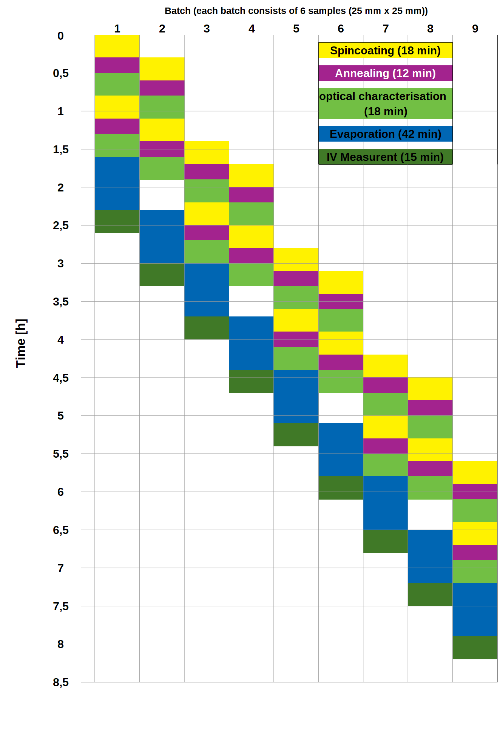
Fig. S3 Parallel processing of OPV devices on 9 substrate carriers (batches) with either 6 or 8 substrates per carrier and 6 solar cells on each substrate

