Supplementary: Optimisation of processing conditions during CVD growth of 2D WS₂ films from a chloride precursor
William R Campbell^{1,2,*}, Francesco Reale², Ravi Sundaram², Simon J Bending¹

¹Centre for Nanoscience and Nanotechnology, University of Bath, Claverton Down, Bath BA2 7AY, UK
²Oxford Instruments Plasma Technology, North End, Yatton, Bristol BS49 4AP, UK
*Corresponding author E-mail: wc500@bath.ac.uk

Thin film contamination
A primary reason as to why we chose WCl₆ as a precursor is that it has been shown in the literature that metal-organic precursors, such as W(CO)₆, can lead to a carbon contamination of the CVD grown films [1, 2]. This carbon contamination can lead to a partial PL quenching and a poor-stoichiometry WS₂ film which is more prone to oxidation. Because we use WCl₆ and H₂S as precursors, we form HCl as a by-product which is volatile at the growth temperature used. Due to this volatility, we observe no chloride contamination on our films, as confirmed by EDX measurements shown in Figure S1 a-d.
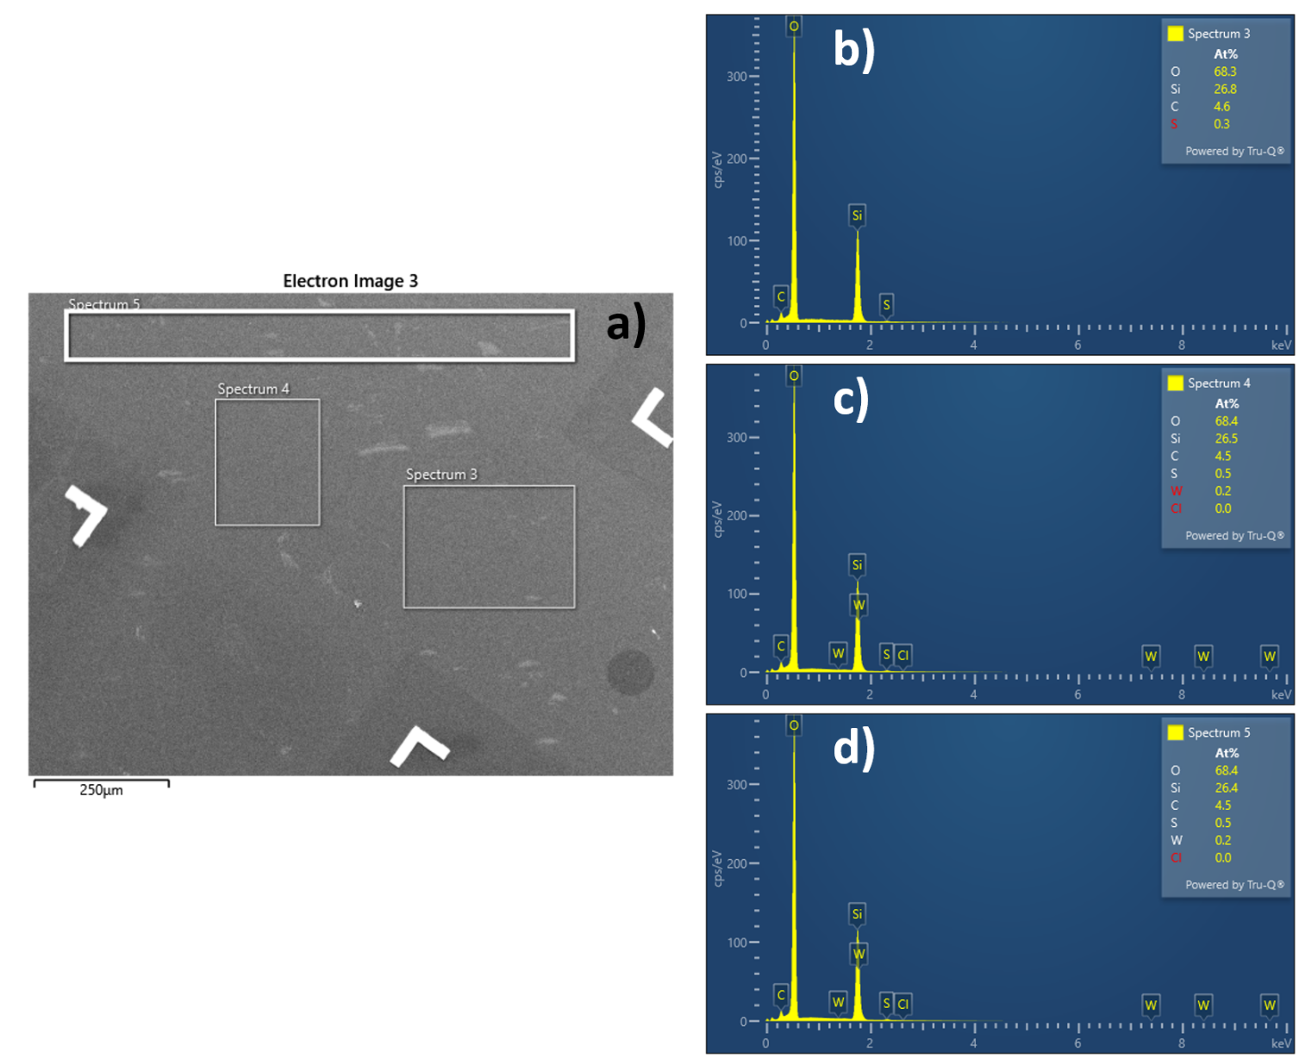
Figure S1 – (a) A SEM image of the CVD grown WS₂ film with markers depicting the EDX scan areas, (b-d) the corresponding EDX spectra showing that there is no chloride contamination.
Comparison of CVD methods
To benchmark our work, we compiled a detailed list of WS₂ growths via CVD. Our table includes the CVD method employed, the substrate and tungsten precursor used, and information of the WS₂ PL spectra. From this, we concluded that our films optical quality lies in the upper end of the values quoted in the literature.
Table S1 – A table highlighting the various CVD method employed to grow monolayer WS₂ and the associated PL peak positions of PL FWHMs observed.
Type of CVD | Substrate | Tungsten Precursor | PL Peak Position | PL FWHM | Reference
WCl₆
Powder CVD | Si/SiO₂/hBN | WCl₆ | 2.01eV | 26meV | ACS Nano 2014, 8, 8, 8273–8277
Gas phase CVD through bubbler | Si/SiO₂ | WCl₆ | 2.01 eV | 67meV | Nanoscale, 2015, 7, 1308-1313
Solid WCl₆ | Si/SiO₂ | WCl₆ | 1.960-2.014eV | 124meV | Nanoscale, 2015, 7, 650-658
W(CO)₆
MOCVD | Sapphire | W(CO)₆ | 2.00eV | 43meV | ACS Photonics 2019, 6, 8, 1832–1839
MOCVD gas phase precursor from bubbler | c-plane sapphire | W(CO)₆ | 1.99 eV | 60 meV | Cryst. Growth Des. 2018, 18, 4357−4364
GE-MOCVD | Si/SiO₂ and sapphire | W(CO)₆ | 1.99eV  2.01eV (Si/SiO₂)  2.00 (sapphire) | 40-90meV  69meV (Si/SiO₂)  55meV (sapphire) | https://arxiv.org/abs/2008.07150
MOCVD gas phase precursor | Si/SiO₂ | W(CO)₆ | Raman but no PL | Raman but no PL | Journal of Vacuum Science & Technology A 35, 061502 (2017)
MOCVD gas phase precursor | epi-G/SiC | W(CO)₆ | 1.99 eV | 27 meV | RSC Adv., 2015, 5, 98700-98708.
MOCVD gas phase precursor | Fused Silica | W(CO)₆ | 2.01 eV | 64 meV | Nature 520, 656 (2015).

WF₆
Gas phase CVD | Si/SiO₂ | WF₆ | 1.97eV | 48meV | Scientific Reports volume 9, Article number: 17678 (2019
Gas phase precursor | Si/SiO₂ | WF₆ | 2.01 eV | 60 meV | IEEE Journal of the Electron Devices Society 6, 1159 – 1163 (2018)
Gas phase precursor | Si/α-Al₂O₃ | WF₆ | 2.01 eV | 83 meV | J. Chem. Phys. 150, 104703 (2019);
WO₃
Low-pressure CVD | Sapphire  Si/SiO₂ | WO₃ | ~1.97eV  ~1.98 eV | ~76 meV  ~100 meV | 10.1021/nn403454e
APCVD | Sapphire | WO₃ | 1.997eV  (~621 nm) | 13.3nm  (~43 meV) | ACS Nano 2015, 9, 6, 6178–6187
APCVD | Si/SiO₂ | WO₃ | 1.949eV  (~636 nm) | 19.8nm  (~61 meV) | ACS Nano 2015, 9, 6, 6178–6187
Thin film sulpherisation | Sapphire | WO₃ | ~2.01 eV | 53meV | ACS Nano 2015, 9, 4, 4056–4063
Powder CVD | Si/SiO₂ | WO₃ | 1.95-2.0eV | 40-68meV | 10.1016/j.mssp.2018.12.035
Powder CVD | Si/SiO₂ | WO₃ | ~1.97eV  (~926 nm) | ~14nm  (~44 meV) | https://doi.org/10.1002/adom.201300428
Powder CVD + PTAS | Si/SiO₂ | WO₃ | 1.96eV | 35meV | https://doi.org/10.1038/srep19159
Powder CVD + NaCl | Si/SiO₂ | WO₃ | 1.98eV | 36meV | https://doi.org/10.1038/srep19159
Powder CVD | Si/SiO₂ | WO₃ | 1.98eV | ~54 meV | Chem. Mater. 2017, 29, 11, 4904–4911
Powder CVD | Si/SiO₂ | WO₃ | 1.95eV | 47meV | ACS Nano 2013, 7, 12, 10985–10994
Powder CVD | Si/SiO₂ | WO₃ | ~1.97 eV | 61meV | ACS Nano 2015, 9, 4, 4056–4063
Powder CVD | Graphite | WO₃ | ~1.99 eV | 21meV | ACS Nano 2015, 9, 4, 4056–4063
Powder CVD | hBN | WO₃ | ~2.02 eV | 22meV | ACS Nano 2015, 9, 4, 4056–4063
AMT
Tube furnace powder CVD | Si/SiO₂ | Ammonium metatungstate hydrate (AMT) | 1.96-1.98eV | ~45meV | ACS Nano 2016, 10, 2, 2399–2405
WS2 powder
Powder CVD | Si/SiO₂ | WS2 powder and Sodium triosulfate | 1.95eV | ~100 meV | RSC Adv., 2019,9, 29628-29635
Mechanically exfoliated WS2 + encapsulation
Mechanical Exfoliation | Si/SiO₂/hBN | WS2 crystal | 1.98eV | 23-25meV | Phys. Rev. X 7, 021026

CVD WS₂ on Si/SiO₂ substrates
Alongside the WS₂ growth on sapphire, we developed a process of direct deposition of WS₂ monolayers onto Si/SiO₂ substrates. The thickness of the SiO₂ was 297nm. In contrast to the growths on sapphire, the WS₂ optical quality continues to increase above a 20sccm H₂S anneal, reaching a maximum at 40sccm (the safety limit of the CVD reactor), as seen in Figure S2a. In Figure S2b, we show a direct comparison of the best growths on sapphire and Si/SiO₂. The difference in FWHM (51meV on sapphire, 83meV on Si/SiO₂) is obvious in Figure S2b, with the growth on sapphire being superior. We attribute this to growth on sapphire being an epitaxial process. We also attribute the peak position difference to substrate doping [3].
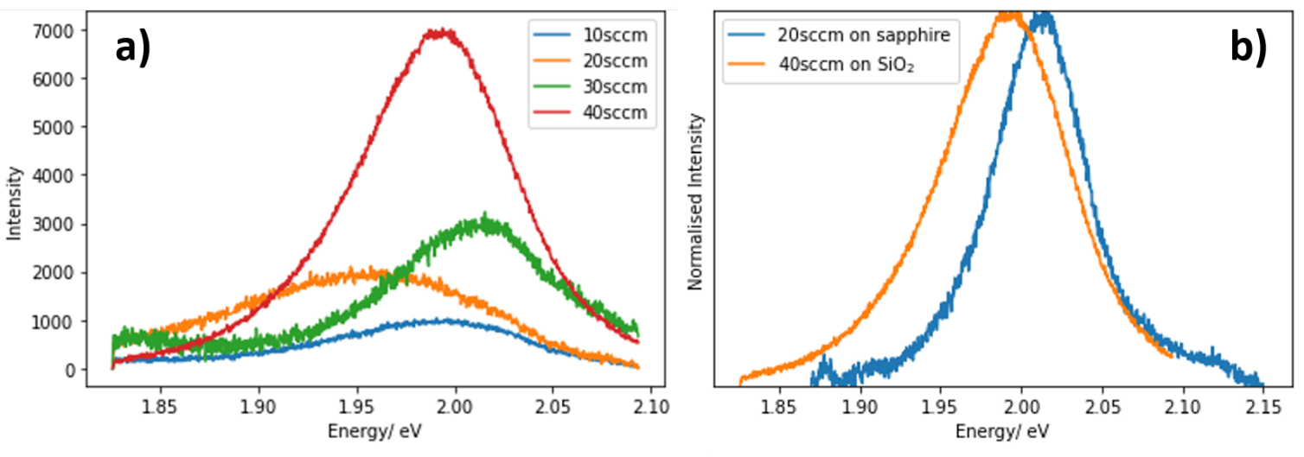
Figure S2 – (a) PL spectra of the four annealing tests on Si/SiO₂ growth substrates, (b) Normalised PL spectra comparing the optimised growths on sapphire and Si/SiO₂.
Fitting of photoluminescence peaks
The fitting of our PL data was largely determined using the reduced chi-square statistic, $χ_{v}^{2}$. In goodness of fit testing, a $χ_{v}^{2}$ >> 1 indicates a poor model fit, a $χ_{v}^{2}$ > 1 indicates that the data has not been fully modelled by the fit, a $χ_{v}^{2}$ ≈ 1 indicates that the fit is good and is in accord with the error variance, and a $χ_{v}^{2}$ < 1 indicates that that the data has been “over-fit” i.e., the contributions to the model are improperly fitting noise or the error variance has been overestimated.
For our fitting, we used the inbuilt peak fitting programme that is packaged with the Renishaw inVia Wire software. The fitting method can be diverse, so we chose a Voigt function that in turn produced 100% Gaussian fits, which is what we expected and is commonplace throughout the literature.
Furthermore, it has been shown that different substrates can induce defect-related trion peaks in WS₂ films [4]. This is most noticeable on Si/SiO₂ substrates where hole traps can be present in the oxide layer. In the case of sapphire, the wafers we used are high-quality and single crystal in nature and we do not expect them to contain a significant density of hole traps, hence they should only exhibit neutral exciton and free trion peaks, similar to the WS₂ samples on hBN of reference [4].
In contrast, after transferring our WS₂ films to Si/SiO₂, we need to consider hole traps in the substrate as our measurements are performed at a relatively high optical power density (2mW laser power, 2μm laser spot), but with a very low accrual time of 1s. In Figures S3-S6, we show Voigt fits of our transferred WS₂ PL data ranging from a single peak fit in S3 to a four-peak fit in S6 where we attempt to capture possible defect-induced DT_{A} and DT_{B} trion peaks. It is clear from our $χ_{v}^{2}$ values that a two peak Gaussian fit is superior to the other as it has a chi-square very close to a value of 1. Hence, we find no evidence for the presence of defect-induced trion peaks in these spectra.
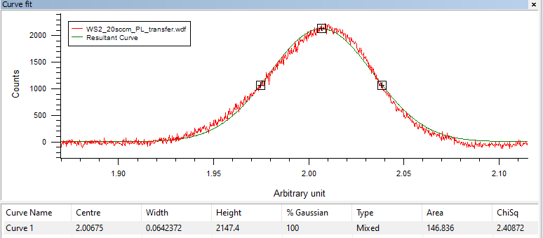
Figure S3 – A single peak Voigt fit of the WS₂ PL spectrum after transfer onto Si/SiO₂. The $χ_{v}^{2}$ >> 1 indicates that the fit is poor. It is also visually obvious that a single peak fit is incorrect.
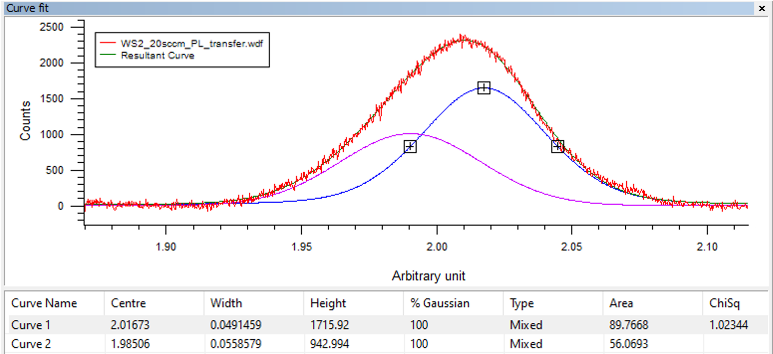
Figure S4 – A double peak Voigt fit of the WS₂ PL spectrum after transfer onto Si/SiO₂. The $χ_{v}^{2}$ ≈ 1 indicates that the fit is very good.
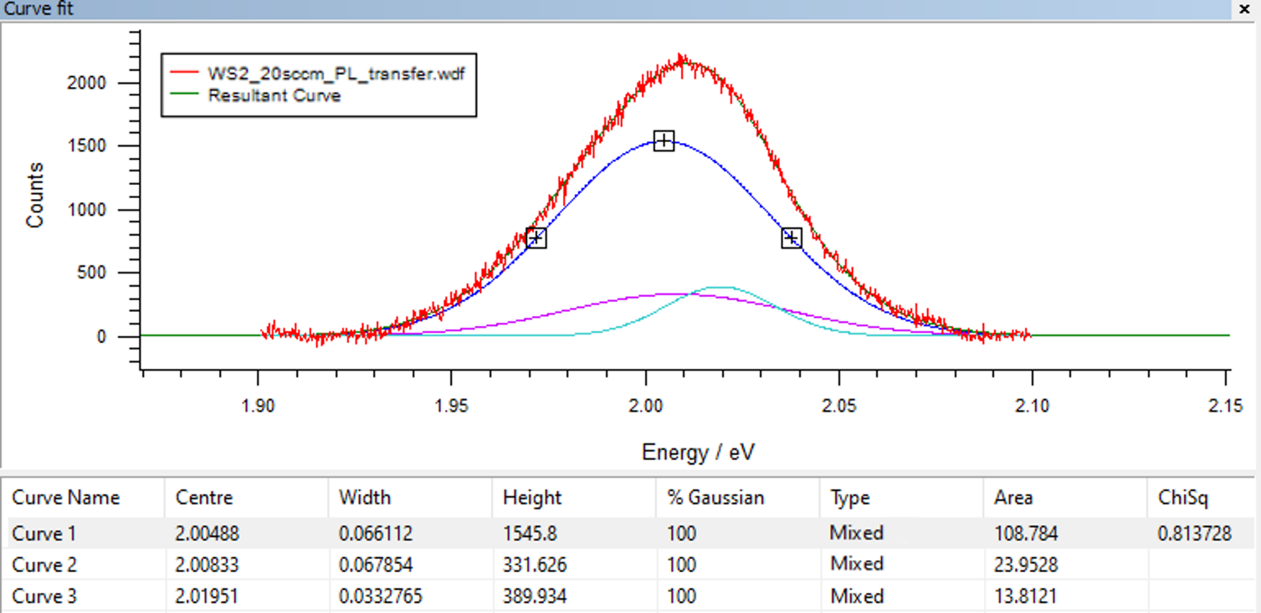
Figure S5 – A triple peak Voigt fit of the WS₂ PL spectrum after transfer onto Si/SiO₂. Here we try to incorporate the defect-induced trion peak DT_{A} (purple), but the overall fit is poor. The $χ_{v}^{2}$ < 1 indicates that the data is overfit.
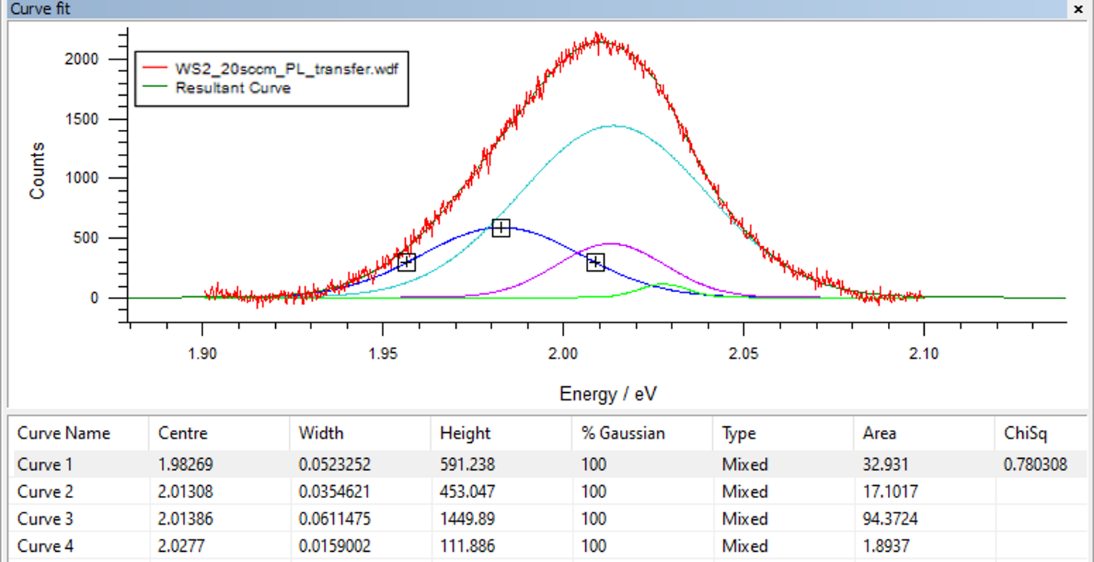
Figure S6 – A four peak Voigt fit of the WS₂ PL spectrum after transfer onto Si/SiO₂. Here we try to incorporate the defect-induced trion peaks DT_{A} (purple) and DT_{B} (blue) but the overall fit is poor. The $χ_{v}^{2}$ < 1 indicates that the data is overfit.
References
1. Zhang X, Al Balushi ZY, Zhang F, et al (2016) Influence of Carbon in Metalorganic Chemical Vapor Deposition of Few-Layer WSe₂ Thin Films. J Electron Mater 45:6273–6279. https://doi.org/10.1007/s11664-016-5033-0
2. Choudhury TH, Simchi H, Boichot R, et al (2018) Chalcogen Precursor Effect on Cold-Wall Gas-Source Chemical Vapor Deposition Growth of WS₂ . Cryst Growth Des 18:4357–4364. https://doi.org/10.1021/acs.cgd.8b00306
3. Yin H, Zhang X, Lu J, et al (2020) Substrate effects on the CVD growth of MoS2 and WS2. J Mater Sci 55:. https://doi.org/10.1007/s10853-019-03993-9
4. Riya Sebait, Chandan Biswas, Bumsub Song, Changwon Seo, and Young Hee Lee (2021) Identifying Defect-Induced Trion in Monolayer WS₂ via Carrier Screening Engineering. ACS Nano 15, 2849-2857. https://dx.doi.org/10.1021/acsnano.0c08828

