Supplementary Figure 1:
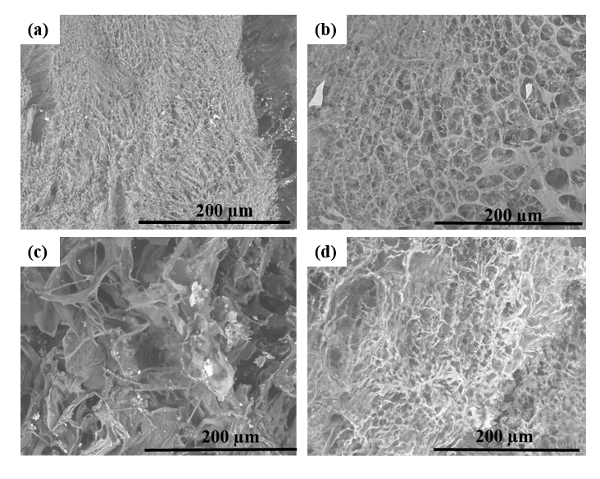
SEM images of (a-d) HA-2, HA-2-RADA-1, HA-2-RADA-5 and HA-2-RADA-10
SEM images of HA-2 and the IPNs of this hydrogel did not show any aligned or arranged porous structure; it was porous, but the porosity did not have any orientation. With the addition of RADA-1 to HA-2, the pores swelled, and their size increased. When the concentration of RADA was increased to 5 mg/ml, the porous structure collapsed, and this concentration of RADA was not effective for fabricating a porous structure. In the case of HA-2-RADA-10, with a RADA concentration of 10 mg/ml, the porous structure was similar to the porous structure of HA-2, and HA-2 and RADA-10 together generated an IPN with a structure similar to HA-2. It appears that IPN hydrogels were not formed using HA-2, so the other characterization techniques were applied only for HA-1 IPN hydrogels.

