Supplementary information
Fig. S1 SEM image of Al-Si binary alloys. (a) Al-3Si, (b) Al-5Si, (c) Al-7Si, (d) Al-9Si, (e) Al-12Si.

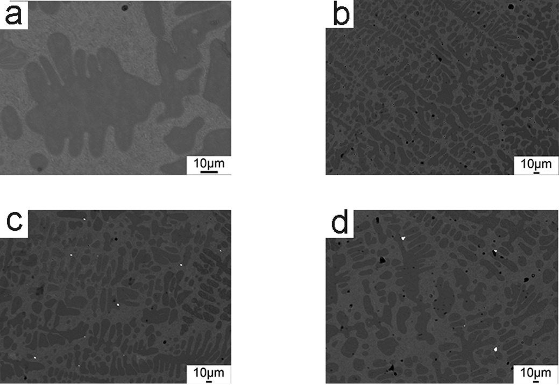
Fig. S2 SEM image of Al-9Si-Sr alloys with the addition of (a) 4ppm Sr, (b) 56ppm Sr, (c) 244ppm Sr, (d) 614ppm Sr.

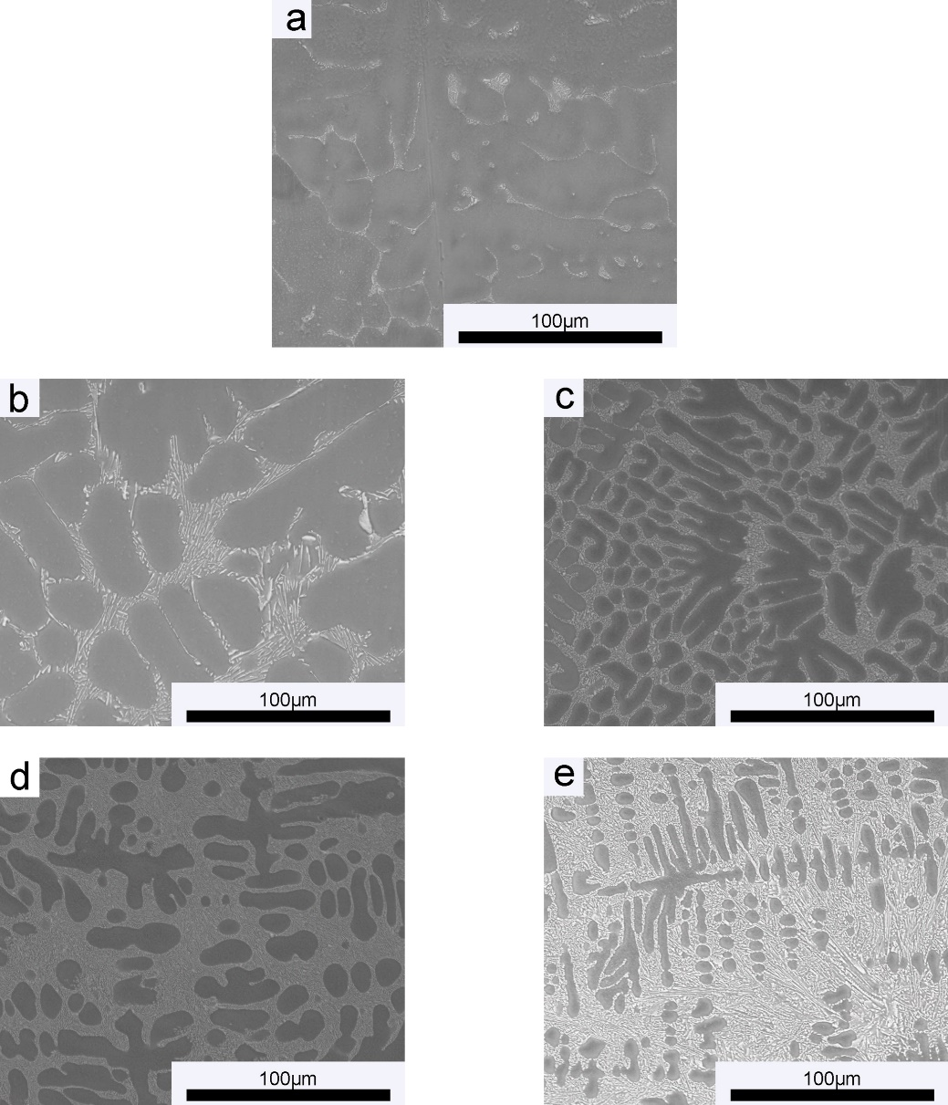
Fig. S3 SEM image of Al-Si binary alloy at 1000× magnification. (a) Al-3Si, (b) Al-5Si, (c) Al-7Si, (d) Al-9Si, (e) Al-12Si.

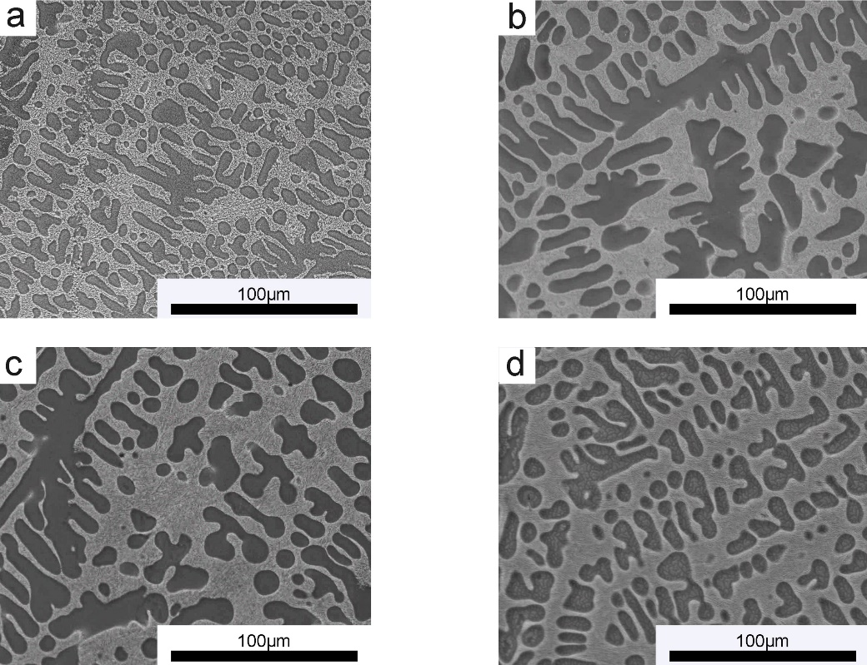
Fig. S4 SEM image of Al-9Si-Sr ternary alloy at 1000× magnification with the addition of (a) 4ppm Sr, (b) 56ppm Sr, (c) 244ppm Sr, (d) 614ppm Sr.

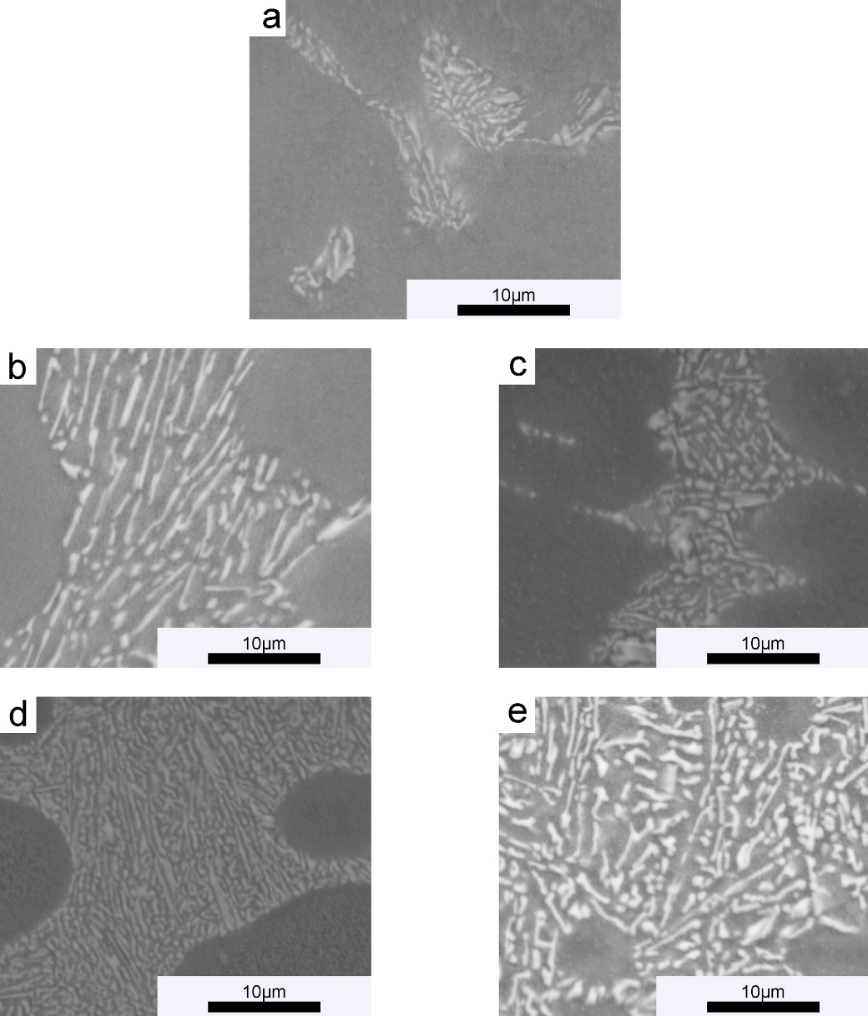
Fig. S5 SEM image of Al-Si binary alloys at 6000× magnification. (a) Al-3Si, (b) Al-5Si, (c) Al-7Si, (d) Al-9Si, (e) Al-12Si.

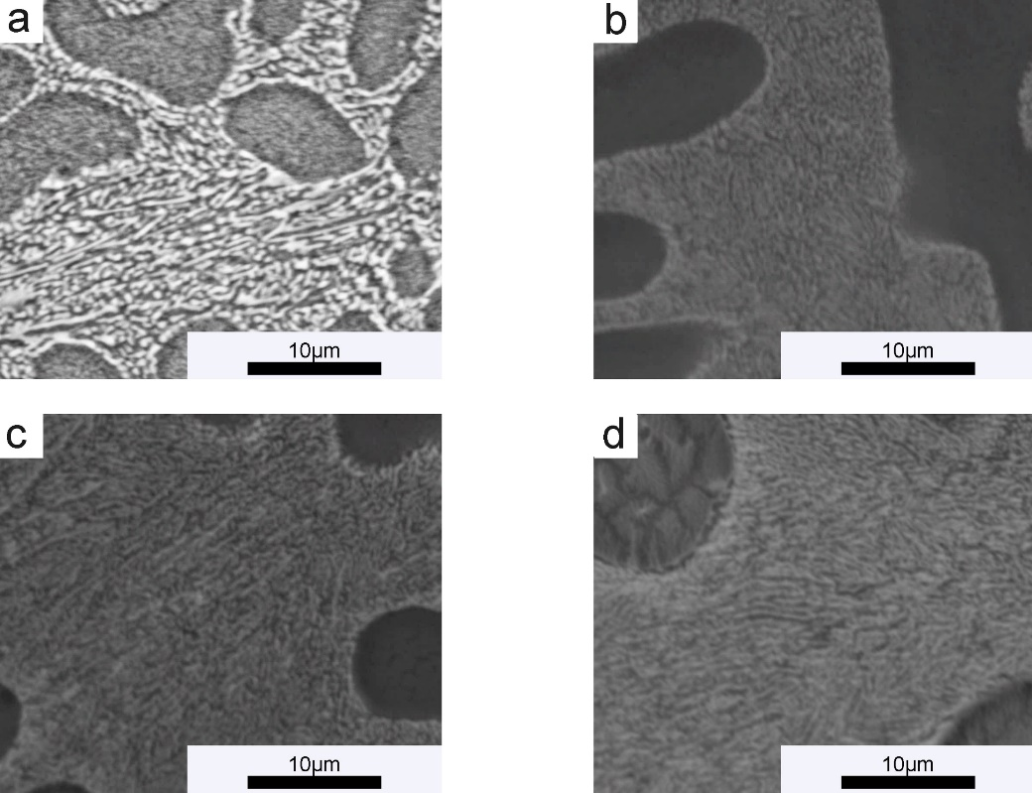
Fig. S6 SEM images of Al-9Si-Sr ternary alloy at 6000× magnification with the addition of (a) 4ppm Sr, (b) 56ppm Sr, (c) 244ppm Sr, (d) 614ppm Sr.

