Supplementary information:
Supplementary Figure 1. Additional dilatometry measurements (and cooling rates) confirming the influence of 0.23% Mo on lowering the M_{s} temperatures during cooling.
Supplementary Figure 2. (a) Lath substructure in the Nb steel showing regions of long (red) and short twins (blue). (b) Lath substructure from a different area in the Nb steel showing long twins along lath boundaries, (c) shorter twins across laths (indicated by yellow arrows).

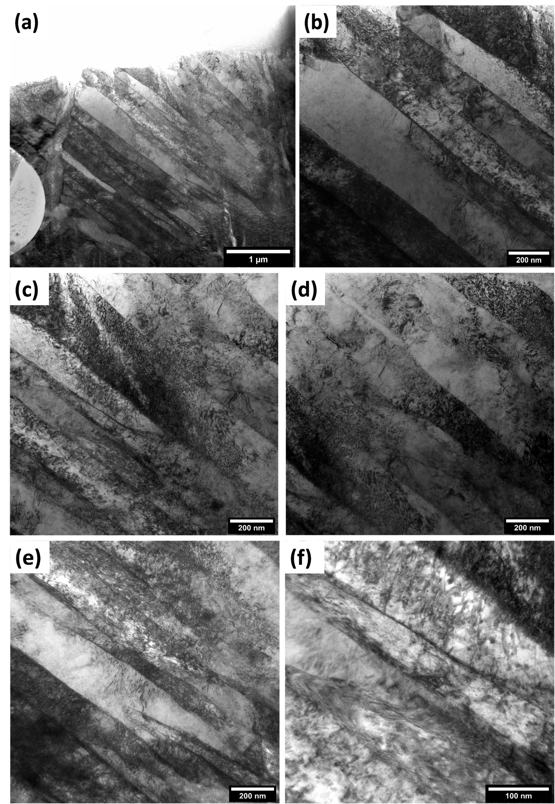
Supplementary Figure 3. (a) NbMo steel lamella overview TEM micrograph, (b) typical NbMo steel lath substructure. (c-f) Additional images showing the absence of twins in the Nb Mo steel in other regions.

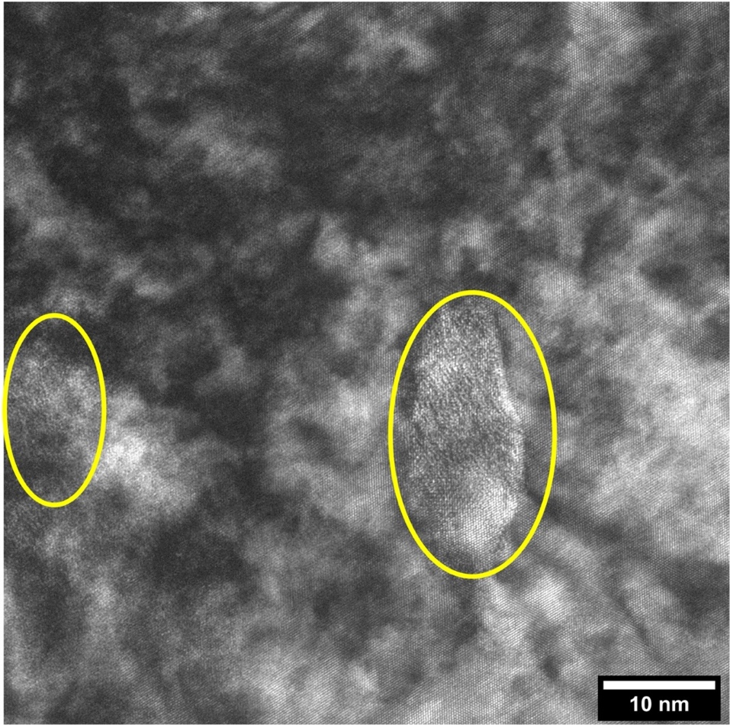
Supplementary Figure 4. Presence of fine precipitates near a short twin region in the Nb steel as evidenced by Moire interference in HRTEM.

