Controllable Si oxidation mediated by annealing temperature and atmosphere
Feitao Li¹, Dong Wang^{1,} *, Malte Klingenhof², Dominik Flock¹, Honglei Wang¹, Peter Strasser², Peter Schaaf¹
¹ TU Ilmenau, Chair Materials for Electrical Engineering and Electronics, Institute of Materials Science and Engineering and Institute of Micro- and Nanotechnologies MacroNano, Gustav-Kirchhoff-Strasse 5, 98693 Ilmenau, Germany
² TU Berlin, Department of Chemistry, Chemical Engineering Division, 10623 Berlin, Germany
*Corresponding authors: dong.wang@tu-ilmenau.de (D. Wang)

Figure S1 Experimental temperature profiles for the isothermal treatments in RTP at 500, 650, 800, 950 and 1050 ℃ for 1 min holding time, respectively. The dashed line corresponds to the Au-Si eutectic temperature (～363 ℃)

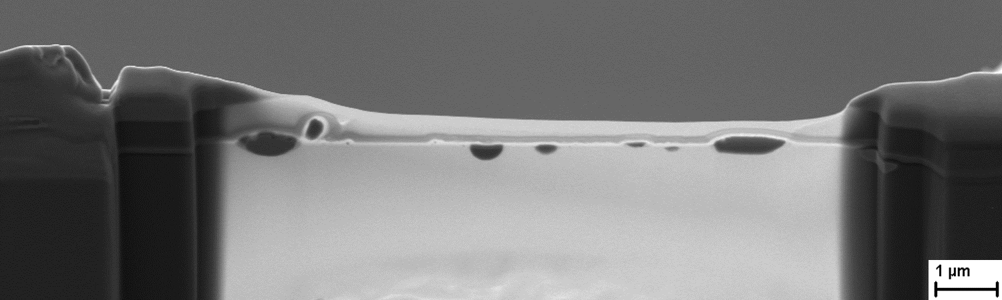
Figure S2 Cross section of TEM lamella for 800-H, and the STEM-EDS mapping of one particle is shown in Figure 2(a).

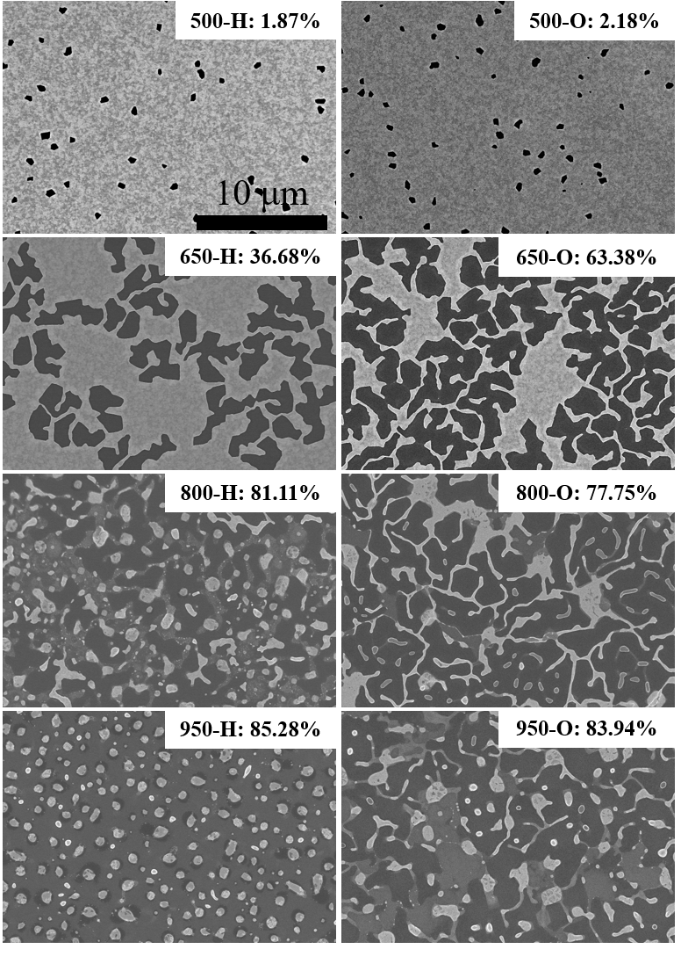
Figure S3 SEM micrographs in plan view for the various dewetted samples. Temperature and atmosphere are stated. Percentages of dewetting (dewetted area/total area, as analyzed by ImageJ) are shown in the upper right corners of each micrograph.

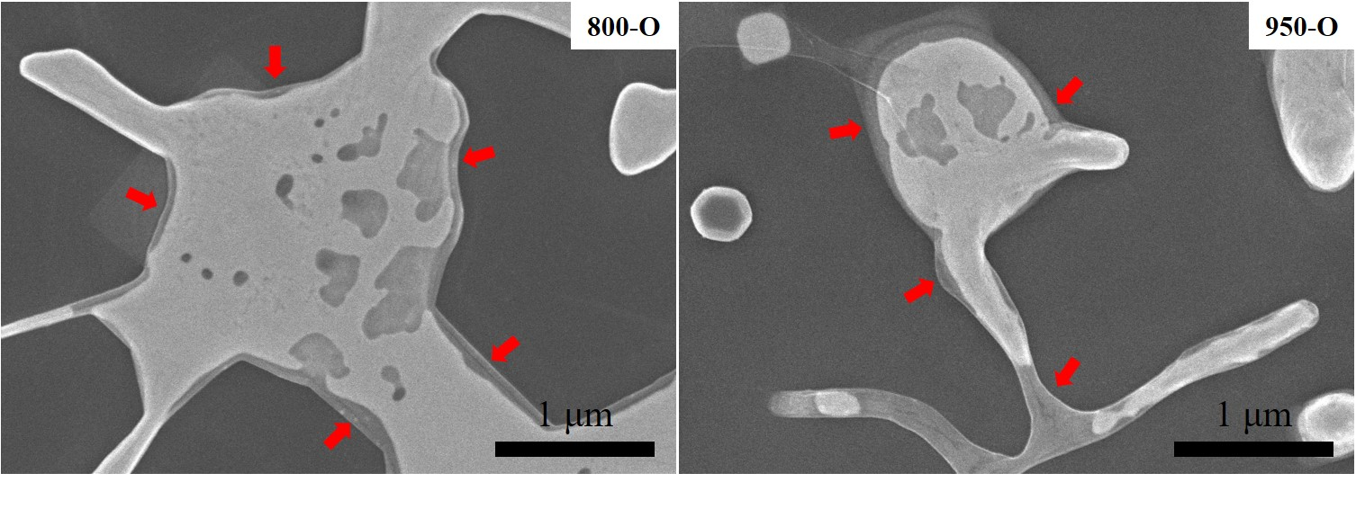 Figure S4 Enlarged details of local areas in Figure 3(c, d). Thin covering layers are marked by arrows.
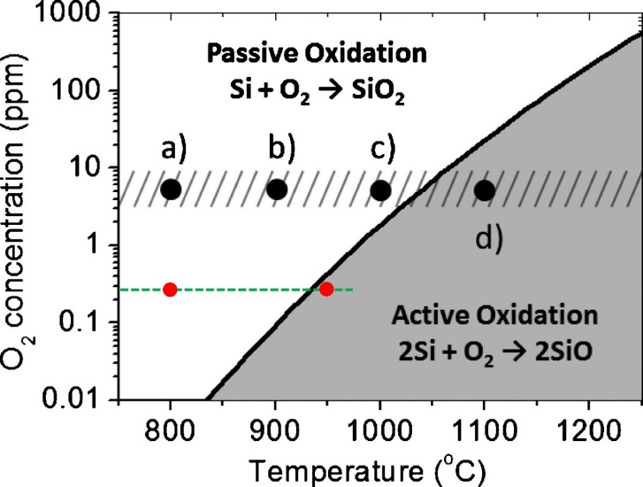
Figure S5 Phase diagram showing the oxidation of Si as a function of O₂ concentration and temperature. Reprinted from Ref. [19] in main text with permission from AIP publishing.

The existence of Si active oxidation:
A diagram in Figure S5 shows the oxidation of Si as a function of O₂ concentration and temperature.
In the present work, the purities of used Ar and H₂ are 6.0N (99.9999%) and 5.0N (99.999%), respectively. The volume ratio of Ar and H₂ is 30:1. The partial oxygen pressure should be related to the residual gas and to the impurities of the Ar and H₂, and it can be estimated as follow:
$\frac{V_{O2}}{V_{total}}=\frac{p_{O2}}{p_{total}}$ (1)
As we use Ar and H₂ in a 30:1 volume ratio, we can consider that we have 31 parts of volume. In the case of Ar, a purity of 99.9999% leads to a 0.0001% of impurities, and the same applies to H₂. Assuming that the impurities of the gases are air, with a 21% of oxygen, the amount of oxygen in those 31 parts can be estimated as:
$21\%\left(V_{Ar}·{impurities}_{Ar}+V_{H2}·{impurities}_{H2}\right)=\frac{21}{100}\left(30·{10}^{-6}+1·{10}^{-5}\right)=8.4·{10}^{-4}$
parts of oxygen in 31 parts of volume.
From eq. (1) the partial pressure of oxygen in our chamber during the annealing process will be:
$p_{O2}=p_{total}·\frac{V_{O2}}{V_{total}}=1 bar·\frac{8.4·{10}^{-4}}{31}= 2.7·{10}^{-7} bar=0.27 ppm$
As marked in the diagram (red dots), the value (0.27 ppm) is lower than the critical partial pressure (0.4 ppm) that allows for the active oxidation of Si at 950 °C. This means that the annealing parameters that we used make the Si active oxidation possible at 950 °C. By contrast, this value is much larger than the critical partial pressure at 800 °C, and, therefore, stripe-like structures (SiO_{x}) can be observed in 800-H since the Si passive oxidation happens at 800 °C.

