Supporting information
High degree of N-functionalization in macroscopically assembled carbon nanotubes
Ruairi J. M^{c}Glynnª, Paul Brunetª, Supriya Chakrabartiª, Adam Boies^{b}, Paul Maguireª, Davide Mariotti^{a*}
ªNanotechnology and Integrated Bio-Engineering Centre (NIBEC), Ulster University, Newtownabbey BT37 0QB, United Kingdom
^{b}Department of Engineering, University of Cambrdige, CB2 1PZ, UK
*Corresponding authors: Tel: +44 28 9536 5266. E-mail: d.mariotti@ulster.ac.uk

Forming the “ribbons”
To produce the CNT ribbons in this work, gas flows of 116 standard cubic centimeters per minute (sccm) of hydrogen through the ferrocene bubbler, 90 sccm of hydrogen through the thiophene bubbler, a methane flow rate of 160 sccm and a carrier hydrogen flow rate of 1470 sccm are flown through a tube furnace held at 1290 °C. The as-collected web-like samples were further processed by mechanical pressing to form the shape of a ribbon as shown in Figure S1. The term “ribbon” is used to describe the material obtained by pressing the macroscopic CNT between two glass microscope slides for 10 minutes under a 2 kg load to create a flat ribbon-like material.
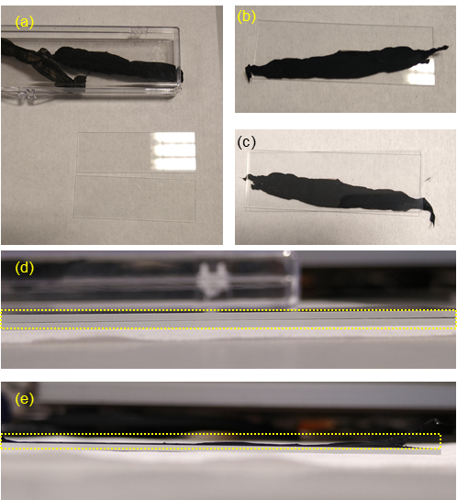
Figure S1 Photographs of the process to press the carbon nanotube aerogel as collected into a ribbon-like material. (a) The as-collected materials and two glass microscope slides. (b) The CNT is laid on a glass slide with a second sandwiched on top (c). (d) shows the cross-section of the slide-CNT-slide assembly and (e) is indicative of the compressed CNT ribbon on top of a single slide, with the dotted yellow lines showing the position of the CNT.

Alternative plasma-induced non-equilibrium electrochemistry configurations
In addition to the plasma treatment described in the main manuscript, two more configurations of plasma-liquid treatment have been used in this work, with schematic diagrams presented in Figure S2. Alongside Figure S2 (a) where the CNT is free to float in the solution, in Figure S2 (b) the CNT can be secured in a PTFE holder and placed at the bottom of the container, but not used as a cathode. It is of note that the CNT ribbon placed within the solution will move randomly until it contacts the submerged anode. After contacting this electrode, the ribbon aligns in the direction of the plasma discharge, schematically shown in Figure S3. Once within the discharge region, the plasma appears to shift toward the CNT ribbon, seemingly discharging directly to the ribbon instead of through the solution.
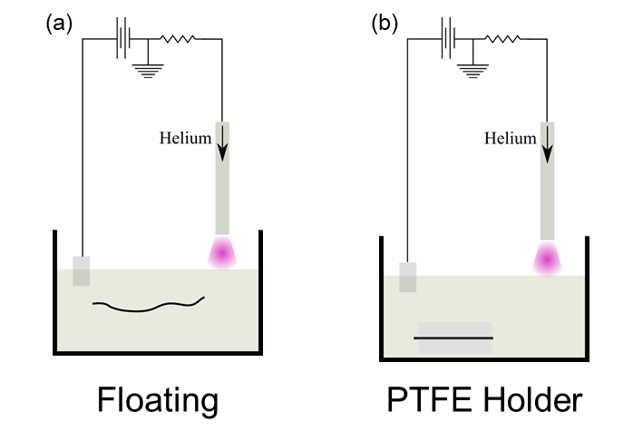
Figure S2 The different configurations of the plasma-induced non-equilibrium electrochemistry system used to treat the ribbons. (a) Floating ribbon and (b) ribbon held in place.

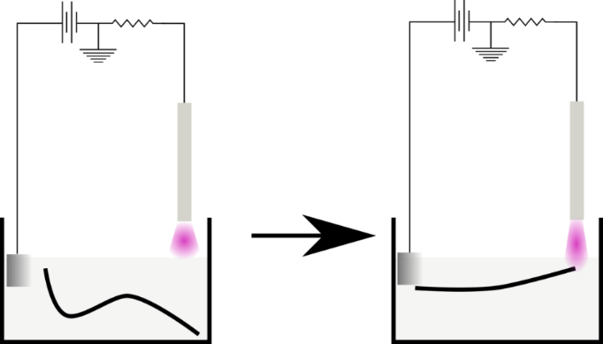
Figure S3 Alignment of the carbon nanotube ribbons under the influence of plasma discharge above the liquid.

Nitrogen-doping of the carbon nanotube ribbons

Additional results and tables
When submerged in the electrolyte solution and subsequently removed, the CNT ribbon undergoes shrinkage, becoming both thinner and narrower as the evaporating electrolyte draws the individual CNT together. SEM micrographs (Figure S4) show the dramatic reduction of the thickness of a representative ribbon before and after the treatment. The shrinkage in this example is found to be about 7-fold, with the average thickness of the pristine ribbon reducing from 1.86 µm to approximately 0.28 µm after treatment. Not all the ribbons undergo the same degree of shrinkage, with no clear link to the electrolyte composition.
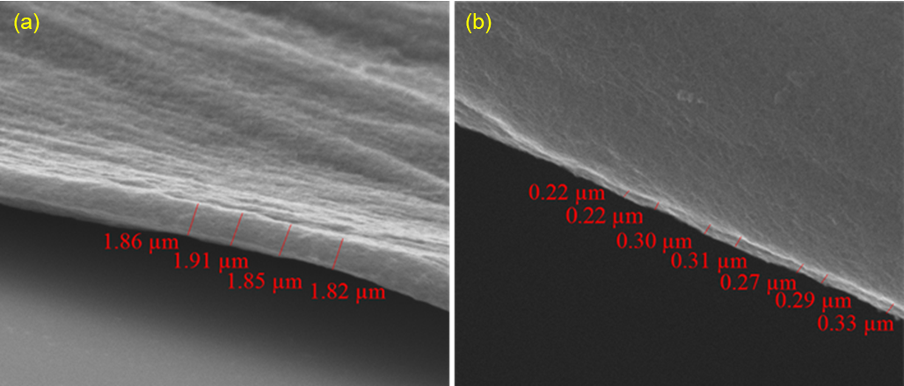
Figure S4 Carbon nanotubes ribbons before (a) and after (b) treatment under a 10 mA microplasma for 10 minutes within a solution of 1 mL ethanol and 9 mL of distilled water. A dramatic reduction of the ribbon thickness is observed.

Figure S5 Raman spectroscopy plots for the carbon nanotube ribbons which have undergone various treatments.
Figure S6 Survey spectra for carbon nanotube ribbons in a variety of ethylenediamine concentrations treated by PiNE and compared against a soaking and electrolysis treatment.
Figure S7 illustrates that increasing the concentration of EDA does not appear to enhance the total nitrogen content of the CNT ribbon after being treated as an electrode. Here we see that increase the EDA concentration above 10 vol% actually results in a diminishment of the nitrogen that can be grafted into the CNT ribbons. Possible reasons for this effect could be the saturation of defect sites or scavenging of radicals that could have yielded more defects by the additional EDA molecules. Additionally, changes to the local chemical environment may occur, such as plasma-generated species, EDA ion content, solution conductivity and pH. The decomposition of each EDA molecule may also be reduced due to the higher content.
Figure S7 Atomic percentage of nitrogen based on the initial ethylenediamine content of the electrolyte in the case where the CNT ribbon behaves as an electrode.
Table S1 The extreme limits found in the literature for the peak center for different bonding types within a high-resolution N 1s scan. These extremes were programmed as limits for the mathematical fitting of the obtained spectra.
Bond | Peak center (eV) |  | References
Bond | Lower limit | Upper limit | References
Pyridinic | 398.3 | 399.1 | [1–8]
Amine | 399.3 | 399.9 | [1,7]
Pyrollic | 400.0 | 400.6 | [1,3,5–7]
Graphitic | 400.7 | 401.4 | [1,3–6,8]
Pyridinic N-oxides | 402.0 | 403.2 | [1,3,4,8,9]

Further analysis of the N 1s fitted peak areas with the 2.5 vol% and 5 vol% EDA given in Figure S8. In all cases the PiNE treatment can be seen to give peak areas with several thousand Counts per second eV (CPSeV) more than the “soaked” sample.
Figure S8 The atomic percentage of nitrogen measured by x-ray photoelectron spectroscopy for samples treated in by plasma in 2.5 vol% and 5 vol% ethylenediamine solutions.

Floating ribbons
Figure S9 Raw raman spectrographs for carbon nanotube ribbons treated as a floating ribbon in a cylinder with one platinum electrode and a counter-electrode of a microplasma discharge.

In terms of the G:D ratio, Table S2 and Figure S10, all of the plasma-treated samples show decreases. There is no difference, beyond random variation, before and after the soaking treatment.
Table S2 The data sets used to calculate the normalized values for g-band to d-band area ratios.
EDA concentration (vol%) | G:D ratio
EDA concentration (vol%) | Pristine | After treatment
Floating
2.5 | 1.3±0.4 | 1.1±0.2
5 | 1.3±0.3 | 1.2±0.2
10 | 1.2±0.4 | 1.1±0.3
Soaked
10 | 1.1±0.3 | 1.1±0.2

Figure S10 G band to D band ratios for ribbons in the floating configuration treated in solutions containing varying concentrations of ethylenediamine normalized against the values for a pristine ribbon. The dashed lines enclose plus or minus 1 standard deviation from the average pristine value.

Figure S11 X-ray photoelectron survey spectra for ribbons allowed to float freely and treated by a microplasma discharge over the electrolyte for a variety of ethylenediamine concentrations.
The at% of nitrogen measured by XPS, Figure S12, both soaked and plasma samples, though plasma samples have a slightly higher inclusion of nitrogen. This implies that the availability of the nitrogen species is enhanced to a degree for the plasma-treated samples.
Figure S12 The atomic percentage of nitrogen determined from the region area of the narrow spectra obtained by x-ray photoelectron spectroscopy at 20 eV pass energy.

Ribbons secured with a PTFE holder
Figure S13 Representative raman spectroscopy plots for ribbons secured in place by a PTFE holder but not connected as the anode.
The Raman data collected in Table S3 (Figure S14) shows there is no difference, beyond random variation, between the samples treated by plasma and those soaked in the solution, with the G:D ratio remaining at approximately 1.
Table S3 A summary of the raw data used to compute the normalized values for conductivity, cross-sectional area and g-band to d-band area ratios.
EDA concentration (vol%) | G:D ratio
EDA concentration (vol%) | Pristine | After treatment
PTFE holder
2.5 | 1.2±0.4 | 1.0±0.3
5 | 1.0±0.3 | 1.1±0.4
10 | 0.9±0.3 | 0.9±0.3
Soaked
10 | 1.1±0.3 | 1.1±0.2

Figure S14 G band to D band ratios for ribbons secured by a PTFE holder and treated in solutions containing varying concentrations of ethylenediamine normalized against the values for a pristine ribbon. The dashed lines enclose plus or minus 1 standard deviation from the average pristine value.

Figure S15 X-ray photoelectron survey spectra of ribbons secured in place by a PTFE block, but not connected as the anode to the system.
The XPS data, Figure S16, elucidates that the nitrogen content is significantly increased for both soaked and plasma-treated samples. The difference between soaked and plasma is low with an overlap of the bounds of ± 1 S.D.
Figure S16 X-ray photoelectron spectroscopy region area percentages plotted for nitrogen with samples treated in ethylenediamine solution, whilst secured within the PTFE holder.

Comparing the configurations
Figure S17 Raman spectroscopy plots of the different functionalisation methodologies used throughout this work at a fixed 10 vol% EDA concentration.
As mentioned in the main manuscript, XPS measurements have revealed that the soaked samples appear to have increased nitrogen content, despite having no exposure to a plasma and may be binding to existing lattice defects, Figure S19. By treating the sample in the “floating” configuration the nitrogen content can be increased slightly (≈ 1 at% increase). Similarly, using the “PTFE holder” to secure the ribbon fully submerged and exposed to the plasma gives a larger nitrogen content than either soaking or floating configurations. An average nitrogen percentage increase of approximately 1.8 at% is observed across the three EDA concentrations. These results suggest that the plasma or plasma-generated species aid the binding of nitrogen groups on the lattice in some manner. Regardless, both of these configurations fall short of both the electrolysis and PiNE configurations. This suggests that the migration of charged species is occurring, which bolsters the attachment of nitrogen to the CNT ribbons when they act as the anode.

Figure S18 X-ray photoelectron survey spectra comparison of the different treatment configurations for a fixed ethylenediamine concentration of 10 vol%.
Figure S19 The atomic percentage of nitrogen measured by x-ray photoelectron spectroscopy for samples treated in by plasma in an ethylenediamine solution for different ribbon positioning.
The different sample configurations are compared for each EDA vol% concentration; 2.5 vol% in Figure S20a, 5 vol% in Figure S20b and 10 vol% in Figure S20c. Of the considered bonding types, only three appear to be present, amines groups, pyrrolic groups and graphitic groups. The method of securing the CNT ribbon can significantly impact the absolute amount of doping present in the ribbons, with a clear trend of increasing content when moving from a simple soaking system to the ribbon electrode configuration. Clearly, the quantity of nitrogen added in either the floating or PTFE holder samples is inferior to that of the ribbon electrode. This becomes particularly apparent when the peak areas for each bonding are normalized against the values for a soaked sample in a given concentration, Table S4 and Figure S21. Taking 2.5 vol% EDA as an example, the peak area for amine of a “floating” sample is 3.2 times the area of a soaked sample, with the “PTFE holder” sample appearing similar at 3.4-fold. This compares with a massive 19-fold increase in the case of the “ribbon electrode”. Similarly, the trend exists for pyrollic nitrogen where moving from “floating” to “PTFE holder” to “ribbon electrode” yields a normalized peak area of 1.7, 3.2 and 7.5 respectively. Interestingly, the graphitic nitrogen quantities are quite low for both the “floating” and “PTFE holder” samples, giving normalized values of 0.9 and 2.1. The “ribbon electrode” appears to facilitate the inclusion of graphitic nitrogens, providing a 19-fold increase compared to the soaked sample.
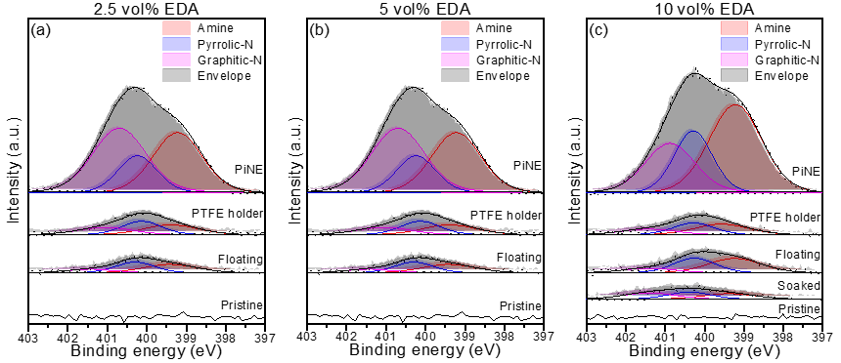
Figure S20 Development of N 1s high-resolution spectra for different system configurations with (a) 2.5 %, (b) 5 % and (c) 10 % ethylenediamine by volume in the electrolyte solution.

Table S4 Nitrogen peak areas from x-ray photoelectron spectroscopy for ribbons treated either floating, held in the PTFE holder or used as an electrode, normalized by dividing by the corresponding peak areas of a soaked sample.
EDA  (% vol) | Sample | Peak area normalized to soaked sample
EDA  (% vol) | Sample | Amine | Pyrollic | Graphitic
2.5 | Floating
2.5 | PTFE holder | 3.4±0.3 | 3.2±0.7 | 2.1±0.2
2.5 | PiNE | 19±2.5 | 7.5±1.9 | 18.9±3.6
5 | Floating
5 | PTFE holder | 2.3±0.3 | 1.9±0.2 | 3.3±0.7
5 | PiNE | 18.2±0.7 | 9.6±1.6 | 27.1±2.4
10 | Floating | 1.6±0.5 | 2.2±0.5 | 1.0±0.4
10 | PTFE holder | 1.6±0.1 | 2.6±0.5 | 1.9±0.1
10 | PiNE | 13.2±0.7 | 9.5±1.2 | 16.1±0.4
10 | Electrolysis | 4.1±2.9 | 4.2±2.6 | 3.9±2.0

Figure S21 Bar charts demonstrating the quantities of each bonding type normalised to a soaked sample.

References
[1] G. Tuci, C. Zafferoni, A. Rossin, L. Luconi, A. Milella, M. Ceppatelli, M. Innocenti, Y. Liu, C. Pham-Huu, G. Giambastiani, Chemical functionalization of N-doped carbon nanotubes: A powerful approach to cast light on the electrochemical role of specific N-functionalities in the oxygen reduction reaction, Catal. Sci. Technol. 6 (2016) 6226–6236. https://doi.org/10.1039/c6cy00796a.
[2] B. Stöhr, H.P. Boehm, R. Schlögl, Enhancement of the catalytic activity of activated carbons in oxidation reactions by thermal treatment with ammonia or hydrogen cyanide and observation of a superoxide species as a possible intermediate, Carbon N. Y. 29 (1991) 707–720. https://doi.org/10.1016/0008-6223(91)90006-5.
[3] J.R. Pels, F. Kapteijn, J.A. Moulijn, Q. Zhu, K.M. Thomas, Evolution of nitrogen functionalities in carbonaceous materials during pyrolysis, Carbon N. Y. 33 (1995) 1641–1653. https://doi.org/10.1016/0008-6223(95)00154-6.
[4] H. Liu, Y. Zhang, R. Li, X. Sun, S. Désilets, H. Abou-Rachid, M. Jaidann, L.-S. Lussier, Structural and morphological control of aligned nitrogen-doped carbon nanotubes, Carbon N. Y. 48 (2010) 1498–1507. https://doi.org/10.1016/j.carbon.2009.12.045.
[5] Z.-Q. Liu, H. Cheng, N. Li, T.Y. Ma, Y.-Z. Su, ZnCo 2 O 4 Quantum Dots Anchored on Nitrogen-Doped Carbon Nanotubes as Reversible Oxygen Reduction/Evolution Electrocatalysts, Adv. Mater. 28 (2016) 3777–3784. https://doi.org/10.1002/adma.201506197.
[6] Y. Ito, W. Cong, T. Fujita, Z. Tang, M. Chen, High Catalytic Activity of Nitrogen and Sulfur Co-Doped Nanoporous Graphene in the Hydrogen Evolution Reaction, Angew. Chemie Int. Ed. 54 (2015) 2131–2136. https://doi.org/10.1002/anie.201410050.
[7] D. Carolan, C. Rocks, D.B. Padmanaban, P. Maguire, V. Svrcek, D. Mariotti, Environmentally friendly nitrogen-doped carbon quantum dots for next generation solar cells, Sustain. Energy Fuels. 1 (2017) 1611–1619. https://doi.org/10.1039/C7SE00158D.
[8] G.R.S. Iyer, P.D. Maguire, Metal free, end-opened, selective nitrogen-doped vertically aligned carbon nanotubes by a single step in situ low energy plasma process, J. Mater. Chem. 21 (2011) 16162. https://doi.org/10.1039/c1jm12829a.
[9] J. Casanovas, J.M. Ricart, J. Rubio, F. Illas, J.M. Jiménez-Mateos, Origin of the Large N 1s Binding Energy in X-ray Photoelectron Spectra of Calcined Carbonaceous Materials, J. Am. Chem. Soc. 118 (1996) 8071–8076. https://doi.org/10.1021/ja960338m.

