Supplementary Material
Calculation of the degree of crystallinity of HDPE/GNPS nanocomposites by using various experimental techniques: A comparative study

Evangelia Tarani^{a*}, Ioannis Arvanitidis^{b}, Dimitrios Christofilos^{c}, Dimitrios N. Bikiaris^{d}, Konstantinos Chrissafisª, George Vourliasª

ª Laboratory of Advanced Materials and Devices, Physics Department, Aristotle University of Thessaloniki, GR 54124, Thessaloniki, Greece
^{b} Optics and Spectroscopy Laboratory, Physics Department, Aristotle University of Thessaloniki, GR 54124, Thessaloniki, Greece
^{c} School of Chemical Engineering & Physics Laboratory, Faculty of Engineering, Aristotle University of Thessaloniki, GR 54124, Greece
^{d} Laboratory of Chemistry and Technology of Polymers and Dyes, Department of Chemistry, Aristotle University of Thessaloniki, GR 54124 Thessaloniki, Greece

*corresponding author, address: Laboratory of Advanced Materials & Devices, Department of Physics, Aristotle University of Thessaloniki, GR 54124 Thessaloniki, Greece, e-mail: etarani@physics.auth.gr, tel.: +30 2310 998134

Content of the supplementary information
Fig. S1 XRD patterns of GNPs M5, GNPs M15, and GNPs M25
Fig. S2 XPS survey scan, High-resolution XPS spectra of C1s and O 1s core level for: (a) GNPs M5, and (b) GNPs M25
Fig. S3 XPS survey scan of (a) HDPE/5 M5 and (b) HDPE/5 M25 nanocomposites
Fig. S4 Raman spectra of GNPs M5, M15 and M25
Table S1 XRD results of GNPs M5, GNPs M15, and GNPs M25

Fig. S1 shows the crystalline structure of the GNPs M5, GNPs M15, and GNPs M25. The XRD patterns reveal a highly crystalline material. The intense and sharp peak observed at 2θ ~26.5° is due to the crystallographic plane (002) of the graphitic structure. Through GNPs, no shift of the main crystallographic plane (002) is detected. The interlayer distance d along the crystalline plane (002) was calculated from Bragg’s law (Equation (1) in the manuscript), whereas the crystallite size along the same plane, L₍₀₀₂₎, was estimated using Scherrer’s equation (Equation (2) in the manuscript). The results for GNPs M5, GNPs M15, and GNPs M25 are shown in Table S1, in good agreement with values reported in the literature [1].
Fig. S1 XRD patterns of GNPs M5, GNPs M15, and GNPs M25

Table S1 XRD results of GNPs M5, GNPs M15, and GNPs M25
A/A | 2θ ( ° ) | d (nm) | FWHM | L (nm)
GNPs M5 | 26.41 | 0.3372 | 0.007 | 19.02
GNPs M15 | 26.45 | 0.3367 | 0.006 | 22.24
GNPs M25 | 26.44 | 0.3790 | 0.007 | 21.53

X-ray photoelectron spectroscopy (XPS) measurements were carried out to analyze the surface area of selected GNPs M5 and GNPs M25. The wide scan C 1s and O 1s XPS spectra of GNPs are shown in Fig. S2a and S2b. The peaks of GNPs at the binding energies of ~284 eV and ~532 eV are generated by photoelectrons emitted from the C1s and O1s core levels, respectively. The relative atomic concentrations of carbon and oxygen atoms were found to be 95.6 and 4.4% for GNPs M5 and 94.8 and 5.2% for GNPs M25.
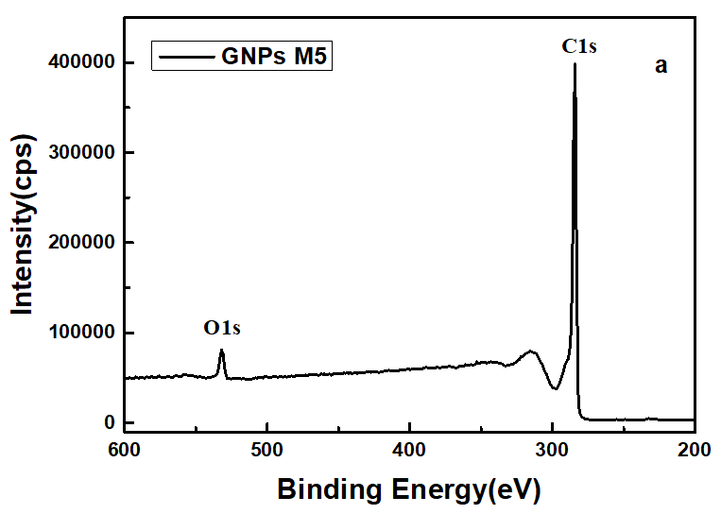 | 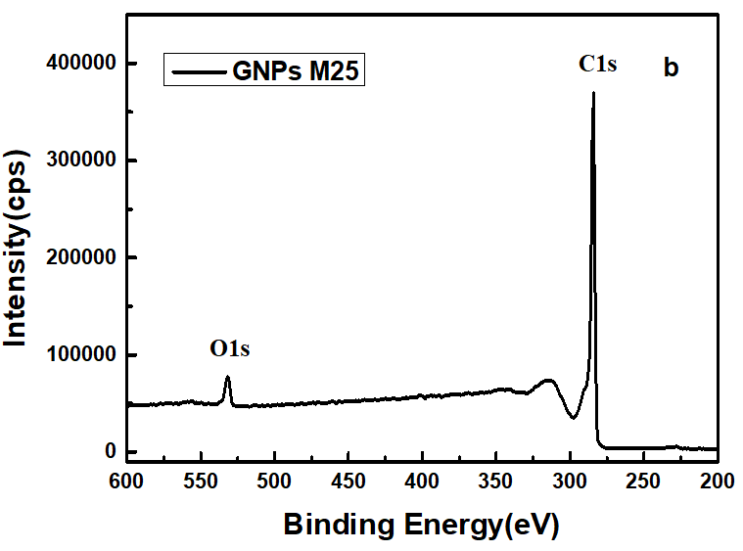
Fig. S2 XPS survey scan, high-resolution XPS spectra of C 1s and O 1s core level for: (a) GNPs M5, and (b) GNPs M25

To evaluate the incorporation of GNPs into the HDPE matrix, XPS measurements were also conducted. The wide scans of HDPE/5 M5 and HDPE/5 M25 nanocomposites are shown in Fig. S3, confirming the carbon and oxygen composition with marginal differences regarding their intensities.

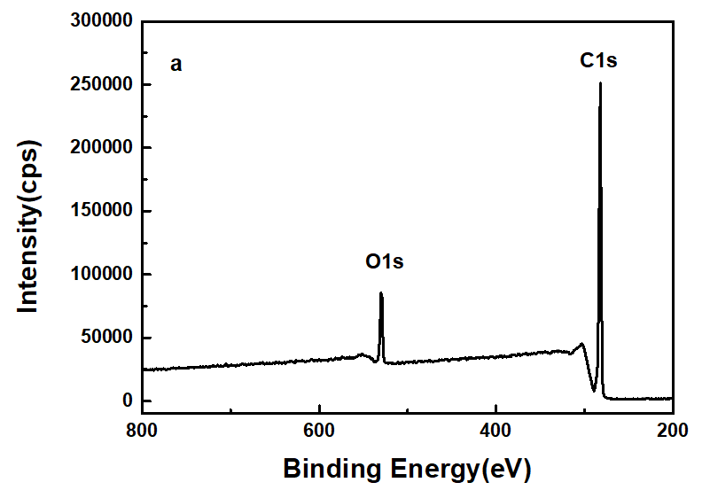 | 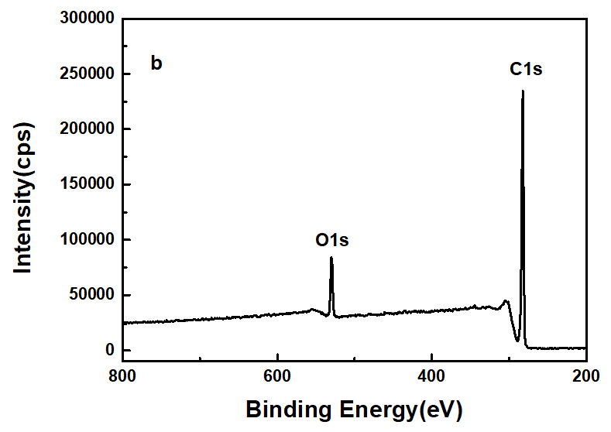
Fig. S3 XPS survey scan of (a) HDPE/5 M5 and (b) HDPE/5 M25 nanocomposites

Raman spectra of the M5, M15, and M25 GNPs are illustrated in Fig. S4. Evidently, they are very similar and spectral features can be observed at 1362, 1581, 1620, 2451, 2694 & 2720 (doublet) and 3246 cm⁻¹, attributed to the D, G, D´, D+D΄΄, 2D and 2D´ modes, respectively [2]. The G band, which is the most intense due to its resonant first order Raman scattering nature and the only symmetry-allowed for perfect crystalline graphitic materials, is associated with the doubly degenerate phonon mode {in-plane transverse optical (iTO) and longitudinal optical (LO)} of E_{2g} symmetry at the Brillouin zone center Γ. The position and intensity of the G band can provide information about the number of layers in the GNPs. Typically, the intensity of the G band increases linearly with the number of layers, and the peak shifts from 1587 cm⁻¹ (monolayer graphene) to 1580 cm⁻¹ (multilayer structure) [1]. In the present case, the G band frequency of the GNPs is compatible with a multilayer exfoliated flake structure. The D band is due to the breathing modes of graphitic rings and is defect-activated by double resonance. It comes from TO phonons near the Brillouin zone corner, K, and is strongly dispersive with excitation energy due to a Kohn anomaly at this point [3]. Double resonance can also happen as an intravalley process, connecting two points belonging to the same cone around K (or Kʹ), resulting in the Dʹ band at a higher frequency. The appearance of relatively intense D and Dʹ bands in the studied GNPs indicates their significantly defected structure, which could include vacancies, heptagon-pentagon pairs, kinks, and heteroatoms. These types of defects are common in finite or nanosized graphitic materials. The D+D" band is a combination of the D mode with another inactive first order D" mode, belonging to the longitudinal acoustic (LA) branch, in between the Γ and the K point, with a wave vector opposite that of the D phonon [4]. Finally, the 2D and the 2Dʹ bands are the overtones of the D and the Dʹ bands, respectively, involving the scattering of two phonons with opposite wave vectors, where momentum conservation is satisfied and thus no defects are required for their activation [3]. The 2D band relative intensity and lineshape provide information about the number of graphitic layers. A single layer leads to a symmetric peak, much stronger than the G band, while its symmetry and intensity decrease with an increasing number of layers, eventually attaining a double peak structure of strongly reduced intensity in the case of graphite [4, 5]. The Raman spectra of the M5, M15, and M25 GNPs in the corresponding frequency range are indicative of multiple graphitic layered structure.
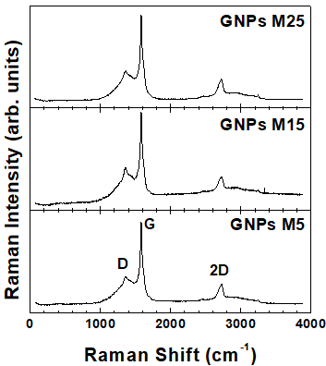
Fig. S4 Raman spectra of GNPs M5, M15 and M25

References
1. Guerra V, Wan C, Degirmenci V, et al (2019) Characterisation of graphite nanoplatelets (GNP) prepared at scale by high-pressure homogenisation. J Mater Chem C Mater 7:6383–6390. https://doi.org/10.1039/c9tc01361j
2. Merlen A, Buijnsters JG, Pardanaud C (2017) A guide to and review of the use of multiwavelength Raman spectroscopy for characterizing defective aromatic carbon solids: From graphene to amorphous carbons. Coatings 7
3. Ferrari AC, Basko DM (2013) Raman spectroscopy as a versatile tool for studying the properties of graphene. Nat Nanotechnol 8:235–246
4. Couzi M, Bruneel JL, Talaga D, Bokobza L (2016) A multi wavelength Raman scattering study of defective graphitic carbon materials: The first order Raman spectra revisited. Carbon N Y 107:388–394. https://doi.org/10.1016/j.carbon.2016.06.017
5. Filintoglou K, Papadopoulos N, Arvanitidis J, et al (2013) Raman spectroscopy of graphene at high pressure: Effects of the substrate and the pressure transmitting media. Phys Rev B Condens Matter Mater Phys 88:. https://doi.org/10.1103/PhysRevB.88.045418

