Supplementary information
Fully bio-based furan/maleic anhydride epoxy resin with enhanced adhesive properties
Noemi Faggio^{1,2}, Angela Marotta¹, Veronica Ambrogi^{1,2,*}, Pierfrancesco Cerruti^{2,*}, Gennaro Gentile²
¹ Department of Chemical, Materials and Production Engineering (DICMaPI) - University of Naples Federico II, P. le Tecchio 80, 80125 Napoli, Italy
² Institute for Polymers, Composites and Biomaterials (IPCB) - CNR, Via Campi Flegrei 34, 80078 Pozzuoli (NA), Italy
* Corresponding authors: ambrogi@unina.it, pierfrancesco.cerruti@ipcb.cnr.it

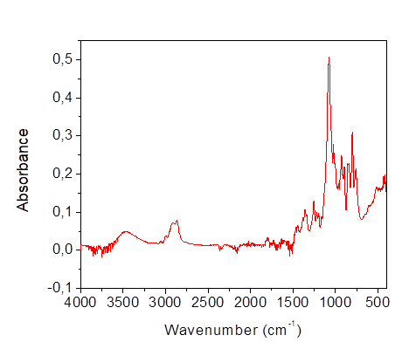
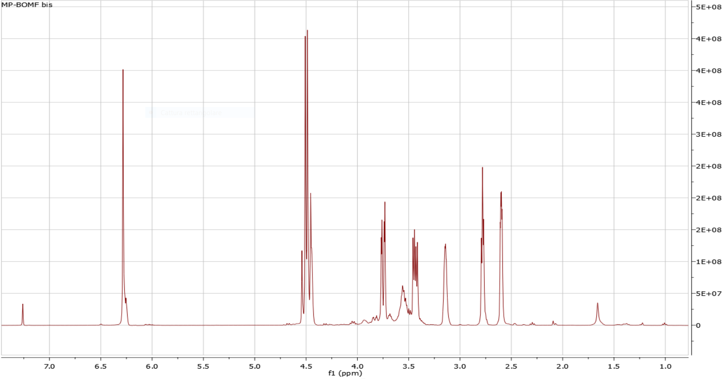

Fig. S1. NMR and FT-IR spectra of BOMF.

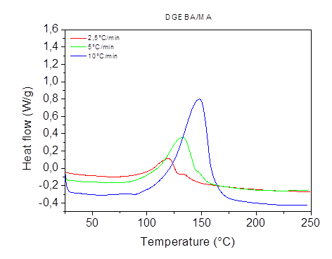
Fig. S2. DSC thermograms of DGEBA/MA at varying heating rates.

Fig. S3. DSC non-isothermal thermograms, second heating ramp from −30°C to 250°C.

Fig.S4. Peak area of ester carbonyl group over curing of BOMF/MA and DGEBA/MA.

