Article title: Influence of extrinsic induced tensile stress on the self-propagating high-temperature synthesis of nanosized Al/Ni multilayers

Journal name: Journal of Materials Science

Authors:
Sebastian Matthes^{1*}, Marcus Glaser², Emina Vardo¹, Yesenia Haydee Sauni Camposano¹, Konrad Jaekel³, Jean Pierre Bergmann², Peter Schaaf¹
¹ Chair Materials for Electrical Engineering and Electronics, Institute of Materials Science and Engineering, Institute of Micro and Nanotechnologies MacroNano, TU Ilmenau, Gustav-Kirchhoff-Str. 5, 98693 Ilmenau, Germany

² Production Technology Group, Institute of Micro and Nanotechnologies MacroNano, TU Ilmenau, Gustav-Kirchhoff-Platz 2, 98693 Ilmenau, Germany

³ Electronics Technology Group, Institute of Micro and Nanotechnologies MacroNano, TU Ilmenau, Gustav-Kirchhoff-Straße 1, 98693 Ilmenau, Germany

*correspondence: sebastian.matthes@tu-ilmenau.de

Supplementary material:
In Fig.-SI 1 the 3d image of the roughness measurement of the different Kapton® substrates via laser scanning microscope (LSM) could be seen. The measured roughness for the 50 µm Kapton® is given as Ra = (0.014 ± 0.003) µm and the roughness of 125 µm Kapton® as Ra = (0.041 ± 0.002) µm.
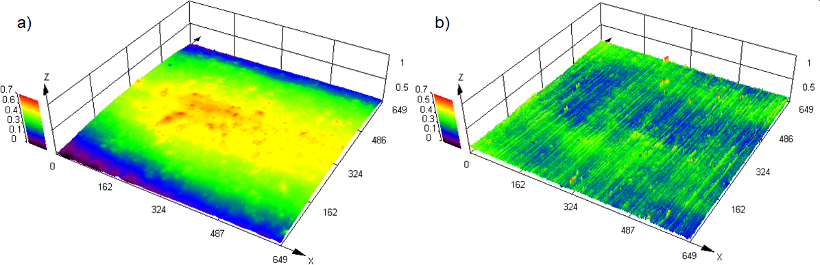
Fig.-SI 1 Surface analysis of the substrates a) 50 µm Kapton® b) 125 µm Kapton® via LSM in a measured area of 649 µm x 649 µm

