Supplementary information
for

Effect of O/N content on the phase, morphology, and optical properties of titanium oxynitride thin films

Sharafat Aliª, Roger Magnusson^{b}, Oleksandr Pshyk^{b,◊}, Jens Birch^{b}, Per Eklund^{b}, Arnaud le Febvrier^{b*}

ªSchool of Engineering, Department of Built Environment and Energy Technology, Linnaeus University, SE-351 95 Växjö, Sweden.

^{b}Department of Physics, Chemistry and Biology (IFM), Linköping University,
SE-58183 Linköping, Sweden

◊Current address: Empa – Swiss Federal Laboratories for Materials Science and Technology, 8600 Dübendorf, Switzerland

* Corresponding Author: Arnaud le Febvrier
E-mail: arnaud.le.febvrier@liu.se

The supplementary material contains details and results from the ellipsometry analysis performed on the samples series on the two substrates. Table S1 gives an overview of the general model applied for the fit of the experimental data for each films. It also gives the bandgap values that have been estimated using a modified Cody plot.

Table S1: optical model used for ellipsometry analyses detailed for each films , along with the bang gap values when possible.

 | Sample # | Composition | Optical model | Bandgap values (eV)
Si (100) | 1 | TiO_{0.73}N_{0.84} | 3 × Cody-Lorentz + Drude | -
Si (100) | 2 | TiO_{1.02}N_{0.71} | 2 × Cody-Lorentz + Drude | -
Si (100) | 3 | TiO_{1.06}N_{0.60} | 3 × Cody-Lorentz / Gradient | 3.00
Si (100) | 4 | TiO_{1.33}N_{0.43} | 3 × Cody-Lorentz oscillators | 3.46
Si (100) | 5 | TiO_{1.52}N_{0.24} | 3 × Cody-Lorentz oscillators | 3.67
Si (100) | 6 | TiO_{1.67}N_{0.14} | 2 × Cody-Lorentz / Gradient | 3.75
c-plane Sapphire | 1 | TiO_{0.63}N_{0.96} | 3 × Cody-Lorentz + Drude | -
c-plane Sapphire | 2 | TiO_{0.89}N_{0.71} | 2 × Cody-Lorentz + Drude / Gradient | -
c-plane Sapphire | 3 | TiO_{1.27}N_{0.49} | 2 × Cody-Lorentz + Drude / Gradient | -
c-plane Sapphire | 4 | TiO_{1.47}N_{0.31} | 3 × Cody-Lorentz | 3.50
c-plane Sapphire | 5 | TiO_{1.53}N_{0.22} | 3 × Cody-Lorentz | 3.63
c-plane Sapphire | 6 | TiO_{1.83}N_{0.08} | 2 × Cody-Lorentz / Gradient | 3.75

Figure S1 presents the refractive index and the absorption coefficient for the film with optical gradient properties. Note here that the values reported in the main manuscript are the values at the bottom of the film. The gradient of the optical properties along the thickness is not necessarily surprising and can be caused by the columnar growth of the film and with the variation of density / number of grain boundaries.
Figure S2 presents the curves for the band gap estimation by a modified Cody plot when possible.

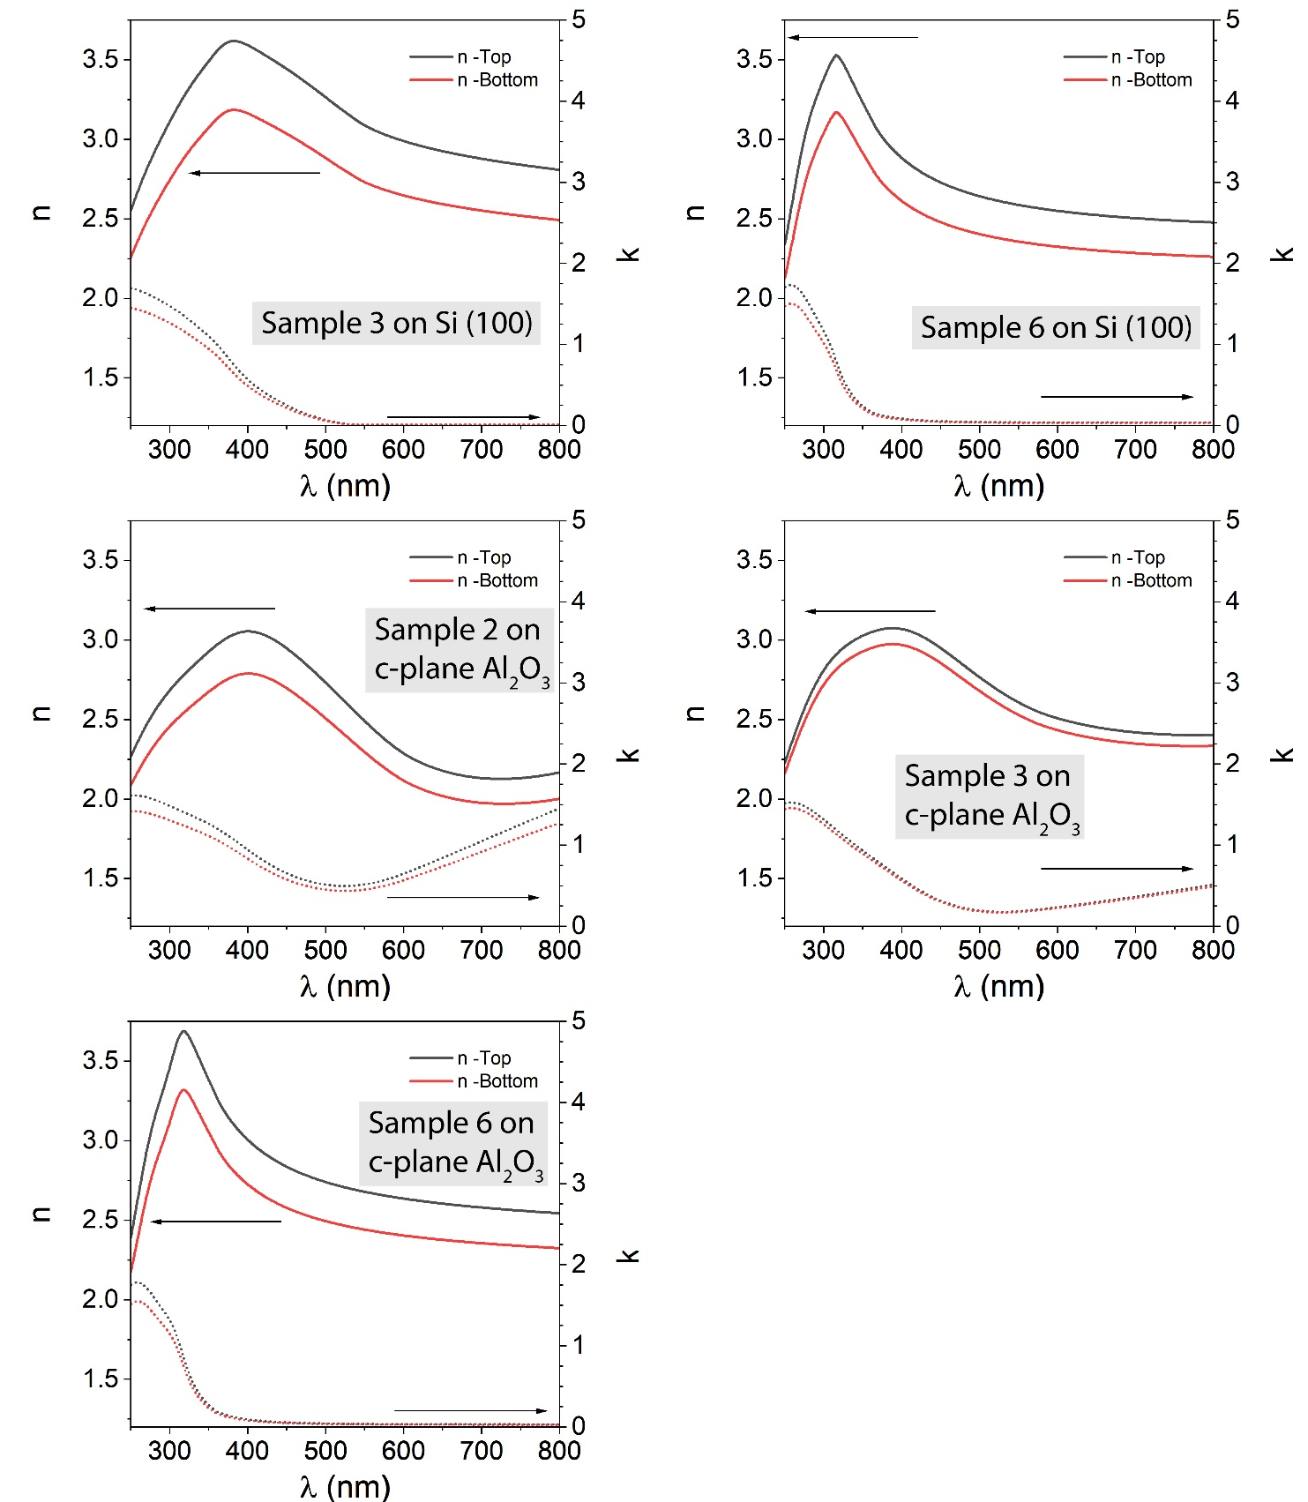
Figure S1: Refractive index and extinction coefficient of the Gradient films of the Ti(O,N) series prepared in various O/N ratio on a), b), Si substrates and c), d), e) on sapphire substrate. The sample # is labelled corresponding to Table S1.

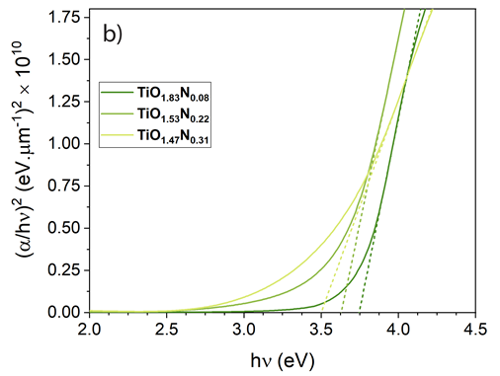
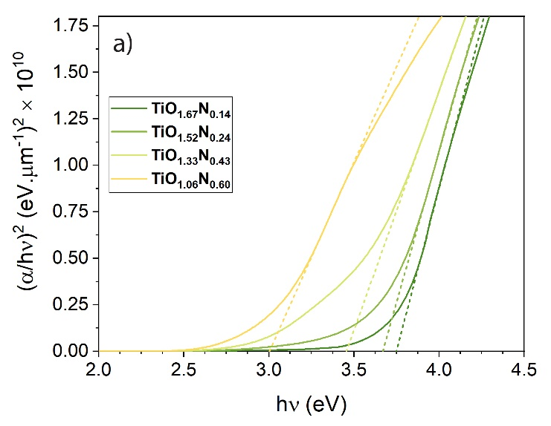

Figure S2: Bandgap values (a) Si (100) substrate for TiO_{1.67}N_{0.14} (3.75 eV), TiO_{1.52}N_{0.24} (3.67 eV), TiO_{1.33}N_{0.43} (3.46 eV), TiO_{1.06}N_{0.60} (3.00 eV), (b) c-plane sapphire substrate for TiO_{1.83}N_{0.08} (3.75 eV), TiO_{1.53}N_{0.22} (3.63), TiO_{1.47}N_{0.31} (3.50 eV).

