Supplementary materials

Processing of high strength thermal resistant Al - 2.2% Cerium - 1.3% Lanthanum alloy rods with high electric conductivity by High Pressure Torsion Extrusion

Rui Xu^{a,b,c}, Yemao Lu^{a,c*}, Yuting Dai^{a,b,c}, Andrea Brognara^{d}, Horst Hahn^{a,b,e} and Yulia Ivanisenko^{a*}

ª Institute of Nanotechnology (INT), Karlsruhe Institute of Technology (KIT), Kaiserstr. 12, 76131 Karlsruhe Germany
^{b} Joint Research Laboratory Nanomaterials, Technical University of Darmstadt (TUDa), 64287 Darmstadt, Germany
^{c} Karlsruhe Nano Micro Facility (KNMFi), Karlsruhe Institute of Technology (KIT), 76344 Eggenstein-Leopoldshafen, Germany
^{d} Department of Structure and Nano/-Micromechanics of Materials, Max-Planck-Institut für Eisenforschung GmbH (MPIE), Max-Planck-straße 1, 40237 Düsseldorf, Germany
^{e} School of Sustainable Chemical, Biological and Materials Engineering, The University of Oklahoma, Norman 73019, United States

e-mail for the *corresponding authors: yemao.lu@ kit.edu; julia.ivanisenko@kit.edu;

Supplementary Materials

S1. Electric conductivity and electric resistivity measurements by means of Eddy Current

The sample surfaces for electric conductivity/resistivity measurements were mechanically polished using grinding papers with a granularity down to 1 μm. Subsequently, they were polished using a vibratory polisher (VibroMet 2 by Buehler) during two hours to the mirror quality.
The electric conductivity (EC, MS/m) was measured at room temperature using eddy current electrical conductivity tester (Sigmascope SMP-350, Helmut Fischer GmbH, Sindelfingen, Germany). The device was calibrated before each measurement using reference samples providing an accuracy of ± 0.3%. Measurements were conducted in longitudinal cross section of the HPTE-processed rod as shown in Fig. S1(a) at room temperature and the sample was held at a constant temperature for at least 5 h.

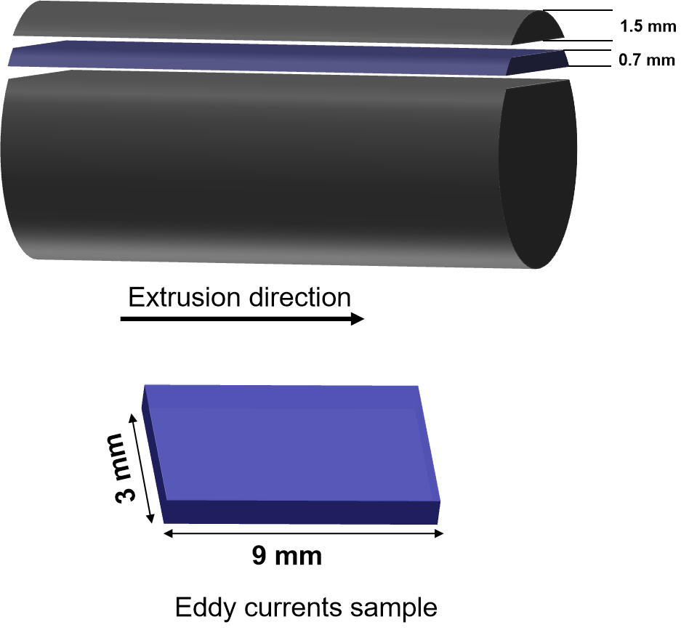
Figure S1. Schematic illustration of sectioning of the HPTE sample for electrical conductivity measurement by the eddy current method
S2. Tensile tests

Tensile tests were conducted at ambient temperature, using an initial strain rate of 10⁻³ s ⁻¹ using a Zwick Z100 screw-driven testing machine. The tensile samples were machined from the HPTE-processed billets in the extrusion direction, conforming to the ASTM E 8/E 8M-08 standards as shown in Fig. S2. At least three samples were pulled to fracture for both sample conditions.

Figure S2. Drawing (top) and photo (bottom) of the tensile test sample. Dimensions are given in millimeters.

S3. Rietveld refinement of XRD patterns
Figure S3. The XRD diffraction patterns and Rietveld refinement curves for: (a) the as-cast sample (b) the HPTE-processed sample (c) the HPTE and annealed at 180 °C for 1 hour sample (d) the HPTE and annealed at 230 °C for 1 hour sample (e) the HPTE and annealed at 280 °C for 1 hour sample (f) the HPTE and annealed at 330 °C for 1 hour sample.

S4. STEM images
Figure S4. Typical STEM images of (a) the as-HPTE sample and (b) the HPTE and annealed at 280 °C for 1 hour sample used for the estimate of the volume fraction and mean radius of the Al₁₁RE₃ phase particles. Only particles with the diameter less than 100 nm were analyzed.

