Supporting information

Microstructure and Mechanical Properties of Ti-Nb alloys: Comparing Conventional Powder Metallurgy, Mechanical Alloying, and High Power Impulse Magnetron Sputtering Processes for Supporting Materials Screening
M. Marczewski ^{*,1,2,3}, K. Wieczerzak ⁴, X. Maeder ⁴, L. Lapeyre ^{1,4}, C. Hain ^{1,4},
M. Jurczyk ⁵, T. Nelis ^{1,4}
¹ Bern University of Applied Science, Institute for Applied Laser, Photonics and Surface Technologies ALPS, Quellgasse 21, 2501 Biel/Bienne, Switzerland
² Poznan University of Technology, Institute of Materials Science and Engineering, Jana Pawla II 24, Poznan 61-138, Poland
³ Lukasiewicz Research Network – Poznan Institute of Technology, 6 Ewarysta Estkowskiego St., 61-755, Poznan, Poland
⁴ Empa - Swiss Federal Laboratories for Materials Science and Technology, Laboratory for Mechanics of Materials and Nanostructures, Feuerwerkerstrasse 39, 3602 Thun, Switzerland
⁵ University of Zielona Gora, Institute of Materials and Biomedical Engineering, Prof. Z. Szafrana 4, 65 -516 Zielona Gora, Poland
Figure S1 Discharge current and voltage traces for an Nb target obtained at 25 µs (green), 75 µs (red) and 250 µs (orange) with a fixed voltage of -480 V, repetition frequency 150 Hz, carrier gas (Ar, 100 sccm) and pressure 0.6 Pa;

Table S1 HiPIMS deposition parameters of Ti-Nb alloys films;
sample composition TF_TiXNb | deposition time [h] | Ti target |  |  | Nb target
sample composition TF_TiXNb | deposition time [h] | voltage [V] | current [A] | frequency [Hz] | voltage [V] | current [A] | frequency [Hz]
X<40 | 5 | 915 | 15 | 500 | 625 | 27 | 500
X=10 | 10 | 570 (Ti-1)  610 (Ti-2) | 20 | 1000 | 520 | 20 | 130
X=20 |  |  |  |  |  |  | 230
X=30 | 8 |  |  |  |  |  | 400

Figure S2 OM micrographs of the MA_Ti10Nb, MA_Ti20Nb, MA_Ti30Nb, PM_Ti10Nb, PM_Ti20Nb, PM_Ti30Nb at. % alloys non-etched with calculated porosities (P) volume content, its morphology and distribution;

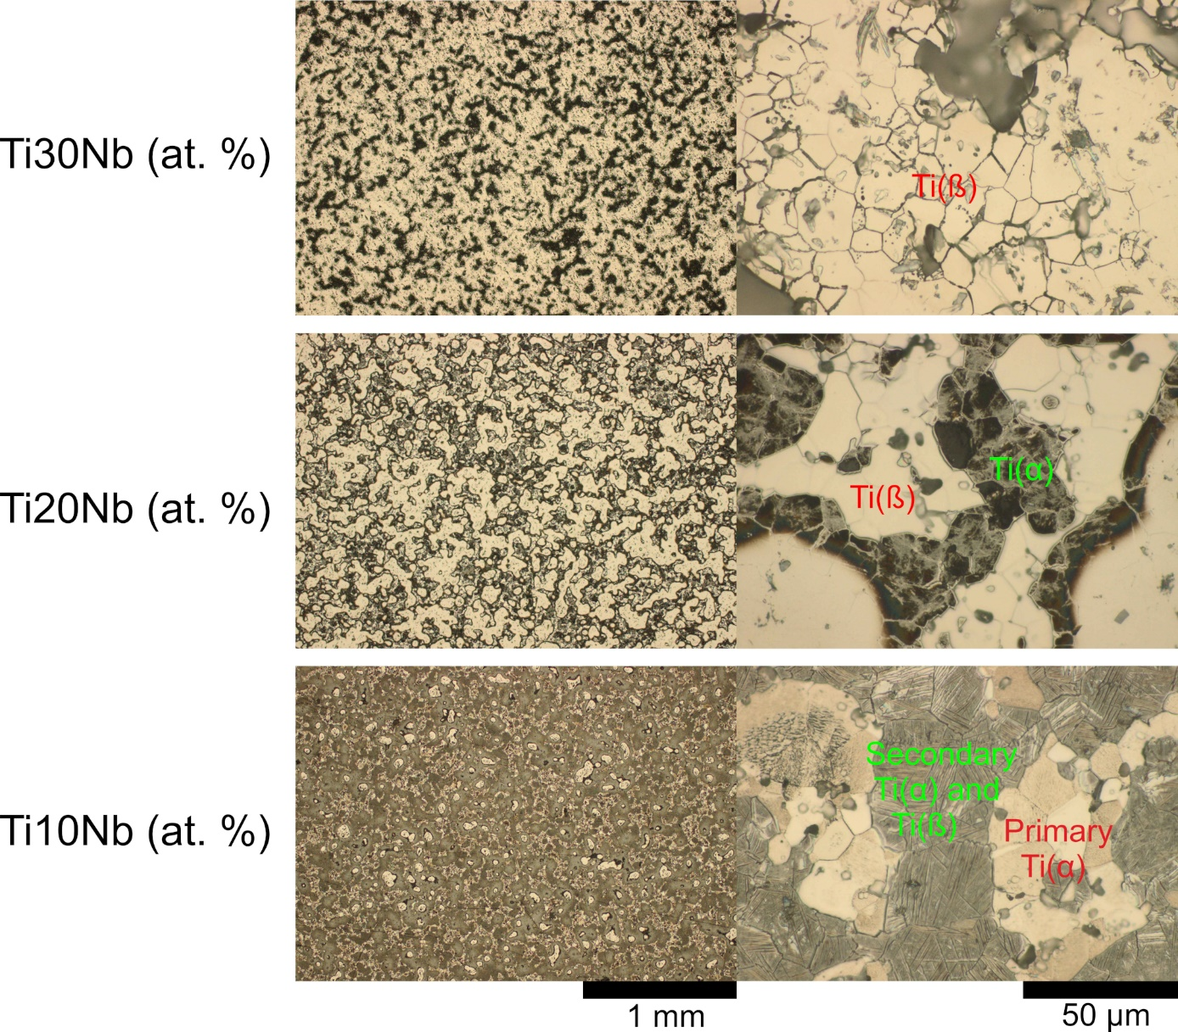
Figure S3 OM micrographs of the PM_Ti10Nb, PM_Ti20Nb, PM_Ti30Nb at. % alloys produced via conventional powder metallurgy and etched with Kroll reagent;

