Supporting Information

Design and evaluation of composite films for in-situ synthesis and antibacterial activity of allicin vapour
Lucie Mašková^{1#}, Lenka Závišová^{1#}, Ondřej Kašpar¹, Zdeněk Knejzlík³, Silvie Rimpelová², Viola Tokárová^{1*}

¹H NMR (D₂O, 400 MHz) spectra
Chemical shifts (f1) are reported in parts per million (ppm) and were referenced to TMS (Tetramethylsilane) as an internal standard. Coupling constants (J) are expressed in Hz.
Figure S1: ¹H NMR spectrum of L-Deoxyalliin
Figure S2: ¹H NMR spectrum of racemic mixture of L-Alliin

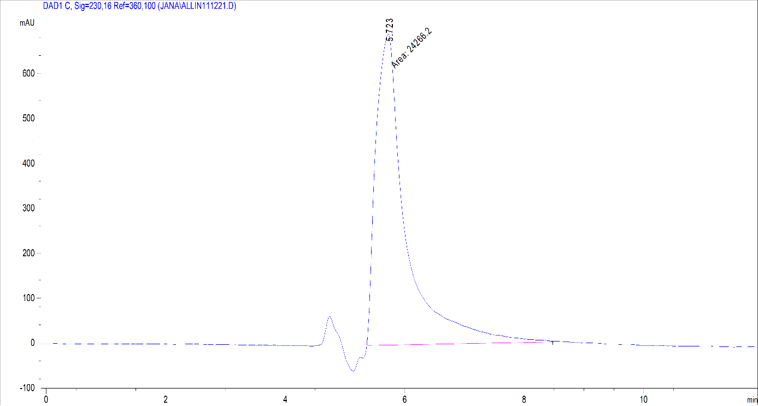
Figure S3: HPLC analysis of synthetic L-Alliin

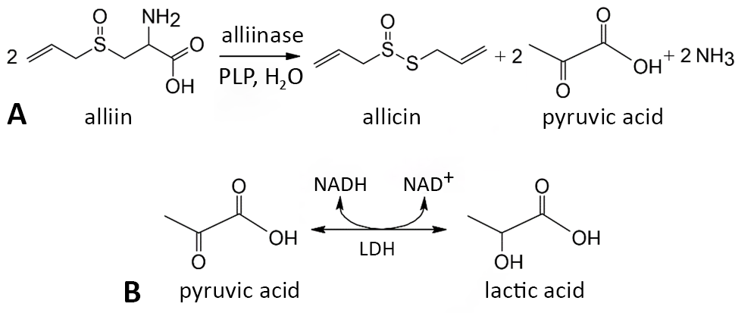
Figure S4: A) Enzymatic formation of allicin; B) LDH assay The LDH assay based on the reduction of pyruvic to lactic acid, coupled with the oxidation of nicotinamide adenine dinucleotide (NAD)

