Supplementary Information

Functional light diffusers based on hybrid CsPbBr₃/SiO₂ aero-framework structures for laser light illumination and conversion
Lena M. Saure¹, Jonas Lumma^{1, 2}, Niklas Kohlmann³, Torge Hartig⁴, Ercules E.S. Teotonio^{2, 5}, Shwetha Shetty⁶, Narayanan Ravishankar⁶, Lorenz Kienle^{3, 7}, Franz Faupel⁴, Stefan Schröder⁴, Rainer Adelung^{1,7}, Huayna Terraschke^{2,7*}, Fabian Schütt^{1,7*}

¹ Functional Nanomaterials, Department for Materials Science, Kiel University, Kaiser Str. 2, 24143 Kiel, Germany
² Institute of Inorganic Chemistry, Kiel University, Max-Eyth-Str. 2, D-24118 Kiel, Germany. E-Mail: hterraschke@ac.uni-kiel.de
³ Synthesis and Real Structure, Department for Materials Science, Kiel University, Kaiser Str. 2, 24143 Kiel, Germany
⁴ Chair for Multicomponent Materials, Department for Materials Science, Kiel University, Kaiser Str. 2, 24143 Kiel, Germany
⁵ Department of Chemistry, Federal University of Paraíba, 58051-970 João Pessoa, Paraíba, Brazil
⁶ Materials Research Centre, Indian Institute of Science, Bangalore, India
⁷ Kiel Nano, Surface and Interface Science KiNSIS, Kiel University, Christian-Albrechts-Platz 4, 24118 Kiel, Germany. E-Mail: fas@tf.uni-kiel.de

Details on light scattering properties

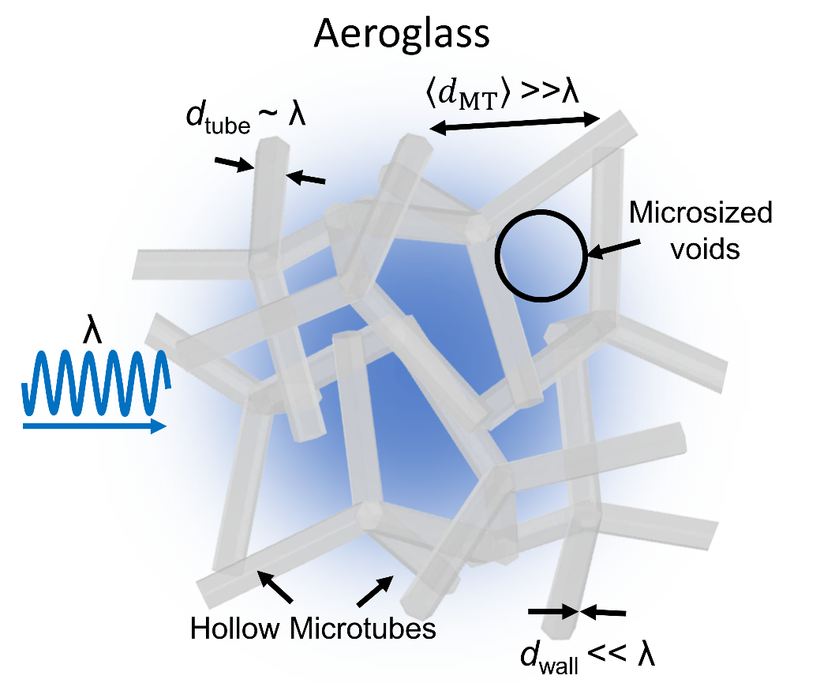
Figure S 1 Schematic of SiO₂ framework structure, named aeroglass, demonstrating different feature sized compared to light in the visible spectrum.

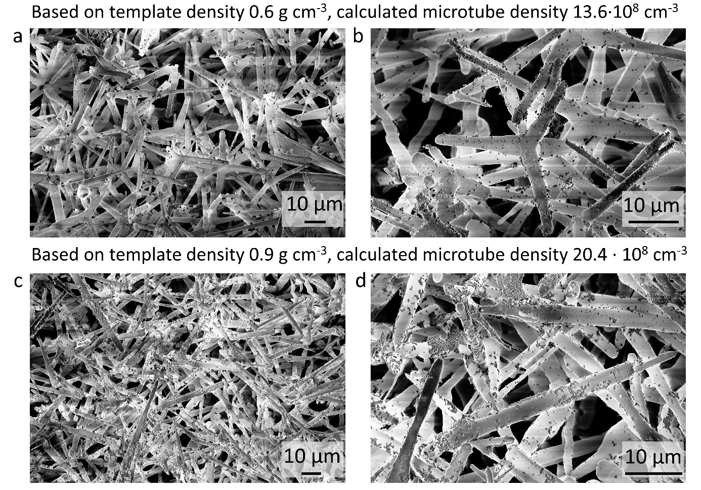
Figure S 2 SEM images of aeroglass based on different densities of ZnO template. (a), (b) aeroglass based on template density 0.6 g cm⁻³. (c), (d) aeroglass based on template density 0.9 g cm⁻³.

Supplementary Note 1 – Calculation of microtube density
To calculate the number of hollow microtubes within a unit volume of aeroglass the number of ZnO tetrapod arms is calculated. For this, it was assumed that the ZnO tetrapods arms are rod-shaped with a diameter d = 2 µm and a length l of 25 µm and the volume of a tetrapod arm $V_{rod }$is calculated by:
$V_{rod}=\frac{π*{(\frac{d}{2})}^{2}*l}{{10}^{12}}$ (S1)
Knowing the template geometries, the density of the template (ρ_{template} = 0.3 g cm⁻³, 0.6 g cm⁻³ and 0.9 g cm⁻³, respectively) and the density of ZnO (ρ_{ZnO} = 5.61 g cm⁻³), the number of ZnO tetrapods arms $n_{rod}$ in the template can be calculated:
$n_{rod}=\frac{V_{ZnO}}{V_{rod}}=\frac{ρ_{template}}{V_{tetrapod}* ρ_{ZnO} }$ (S2)

As the number of ZnO tetrapod arms equals the number of hollow SiO₂ microtubes, the density of microtubes per unit volume can be calculated:
$ρ_{microtube}=\frac{n_{rod}}{V_{template}}$ (S3)
The calculation results are summarized in the Table 1:
Table 1 Calculation results of microtube densities based on ZnO template density.
ZnO template density [g cm⁻³] | Density of microtubes [10⁸ cm⁻³]
0.3 | 6.8
0.6 | 13.6
0.9 | 20.4

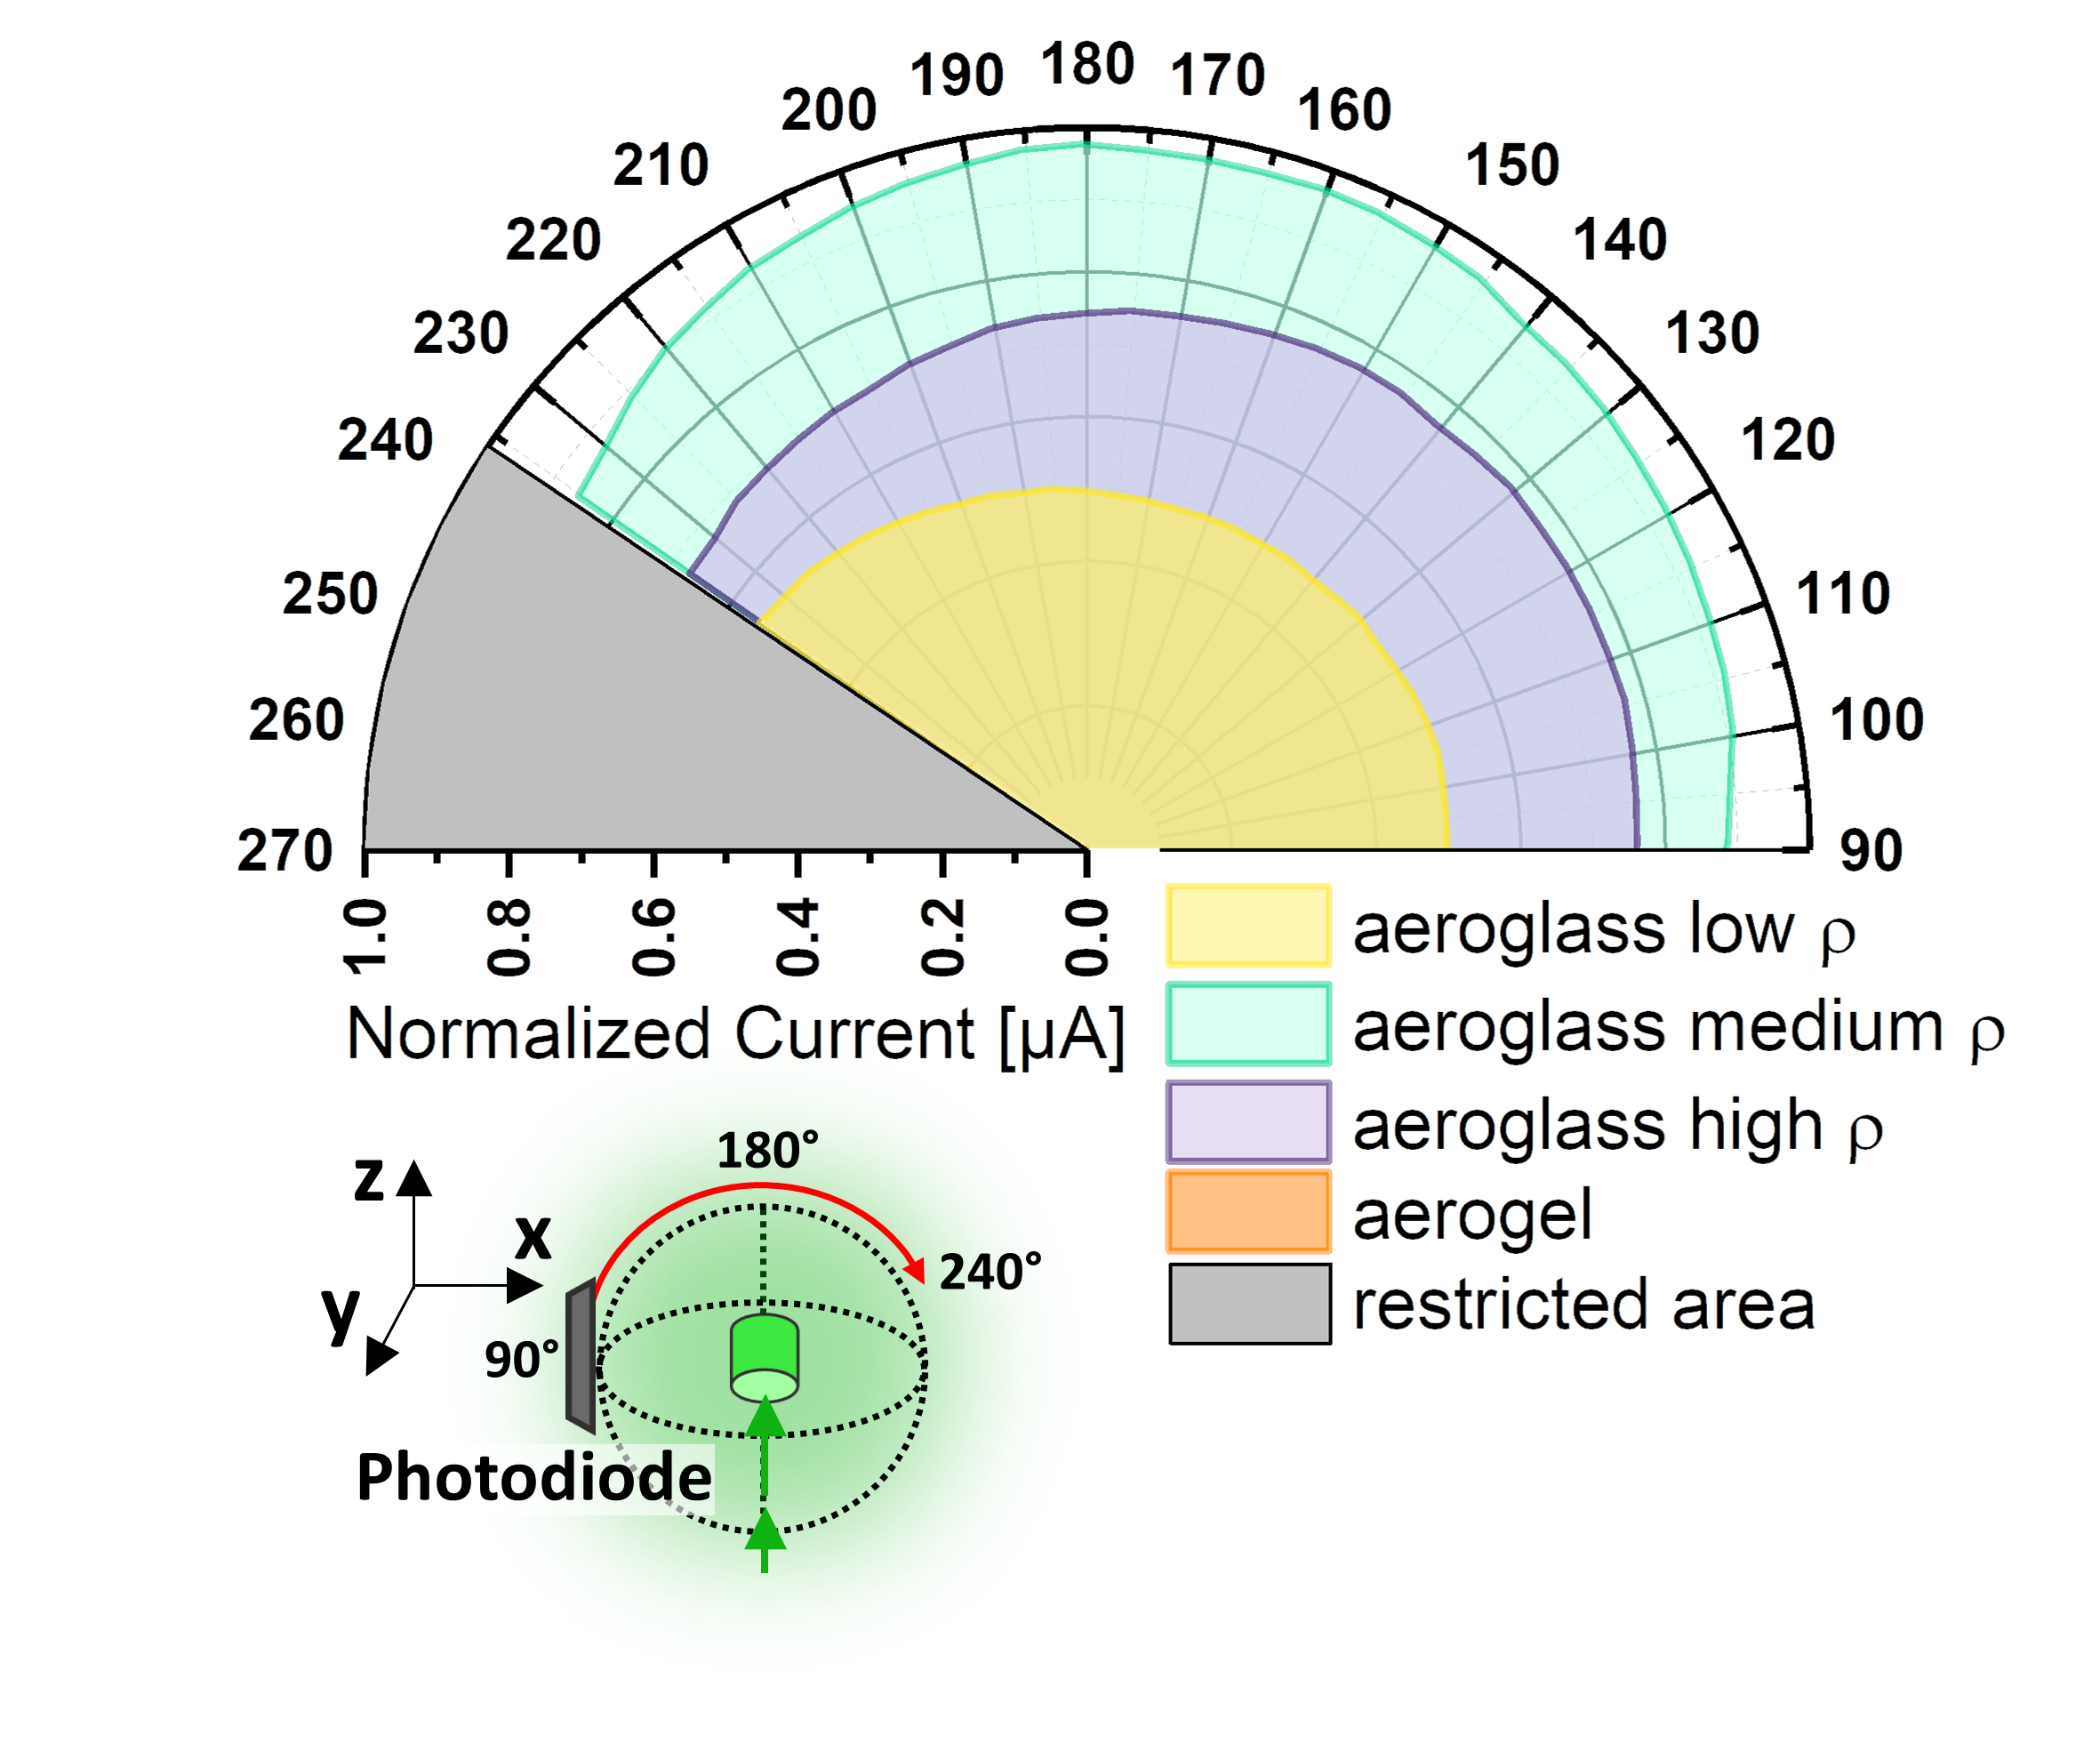
Figure S 3 Light scattering in x-z-plane of aeroglass with different densities of scattering centers (low, medium and high), as well as of a conventional silica aerogel. The intensity of the photocurrent is normalized to the transmitted light.

Speckle contrast determination
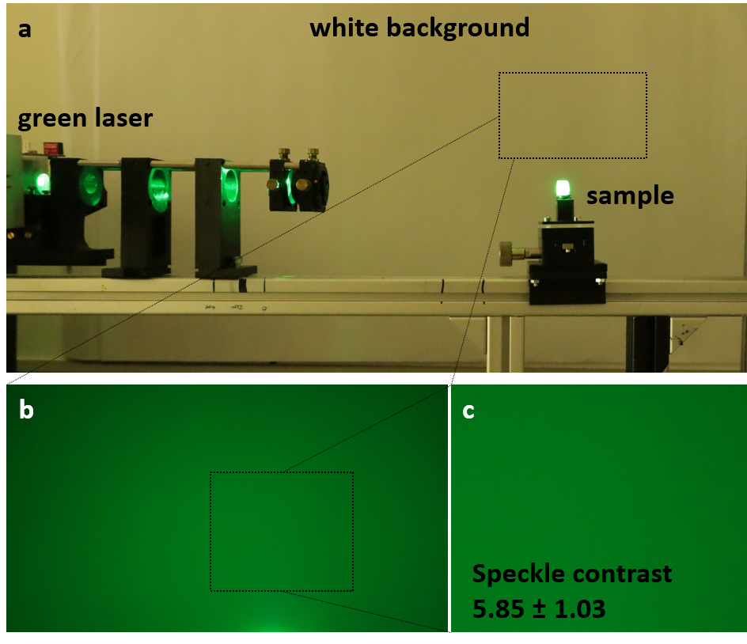
Figure S 4 Speckle reduction of Aeroglass. (a) set-up of green laser illuminating the aeroglass sample. The square on the white background denotes the area which has been photographed and considered for speckle contrast calculations. (b) Photograph of white background illuminated by scattered light from the aeroglass sample. (c) Cutout of photograph, used for speckle contrast calculations.

Supplementary Note 2 – Calculation of speckle contrast
The speckle contrast of an aeroglass sample was determined using a focused laser green laser (450 nm, 100 mW) to illuminate the sample. The objective speckle pattern was evaluated from a white wall in 90° angle to the incoming light beam (distance to sample is 40 cm). The speckle pattern is captured with a photocamera (Canon EOS RP) with a focal distance of 105 mm, an exposure time of 1/60 s, ISO-12800 and an aperture of 7.1, placed slightly above the sample with a distance of ~20 cm.
From the photograph a representative area (cf. Figure S 4) is selected to determine the speckle contrast using Gatan Microscopy Suite. First, the image is converted into black and white, followed by the calculation of the mean intensity I and the standard deviation σ.
From this, the speckle contrast χ can be calculated by¹:
χ = σ I⁻¹ (1)

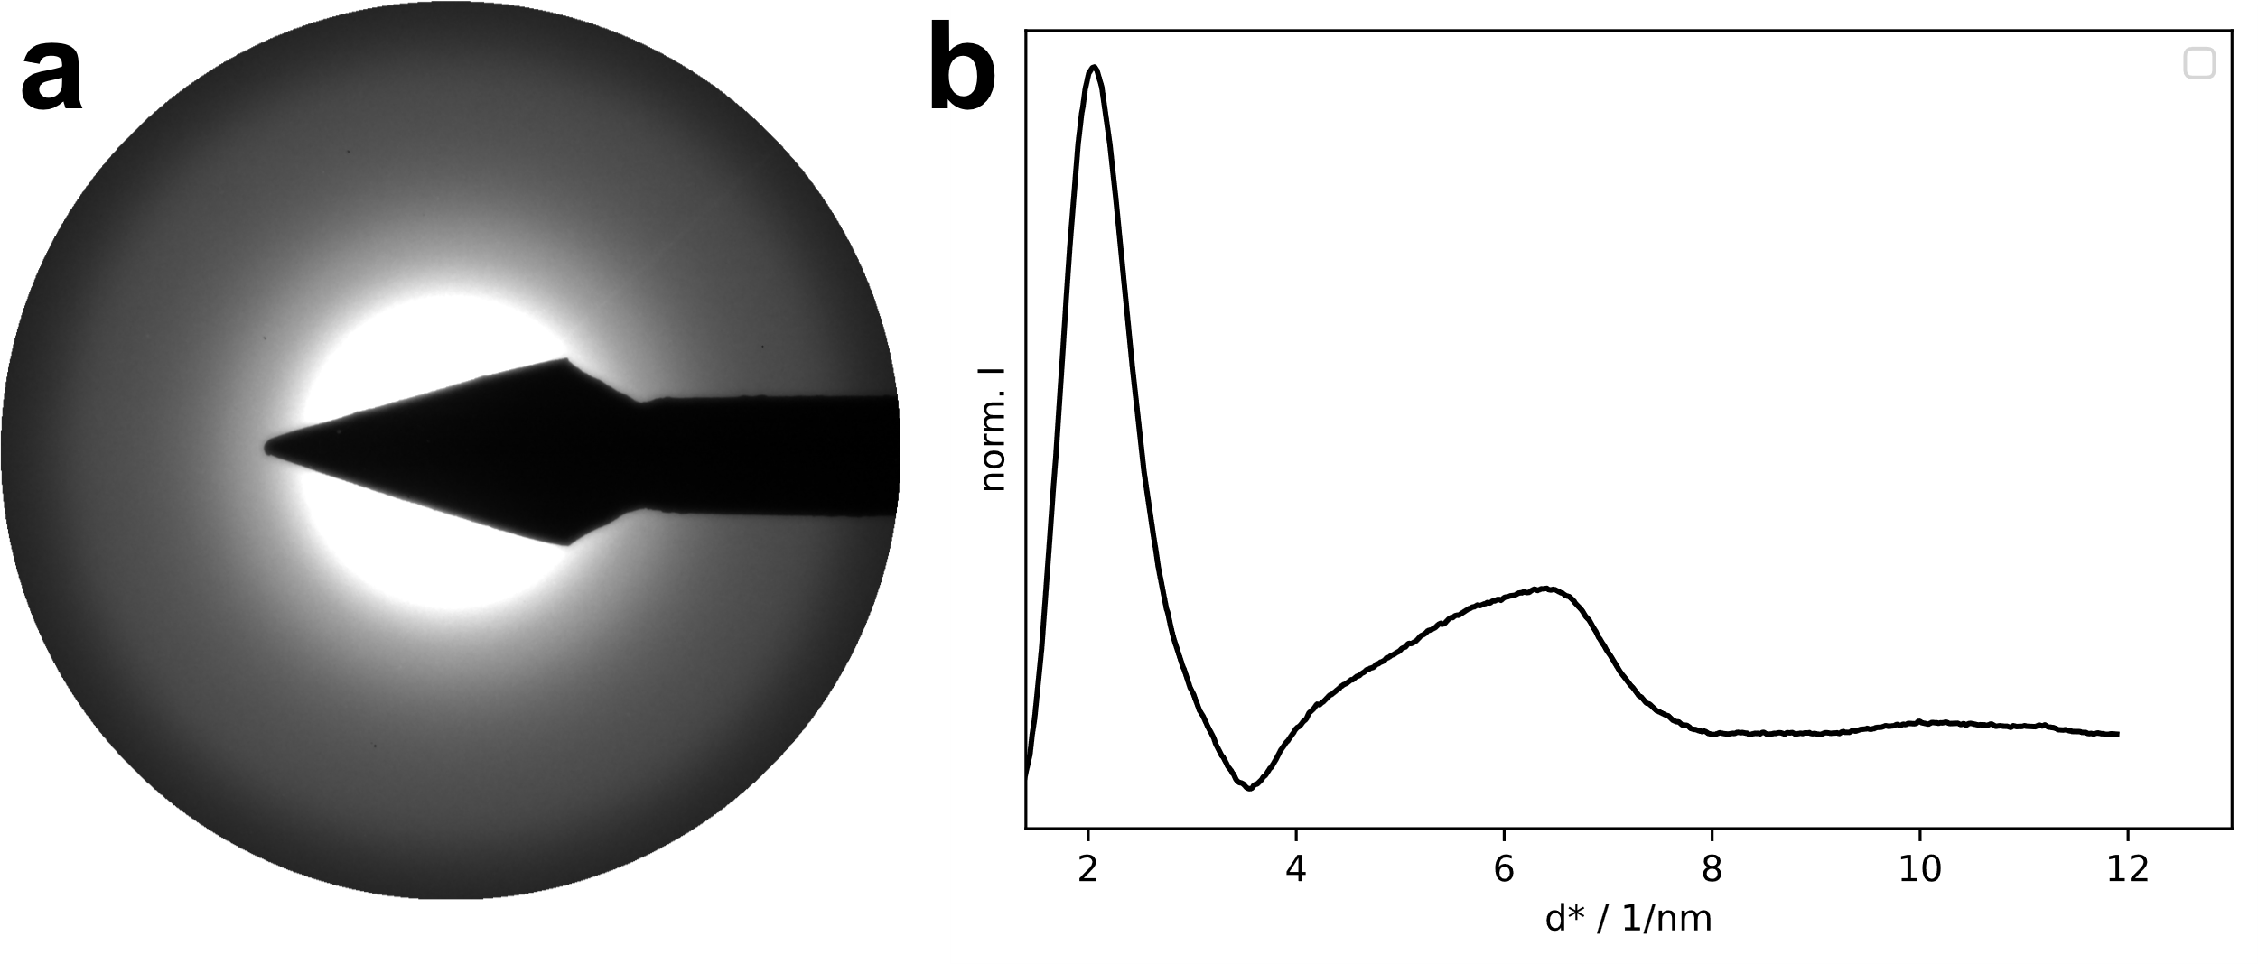
Figure S 5 Electron diffraction pattern (a) and rotational average (b) of non-decorated aeroglass, revealing its amorphous structure.

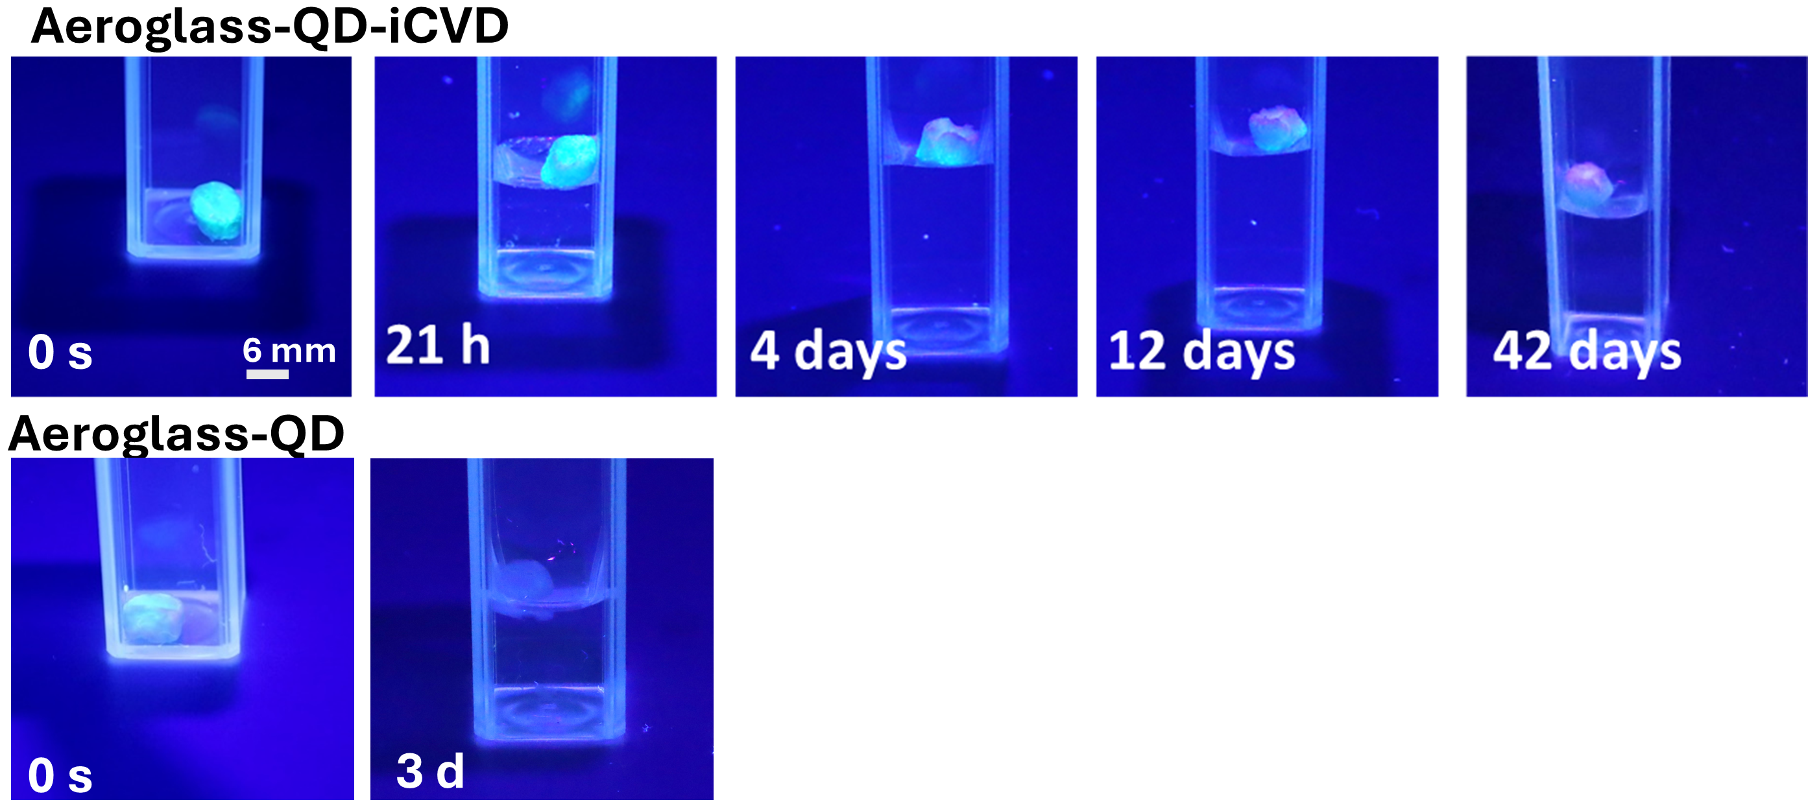
Figure S 6 Long-term stability of aeroglass-QD-iCVD and aeroglass-QD. Images were taken at different time points and show the gradual decrease in luminescence.

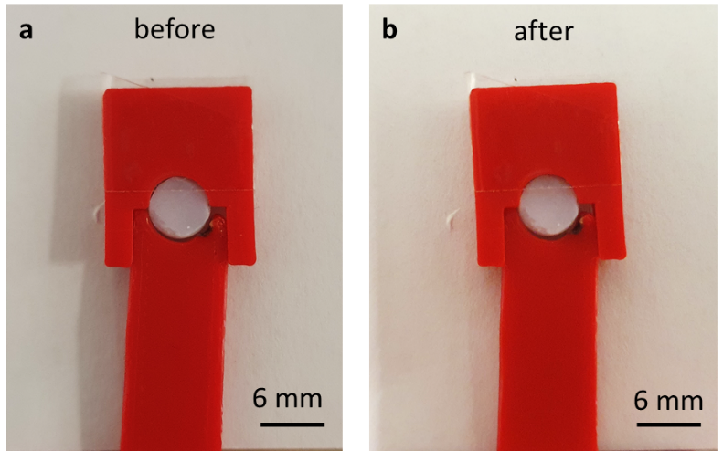
Figure S 7 Aeroglass in sample holder (a) before and (b) after illumination with a 5W blue laser for 1 min.

Supplementary Note 3 – Determination of layer thickness of pEGDMA coating
The wall thickness of an individual microtube arm of a f-SiO2-QD sample as well as of a f-SiO2-QD-iCVD samples is determined by electron energy loss spectroscopy log ratio method. Performing a line scan across a hollow microtube yields the relative thickness in multiples of the inelastic electron mean free path (eMFP). The difference in eMFP between an iCVD-coated and non-coated microtube arms is 0.073 eMFP, which is the thickness of the pEGDMA coating.
Calculating the mean free path of pEGDMA after Malis et al. ² results in a mean free path of λ_{EGDMA} ~ 150 nm, thus, the thickness of the pEGDMA coating is approximately 5.5 nm.
It has to be noted, that the relative thickness of the pEGDMA coating has to be divided by a factor of two, as the electron beam passes twice through the hollow microtube.

Supplementary Note 4 – Data processing of selective area electron diffraction (SAED) data
The SAED data is processed via a custom analysis and manipulation tool in multiple steps in order to improve data quality and enable combination of multiple data points. First, the center of the SAED patterns is automatically detected followed by a rotational average (taking the mean of radial intensity profiles from the center outwards for a fixed number of polar angles). The rotational averages are background subtracted using an asymmetric least squares approach followed by a multi exponential model. The background subtracted models can be corrected for slight misalignments of the microscope scattering angle calibration via a multiplicative correction factor (empirical) determined using a known reflection present in the data. The so corrected and background subtracted rotational averages are then used to determined the crystal phase by comparison the calculated diffraction patterns of multiple structure candidates. Multiple rotational averages can be superimposed to improve data quality.

References
1. Draijer, M., Hondebrink, E., van Leeuwen, T. & Steenbergen, W. Review of laser speckle contrast techniques for visualizing tissue perfusion. Lasers in medical science 24, 639–651; 10.1007/s10103-008-0626-3 (2009).
2. Malis, T., Cheng, S. C. & Egerton, R. F. EELS log-ratio technique for specimen-thickness measurement in the TEM. Journal of electron microscopy technique 8, 193–200; 10.1002/jemt.1060080206 (1988).
3. Aktas, O. C. et al. Superhydrophobic 3D Porous PTFE/TiO 2 Hybrid Structures. Adv. Mater. Interfaces 6, 1801967; 10.1002/admi.201801967 (2019).
4. Barg, I. et al. Strain‐Invariant, Highly Water Stable All‐Organic Soft Conductors Based on Ultralight Multi‐Layered Foam‐Like Framework Structures. Adv Funct Materials, 2212688; 10.1002/adfm.202212688 (2023).

