Black sand as source of catalysts that selectively isomerize α- and β-pinene epoxides

Luis Fernando Valenciaª, Aída Luz Villa^{a,*}.
ªEnvironmental Catalysis Research Group, Chemical Engineering Department, Engineering Faculty, Universidad de Antioquia UdeA, Calle 70 No. 52-21, Medellín, Colombia

*Corresponding author e-mail : aida.villa@udea.edu.co

β-pinene epoxide synthesis.
β-Pinene epoxide was synthesized according to a reported methodology [1] with some modifications. The mass ratio of the used reagents for acetone: acetonitrile: H₂O: H₂O₂: H₂O₂: MgO was 1: 9.33: 7.85: 14.7: 0.48. The reagents, except hydrogen peroxide, were heated at 50 °C under continuous stirring at 500 rpm; then, H₂O₂ was added dropwise and after 80 min of reaction, the mixture was cooled in a water with ice bath and manganese oxide was added for decomposing H₂O₂. Then, the suspension was filtered under vacuum to separate the solid material, and a liquid-liquid extraction was performed with dichloromethane to separate the organic phase which was rotoevaporated at 60 °C to separate dichloromethane, acetone and acetonitrile under vacuum of 800, 420, 180 mbar, respectively. Finally, the β-pinene epoxide was analyzed by gas chromatography coupled to mass spectrometry using an Agilent 7890A gas chromatograph with FID and Agilent 5975C mass detector, using He as carrier gas. A silica HP-5MS capillary column (30 m, 0.25 mm, 0.25 µm) and FID detector were used. The velocity and flow rate of the carrier gas was 30.5 cm/s and 2.2 mL/min, respectively. The oven temperature was 70 °C for 1 min and then increased to 90 °C (10 °C/ min) for 0.5 min, then raised to 110 °C (10 °C /min) for 0.5 min, then to 130 °C (10 °C/min) for 0.5 min and finally up to 160 °C (15 °C/min) for 1 min. The injection volume was 1 μL in split mode (25:1) with injector temperature of 250 °C. Compound identification was performed using the NIST database5. Figure S12 shows a chromatogram of the synthesized β-pinene epoxide.

Analysis of the solid after hydrothermal treatment with sulfuric acid

“The material after treatment with sulfuric acid was washed with water at 85 °C dried and analyzed by FTIR (Figure S1) and compared with the solid washed with water at room temperature. Any of the materials show the bands at 1238 and 1156 cm⁻¹ that correspond to the asymmetry and symmetry vibrations of S=O, respectively, nor the bands at 1061 and 1001 cm⁻¹ that are assigned to the S–O asymmetry and symmetry vibrations from the (SO₄)⁻² anion [2]. It is concluded that the washed solid after treatment with sulfuric acid did not contain sulfur species.”

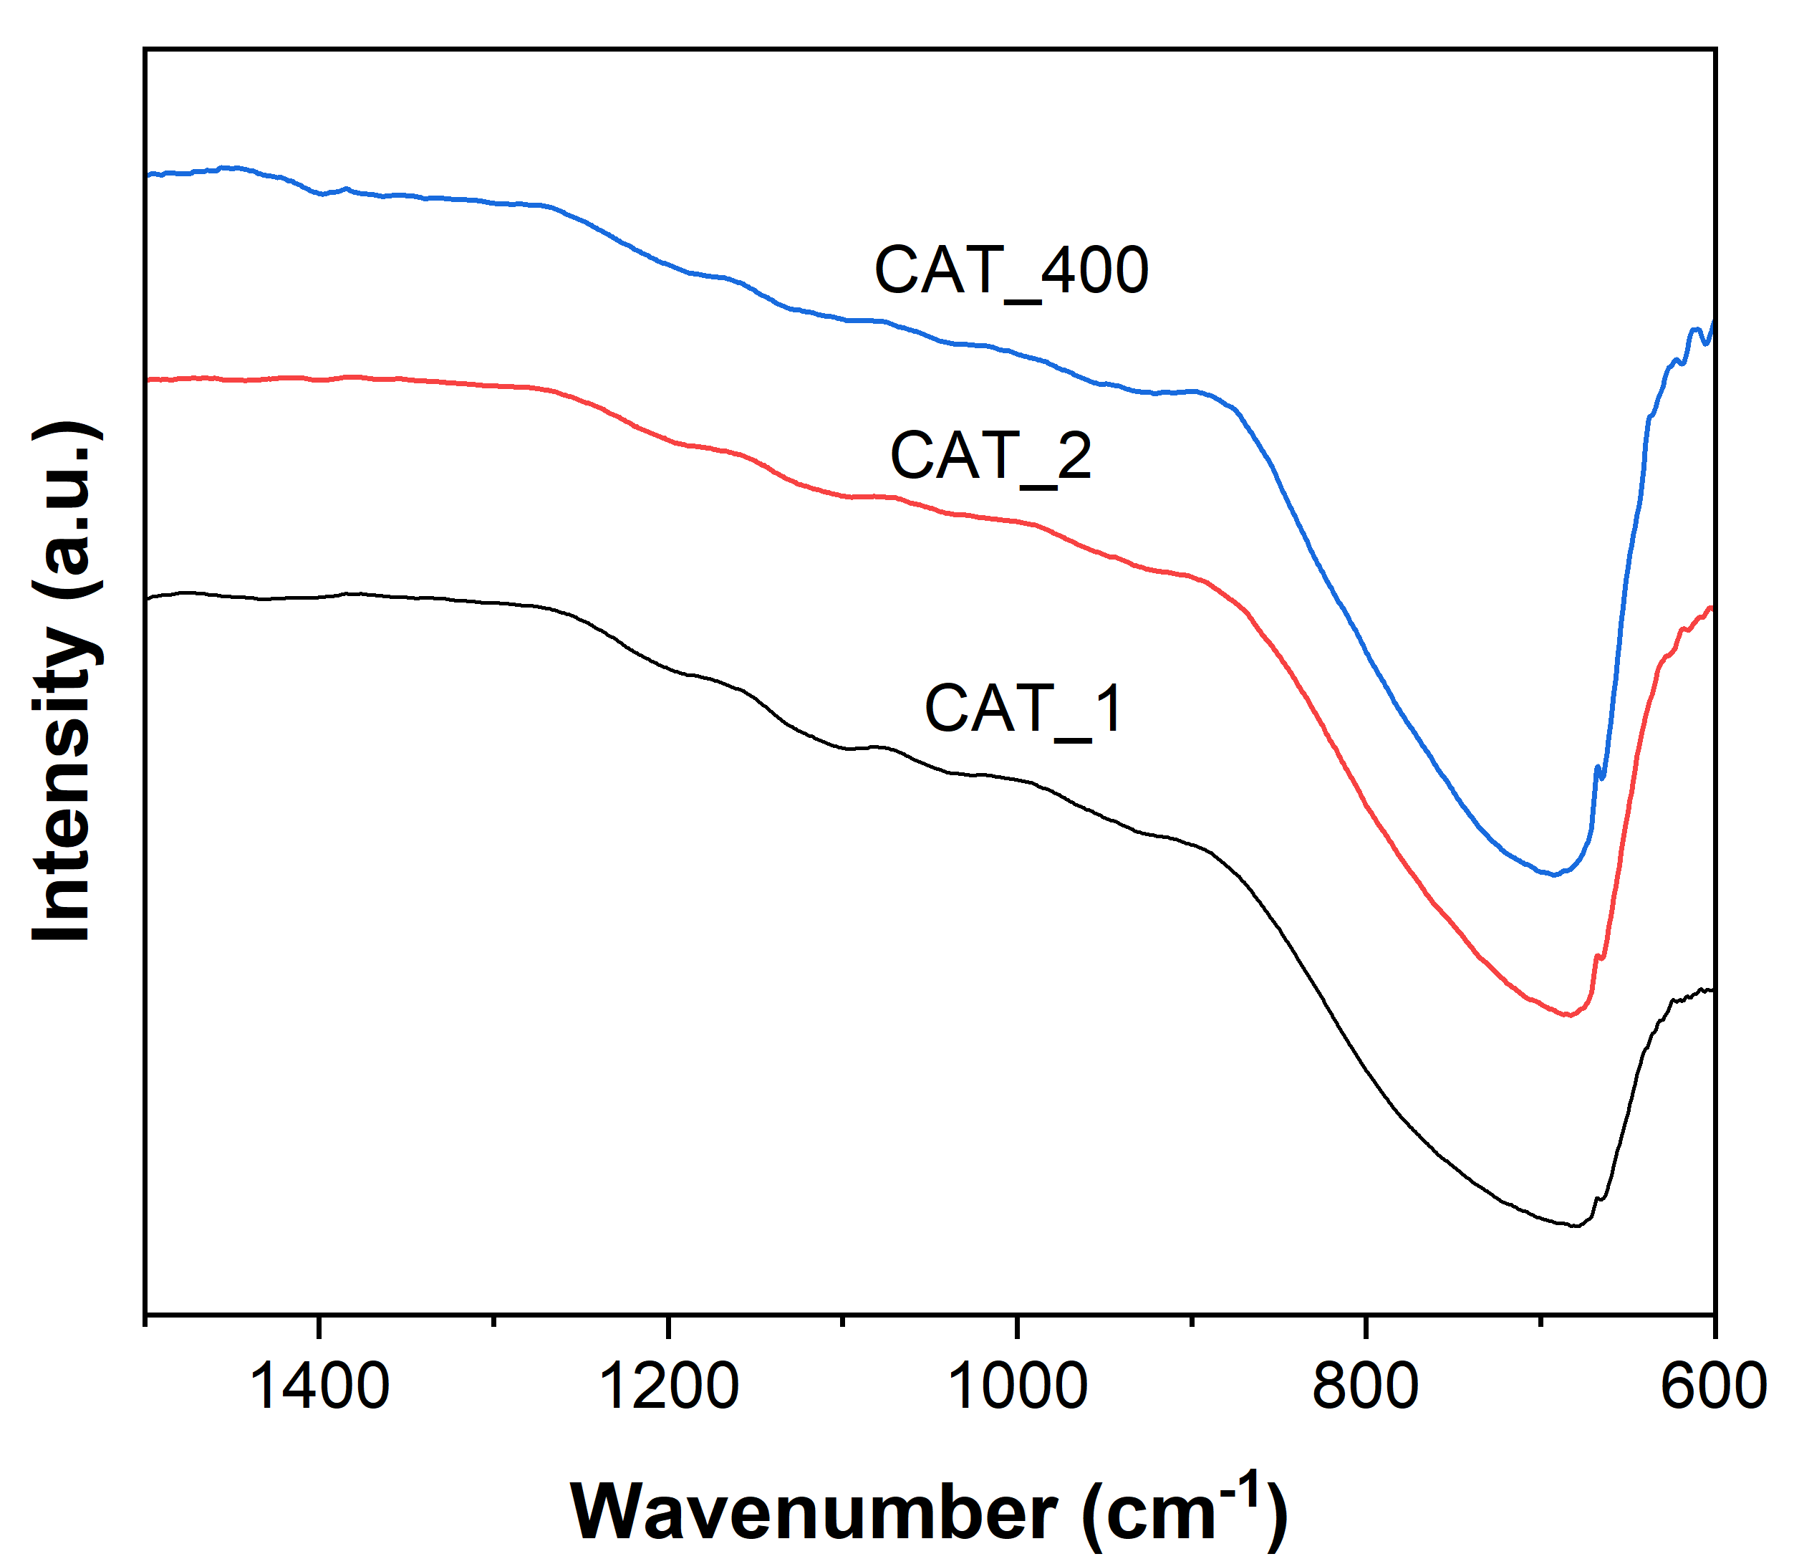
Figure S1. FTIR spectra of IC after sulfuric acid treatment and washing with water at 85 °C (CAT_1) or at room temperature (CAT_2); and IC after sulfuric acid treatment, washing with water at room temperature and calcination at 400 °C (CAT_400).

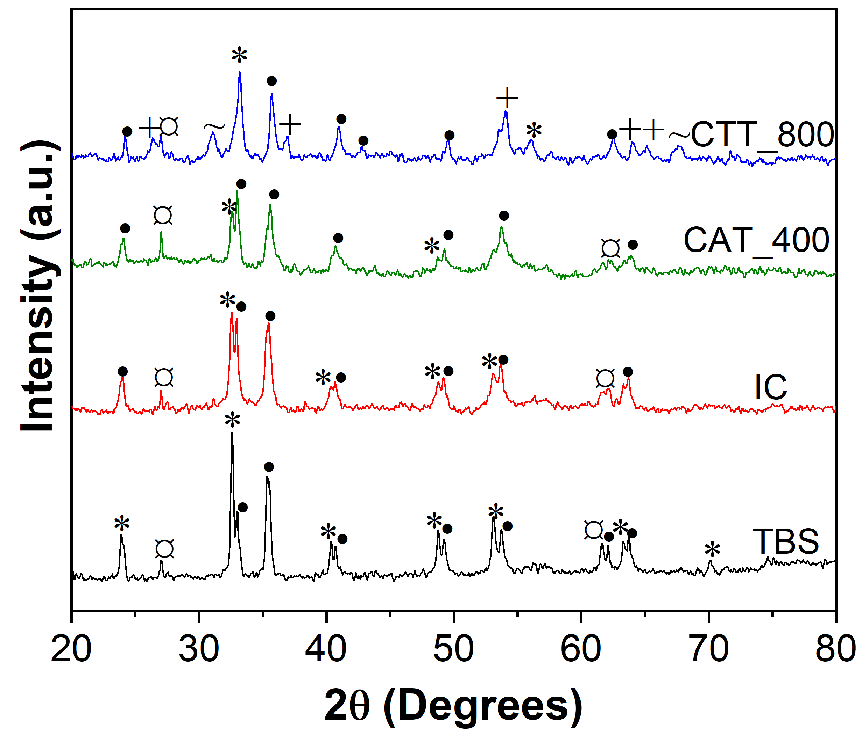
Figure S2. XRD pattern of TBS, IC, CTT_800, and CAT_400 materials. *Ilmenite, •hematite, ⁺pseudobrookite, ~magnetite, ¤ rutile.

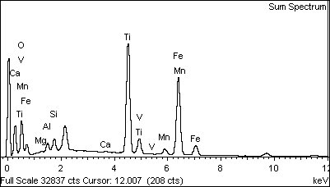

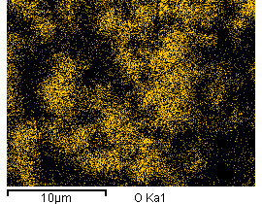
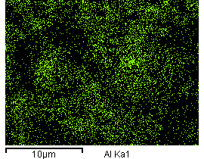
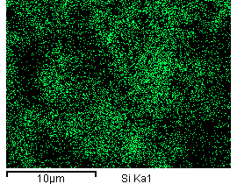
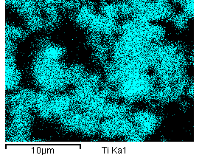
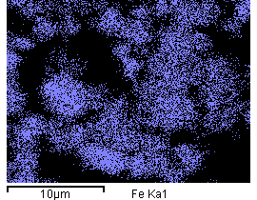
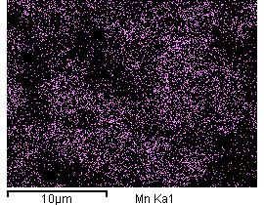

Figure S3. EDX and elemental mapping of TBS.

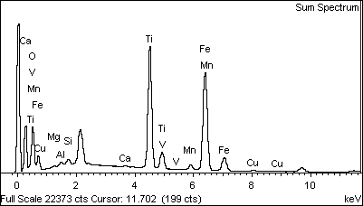
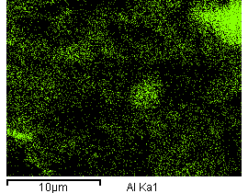
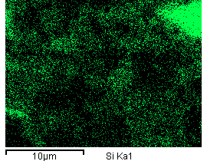
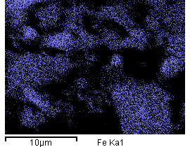
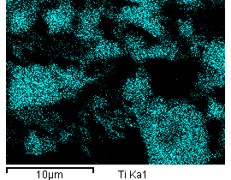
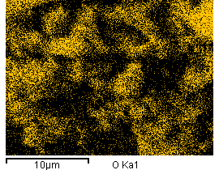
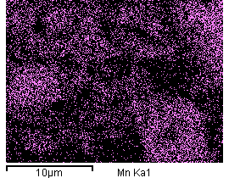

Figure S4. EDX and elemental mapping of IC.

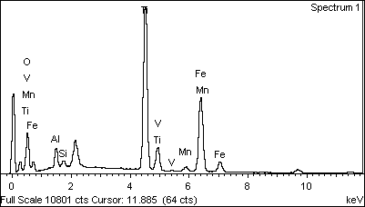

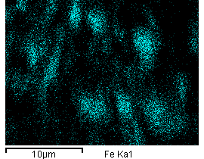
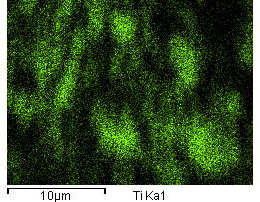
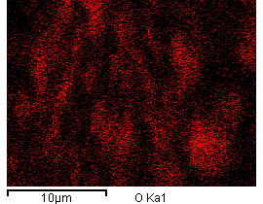

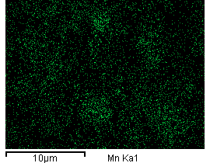
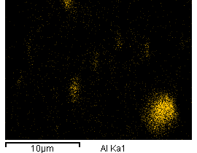
Figure S5. EDX and elemental mapping of CAT_400.

Figure S6. EDX and elemental mapping of CTT_800.

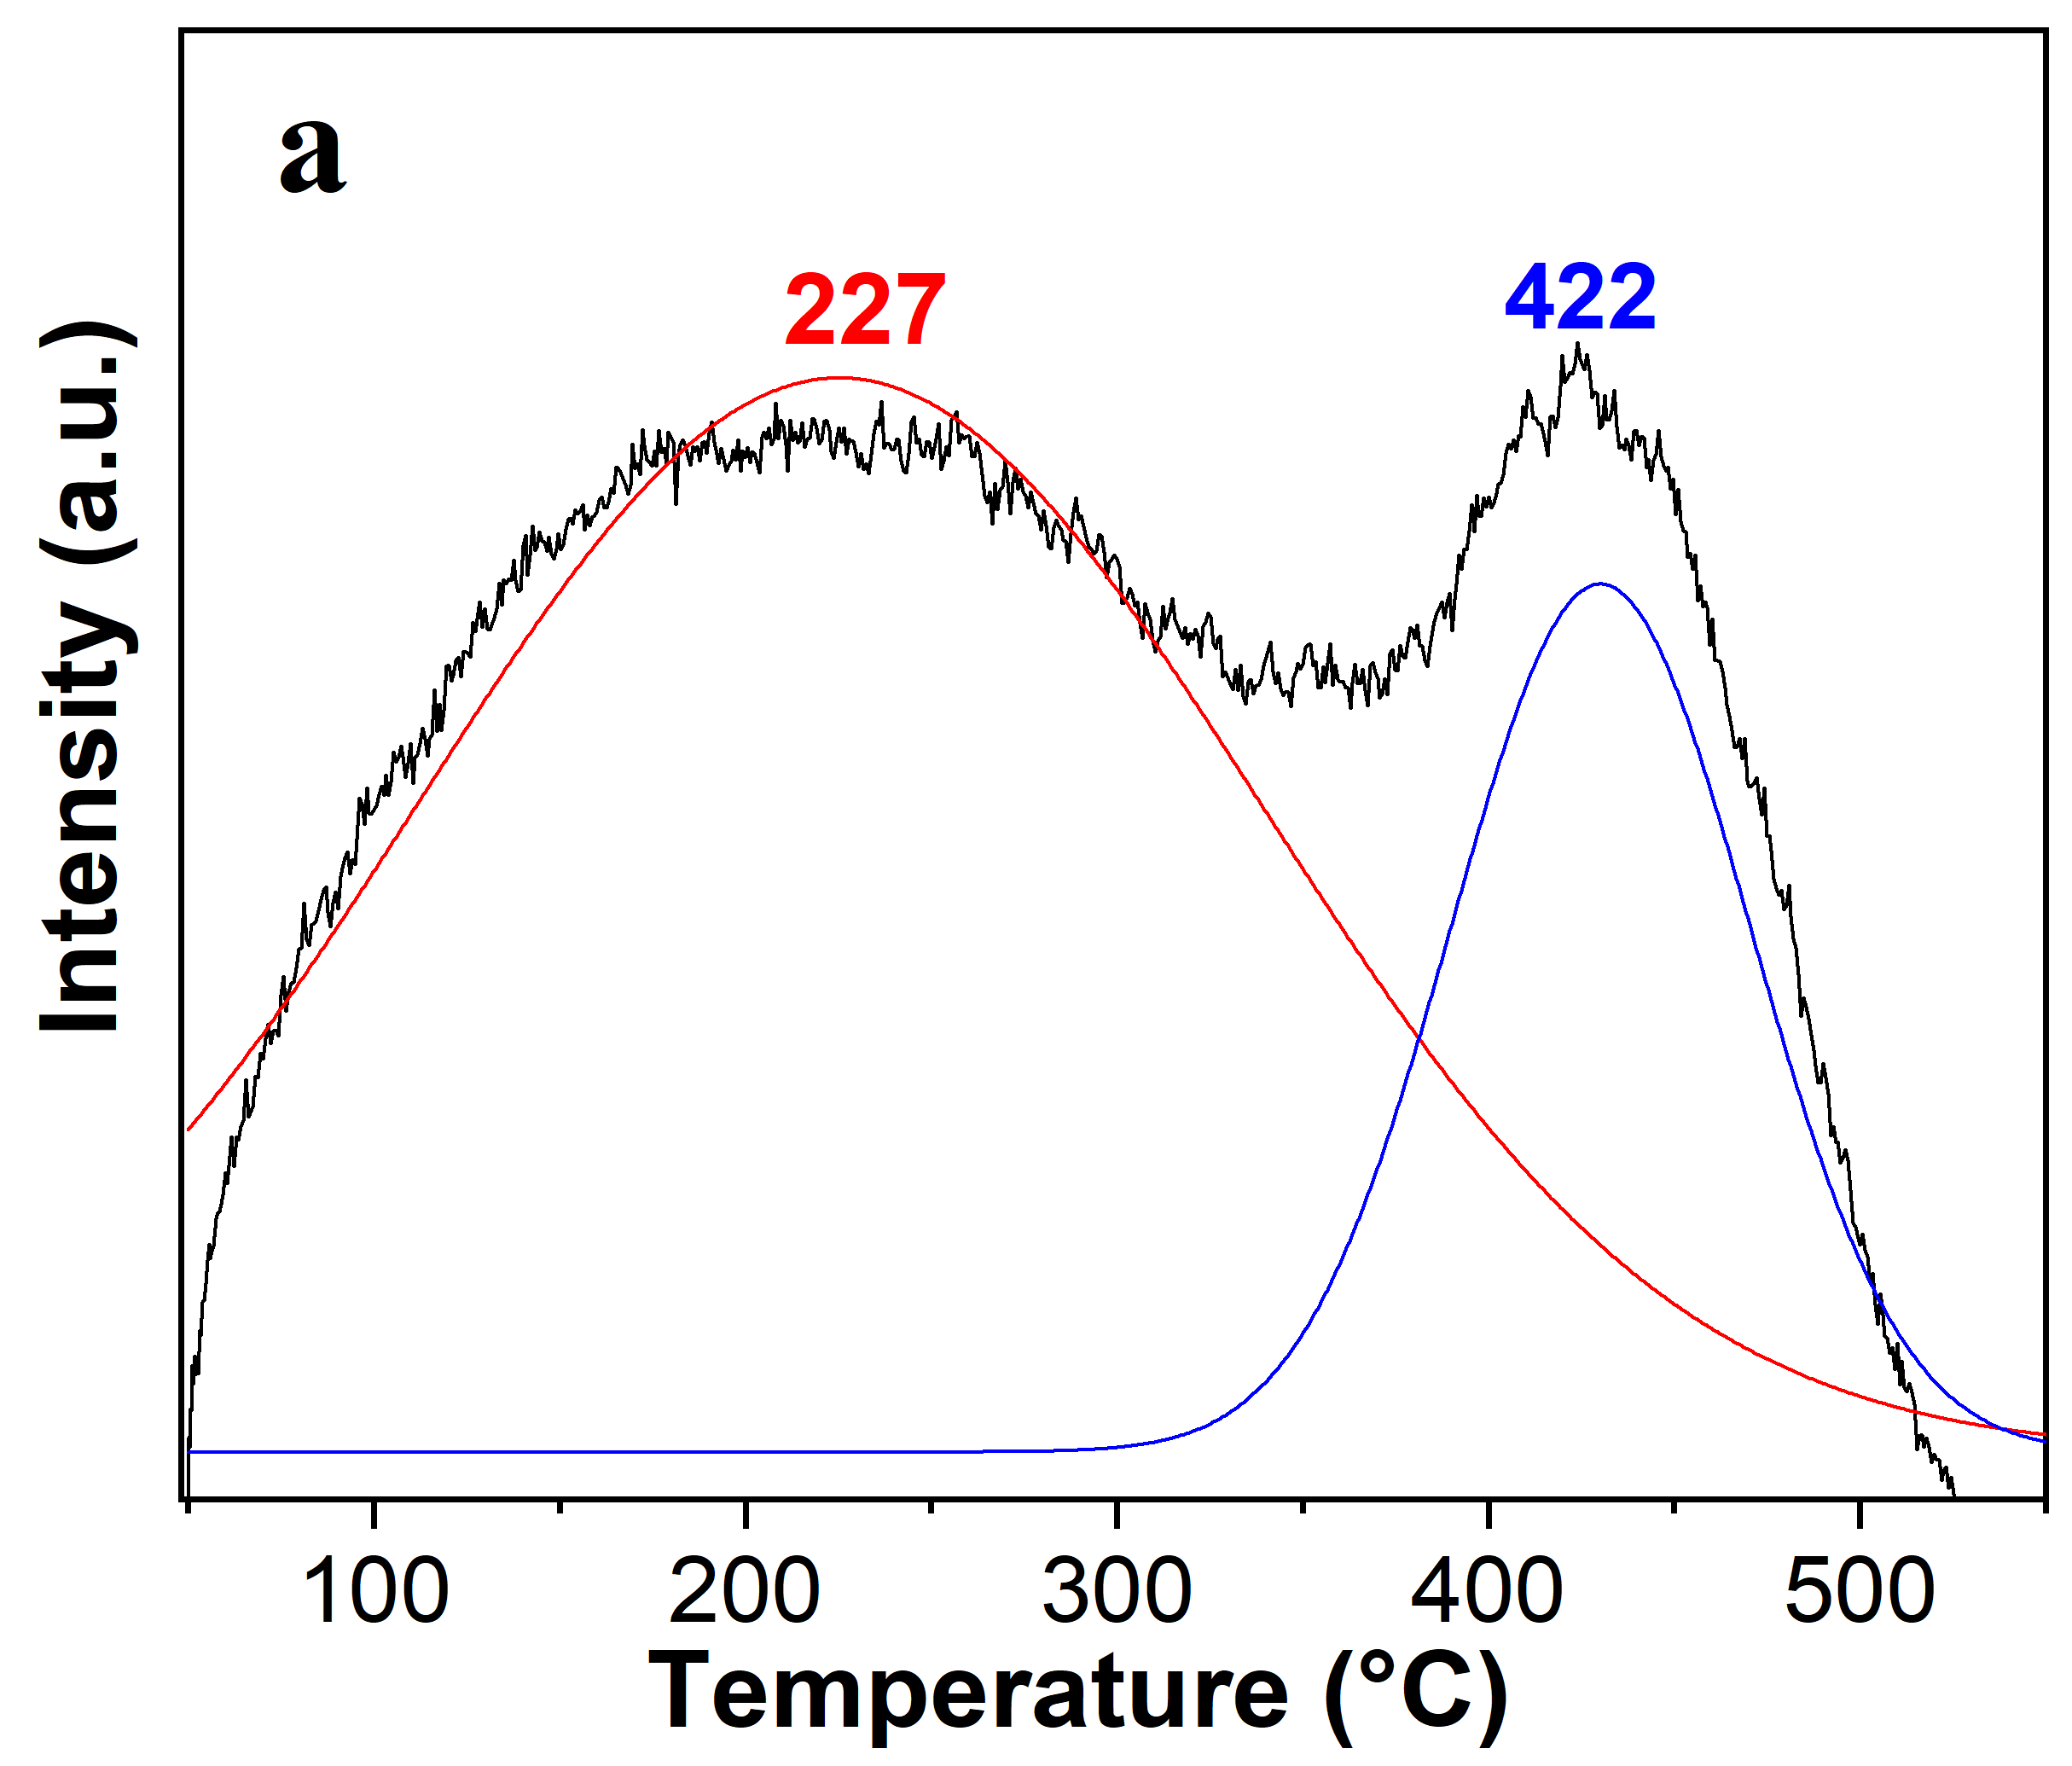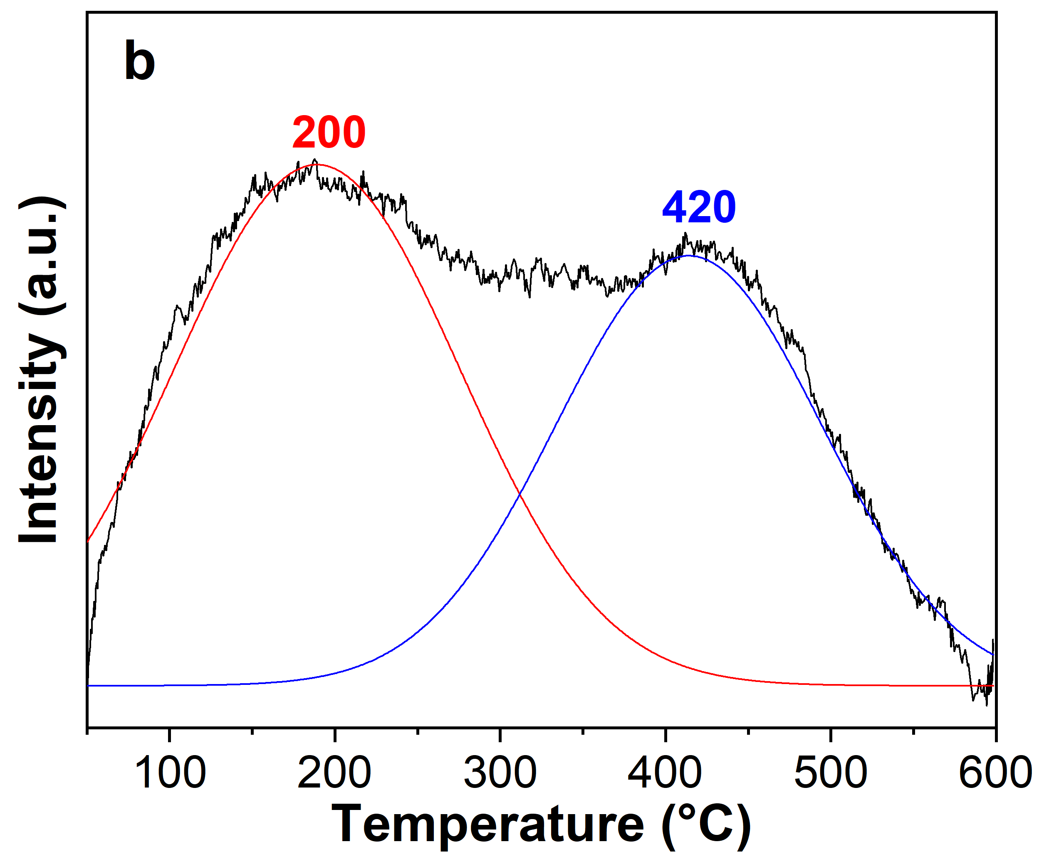
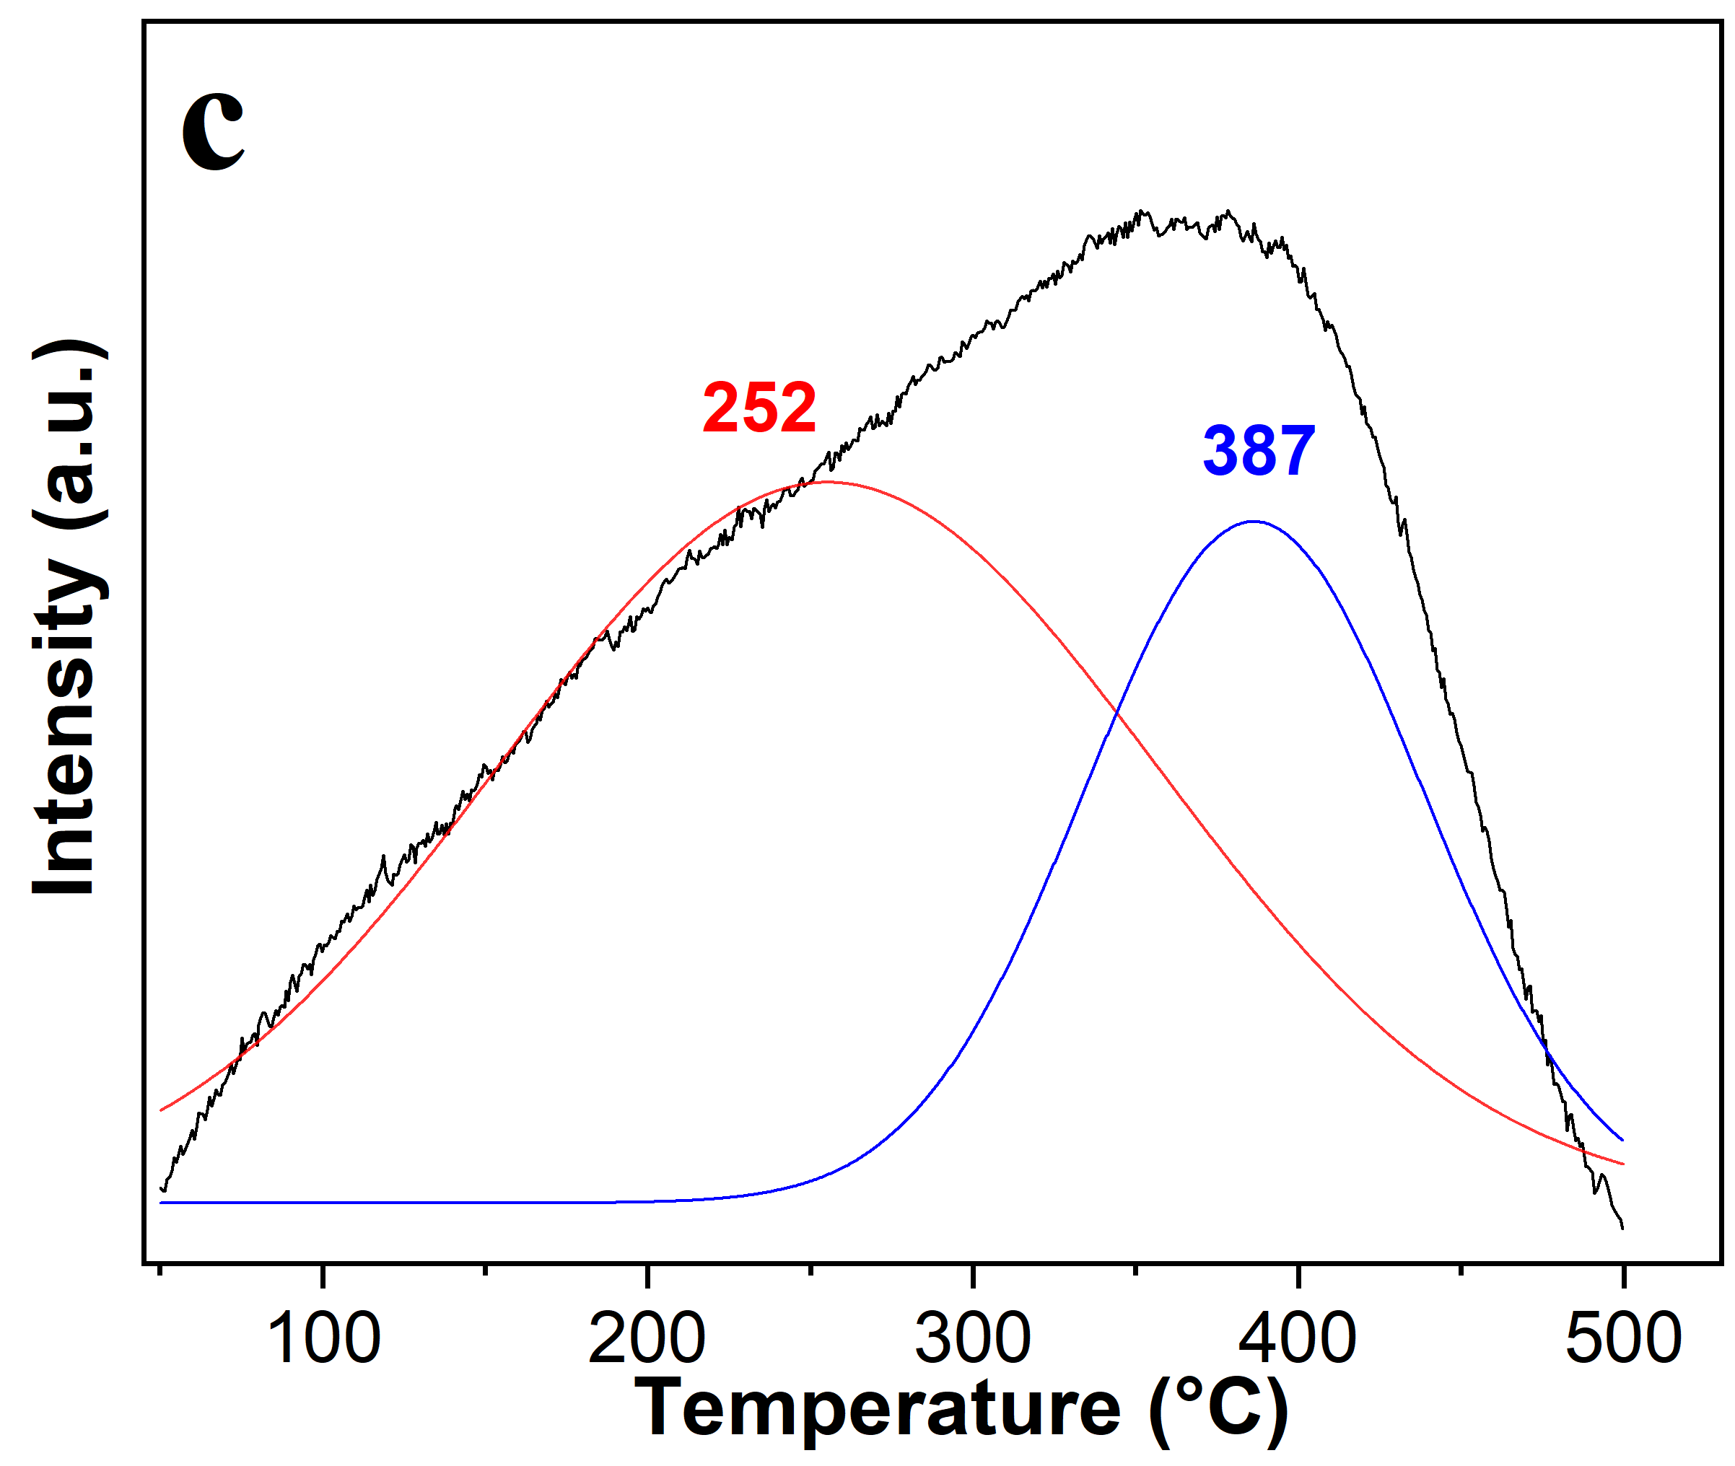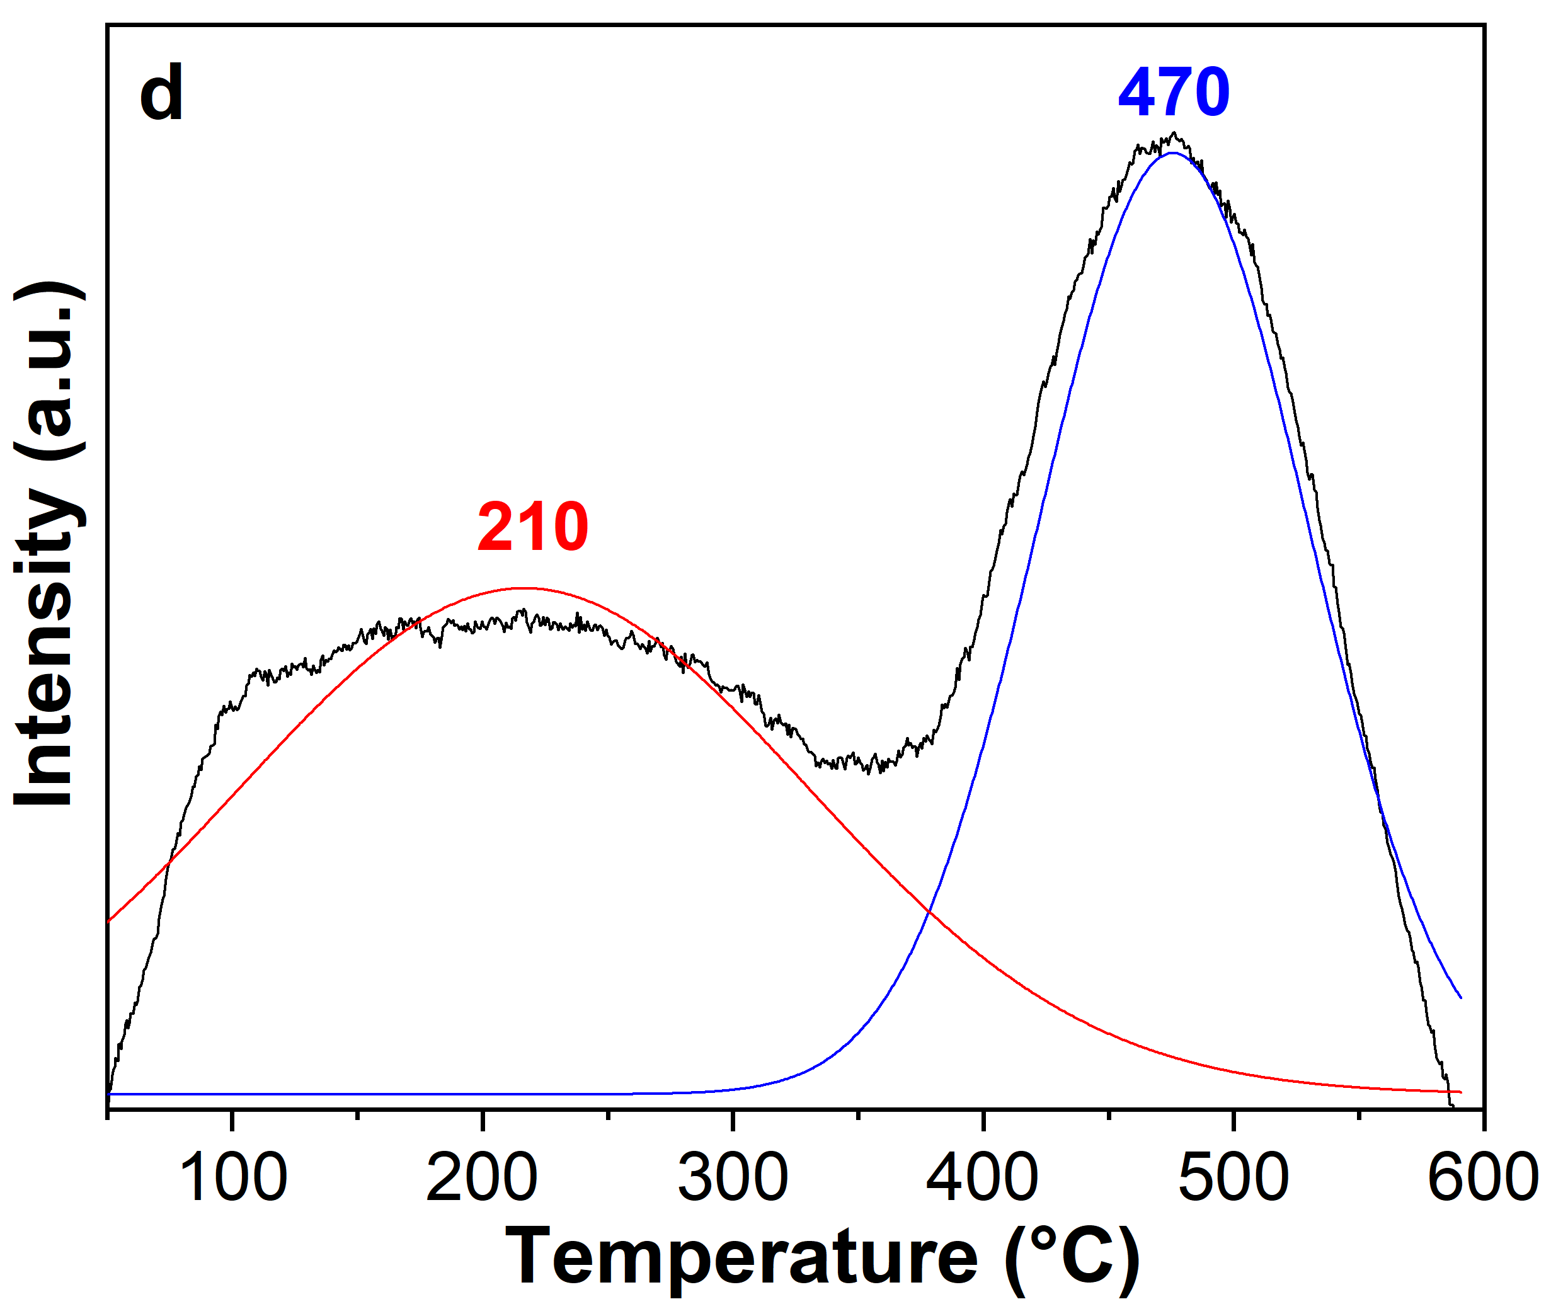
Figure S7. TPD-NH₃ TBS (a), IC (b), CAT_400 (c) and CTT_800 (d). Line black represents raw experimental data, line red and blue show the peaks obtained using Gaussian peak deconvolution with a coefficient of determination (R²) of 0.95.

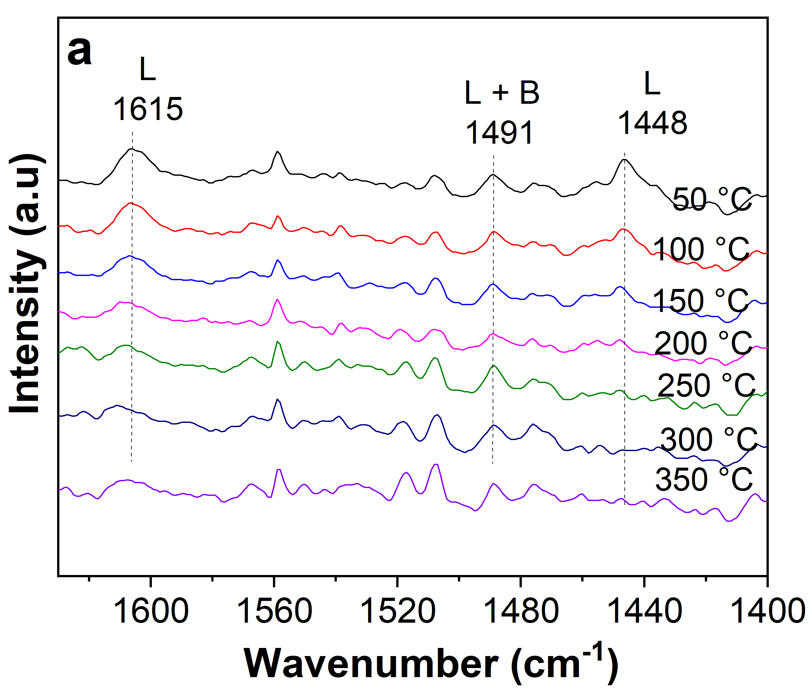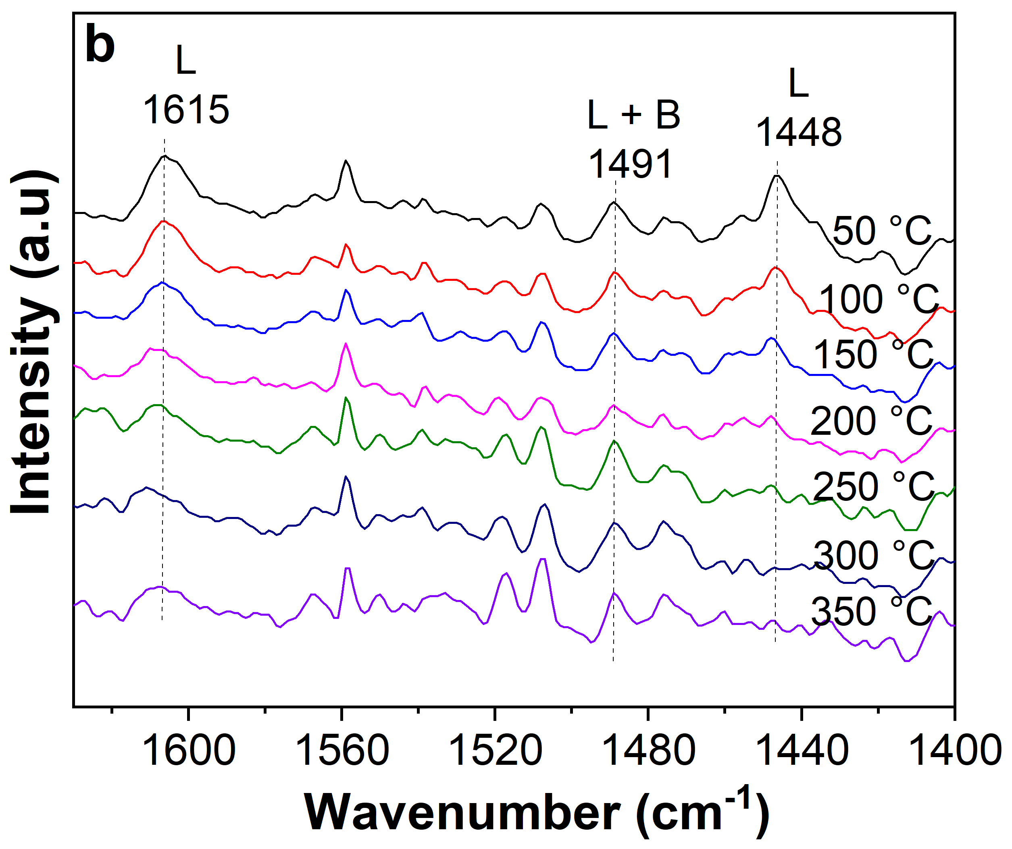
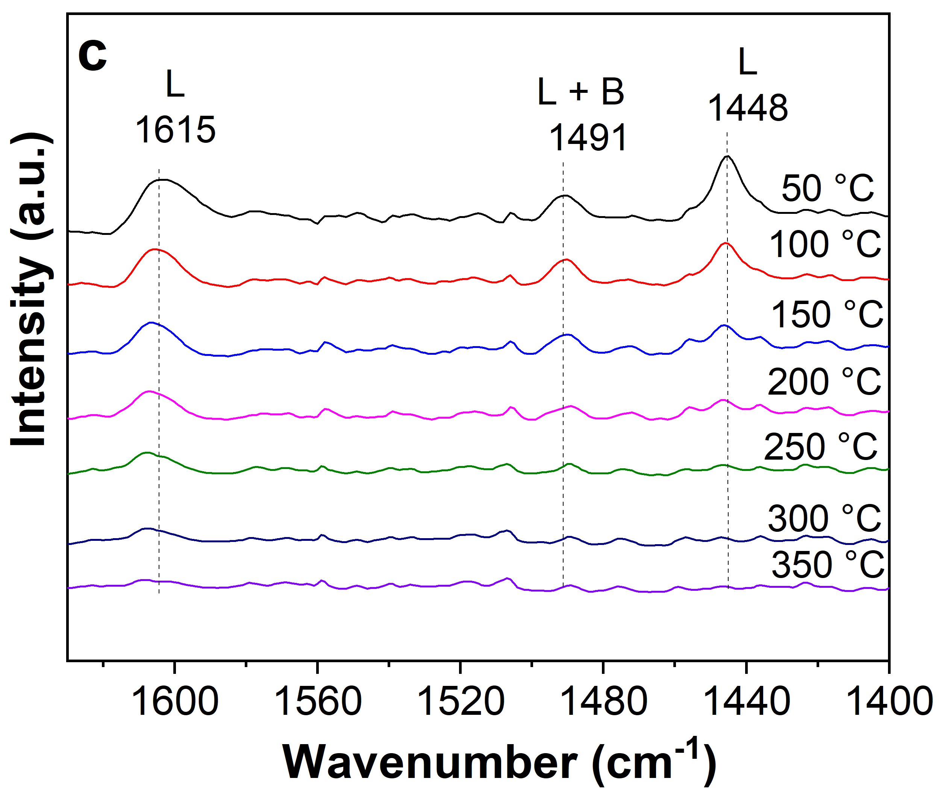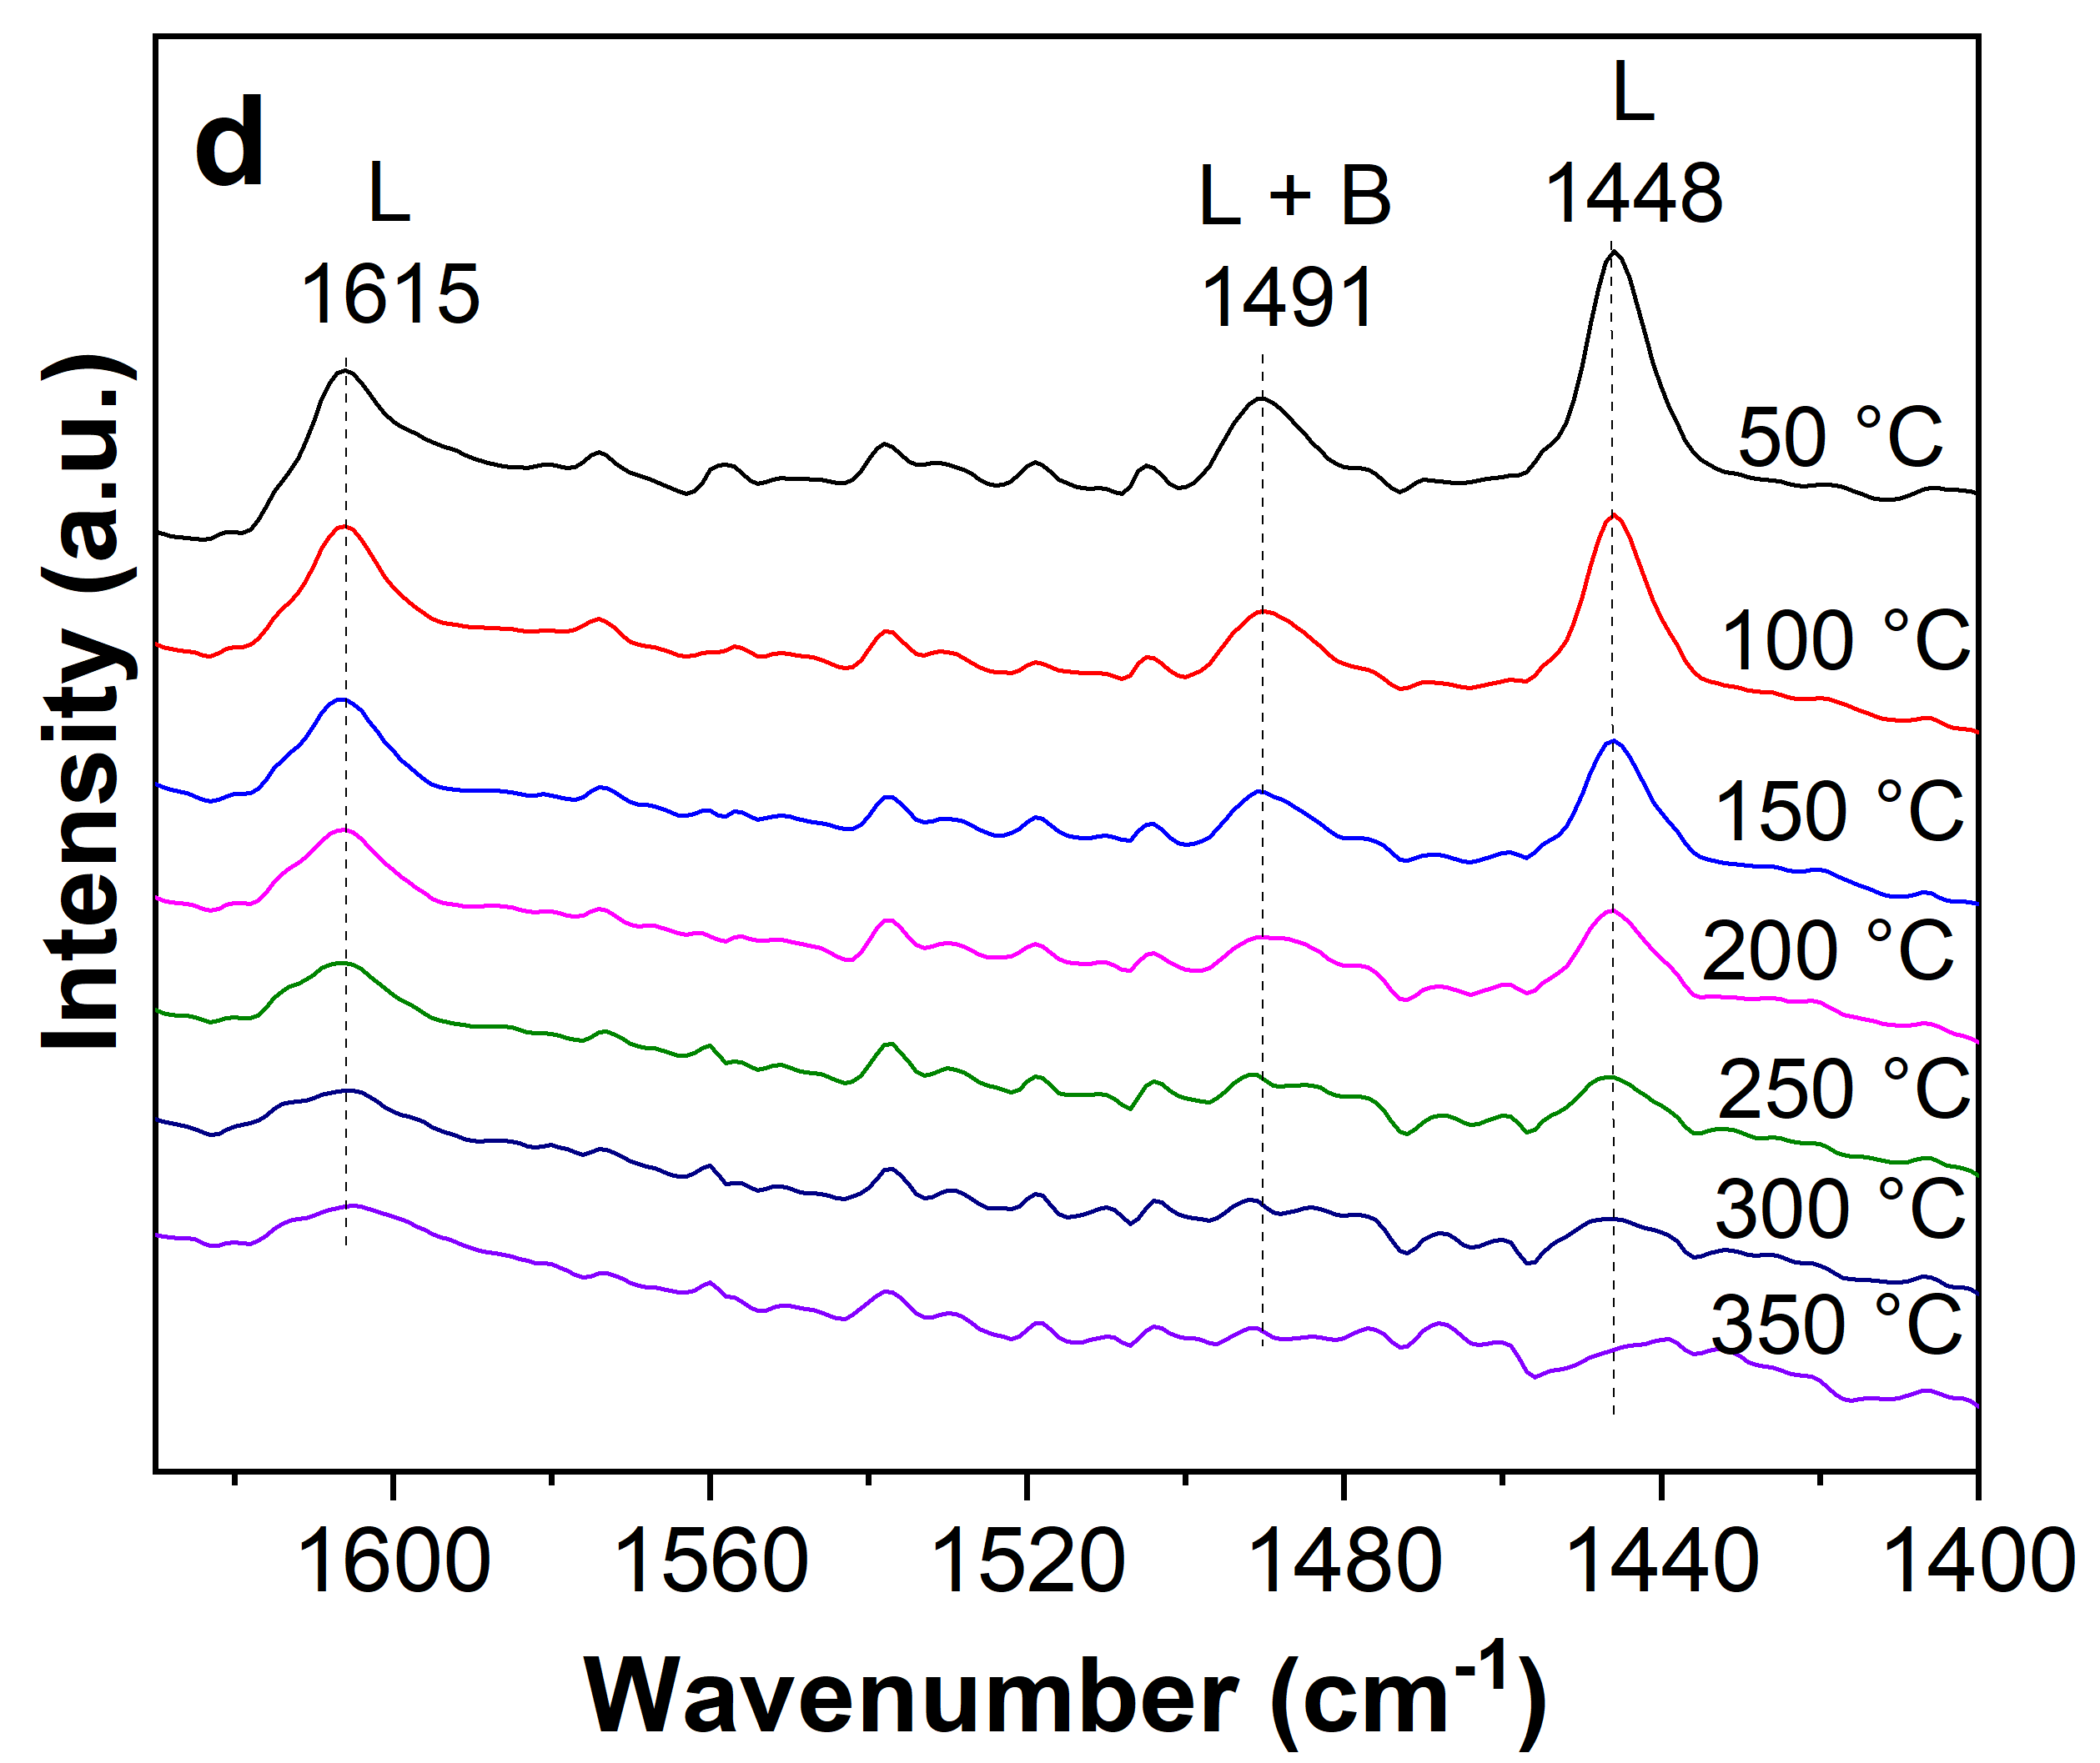

Figure S8. FTIR of pyridine desorbed at different temperatures for TBS (a), IC (b), CTT_800 (c), and CAT_400 (d). Lewis (L) and Bronsted (B) acid sites.

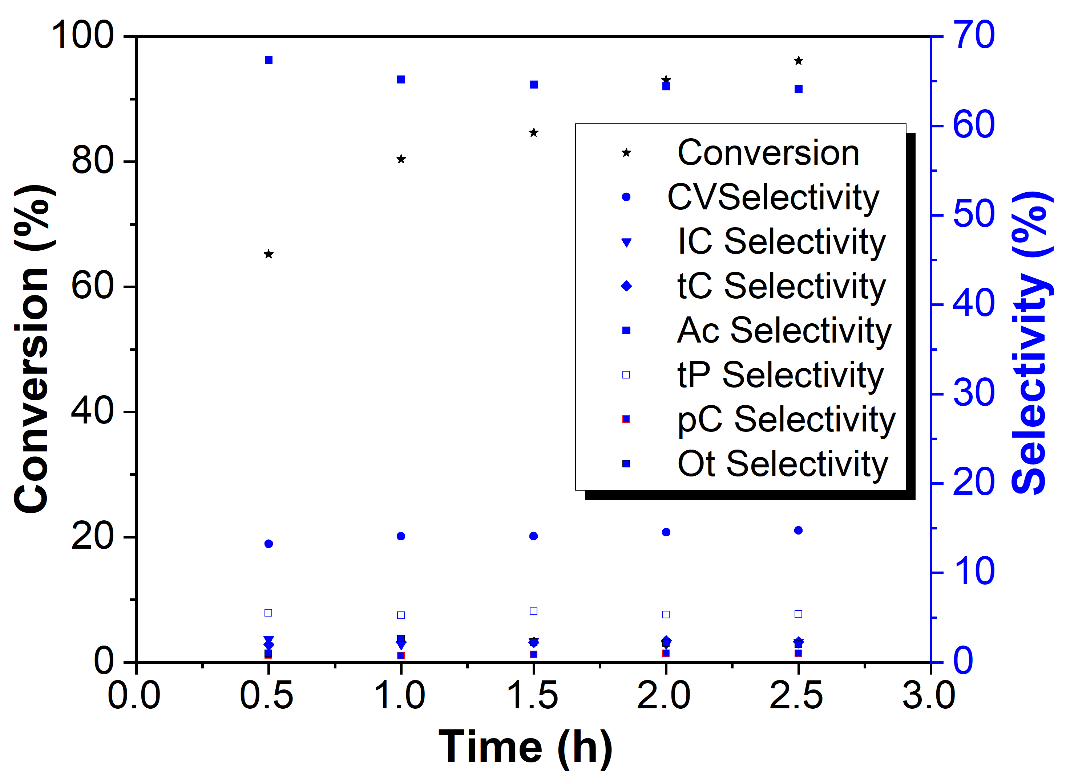

Figure S9. Effect of time on the isomerization of α-pinene epoxide. Reaction conditions: 0.25 mmol of α-pinene epoxide, 1 mL cyclohexane, 750 rpm, 90 °C, 100 mg CAT_400. AC: campholenic aldehyde, CV: cis-carveol, tP: trans-pinocarveol, IC: isocamphone, pC: p-cymene, tC: trans-caren-4-ol. Ot: others.

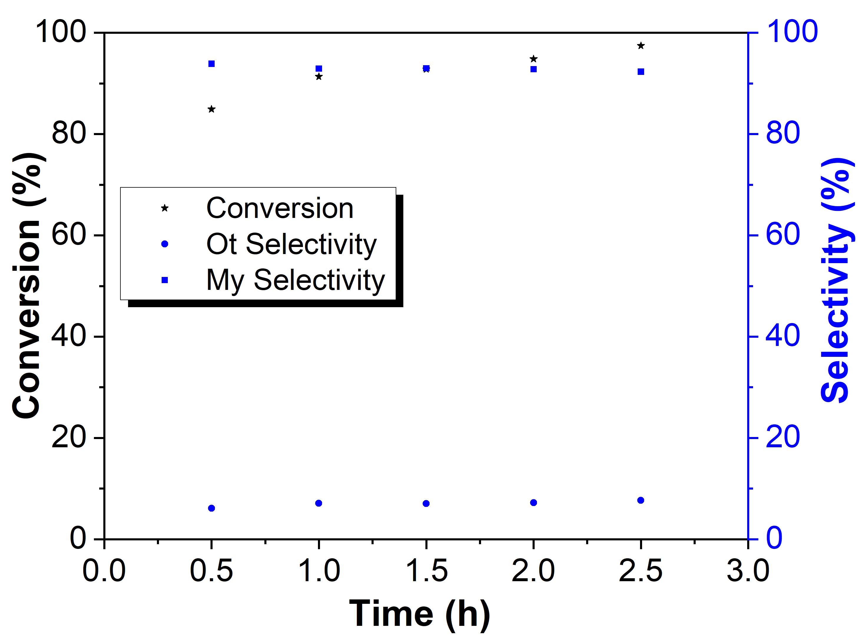

Figure S10. Effect of time on the isomerization of β-pinene epoxide. Reaction conditions: 0.25 mmol β-pinene epoxide, 75 mg catalyst (CAT_400), 1 mL dioxane, 750 rpm, 90 °C. My: myrtanal. Ot: others.

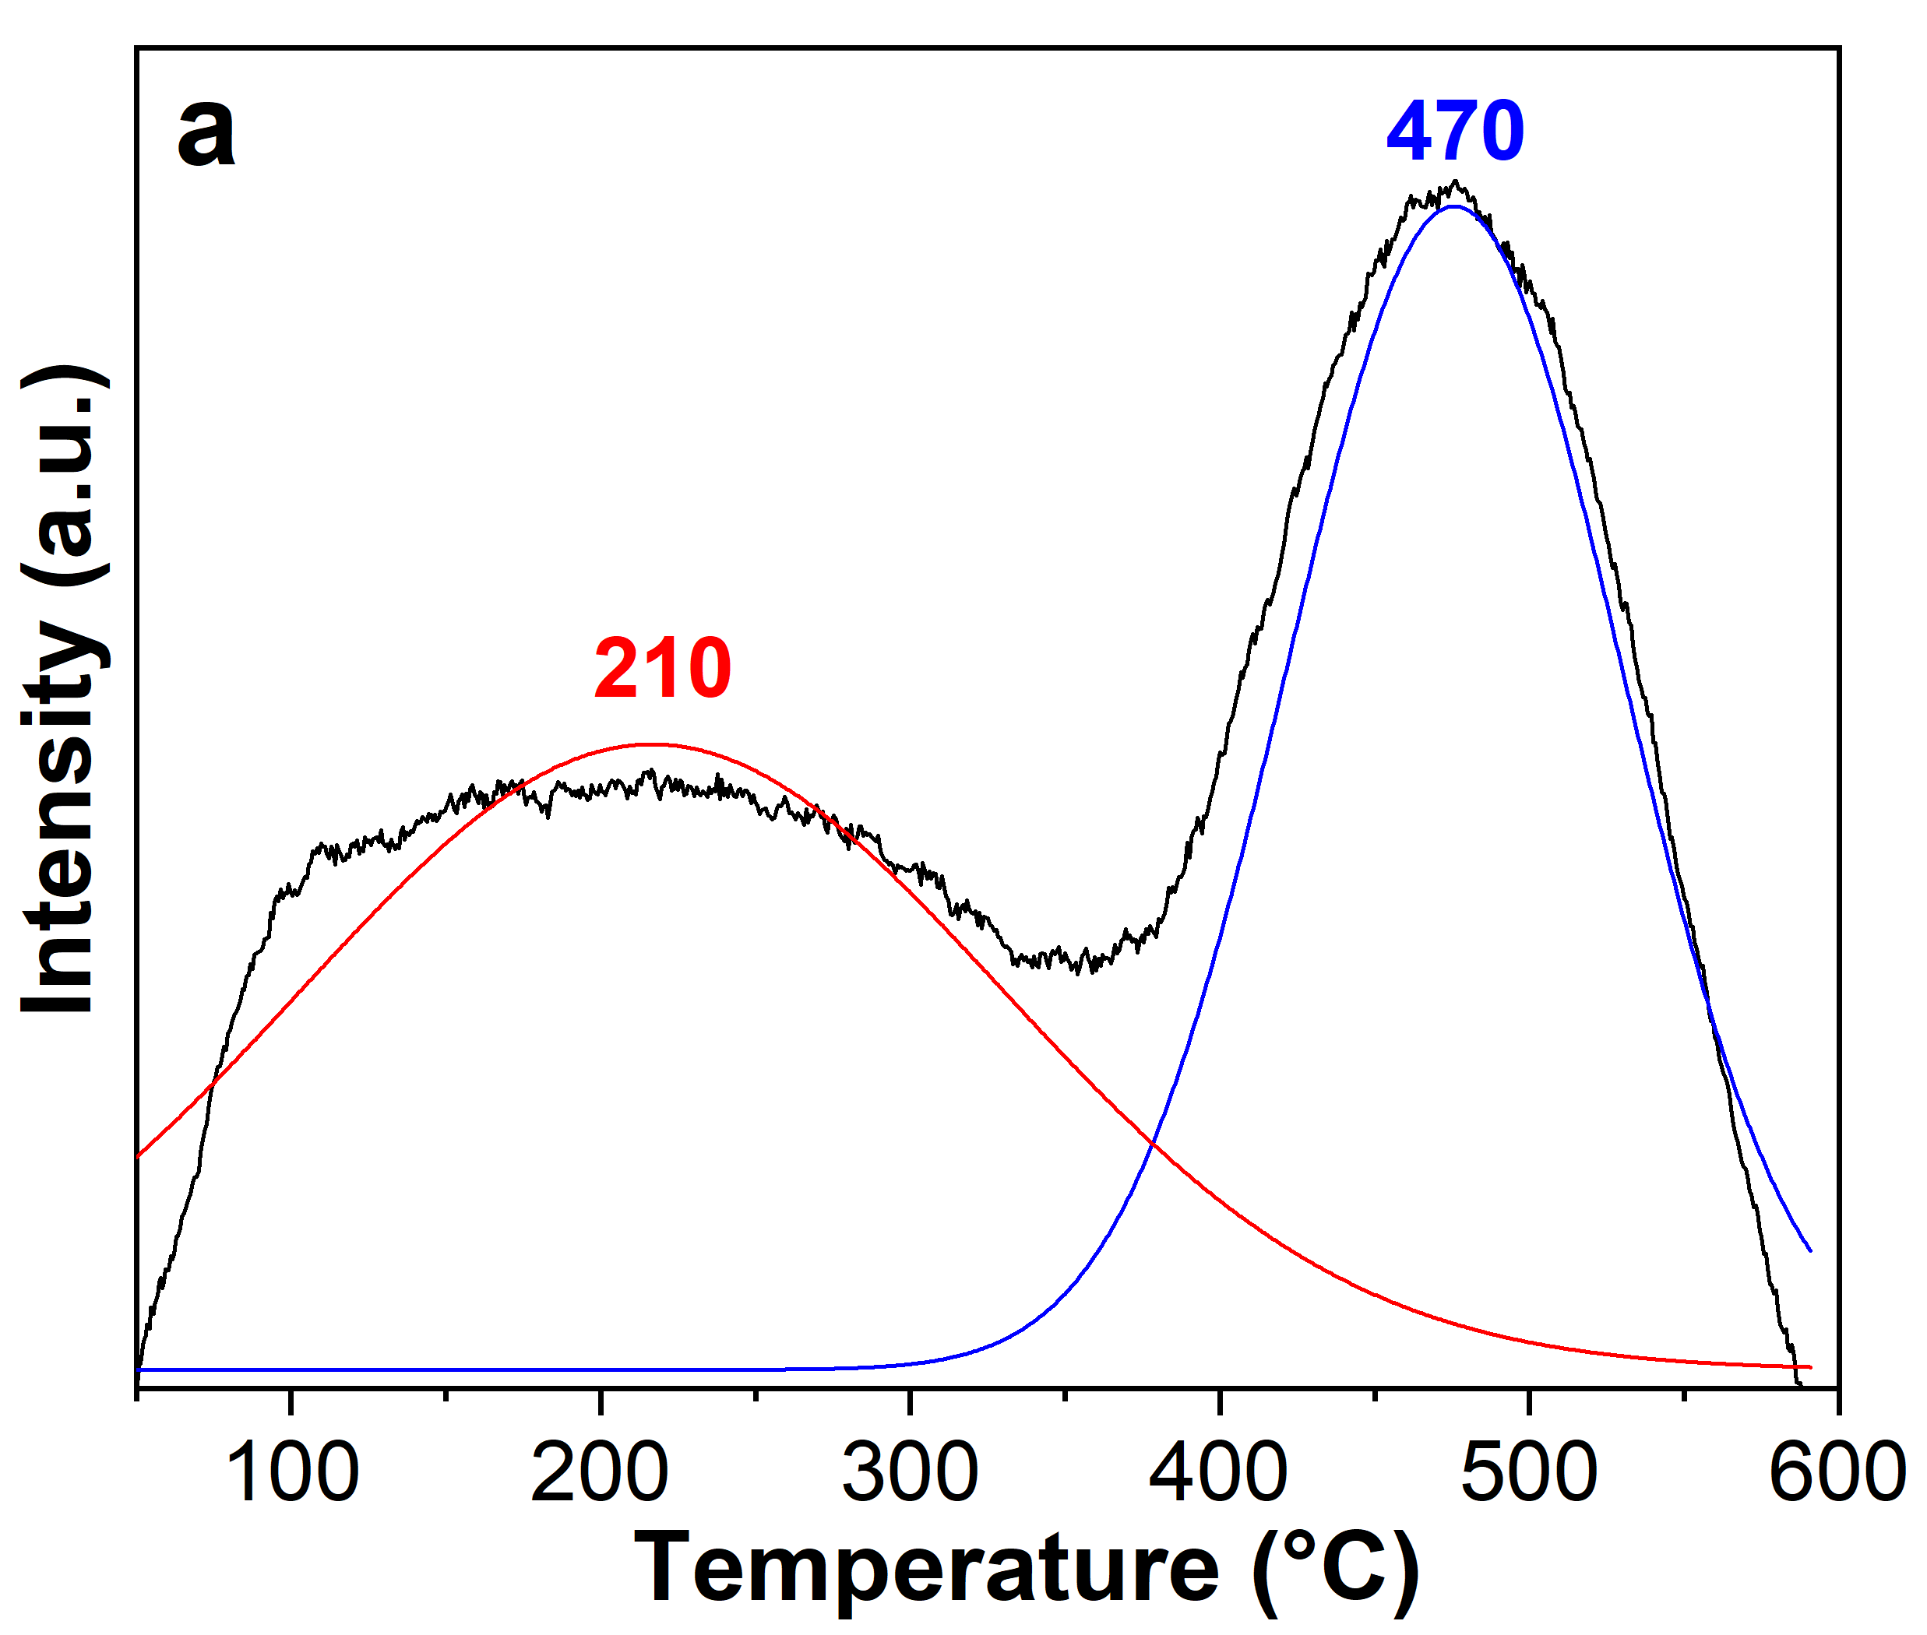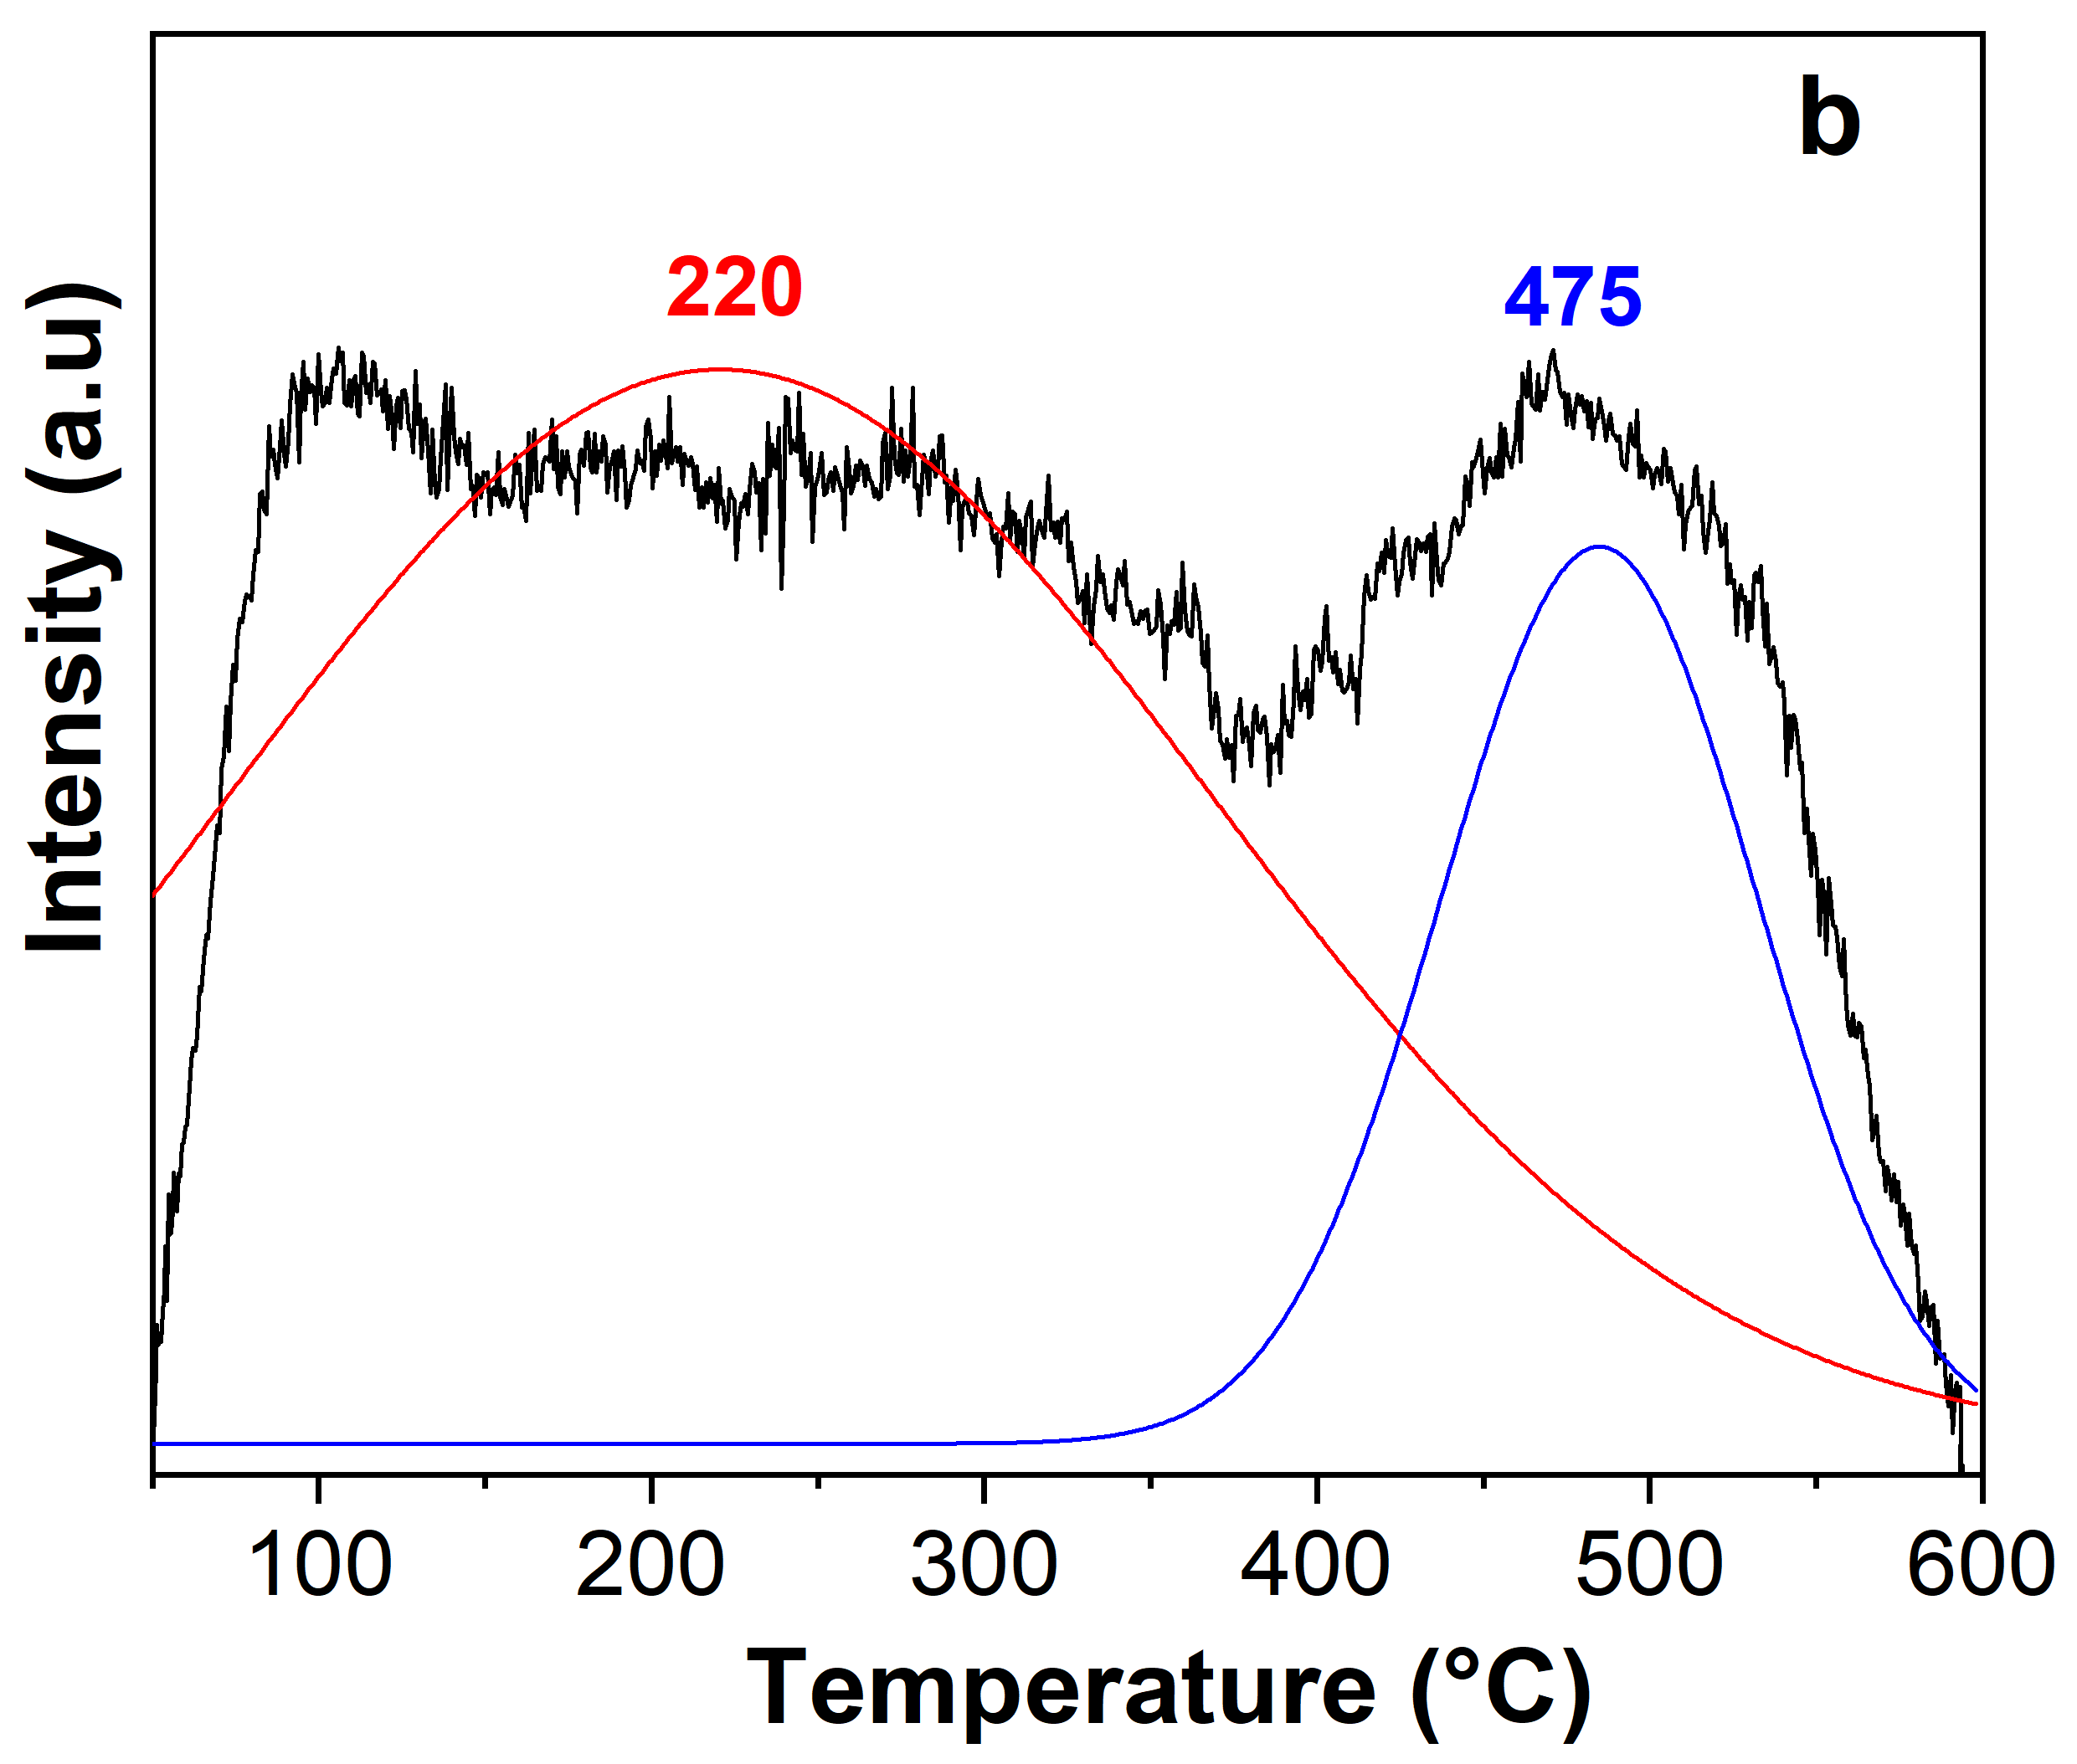
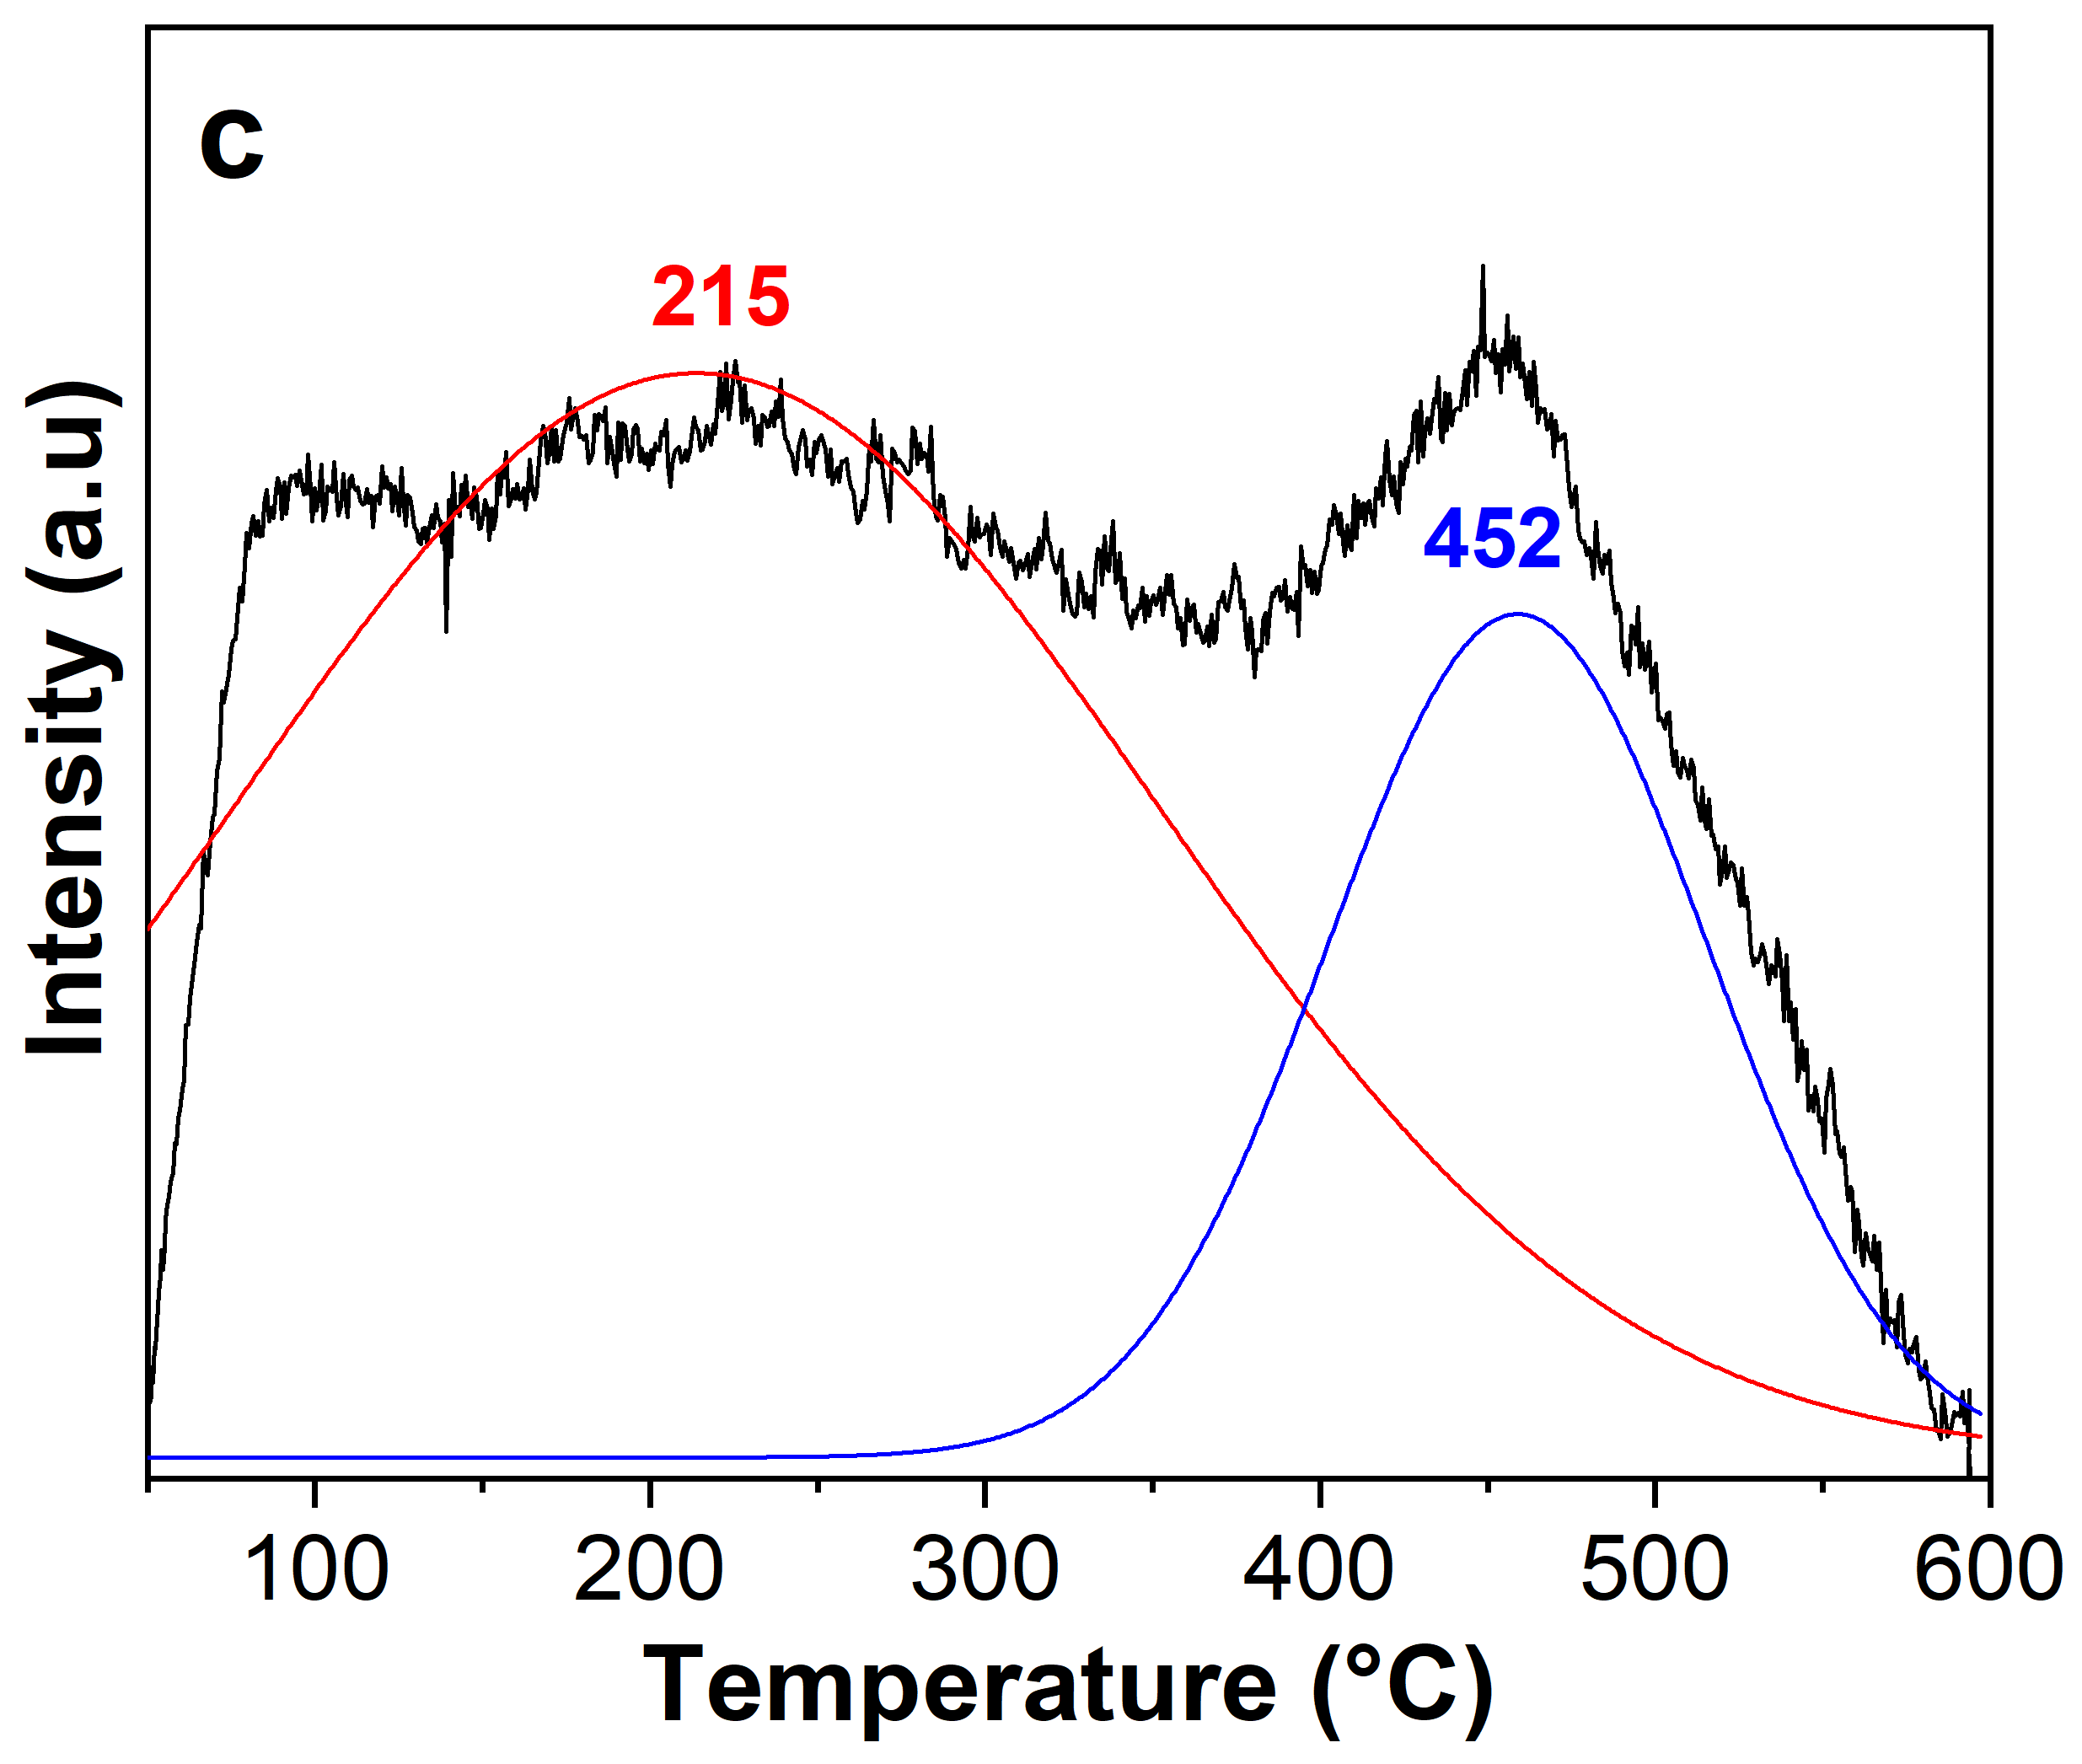
Figure S11. TPD-NH₃ of fresh and reused CAT_400 catalysts. CAT_400 (a), CAT_400a (b) and CAT_400b (c). Line black represents raw experimental data, line red and blue show the peaks obtained using Gaussian peak deconvolution with a coefficient of determination (R²) of 0.96

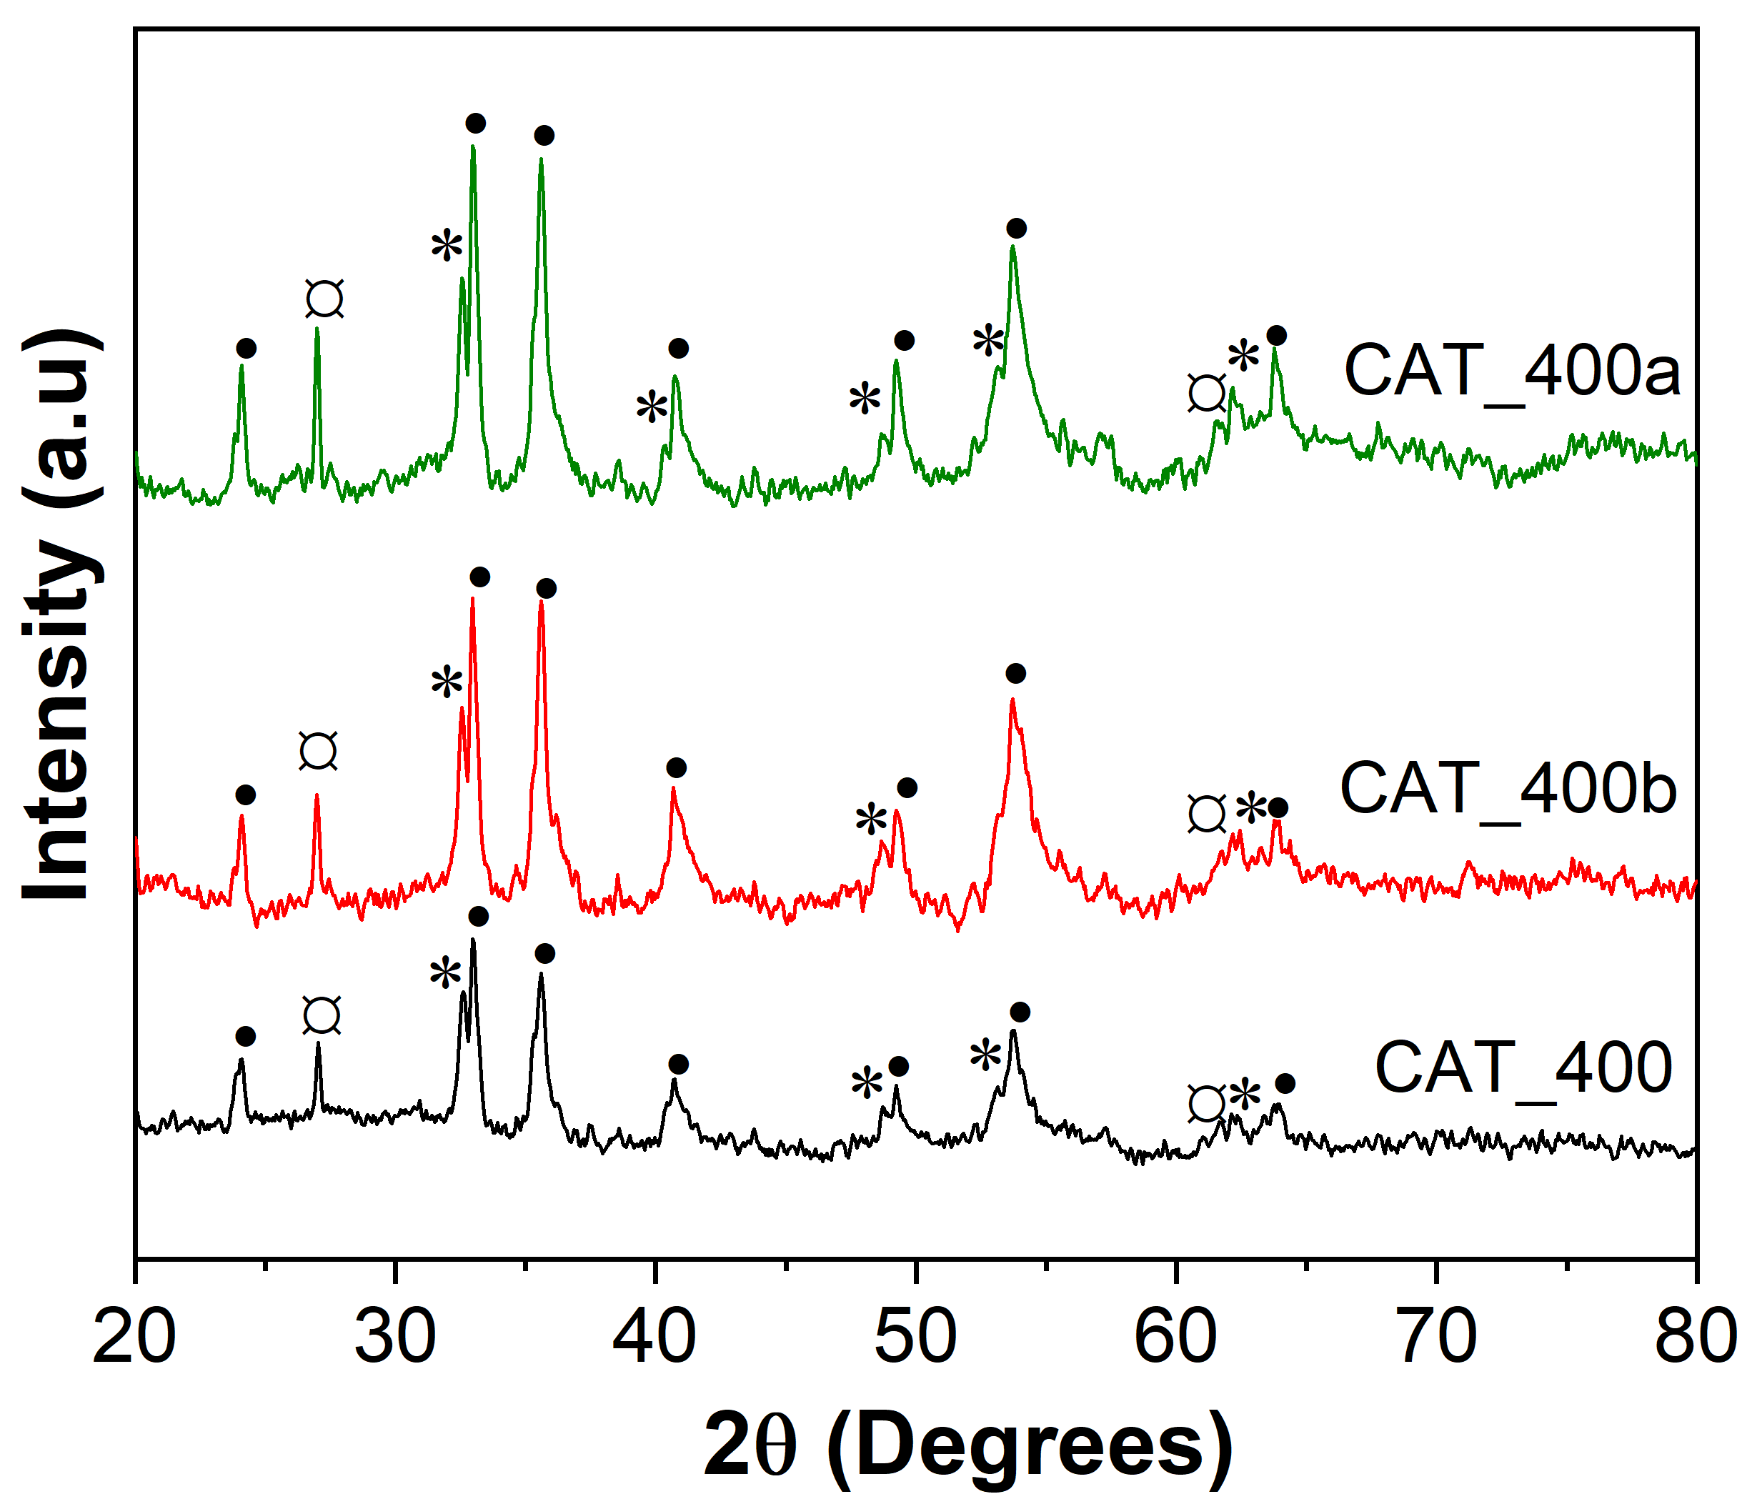
Figure S12. XRD pattern of fresh and reused CAT_400 catalysts. *Ilmenite, •hematite, and ¤ rutile.

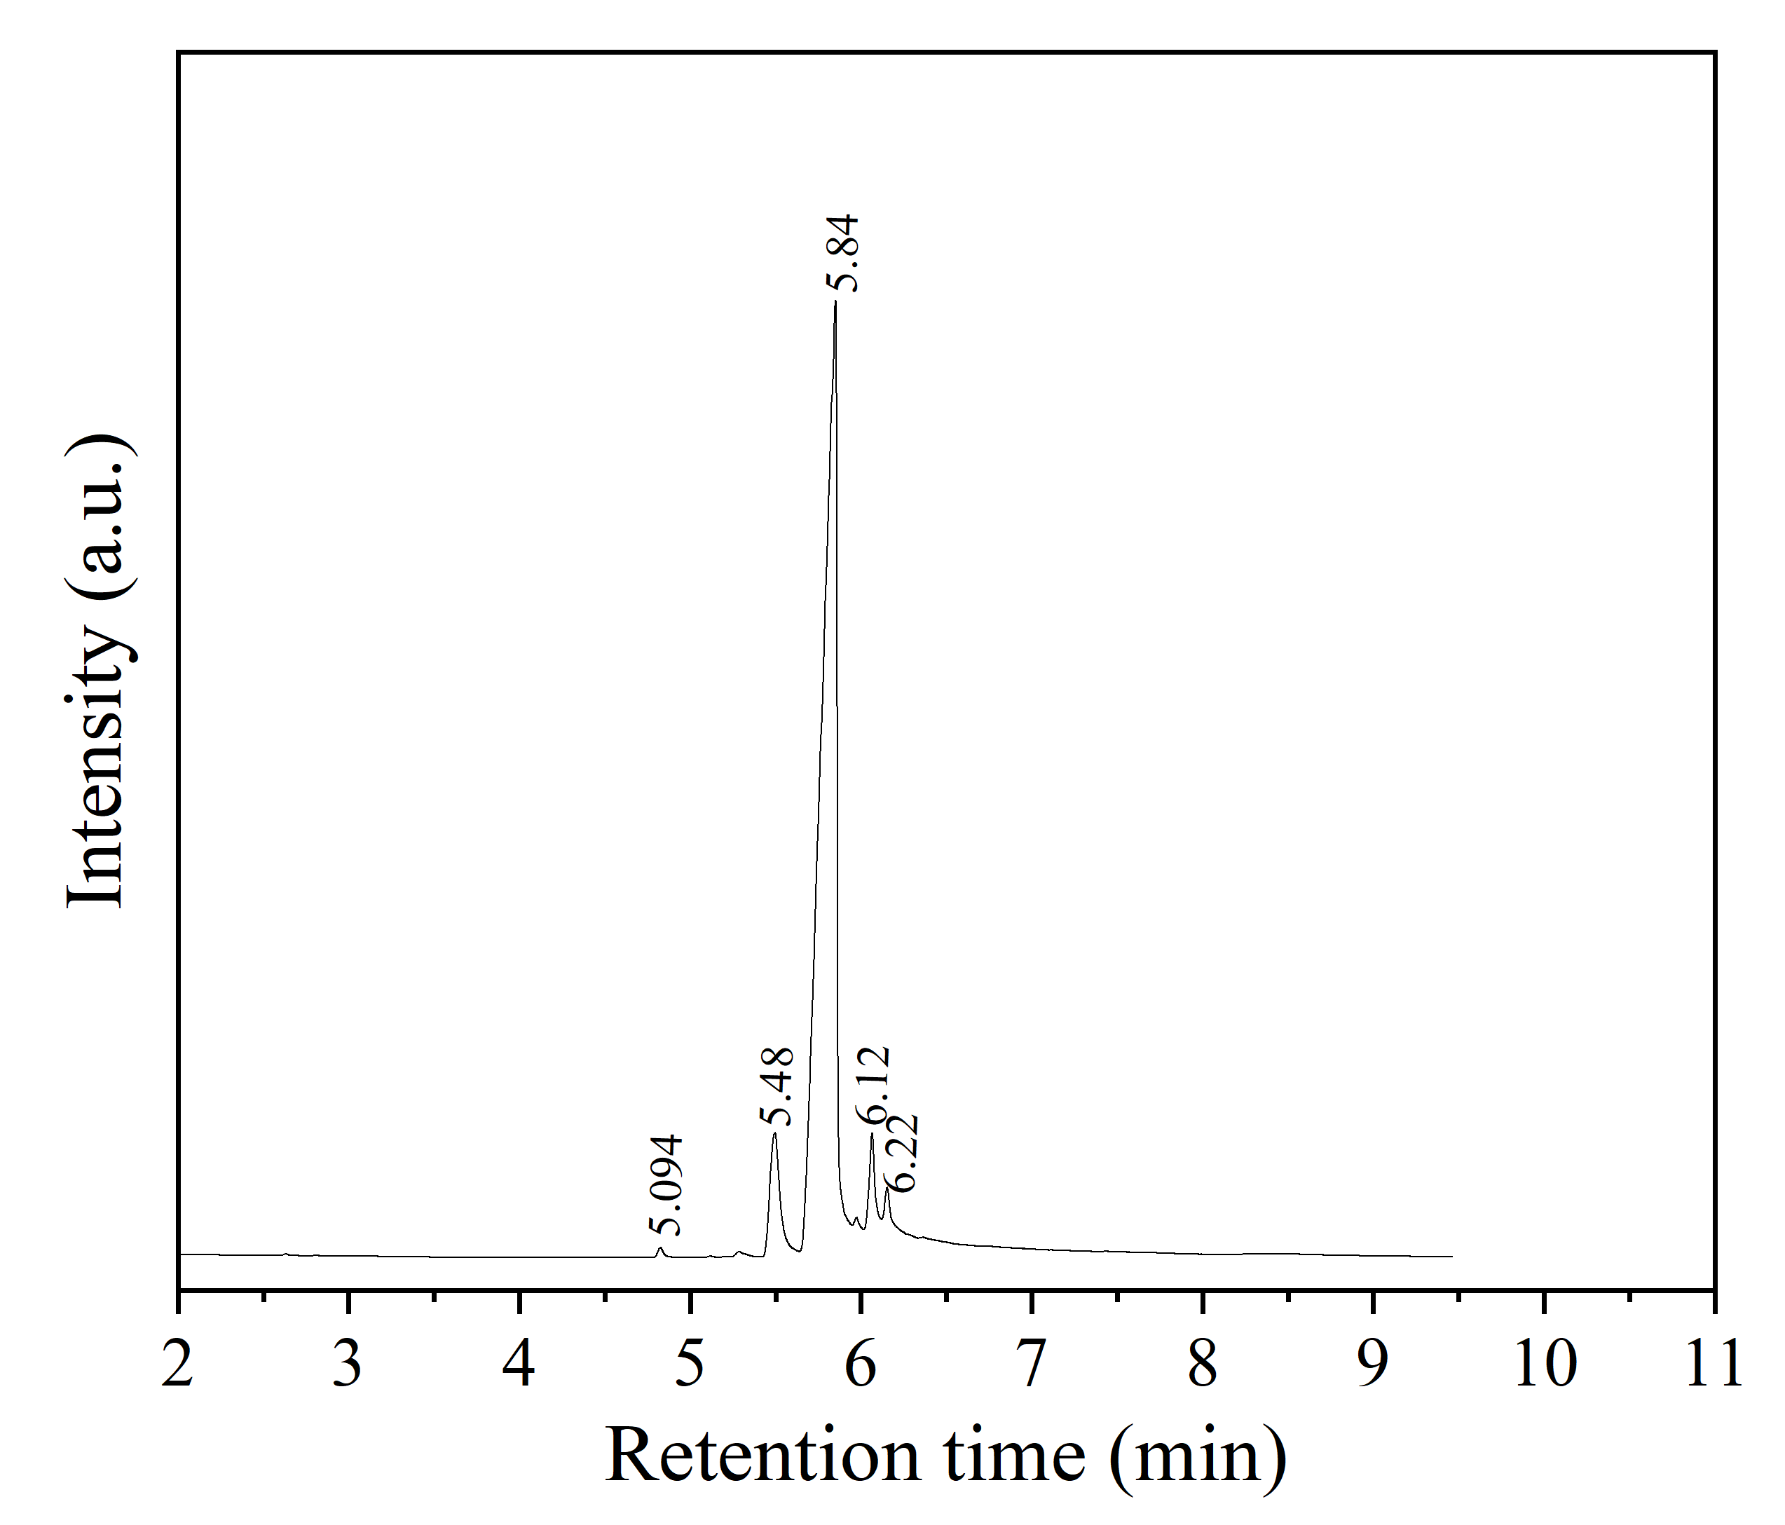
Figure S13. Chromatogram of the synthesized β-pinene epoxide. α-Pinene epoxide (5.094), β-pinene epoxide (5.48), β-pinene epoxide (5.84), myrtanal 6.12), myrtanal (6.22).

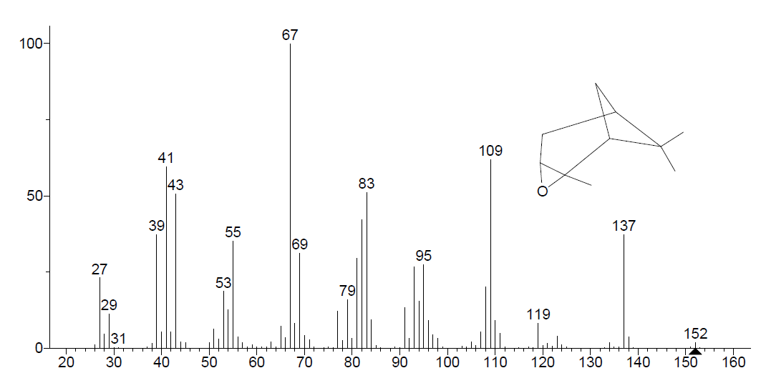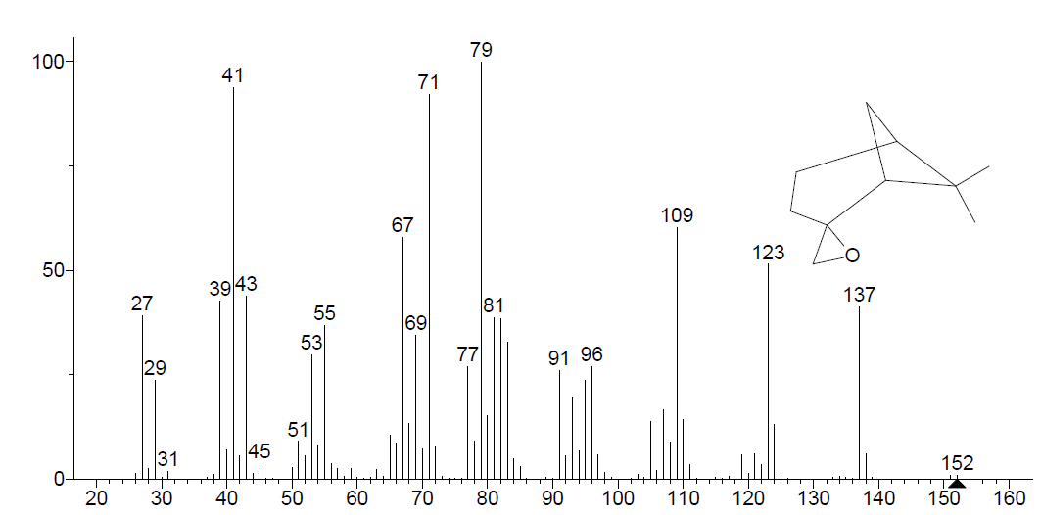
TR (5.48)
TR (5.094)
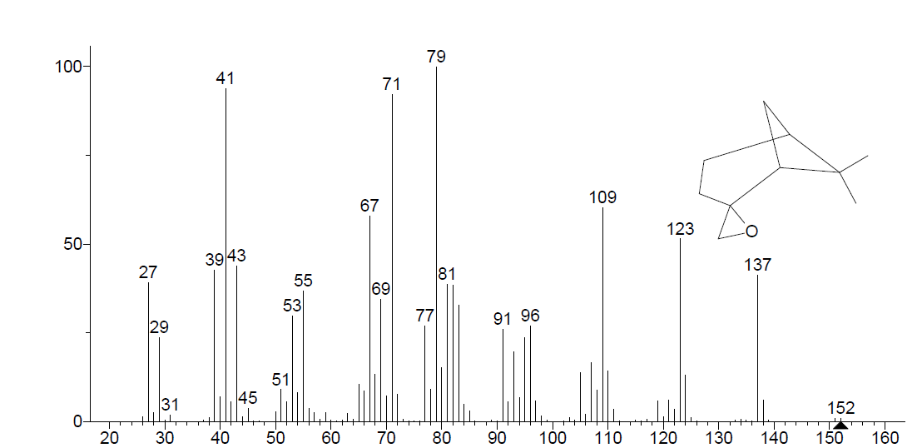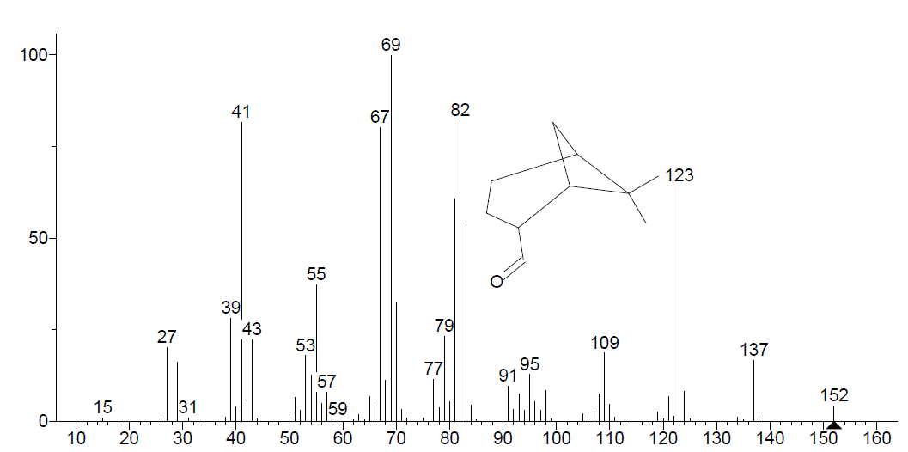
TR (6.12)
TR (5.84)
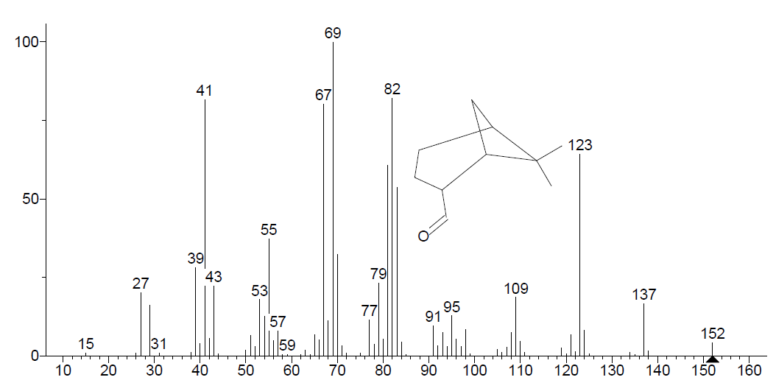
TR (6.22)

Figure S14. Mass spectra of the synthesized β-pinene epoxide.TR=Retention time.

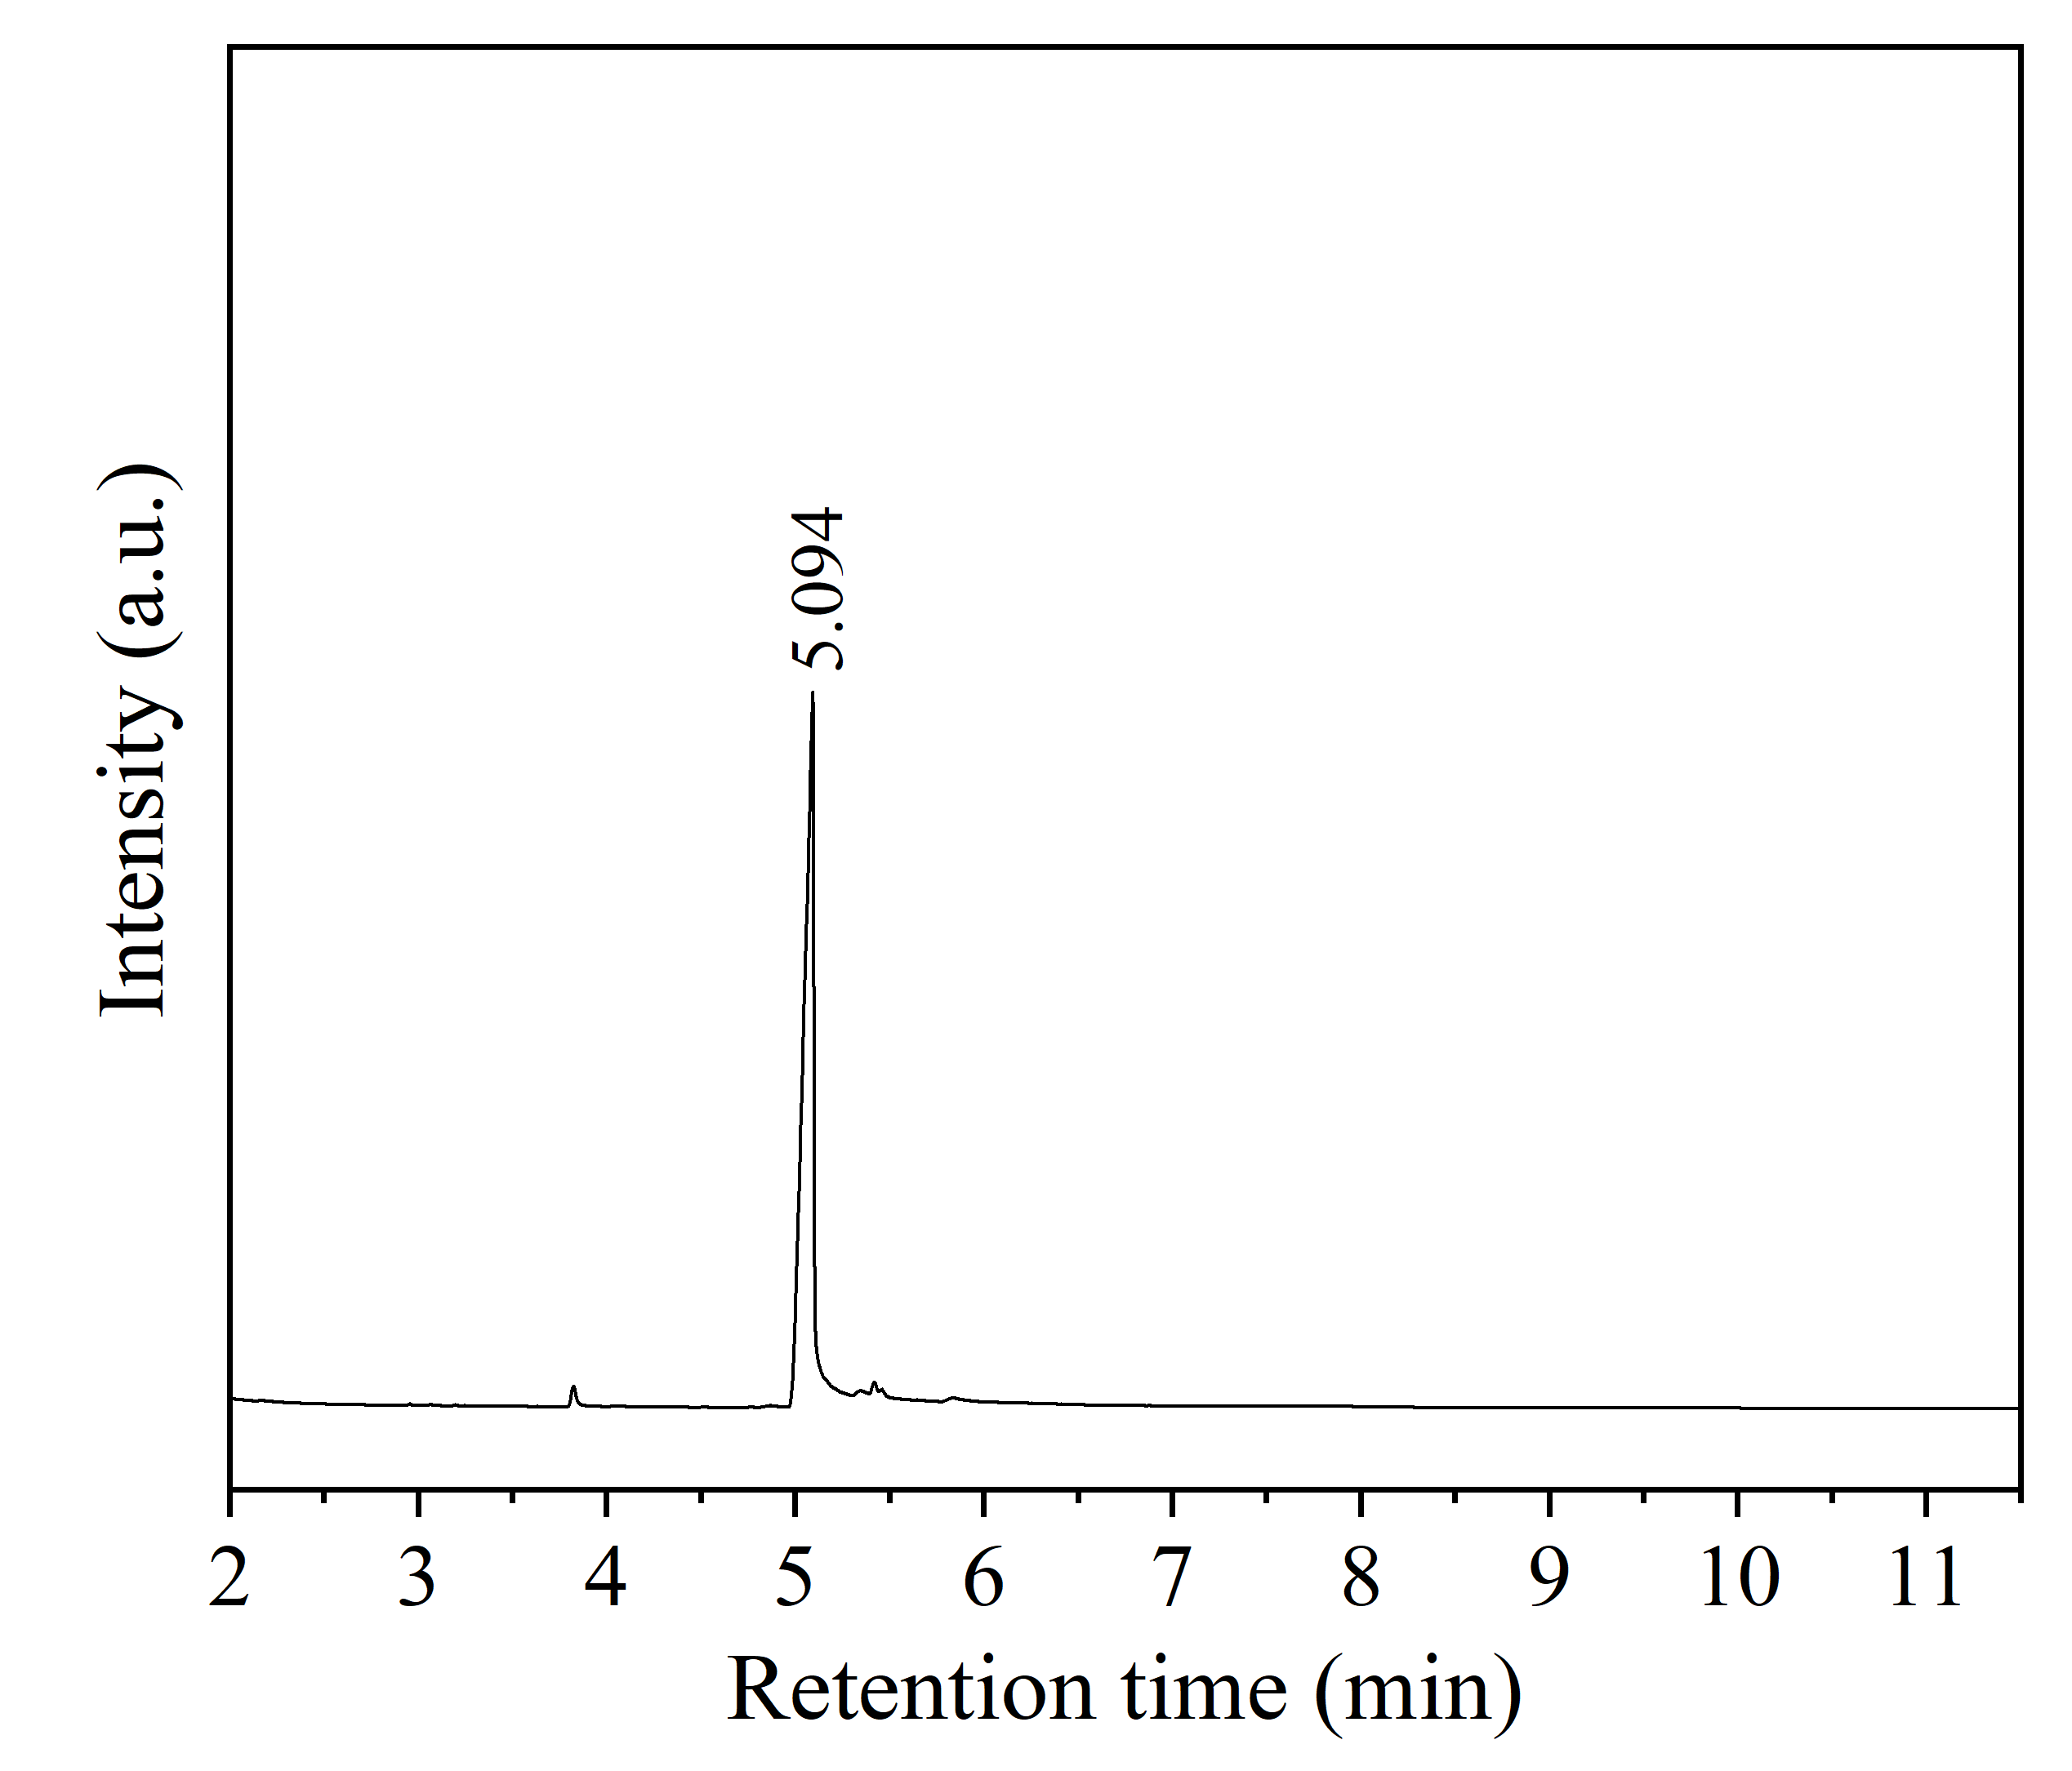
Figure S15. Chromatogram of commercial α -pinene epoxide (5.094).

Figure S16
. Mass spectra of the synthesized α-pinene epoxide.

Table S1. Reported heterogeneous catalytic systems for the isomerization of α-pinene epoxide.
Catalyst (mg) | T (°C) | Solvent (mL) | α-Pinene epoxide | t (h) | X (%) | S_{Ac} (%) | S_{tP} (%) | S_{IC} (%) | S_{CV} (%) | S_{pC} (%) | References
Au/TiO₂ (35) | 80 | 1,2-Dicloroethane (10) | 0.4 mmol | 3 | 100 | 38 | 32 | 22 | 8 | 0 | [3]
Fe-Beta-zeolite (75) | 70 | Toluene | 0.013 mmol/L | 3 | 100 | 51 | 0 | 0 | 0 | 0 | [4]
MoO₃-Beta zeolite | 70 | Cyclohexane (6) | 82.1 mmol | 3 | 99 | 35 | 0 | 0 | 17 | 0 | [5]
MoO₃-Beta zeolite | 70 | Toluene (6) | 82.1 mmol | 3 | 100 | 34 | 0 | 0 | 15 | 0 | [5]
MoO₃-Beta zeolite | 70 | 1.4-Dioxane (6) | 82.1 mmol | 3 | 100 | 29 | 0 | 0 | 18 | 0 | [5]
2.1/Cu-SBA-15 (2) | 70 | Toluene | 0.25 mmol | 24 | 30 | 100 | 0 | 0 | 0 | 0 | [6]
USY-15 | 70 | Toluene (30) | 91.34 mmol | 1 | 100 | 62 | 2 | 5 | 2 | 9
USY-40 | 70 | Toluene (30) | 91.34 mmol | 5 | 75 | 65 | 7 | 1 | 9 | 3
BETA-25 | 70 | Toluene (30) | 91.34 mmol | 1 | 100 | 52 | 0 | 4 | 2 | 13
Clay modified with 10% HCl (60) | 30 | Cyclohexane (20) | 13.14 mmol | 0.5 | 100 | 40 | 1 | 3 | 7 | 4 | [7]
1.3/Cu-MCM-41 (25) | 70 | Toluene (1) | 0.25 mmol | 2.5 | 20 | 82 | 0 | 0 | 0 | 0 | [8]
4.6/Fe-MCM-41 (25) |  |  |  |  | 100 | 67 | 0 | 0 | 0 | 0 | [8]
3.9/Fe-SBA-15 (25) |  |  |  |  | 100 | 64 | 0 | 0 | 0 | 0 | [8]
Ti-MCM-22 (25) | 70 | Toluene | 0.02 mol/L | 1 | 100 | 95 | 0 | 0 | 0 | 0 | [9]
Hierarchical Beta zeolite | 140 | N,N-dimethylacetamide | 2 mmol | 3 | 95 | 31 | N.R. | N.R. | 31 | N.R. | [10]
Fe³⁺-MCM | 60 | Dichloroethane | 0.15 mol/L | 3 | 100 | 64 | N.R. | N.R. | 19 | N.R. | [11]
Sn/SiO₂ | 120 | N,N-dimethylacetamide | 0.16 mol/L | 1.5 | 100 | 20 | 5 | N.R. | 70 | N.R. | [12]
Sulfonic acid functionalized carbon (50) | 160 | N,N-dimethylacetamide | 1.64 mol /L | 1.5 | 100 | N.R. | N.R. | N.R. | 85 | N.R. | [13]
HYZeolite (500) | RT* | N,N-dimethylacetamide (2) | 0.0016 mol/L | 12 | 60 | 29 | 0 | 0 | 71 | 0 | [14]
zirconium phosphate (50) | 160 | Dimethylacetamide (2) | 1.64 mol/L | 5 | 100 | 19 | 0 | 0 | 73 | 0 | [15]
Ti(1.9%)-beta-PS-Li(04%) (8) | 150** | Acetonitrile (0.5) | 1 mol/L | 0.05 | 100 | 89 | 0 | 2 | 2 | 0 | [16]
Molybdenum dicarbonyl complex | 35 | 1,2-dichloroethane (0.5) | 0.0019 mol/L | 0.5 | 100 | 67 | N.R. | N.R. | N.R. | N.R. | [17]
H₃PW₁₂O₄₀ | 120 | N,N-dimethylacetamide (1) | 0.15 mol/L | 3 | 94 | 7 | N.R. | N.R. | 93 | N.R. | [18]
Ce/SiO₂ | 140 | N,N-dimethylacetamide (1) | 2.4 mol/L | 8 | 98 | 18 | 5 | N.R. | 73 | N.R. | [19]
MZ-5 (75) | 140 | N,N-dimethylacetamide (100) | 0.02 mol/L | 3 | 92 | 25 | N.R. | N.R. | 42 | N.R. | [20]
Fe-Beta-300 (75) | 140 | N,N-dimethylacetamide (100) | 0.02 mol/L | 3 | 100 | 29 | N.R. | N.R. | 43 | N.R. | [21]
RT: room temperature, N.R.: not reported, X: Conversion of α-pinene epoxide, S_{Ac}: selectivity towards campholenic aldehyde, S_{tP}: selectivity towards trans-pinocarveol, S_{IC}: selectivity towards isopinocamphone, S_{CV}: selectivity towards cis-carveol, S_{pC}: selectivity towards p-cymene. *Under irradiation of light-emitting diodes. **Microwave heating.

Table S2. Reported heterogeneous catalytic systems for the isomerization of β-pinene epoxide.
Catalyst (mg) | T (ºC) | Solvent (mL) | β-pinene epoxide | t (h) | X (%) | S_{My} (%) | S_{Mt} (%) | S_{Ap} (%) | References
1.4/Fe-SBA-15 (2) | 70 | Toluene (1) | 0.25 mmol | 24 | 60 | 100 | 0 | 0 | [6]
Fe-SBA-15 | 70 | ter-butanol (1) | 0.25 mmol | 24 | 99 | 85 | 6 | 7 | [22]
Mo/SBA-15 (10) | 80 | Hexane (0.5) | 0.25 mmol | 1 | 99 | 0 | 0 | 63 | [23]
Zr- Beta zeolite Beta (50) | 80 | Acetonitrile (3.2) | 3.9 mmol | 2 | 98 | 94 | 2 | 1 | [24]
Sn- Zeolita Beta | 70 | Toluene |  | 2 | 72 | 66 | 2 | 10 | [25]
Zeolita natural | 70 | Toluene (1) | 0.25 mmol | 2.5 | 97 | 23 | 12 | 47 | [26]
Fe- Zeolite Beta | 70 | Dimethyl sulfoxide |  |  | >99 | 0 | 0 | 66 | [27]
X: Conversion of β-pinene epoxide, S_{My}: Selectivity towards myrtanal, S_{Mt}: selectivity towards myrtenol, S_{Ap}: selectivity towards perillyl alcohol.

References

[1] García D, Jaramillo M, Bustamante F, Villa AL, Alarcon E (2020) Epoxidation of β-pinene with a highly-active and low-cost catalyst. Braz. J. Chem. Eng. 38:89 - 100. https://doi.org/10.1007/s43153-020-00078-y
[2] Pratika RA, Nafisah Z, Yuliana Y, Syarpin S, Iqbal RM, Ysrafil Y, Wijaya K (2024) Conversion of used cooking oil into biodiesel by utilizing zirconia catalyst as acid catalyst (SO₄/ZrO₂) and base catalyst (ZrO₂/CaO). Arab. J. Sci. Eng. 1-14. https://doi.org/10.1007/s13369-024-09520-6
[3] Demidova YS, Ardashov OV, Simakova OA, Simakova IL, Volcho KP, Salakhutdinov NF, Murzin DY (2014) Isomerization of bicyclic terpene epoxides into allylic alcohols without changing of the initial structure. J. Mol. Catal. A Chem. 388–389:162–166. https://doi.org/10.1016/J.MOLCATA.2013.09.016.
[4] Stekrova M, Kumar N, Aho A, Sinev I, Grünert W, Dahl J, Roine J, Arzumanov SS, Mäki-Arvela P, Murzin DY (2014) Isomerization of-pinene oxide using Fe-supported catalysts: Selective synthesis of campholenic aldehyde. Appl. Catal. A: Gen. 470:162–176. https://doi.org/10.1016/j.apcata.2013.10.044.
[5] Vrbková E, Vyskočilová E, Lhotka M, Červený L (2020) Solvent Influence on Selectivity in α-Pinene Oxide Isomerization Using MoO3-Modified Zeolite BETA. Catal. 10(11):1–17. https://doi.org/10.3390/catal10111244
[6] Sánchez-Velandia JE, Villa AL (2019) Isomerization of α-and β-pinene epoxides over Fe or Cu supported MCM-41 and SBA-15 materials. Appl. Catal. A: Gen. 580:17 - 27. https://doi.org/10.1016/j.apcata.2019.04.029
[7] Sidorenko AY, Kravtsova AV, Aho A, Heinmaa I, Kuznetsova TF, Murzin DY, Agabekov VE (2018) Catalytic isomerization of Α-pinene oxide in the presence of acid-modified clays. Mol. Catal., 448:18–29. https://doi.org/10.1016/j.mcat.2018.01.021
[8] Sánchez-Velandia JE, Villa AL (2022) Selective synthesis of high-added value chemicals from α-pinene epoxide and limonene epoxide isomerization over mesostructured catalysts: Effect of the metal loading and solvent. Catal. Today 394–396:208–218. https://doi.org/10.1016/j.cattod.2021.09.011
[9] Pitínová M, Eliášová P, Weissenberger T, Shamzhy M, Musilová Z, Čejka J (2018) Highly selective synthesis of campholenic aldehyde over Ti-MWW catalysts by α-pinene oxide isomerization. Catal. Sci. Technol. 8(18): 4690–4701. https://doi.org/10.1039/C8CY01231H
[10] Barakov R, Shcherban N, Mäki-Arvela P, Yaremov P, Bezverkhyy I, Wärnå J, Murzin DY (2022) Hierarchical Beta Zeolites As Catalysts in α-Pinene Oxide Isomerization. ACS Sustain. Chem. Eng. 10(20): 6642 – 6656. https://doi.org/10.1021/acssuschemeng.2c00441
[11] Coelho JV, de Meireles AL, da Silva Rocha KA, Pereira MC, Oliveira LC, Gusevskaya EV (2012) Isomerization of-pinene oxide catalyzed by iron-modified mesoporous silicate. Appl. Catal. A: Gen. 443:125–132. https://doi.org/10.1016/j.apcata.2012.07.030.
[12] Costa V, da Silva Rocha K, de Sousa LF, Robles PA, Gusevskaya EV (2011) Isomerization of α-pinene oxide over cerium and tin catalysts: Selective synthesis of trans-carveol and trans-sobrerol. J. Mol. Catal. A Chem. 345:69 – 74. https://doi.org/10.1016/j.molcata.2011.05.020
[13] Advani JH, Singh AM, Khan NH, Bajaj HC, Biradar AV (2020) Black yet green: Sulfonic acid functionalized carbon as an efficent catalyst for highly selective isomerization of α-pinene oxide to trans-carveol. Appl. Catal. B: Environ. 268:118456. https://doi.org/10.1016/j.apcatb.2019.118456.
[14] Naikwadi DR, Muthukumar D, Tayade RJ, Pillai RS, Biradar AV (2023) A novel route for isomerization of α-pinene oxide at room temperature under irradiation of light-emitting diodes. Mater. Today Chem. 33:101682. https://doi.org/10.1016/j.mtchem.2023.101682.
[15] Singh AS, Naikwadi DR, Ravi K, Biradar AV (2022) Chemoselective isomerization of α-Pinene oxide to trans-Carveol by robust and mild Brønsted acidic zirconium phosphate catalyst. Mol. Catal. 521: 112189. https://doi.org/10.1016/j.mcat.2022.112189
[16] Panadero MP, Velty A (2019) Readily available Ti-beta as an efficient catalyst for greener and sustainable production of campholenic aldehyde. Catal. Sci. Technol. 9(16):4293 - 4303. https://doi.org/ 10.1039/c9cy00957d
[17] Bruno SM, Gomes AC, Gamelas CA, Abrantes M, Olivera MC, Valente AA, Almeida FA, Pillinger M, Romao CC, Gonçalves IS (2014) Application of an indenyl molybdenum dicarbonyl complex in the isomerisation of a-pinene oxide to campholenic aldehyde. New J. Chem. 38: 3172 – 3180. https://doi.org/10.1039/C4NJ00371C
[18] da Silva Rocha KA, Hoehne JL, Gusevskaya EV (2008) Phosphotungstic Acid as a Versatile Catalyst for the Synthesis of Fragrance Compounds by a-Pinene Oxide Isomerization: Solvent-Induced Chemoselectivity. Chem. Eur. J. 14(20):6166 – 6172. https://doi.org/10.1002/chem.200800184
[19] Costa VV, da Silva Rocha KA, de Sousa LF, Robles PA, Gusevskaya EV (2011) Isomerization of -pinene oxide over cerium and tin catalysts: Selective synthesis of trans-carveol and trans-sobrerol. J. Mol. Catal. A Chem. 345: 69 – 74. https://doi.org/10.1016/j.molcata.2011.05.020
[20] Barakov R, Shcherban N, Maki-Arvela P, Yaremov P, Bezverkhyy I, Wärnå J, Murzin DY (2022) Hierarchical beta zeolites as catalysts in α-pinene oxide isomerization. ACS Sustain. Chem. Eng. 10(20): 6642-6656. https://doi.org/10.1021/acssuschemeng.2c00441
[21] Stekrova M, Kumar N, Díaz SF, Mäki-Arvela P, Murzin DY (2015) H-and Fe-modified zeolite beta catalysts for preparation of trans-carveol from α-pinene oxide. Catal. Today 241: 237-245. https://doi.org/10.1016/j.cattod.2013.12.004
[22] Chaves-Restrepo M, Viloria A, Sánchez-Velandia JE, Villa AL (2022) Effect of reaction conditions and kinetics of the isomerization of β-pinene epoxide to myrtanal in the presence of Fe/MCM-41 and Fe/SBA-15. React. Kinet. Mech. Catal. 135:2013–2029. https://doi.org/10.1007/s11144-022-02220-y
[23] Cruz MC, Sánchez JE, Causíl S, Villa AL (2021) Selective Synthesis of Perillyl Alcohol from β-Pinene Epoxide over Ti and Mo Supported Catalysts. Catal. Letters 151:2279–2290. https://doi.org/10.1007/s10562-020-03489-1
[24] De La Torre O, Renz M, Corma A (2010) Biomass to chemicals: Rearrangement of β-pinene epoxide into myrtanal with well-defined single-site substituted molecular sieves as reusable solid Lewis-acid catalyst. Appl. Catal. A: Gen. 380:165–171. https://doi.org/10.1016/j.apcata.2010.03.056.
[25] Mäki-Arvela P, Kumar N, Díaz SF, Aho A, Tenho M, Salonen J, Leino AR, Kordás K, Laukkanen P, Dahl J, Sinev I, Salmin T, Murzin DY (2013) Isomerization of β-pinene oxide over Sn-modified zeolites. J. Mol. Catal. A Chem. 366:228–237. https://doi.org/10.1016/j.molcata.2012.09.028
[26] Sánchez-Velandia JE, Gelves JF, Dorkis L, Márquez MA, Villa AL (2019) Ring-opening of β-pinene epoxide into high-added value products over Colombian natural zeolite. Microporous and Mesoporous Mater. 287:114 - 123. https://doi.org/10.1016/j.micromeso.2019.05.053
[27] Vyskočilová E, Dušek J, Babirádová M, Krupka J, Paterová I, Červený L (2018) Perillyl alcohol preparation from β-pinene oxide using Fe-modified zeolite beta. Res. Chem. Intermed. 44(7):3971–3984. https://doi.org/10.1007/s11164-018-3335-y
[28] Valencia L.F, Agudelo I, Badano J, Quiroga M, Betti C, Lederho C, Villa A. L (2025) Zn supported on composite materials as catalysts for fine chemical applications. Mol. Catal., 578:115012. https://doi.org/10.1016/j.mcat.2025.115012

