Supporting Information
Investigation of aggregation behavior and microstructure of hard carbon dispersions for semisolid sodium flow batteries
Hanan Dabash and Mohamed Youssry*
Chemistry Program, Department of Chemistry and Earth Sciences, College of Arts and Sciences, Qatar University, Doha 2713P.O. Box 2713, Doha, Qatar

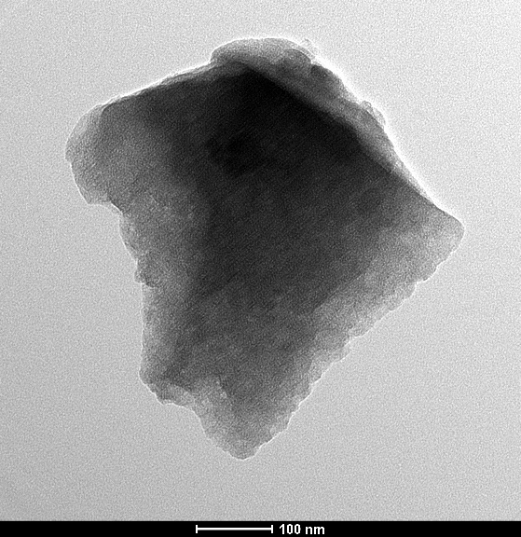

Figure S1. Transmission electron micrograph of the hard carbons.

