Supplementary information
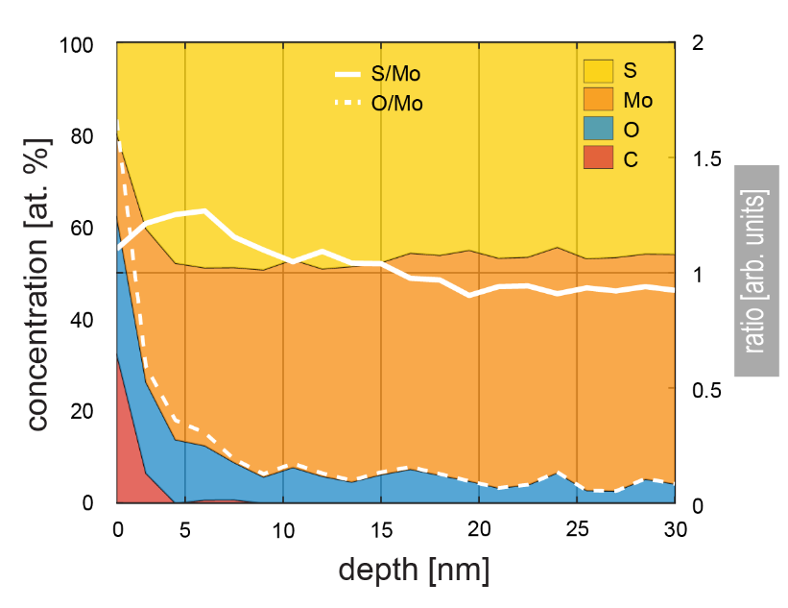
Figure S1: Depth XPS analysis with atomic concentrations of relevant components. In regions near the surface of as-grown MoS₂ (depth < 5 nm), the oxygen and carbon contents are comparingly high, resulting from exposition to air and therefore adsorption of humidity and hydrocarbons. The seemingly sub stoichiometric sulfur-to-molybdenum-ratio may be consequence of preferential sulfur-etching of the applied method.
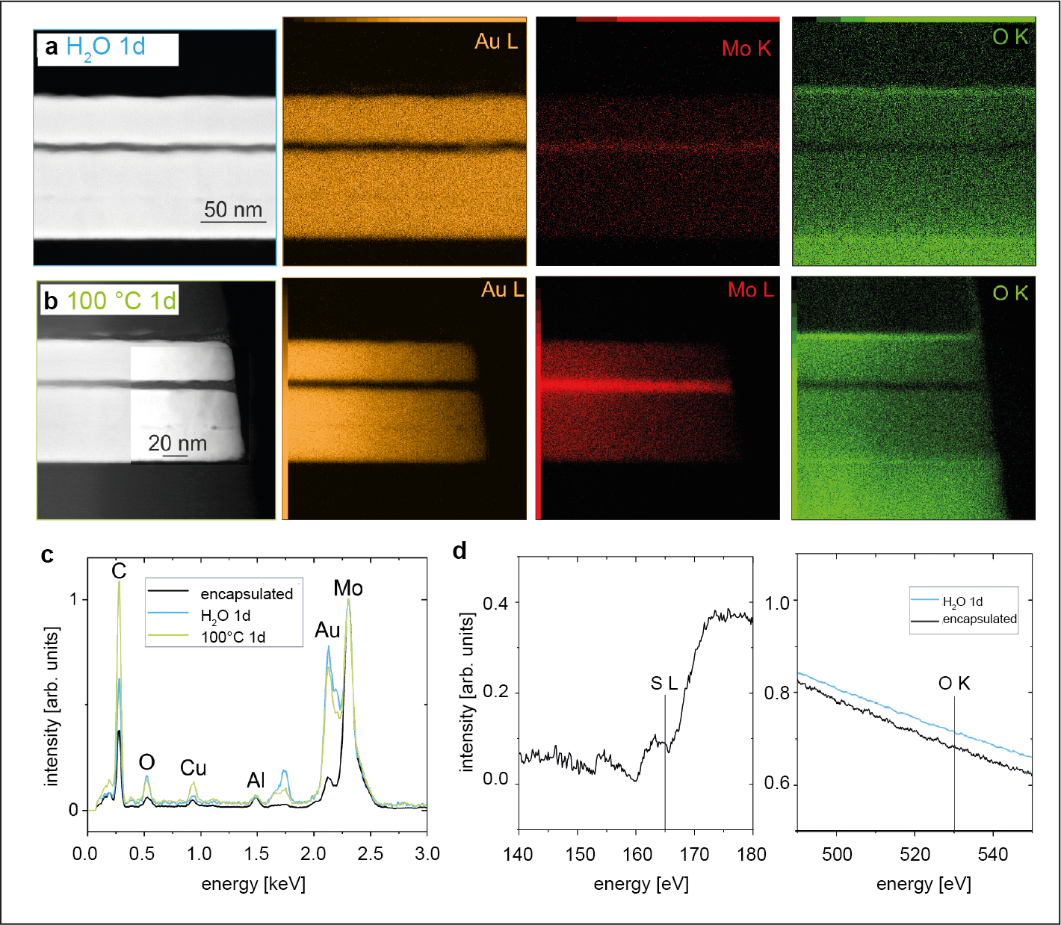
Figure S2: a) STEM-EDS-maps of H₂O 1d and b) of 100°C 1d. c) EDS spectra of the encapsulated MoS_{x}, the H₂O 1d and the 100°C 1d, all normalized to the Mo L peak reveals the lowest oxygen content for the encapsulated MoS_{x}. d) Background subtracted EEL spectrum of encapsulated MoS_{x} shows S L edge at the expected 165 eV, whereas mapping of S L for the H₂O 1d sample was not possible due to the absence of signal. The EEL spectra of the MoS_{x} layer of the H₂O 1d and the encapsulated MoS_{x} did not show any O K edge around 530 eV. This discrepancy between EDS and EELS of the O K edge may indicate that all samples have a very low oxygen content and that the EDS O K edge may originate from spurious signals.

