Supplemental Information
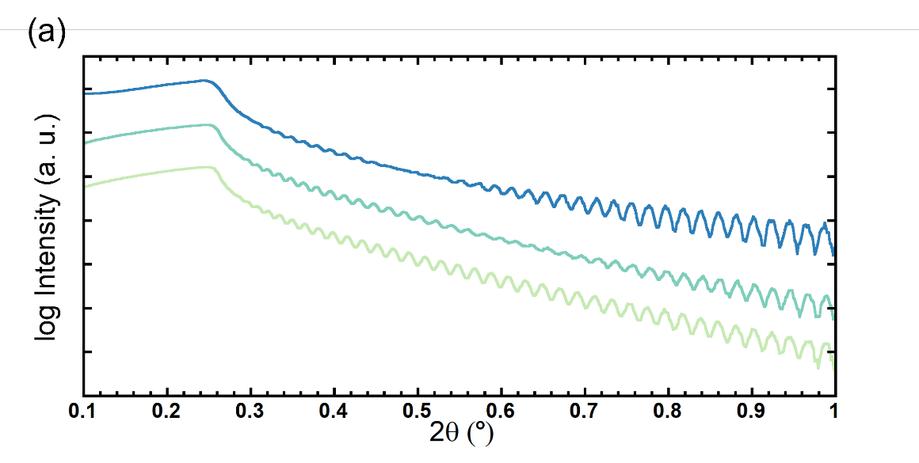
S1: X-ray reflectivity (XRR) as a function of increasing plasma treatment. The development of a pinched reflectivity corresponds to a thicker Si₃N₄ layer on the surface of the n-Si substrate, which ultimately reaches a thickness of 3.5 nm.
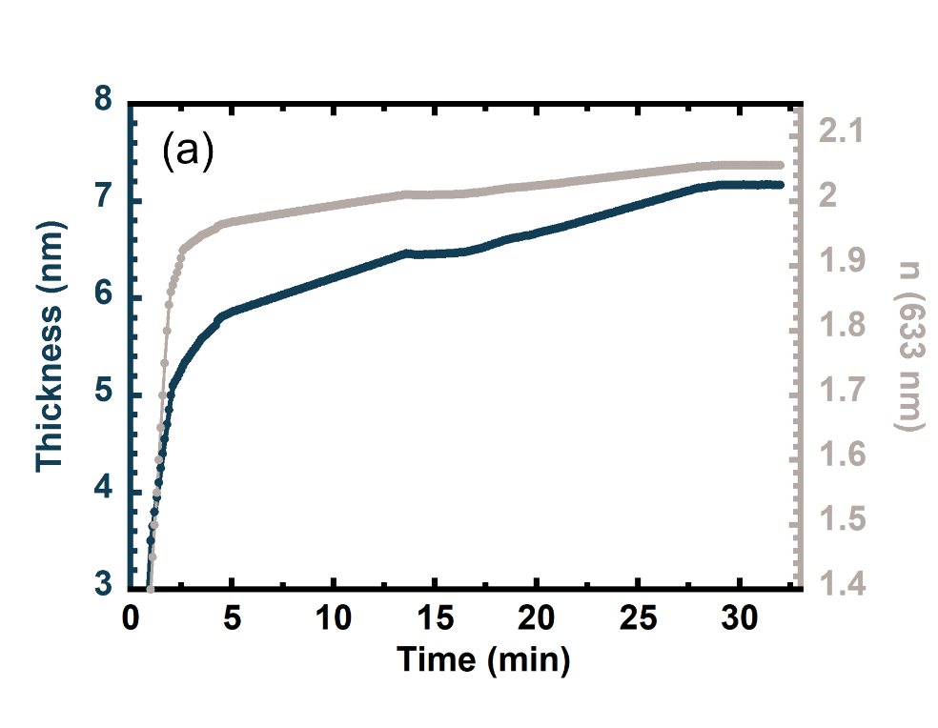
S2: In-situ visible six-wavelength ellipsometry during the plasma treatment step where the thickness and refractive index of the native SiO₂ transitions to Si₃N₄. We hypothesize that as the Si₃N₄ reaches a steady state in thickness and stoichiometry the electrical properties also asymptotically approach a maximum in quality. Interestingly, the Si₃N₄ grows to around 7 nm, however, after deposition the thickness reduces, indicating either mixing or etching occurs within the initial stages of AlBN deposition but further study is needed.
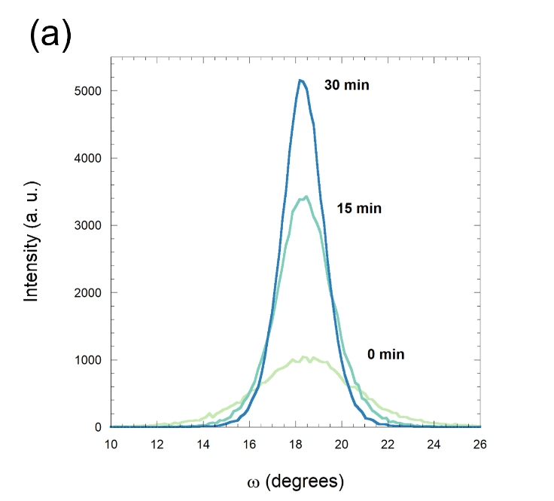
S3: Rocking curves as a function of plasma treatment showing that not only does 2theta become more intense but mosaicity also decreases as the surface is nitrided.
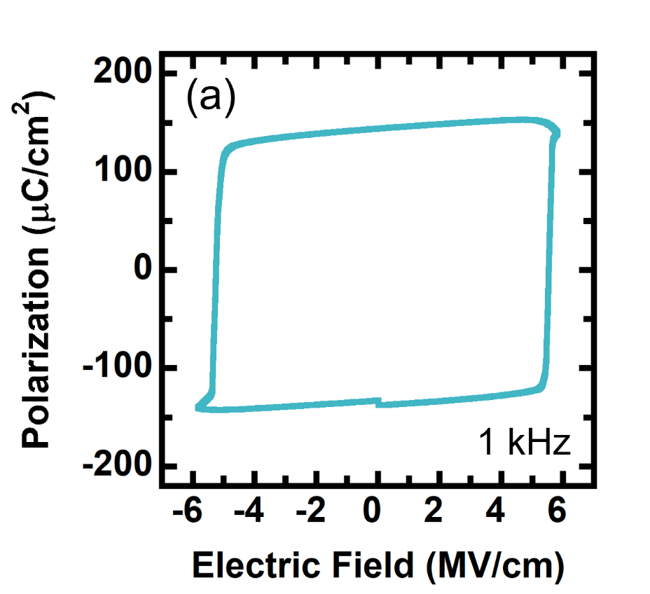
S4: 200 nm hysteresis of Al_{0.78}B_{0.4}Sc_{0.18}N grown directly on highly doped n-Si measured at 1 kHz. This indicates that both Sc, B, and most likely any cations of interest may be grown on n-Si while still satisfying the conductivity needed for a bottom electrode.
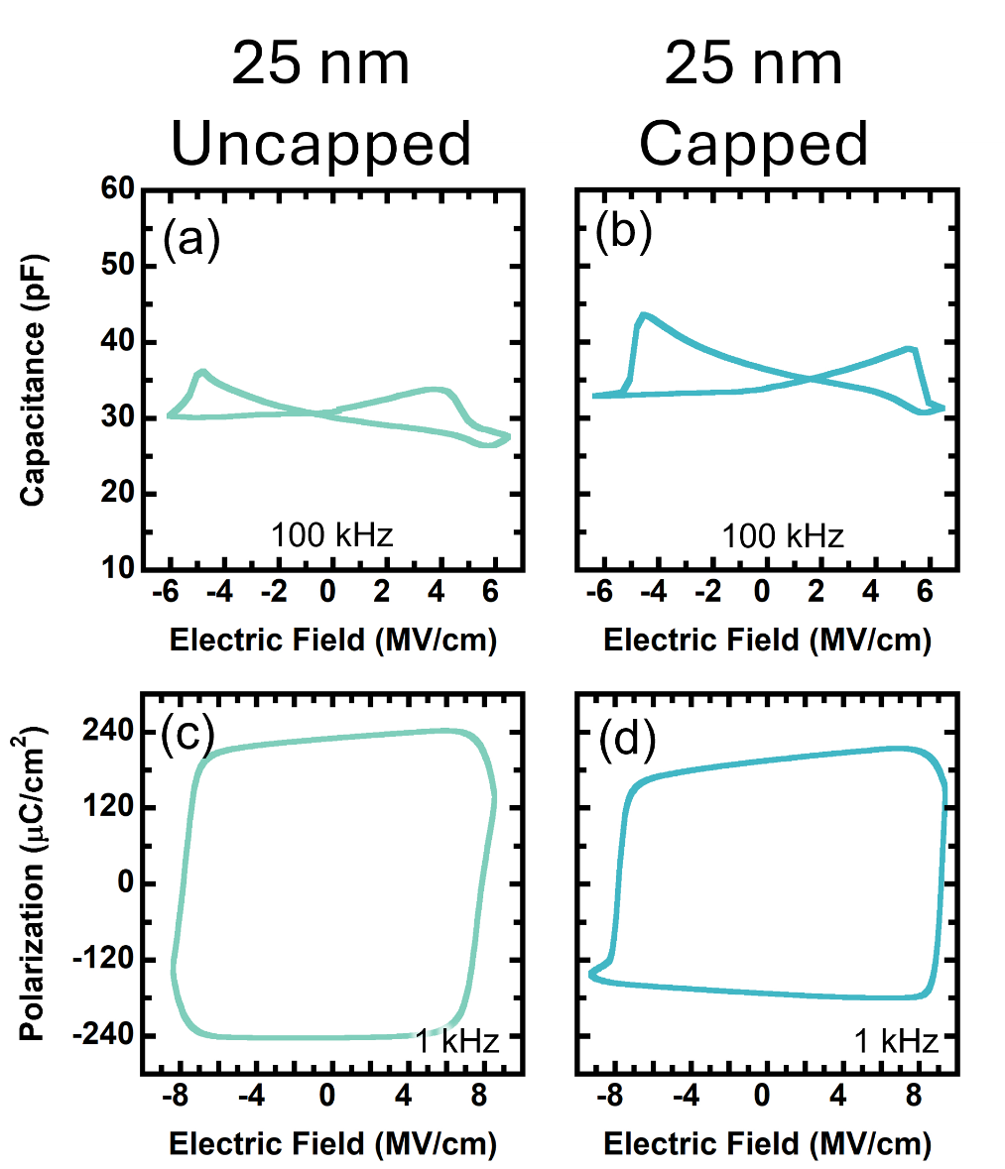
S5: Effects of capping 25 nm AlBN films on n-Si with CV (a-b) and PE (c-d) loops with W as the top electrode. As expected, both leakage and the coercive field is reduced when capping with W. This is an extremely exciting milestone as the 25 nm hysteresis at 1 kHz qualitatively displays low leakage switching.
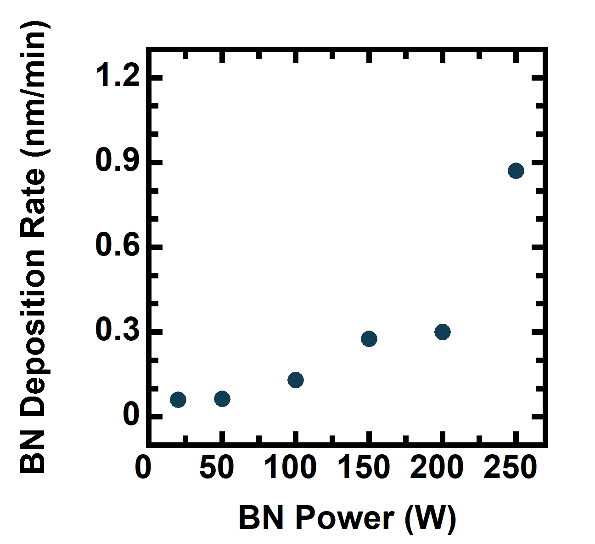
S6: BN deposition rate (nm/min) vs BN power (W) through B composition series. AlN deposition rate for each deposition was measured to be 8.06 nm/min. There appears to be a non-linear behavior at higher BN powers, which was not explored further than 250 W RF power.

