Supporting Information
Flexible and Efficient Supercapacitor Devices Based on Inkjet-Printed Ni–Co Layered Double Hydroxides
Mohamed Ahmed Belal^{1,2*}, Hosam Hassan Khalil^{1,3}, Ahmed Elsayed Rashed ⁴, Sherine Nabil Khattab ¹, Ahmed Abd El-Moneim^{2,5,6 **}
¹Chemistry Department, Faculty of Science, Alexandria University, Alexandria 21321, Egypt
²Graphene Center of Excellence, Energy and Electronics Applications, Egypt-Japan University of Science and Technology, New Borg El-Arab, 21934, Egypt.
³Chemistry Department, Faculty of Science and Art, Najran University, Najran, 1988, Kingdom of Saudi Arabia.
⁴Environmental Sciences Department, Faculty of Science, Alexandria University, Alexandria, 21511, Egypt.
⁵School of Basic and Applied Science, Egypt-Japan University of Science and Technology, New Borg El Arab City, Alexandria 21934, Egypt.
⁶Physical Chemistry Department, National Research Centre, El-Dokki, Cairo, 12622, Egypt.
Corresponding authors' E-mails:
*mohamed_belal@alexu.edu.eg , **ahmed.abdelmoneim@ejust.edu.eg
This PDF file includes:
Supplementary Discussion
Supplementary Method
Supplementary Figures S1 to S11
Supplementary Tables S1 to S4
Supplementary References

Materials
The graphite flakes, the absolute ethanol and ethyl cellulose (EC) of 22 cP grade, measured at 5% concentration in a mixture of 80% toluene and 20% ethanol, with 48% ethoxy content, were provided Fischer and Acros (England), whereas the NaCl solution (0.04 gm mL⁻¹ NaCl, >99.5%) was supplied by Adwic, Egypt. We obtained cyclohexanone from Loba (India), ethylene glycol monomethyl ether from Qualikems (India), and terpineol from SDFCL (India). The tetrabutylammonium hydroxide (TBAOH) in a 40% weight concentration of water solution was acquired from Chem-Lab, Belgium, while the hydrogen peroxide (H₂O₂) in a 30% weight concentration of water was obtained from EDWIC, Egypt. Ethylene glycol (EG) 99% pure, cobalt chloride hexahydrate, and Nickel chloride hexahydrate were provided by SDFCL, a Mumbai, (India) for the study. The commercial ethanol used in the study was obtained from ISO-LAB, located in Cairo, Egypt. The filter paper used was Millipore Nitrocellulose HAWP, with a thickness of 0.9 mm. Liquid-phase exfoliated graphene (LPEG) was manufactured using a kitchen blender (Tornado Blender 2 Mill Black BL500/2-Toshiba Elaraby Group), along with a probe sonicator (Hielscher 400S) and a Hermle high-speed centrifuge. In the investigation, a Dimatix Fujifilm DMP-2850 inkjet printer was used with a legacy 10 pL cartridge (DMC-11610) for the specified application in this study.

Synthesis of Liquid Phase Exfoliated Graphene (LPEG)
Into the kitchen blender for 8 hrs, a mixed solution of ethyl cellulose (EC) (1% w/v), graphite flakes (20% w/v), and ethanol (100 mL) was added to be exfoliated by high turbulence, according to the method of Li et al. [1]. Then, the mixture was sonicated for 1 hour in an ice bath to enhance dispersion. After that, the mixture was left to settle overnight and then centrifuged at 6000 rpm for 10 min to sediment out large graphite flakes. The supernatant was harvested by pipette and then mixed with an aqueous NaCl solution (4 wt.%) in a 2:1 ratio. The formed flocculates were collected and washed by vacuum filtration. The flocculates were then redispersed in ethanol, and the washing and collection procedure was repeated.

Ink Formulation of LPEG
For inkjet printing, the graphene-EC (LPEG) powder was dispersed in a solvent mixture consisting of terpineol, ethylene glycol monomethyl ether, and cyclohexanone in a ratio of 90:5:5. After stirring the dispersion at 1500 rpm, it was sonicated using a 3 mm probe sonicator at 60% amplitude. The resulting ink had a solid content of 3wt.%. Following this, a 0.45 µm nylon syringe was utilized to filtrate the ink.
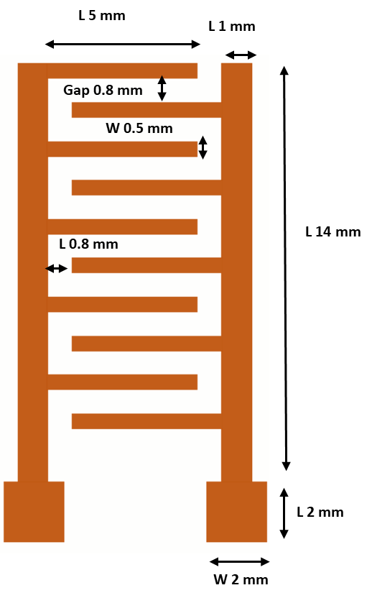
Fig. S1 Interdigitated microsupercapacitor design.
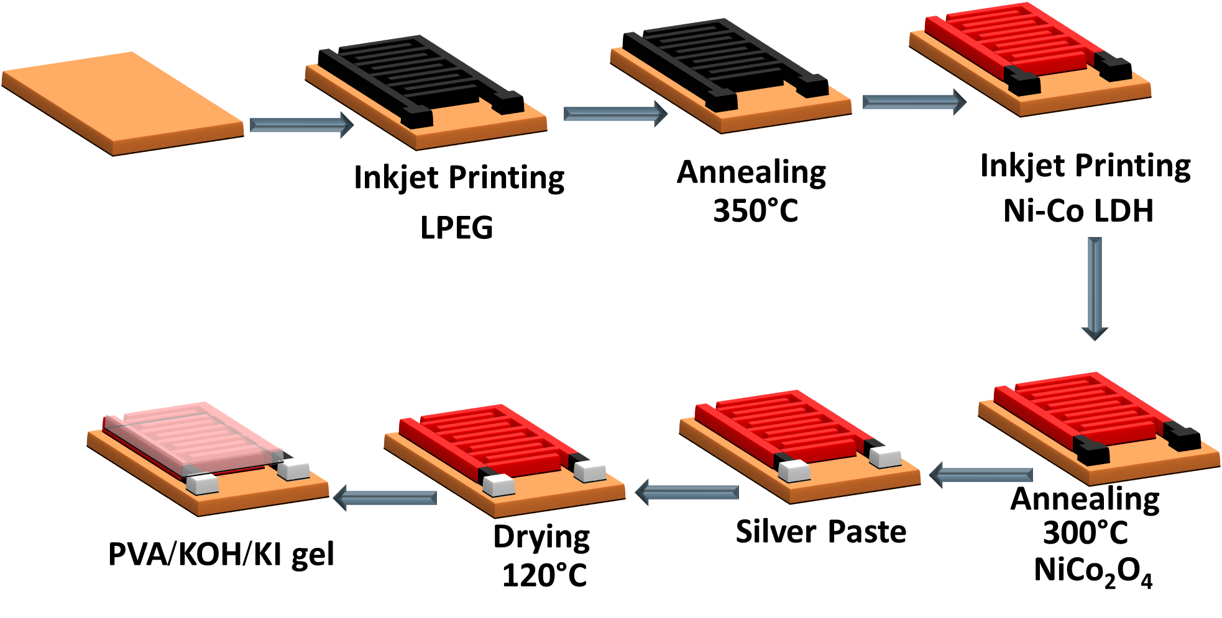
Fig. S2 Schematic illustration of the fabrication process of interdigitated µSC.

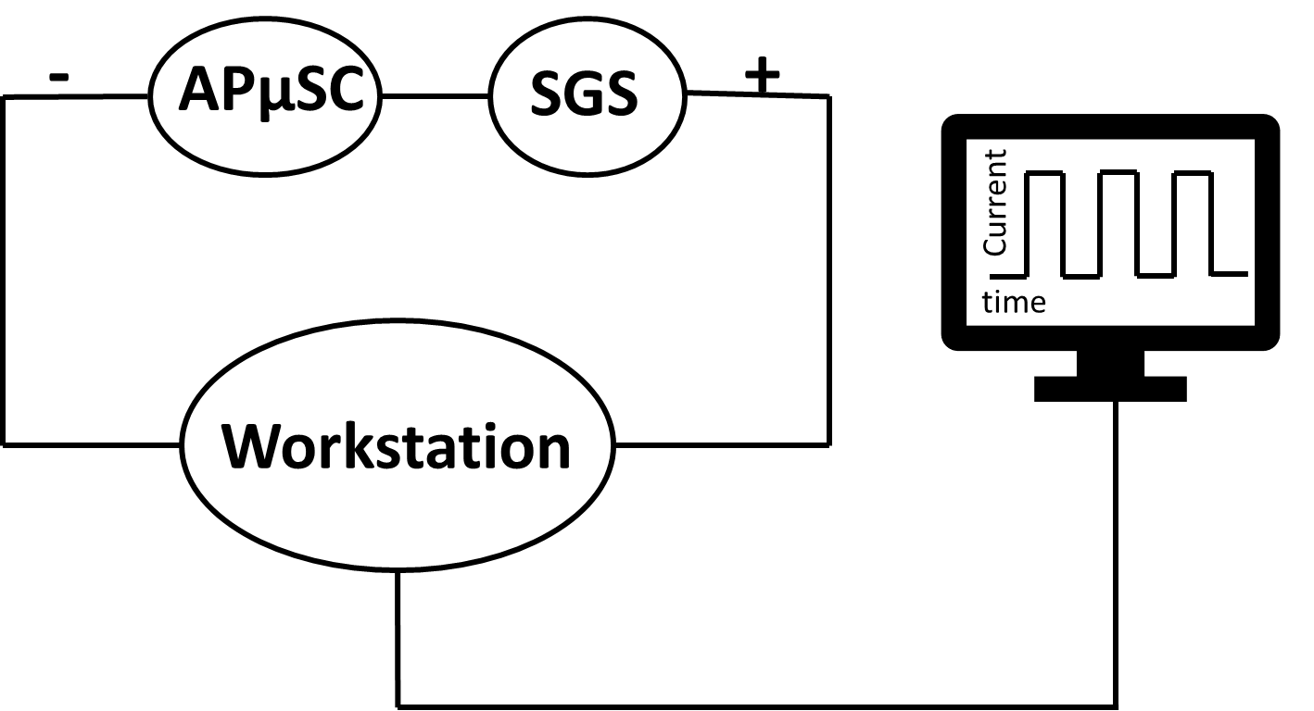
Fig. S3 Schematic illustration of SGS circuit with AµSC.

Physicochemical and Electrochemical Characterization
X-ray diffractometry (XRD) was used in the reflection mode with Cu K-α radiation in a Shimadzu Lab X XRD-6100 diffractometer to characterize the crystal structure of Ni-Co LDH and NiCo₂O₄, covering an angular range from 5 to 80° at a scan rate of 12°/min. Bruker, VERTEX 70v spectrometer equipped with an ATR unit and Bruker and Senterra II Raman microscope at an excitation wavelength of 532 nm were used to perform Fourier transform infrared (FTIR) and Raman spectroscopies, respectively. Scanning electron microscopy (SEM) (JEOL JSM-6010LV) and transmission electron microscopy (TEM) (JEOL JEM-2010F), both equipped with Energy-dispersive X-ray spectroscopy (EDX) analyzers from Oxford Instruments, were used to characterize the morphology and microstructure of the produced materials. Complementary to the XRD analysis, X-ray photoelectron spectroscopy (XPS) measurements were performed using a K-α instrument (Thermo Fisher Scientific, USA) to characterize NiCo₂O₄@LPEG film. The XPS analysis utilized monochromatic X-rays with an Al K-alpha energy ranging from 10 to 1350 eV. The spot size used for the measurements was 400 μm, and the pressure during the analysis was maintained at 10⁻⁹ mbar. Two different pass energies were employed: a full-spectrum pass energy of 200 eV and a narrow-spectrum pass energy of 50 eV. The thermal behavior of LPEG and Ni-Co LDH was investigated using thermogravimetric analysis (TGA) and differential scanning calorimetry (DSC) in air at a heating rate of 10 °C/min over a temperature range of 25 to 800 °C using a Linseis STA PT TGA instrument. The dynamic light scattering (DLS) method (Malvern Panalytical zeta sizer Nano-ZS) was utilized to determine the Ni-Co LDH ink’s particle size and zeta potential. A rheometer (specifically a Malvern Panalytical KINEXUS PRO Rheometer) was utilized to determine the ink's degree of viscosity. To determine contact angle and surface tension, an Ossila contact angle goniometer was utilized. Using a Hitachi U-3900 UV–Vis spectrophotometer, we were able to determine the final concentration of Ni-Co LDH ink by performing UV-Vis spectroscopy between 200 and 900 nm.

Electrochemical Measurements

NiCo₂O₄@LPEG µSC
Electrochemical testing was performed using the VersaSTAT4 electrochemical workstation. The prepared NiCo₂O₄@LPEG device was tested using a two-electrode configuration using a gel electrolyte comprising PVA/KOH/KI gel, as detailed in Lee et al.’s work [2]. The gel electrolyte was prepared by dissolving 1.5 g polyvinyl alcohol (PVA) (MW 85,000–124,000, Aldrich) in 10 mL DW at 85 °C under vigorous stirring. To this solution, 10 mL of aqueous potassium hydroxide (1.5 g in 10 mL) (KOH, 15%) was added with stirring. Subsequently, 0.9 g of potassium iodide (redox material) was added to this mixture. The resulting solution was heated in a water bath for 30 min at 85 °C. The gel electrolyte was then deposited and dried on the active area of the devices under ambient conditions. Cyclic voltammetry (CV) and Galvanostatic charge-discharge (GCD) experiments were conducted at a scan rate of 0-100 mV s⁻¹ and current densities ranging from 0.1 to 1.0 A m⁻², respectively. The resulting curves were analyzed to determine the areal-specific capacitance (C_{A, CV}) using Equation 1 [3].
$$C_{A,CV}=\frac{Q}{{2* A}_{device}*V} Eq.1$$
Where C_{A, CV} is the areal capacitance in F m⁻², Q is the charge (C), V is the potential window (V), and A_{device} refers to the area of the device (25* 10⁻⁶ m²), excluding finger space gaps.
In galvanostatic charge-discharge (GCD) experiments, current densities ranged from 0.1 to 1 A m⁻². The areal capacitance was calculated according to Equation 2 [4].
$$C_{A,GCD}=I/{\frac{dV}{dt}}×\frac{1}{A_{device}} Eq.2$$
Where C_{A, GCD} is the areal capacitance in F m⁻², A_{device} the area of the device (25 * 10⁻⁶ m²), excluding finger space gaps, I is the discharge current in A, and $\frac{dV}{dt}$ is the slope of the discharge curve.
The energy density (E_{A}, Wh m⁻²) and power density (P_{A}, W m⁻²) were calculated according to Equations 3 and 4.[5]
$$E_{A}=\frac{1}{2}\frac{C_{A,GCD}V^{2}}{3600} Eq.3$$
$$P_{A}=\frac{{3600×E}_{A}}{∆t} Eq.4$$
A factor of 3600 is applied to the derived energy density to convert it from Ws m⁻² to Wh m⁻². Similarly, to acquire units of W m⁻², power density is multiplied by 3600, where Δt is in seconds [6].

Physical Properties Study of Ink and Printed Film
To avoid clogging, DOD inkjet printers typically need a lateral size of less than 1/100th of the nozzle's diameter [7], which is 430 nm in the case of the printer used in this work with a 21.5 µm nozzle diameter, as shown in Table S1. The optimal ink formulation of Ni-Co LDH, Fig. S4a, showed a hydrodynamic size of 104.5 nm, Fig. S4b. Because of the excellent stability of the produced nanosheets [8, 9], which is necessary for optimal printing and long ink shelf life; the zeta potential value was about 40.1 mV at pH 5.5, Fig. S4c.
Table S1 Properties of the optimal Ni-Co LDH ink.
Material | ⍴ (g mL⁻¹) | Size | ζ (mV) | 𝛈 (cP) | 𝛄 (mN m⁻¹) | Oh | Z
Ni-Co LDH | 1.1 | 104.5 | 40.1 | 2.097 | 52.71 | 0.0632 | 15.82

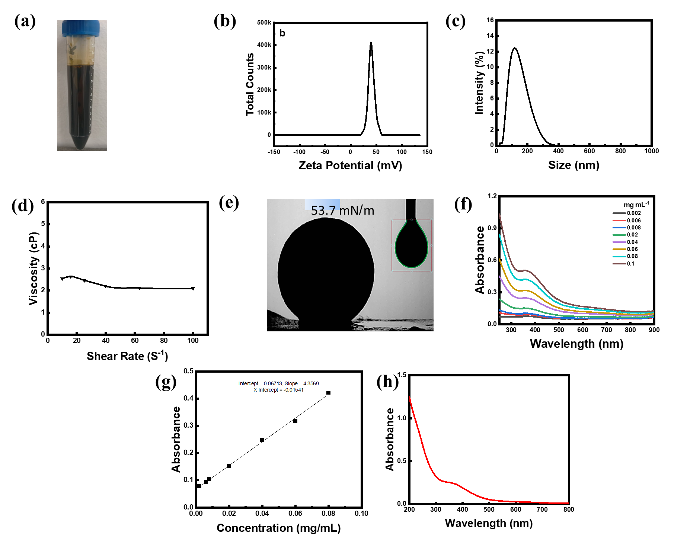
Fig. S4 a) Digital photograph of the prepared ink; b) DLS size; c) Zeta potential distributions; d) Dynamic viscosity at increasing shear rates; e) Surface tension; f) UV-Vis spectra at different concentrations; g) Calibration curve of Ni-Co LDH ink; and h) UV-Vis spectrum of used concentration Ni-Co LDH ink.
An essential factor is the ink concentration, which permits more material loading with fewer printed layers. This makes it more productive, saves money, and allows a higher volumetric energy density. Fig. S4f-h shows that UV-Vis spectroscopy was used to estimate the concentration of Ni-Co LDH. The maximum peak was observed at 362 nm and was attributed to the d-d transition of Co²⁺ in the tetrahedral coordination. The absorption coefficient was determined to be 4.36 g⁻¹ dm³ cm⁻¹ utilizing the Beer-Lambert law, Equation 5 [10], and a concentration range of 0.002-0.1 mg mL⁻¹ of Ni-Co LDH to create a calibration curve.
$$A=εcl Eq.5$$
The concentration of the absorbing species (c), the route length through the sample (l), and the molar absorptivity ($ε$) are shown in Table S1. The large interlayer spacing, resulting in a strong zeta potential for our hexagonal sheets, enabled us to generate high concentrations of Ni-Co LDH at 13.82 mg mL⁻¹, indicating high dispersibility and particularly good stability.
Table S2: The optimum concentration of Ni-Co LDH ink.
Ink | Dilution time | Wavelength (nm) | absorption coefficient (dm³ g⁻¹ cm⁻¹) | Length (cm) | Absorbance | C(mg/mL)
Ni-Co LDH | 500 | 362 | 4.36 | 1 | 0.241 | 13.82

One of the primary challenges of inkjet printing is formulating the ink, which requires it to be optimized for various types of substrates. As indicated in Equation 6,[11] the inverse Ohnesorge number, or Z, was utilized to assess ink printability and drop stability. The surface tension of the ink and its viscosity are the two most important characteristics to consider.
$$Z=\frac{{\left(γρα\right)}^{0.5}}{η} Eq.6$$
Where γ (mN/m) represents the surface tension of the fluid, ρ (g/ml) is the density of the fluid, α (μm) is the diameter of the nozzle, and η (cP) is the viscosity of the fluid. Z ought to fall within the range of 4 and 20 [11]; therefore, reliable drop formation and good-quality printing can be achieved. For environmental concerns, the aqueous water-based inks are affordable and friendly to the environment; nevertheless, water has a Z value of 37.89, which is very high and results in poor printability. To meet the printer requirements, utilizing liquid modifiers that are not harmful to the surrounding ecosystem and inexpensive, such as EG, to modify the water's rheological properties successfully. Therefore, EG at a concentration of 20% was used to increase the viscosity of water from 1 to 2.746 cP (Fig. S4d), and EtOH at a concentration of 5% was used as a cosolvent to decrease the surface tension from 72 to 52.71 mN m⁻¹. The results of these experiments are presented in Table S1.
Additionally, these modifiers serve to prevent the nozzle from clogging, which in turn improves print quality. They also aid in minimizing the spread of ink in the horizontal direction, which lessens the coffee-ring effect by upsetting the Marangoni flow [12]. The Z value of the Ni-Co LDH ink that had been produced in a mixture of DW, EG, and EtOH (7.5:2:0.5) was 15.82, which indicated that it was acceptable for good jetting. It was demonstrated by the development of stable ink droplets, which included a well-rounded drop that formed at 40 microseconds and remained stable thereafter, as well as the total absence of satellites (Fig. S2).
For a better understanding of substrate wettability, the contact angle demonstrates that LPEG has excellent wettability when combined with a polyimide substrate, Fig. S5, which is approximately 40°, and Ni-Co LDH with LPEG, which was measured at zero seconds and after 60 s to be approximately 46° and 44°, respectively.

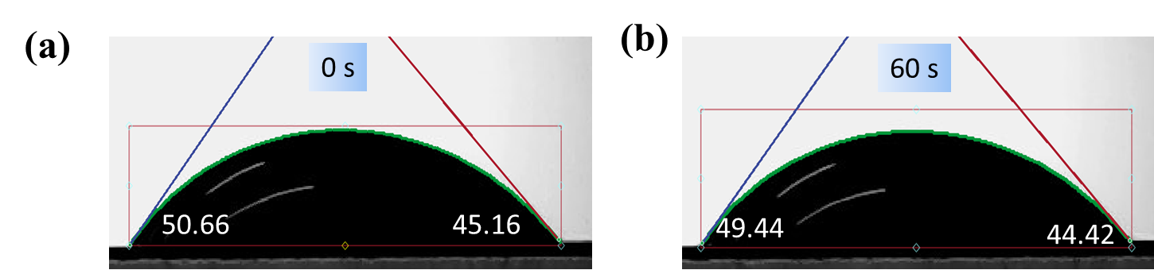
Fig. S5 Contact angle of Ni-Co LDH ink at a) 0 s; and b) 60 s.

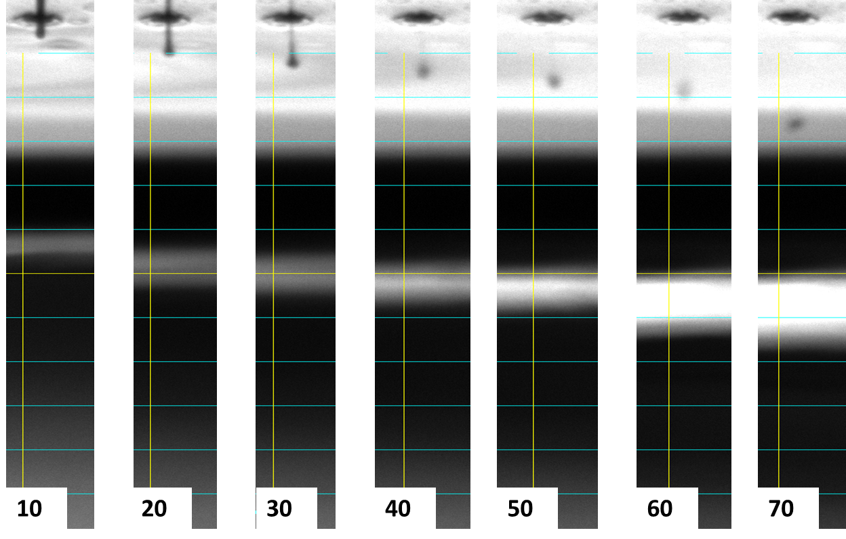
Fig. S6 Inkjet drop formation at delay times of 20‒70 µs.

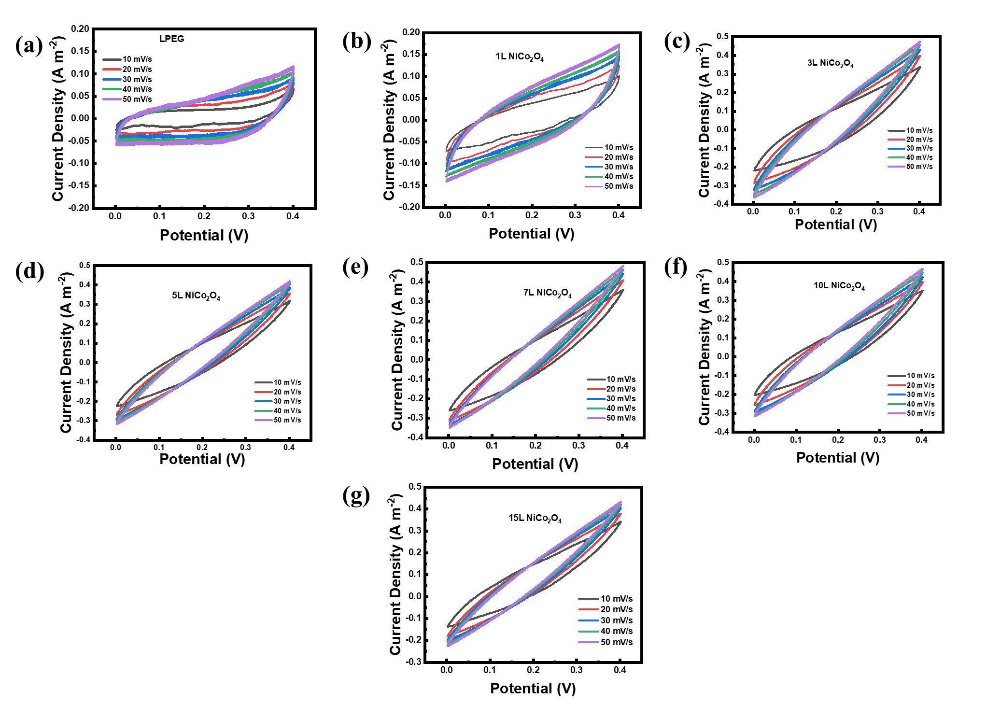
Fig. S7 CV profiles of a) LPEG and NiCo₂O₄@LPEG; b) 1L; c) 3L; d) 5L; e) 7L; f) 10L; and g) 15L at different scan rates.
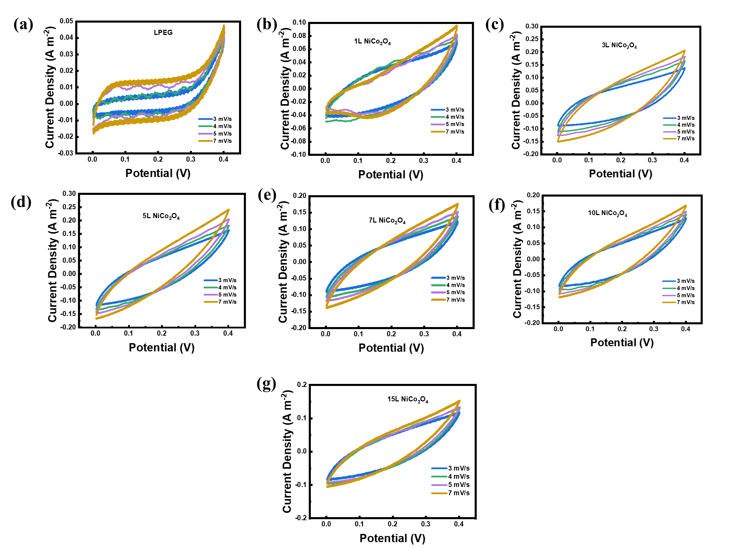
Fig. S8 CV profiles of a) LPEG and NiCo₂O₄@LPEG; b) 1L; c) 3L, d) 5L, e) 7L, f) 10L, and d) 15L at low scan rates.

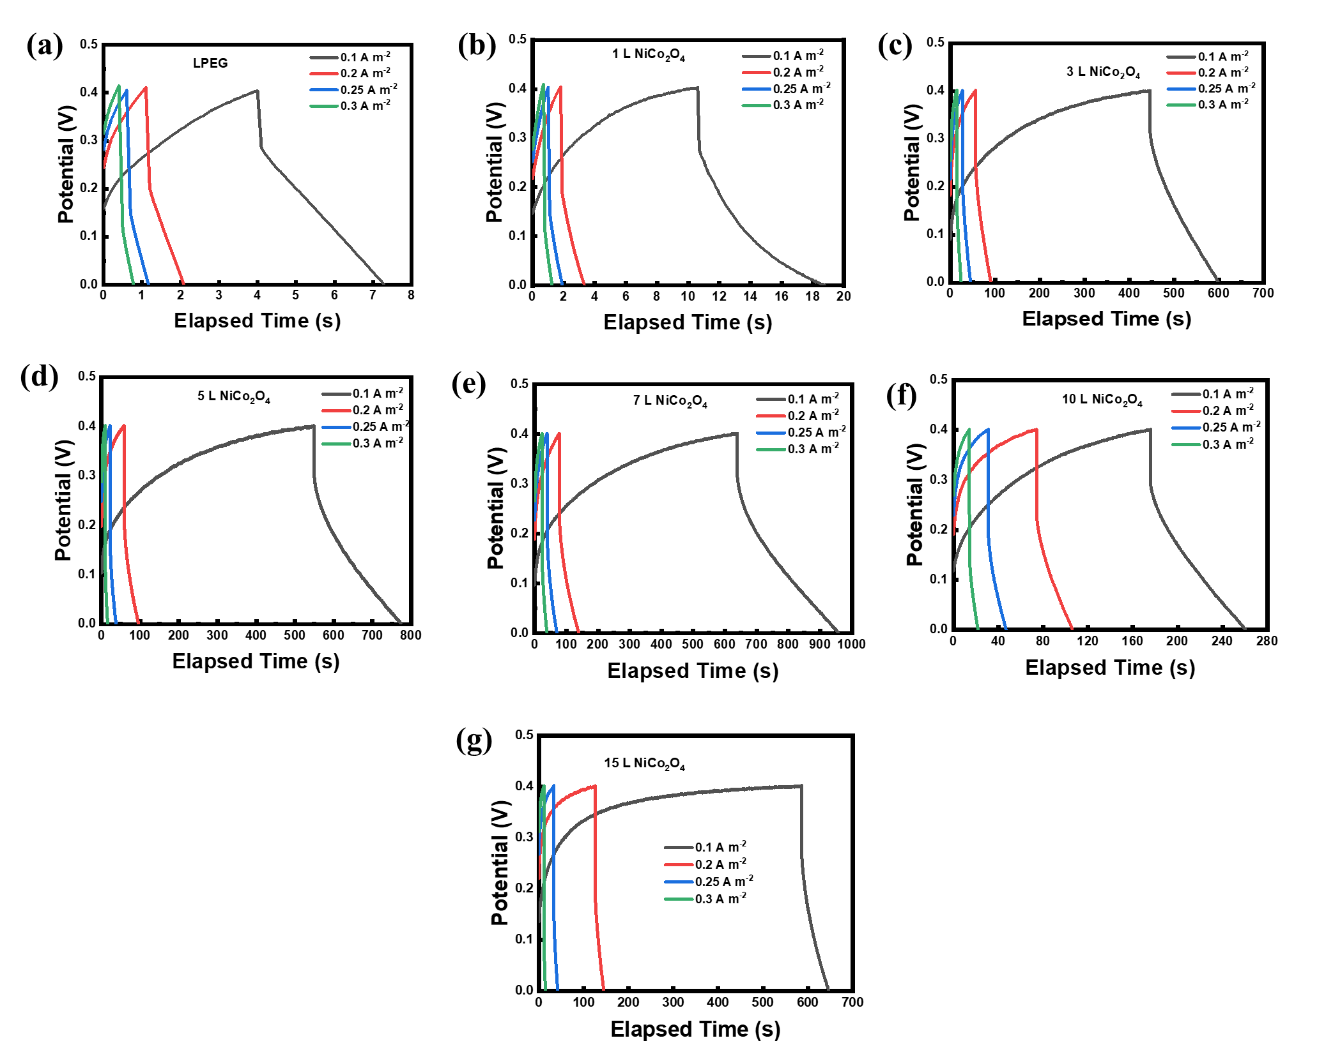
Fig. S9 Charge-discharge profiles of a) LPEG and NiCo₂O₄@LPEG; b) 1L; c) 3L; d) 5L; e) 7L; f) 10L; and g) 15L at different current densities.
Table S3: Calculated droplet mass of different printed layers of Ni-Co LDH.
Droplet volume = 5.572453333 pL, then droplet mass = 5.572453333 × 13 × 10⁻⁹ mL = 72.441893329 × 10⁻⁹ mg.
Mass of each layer = 128250 × 72.441893329 × 10⁻⁹ mg = 9,290,672.819 × 10⁻⁹ mg.
No. of Layers | Pattern Mass (mg) | Pattern Mass (gm) | Pattern Mass (gm)
1 | 9,290,672.819×10⁻⁹ mg×1=  9,290,672.819×10⁻⁹ | 9,290,672.819×10⁻¹² | 9.29E-06
3 | 9,290,672.819×10⁻⁹ mg×3=  27,872,018.46×10⁻⁹ | 27,872,018.46×10⁻¹² | 2.79E-05
5 | 9,290,672.819×10⁻⁹ mg×5=  46,453,364.1×10⁻⁹ | 46,453,364.1×10⁻¹² | 4.65E-05
7 | 9,290,672.819×10⁻⁹ mg×7=  65,034,709.73×10⁻⁹ | 65,034,709.73×10⁻¹² | 6.50E-05
10 | 9,290,672.819×10⁻⁹ mg×10 = 92,906,728.19×10⁻⁹ | 92,906,728.19×10⁻¹² | 9.29E-05
15 | 9,290,672.819×10⁻⁹ mg×15 = 139,360,092.3×10⁻⁹ | 139,360,092.3×10⁻¹² | 1.39E-04

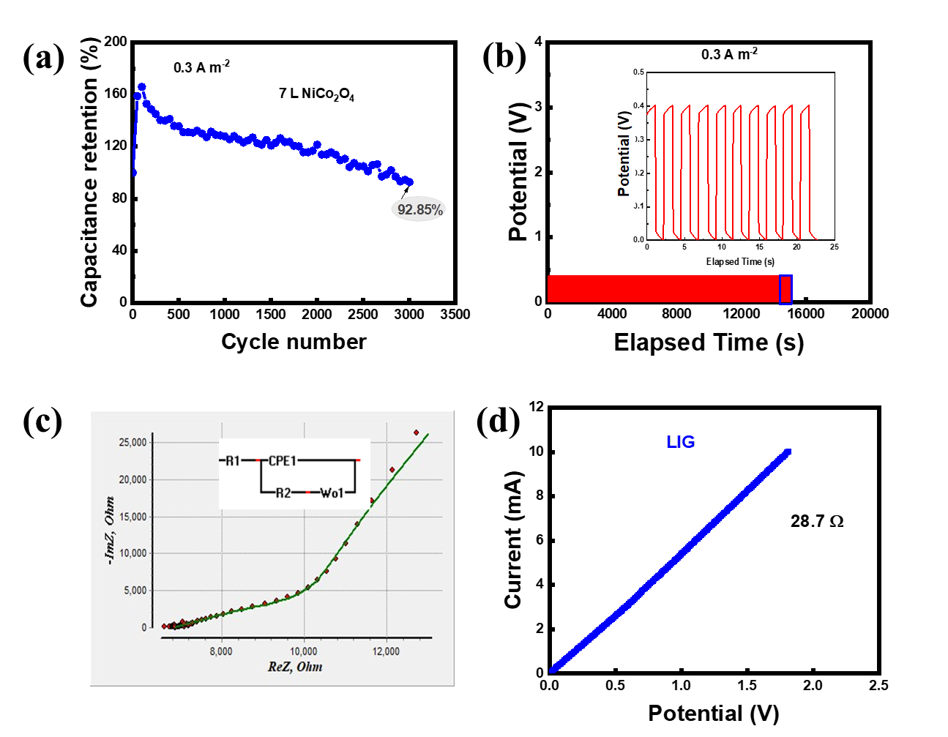
Fig. S10 a) Capacitance retention (%); b) Cycling stability of 7L NiCo₂O₄@LPEG µSC device; c) The fitted electrochemical impedance spectra of 7L Printed NiCo₂O₄@LPEG//LPEG AµSC device; and d) IV curve of LIG.

Table S4: Values for the fitting of R_{s}, R_{ct}, CPE, and W of 7L NiCo₂O₄@LPEG//LPEG AµSC device.
R_{s} (Ω) | R_{ct} (Ω) | CPE (µF) | n | W_{or} | W_{oc}
6863.9 | 246.02 | 21.26 | 0.77 | 15817 | 0.81362

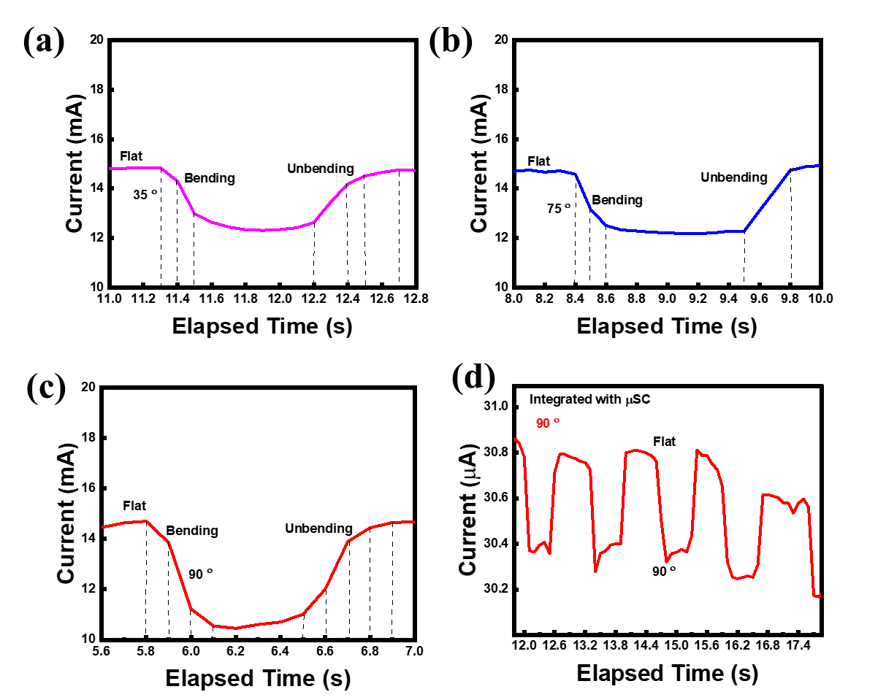
Fig. S11 a,b,c) Recovery and response time of different bending angles and d) SGS-AµSC at 90 °.
Reference
[1] L. Li, E.B. Secor, K.S. Chen, J. Zhu, X.L. Liu, T.Z. Gao, J.W.T. Seo, Y.C. Zhao, M.C. Hersam, Advanced Energy Materials, 6 (2016).
[2] S.C. Lee, U.M. Patil, S.J. Kim, S. Ahn, S.W. Kang, S.C. Jun, Rsc Adv, 6 (2016) 43844-43854.
[3] Z. Karimi, J. Moon, J. Malzahn, E. Eddings, R. Warren, Energy Advances, 2 (2023) 1036-1044.
[4] P. Sundriyal, S. Bhattacharya, Acs Appl Energ Mater, 2 (2019) 1876-1890.
[5] Y. Wang, Y.-Z. Zhang, D. Dubbink, J.E. ten Elshof, Nano Energy, 49 (2018) 481-488.
[6] M.K. Jha, R. Ball, R. Seelaboyina, C. Subramaniam, Acs Appl Energ Mater, 3 (2020) 3454-3464.
[7] Y. Wang, Y.Z. Zhang, D. Dubbink, J.E. ten Elshof, Nano Energy, 49 (2018) 481-488.
[8] H. Fei, N. Saha, N. Kazantseva, R. Moucka, Q. Cheng, P. Saha, Materials (Basel), 10 (2017).
[9] S.L. Dashtban Kenari, B. Barbeau, Journal of Environmental Engineering, 142 (2016).
[10] F. Lozano-Steinmetz, M.P. Ramirez-Navarro, L. Vivas, D.A. Vasco, D.P. Singh, C. Zambra-Sazo, Nanomaterials (Basel), 12 (2022).
[11] A. Samos-Puerto, G. Rodríguez-Gattorno, M.A. Ruiz-Gómez, Colloid Surface A, 583 (2019).
[12] D. Mampallil, H.B. Eral, Adv Colloid Interface Sci, 252 (2018) 38-54.

