Supplementary Material
Failure Behavior of Carbon Nanotube Yarns in a Polymer Matrix Environment

Redha A. Ramadhan^{a,}*, Go Yamamotoª
ªDepartment of Aerospace Engineering, Tohoku University, 6-6-01 Aramaki-Aza Aoba, Aoba-ku, Sendai 980-8579, Japan
*Corresponding author:
Tel.: +81 22 795 6960
E-mail Address: ramadhan.redha.akbar.t6@dc.tohoku.ac.jp (Redha A. Ramadhan)
E-mail Address of Co-author: gyamamoto@tohoku.ac.jp (Go Yamamoto)

Transmission Electron Microscopy for CNTY
TEM analysis was performed using a JEM-2100F TEM microscope. Initially, a small sample of CNTY was dissolved in ethanol to create a CNTY-ethanol solution, which was subsequently placed on an observation plate for microscopic examination. Multiple images of the solution were captured, each displaying several individual CNTs. The diameters of these CNTs were measured using ImageJ software. A total of approximately 200 measurement points were analyzed, yielding an average CNT diameter of 41.5 ± 10.9 nm. Representative TEM images are displayed in Figure S1.
Fig. S1. Examples of TEM images for the measurement of individual CNTs diameter.

SYT Specimen Preparation
For the SYT specimen, a paperboard was crafted into a jig, featuring a central rectangular hole designed to match gauge lengths of 10 mm and 20 mm. The paperboard was split into two sections by cutting through the middle of the hole, and a ~1 mm gap was precisely created by trimming both ends of the cut sections. To maintain the gap's consistency during subsequent processes, two binder clips were securely attached.
The CNTY was carefully aligned along the centerline of the hole and fastened at both ends using double-sided tape for stability. To further secure the setup, a 10 mm square patch of epoxy adhesive was applied over the CNTY and the paperboard, positioned just in front of the tape on each end. This meticulous preparation ensured a robust and consistent specimen configuration for tensile testing.
The SYT tests utilized a universal testing machine, specifically the Instron 5982 from Instron, USA. This machine was equipped with a 1-kN capacity load cell. The crosshead speed was set at 1.67×10^-6 m/s. The SYT test setting is shown in Figure S2.
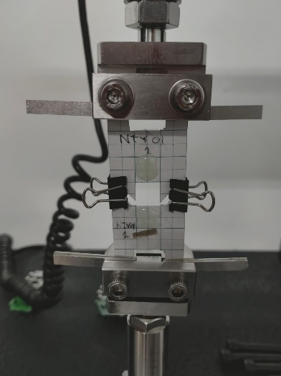
Fig. S2. SYT specimen mounted on the Instron 5982 universal testing machine.

Fragmentation Specimen Preparation
Three strands of CNTYs were carefully positioned on a glass mold, ensuring a spacing of approximately 1 mm between the yarns. This spacing was chosen to prevent any interaction between the yarns caused by stress concentrations originating from adjacent yarn breaks [S1]. To address potential residual strain arising from differences in thermal expansion coefficients between the CNTY and the polymer matrix, an appropriate level of tension was applied to each strand before embedding [S2].
The fragmentation specimens were prepared by pouring a polymer mixture, consisting of 90% bisphenol A diglycidyl ether (jER828, Mitsubishi Chemical, Japan) and 10% diethylenetriamine (D0493, Tokyo Chemical Industry, Japan), into the glass mold. The polymer mixture was chosen considering its transparency to support the birefringence pattern observation. Prior to the CNTYs embedding, the bisphenol A resin was degassed for 1 and a half hour, and the mixture was degassed for approximately 15 minutes, both using a vacuum oven under room temperature. The polymer mixture was then cured in an oven without vacuum at 50 °C for 5 hours, forming a solid plate-shaped composite specimen. Once cured, this composite plate was machined into several dumbbell-shaped fragmentation specimens to facilitate further testing and analysis. The example of such specimen is shown in Figure S3.
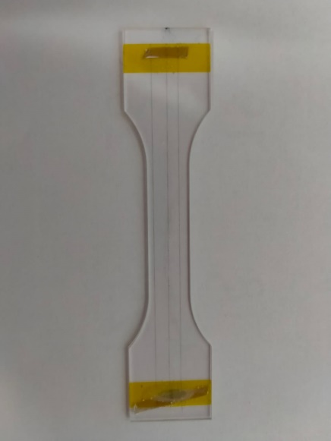
Fig. S3. Example of a CNTY fragmentation dumbbell specimen.
Figure 3 of the main text illustrates the specimen set up for the test. The strain gauge positioned on the specimen, ensuring its longitudinal direction aligned with that of the fragmentation specimen. This configuration was chosen to accurately measure the strain during tensile loading along the specimen's longitudinal axis. The strain gauge was carefully placed to avoid obstructing the observation of CNTYs under a polarized microscope while ensuring uniform strain measurement in the narrow middle section of the specimen. To verify the uniform strain region of the dumbbell specimen under tensile loading, we conducted a finite element (FE) simulation using ABAQUS. The simulation results indicate that the strain distribution in the narrow middle section, approximately 25 mm in length, remains uniform throughout the tensile loading process. Based on these findings, we positioned the strain gauge within this uniform strain region to achieve accurate strain measurement. This placement also ensures that the CNTYs remain visible during observation, allowing for clear monitoring of their deformation behavior throughout the testing process.

Raman Spectra Measurement Procedures and Details
We utilized our previous method to calibrate the residual strain of CNTY embedded in a polymer matrix using Raman spectroscopy [S2]. Raman spectra of CNTYs were acquired using a laser Raman spectrometer (LabRAM HR Evolution, HORIBA, Japan) operating at a 532 nm excitation wavelength under standard ambient conditions. During measurements, tensile loading was applied to the fragmentation specimen using a tabletop tensile/compression testing machine (IMC-90F3, Imoto Machinery, Japan) in strain increments of approximately 0.25%, reaching a maximum composite strain of ~1.0%. To monitor applied strain, foil-type strain gauges (KFEM-2-120-C1, KYOWA, Japan) were employed, ensuring precise measurements throughout the test.
To protect the specimen from potential thermal damage caused by laser radiation, a neutral density filter was employed to carefully regulate the exposure time. The spectrometer was calibrated with polystyrene sample traceable to the NIST polystyrene standard 19125 reference material. The observations were conducted with optical microscope (SLMPlan N, Olympus, Japan) with 100 times magnification. In every observation, the acquisition time is 15 seconds, with 10 times accumulation.
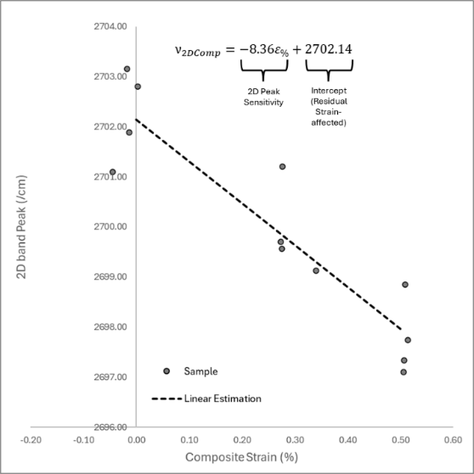
Fig. S4. CNTY 2D band – strain graph for the residual strain calibration. The linear estimation of the gradient change is -8.36 cm⁻¹/%.
Figure S4 presents the calibration graph for fragmentation specimen during tensile, from which the 2D band peak sensitivity was derived. A linear approximation was applied to the 2D band peak – strain graph of CNTYs samples inside fragmentation specimen. Under these experimental conditions, the sensitivity of the CNTY 2D band peak position to strain was determined to be -8.36 cm⁻¹/%, corresponding to the gradient of the linear approximation. However, the intercept obtained from the linear estimation could not be directly used for the residual strain calibration equation, due to variations in the residual strain of CNTY samples within the polymer matrix. To set the intercept for the residual strain equation, the 2D peak position of CNTYs under unloaded conditions was measured using samples bonded to glass slides with adhesive, ensuring zero strain. Approximately 10 points were observed along the zero-strain CNTY, and the corresponding 2D band peak positions were averaged. This provided a baseline intercept for the calibration equation, enabling estimation of CNTY residual strain ($ε_{y}^{r}$) within the composite, as shown in Equation (2) in the main text.

Weibull Parameters Determination from SYT and Fragmentation Tests
As stated in the main text, Weibull distribution analysis was employed to assess the strength distribution and failure behavior of CNTY, both under atmospheric conditions at room temperature and within polymer matrix. The research adopted the Weibull distribution equation for the probability of carbon fiber failure [S3]. The basic equation for the probability of yarn failure is as follows,
$F\left(σ\right)=1-exp⁡\left[-\left(\frac{L}{L_{0}}\right){\left(\frac{σ}{σ_{0}}\right)}^{m}\right]$. (S1)
In Equation (S1), F(σ) represents the probability of yarn failure at a stress level σ, L is the gage length of the SYT specimen, and L₀ is the reference length, set at 10 mm for this study. σ denotes the stress level, while σ₀ and m are the characteristic strength and shape parameter of CNTY, respectively. To determinate the values of σ₀ and m, Equation S1 was first converted to a log-log form to simplify the subsequent linear estimation. This equation is presented as Equation (3) in the main text and is as follows,
$\ln\left\{\ln{\frac{1}{\left(1-F\left(σ\right)\right)}}\right\}-\ln\left(\frac{L}{L_{0}}\right)=m\ln{σ}-m\ln{σ_{0}}$. (S2)
Equation (S2) functions as a linear equation, y = mx + b, where y represents the left-hand side of the equation, m is the shape parameter (m), $\ln{σ}$ as x, and $-m\ln{σ_{0}}$ as b. By plotting x and y on a log-log plot, the linear relationship can be estimated, allowing for the determination of the shape parameter and characteristic strength.
For the CNTYs tested under atmospheric conditions at room temperature, SYT test results were used to determine their characteristic strength. Two sets of SYT specimens, with gauge lengths of 10 mm and 20 mm respectively, each comprising 10 specimens, were subjected to the SYT procedures detailed in the SYT Specimen Preparation and the main text. The ultimate strengths, corresponding to the failure stress of CNTY under tensile loading, were recorded. These strengths were ranked from lowest to highest within each group, with each specimen assigned a rank number from 1 to 10. Based on these rankings, probabilities of failure (F(σ)) were estimated by applying Benard’s median rank,
$F\left(σ\right)=\frac{Rank-0.5}{10}$. (S3)
Then, by including the normalization by the reference length (L₀), the left-hand side of equation S2 can be obtained. The corresponding ultimate strength in every rank was then log-transformed to establish the x-axis values for the log-log plot. The log-log plots for SYT specimens with 10mm and 20mm gauge lengths are presented below,
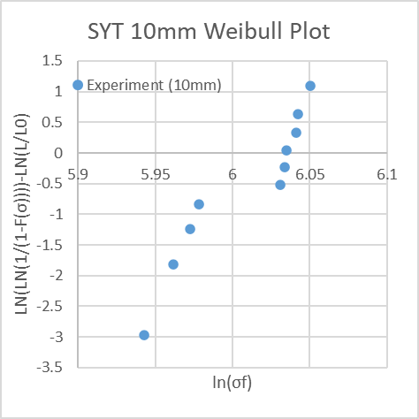 | 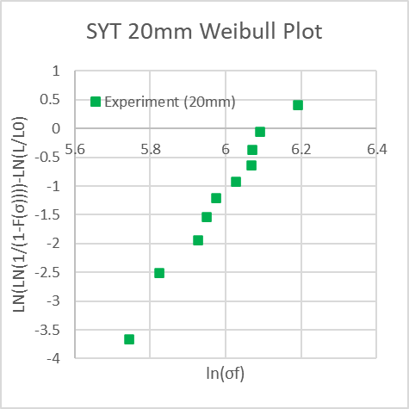
(a) | (b)
Fig. S5. Log-log plot of Weibull distribution of CNTY strength under atmospheric condition at room temperature from fragmentation tests for (a) 10mm gauge length and (b) 20mm gauge length.
To calculate the Weibull parameters, the data from both plots were combined, and a linear equation was derived using least-square estimation based on Equation (S2) (referred to as Equation (3) in the main text). The resultant combined plot is displayed in the main text as Figure 5, featuring the linear equation derived from the least-square estimation. From this equation, the shape parameter (m) can be determined. The characteristic strength (σ₀) is then calculated with the following equation,
$σ_{0}=\exp\left(\frac{-b}{m}\right)$, (S4)
where m is the shape parameter and b is the intercept, both derived from the linear least-square estimation.
For CNTY within a polymer matrix, similar procedures were adapted with specific adjustments. First, the reference length for fragmentation specimens was set to the observation length (10mm) to maintain consistency with the Weibull distribution used under atmospheric conditions at room temperature. Then, The ultimate strength of CNTY in the polymer matrix was estimated by multiplying the onset strain—defined as the strain level at which the first yarn break is observed, indicated by the first visible birefringence pattern under a polarized microscope—with the elastic modulus of CNTY obtained from SYT tests under atmospheric conditions. This calculation incorporates the residual strain as detailed in the Raman Spectra Measurement Procedures and Details.
The ultimate strength estimation of CNTY in polymer matrix assumption is made based on the argument that the first fragmentation observed within the polymer matrix equates to a CNTY failure similar to that under atmospheric conditions at room temperature. With that assumption, the ultimate strength data for the 18 fragmentation specimens can be ranked, and the probability of failure can be calculated using Equation (S3), adjusting the denominator from 10 to 18 to reflect the number of specimens. Subsequently, the same methods are employed to derive the estimates of the shape parameter (m) and characteristic strength (σ₀) for CNTY within polymer matrix.

Weibull statistics and goodness-of-fit
Strength distributions were analyzed in Weibull space by linear regression of the plotted pairs with the empirical failure probability computed with Benard’s median ranks. From the slope and intercept of the regression, the shape parameter $m$ and the characteristic strength $σ_{0}$were recovered in the usual way. Uncertainty on $m$ and $σ_{0}$ in the main tables was quantified using a first-order (delta-method) approximation about the least-squares solution. As a robustness check, nonparametric pairs bootstrap (B = 5,000) was applied directly to the plotted $(X,Y)$data; percentile 95% intervals for $m$ and $σ_{0}$ are reported in table below.
Condition | n | m (point) | m 95% CI (bootstrap) | σ₀ (MPa) (point) | σ₀ 95% CI (bootstrap) (MPa) | R²
CNTY in air | 20 | 11.01 | [8.80, 15.61] | 436.72 | [421.35, 451.84] | 0.73
CNTY in polymer matrix | 18 | 5.319 | [4.94, 5.77] | 23.768 | [23.41, 24.20] | 0.98

Goodness-of-fit was quantified using the Kolmogorov–Smirnov (KS) statistic relative to the fitted Weibull CDF, $F(σ)=1-exp⁡[-(σ/σ_{0})^{m}]$, and the Anderson–Darling (AD) statistic as a tail-sensitive complement. For CNTYs embedded in the matrix, linearity in Weibull space is strong (R² ≈ 0.98) with small KS and AD values. Under atmospheric conditions, linearity is moderate (R² ≈ 0.73) and KS and AD are correspondingly higher.
Condition | R² (Weibull plot) | KS D | AD A²
CNTY in air | 0.729657 | 0.306418 | 2.119433
CNTY in polymer matrix | 0.982198 | 0.117492 | 0.228142

The largest KS contribution in air occurs on the positive side of the Empirical Cumulative Distribution Function (ECDF) difference (D⁺ > D⁻), which implies that the experimental failure probability exceeds the fitted curve at part of the upper half of the sample. This behavior is consistent with multi-stage structural evolution prior to failure (densification, partial untwisting, inter-bundle slip), which can increase scatter at higher stresses relative to a single-hazard idealization. By contrast, matrix confinement limits internal mobility and yields a more uniform failure mode, consistent with the smaller KS and AD values for embedded yarns.
These diagnostics support the main-text interpretation: embedding suppresses progressive rearrangement and produces a distribution that is well described by the fitted model over the observed range, while the atmospheric dataset shows characteristic deviations that align with its hierarchical deformation sequence.

CNTY Diameter and Twist Angle Measurement and Normalization
To evaluate changes in the diameter and twist angle of CNTYs during tensile loading, microscopy observations were conducted under both ambient conditions at room temperature and within a polymer matrix environment. A laser microscope (VK-X200K, Keyence, Japan) was used to examine five CNTY specimens per condition. Tensile loading was applied using a custom hand-operated micro tensile testing machine, with a 10 mm observation scope, corresponding to the gauge length. Strain was determined based on the elongation of the gauge length during loading.
At each strain level, approximately five images were captured along the 10 mm observation scope. These images were analyzed using ImageJ, where the diameter and twist angle were measured at five different points per image. The measured values were then averaged for each strain level. Then, normalization was performed using the following equations:
$\text{Normalized Diameter} =\frac{D}{D_{0}}$, (S5)
$\text{Normalized Twist Angle} =\frac{θ}{θ_{0}}$. (S6)
Here, $D$ represents the average diameter, and $θ$ represents the twist angle, while $D_{0}$ and $θ_{0}$ denote their respective initial values measured under zero strain condition.. Figure 9 in the main text presents the normalized diameter – strain and normalized twist angle – strain graphs for CNTYs under both atmospheric condition at room temperature and within polymer matrix. The normalized extreme values at each strain level are also presented as vertical error bars.

Characteristic Strengths in Tenacity Term
Due to the lack of precise tools and data required to determine the exact density of CNTY in this study, the density of CNTY was assumed to be 1400 kg/m³ [S4]. According to the manufacturer’s specifications, the void content of CNTY is approximately 50%. Assuming the voids are filled with air (density: 1.29 kg/m³), the effective density of CNTY can be estimated as follows,
$\text{CNTY Effective Density} =0.5×ρ_{CNTY}+0.5×ρ_{Air}=700.65 kg/m^{3}$. (S7)
For carbon fiber, the density provided in the manufacturer’s datasheet is 1750 kg/m³. he tenacity, derived from the stress results, can be calculated using the following equation,
$\text{Tenacity (N/}\text{tex}\text{)} =\frac{Stress (Pa)}{Effective Density \left(\frac{kg}{m^{3}}\right) × {10}^{6}}$ . (S8)
The characteristic strengths of CNTY and carbon fiber are presented in Table 2 of the main text. By applying Equation S8 to the listed characteristic strengths, their values in terms of tenacity can be calculated as follows,
 | CNTY | Carbon Fiber
Characteristic Tenacity (N/tex)  (atmospheric conditions) | 0.62 | 2.31
Characteristic Tenacity (N/tex)  (within polymer matrix) | 0.03 | 2.29

The results indicate a sharp decrease in the characteristic tenacity of CNTY when embedded in a polymer matrix compared to atmospheric conditions. In contrast, carbon fiber exhibits only a slight change in characteristic tenacity between the two conditions.

Quantification of the Strain-Normalized Diameter and Strain-Normalized Twist Angle Evolution
Figure 10 of the main text shows the evolution of the normalized diameter and normalized twist angle. Simple fitting approaches were applied to two graphs. A 1st order linear fitting was applied on the strain-normalized diameter, while an exponential fitting was applied to the strain-normalized twist angle. The fitting results along with the equations are shown in Figure S6.
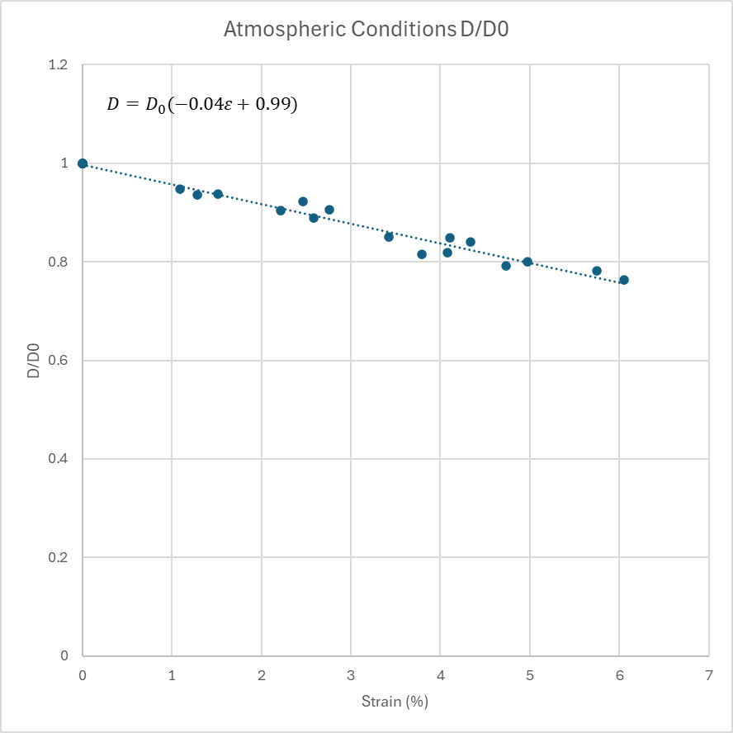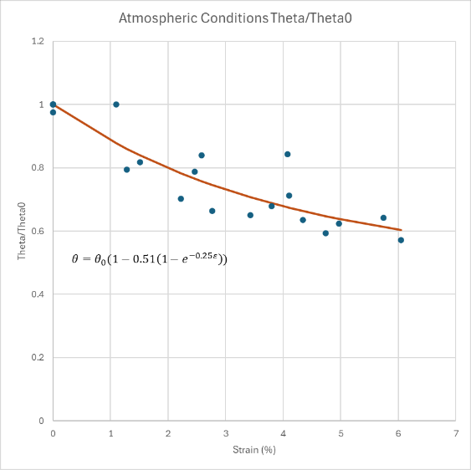
Fig. S6. Atmospheric condition’s strain – normalized diameter and strain – twist angle with fitting approaches.
The observed diameter and twist angle reduction during tensile loading of CNTY under atmospheric conditions reflects a densification mechanism that increases internal friction and alignment within the yarn. This behavior is consistent with the helical structure of CNTY as a twisted yarn, where axial strain leads to untwisting and densification. The twist angle θ is geometrically related to the yarn radius r, where $\text{tan (}\text{θ}\text{) = }{2πr}/h$ (S9)
In the equation above, h is the twist pitch of the CNTY. From the equation, both axial elongation and radial contraction contribute to a reduction of θ during loading. Similar trends have been reported in CNTY, where strain-induced reorientation of individual CNTs and bundles leads to improved alignment and reduced cross-section dimension [S5]. The CNTY’s diameter shrinkage up to ~80% of its initial diameter after ~5% axial strain reflects the highly porous nature of the CNTY and its ability to collapse inward during tensile deformation.
In this study, the normalized diameter reduction under axial strain was expressed as a linear equation and the normalized twist angle reduction was expressed as an exponential function. Although these empirical relationships differ from classical helical yarn mechanics [S6], the physical interpretation aligns closely with the established yarn theory. The linear reduction in diameter suggests progressive and continuous radial compaction under tensile load, consistent with previously reported radial contraction behaviors observed in yarn-like hierarchical structures [S5,S7]. Furthermore, the exponential reduction in twist angle reflects an initially rapid fiber realignment phase, followed by gradual stabilization as internal frictional resistance increases and fiber realignment saturates.
In contrast, the CNTY embedded in the polymer matrix exhibits minimal changes in both diameter and twist angle across the same strain range (Figure 10 in the main text). This suggests that matrix infiltration restricts the radial contraction and internal reconfiguration of the yarn, effectively suppressing the self-tightening effect. The constraint imposed by the surrounding resin limits the rotation and axial alignment of CNT bundles, leading to a more brittle, fragmentation-dominated failure mode. This observation further supports the hypothesis that the self-tightening mechanism plays a critical role in enhancing load transfer and ductility in free-state CNTYs.
To quantify these trends, all strain-normalized measurements within 0–1% strain were used for each condition and for both diameter and twist angle. A straight line was fitted to each dataset, and the slope was taken as the rate of change per percent strain. Uncertainty in the slope was estimated with a non-parametric pairs bootstrap: the same number of (strain, value) points was resampled with replacement, the slope was re-fitted, and this was repeated 5,000 times with a fixed random seed. The 2.5th and 97.5th percentiles of the bootstrap slopes were reported as the 95% confidence interval, and the median bootstrap slope was listed alongside the ordinary least-squares estimate. As a practical check, using a wider window for the atmospheric condition (0–5%) produced slopes with the same sign and similar magnitude, while the embedded case remained close to zero in the 0–1% window.

Interfacial Shear Strength for CNTY
One of the aspects that governs the strength and failure of fiber and yarn materials inside polymer matrix is the interfacial shear strength. In this section, an approach for predicting the interfacial shear strength of CNTY and its interpretation is presented. First, with Kelly-Tyson model [S8], the interfacial shear strength of a fiber inside polymer matrix can be estimated with the equation as follows,
$τ_{ISS} =\frac{σ_{f}.d}{2.l_{c}}$ . (S10)
In equation (S9) $τ_{ISS}$ is the interfacial shear strength and $σ_{f}$ is the final strength of the CNTY inside the polymer matrix, which in this study is 21.89 MPa. The variables $d$ and $l_{c}$ stand for the CNTY diameter and fragmentation length, respectively, which are 38.1 μm and ~0.5mm based on the final number of breaks within 10mm observation scope + 1 (19+1). Inserting those numbers into the equation, the estimated interfacial shear strength is ~0.83 MPa with Kelly-Tyson model, which is smaller than that reported in previous study [S9], which is 14.4 MPa.
The underestimation of the interfacial shear strength of CNTY with Kelly-Tyson approximation rooted in the assumptions used in the approach.
Kelly-Tyson Assumption | CNTY Physical Condition
Solid, uniform cross-section of the yarn | CNTY is porous, allowing matrix infiltration. In practice, the actual load-bearing interface surface might be smaller than the CNTY diameter of 38.1 mm.
Yarn is aligned in the loading direction | CNTY has a twist angle. In polymer matrix, such twist angle reduces axial stress load bearing capability of the yarn.
Clean fiber break at fragmentation length | The breakpoints along CNTY in polymer matrix might not be as clean as carbon fiber. The TEM images showed the mixed-phase regions where the CNTY is infiltrated by the matrix. These regions induce a non-uniform failure behavior along the radial direction of CNTY.
The key aspect that renders Kelly-Tyson interfacial shear stress approach incompatible with CNTY is the fact that the polymer matrix infiltrates the surface of the CNTY, limiting the actual interaction between the pure CNTY and the pure polymer matrix, separated by the mixed-phase region. In our study, the mixed-phase region can be confirmed, however, the depth of those mixed-phase regions is not confirmed due to the equipment limitation. The mechanism of how the CNTY itself interacts with the surrounding polymer matrix should be studied in the future.

Segmentation of CNTY Stress-strain Stages with Piecewise + 95% Confidence Interval
The stress-strain curve was approximated by a continuous three segment piecewise-linear model with two inflection points, $ε_{1}$ and $ε_{2}$. The maximum strain is denoted with $ε_{U}$
$σ\left(ε\right)=\left\{\begin{aligned}E_{1}ε , 0≤ε{≤ε}_{1}, \\ σ_{1}+E_{2}\left(ε- ε_{1}\right),{ ε}_{1}≤ε{≤ε}_{2}, \\ σ_{2}+E_{3}\left(ε- ε_{2}\right),{ ε}_{2}≤ε{≤ε}_{U}.\end{aligned}\right.$ (S11)
The $E_{1}$, $E_{2}$, $E_{3}$ are the stage elastic moduli. The inflection points and elastic moduli were estimated using least-squares method between the experiment $σ$ and estimated $σ_{Est}$.
For any target variable (inflection point or elastic modulus) z over n specimens,
$\overline{z} =\frac{1}{n}\sum_{k=1}^{n}{z_{k}}$, (S12)
$s =\sqrt{\frac{1}{n-1}\sum_{k=1}^{n}{{\left(z_{k}-\overline{z}\right)}^{2}}}$ , (S13)
$95\% CI =\overline{z}±t_{0.975,n-1}\frac{s}{\sqrt{n}}$. (S14)
The generated mean 3-stage stress-strain curve from the piecewise fitting using python file is shown in Fig.S7.
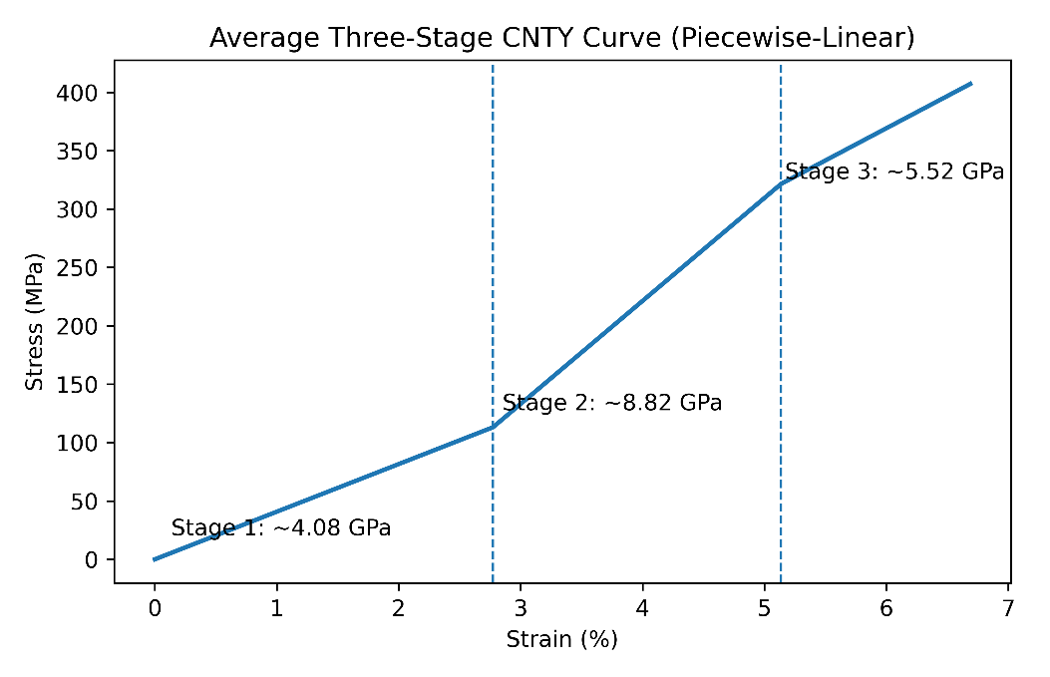
Fig. S7. Three-stage CNTY curve estimated with piecewise-linear method.

Diameter Sensitivity Report
The tensile stress was calculated with the specimen-specific mean diameter measured at around 10 points along the gauge length. The general stress equation $σ=F/A$ with $A=π$ was used. Based on the equation, the uncertainty propagation would be,
$\frac{∆σ}{σ} ≈2\frac{∆d}{\overline{d}}$. (S15)
At $\overline{d}$ = 38.1 μm, a 1 μm change gives 5.25% stress scaling. However, he specimen-specific diameter variability is already included in the confidence intervals reported across the specimen in the main text.

Uncertainty Propagation for Failure Strength of Embedded CNTY
The failure strength of CNTY embedded within polymer matrix was estimated from the birefringence onset strain using the atmospheric elastic modulus obtained within 0.1 – 0.6% strain. Per-yarn mapping of the failure strength is shown below,
$σ_{i}=E_{atm}×ε_{onset,i}$. (S16)
The propagated uncertainty for the mean stress with the first-order method with both elastic modulus and onset strain independent of each other is as follows,
$u^{2}\left(\overline{σ}\right)={\left(\overline{ε_{on}}.10\right)}^{2}u^{2}\left(E_{atm}\right)+{\left(E_{atm}.10\right)}^{2}u^{2}\left(\overline{ε_{on}}\right)$. (S17)
The standard uncertainty of the mean onset strain combines sampling variability and the 0.1% step detection resolution (uniform, half-width = 0.1/2 = 0.05%):
$u\left(\overline{ε_{on}}\right)=\sqrt{\frac{{SD}_{ε}^{2}+{\left(\frac{0.05}{\sqrt{3}}\right)}^{2}}{N}}$, (S18)
$u\left(E_{atm}\right)=SE\left(E_{atm}\right)$, (S19)
The reported mean failure strength with 95% confidence interval is defined by $\overline{σ}±1.96u\left(\overline{σ}\right)$. In this study, with $E_{atm}$=3.67 GPa with its uncertainty (95% CI, 3.21 – 4.14 GPa), and $\overline{ε_{on}}$ = 0.60% and ${SD}_{ε}$=0.12%, the mean failure strength is 21.87 ± 3.37 MPa (95% CI).

Rough Estimation of Mixed-phase Region Depth from TEM Images
To provide an order-of-magnitude estimate of the polymer-infiltrated mixed-phase thickness $t$at the fracture plane and the corresponding cross-sectional area fraction $f$. This estimate is intended only to contextualize the three-region model. TEM fracture-plane images were exported with a linear normalization to provide ease on the color histogram separation. The images were divided with rule of black (CNTY core) from 0 to 9-11, white (polymer) from 59 – 61 to 255, and the mixed phase between them. The sample of the simplified image is shown in Fig. S8.
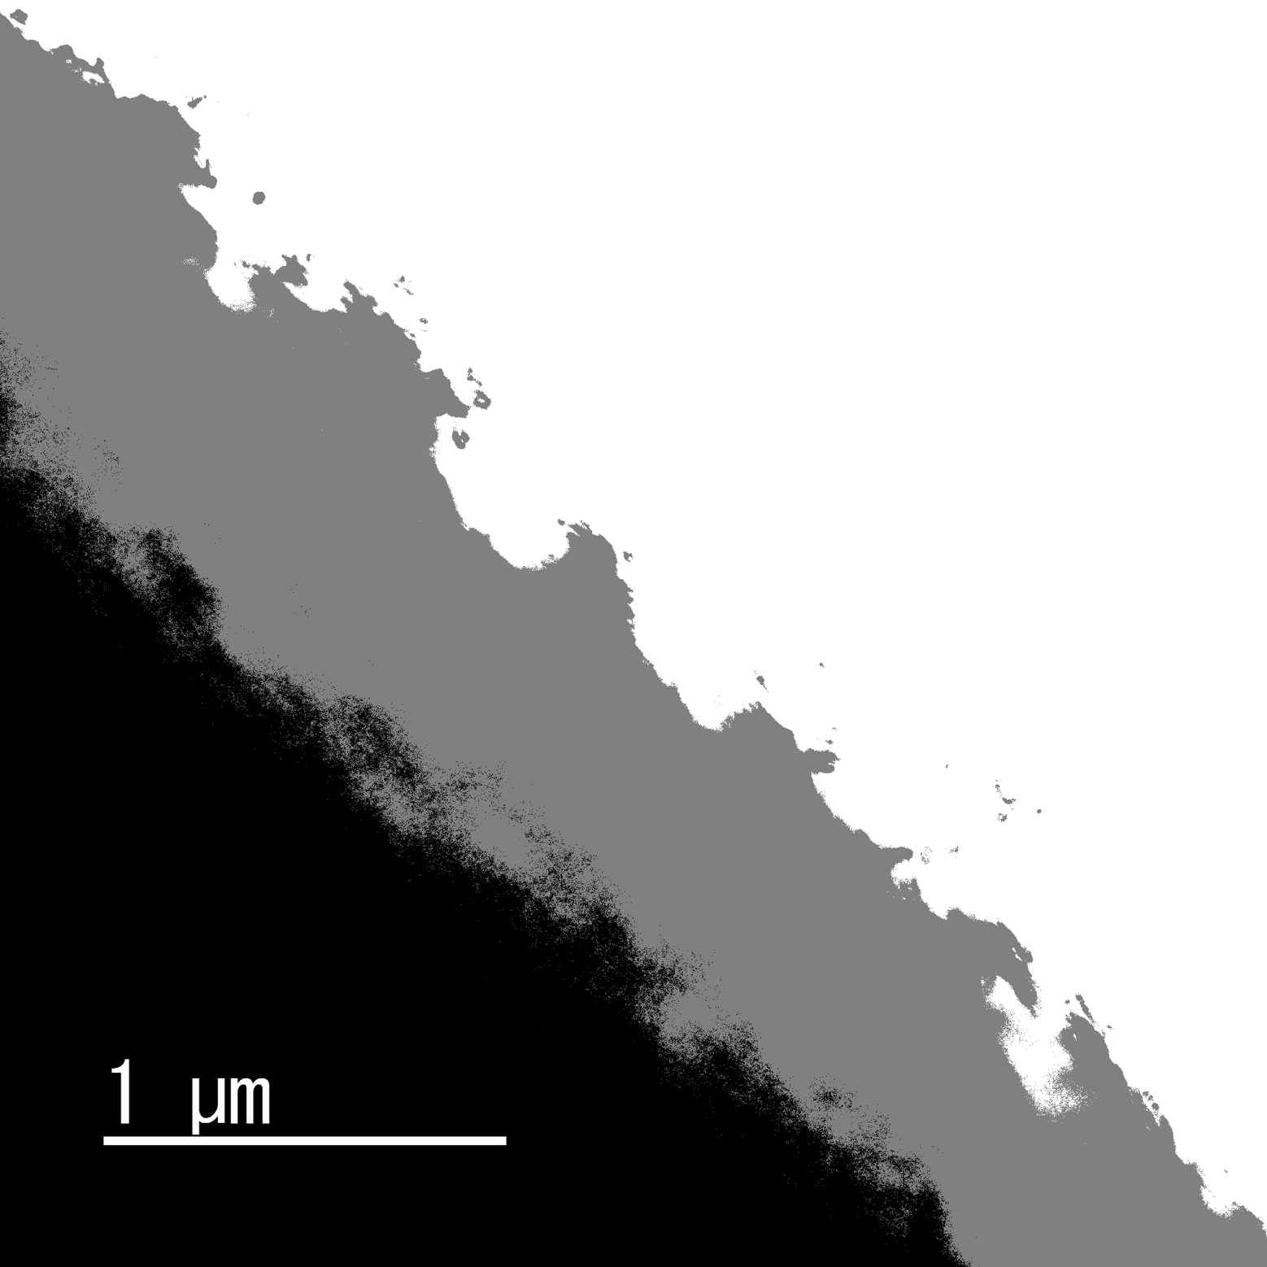
Fig. S8. The example of the original TEM image and simplified version for the rough estimation. In the simplified version, black = CNTy core, grey = mixed-phase, white = polymer
Several lines were measured to capture the depth of the mixed-phase region. Because each frame covers only the near-surface region, the yarn radius was taken from the batch-average diameter $D=38.1 μm$. Assuming a circular cross-section with a uniform shell,
$f=1-{\left(1-\frac{t}{R}\right)}^{2}$. (S20)
Across $n=57$picks, $t$ had a median of 0.566 µm (95% CI 0.544–0.610 µm). The corresponding $f$ had a median of 5.85% (95% CI 5.63–6.30%). Mean ± SD are 0.570 ± 0.130 µm for $t$ and 5.89 ± 1.33% for $f$. The method does not provide volumetric infiltration or the spatial distribution of polymer within bundles. Definitive 3-D quantification would require nano-CT, FIB-SEM serial sectioning, or chemical mapping. The estimate supports the interpretation that only a thin outer shell of the yarn ~6% of whole cross section is effectively polymer-coupled under matrix confinement, consistent with the absence of self-tightening signatures in embedded specimens.

References
[S1] Yamamoto G, Nakano S, Oyamada H, Ramadhan RA, Okamoto S, Takeuchi A, et al. Unravelling the role of inter CNT yarn–yarn interactions in governing the failure behavior in a unidirectional CNT yarn-reinforced plastic composite. Compos Sci Technol 2025;265:111137. https://doi.org/10.1016/j.compscitech.2025.111137.
[S2] Yamamoto G, Oshima K, Ramadhan RA, Lim T, Megra YT, Suk JW, et al. Tensile strength prediction of unidirectional polyacrylonitrile (PAN)-based carbon fiber reinforced plastic composites considering stress distribution around fiber break points. Compos Part A Appl Sci Manuf 2024;183:108234. https://doi.org/10.1016/j.compositesa.2024.108234.
[S3] Watanabe J, Tanaka F, Okuda H, Okabe T. Tensile strength distribution of carbon fibers at short gauge lengths. Adv Compos Mater 2014;23:535–50. https://doi.org/10.1080/09243046.2014.915120.
[S4] Collins PG, Avouris P. Nanotubes for Electronics. Sci Am 2000;283:62–9. https://doi.org/10.1038/scientificamerican1200-62.
[S5] Miao M, McNally T, Goda K, Mandal DK. Structure and radial contraction of dry-spun carbon nanotube yarns. Carbon 2010;48:2679–86. https://doi.org/10.1016/j.carbon.2010.04.009.
[S6] Hearle JWS, Grosberg P, Backer S. Structural mechanics of fibers, yarns, and fabrics. New York: Wiley-Interscience; 1969.
[S7] Pérez-Aranda C, Díez-Pascual AM, Vilatela JJ. Understanding the radial contraction and axial mechanical behavior of carbon nanotube fibers. Carbon 2024;222:119400. https://doi.org/10.1016/j.carbon.2024.119092
[S8] Kelly A, Tyson WR. Tensile properties of fibre-reinforced metals: copper/tungsten and copper/molybdenum. J Mech Phys Solids 1965;13:329–50. https://doi.org/10.1016/0022-5096(65)90035-9.
[S9] Zu M, Li Q, Zhu Y, et.al. The effective interfacial shear strength of carbon nanotube fibers in an epoxy matrix characterized by a microdroplet test. Carbon 2012;50:1271–79. https://doi.org/10.1016/j.carbon.2011.10.047

