Temperature-controlled nanomosaics of AuCu bimetallic structure
towards smart light management

Wiktoria Lipińska*¹, Katarzyna Grochowska¹, Jakub Karczewski^{2,3},
Jacek Ryl^{2,3} and Katarzyna Siuzdak¹

¹Centre for Plasma and Laser Engineering, The Szewalski Institute of Fluid-Flow Machinery Polish Academy of Sciences, Fiszera 14 St., 80-231 Gdańsk, Poland
²Institute of Nanotechnology and Materials Engineering, Faculty of Applied Physics and Mathematics, Gdańsk University of Technology, Narutowicza 11/12 St., 80-233 Gdańsk, Poland
³Advanced Materials Center, Gdańsk University of Technology, Narutowicza 11/12 St.,
80-233 Gdańsk
Corresponding author
*Email wlipinska@imp.gda.pl
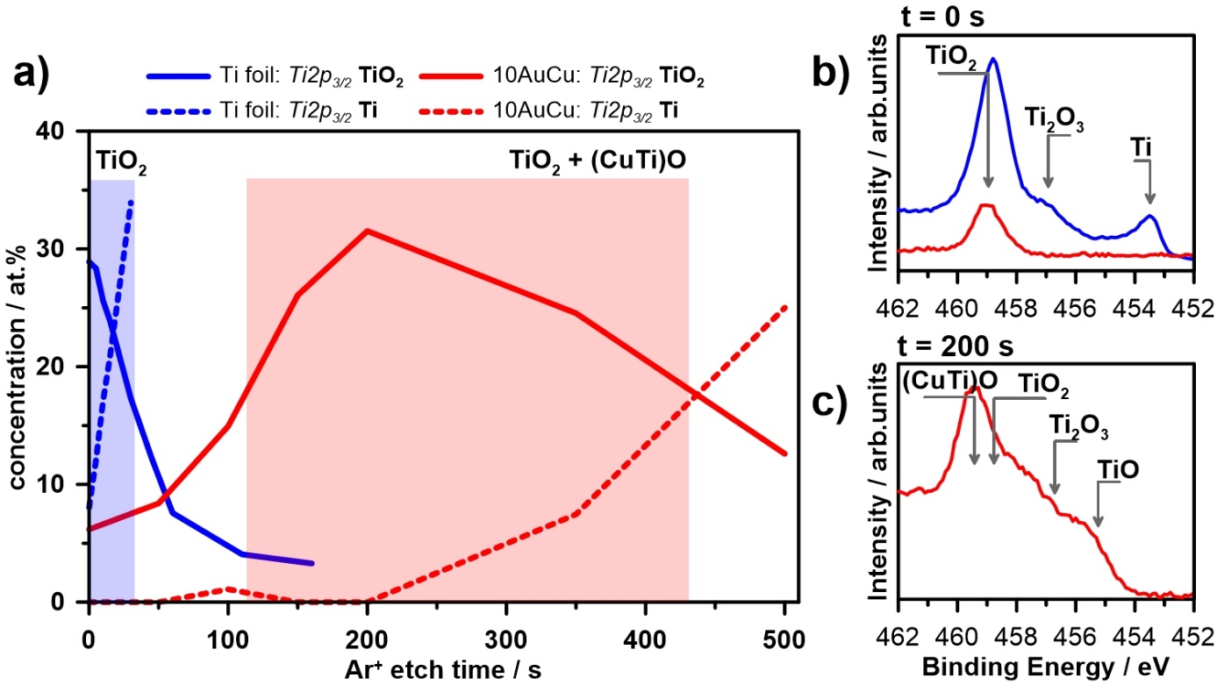
Fig. S1 – a) depth profile through the Ti foil and 10AuCu sample formed at 400 °C considering the share of Ti2p_{3/2} spectral components TiO₂ and metallic Ti, b) Ti2p_{3/2} spectra of the studied samples b) at the surface and c) after 200 s Ar⁺ bombardment.

XPS measurements were conducted for the 10AuCu electrode annealed at 500°C after photoelectrochemical measurements. The curves are presented in Fig.S2 and results are summarized in Tab.S1. The spectrum of copper appears as an overlapping four peaks located at 931.2 eV, 932.6 eV, 933 eV, and 935.0 eV same as for the sample before electrochemical measurements. The same peaks after and before electrochemical measurements can be observed for Ti2p and O1s spectra. The most prominent change occurring due to the performed measurements was noted for Au4f spectrum as a new third peak Au₂O₃ located at 86.3 eV
[1, 2]. The Au₂O₃ oxide was formed during cyclic voltammetry measurements, however, its amount was too small to observe an anodic peak on the CV curve. Additionally, the increase of Atomic% of metallic Au were confirmed.
Fig.S2 XPS high resolution spectra registered for 10AuCu electrode annealed at 500°C
after photoelectrochemical measurements

Table.S1 Binding energies (BE) of 10AuCu electrodes annealed at 500°C after photoelectrochemical measurements.
Peak | Component | BE / eV | At.% | Peak | Component | BE / eV | At.%
Au4f 7/2 | Au (CuAuTi) | 83.2 | 1.16 | Cu2p 3/2 | Cu (CuAuTi) | 931.2 | 0.48
Au4f 7/2 | Au | 84.2 | 8.26 | Cu2p 3/2 | Cu (Au-Cu) | 932.6 | 0.93
Au4f 7/2 | Au₂O₃ | 86.3 | 0.51 | Cu2p 3/2 | CuO | 933.6 | 1.4
 |  |  |  | Cu2p 3/2 | Cu(OH)₂*CuCO₃ | 935.0 | 1.7
O1s | O²⁻ | 528.8 | 7.02
O1s | O²⁻ | 529.8 | 29.2 | Ti2p 3/2 | Ti (CuAuTi) | 457.4 | 1.5
O1s | OH⁻ | 531.7 | 32.8 | Ti2p 3/2 | TiO₂ | 458.5 | 15.0

Fig.S3 Linear voltammetry curve registered in 0.1 M NaOH
under UV-vis illumination for 10AuCu electrode annealed at 300°C.

Fig. S4 Chronoamperometry curves registered in 0.1M NaOH under UV-vis illumination for
a) 10AuCu, b) 5Au5Cu, c) 5Cu5Au electrode.
Fig. S5 a) 3D map for the photocurrent density and b) the relationship between absorbance, photocurrent density at +0.3 V and wavelength registered for
10AuCu electrode annealed at 600°C.

References
1. J.P. Sylvestre, S. Poulin, A.V. Kabashin, E. Sacher, M. Meunier, J.H.T. Luong, J. Phys. Chem. B. 108, 16864-16869 (2018)
2. M. Gougis, A. Pereira, D. Ma, M. Mohamedi, RSC Adv. 4, 39955-39961 (2014)

