MXene/rGO/sulfur loaded separator based current collector-free lithium sulfur batteries with high sulfur loading and cycle life
K. Sandeep Rao,^{1,2} Dipa Dutta Pathak*,¹ Balaji P Mandal*,^{1,2} and A. K. Tyagi*^{1,2}
¹Chemistry Division, Bhabha Atomic Research Center, Mumbai – 400085, India
²Homi Bhabha National Institute, Anushaktinagar, Mumbai – 400094, India

*Corresponding Authors:
bpmandal@barc.gov.in (BPM), drdipa01@gmail.com (DDP), aktyagi@barc.gov.in (AKT)
Phone: +91-22-25592201

Supporting Information
Synthesis
Synthesis of Mxene/S (MS) composite
15 mg of Mxene was dispersed in 100 mL distilled water by ultra-sonication till a uniform suspension was formed. Thereafter the same procedure as above for MGS was followed.
Synthesis of rGO/S (GS) composite
15 mg of rGO was dispersed in 100 mL distilled water by ultra-sonication till a uniform suspension was formed. Thereafter the same procedure as above for MGS was followed.

Calculation of active mass of sulfur
Weight of each 12 mm microfiber disc with MGS coating = 21.35 mg
Weight loss fraction attributed to S₈ (from TG) = 17 wt %
Hence, weight of S₈ on each coated disc = 0.17 * 21.35 = 3.63 mg

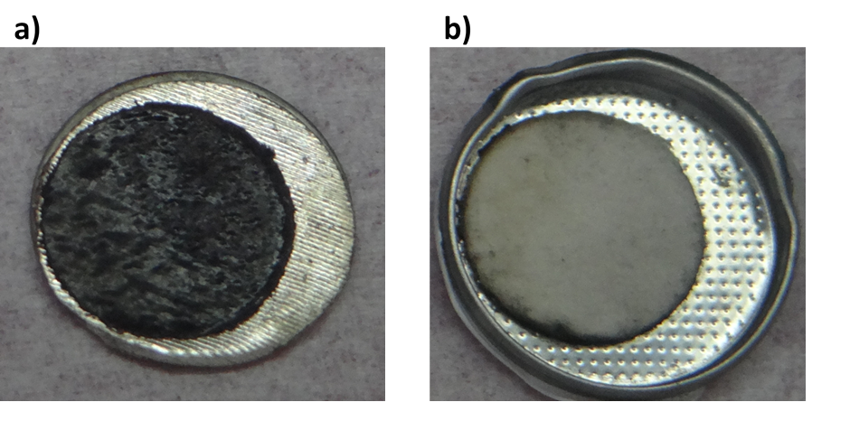
Figure S1. Digital photographs of (a) Li anode facing separator (b) separator facing anode.

