The electrical and dielectric features of Al/YbFeO₃/p-Si/Al and Al/YbFe_{0.90}Co_{0.10}O₃/p-Si/Al structures with interfacial perovskite-oxide layer depending on bias voltage and frequency
M. Coskun^{1,2*}, O. Polat^{3,4*}, I. Orak⁵, F. M. Coskun^{1,2}, Y. Yildirim⁶, D. Sobola^{3,7}, C. Sen⁸,
Z. Durmus⁹, Y. Caglar¹⁰, M. Caglar¹⁰, A. Turut^{1,2}
¹ Faculty of Engineering and Natural Sciences, Department of Engineering Physics, Istanbul Medeniyet University, Uskudar, 34700 Istanbul, Turkey
² Istanbul Medeniyet University Science and Advanced Technology Research Center (IMU-BILTAM), Istanbul, Turkey
³ CEITEC BUT, Brno University of Technology, Purkyňova 123, 612 00 Brno, Czech Republic
⁴ Tallinn European School, Tehnika 18, 10149 Tallinn, Estonia
⁵ Vocational School of Health Services, Bingol University, 12000 Bingol, Turkey
⁶Faculty of Engineering and Natural Sciences, Department of Mechanical Engineering, Istanbul Bilgi University, Eyüpsultan, 34060 Istanbul, Turkey
⁷Institute of Physics of Materials, Academy of Sciences of the Czech Republic, Žižkova 22, CZ-616 62 Brno, Czech Republic
⁸Department of Physics, Lamar University, Beaumont, Texas 77710, USA
⁹Department of Biomedical Engineering, Faculty of Engineering and Natural Sciences, Biruni University, 34010 Istanbul, Turkey
¹⁰Faculty of Science, Department of Physics, Eskisehir Technical University, Yunusemre Campus, 26470 Eskisehir, Turkey

Fig. 1 S a) and b) show the dielectric constant (ɛ′) of pure and 10% Co doped YbFeO₃ samples. The ɛ′ strongly depend on frequency for both devices. It has been observed that ɛ′ increases after doping process.
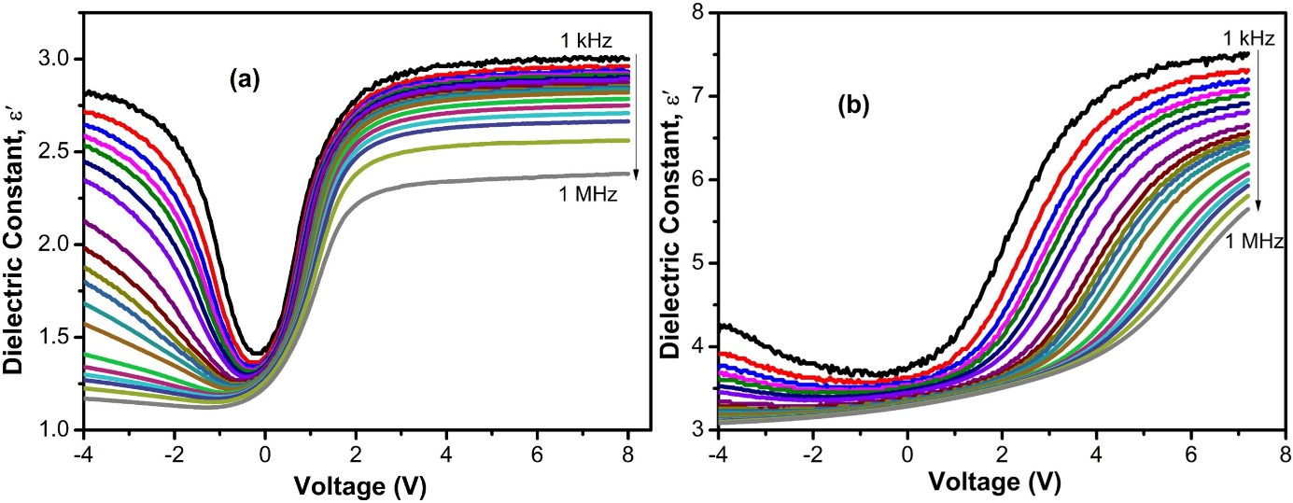
Fig. 1S Dielectric constant variation depends on voltage for various frequencies, a) YbFeO₃, b) 10 % Co-doped YbFeO₃.

