Supplementary Information

MoSe₂ nanosheets-based electrochemical sensor for simultaneous determination of ascorbic acid, dopamine and uric acid
Deniz Coban¹, Yasin Tangal², Sadik Cogal³
¹Burdur Mehmet Akif Ersoy University, The Graduate School of Natural and Applied Sciences, Department of Material Technology Engineering, 15030, Burdur, Turkey
²Burdur Mehmet Akif Ersoy University, The Graduate School of Natural and Applied Sciences, Department of Chemistry, 15030, Burdur, Turkey
³Burdur Mehmet Akif Ersoy University, Faculty of Arts and Science, Department of Chemistry, 15030, Burdur, Turkey

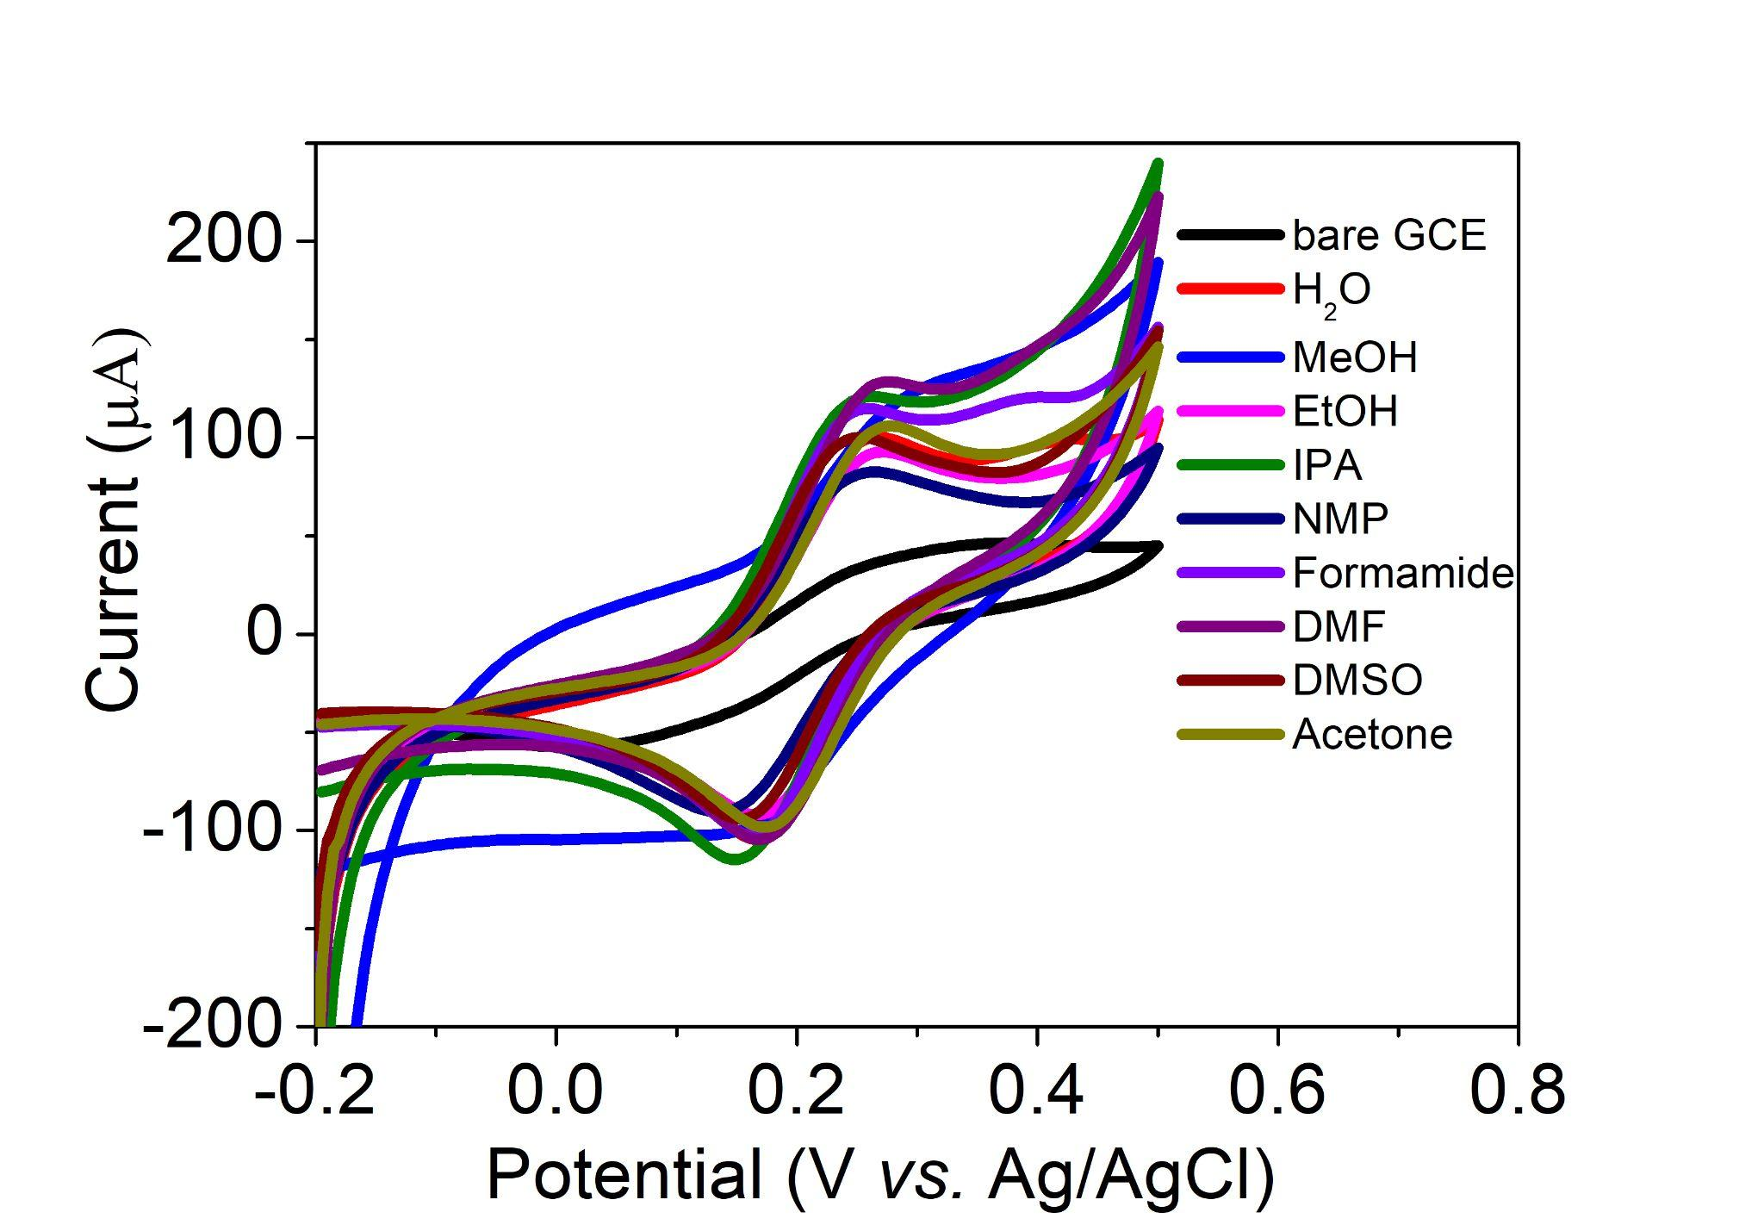
Figure S1. Cyclic voltammograms (CVs) of various GCE-MoSe₂ electrodes in 0.1 M KCl containing 5 mM [Fe(CN)₆]^{3-/4-}
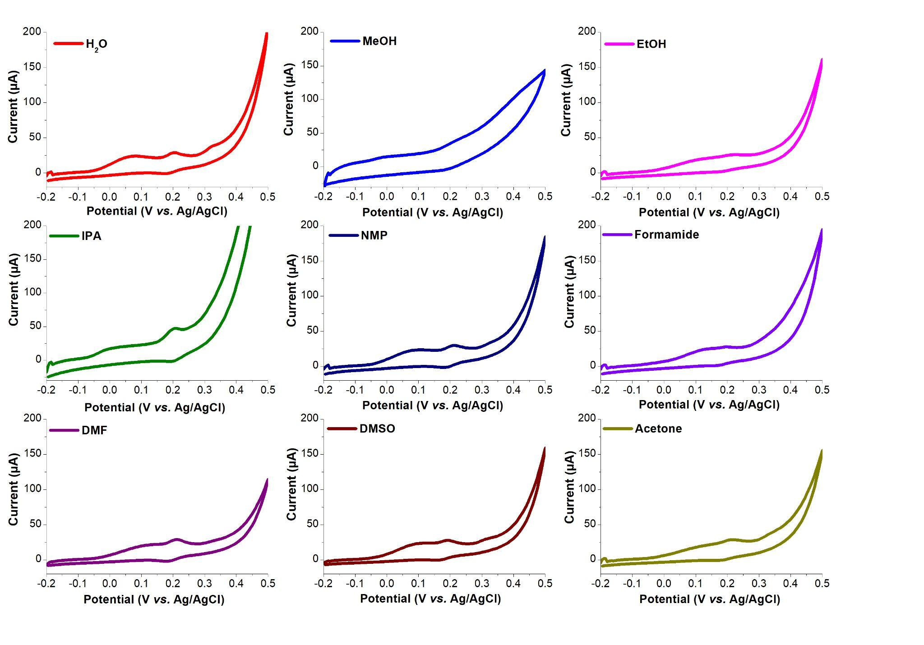
Figure S2. Cyclic voltammograms (CVs) of various GCE-MoSe₂ electrodes in PBS solution containing 1.13 mM ascorbic acid (AA), 0.19 mM dopamine (DA), and 0.38 mM uric acid (UA)
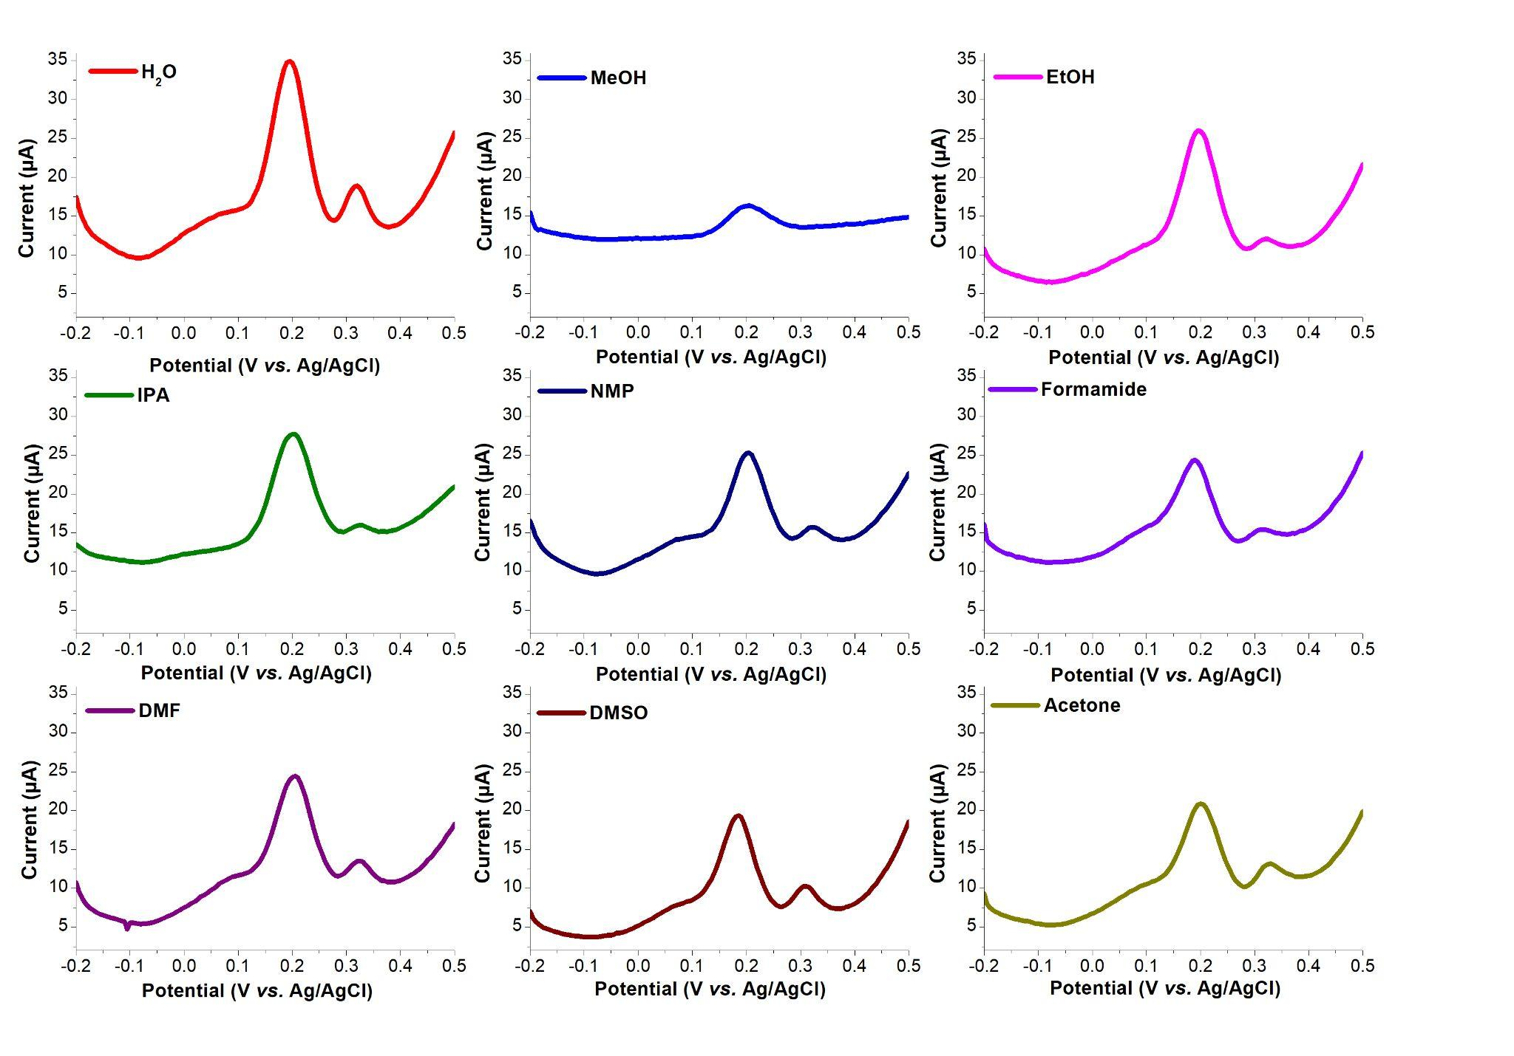
Figure S3. Differential pulse voltammograms (DPVs) of various GCE-MoSe₂ electrodes in PBS solution containing 1.13 mM ascorbic acid (AA), 0.19 mM dopamine (DA), and 0.38 mM uric acid (UA)

Table S1. Comparison of various electrodes for electrochemical determination of ascorbic acid (AA), dopamine (DA), and uric acid (UA)
Electrode | Linear range (µM) |  |  | LOD (µM) |  |  | Reference
Electrode | AA | DA | UA | AA | DA | UA
AuNPs@MoS₂ | 50-1.0x10⁵ | 0.05-30 | 50-4.0x10⁴ | 100 | 0.05 | 10 | [1]
3D-MoS₂/rGO/Au | 2-5400 | 0.3-198.3 | 5-2215 | 0.93 | 0.11 | 0.74 | [2]
MoS₂/rGO | 12-5402 | 5-545 | 25-2745 | 0.72 | 0.05 | 0.46 | [3]
MoS₂/PEDOT | 20-140 | 1-80 | 2-25 | 5.83 | 0.52 | 0.95 | [4]
AuNPs@MoS₂-NSs | 20-300 | 5-200 | 20-400 | 3 | 1 | 5 | [5]
3D MoS₂-PANI/rGO | 50-8.0x10³ | 5-500 | 1-500 | 22.20 | 0.70 | 0.36 | [6]
S-MoSe₂/NSG/Au/MIPs |  | 0.05-1000 |  |  | 0.02 |  | [7]
CB-CNT/PI | 1000-24000 | 3-300 | 5-500 | 154 | 1.86 | 3 | [8]
WSe₂@C | 8-2456 | 1.0-49  72.8-381.4 | 1-24.8  36,9-185.2 | 3.2 | 0.18 | 0.42 | [9]
Co/MoSe₂/PPy@CNF | 30–3212 | 1.2–536 | 10–1071 | 6.32 | 0.45 | 0.81 | [10]
AuNps@MoSe₂/SPCE |  | 3-20 |  |  | 0.21 |  | [11]
MoSe₂ | 50-3440 | 1-333 | 5-1146 | 13.7 | 0.57 | 1.75 | This work

References
1. H. Sun, J. Chao, X. Zuo, S. Su, X. Liu, L. Yuwen, C. Fan, and L. Wang, RSC Adv. 4, 27625 (2014).
2. Y. Zhao, J. Zhou, Z. Jia, D. Huo, Q. Liu, D. Zhong, Y. Hu, M. Yang, M. Bian, and C. Hou, Microchim. Acta 186, 1 (2019).
3. L. Xing and Z. Ma, Microchim. Acta 183, 257 (2016).
4. Y. Li, H. Lin, H. Peng, R. Qi, and C. Luo, Microchim. Acta 183, 2517 (2016).
5. H. L. Zou, B. L. Li, H. Q. Luo, and N. B. Li, Sensors Actuators B Chem. 253, 352 (2017).
6. S. Li, Y. Ma, Y. Liu, G. Xin, M. Wang, Z. Zhang, and Z. Liu, RSC Adv. 9, 2997 (2019).
7. Y. jiao Zang, J. Nie, B. He, W. Yin, J. Zheng, C. jun Hou, D. qun Huo, M. Yang, F. mei Liu, Q. qian Sun, Y. ling Qin, and H. bao Fa, Microchem. J. 156, 104845 (2020).
8. Y. Wang, T. Yang, Y. Hasebe, Z. Zhang, and D. Tao, Mater. 2018, Vol. 11, Page 1691 11, 1691 (2018).
9. S. Cogal and V. R. Bhethanabotla, IEEE Sens. J. 22, 14952 (2022).
10. G. Celik Cogal, S. Cogal, P. Machata, A. Uygun Oksuz, and M. Omastová, Microchim. Acta 191, 1 (2024).
11. K. Abid, A. Foti, A. Khaskhoussi, C. Celesti, C. D’Andrea, P. Polykretis, P. Matteini, D. Iannazzo, R. Maalej, P. G. Gucciardi, and G. Neri, Electrochim. Acta 475, 143371 (2024).

