Supplementary file

3D Printing Flexible Ga-doped ZnO Films for Wearable Energy Harvesting: Thermoelectric and Piezoelectric Nanogenerators
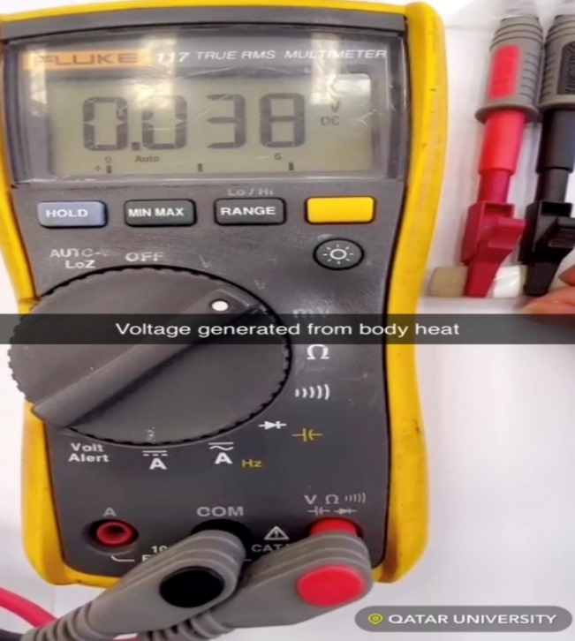
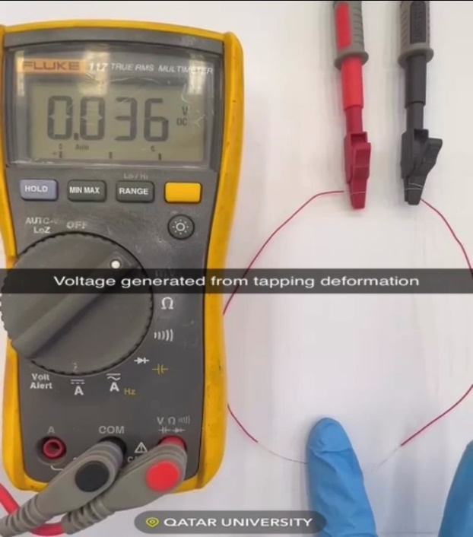
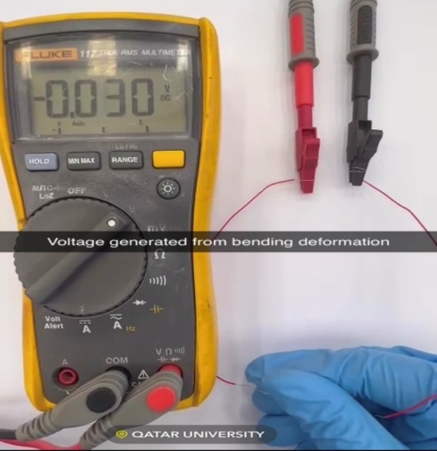
Figure S1: Voltage generation from (a) body heat, (b) tapping deformation, and (c) bending deformation

