Figure S1. AuE XPS Survey
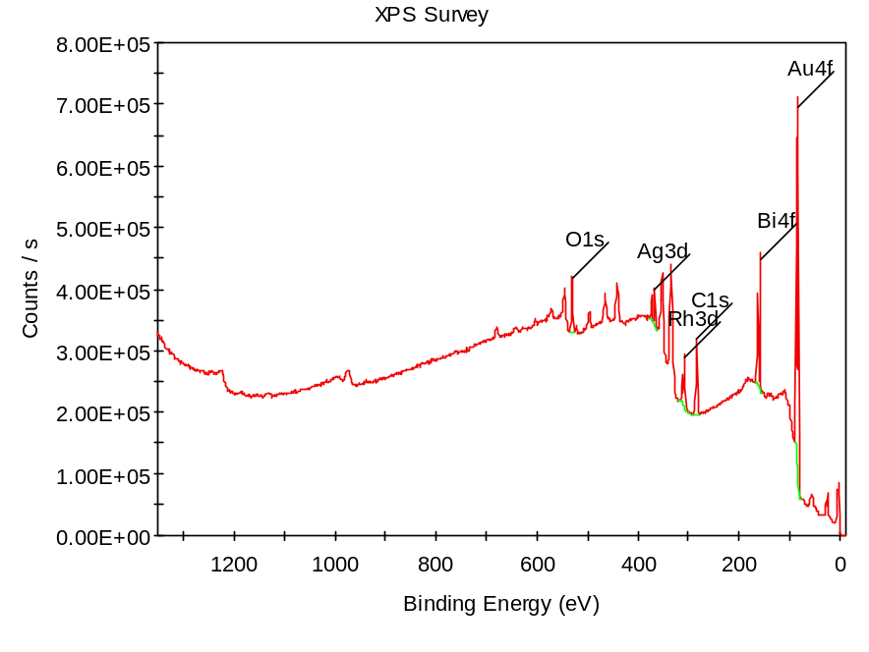
Figure S2. AuE-Cys electrode XPS Survey

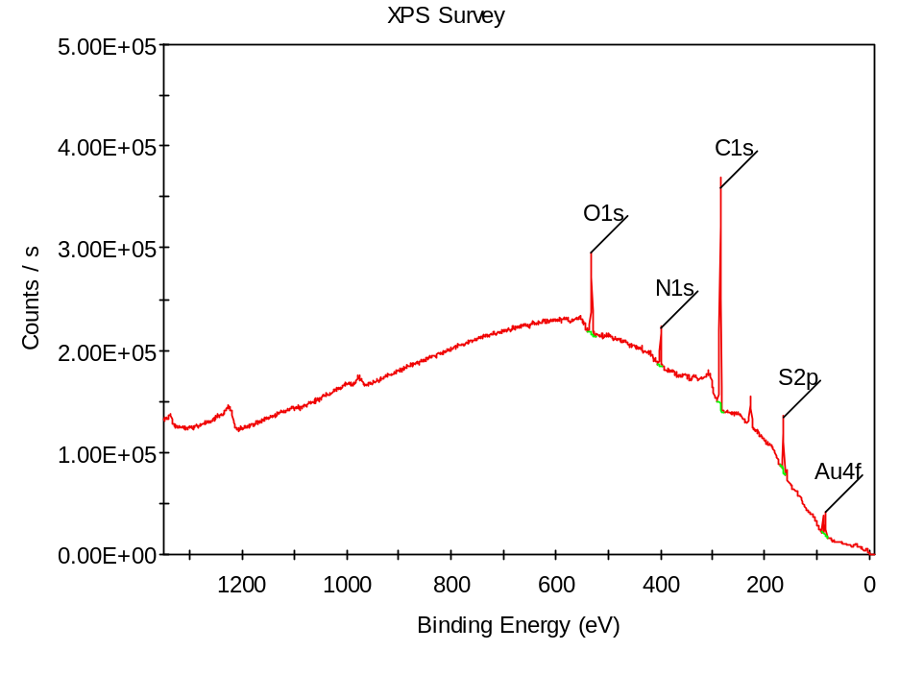

Figure S3. AuE-Cys-APBA electrode XPS survey

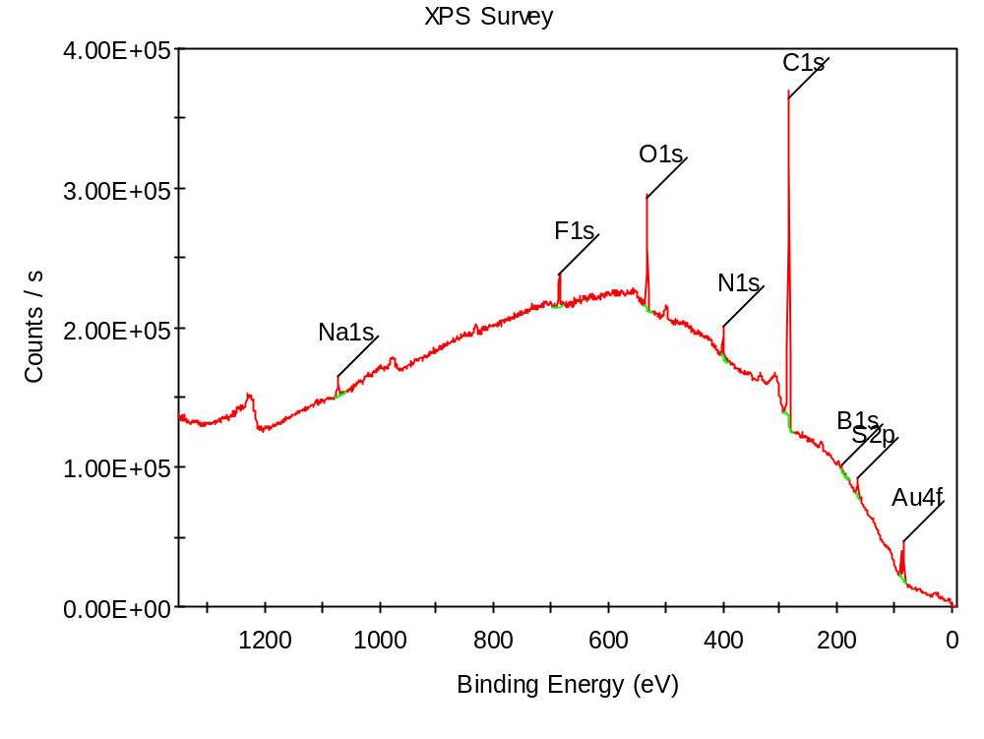
Figure S4. Relative signals of the DA sensor for noradrenaline and seratonine

Figure S5. Storage stability of the sensor

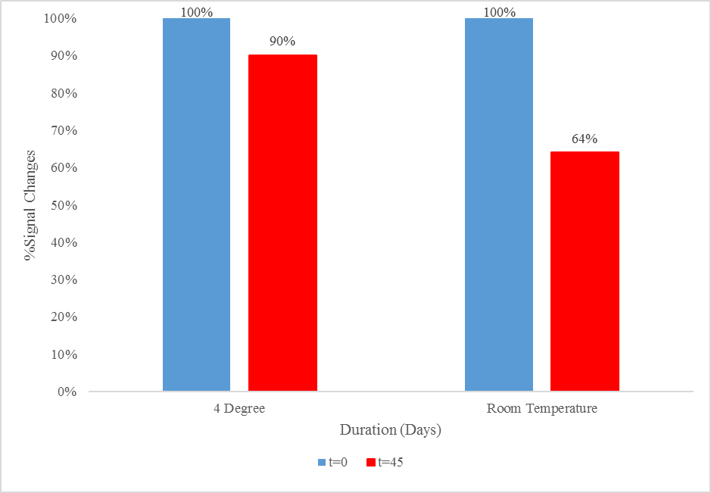

Figure S6. Spectrum of the Dopamine calibration curve
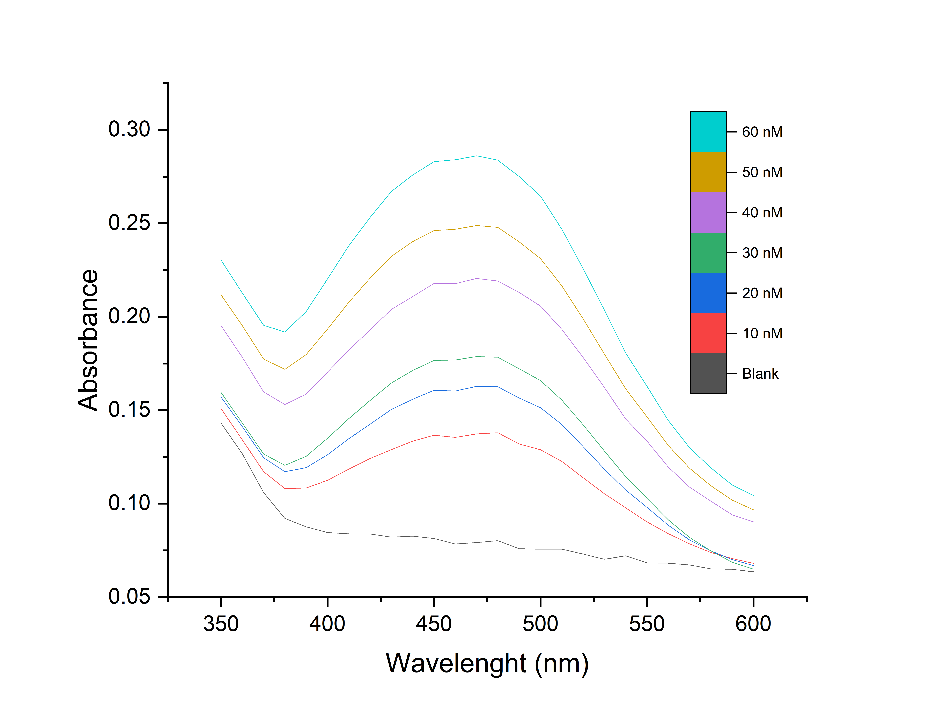

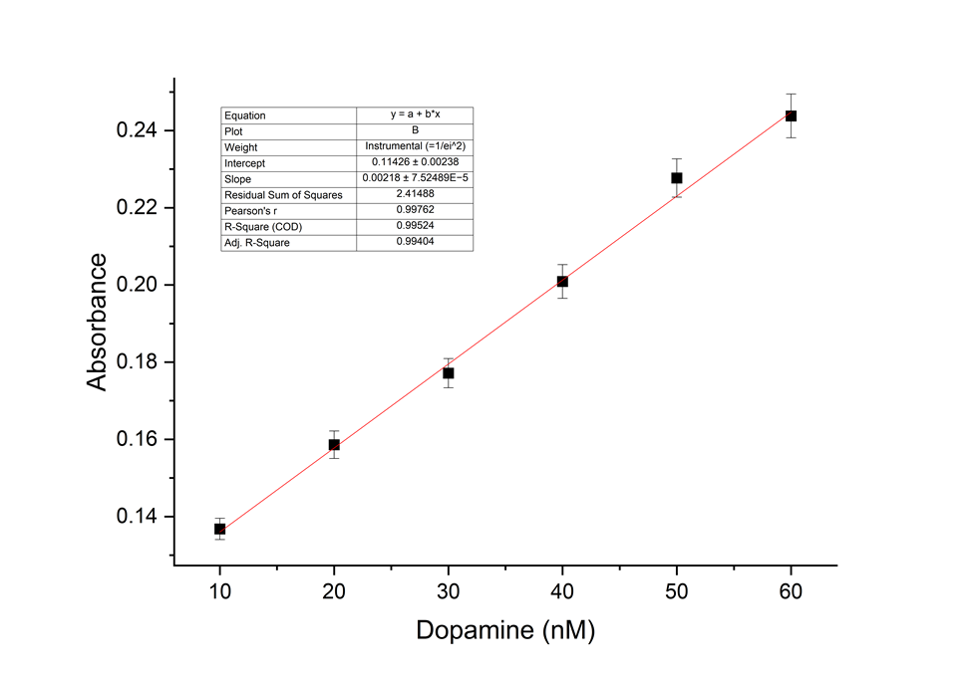
Figure S7. Calibration curve of the dopamine

