Supplementary Materials

The effect of different metal pad sizes on shear stress in solder ball bonding
Kyungrae Kim, Yekyung Kim, Sungho Kang and Tae Hoon Park*
*Corresponding Author: Tae Hoon Park, E-mail: thpark8@snu.ac.kr

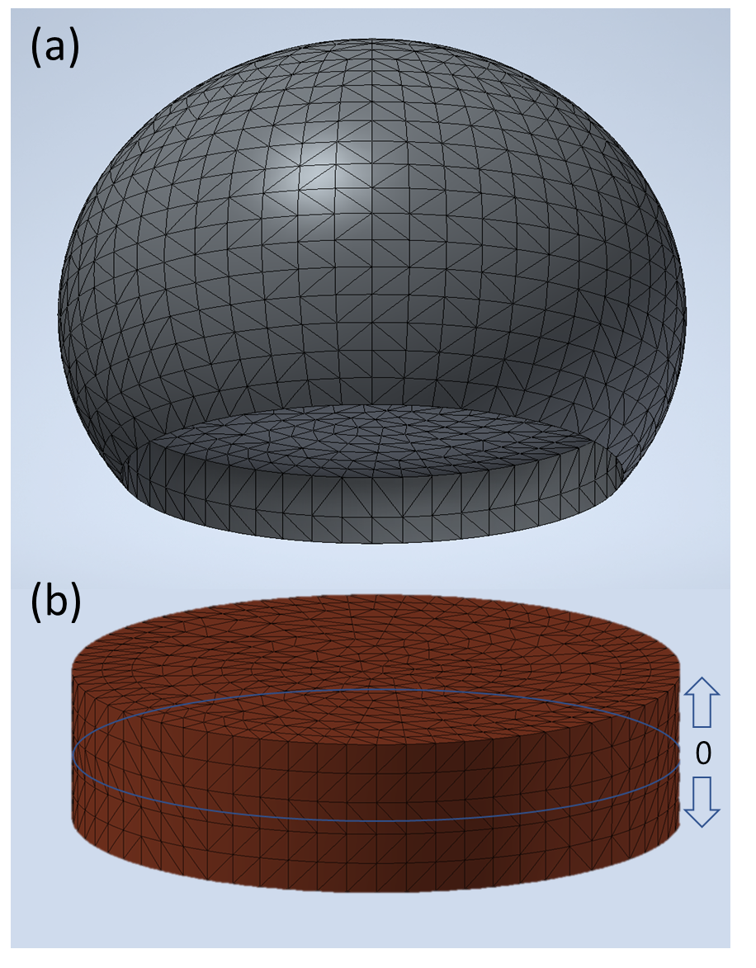
Fig. S1. The Simulation structural model of (a) solder ball, and (b) metal pad.

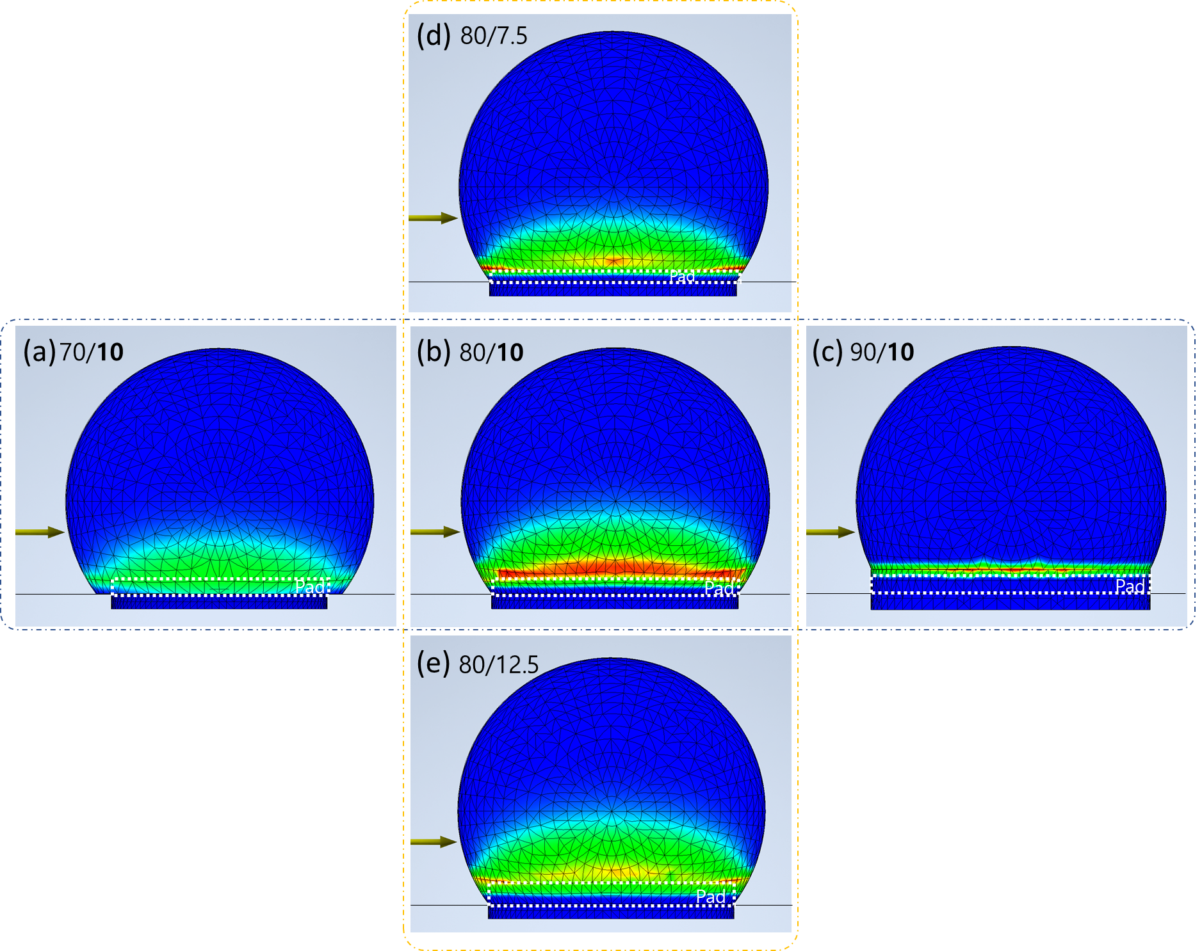
Fig. S2. The Simulation results according to pad sizes (Diameter/Height) of 100 μm diameter solder ball. (a) 70/10, (b) 80/10, (c) 90/10, (d) 80/7.5, (e) 80/12.5.

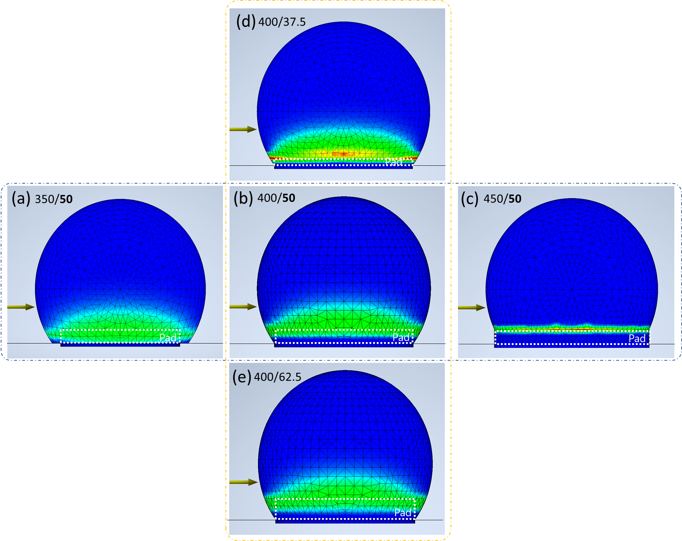
Fig. S3. The Simulation results according to pad sizes (Diameter/Height) of 500 μm diameter solder ball. (a) 350/50, (b) 400/50, (c) 450/50, (d) 400/37.5, (e) 400/62.5.

