Supporting Information
Effect of Synthesis Conditions on Morphology, Surface Chemistry and Electrochemical Performance of Nickel Ferrite Nanoparticles for Lithium-ion Battery Applications.
Reshma S Babu¹, Eszter Madai², Durga S Nair³, Prasad Gonugunta², Seyedamirhossein Mohseni Armaki², Ruud Hendrikx², Thamayanthi Panneerselvam¹, Ramaswamy Murugan¹, V.V. Ravi Kanth Kumar¹, Peyman Taheri², Arjan Mol², N. Satyanarayana^{1*}, Prasaanth Ravi Anusuyadevi^{2*}.
¹Department of Physics, Pondicherry University, Puducherry 605014, India.
²Department of Materials Science and Engineering (MSE), Faculty of Mechanical Engineering (ME), Delft University of Technology, Mekelweg 2, 2628 CD, Delft, The Netherlands.
³Department of Physics, Puducherry Technological University, Puducherry 605014, India
E-mail: nallanis2011@gmail.com; P.RaviAnusuyadevi@tudelft.nl or ranu.prasaanth@gmail.com
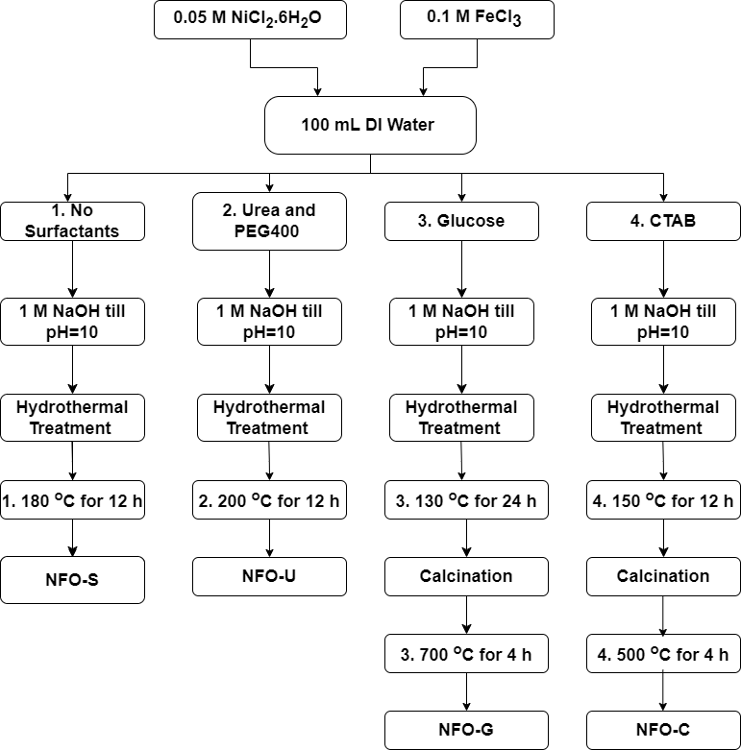
Supplementary Figure S1: Flowchart of detailed synthesis of NiFe₂O₄ nanoparticles

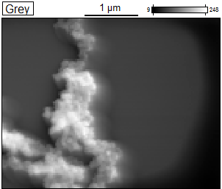
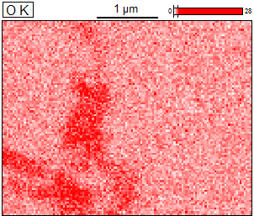
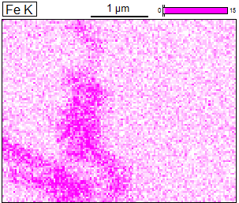
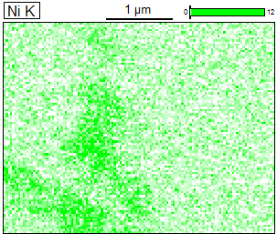

Supplementary Figure S2: SEM-EDX mapping of elements Ni, Fe and O in NFO-C sample

Supplementary Figure S3: Rate performance of NFO-S, NFO-G and NFO-C

Supplementary Table S1: Equivalent circuit components of NiFe₂O₄ samples
Sample |  | R_{el} | R_{ct} | R_{SEI} | Q_{dl} | a_{dl} | Q_{SEI} | a_{SEI} | Warburg  coefficient | Q_{int} | a_{int} | χ²
 |  | (Ω) | (Ω) | (Ω) | (F.s^{(a-1)}) |  | (F.s^{(a-1)}) |  | (Ω. s^{-1/2}) | (F.s^{(a-1)})
NFO-S | Before 1st  cycle | 5.622 | 23.51 | - | 55.22 x10⁻⁶ | 0.725 | - | - | 10.95 | 54.78 x10⁻³ | 0.356 | 14.05 x10⁻³
NFO-S | After 100th  cycle | 4.385 | 208.4 | 14.53 | 10.08 x10⁻⁶ | 0.803 | 2.541 x10⁻³ | 0.898 | 5.604 | 0.291 x10⁻³ | 0.699 | 1.568 x10⁻³
NFO-U | Before 1st  cycle | 7.902 | 117.2 | - | 48.08 x10⁻⁶ | 0.66 | - | - | -1845 | 0.134 x10⁻³ | 0.658 | 2.598 x10⁻³
NFO-U | After 100th  cycle | 9.007 | 190.9 | 1.416 | 25.13 x10⁻⁶ | 0.731 | 0.351 x10⁻³ | 1 | -290.8 | 0.105 x10⁻³ | 0.702 | 0.434 x10⁻³
NFO-G | Before 1st cycle | 4.076 | 67.61 | - | 31.83 x10⁻⁶ | 0.75 | - | - | 26.54 | 0.962 x10⁻³ | 0.878 | 5.455 x10⁻³
NFO-G | After 100th cycle | 4.941 | 197.5 | 0.298 | 27.09 x10⁻⁶ | 0.745 | 0.352 x10⁻³ | 0.401 | 198.2 | 0.488 x10⁻³ | 0.648 | 3.342 x10⁻³
NFO-C | Before 1st  cycle | 12.16 | 200 | - | 21.22 x10⁻⁶ | 0.687 | - | - | 2.29 x10⁻¹² | 0.128 x10⁻³ | 0.895 | 3.808 x10⁻³
NFO-C | After 100th  cycle | 341.9 | 253.9 | 0.455 | 44.66 x10⁻⁶ | 0.619 | 1.287 x10⁻⁶ | 0.595 | 1608 | 96.9 x10⁻⁶ | 0.732 | 0.287 x10⁻³

Supplementary Table S2: Comparison of electrochemical performance of NiFe₂O₄ anode materials from the literature.

Material | Electrochemical Performance | Ref
NiFe₂O₄ | 400 mAh/g after 10 cycles at C/5 rate | [1]
NiFe₂O₄ thin film | 355 mAh/g after 100 cycles at 10 µA/cm² | [2]
NiFe₂O₄ | 470 mAh/g after 20 cycles at C/8 rate | [3]
NiFe₂O₄ | 600 mAh/g after 80 cycles at 1 C rate | [4]
NiFe₂O₄ nanoparticles | 709 mAh/g after 3 cycles at 0.2 mA/cm² | [5]
NiFe₂O₄ nanorods | 887 mAh/g at 1st discharge at 0.1 mA/cm² | [6]
3D ordered microporous NiFe₂O₄ | 670 mAh/g after 50 cycles at 0.2 mA/cm² | [7]
NiFe₂O₄ nanofiber | 1000 mAh/g after 100 cycles at 100 mA/g | [8]
NiFe₂O₄/C | 780 mAh/g after 40 cycles at 1/8 C | [9]
NiFe₂O₄ | 600 mAh/g after 10 cycles at 0.2 mA/cm² | [10]
NiFe₂O₄ nanoparticles | 880 mAh/g after 30 cycles at 0.1 C | [11]
NiFe₂O₄ nanorods | 520 mAh/g after 300 cycles at 1000 mA/g | [12]
1D NiFe₂O₄ | 1349 mAh/g after 220 cycles at 100 mA/g | [13]
NiFe₂O₄ thin film | 1000 mAh/g after 100 cycles at 0.1 C | [14]
NiFe₂O₄ | 502.3 mAh/g after 100 cycles at 100 mA/g | [15]
NiFe₂O₄ Nanoparticles (NFO-S) | 2258 mAh/g at first discharge at 100 mA/g | This work
NiFe₂O₄ Nanoparticles (NFO-S) | 116 mAh/g after 100 cycles at 100 mA/g | This work

References

1. Alcántara R, Jaraba M, Lavela P, Tirado JL, Jumas JC, Olivier-Fourcade J (2003) Changes in oxidation state and magnetic order of iron atoms during the electrochemical reaction of lithium with NiFe2O4. Electrochem commun 5:16–21. https://doi.org/https://doi.org/10.1016/S1388-2481(02)00520-9
2. NuLi Y-N, Qin Q-Z (2005) Nanocrystalline transition metal ferrite thin films prepared by an electrochemical route for Li-ion batteries. J Power Sources 142:292–297. https://doi.org/10.1016/j.jpowsour.2004.10.015
3. Li XD, Yang WS, Li F, Evans DG, Duan X (2006) Stoichiometric synthesis of pure NiFe2O4 spinel from layered double hydroxide precursors for use as the anode material in lithium-ion batteries. Journal of Physics and Chemistry of Solids 67:1286–1290. https://doi.org/10.1016/j.jpcs.2006.01.096
4. Lavela P, Tirado JL (2007) CoFe2O4 and NiFe2O4 synthesized by sol-gel procedures for their use as anode materials for Li ion batteries. J Power Sources 172:379–387. https://doi.org/10.1016/j.jpowsour.2007.07.055
5. Zhao H, Zheng Z, Wong KW, Wang S, Huang B, Li D (2007) Fabrication and electrochemical performance of nickel ferrite nanoparticles as anode material in lithium ion batteries. Electrochem commun 9:2606–2610. https://doi.org/10.1016/j.elecom.2007.08.007
6. Zhang D, Tong Z, Xu G, Li S, Ma J (2009) Templated fabrication of NiFe2O4 nanorods: Characterization, magnetic and electrochemical properties. Solid State Sci 11:113–117. https://doi.org/10.1016/j.solidstatesciences.2008.05.001
7. Zhang T, Cao H, Peng J, Xiao Q, Li Z, Lei G (2011) Excellent cycling performance of three-dimensional-ordered macroporous nife 2O 4 as anode material for lithium ion batteries. Functional Materials Letters 4:327–331. https://doi.org/10.1142/S1793604711002196
8. Cherian CT, Sundaramurthy J, Reddy M V., Suresh Kumar P, Mani K, Pliszka D, Sow CH, Ramakrishna S, Chowdari BVR (2013) Morphologically robust NiFe2O4 nanofibers as high capacity Li-Ion battery anode material. ACS Appl Mater Interfaces 5:9957–9963. https://doi.org/10.1021/am401779p
9. Ding Y, Yang Y, Shao H (2013) One-pot synthesis of NiFe2O4/C composite as an anode material for lithium-ion batteries. J Power Sources 244:610–613. https://doi.org/10.1016/j.jpowsour.2013.01.043
10. Liu H, Zhu H, Yang H (2013) A low temperature synthesis of nanocrystalline spinel NiFe 2O4 and its electrochemical performance as anode of lithium-ion batteries. Mater Res Bull 48:1587–1592. https://doi.org/10.1016/j.materresbull.2012.12.072
11. Kumar PR, Mitra S (2013) Nickel ferrite as a stable, high capacity and high rate anode for Li-ion battery applications. RSC Adv 3:25058–25064. https://doi.org/10.1039/c3ra44001j
12. Wang N, Xu H, Chen L, Gu X, Yang J, Qian Y (2014) A general approach for MFe2O4 (M = Zn, Co, Ni) nanorods and their high performance as anode materials for lithium ion batteries. J Power Sources 247:163–169. https://doi.org/10.1016/j.jpowsour.2013.08.109
13. Wang J, Yang G, Wang L, Yan W (2016) Synthesis of one-dimensional NiFe2O4 nanostructures: Tunable morphology and high-performance anode materials for Li ion batteries. J Mater Chem A Mater 4:8620–8629. https://doi.org/10.1039/c6ta02655a
14. Choi M, Lee SH, Jung Y Il, Jung JY, Park JS, Choi WK, Park SY, Won HJ, Moon JK, Choi J, Kim SB (2017) The high capacity and cycle stability of NiFe2O4 thin film prepared by E-beam evaporation method for lithium ion batteries. J Alloys Compd 729:802–808. https://doi.org/10.1016/j.jallcom.2017.06.334
15. Dai S, Tang X, Li X, Zhang J, Shao Z (2022) Synthesis of NiFe2O4 with different precipitation agents for Li-ion battery anode material by co-precipitation. Journal of Solid State Electrochemistry 26:1211–1220. https://doi.org/10.1007/s10008-022-05158-2

