Supporting Information
Bismuth Sulfide/Oxide Composites as High-Performance Anode Material for Lithium-ion and Sodium-ion Batteries
Materials and Methods
Hydrothermal synthesis of Bi₂O₃
0.05M of Bi(NO₃)₃.5H₂O was dissolved in 15ml of 0.01M HNO₃. Then NaOH dissolved in 40 ml of distilled water was added dropwise into the above solution with continuous stirring until the pH was ∼8, which immediately resulted in the formation of yellowish precipitates in the container. The mixed solution was transferred into a Teflon lined stainless steel autoclave and subjected to hydrothermal reaction at 60˚C. The samples were then allowed to cool to room temperature naturally. The as-formed yellow precipitates were washed with deionized water and ethanol several times, and finally dried in air at 80˚C to obtain the final faint yellow Bi₂O₃ samples.
Hydrothermal synthesis of Bi₂S₃
Bi(NO₃)₃.5H₂O (1mmol) and thioacetamide (3mmol) were added to 70ml of solvent mixture (ethylene glycol, DI water, ethanol). The solution was stirred for 1h at room temperature to form a homogenous solution. The solution was transferred to a Teflon lined stainless steel autoclave and heated at 150°C for 8h. The black precipitate obtained was collected, washed with ethanol/ DI water several times and dried under IR lamp.
Hydrothermal synthesis of Bi₂O₃/Bi₂S₃ composite
Bi(NO₃)₃.5H₂O (1mmol) and thioacetamide (3mmol) were added to 70ml of solvent mixture (ethylene glycol, DI water, ethanol). Then, 6 mmol of NaOH dissolved in 40 ml of distilled water was added dropwise into the above solution with continuous stirring. The solution was stirred for 1h at room temperature to form a homogenous solution. The solution was transferred to a Teflon lined stainless steel autoclave and heated at 150°C for 8h. The black precipitate obtained was collected, washed with ethanol/ DI water several times and dried under IR lamp.
Hydrothermal synthesis of core-shell Bi₂O₃@Bi₂S₃
To 1g of hydrothermally synthesized Bi₂O₃ dispersed in 20ml of DI water, Bi(NO₃)₃.5H₂O (1mmol) and thioacetamide (3mmol) in 50 ml mixture of ethylene glycol, DI water and ethanol were added. The total volume was adjusted to 70ml. The solution was transferred to a Teflon lined stainless steel autoclave and heated at 150°C for 8h. The black precipitate obtained was collected, washed with ethanol/ DI water several times and dried under IR lamp.
Material characterization
Powder X-ray diffraction (XRD) was recorded with Cu K_{α} source with λ =1.5418 Å within 10º ≤ 2θ ≤80º range (Rigaku Ultima IV diffractometer). The scanning electron microscopy (SEM) images were recorded on Ultra 55 FESEM, ZEISS instrument. Transmission electron microscopy (TEM) and HRTEM was done using FEI Tecnai (G2, F30, 300 kV) instrument by dispersing the samples in isopropyl alcohol and then spreading it on carbon coated Cu grids. XPS of the materials was recorded on the AXIS Supra model of the Kratos SHIMADZU Analytical instrument.
Electrode preparation
The working anodes for LIB and SIB were prepared using standard procedure. The active material, carbon black (conducting agent) and binder carboxy methyl cellulose (CMC) was mixed in DI water in 7:2:1 ratio according to their weight %. The paste obtained was smeared on a Cu foil current collector using doctor blade. The area of each electrode was 1cm⁻² and they were dried for 8h in a hot air oven maintained at 50˚C. The active material loading ranged between 1.6 - 1.9 mg cm⁻². The separator was Whatmann microfiber filter GF/D and electrolyte was 1M LiPF₆ in a 50:50 (v/v) mixture of dimethyl carbonate (DMC) and ethylene carbonate (EC) and 1M NaClO₄ in a 50:50 (v/v) mixture of propylene carbonate (PC) and EC along with 5 wt.% fluoroethylene carbonate (FEC) for lithium and sodium ion coin cells, respectively. Electrodes and separator with electrolytes were assembled in CR2032 coin cell in mbraun glove box with oxygen and moisture level below 0.1 ppm with high purity Argon environment inside the glove box.
Electrochemical studies
The coin cells were charged/discharged with various current densities on an Arbin Instrument (BT2000, USA) within a voltage window of 0.01–3.0 V with respect to Li/Li⁺ and 0.01–2.5 V with respect to Na/Na⁺. The specific capacities were determined based on the weight of active material loading. Cyclic voltammetry (CV) was performed on a BioLogic VMP-3 (France) instrument at a scan speed of 0.05 mV s^{‒1} against lithium metal half-cell configurations within a voltage range of 0.01–3.0V. Electrochemical impedance spectroscopy (EIS) analysis was performed using the CHI760D in the frequency range of 100 kHz to 0.01 Hz under open circuit voltage.
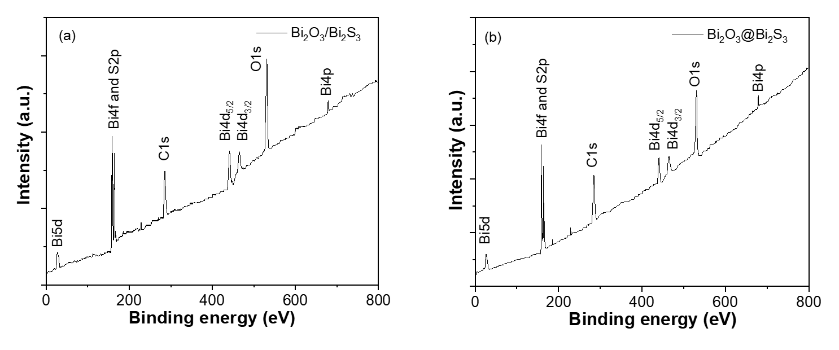
Fig. S1: XPS core level survey spectrum of the (a) Bi₂O₃/Bi₂S₃ composite and (b) core shell Bi₂O₃@Bi₂S₃

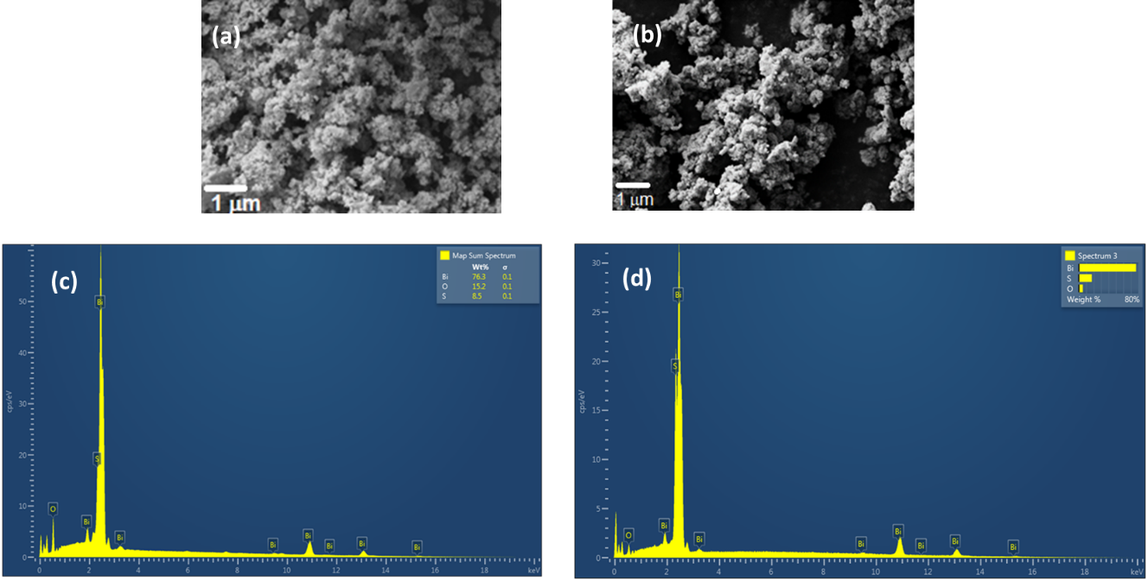
Fig. S2: SEM of (a) Bi₂O₃/Bi₂S₃ composite, (b) core shell Bi₂O₃@Bi₂S₃, and corresponding EDS of (c) Bi₂O₃/Bi₂S₃ composite and (d) core shell Bi₂O₃@Bi₂S₃
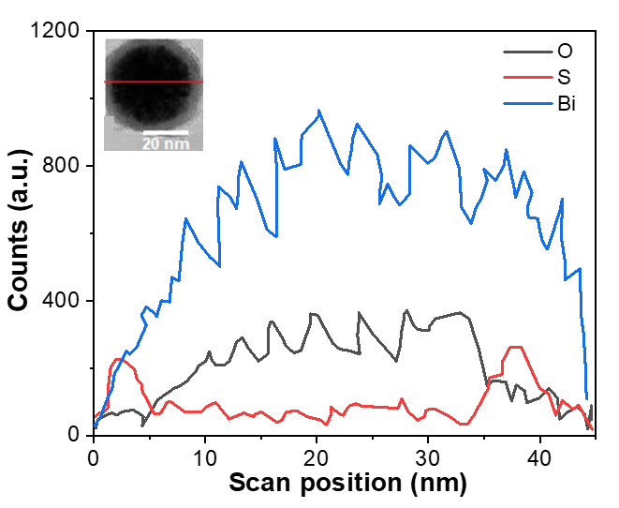
Fig. S3: EDS line scan spectra of Bi₂O₃@Bi₂S₃.
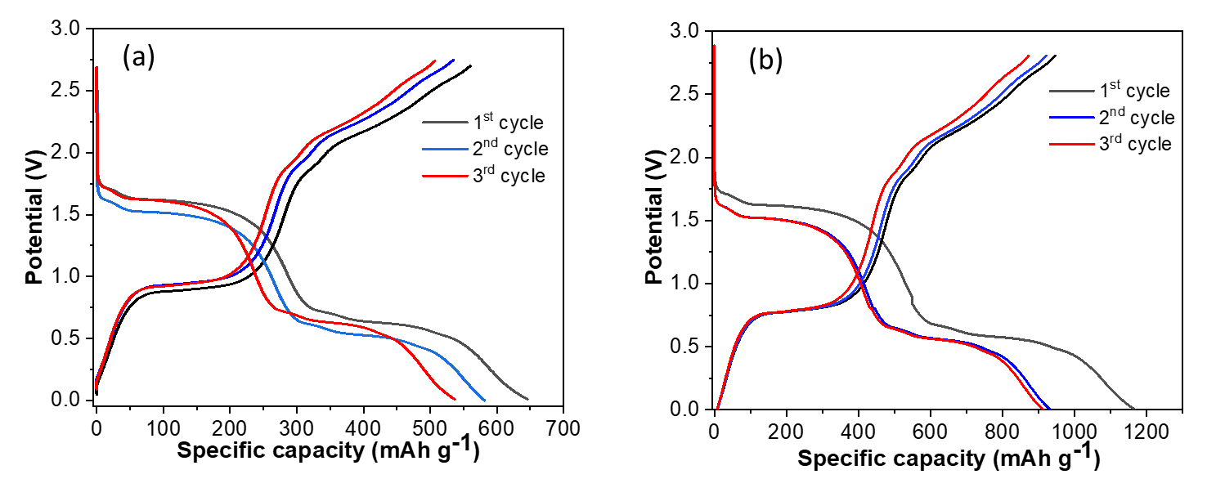
Fig. S4: Galvanostatic charge discharge profile of (a) Bi₂O₃@Bi₂S₃ core-shell and (b) Bi₂O₃/Bi₂S₃ heterostructure composite for first three cycles
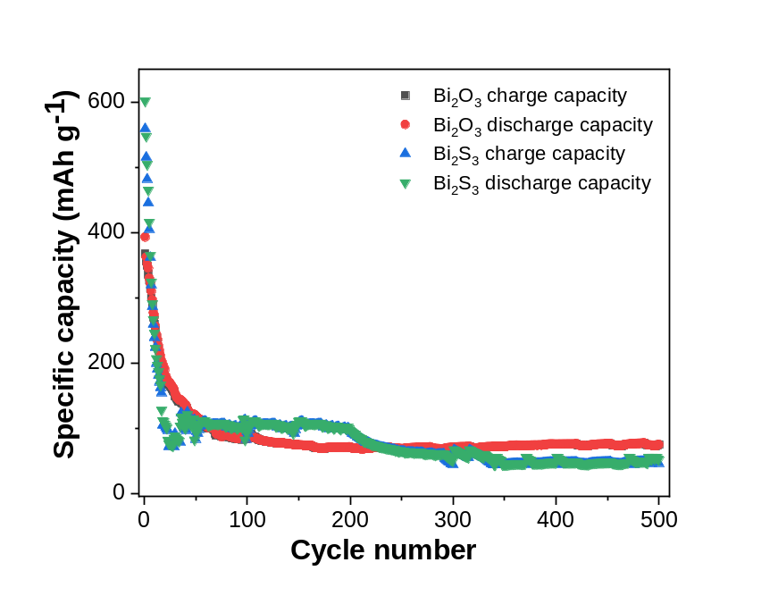
Fig. S5: Cyclability plots of Bi₂O₃ and Bi₂S₃
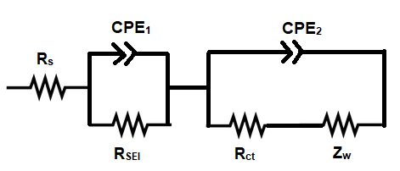
Fig. S6: Equivalent circuit for the Nyquist plot fitting of Bi₂O₃/Bi₂S₃ heterostructure composite and Bi₂O₃@Bi₂S₃ core-shell electrodes after 50 cycles.

