Table S1. XRF compositions of raw powders (wt%).
Powder | Fe (wt%) | Si (wt%) | Cr (wt%) | P (wt%) | Remarks
FeSiCr (matrix) | 88.5 | 5.1 | 6.1 | — | Fe–Si–Cr solid solution
RIP (SiO₂-coated) | > 98 | trace | — | — | Si from silica shell
CIP (SiO₂-coated) | > 98 | trace | — | — | Si from silica shell
CIP-P (phosphate-coated) | > 98 | — | — | trace | P from phosphate shell
Table S2 Particle-size distribution metrics (laser diffraction).
Powder | D₁₀ (µm) | D₅₀ (µm) | D₉₀ (µm) | Span = (D₉₀ − D₁₀)/D₅₀
FeSiCr | 12.4 | 17.8 | 30.6 | 1.02
RIP | 2.4 | 4.6 | 9.1 | 1.46
CIP | 2.7 | 5.5 | 9.8 | 1.29
CIP-P | 2.5 | 4.9 | 9 | 1.33

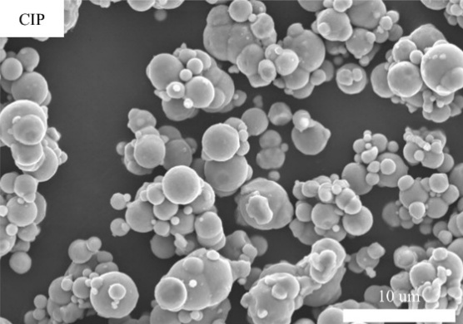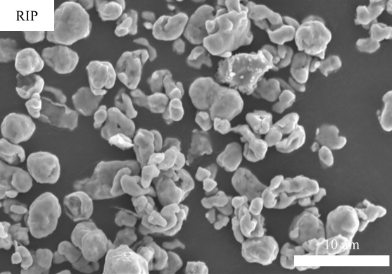
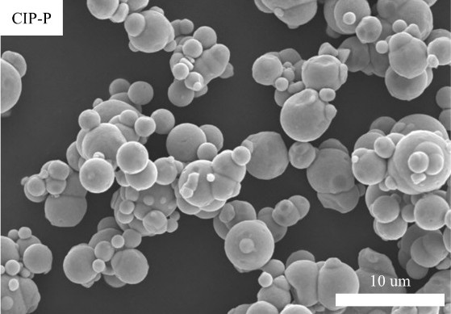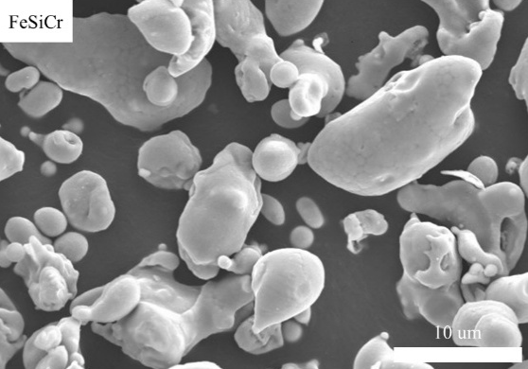
Fig.S1 SEM images of the raw materials.
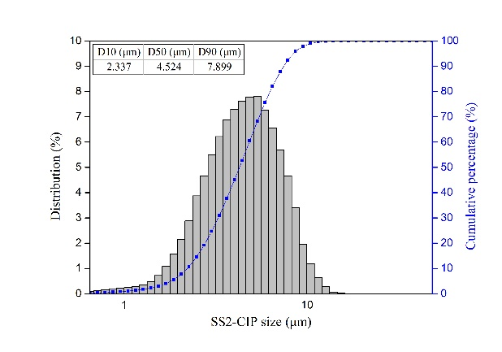 | 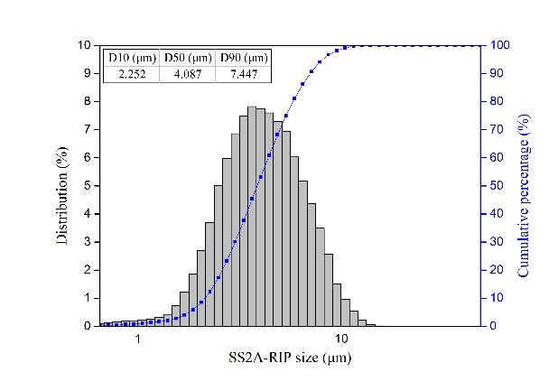
CIP | RIP
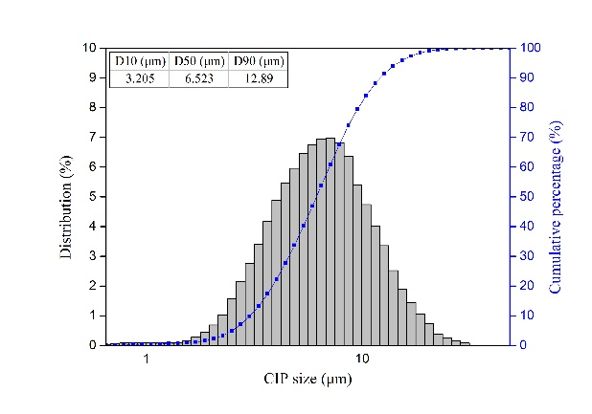 | 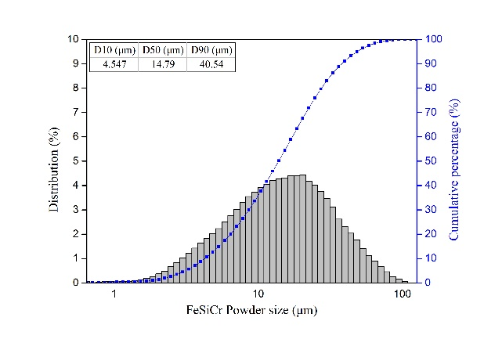
CIP-P | FeSiCr
Fig.S2 Volume-based particle-size distribution (PSD) curves of the raw materials.

Fig.S3 Variation of initial permeability (μ_{i}) with the measuring frequency (100-1000 kHz).

