Human Cardiomyocyte-Derived Exosomes Induce Cardiac Gene Expressions in Mesenchymal Stromal Cells within 3D Hyaluronic Acid Hydrogels and in Dose-Dependent Manner
Burak Derkus

Department of Chemistry, Faculty of Science, Ankara University, 06560 Ankara, Turkey
burakderkus@gmail.com
Mobile: +905069069786

SUPPLEMENTARY INFORMATION

Figure S1 – Schematic illustration of hydrogelation/cross-linking mechanism of HA-Tyr after inoculation of exosomes and stem cells (A). 3D view of HA-Tyr/CExo w/wo hAMSCs (B). Below illustration shows the hypothesis/strategy of this work.
Figure S2 – Characterization of cardiac exosomes: TEM image of CExo (A). Calibration graph related to ELISA test against CD63 antibody, an exosomal biomarker (B).

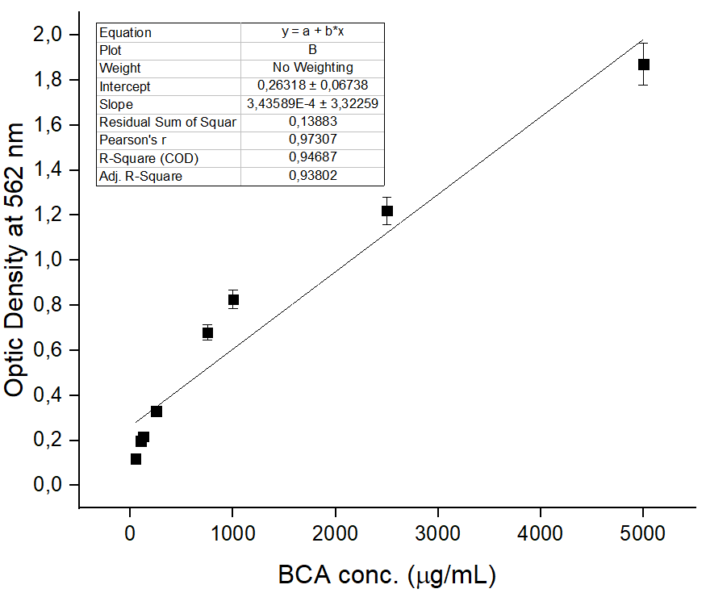
Figure S3 – Calibration graph related to BCA test

Table S1. Primer sequences used in qPCR study

Genes | Primer, Forward | Primer, Reverse
cTnT | GGCAGCGGAAGAGGATGCTGA | GAGGCACCAAGTTGGGCATGAACGA
GATA4 | CTGTGCCAACTGCCACACCA | GGCTGACCGAAGATGCGTAG
Nkx2.5 | CTGCCGCCGCCAACAAC | CGCGGGTCCCTTCCCTACCA
Tbx5 | AGTCCCCCGGAACAACTCGAT | ACAGCAGCTGCACCGTCACC

