Supplementary Figure:
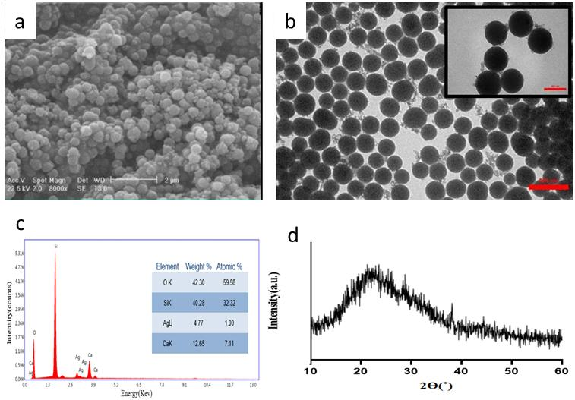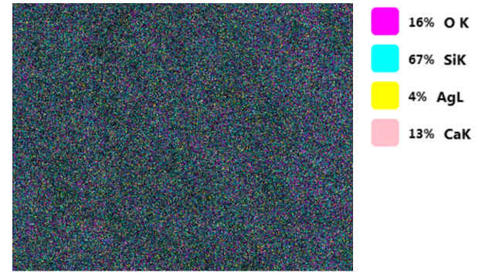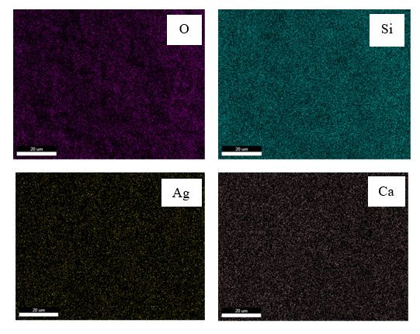
Supplementary 1: SEM-EDS mapping of the O, Si, Ag and Ca elements in as-synthesized Ag-BG.

