Stable sol–gel hydroxyapatite coating on zirconia dental implant for improved osseointegration
Jinyoung Kim¹, In-Gu Kang¹, Kwang-Hee Cheon¹, Sungmi Lee², Suhyung Park¹, Hyoun-Ee Kim¹, Cheol-Min Han^{*,3}
¹Department of Materials Science and Engineering, Seoul National University, Seoul 08826, Republic of Korea
²Biomedical Implant Convergence Research Center, Advanced Institutes of Convergence Technology, Suwon 16229, Republic of Korea
³Department of Carbon and Nano Materials Engineering, Jeonju University, Jeonju 55069, Republic of Korea

*Corresponding Author
Cheol-Min Han, Jeonju University
Email : hancm@jj.ac.kr
Tel : +82-63-220-2208
Postal Address : 303 Cheonjam-ro, Wansan-gu, Jeonju-si, Jeollabuk-do, 55069, Republic of Korea

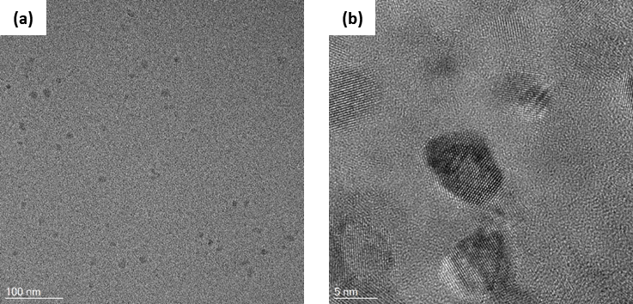
Figure S1. Transmission electron microscopy images of dried HA sol after 1 day of aging observed with (a) low (× 40,000) and (b) high (× 600,000) magnifications. Scale bars are (a) 100 nm and (b) 5 nm.

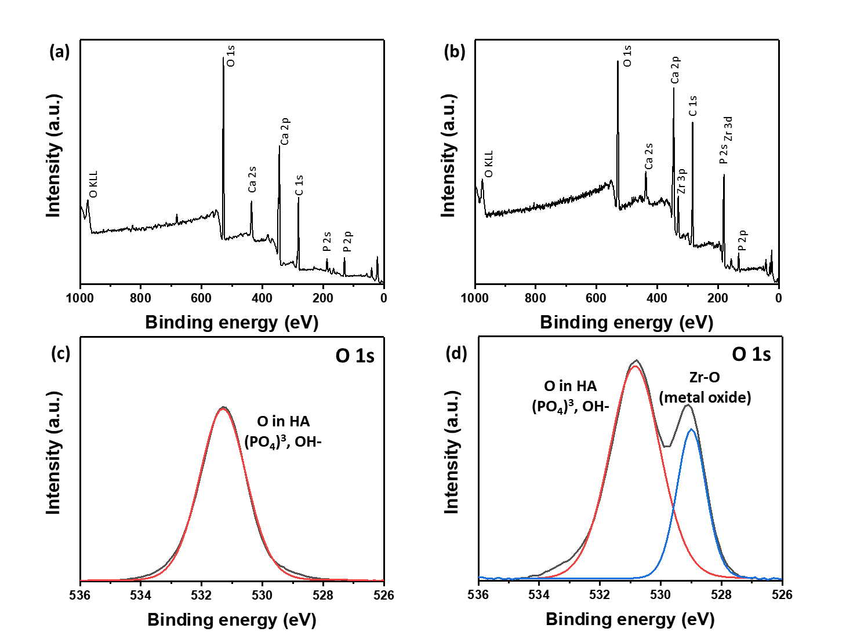
Figure S2. X-ray photoelectron spectroscopy data of (a, c) HA800 and (b, d) HA1000. (a, b : survey spectra, c, d : O 1s).

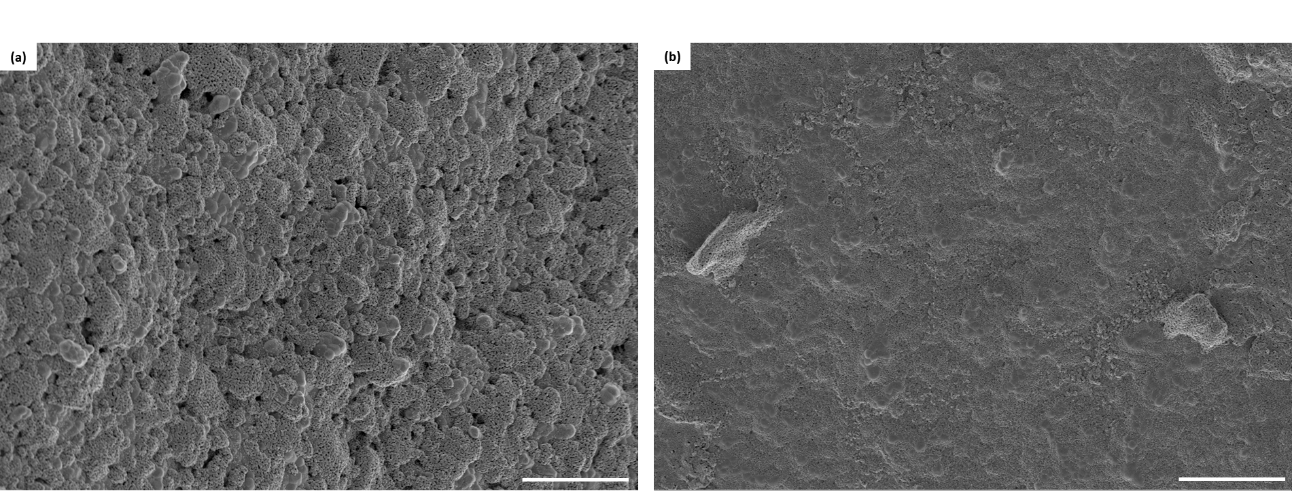
Figure S3. Scanning electron microscopy images of HA-coated zirconia screw sintered at 800 °C after implantation on synthetic bone; (a) ridge and (b) groove of screw. scale bars are 2 μm.

