Supporting Information
In vitro and In vivo MRI imaging and photothermal therapeutic properties of Hematite(α-Fe₂O₃) Nanorods
Aanisa Gulzar,^{a1} Nowsheena Ayoub,^{a1} Jaffar Farooq Mir, ª Amer M Alamazi,^{b} M A Shah, ^{a*} Arif Gulzar, ^{c,d}*
ªDepartment of Physics, National Institute of technology, Srinagar, J&K,190006, India
^{b} Pharmaceutical Chemistry Department, College of Pharmacy , King Saud University, Riyadh 11451, Saudi Arabia.

^{c}MedX institute, College of Biomedical Engineering, Shanghai Jiaotong University. Shanghai,200030, PRC.
^{d} Hevesy Laboratory, DTU Health Tech, 4000, Roskilde, Denmark

E-mail: arifgulzar@sjtu.edu.cn, Shah@nitsri.ac.in

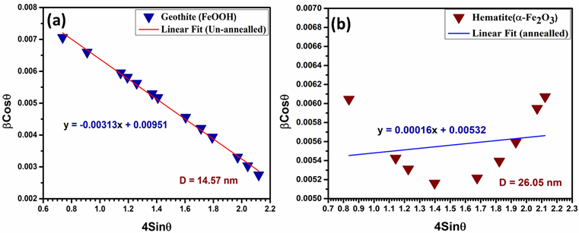
Fig.S1. (Williamson Hall Plot: Goethite (Unannealed sample) 500ºC(a). Hematite (annealed) sample (b).
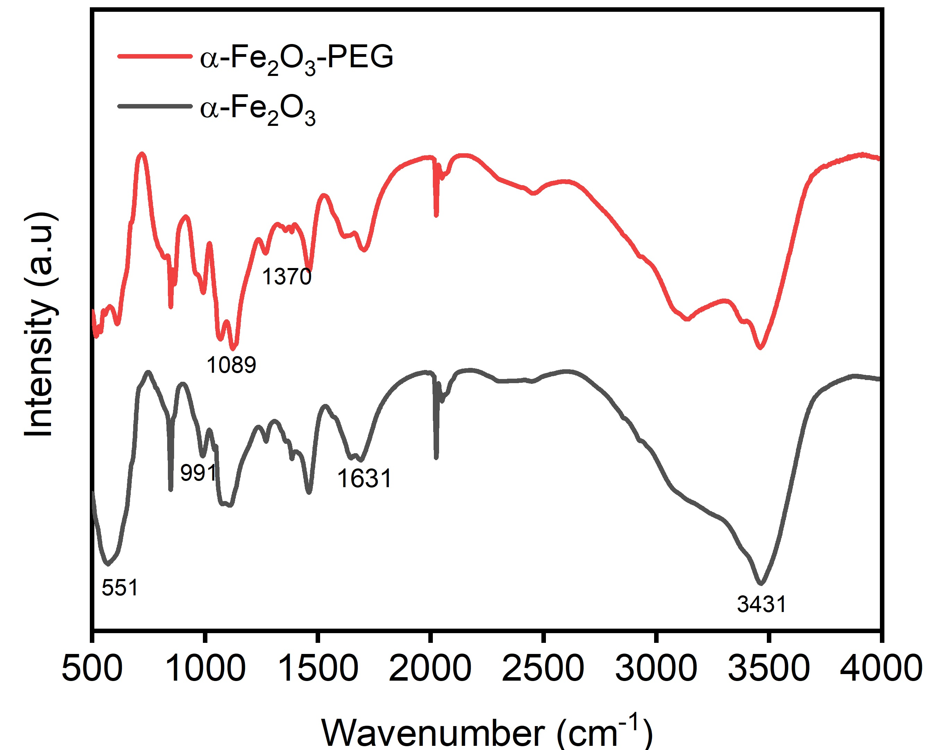

Fig.S2. FT-IR of α- Fe₂O₃ and α- Fe₂O₃-PEG.
Fig.S3. UV- vis spectra of the hematite nanorods: (a) Absorption spectra (b) Reflectance spectra.
Fig.S4. Tauc plot showing band gap energy of hematite nanorods.

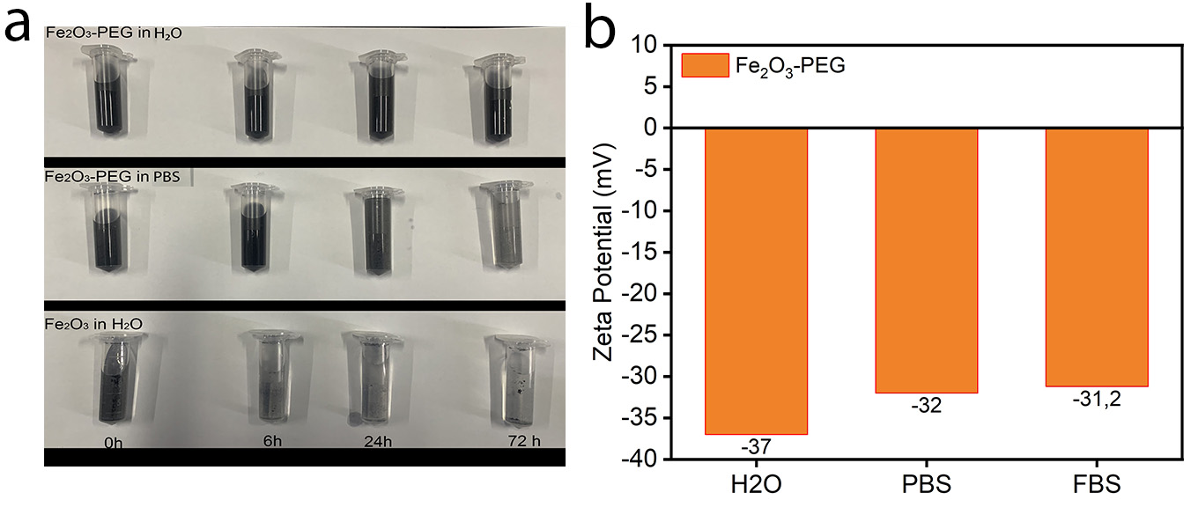

Fig.S5. (a)Solubility of α-Fe₂O₃ and α-Fe₂O₃-PEG in water and PBS over a time period of 72 hours (b) Zeta potential of α-Fe₂O₃-PEG in water, PBS and FBS.

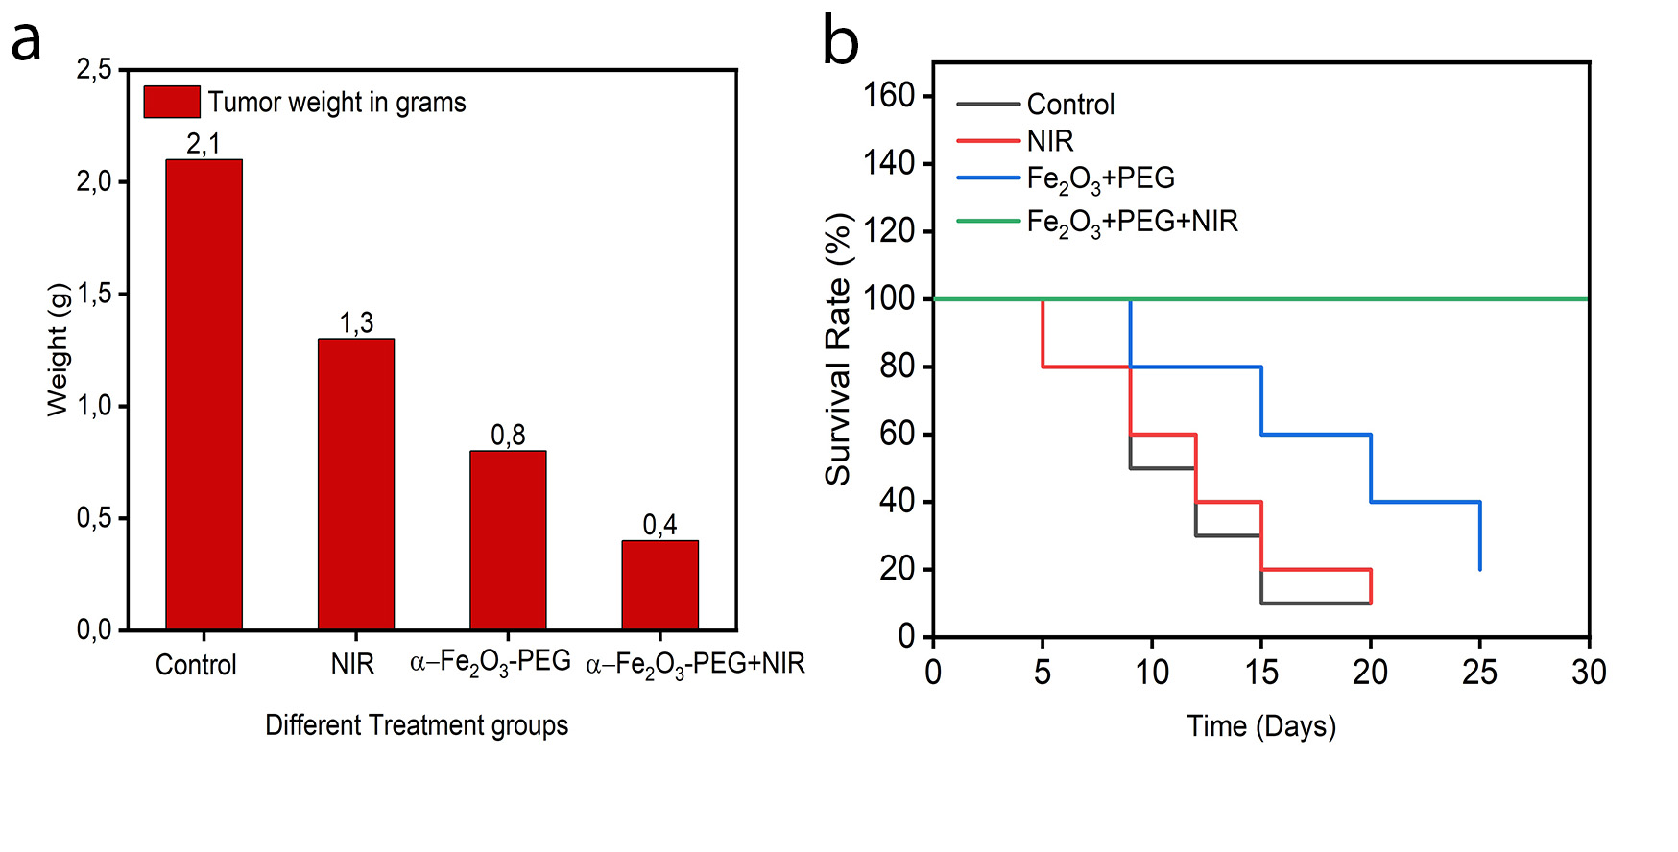
Fig.6S (a) Tumor weight after extraction of different treatment groups, (b) Survival rate of various treatment groups.

Calculation of Photothermal conversion efficiency
Photothermal conversion efficiency of the α-Fe₂O₃₋PEG was calculated by recording the change in the temperature of the NP aqueous dispersion as a function of time under continuous irradiation of a 808 nm laser (0.5 W/cm²) for 5 mins until the solution reached a steady-state temperature. The photothermal conversion efficiency (ƞ) was calculated according to Equation S1:

Equation S1.

Where, h represents the heat transfer coefficient, A is the surface area of the container, T_{max} represents the maximum steady-state temperature (60 °C), T_{surr} is the ambient temperature of the environment (25 °C), Q_{dis} represents the heat dissipation from the light absorbed by the solvent and the quartz sample cell, I is the incident laser power (0.5 W/cm²), and A660 is the absorbance of the sample at 740 nm (1.776). The value of hA is derived from Equation S2:

Equation S2.

Where τ is the time constant for heat transfer of the system which was determined to be τ =390.96 from Fig 6d. m_{D} and c_{D} are respectively the mass (1.0 g) and heat capacity (4.2 J/g) of the deionized water used to disperse the α-Fe₂O₃₋PEG. So, the hA was determined to be 0.0201 W. Q_{dis} represents the heat dissipation from the light absorbed by the water and the quartz sample cell, so Q_{dis} was calculated according to Equation S3:

Equation S3.

Where T_{max}(water)is 26.8 °C, τ (water) is 259.25, so Q_{dis} was calculated to be 0.0211 W.
According to the obtained data and Equation (1), the photothermal conversion efficiency of the α-Fe₂O₃₋PEG was determined to be 39.5%.

