Supplementary Figure

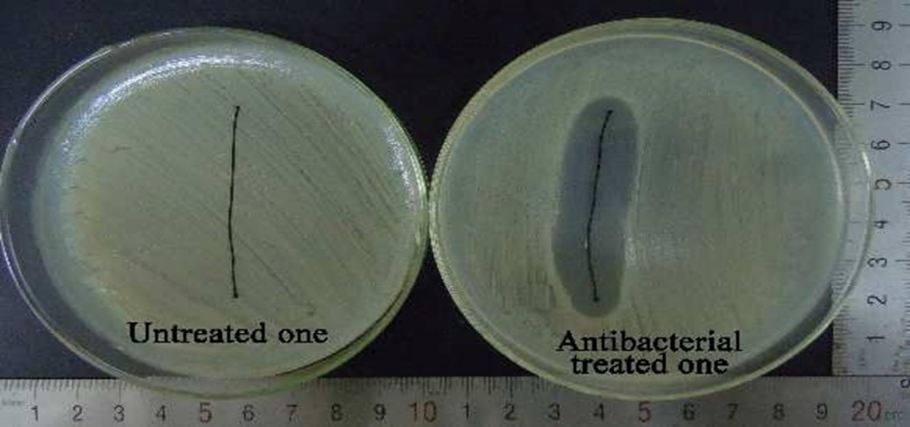
Antibacterial Testing for Untreated and Treated Coated suture

