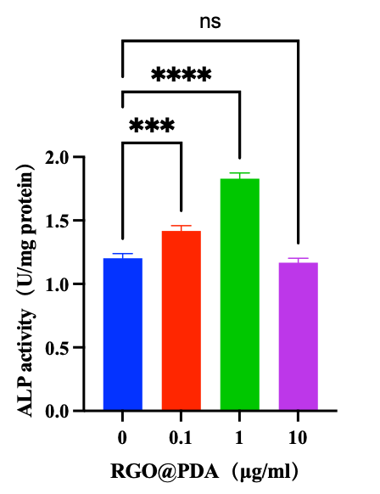
Figure S1. The optimal concentration for osteogenesis of RGO@PDA. ALP activity quantitative analyses of rBMSCs after 7 days cultured with RGO@PDA. All data are presented as mean ± SD (n = 3). Statistical analysis: NS, non-significant; *P < 0.05; **P < 0.01; ***P < 0.001.

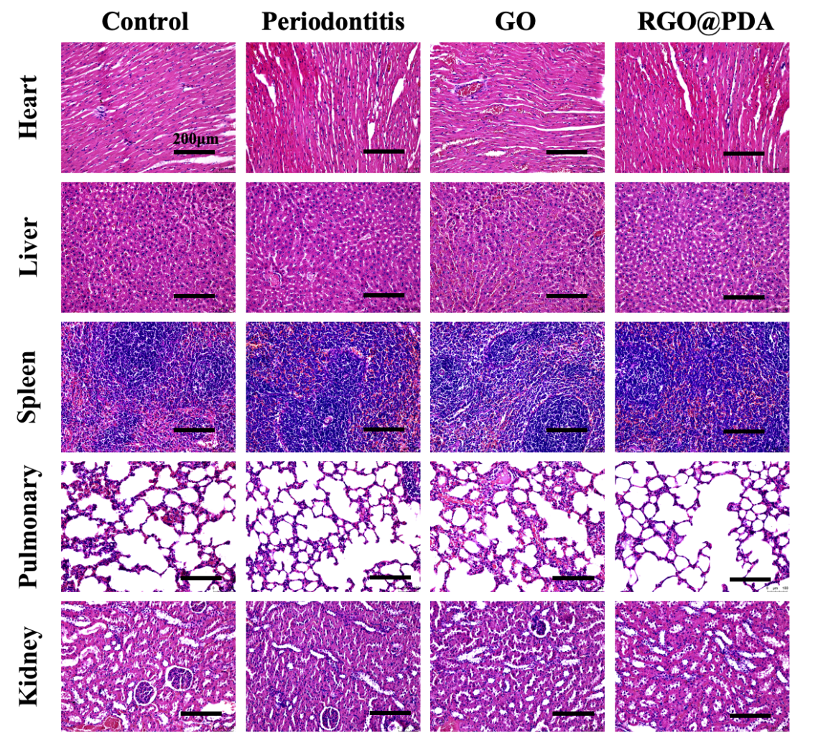
Figure S2. In vivo biosafety assessment of RGO@PDA. The H&E staining results of the major internal organs of rats (heart, liver, spleen, lungs and kidneys). Scale bar: 200 μm.

